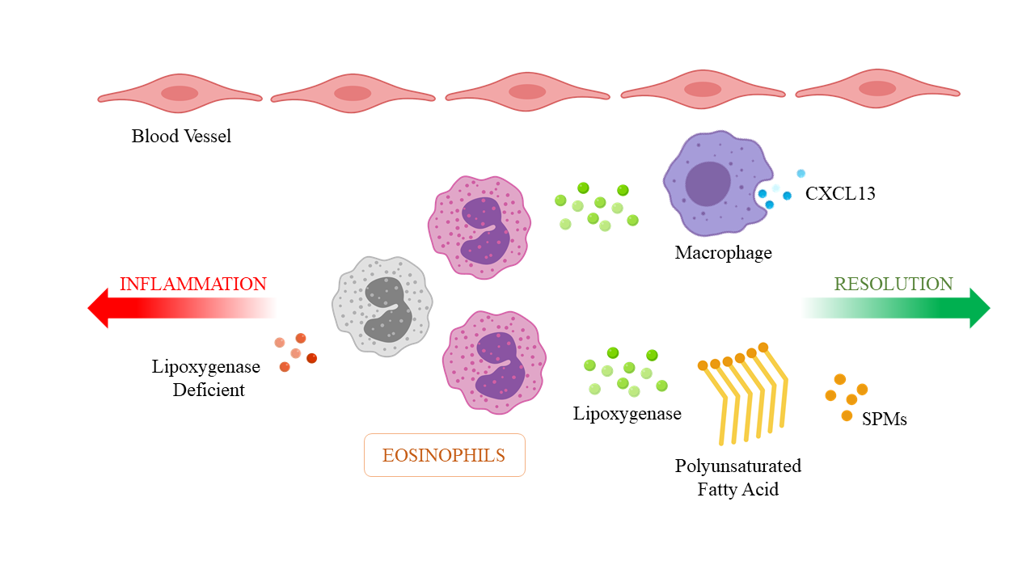
Supplemental Figure 2. Inflammatory response in eosinophils. Eosinophils promote resolution of acute inflammation via lipid signals. Eosinophils are recruited in the early resolution phase, where they locally produce resolution mediators via a 12/15-LOX-initiated biosynthetic route, and play roles leading to the efficient clearance of inflammatory exudates, through the CXCL13 pathway.

