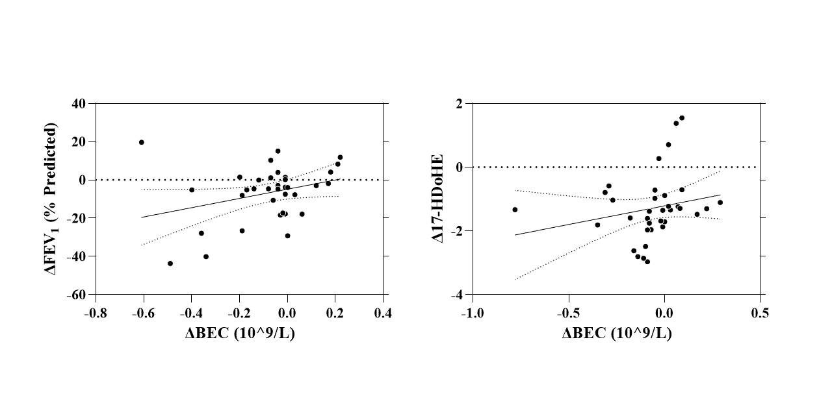Supplemental Figure 1. Correlations between ΔBEC with ΔFEV1 (% Predicted) and Δ17-HDoHE in eosinophilic COPD. Statistical analysis using spearman correlation.
Abbreviations: FEV1, Forced expiratory volume in 1st second; BEC, blood eosinophil count

