Supplement to Ozodiegwu et al: Agricultural Work, Malaria Prevalence, and Mediating Factors: A Cross-Sectional Analysis of Data from 15 Sub-Saharan African Countries to Inform Risk Stratification and Intervention Planning

Authors: Ifeoma D. Ozodiegwu*¹, Grace Legris¹, Chilo Chiziba¹, Laurette Mhlanga¹

¹Department of Health Informatics and Data Science, Loyola University Chicago, Health Science Campus, Maywood IL 60153

Supplementary Table 1. Number of children aged 6–59 months tested for malaria by country and by place of residence.

(a) Preceding Surveys
DHS | Urban | Rural | Total
Burkina Faso 2010 | 5096 | 994 | 6090
Cameroon 2011 | 2947 | 2268 | 5215
Mali 2012–13 | 3714 | 852 | 4566
Mozambique 2015 | 3396 | 1109 | 4505
Benin 2011–12 | 2175 | 1379 | 3554
Cote d'Ivoire 2011–12 | 1970 | 1135 | 3105
Ghana 2014 | 1310 | 1118 | 2428

(b) Recent Surveys
DHS | Urban | Rural | Total
Nigeria 2018 | 6192 | 4881 | 11073
DRC 2013–14 | 5616 | 2379 | 7995
Cameroon 2018–19 | 5218 | 2034 | 7252
Angola 2015–16 | 2530 | 3643 | 6173
Benin 2017–18 | 3745 | 2254 | 5999
Burundi 2016–17 | 5176 | 509 | 5685
Burkina Faso 2021 | 4192 | 1362 | 5554
Madagascar 2021 | 4580 | 812 | 5392
Uganda 2016 | 3539 | 885 | 4424
Mali 2018 | 3415 | 874 | 4289
Cote d'Ivoire 2021 | 2259 | 2007 | 4266
Mozambique 2022–23 | 2733 | 1043 | 3776
Ghana 2022–23 | 1873 | 1795 | 3668
Guinea 2012 | 2339 | 792 | 3131
Togo 2013–14 | 1913 | 981 | 2894

Supplementary Figure 1: Percentage of malaria positivity in children aged 6-59 months tested for malaria by household occupation category, in urban and rural clusters combined.

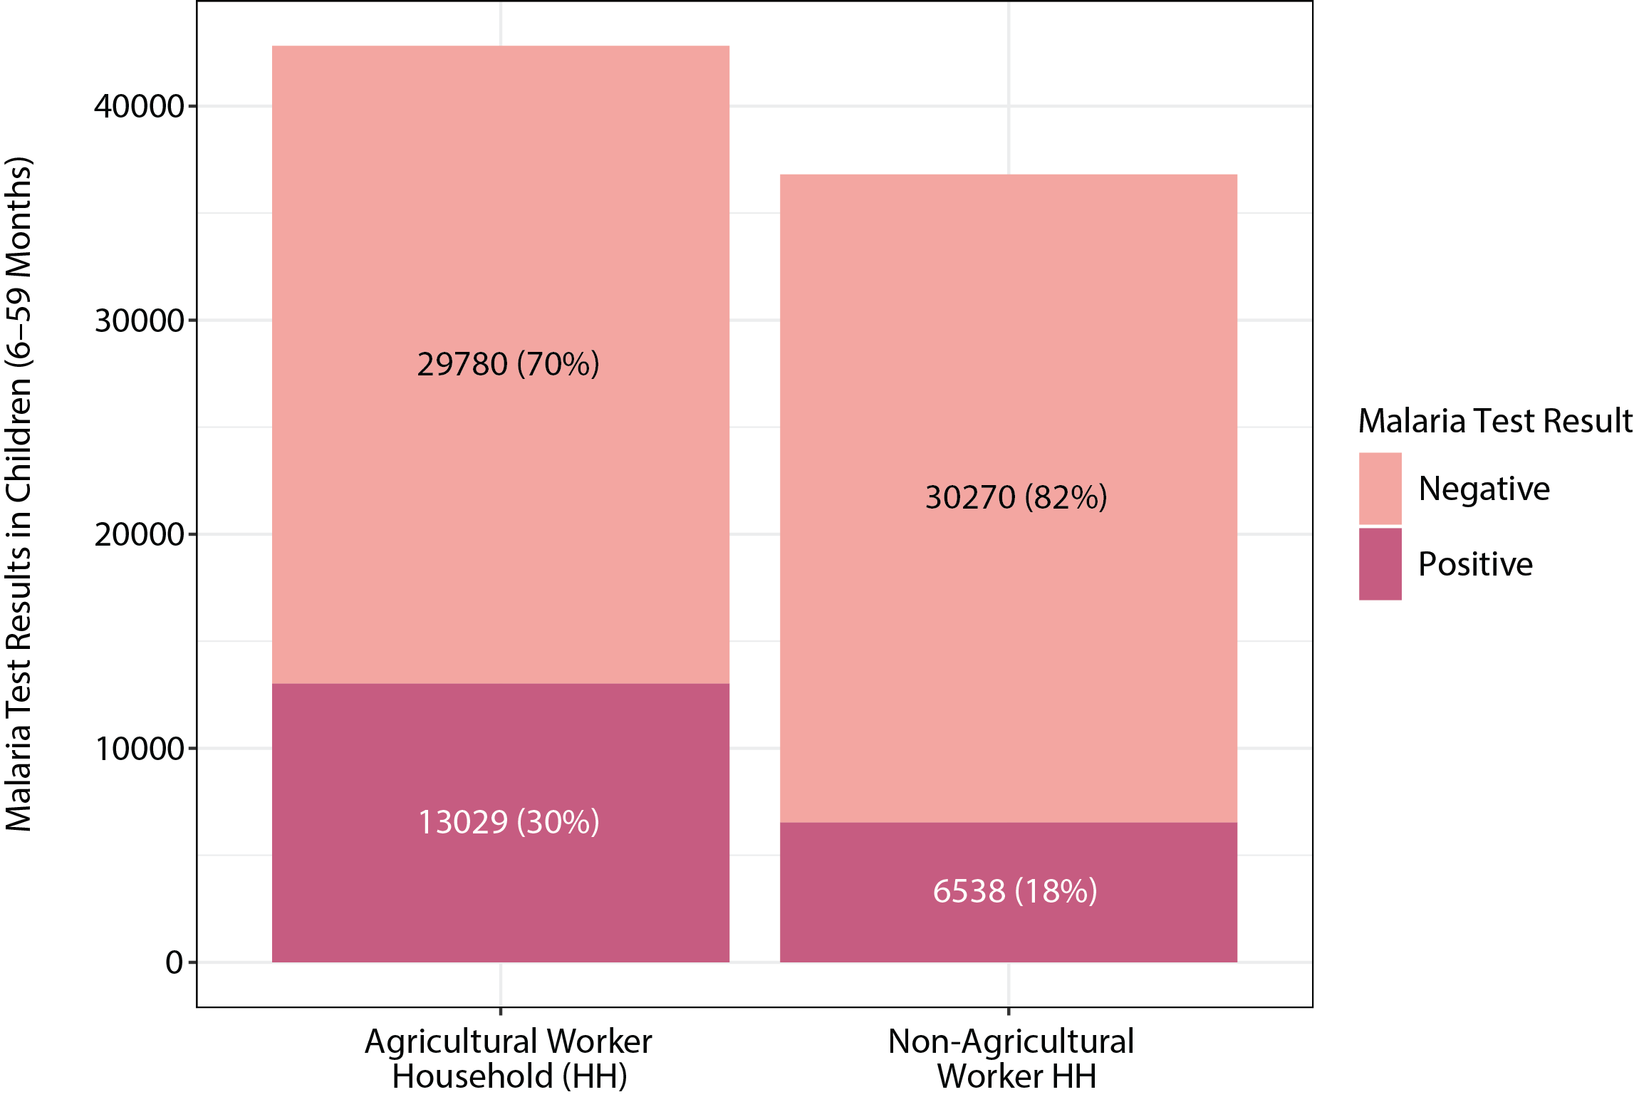

Supplementary Figure 2. Percentage of malaria positivity in children aged 6–59 months tested for malaria in urban and rural clusters per country.
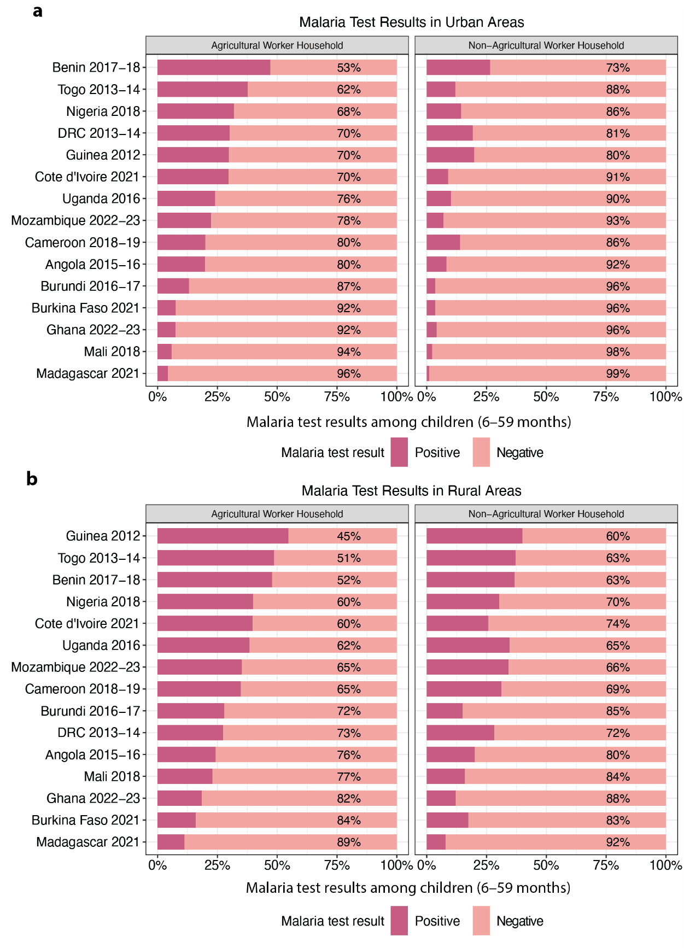
Supplementary Figure 2: Malaria test results in children aged 6–59 months who were tested for malaria in urban and rural clusters per country, stratified by household occupation category.
Supplementary Table 2. Adjusted Association of Covariates with Odds of Testing Positive for Malaria in Urban and Rural Populations. Model adjusts for home type (agricultural vs. non-agricultural). Table only includes variables considered for mediation.
Covariate | Odds of testing positive for malaria (CI), Urban | Odds of testing positive for malaria (CI),  Rural
Enhanced vegetation index | 1.483 (1.413 – 1.556) | 1.132 (1.096 – 1.169)
Housing quality
Non-modern house | 1.000 | 1.000
Modern house | 0.581 (0.511 – 0.660) | 0.783 (0.724 – 0.847)
Household size | 1.027 (1.013 – 1.041) | 1.034 (1.026 – 1.042)
Prior night net use among children under five
Did not use | 1.000 | 1.000
Used | 1.026 (0.922 – 1.141) | 0.820 (0.772 – 0.871)
Stunting
Not stunted | 1.000 | 1.000
Stunted | 1.613 (1.392 – 1.870) | 1.447 (1.354 – 1.546)
Wealth index
Poorest | 1.000 | 1.000
Poor | 0.525 (0.415 – 0.663) | 0.874 (0.813 – 0.940)
Middle | 0.394 (0.316 – 0.493) | 0.659 (0.607 – 0.715)
Rich | 0.290 (0.231 – 0.364) | 0.464 (0.415 – 0.519)
Richest | 0.135 (0.107 – 0.171) | 0.209 (0.171 – 0.254)
Treatment-Seeking
Less than or equal to 60% sought treatment | 1.000 | 1.000
More than 60% sought treatment | 0.714 (0.619 – 0.823) | 0.866 (0.795 – 0.944)

Supplementary Table 3. Unadjusted Association of Home Type with Covariates in Urban and Rural Populations. Table only includes variables considered for mediation.

Term | Covariate (Dependent Variable) | Estimate Type* | Urban | Rural
Home type: agricultural | Enhanced vegetation index | Coef | 0.962 (0.855 – 1.070) | 0.257 (0.193 – 0.321)
Home type: agricultural | Housing quality: modern | OR | 0.261 (0.229 – 0.298) | 0.330 (0.302 – 0.360)
Home type: agricultural | Household size | Coef | 1.303 (1.038 – 1.567) | 0.963 (0.814 – 1.111)
Home type: agricultural | Net use among children under five: used | OR | 1.268 (1.137 – 1.413) | 0.911 (0.849 – 0.977)
Home type: agricultural | Stunting: stunted | OR | 1.749 (1.494 – 2.047) | 1.368 (1.268 – 1.476)
Home type: agricultural | Wealth index | OR | 0.067 (0.052 – 0.086) | 0.535 (0.487 – 0.588)
Home type: agricultural | Treatment-seeking: Over 60% Sought | OR | 0.261 (0.229 – 0.298) | 0.330 (0.302 – 0.360)

*Regression estimates are presented as coefficients (Coef) for continuous variables and odds ratios (OR) for binary or categorical variables. The independent variable in all models is home type (agricultural vs. non-agricultural), with non-agricultural as the reference category. Dependent variables are modeled individually; for binary outcomes, the reference category is the absence of the characteristic (e.g., not stunted, not modern housing).
Supplementary Table 4. Mediation Analysis Results

Urban
Mediator | Effect Type | Estimate | SE | Lower 95% CI | Upper 95% CI | P-Value | % Mediation | Bootstrapped Lower CI | Bootstrapped Upper CI
Stunting | Indirect | 0.0037 | 0.0005 | 0.0027 | 0.0047 | p < 0.0001 | 2.6994 | 1.8777 | 3.5740
Stunting | Direct | 0.1350 | 0.0053 | 0.1246 | 0.1454 | p < 0.0001 | NA | NA | NA
Stunting | Total | 0.1387 | 0.0053 | 0.1283 | 0.1491 | p < 0.0001 | NA | NA | NA
Household Size | Indirect | 0.0043 | 0.0008 | 0.0028 | 0.0059 | p < 0.0001 | 3.1943 | 1.9880 | 4.4953
Household Size | Direct | 0.1333 | 0.0053 | 0.1229 | 0.1437 | p < 0.0001 | NA | NA | NA
Household Size | Total | 0.1377 | 0.0053 | 0.1274 | 0.1480 | p < 0.0001 | NA | NA | NA
Wealth | Indirect | 0.0637 | 0.0024 | 0.0590 | 0.0684 | p < 0.0001 | 46.4459 | 41.7435 | 51.7795
Wealth | Direct | 0.0739 | 0.0056 | 0.0629 | 0.0850 | p < 0.0001 | NA | NA | NA
Wealth | Total | 0.1377 | 0.0053 | 0.1274 | 0.1480 | p < 0.0001 | NA | NA | NA
Housing Quality | Indirect | 0.0193 | 0.0014 | 0.0165 | 0.0221 | p < 0.0001 | 14.0577 | 11.7884 | 16.5194
Housing Quality | Direct | 0.1184 | 0.0054 | 0.1078 | 0.1290 | p < 0.0001 | NA | NA | NA
Housing Quality | Total | 0.1377 | 0.0053 | 0.1274 | 0.1480 | p < 0.0001 | NA | NA | NA
Net Use | Indirect | -0.0001 | 0.0001 | -0.0004 | 0.0001 | 0.3704 | -0.0926 | -0.3282 | 0.1015
Net Use | Direct | 0.1378 | 0.0053 | 0.1275 | 0.1481 | p < 0.0001 | NA | NA | NA
Net Use | Total | 0.1377 | 0.0053 | 0.1274 | 0.1480 | p < 0.0001 | NA | NA | NA
EVI | Indirect | 0.0374 | 0.0016 | 0.0343 | 0.0406 | p < 0.0001 | 27.4059 | 24.3778 | 30.6996
EVI | Direct | 0.0993 | 0.0054 | 0.0887 | 0.1098 | p < 0.0001 | NA | NA | NA
EVI | Total | 0.1367 | 0.0053 | 0.1263 | 0.1471 | p < 0.0001 | NA | NA | NA
Treatment-Seeking | Indirect | 0.0193 | 0.0014 | 0.0165 | 0.0221 | p < 0.0001 | 13.9904 | 11.6532 | 16.5099
Treatment-Seeking | Direct | 0.1184 | 0.0054 | 0.1078 | 0.1290 | p < 0.0001 | NA | NA | NA
Treatment-Seeking | Total | 0.1377 | 0.0053 | 0.1274 | 0.1480 | p < 0.0001 | NA | NA | NA

Rural
Mediator | Effect Type | Estimate | SE | Lower 95% CI | Upper 95% CI | P-Value | % Mediation | Bootstrapped Lower CI | Bootstrapped Upper CI
Stunting | Indirect | 0.0037 | 0.0004 | 0.0030 | 0.0044 | p < 0.0001 | 7.0099 | 5.3908 | 8.9807
Stunting | Direct | 0.0491 | 0.0043 | 0.0406 | 0.0576 | p < 0.0001 | NA | NA | NA
Stunting | Total | 0.0528 | 0.0043 | 0.0443 | 0.0613 | p < 0.0001 | NA | NA | NA
Household Size | Indirect | 0.0056 | 0.0006 | 0.0045 | 0.0067 | p < 0.0001 | 10.7367 | 8.3703 | 13.4419
Household Size | Direct | 0.0474 | 0.0043 | 0.0389 | 0.0559 | p < 0.0001 | NA | NA | NA
Household Size | Total | 0.0530 | 0.0043 | 0.0446 | 0.0615 | p < 0.0001 | NA | NA | NA
Wealth | Indirect | 0.0282 | 0.0011 | 0.0261 | 0.0304 | p < 0.0001 | 53.6051 | 45.2476 | 64.1169
Wealth | Direct | 0.0248 | 0.0044 | 0.0163 | 0.0333 | p < 0.0001 | NA | NA | NA
Wealth | Total | 0.0530 | 0.0043 | 0.0446 | 0.0615 | p < 0.0001 | NA | NA | NA
Housing Quality | Indirect | 0.0094 | 0.0010 | 0.0075 | 0.0113 | p < 0.0001 | 17.7556 | 13.4862 | 22.8902
Housing Quality | Direct | 0.0437 | 0.0044 | 0.0351 | 0.0523 | p < 0.0001 | NA | NA | NA
Housing Quality | Total | 0.0531 | 0.0043 | 0.0446 | 0.0615 | p < 0.0001 | NA | NA | NA
Net Use | Indirect | 0.0010 | 0.0002 | 0.0006 | 0.0015 | p < 0.0001 | 1.9966 | 1.2620 | 2.8858
Net Use | Direct | 0.0520 | 0.0043 | 0.0436 | 0.0604 | p < 0.0001 | NA | NA | NA
Net Use | Total | 0.0530 | 0.0043 | 0.0446 | 0.0615 | p < 0.0001 | NA | NA | NA
EVI | Indirect | 0.0073 | 0.0005 | 0.0063 | 0.0084 | p < 0.0001 | 13.9346 | 11.2977 | 16.9912
EVI | Direct | 0.0457 | 0.0043 | 0.0372 | 0.0541 | p < 0.0001 | NA | NA | NA
EVI | Total | 0.0530 | 0.0043 | 0.0445 | 0.0615 | p < 0.0001 | NA | NA | NA
Treatment-Seeking | Indirect | 0.0094 | 0.0010 | 0.0075 | 0.0113 | p < 0.0001 | 17.7842 | 13.1598 | 22.7262
Treatment-Seeking | Direct | 0.0437 | 0.0044 | 0.0351 | 0.0523 | p < 0.0001 | NA | NA | NA
Treatment-Seeking | Total | 0.0531 | 0.0043 | 0.0446 | 0.0615 | p < 0.0001 | NA | NA | NA

Supplementary Table 5. Environmental Variable Likelihood Ratio Test Results

(A) Urban
Variable name | Likelihood ratio test p-value
Enhanced vegetation index | 8.4775e-15
Precipitation (mm) | 0.00050868
Relative humidity | 3.8212e-15
Temperature | 0.93006

(B) Rural
Variable name | Likelihood ratio test p-value
Enhanced vegetation index | 2.193e-06
Precipitation (mm) | 0.52002
Relative humidity | 0.064546
Temperature | 0.016866
Supplementary Table 6: Population Estimates for 3 Most Populous First-Level Administrative Subdivisions

Country | Subdivision Name | Subdivision Type | Population Estimate
Angola | Benguela | Province | 2009036
Angola | Huíla | Province | 2609916
Angola | Luanda | Province | 8732536
Burkina Faso | Centre | Region | 4219205
Burkina Faso | Est | Region | 2029244
Burkina Faso | Haut-Bassins | Region | 2479624
Benin | Atlantique | Department | 1688688
Benin | Borgou | Department | 1534438
Benin | Ouémé | Department | 1305924
Burundi | Gitega | Province | 844019
Burundi | Kirundo | Province | 792388
Burundi | Muyinga | Province | 915425
Democratic Republic of the Congo | Haut-Katanga | Province | 6332890
Democratic Republic of the Congo | Kinshasa | Province | 6847929
Democratic Republic of the Congo | Nord-Kivu | Province | 7196505
Côte d'Ivoire | Abidjan | District | 5477720
Côte d'Ivoire | Montagnes | District | 2868437
Côte d'Ivoire | Sassandra-Marahoué | District | 2763779
Cameroon | Centre | Region | 5544560
Cameroon | Extrême-Nord | Region | 4521621
Cameroon | Littoral | Region | 4259234
Ghana | Ashanti | Region | 6759214
Ghana | Eastern | Region | 3355397
Ghana | Greater Accra | Region | 5632346
Guinea | Conakry | Region | 1570273
Guinea | Kankan | Region | 1823141
Guinea | Nzérékoré | Region | 1540905
Madagascar | Analamanga | Region | 4713540
Madagascar | Vakinankaratra | Region | 1877858
Madagascar | Vatovavy Fitovinany | Region | 1896047
Mali | Koulikoro | Region | 3950045
Mali | Ségou | Region | 3135600
Mali | Sikasso | Region | 3763009
Mozambique | Nampula | Province | 6047604
Mozambique | Tete | Province | 3535341
Mozambique | Zambezia | Province | 5785796
Nigeria | Kaduna | State | 8695951
Nigeria | Kano | State | 13815361
Nigeria | Lagos | State | 13207366
Togo | Maritime | Region | 2917236
Togo | Plateaux | Region | 1521410
Togo | Savanes | Region | 950788
Uganda | Central | Region | 10243258
Uganda | Eastern | Region | 9684526
Uganda | Western | Region | 9481493

Supplementary Figure 3. Percentages of prior night net use in children aged 6–59 months who were tested for malaria in urban and rural clusters per country.

(a) Urban
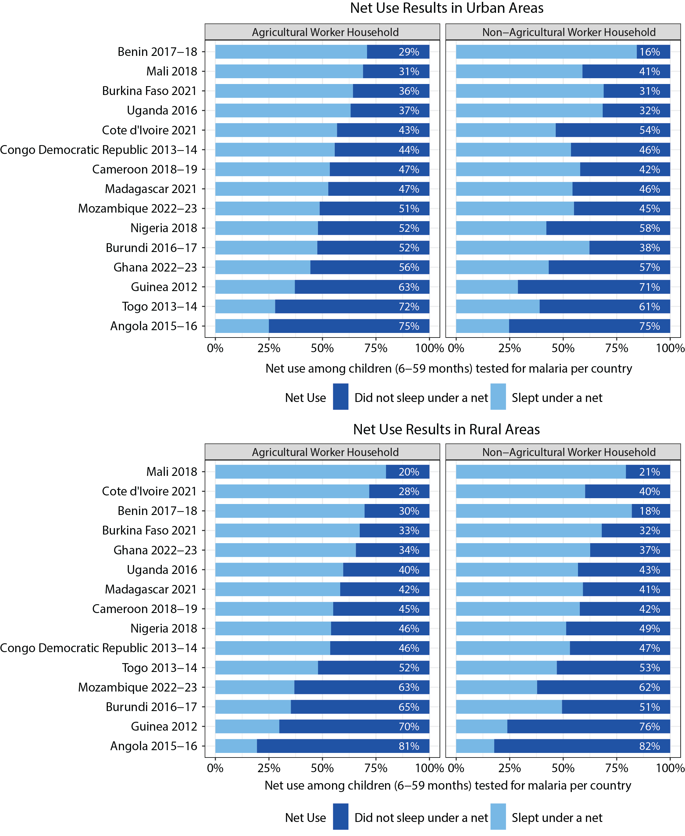
(b) Rural

Supplementary Figure 3: Percentages of net use the night prior to the survey in children aged 6–59 months who were tested for malaria in urban and rural clusters per country, stratified by household occupation category.

Supplementary Figure 4. Malaria test positivity rate and net use rate in children under 5 with percentage change in number of nets distributed yearly compared to first year of distribution.

(a) Urban

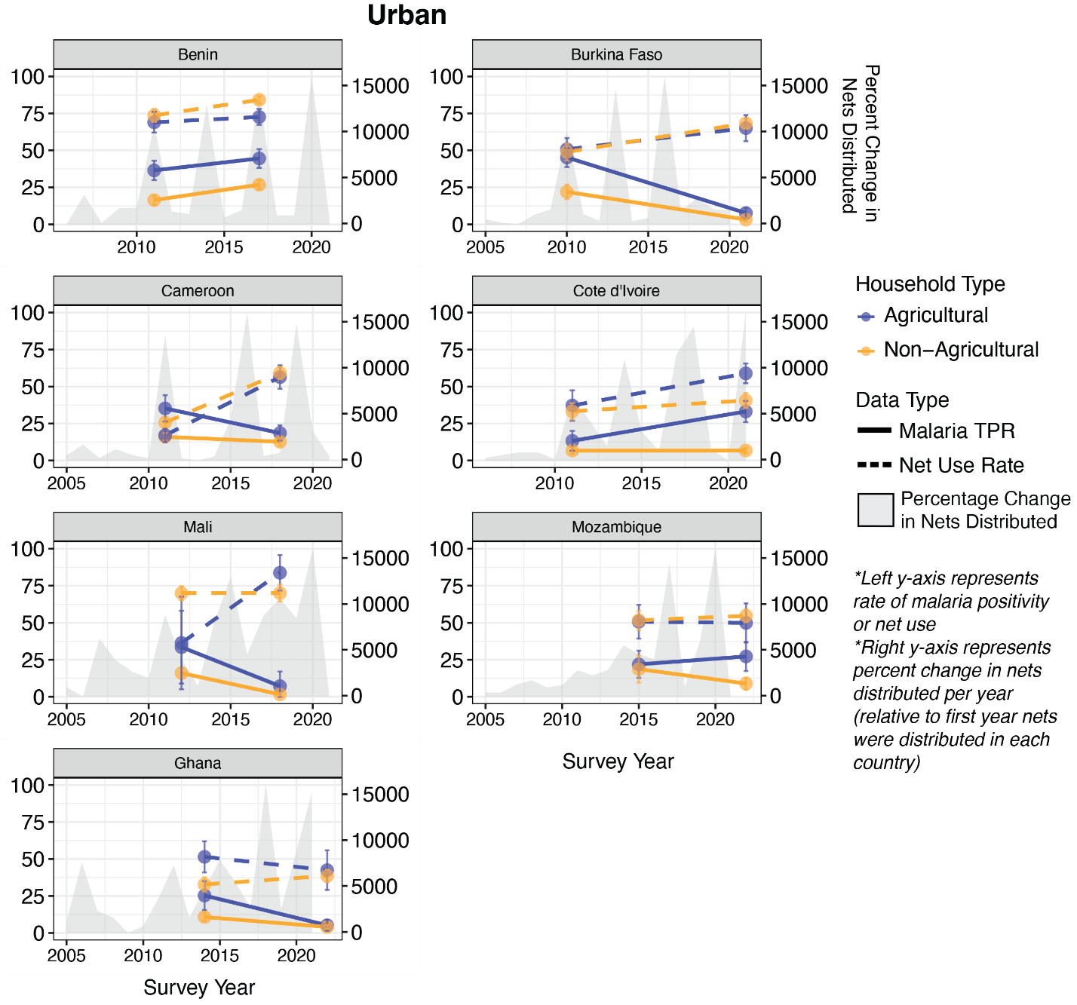

(b) Rural

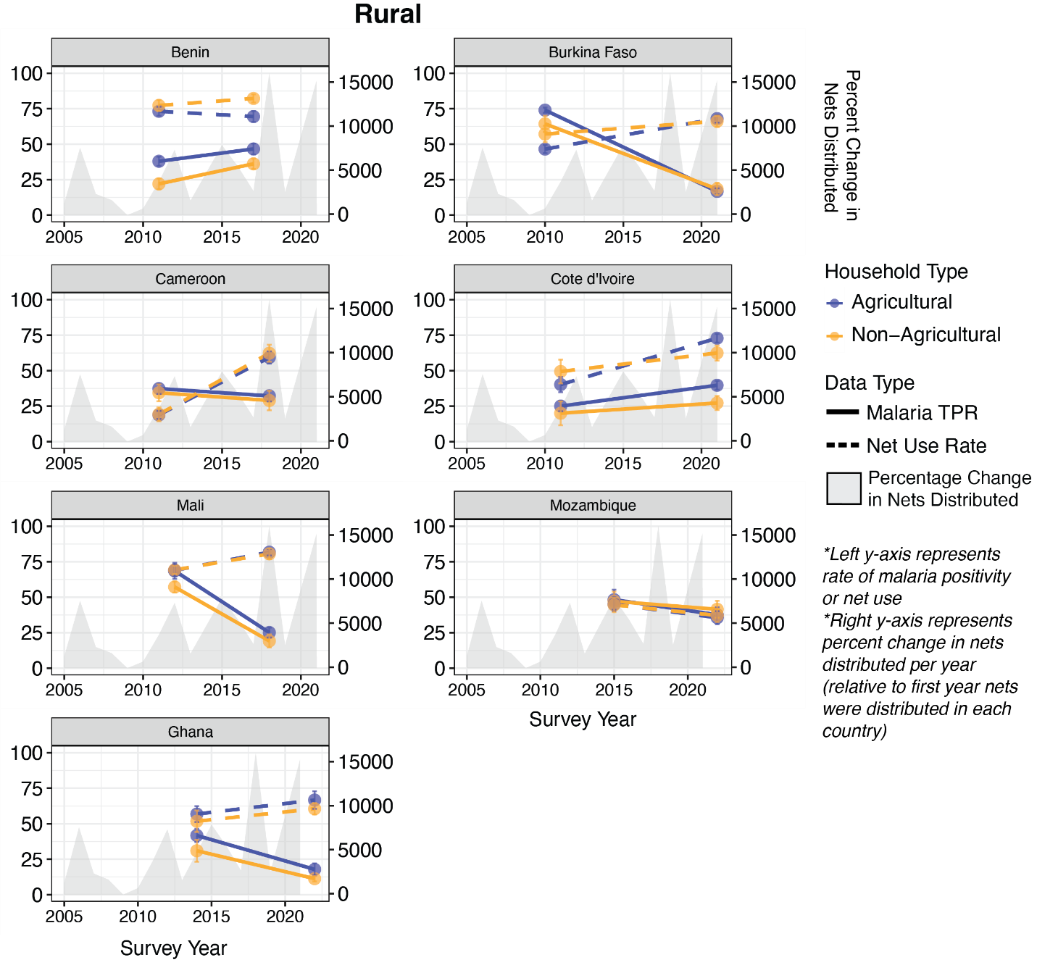

Supplementary Figure 4: (a) Trends in test positivity rates and net use rates between agricultural worker HHs and non-agricultural worker HHs within urban clusters per country with both preceding and recent survey data included in the analysis. (b) Trends in test positivity rates and net use rates between agricultural worker HHs and non-agricultural worker HHs within rural clusters per country with both preceding and recent survey data included in the analysis. The left y-axis on each plot represents the rate of malaria positivity or net use, while the right y-axis represents the percent change in nets distributed per year relative to the first year nets were distributed in the given country. The grey area plot shows this percentage change in nets distributed per year.
Supplementary Figure 5. Percent Mediated by Key Mediators Across Countries, Stratified by Urban and Rural Residence
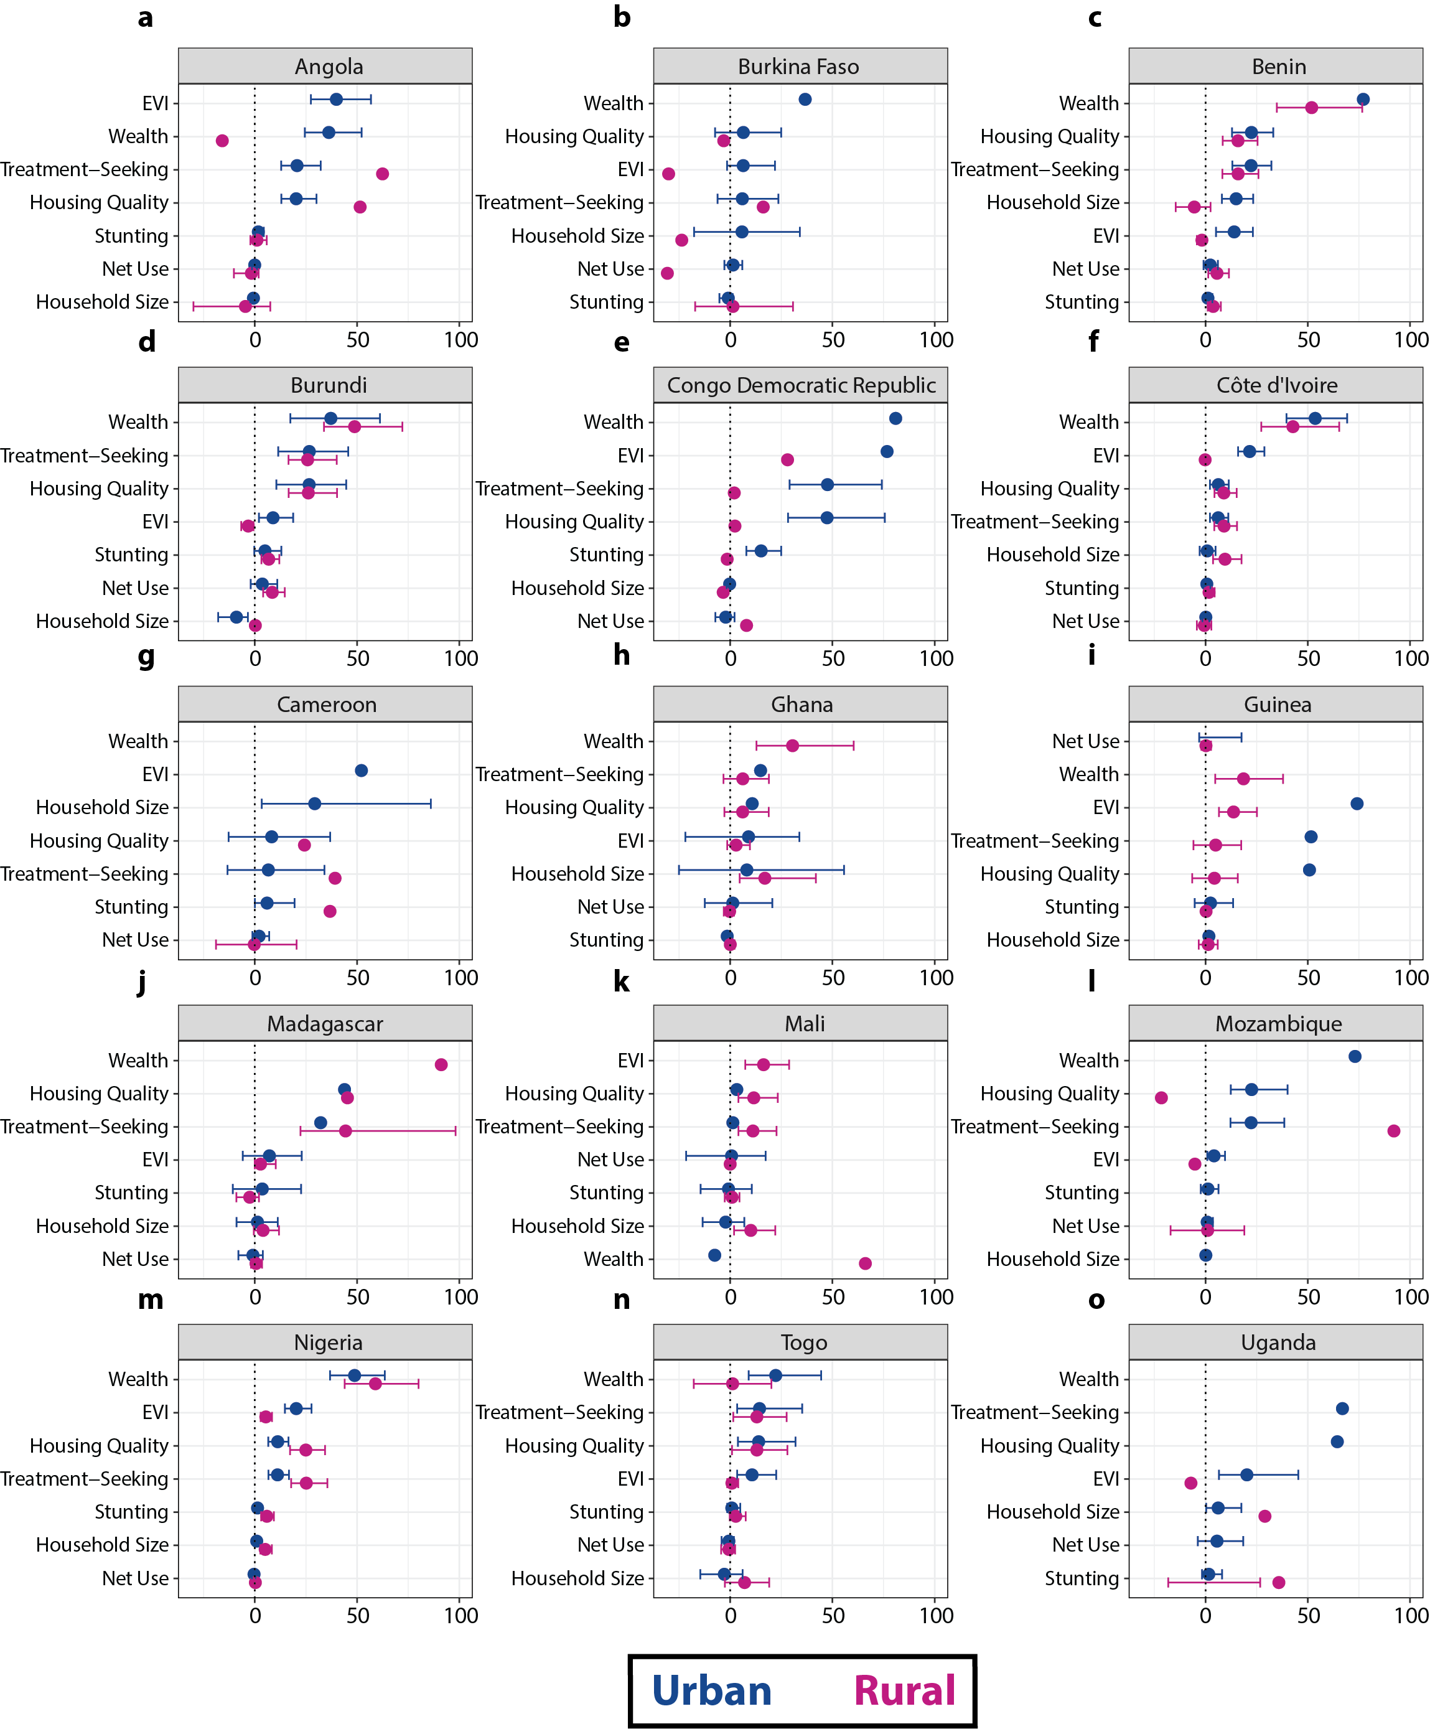
Supplementary Figure 5: (a–o) Percent mediated by various mediators of the relationship between home type and malaria test positivity rate, stratified by country and by urban and rural place of residence. Error bars represent 95% confidence intervals.
Supplementary Figure 6. Odds ratios and predicted probabilities of testing positive for malaria (by RDT or microscopy) in children aged 6–59 months from urban and rural households combined by home type and after adjustment with each potential mediator.

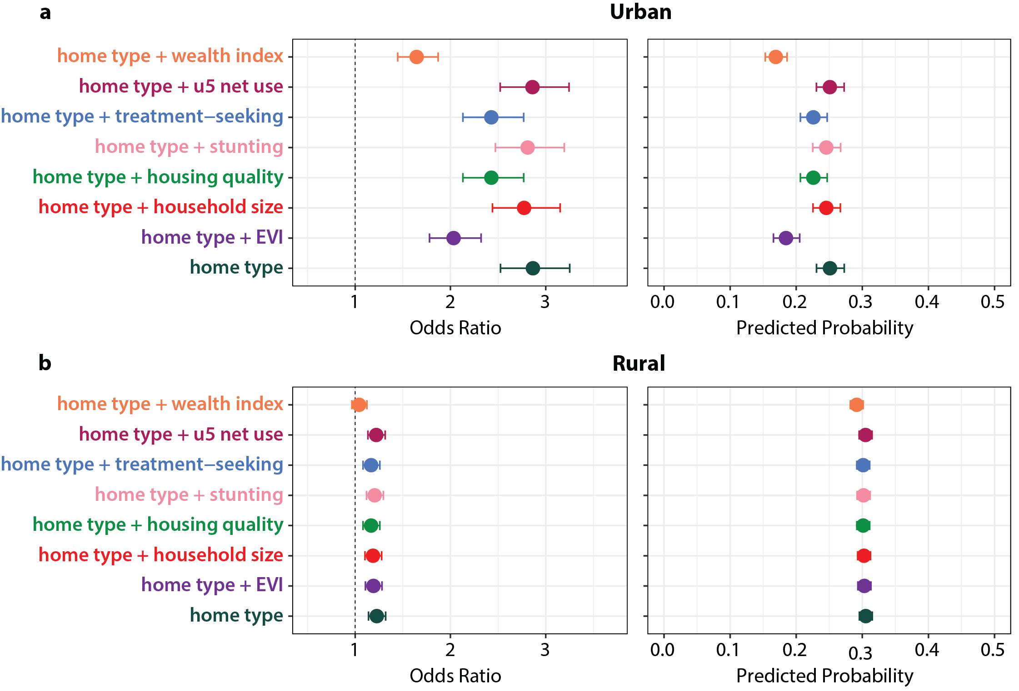
Supplementary Figure 7. Mediation Analysis Results (Indirect, Direct, and Total Effects for each Mediator)

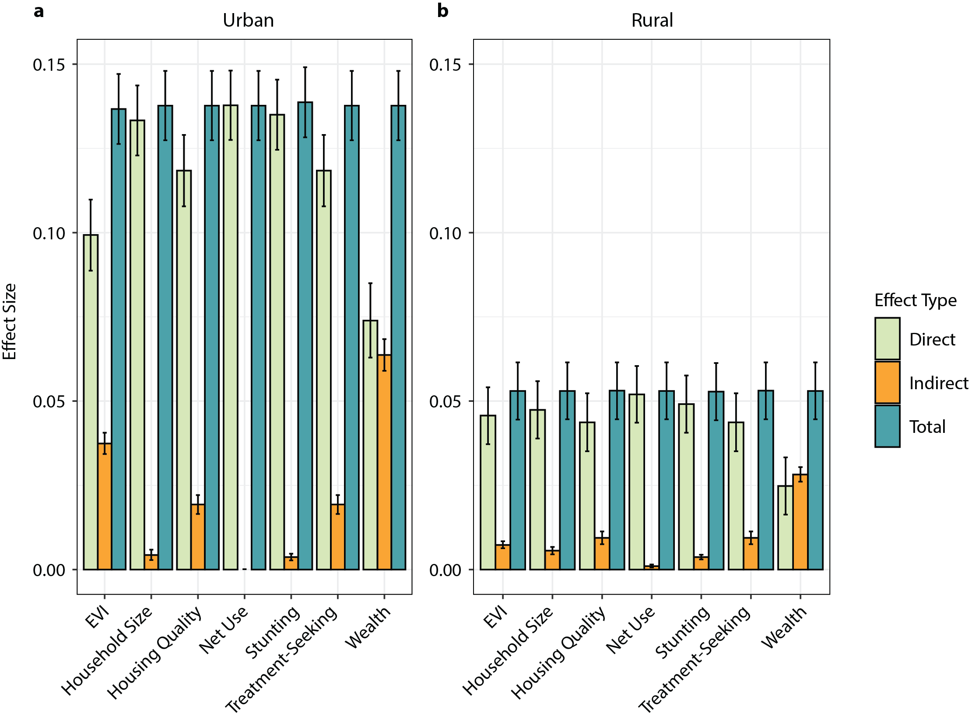

Supplementary Figure 7: Direct, indirect, and total effects calculated via mediation analysis for various mediators of the relationship between home type and malaria test positivity rate. Error bars represent 95% confidence intervals.

Supplementary Figure 8. Directed Acyclic Graph (DAG) Used to Model Potential Mediators

