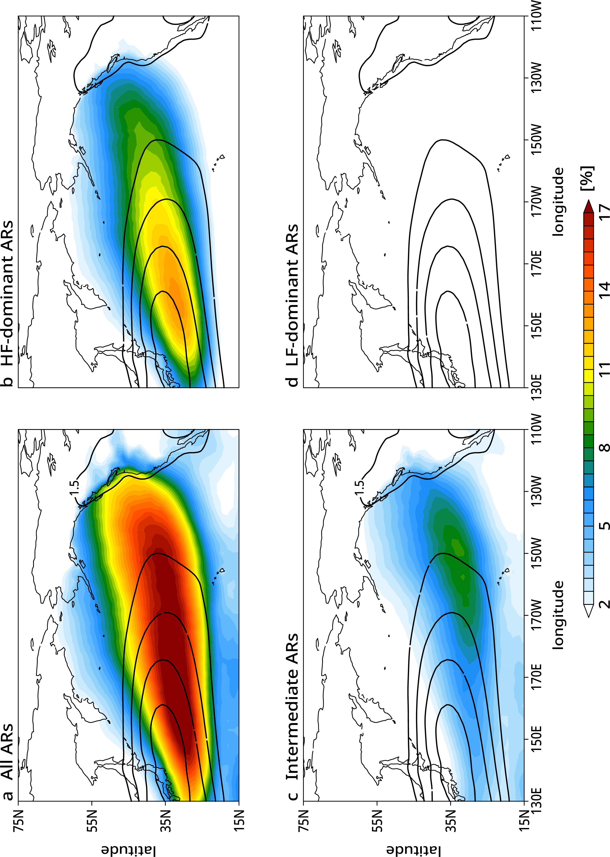

Fig. S1 | AR frequency and baroclinicity over the North Pacific
(a) AR frequency (shading, %) and baroclinicity (contoured in a 0.5 interval starting from 1.5; see Eq. 5 in Materials and Methods) over the North Pacific. (b to d) As in (a), but for (b) HF-dominant ARs, (c) intermediate ARs, and (d) LF-dominant ARs.
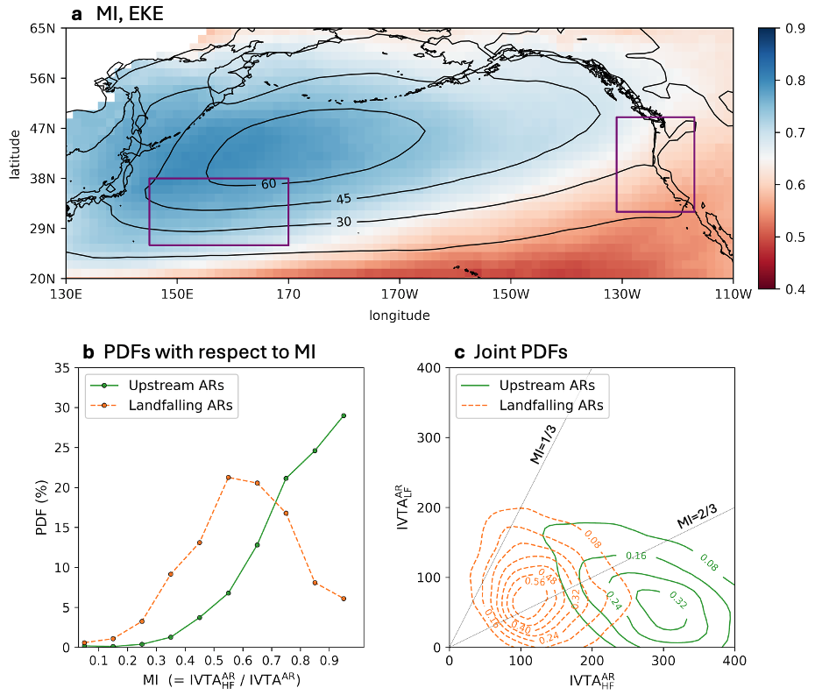

Fig. S2 | Contrasting nature of upstream versus downstream ARs over the North Pacific
As in Figure 1, but derived from the GW15 algorithm.

Fig. S3 | Sensitivity to different AR detection methods
As in Figure 1b, but derived from (a) different thresholds for AR detection with other requirements unchanged and (b) different AR catalogs participating in ARTMIP (see Materials and Methods for details). In (b), only the common period of 2000–2019 is considered due to data availability.
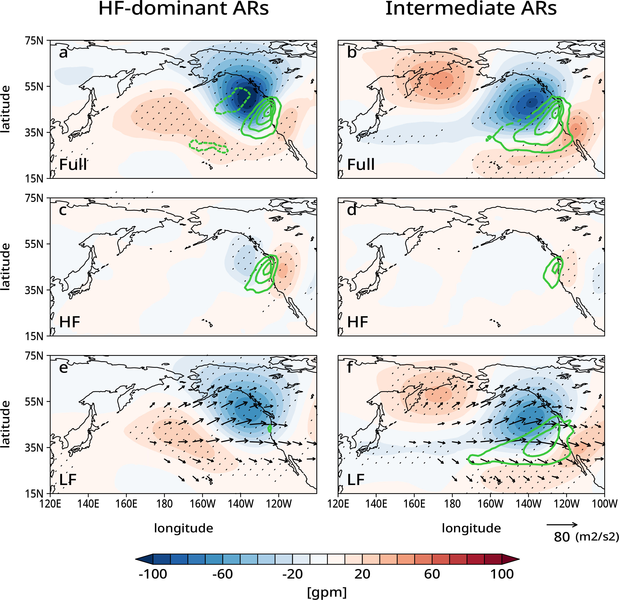

Fig. S4 | Synoptic and large-scale circulations of AR landfalls
As in Figure 2, but derived from the GW15 algorithm.

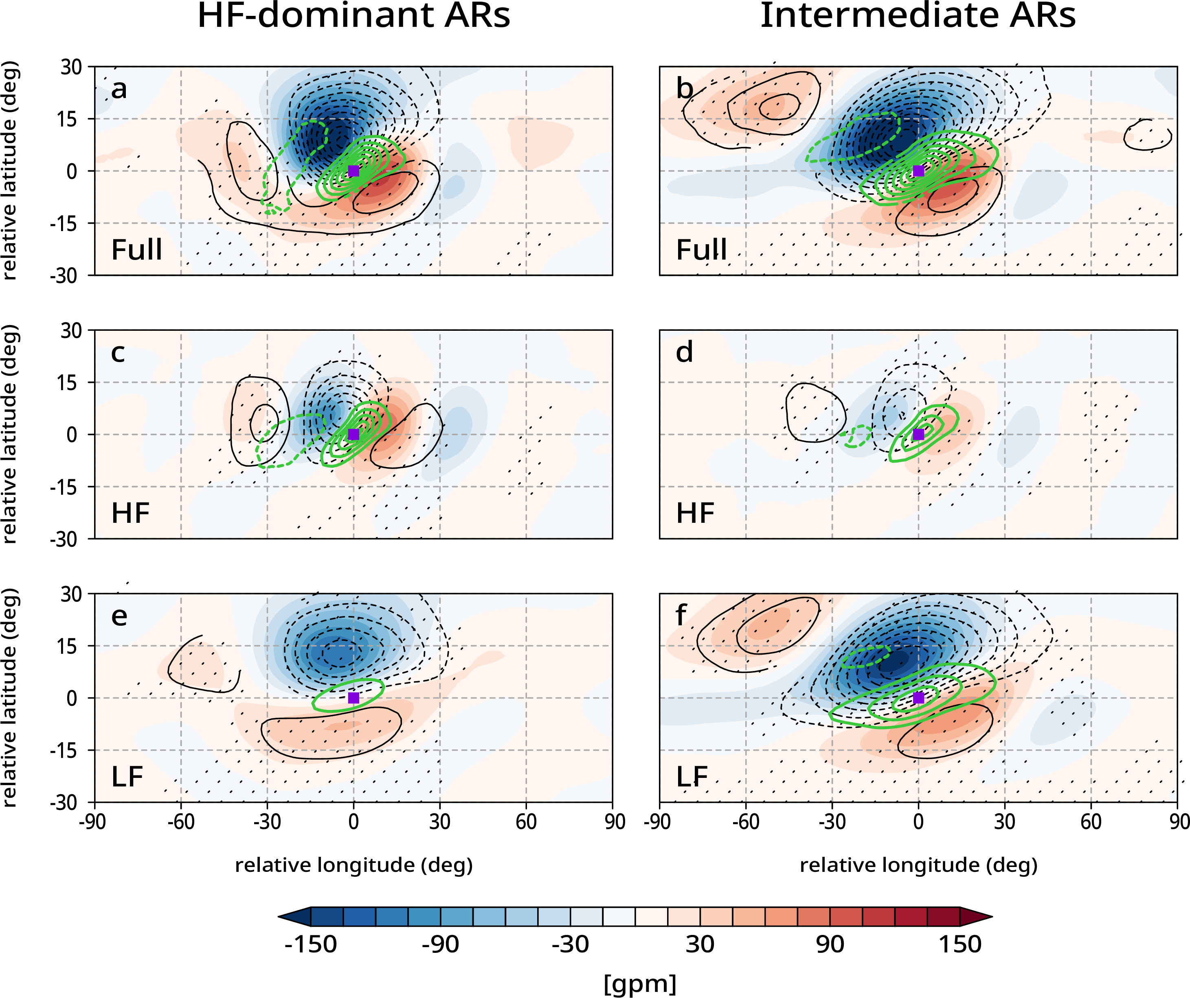

Fig. S5 | AR-relative composites of AR landfalls
AR-relative composites of (a and b) geopotential height anomalies at 300 hPa (shading, gpm), those at 850 hPa (contoured in black with a 10-gpm interval), and IVTA (contoured in green with a 50-kg m⁻¹ s⁻¹ interval), and their (c and d) HF and (e and f) LF components for (left) HF-dominant ARs and (right) intermediate ARs making landfall on the U.S. west coast. Only the first landfalling snapshot is considered for each landfall event. Only the statistically significant 850-hPa geopotential height anomaly and IVTA at the 95% confidence level are displayed. Stipples indicate the statistically significant 300-hPa geopotential height anomaly. The purple rectangle marks the location of the AR centroid.
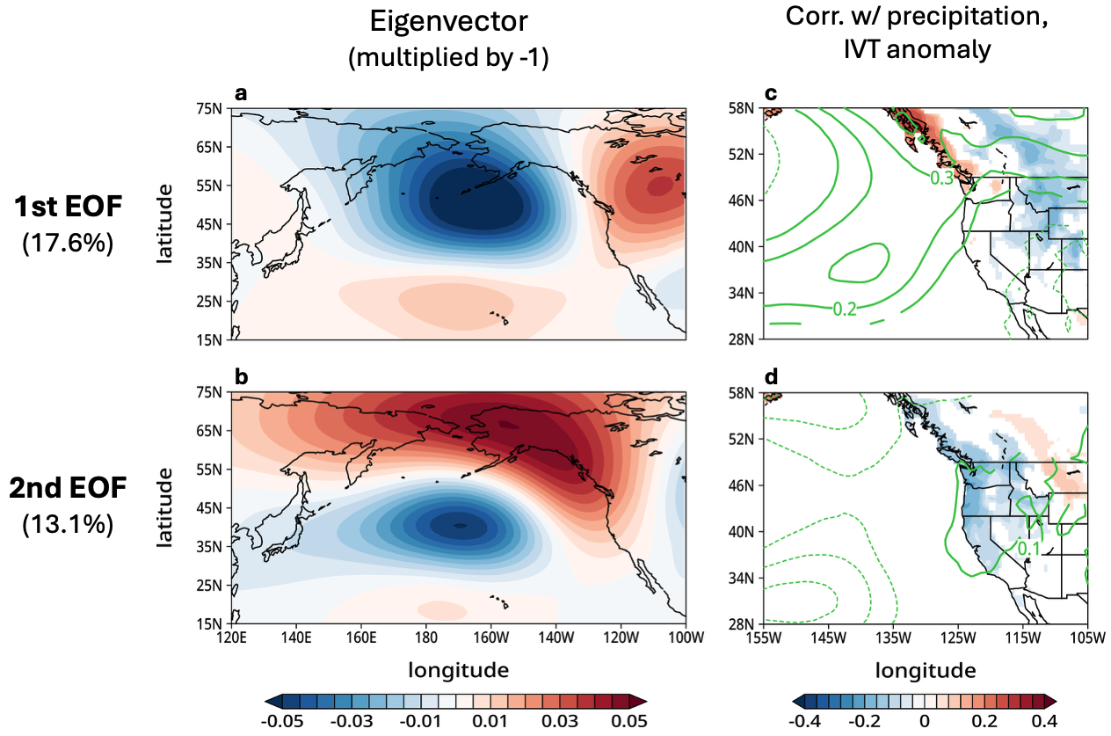

Fig. S6 | The first and second EOF modes
(a and b) As in Figure 3a, but for the (a) first and (b) second EOF modes. The eigenvectors are multiplied by -1 so that they align with the positive phases of PNA and NPO-like patterns, respectively. (C and D) As in Figure 3b, but for the (c) first and (d) second EOF modes.

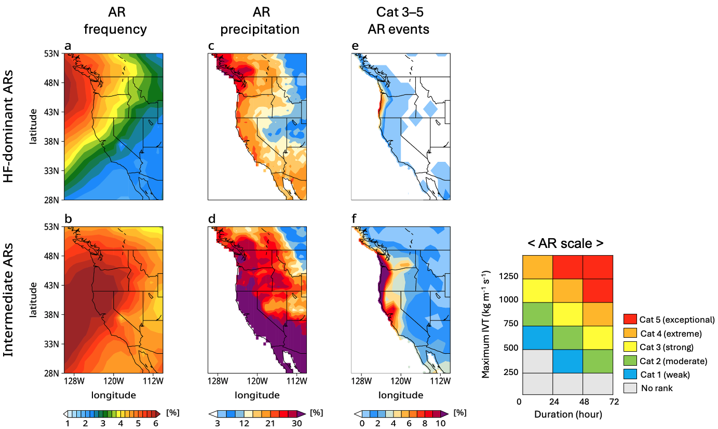

Fig. S7 | Hydrological impacts of HF-dominant versus intermediate ARs
As in Figure 4, but derived from the GW15 algorithm.
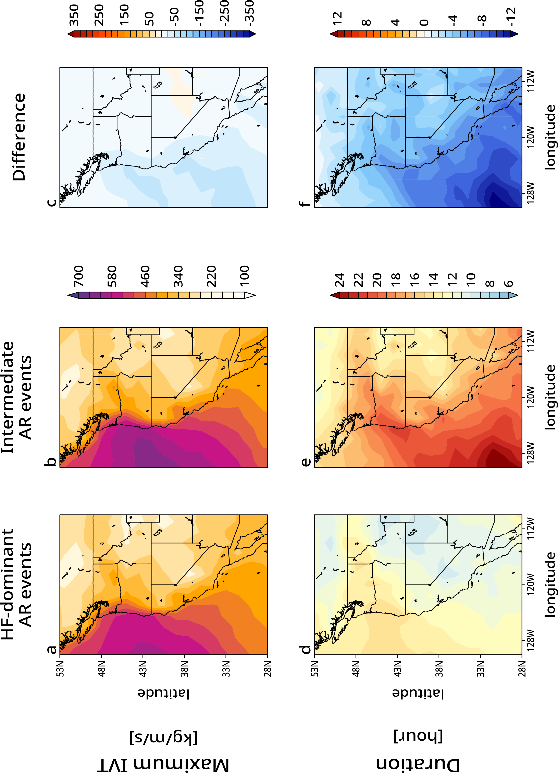

Fig. S8 | Maximum IVT and duration of AR events
Mean maximum IVT for (a) HF-dominant AR events and (b) intermediate AR events, and (c) their differences. (d to f) As in (a to c), but for mean duration of AR events.

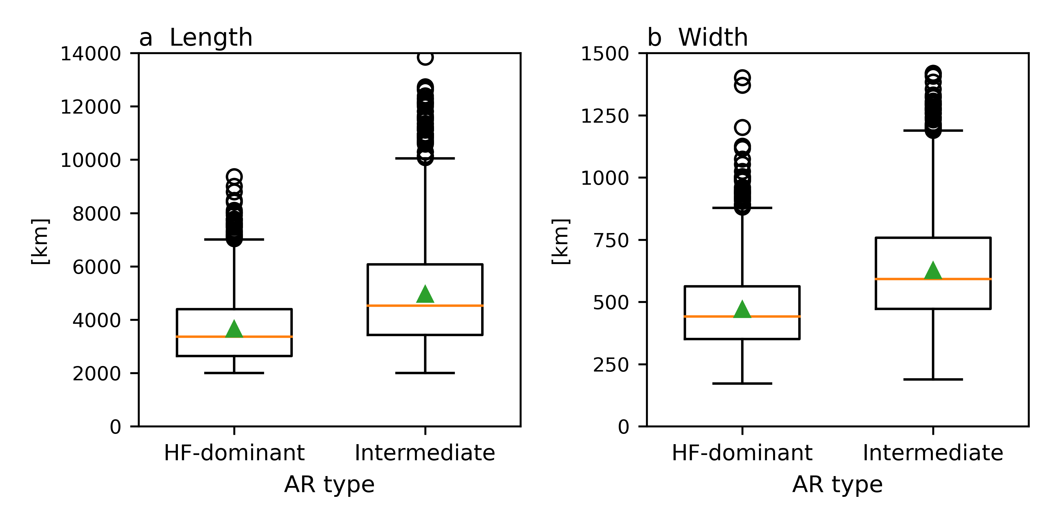

Fig. S9 | Size of landfalling ARs
Box-whisker plots of (a) length and (b) width of HF-dominant and intermediate ARs that make landfall on the U.S. west coast. The orange line and green triangle mark the median and mean, respectively.

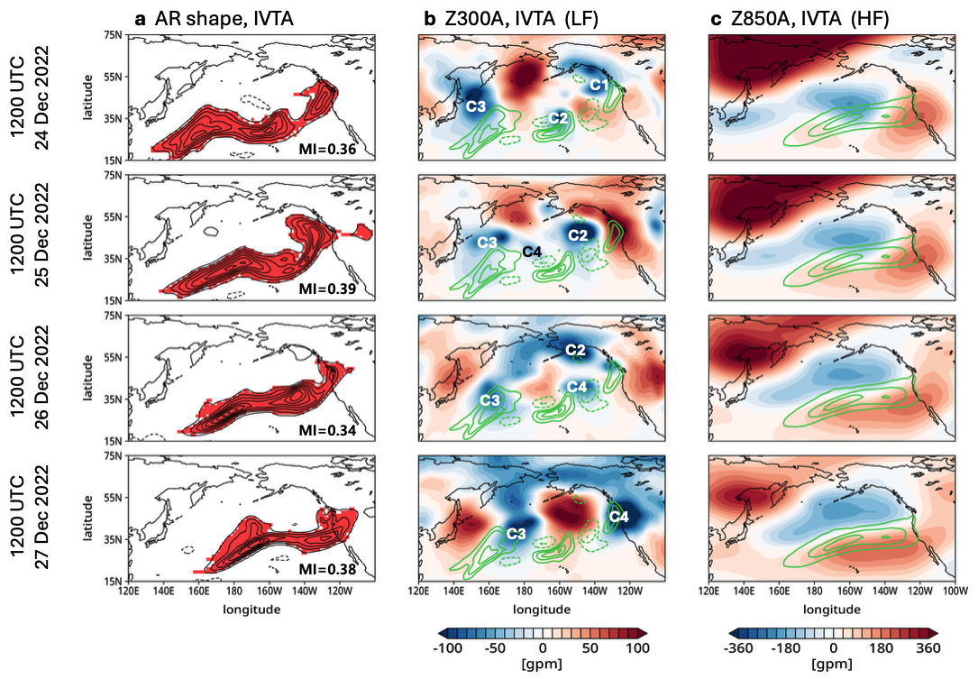

Fig. S10 | Daily evolution of HF and LF circulations during extreme AR landfall in late December 2022
(a) AR shape and IVTA (contoured in a 150-kg m⁻¹ s⁻¹ interval), (b) HF components of 850-hPa geopotential height anomaly (shading, gpm) and IVTA (contoured in a 150-kg m⁻¹ s⁻¹ interval), and (c) LF components of 300-hPa geopotential height anomaly (shading, gpm) and IVTA (contoured in a 150-kg m⁻¹ s⁻¹ interval), from 1200 UTC 24 to 1200 UTC 27 December 2022 in 24-hour interval. In (a), MI values are represented at each time. In (b), traveling extratropical cyclones are labeled with C1 to C4 in the order of their first occurrence.

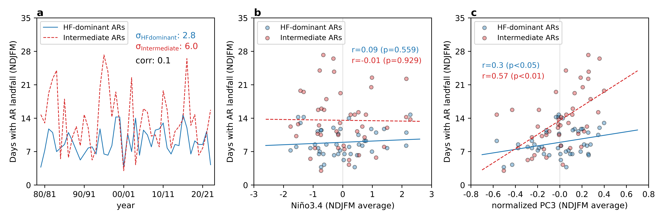

Fig. S11 | Interannual variability of AR landfalls
(a) Yearly time series of equivalent AR landfall days (i.e., the total number of 6-hourly landfalling AR snapshots divided by 4) for HF-dominant ARs (blue solid) and intermediate ARs (red dashed) during the cold season. Also printed are their standard deviations and linear correlation coefficient. (b) Scatter plots of AR landfall days and Niño 3.4 during the cold season for HF-dominant ARs (blue) and intermediate ARs (red). The linear best fits and linear correlation coefficients are also represented. (c) As in (b), but against the seasonal-mean PC3.
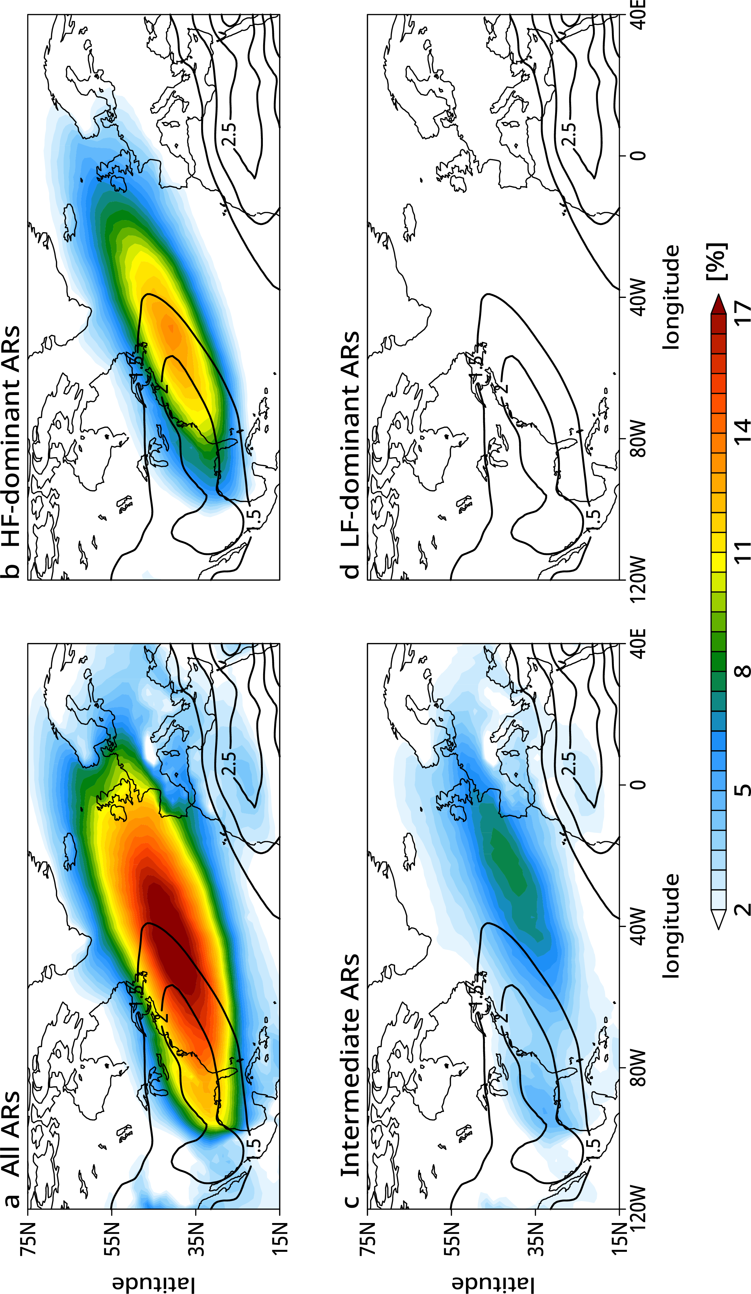

Fig. S12 | AR frequency and baroclinicity over the North Atlantic
As in Supplemental Figure S1, but over the North Atlantic.

