Supplementary data
Bakuchiol dimers from Psoraleae Fructus that inhibit nitric oxide production in RAW264.7 macrophages cells
Qingxia Xu‡, Qian lv‡, Lu Liu, Yingtao Zhang* and Xiuwei Yang*
State Key Laboratory of Natural and Biomimetic Drugs (Peking University), Department of Natural Medicines, School of Pharmaceutical Sciences, Peking University Health Science Center, Peking University, Beijing 100191, PR China.

*Corresponding author at: No. 38, Xueyuan Road, Haidian District, Beijing, 100191, PR China. Tel.: +86 10 82801569; fax: +86 10 82802724. E-mail address: zytao1988@163.com (Ying-Tao Zhang), xwyang@bjmu.edu.cn (Xiu-Wei Yang).
‡These authors contributed equally to this paper.

Table of Contents
Bisbakuchiol M
Figure S1. The HRESIMS spectrum of 1 6
Figure S2. The IR spectrum of 1 7
Figure S3. The ¹H NMR spectrum of 1 in CDCl₃ (400 MHz) 7
Figure S4. The ¹³C NMR spectrum of 1 in CDCl₃ (100 MHz) 8
Figure S5. The ¹H–¹H COSY spectrum of 1 8
Figure S6. The HSQC spectrum of 1 9
Figure S7. The HMBC spectrum of 1 9
Figure S8. The DEPT135 spectrum of 1 10
Bisbakuchiol N
Figure S9. The HRESIMS spectrum of 2 11
Figure S10. The IR spectrum of 2 12
Figure S11. The ¹H NMR spectrum of 2 in CDCl₃ (400 MHz) 12
Figure S12. The ¹³C NMR spectrum of 2 in CDCl₃ (100 MHz) 13
Figure S13. The ¹H–¹H COSY spectrum of 2 13
Figure S14. The HSQC spectrum of 2 14
Figure S15. The HMBC spectrum of 2 14
Bisbakuchiol O
Figure S16. The HRESIMS spectrum of 3 15
Figure S17. The IR spectrum of 3 16
Figure S18. The ¹H NMR spectrum of 3 in CDCl₃ (400 MHz) 16
Figure S19. The ¹³C NMR spectrum of 3 in CDCl₃ (100 MHz) 17
Figure S20. The ¹H–¹H COSY spectrum of 3 17
Figure S21. The HSQC spectrum of 3 18
Figure S22. The HMBC spectrum of 3 18
Figure S23. The NOESY spectrum of 3 19
Bisbakuchiol P
Figure S24. The HRESIMS spectrum of 4 20
Figure S25. The IR spectrum of 4 21
Figure S26. The ¹H NMR spectrum of 4 in CDCl₃ (400 MHz) 21
Figure S27. The ¹³C NMR spectrum of 4 in CDCl₃ (100 MHz) 22
Figure S28. The ¹H–¹H COSY spectrum of 4 22
Figure S29. The HSQC spectrum of 4 23
Figure S30. The HMBC spectrum of 4 23
Figure S31. The NOESY spectrum of 4 24
Bisbakuchiol Q
Figure S32. The HRESIMS spectrum of 5 25
Figure S33. The IR spectrum of 5 25
Figure S34. The ¹H NMR spectrum of 5 in CDCl₃ (400 MHz) 26
Figure S35. The ¹³C NMR spectrum of 5 in CDCl₃ (100 MHz) 26
Figure S36. The ¹H–¹H COSY spectrum of 5 27
Figure S37. The HSQC spectrum of 5 27
Figure S38. The HMBC spectrum of 5 28
Figure S39. The NOESY spectrum of 5 28
Bisbakuchiol R
Figure S40. The HRESIMS spectrum of 6 29
Figure S41. The IR spectrum of 6 29
Figure S42. The ¹H NMR spectrum of 6 in CDCl₃ (400 MHz) 30
Figure S43. The ¹³C NMR spectrum of 6 in CDCl₃ (100 MHz) 30
Figure S44. The ¹H–¹H COSY spectrum of 6 31
Figure S45. The HSQC spectrum of 6 31
Figure S46. The HMBC spectrum of 6 32
Figure S47. The NOESY spectrum of 6 32
Bisbakuchiol S
Figure S48. The HRESIMS spectrum of 7 33
Figure S49. The IR spectrum of 7 33
Figure S50. The ¹H NMR spectrum of 7 in CDCl₃ (400 MHz) 34
Figure S51. The ¹³C NMR spectrum of 7 in CDCl₃ (100 MHz) .34
Figure S52. The ¹H–¹H COSY spectrum of 7 35
Figure S53. The HSQC spectrum of 7 35
Figure S54. The HMBC spectrum of 7 36
Figure S55. The NOESY spectrum of 7 36
Bisbakuchiol T
Figure S56. The HRESIMS spectrum of 8 37
Figure S57. The IR spectrum of 8 37
Figure S58. The ¹H NMR spectrum of 8 in CDCl₃ (400 MHz) 38
Figure S59. The ¹³C NMR spectrum of 8 in CDCl₃ (100 MHz) 38
Figure S60. The ¹H–¹H COSY spectrum of 8 39
Figure S61. The HSQC spectrum of 8 39
Figure S62. The HMBC spectrum of 8 40
Figure S63. The NOESY spectrum of 8 40
Bisbakuchiol U
Figure S64. The HRESIMS spectrum of 9 41
Figure S65. The IR spectrum of 9 41
Figure S66. The ¹H NMR spectrum of 9 in CDCl₃ (400 MHz) 42
Figure S67. The ¹³C NMR spectrum of 9 in CDCl₃ (100 MHz) 42
Figure S68. The ¹H–¹H COSY spectrum of 9 43
Figure S69. The HSQC spectrum of 9 43
Figure S70. The HMBC spectrum of 9 44
Figure S71. The NOESY spectrum of 9 44
Bakuchiol ether A
Figure S72. The HRESIMS spectrum of 10 45
Figure S73. The IR spectrum of 10 45
Figure S74. The ¹H NMR spectrum of 10 in CDCl₃ (400 MHz) 46
Figure S75. The ¹³C NMR spectrum of 10 in CDCl₃ (100 MHz) 46
Figure S76. The ¹H–¹H COSY spectrum of 10 47
Figure S77. The HSQC spectrum of 10 47
Figure S78. The HMBC spectrum of 10 48
Figure S79. The NOESY spectrum of 10 48
Bakuchiol ether B
Figure S80. The HRESIMS spectrum of 11 49
Figure S81. The IR spectrum of 11 49
Figure S82. The ¹H NMR spectrum of 11 in CDCl₃ (400 MHz) 50
Figure S83. The ¹³C NMR spectrum of 11 in CDCl₃ (100 MHz) 50
Figure S84. The ¹H–¹H COSY spectrum of 11 51
Figure S85. The HSQC spectrum of 11 51
Figure S86. The HMBC spectrum of 11 52
Bakuchiol ether C
Figure S87. The HRESIMS spectrum of 12 53
Figure S88. The IR spectrum of 12 53
Figure S89. The ¹H NMR spectrum of 12 in CDCl₃ (400 MHz) 54
Figure S90. The ¹³C NMR spectrum of 12 in CDCl₃ (100 MHz) 54
Figure S91. The ¹H–¹H COSY spectrum of 12 55
Figure S92. The HSQC spectrum of 12 55
Figure S93. The HMBC spectrum of 12 56
LC/MS analysis for 1–3, 6–9, and 13–17 57
Table S1 ¹H NMR data of known compounds 59
Table S2 ¹³C NMR data of known compounds 61

Figure S1. The HRESIMS spectrum of 1.
Figure S2. The IR spectrum of 1.

Figure S3. The ¹H NMR spectrum of 1 in CDCl₃ (400 MHz).

Figure S4. The ¹³C NMR spectrum of 1 in CDCl₃ (100 MHz).
Figure S5. The ¹H–¹H COSY spectrum of 1.

Figure S6. The HSQC spectrum of 1.
Figure S7. The HMBC spectrum of 1.

Figure S8. The DEPT135 spectrum of 1.

Figure S9. The HRESIMS spectrum of 2.
Figure S10. The IR spectrum of 2.

Figure S11. The ¹H NMR spectrum of 2 in CDCl₃ (400 MHz).

Figure S12. The ¹³C NMR spectrum of 2 in CDCl₃ (100 MHz).
Figure S13. The ¹H–¹H COSY spectrum of 2.

Figure S14. The HSQC spectrum of 2.

Figure S15. The HMBC spectrum of 2.

Figure S16. The HRESIMS spectrum of 3.

Figure S17. The IR spectrum of 3.
Figure S18. The ¹H NMR spectrum of 3 in CDCl₃ (400 MHz).

Figure S19. The ¹³C NMR spectrum of 3 in CDCl₃ (100 MHz).

Figure S20. The ¹H–¹H COSY spectrum of 3.

Figure S21. The HSQC spectrum of 3.

Figure S22. The HMBC spectrum of 3.

Figure S23. The NOESY spectrum of 3.

Figure S24. The HRESIMS spectrum of 4.

Figure S25. The IR spectrum of 4.

Figure S26. The ¹H NMR spectrum of 4 in CDCl₃ (400 MHz).

Figure S27. The ¹³C NMR spectrum of 4 in CDCl₃ (100 MHz).

Figure S28. The ¹H–¹H COSY spectrum of 4.

Figure S29. The HSQC spectrum of 4.

Figure S30. The HMBC spectrum of 4.

Figure S31. The NOESY spectrum of 4.

Figure S32. The HRESIMS spectrum of 5.

Figure S33. The IR spectrum of 5.

Figure S34. The ¹H NMR spectrum of 5 in CDCl₃ (400 MHz).

Figure S35. The ¹³C NMR spectrum of 5 in CDCl₃ (100 MHz).

Figure S36. The ¹H–¹H COSY spectrum of 5.

Figure S37. The HSQC spectrum of 5.

Figure S38. The HMBC spectrum of 5.

Figure S39. The NOESY spectrum of 5.

Figure S40. The HRESIMS spectrum of 6.

Figure S41. The IR spectrum of 6.
Figure S42. The ¹H NMR spectrum of 6 in CDCl₃ (400 MHz).

Figure S43. The ¹³C NMR spectrum of 6 in CDCl₃ (100 MHz).

Figure S44. The ¹H–¹H COSY spectrum of 6.

Figure S45. The HSQC spectrum of 6.

Figure S46. The HMBC spectrum of 6.

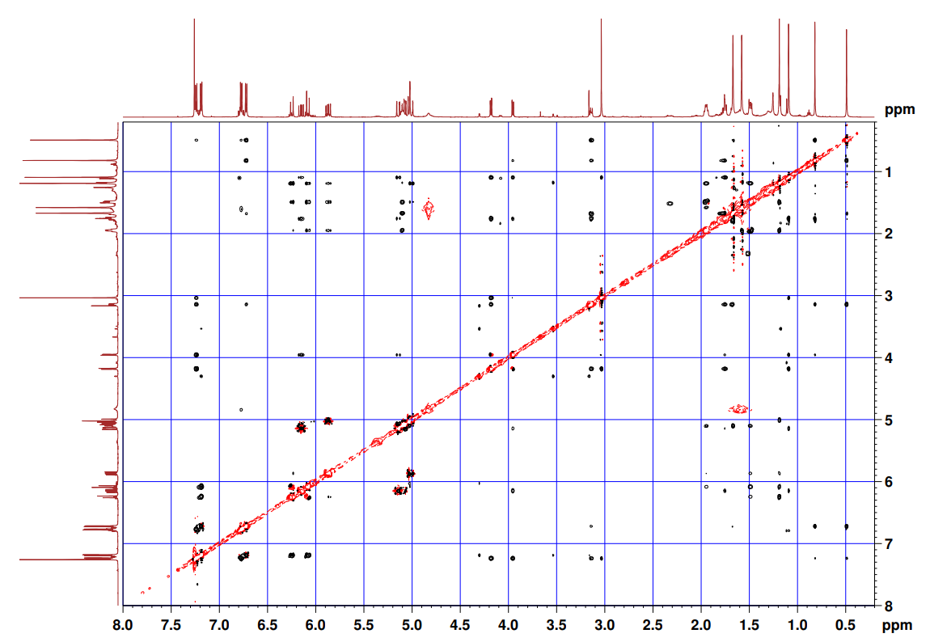
Figure S47. The NOESY spectrum of 6.
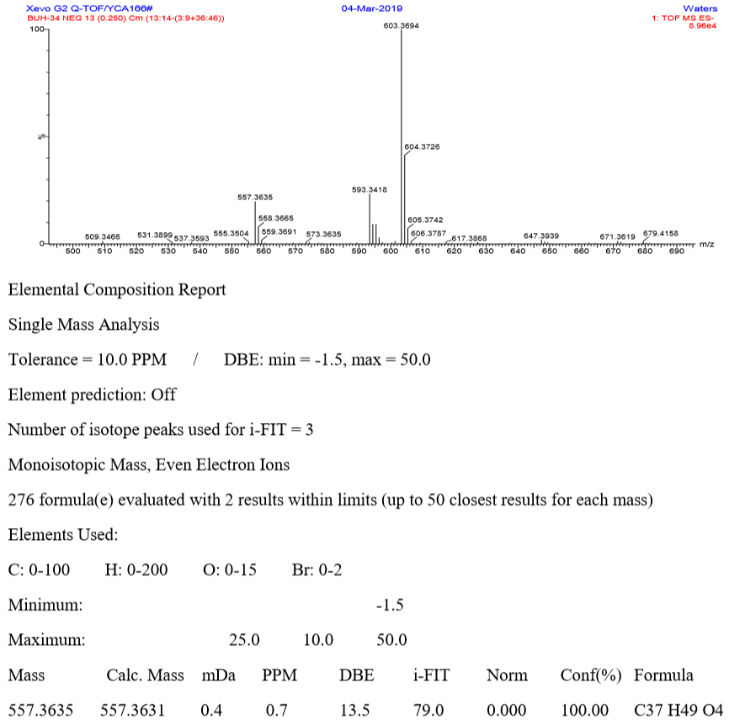
Figure S48. The HRESIMS spectrum of 7.
Figure S49. The IR spectrum of 7.
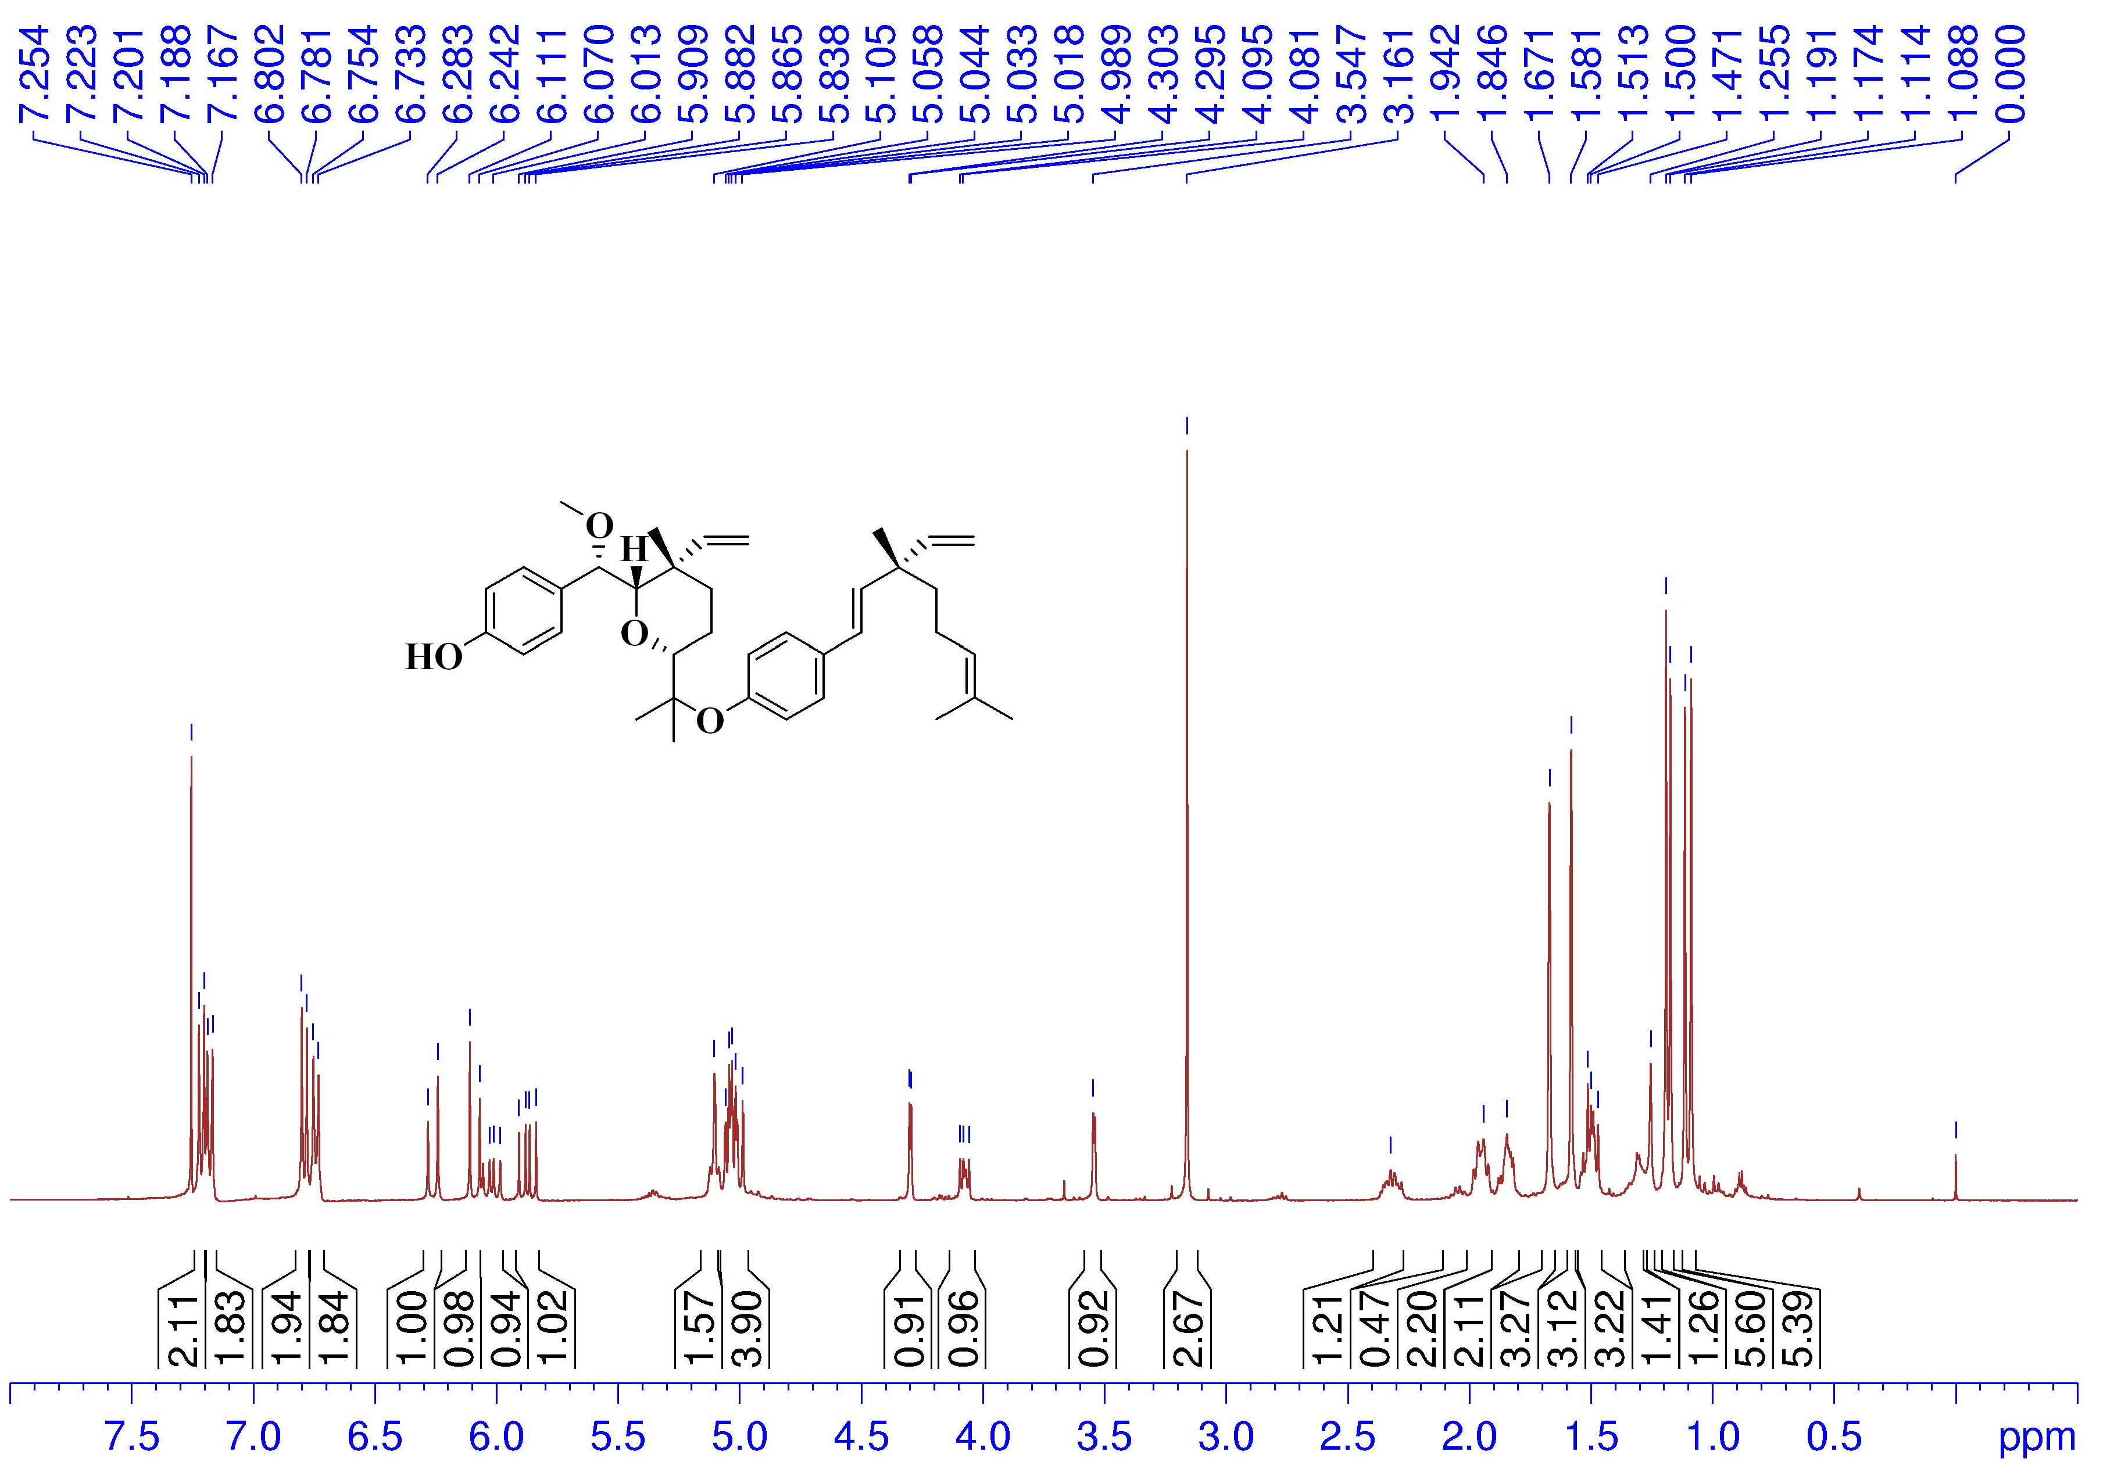
Figure S50. The ¹H NMR spectrum of 7 in CDCl₃ (400 MHz).

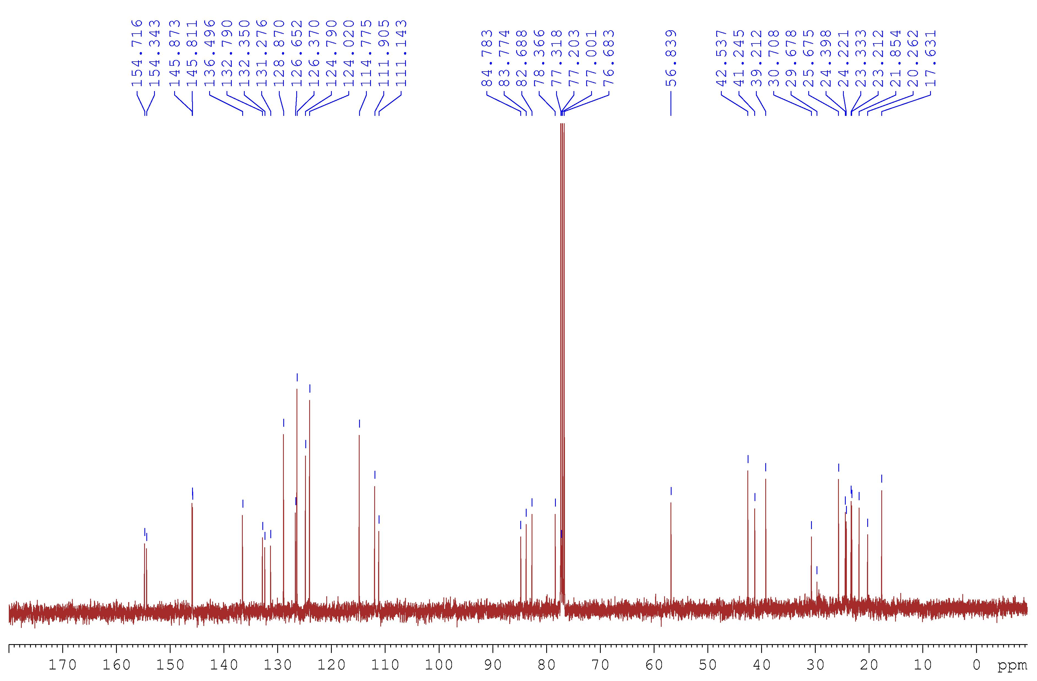
Figure S51. The ¹³C NMR spectrum of 7 in CDCl₃ (100 MHz).

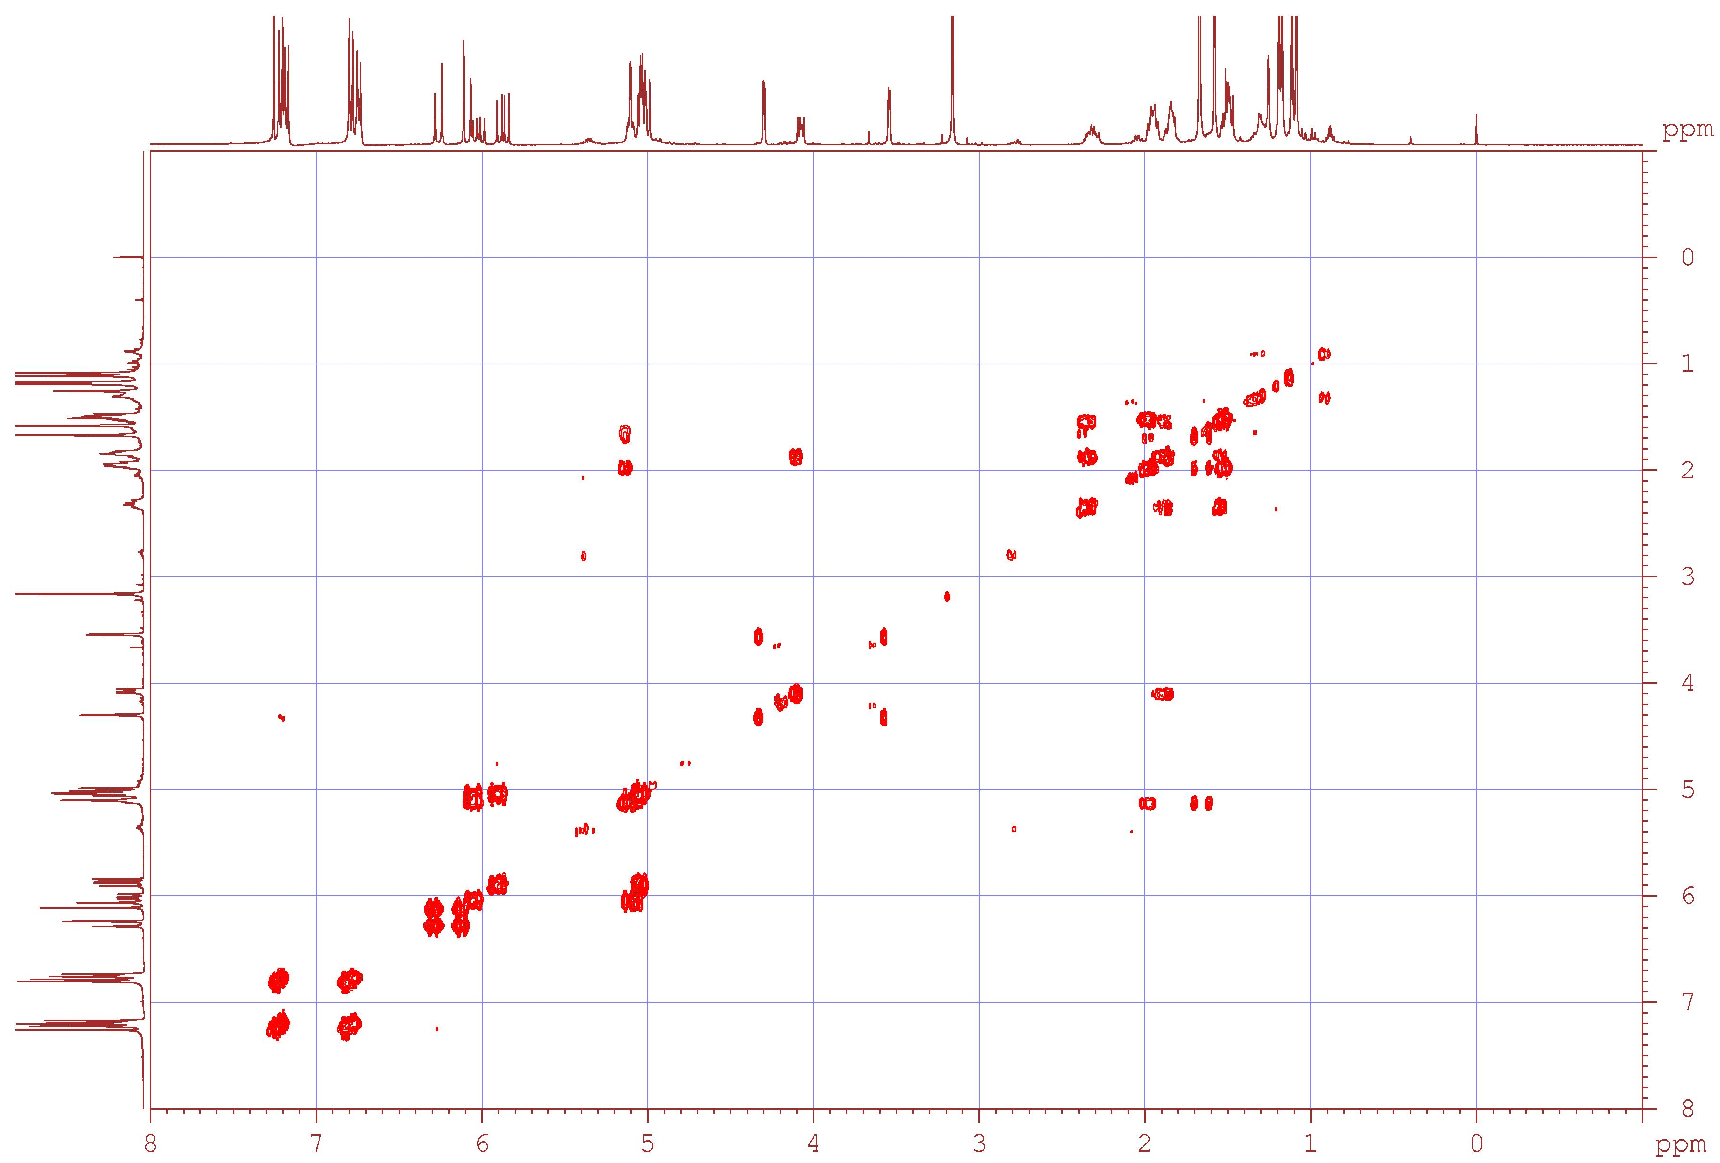
Figure S52. The ¹H–¹H COSY spectrum of 7.

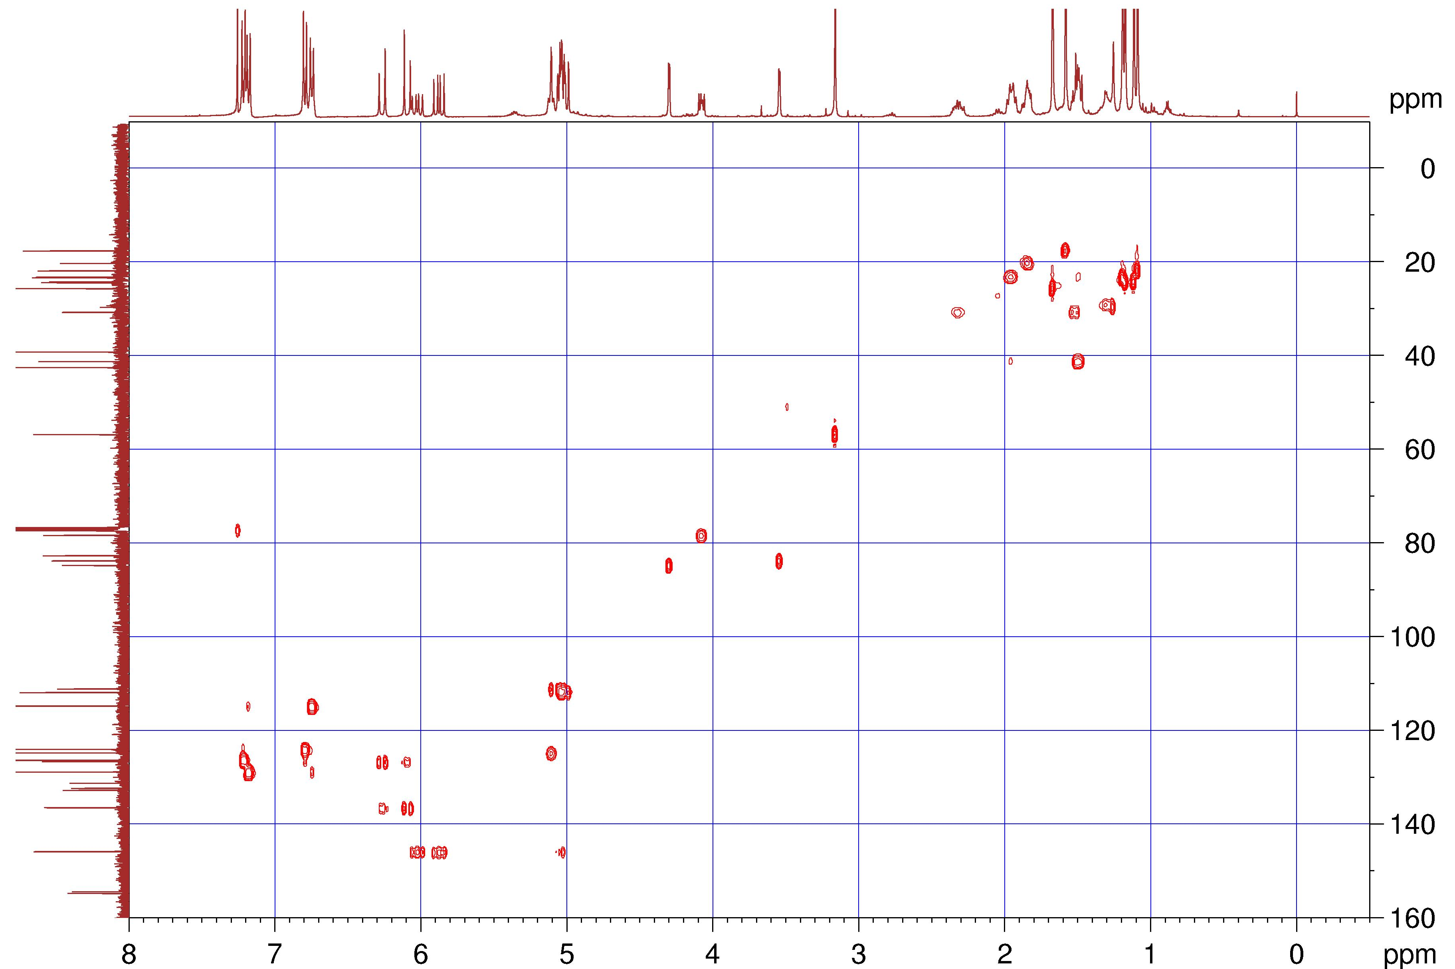
Figure S53. The HSQC spectrum of 7.

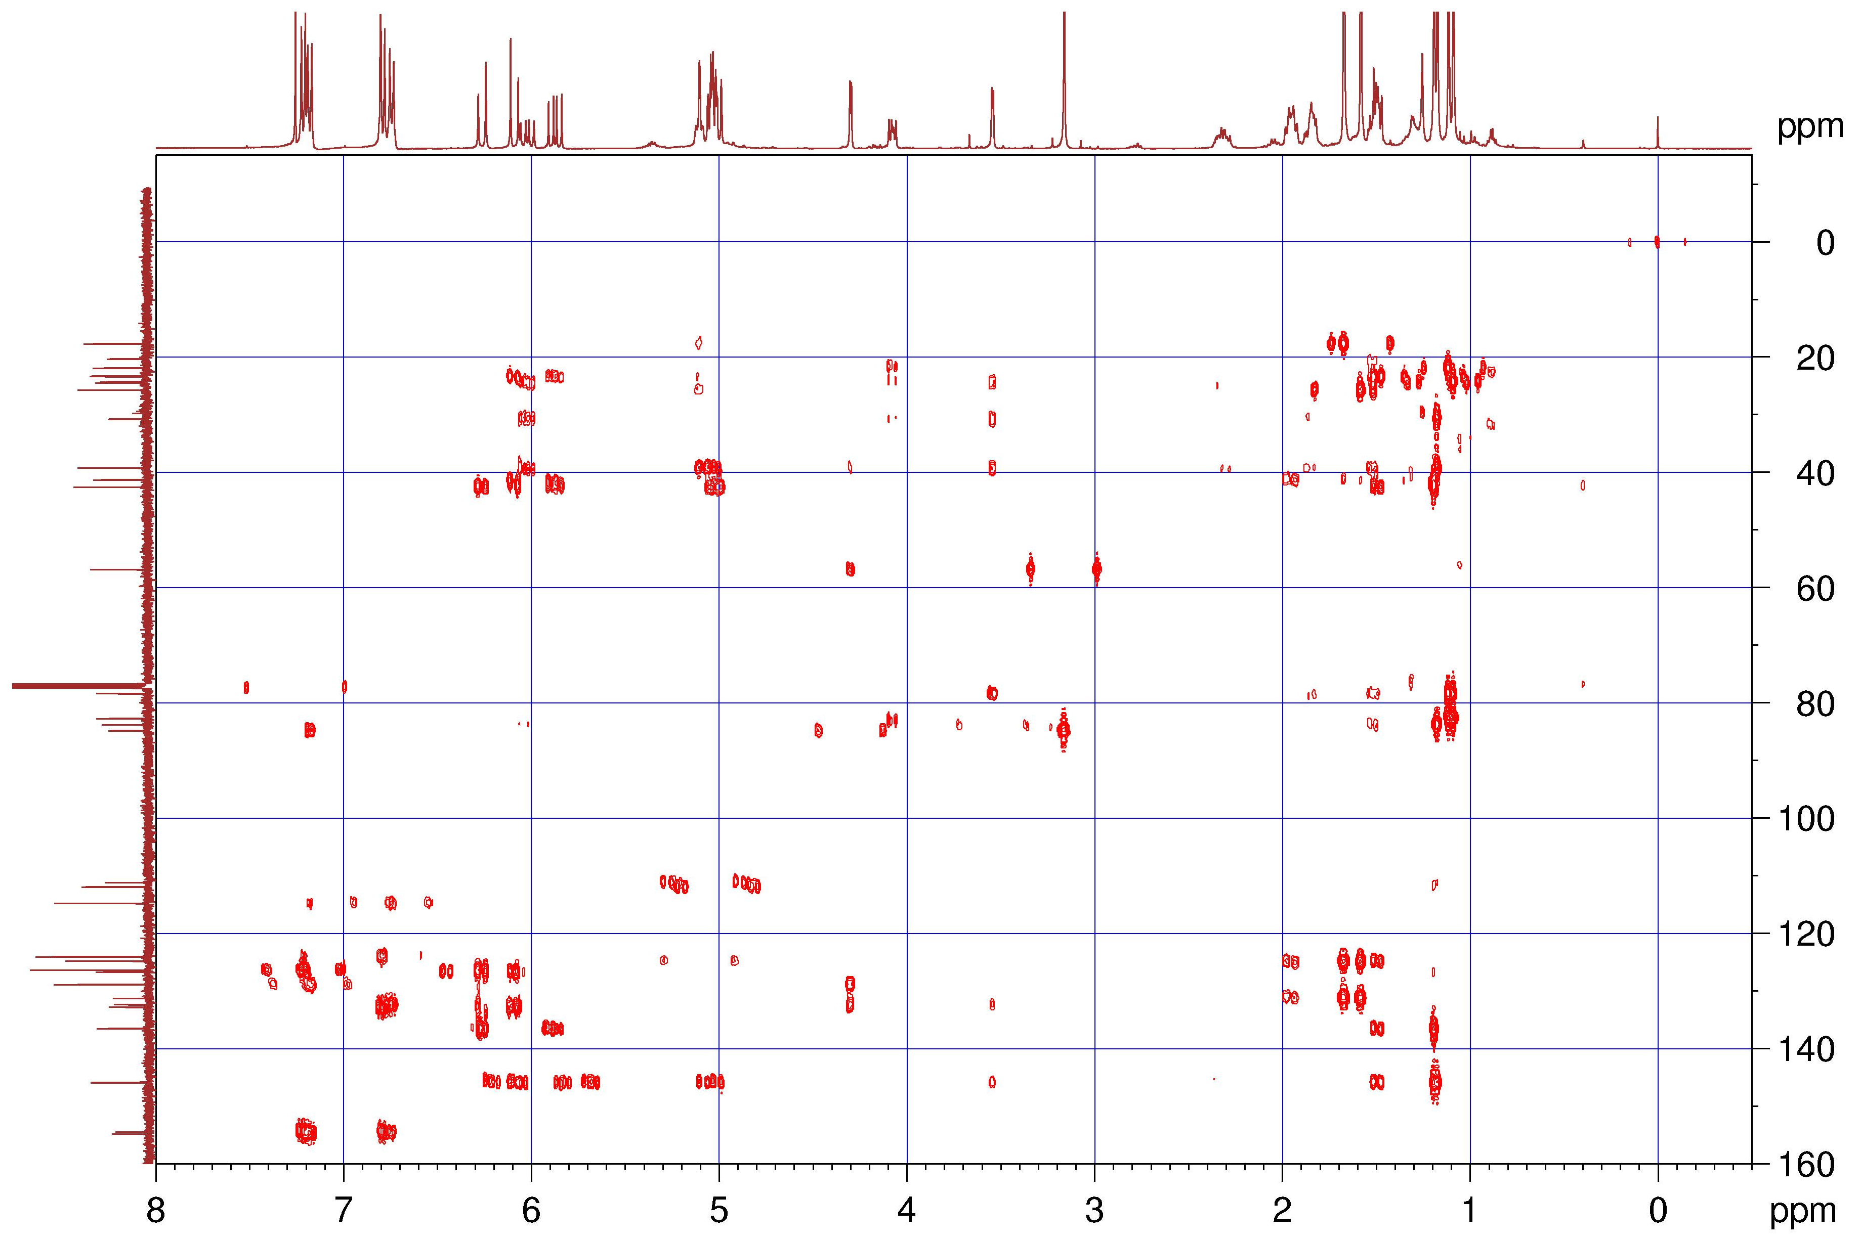
Figure S54. The HMBC spectrum of 7.

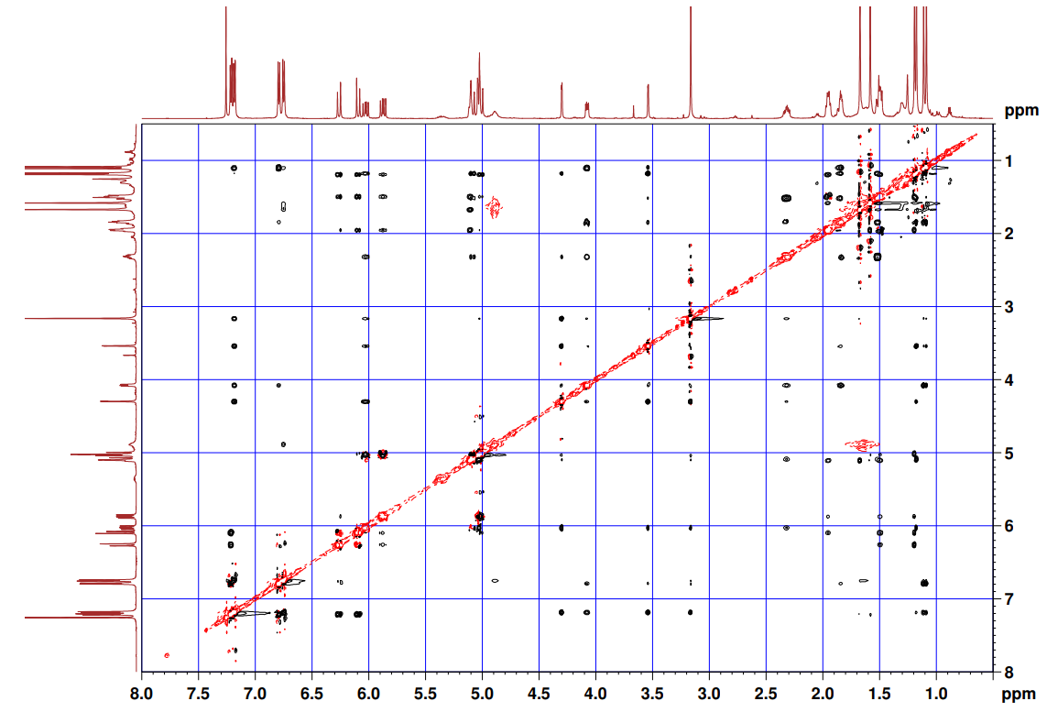
Figure S55. The NOESY spectrum of 7.
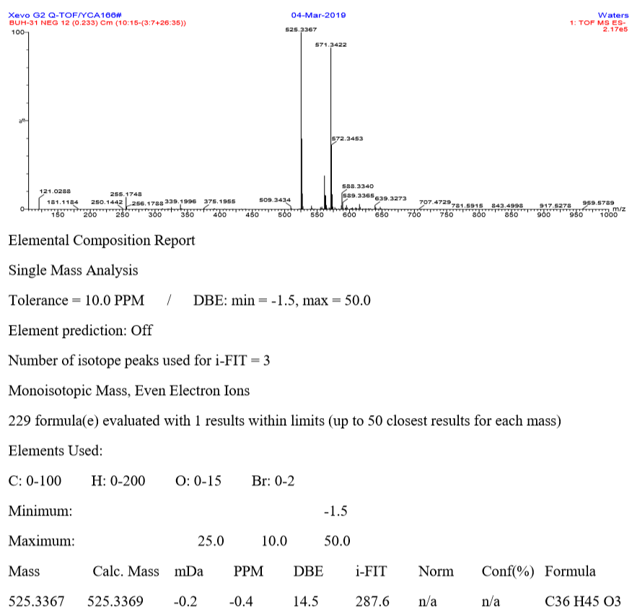
Figure S56. The HRESIMS spectrum of 8.
Figure S57. The IR spectrum of 8.
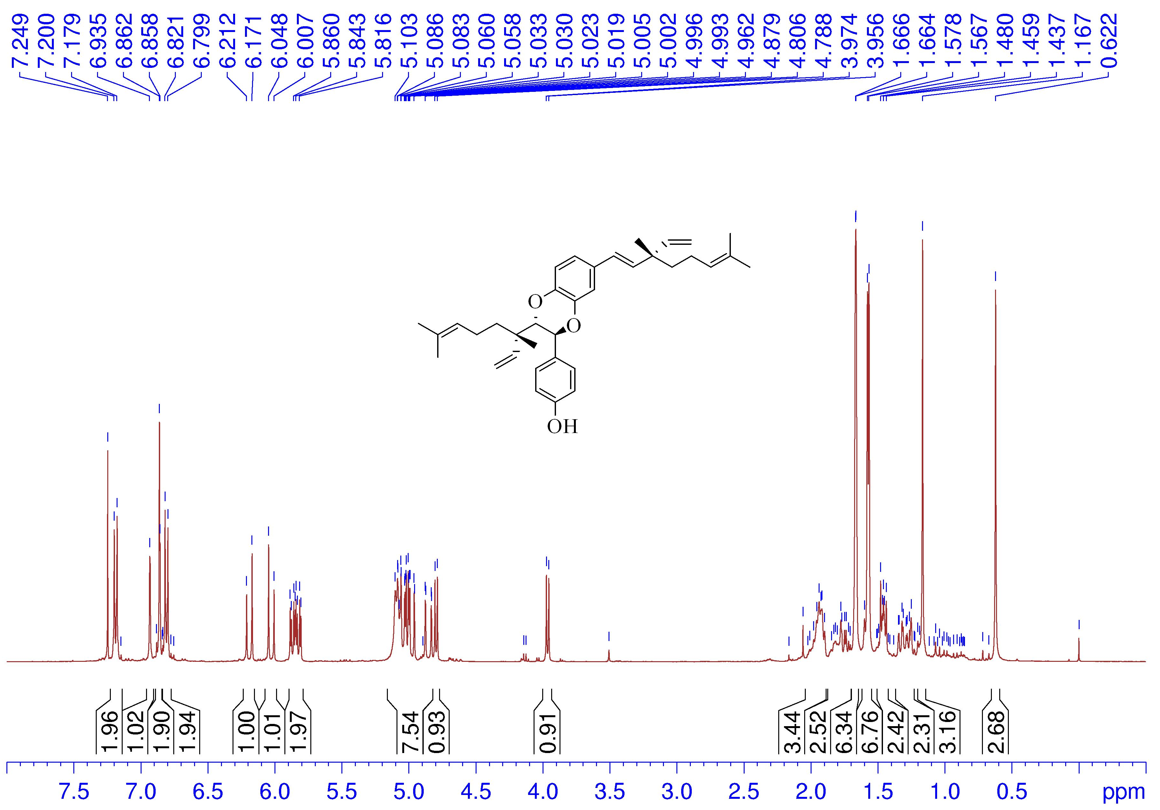
Figure S58. The ¹H NMR spectrum of 8 in CDCl₃ (400 MHz).

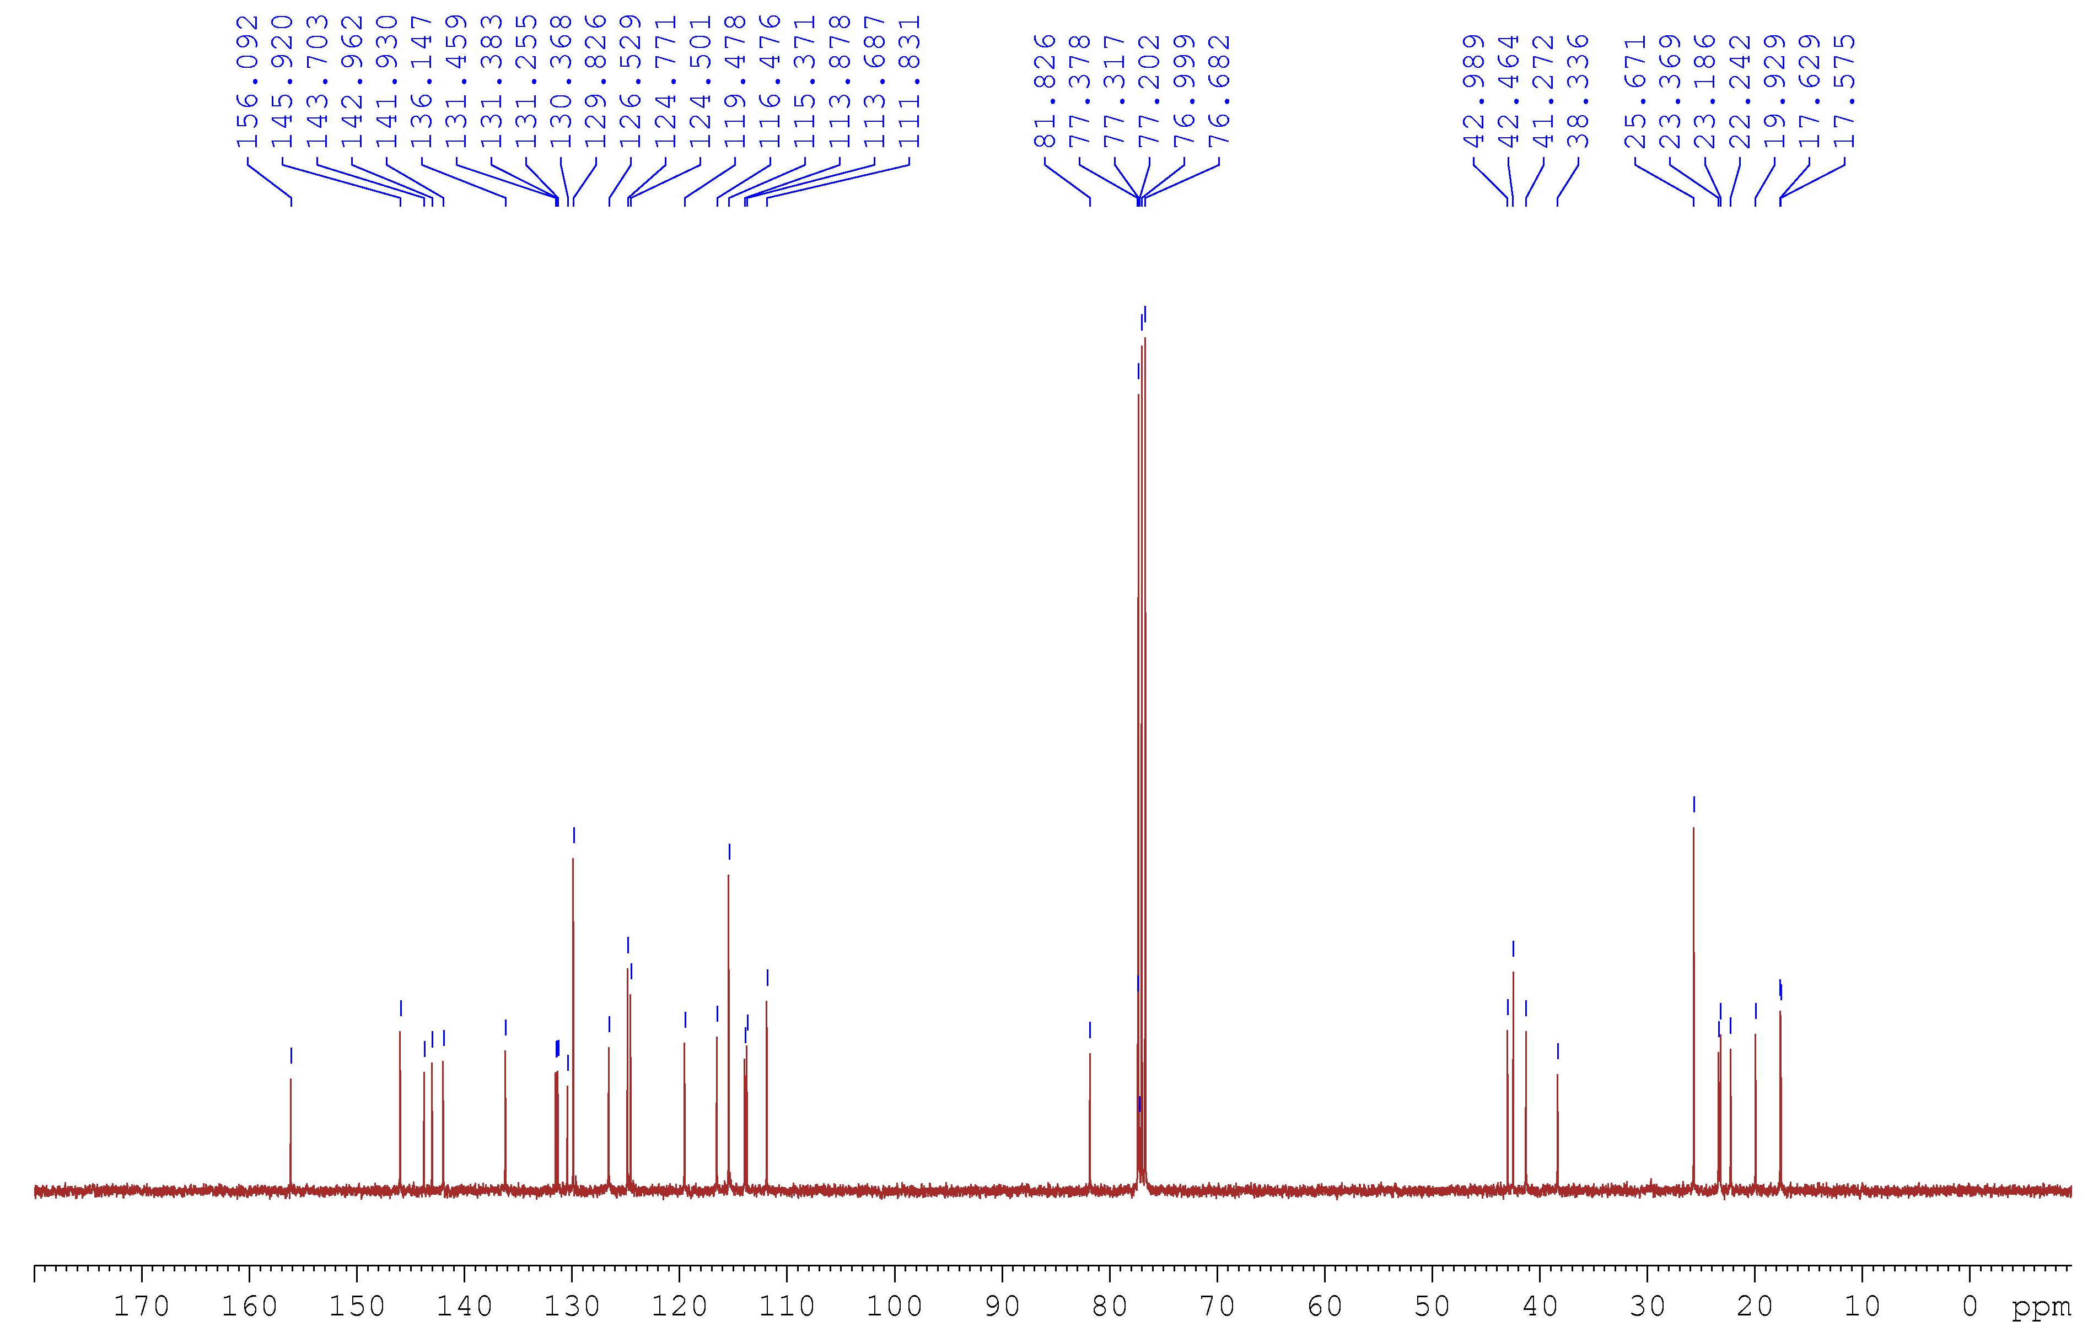
Figure S59. The ¹³C NMR spectrum of 8 in CDCl₃ (100 MHz).

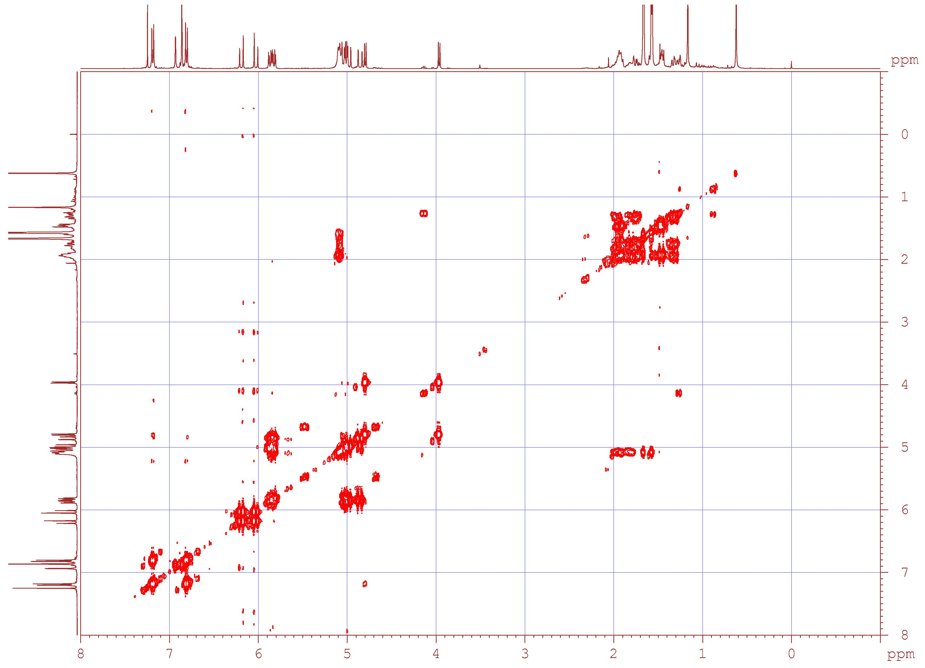
Figure S60. The ¹H–¹H COSY spectrum of 8.

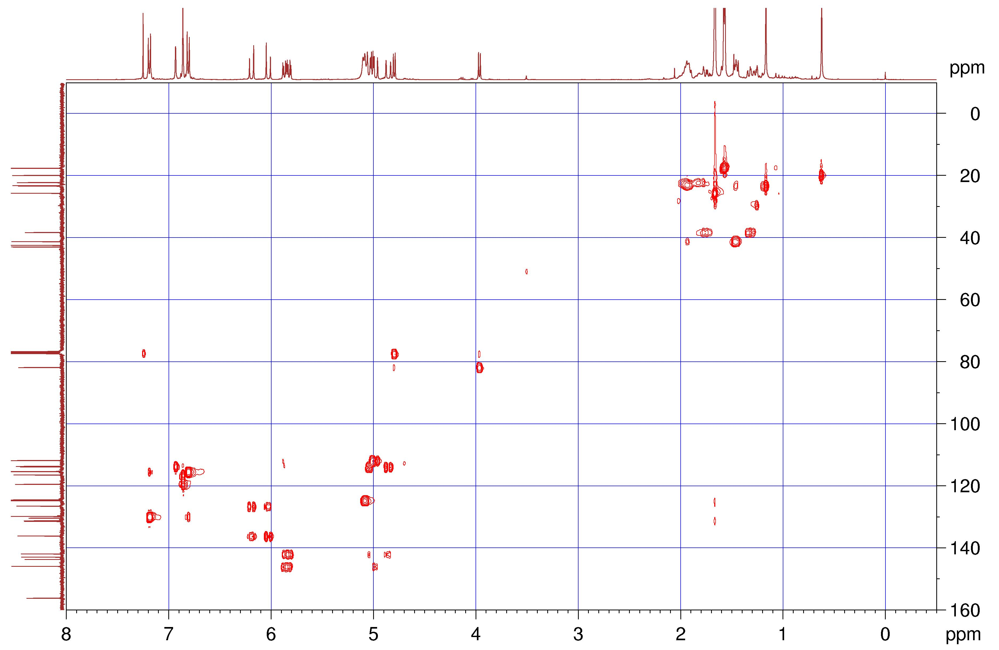
Figure S61. The HSQC spectrum of 8.

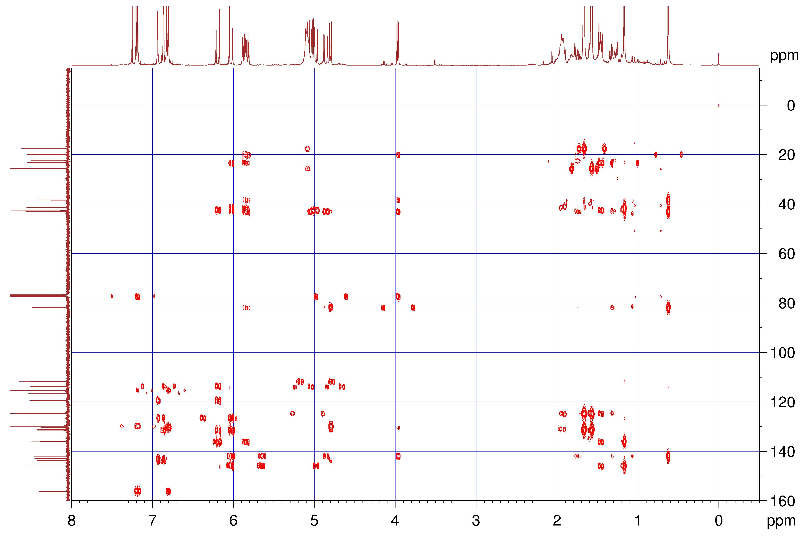
Figure S62. The HMBC spectrum of 8.

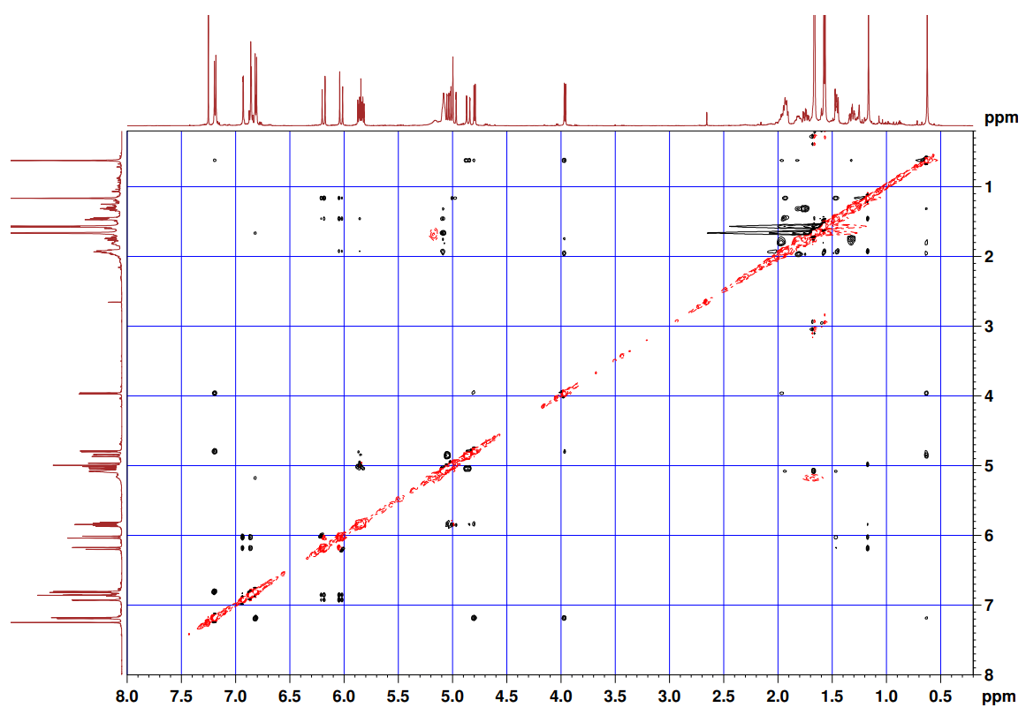
Figure S63. The NOESY spectrum of 8.

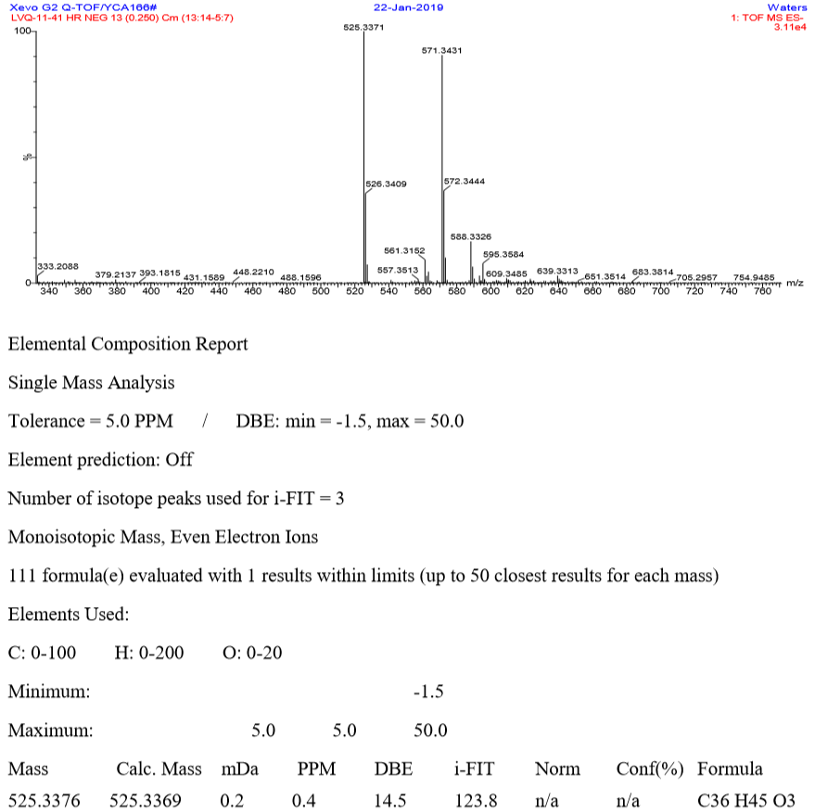
Figure S64. The HRESIMS spectrum of 9.

Figure S65. The IR spectrum of 9.
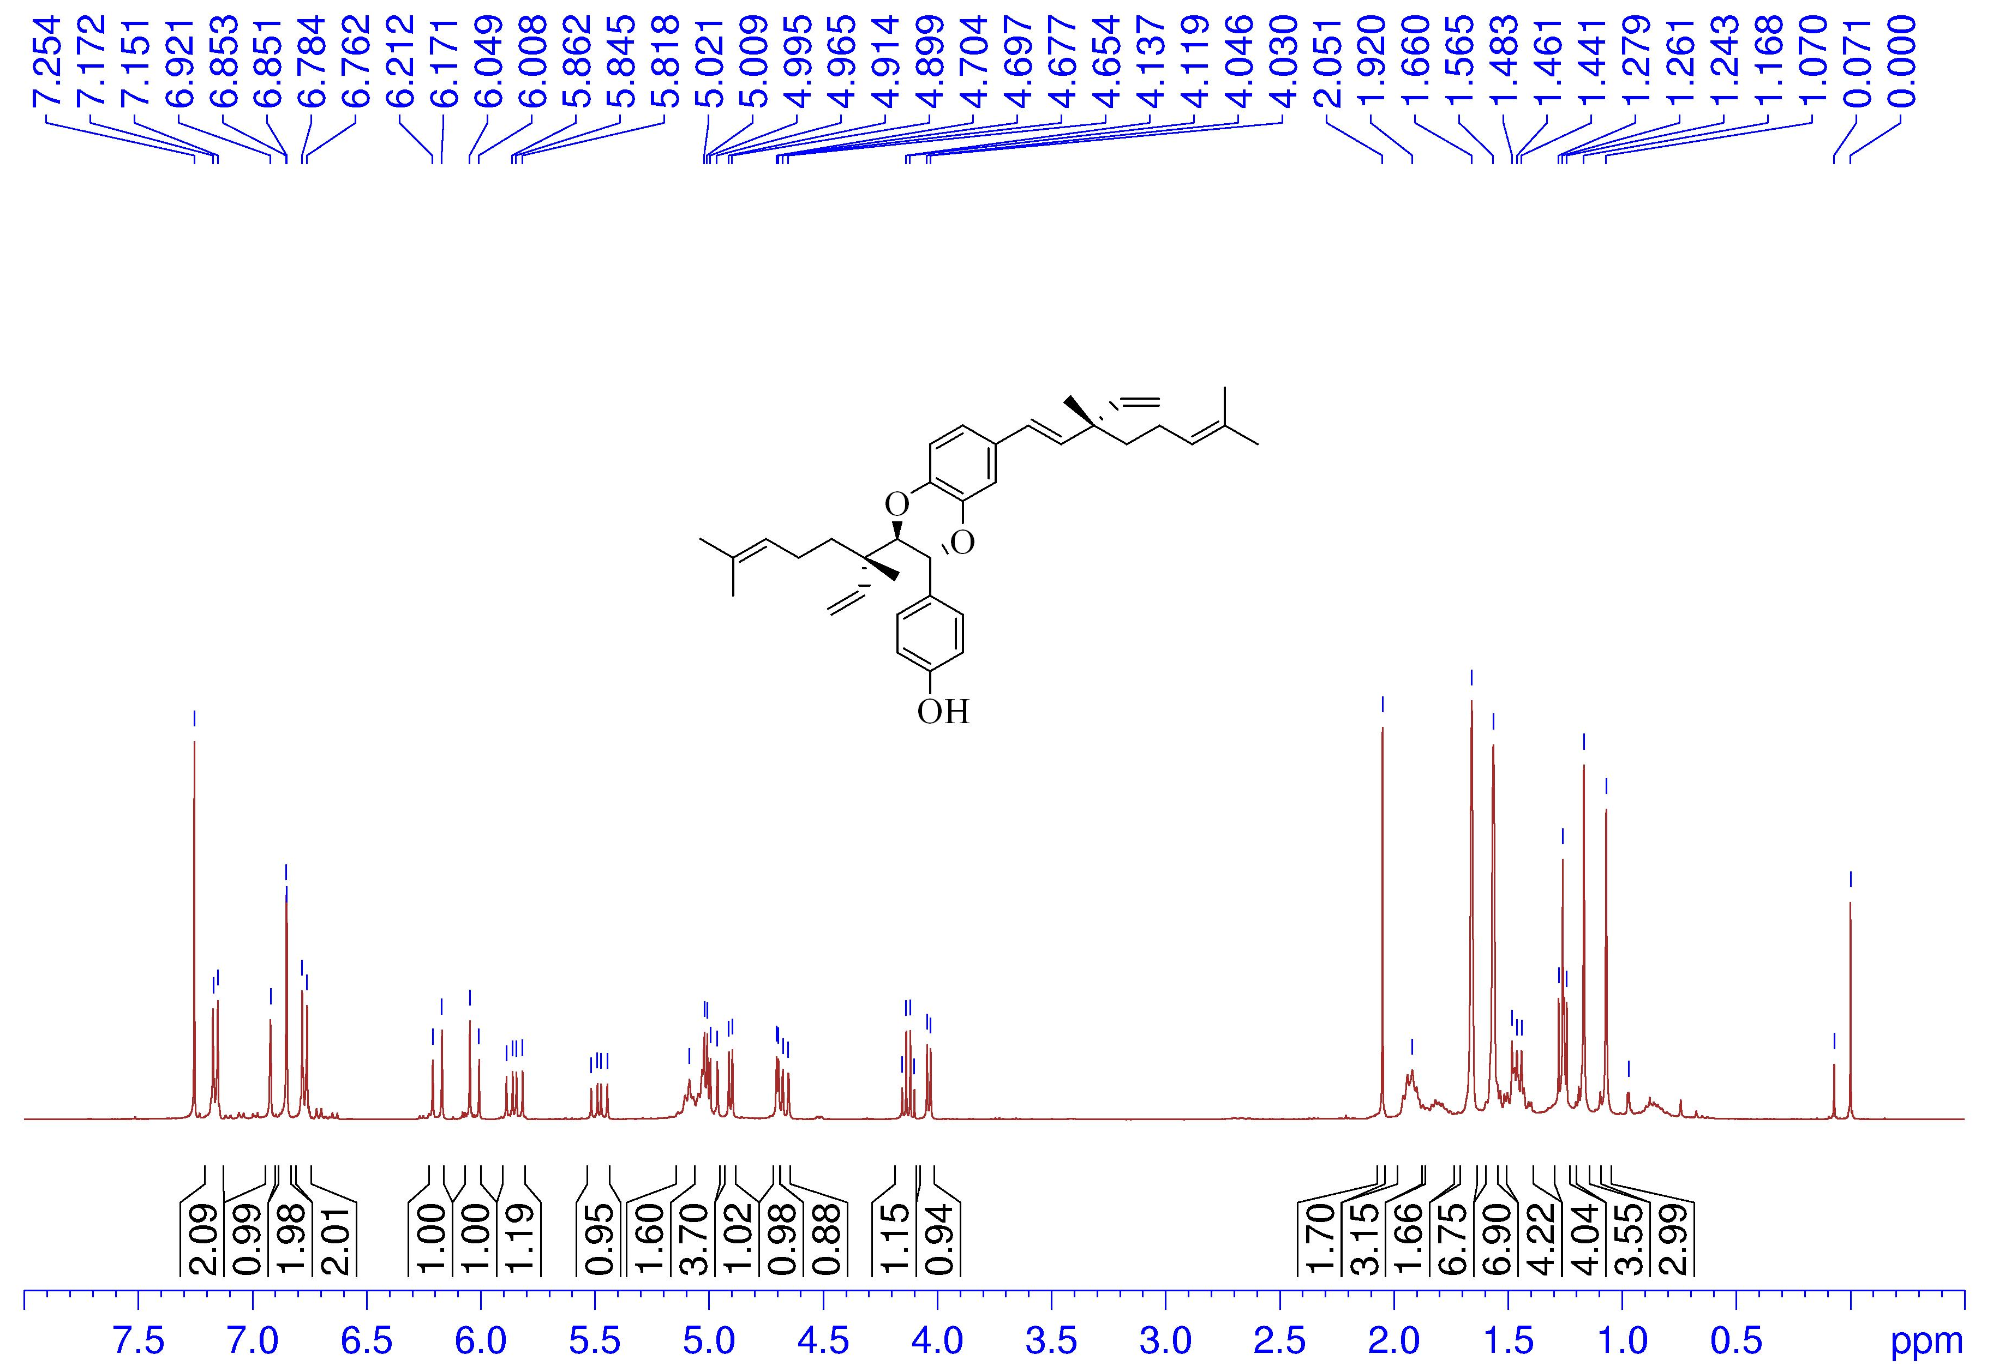
Figure S66. The ¹H NMR spectrum of 9 in CDCl₃ (400 MHz).

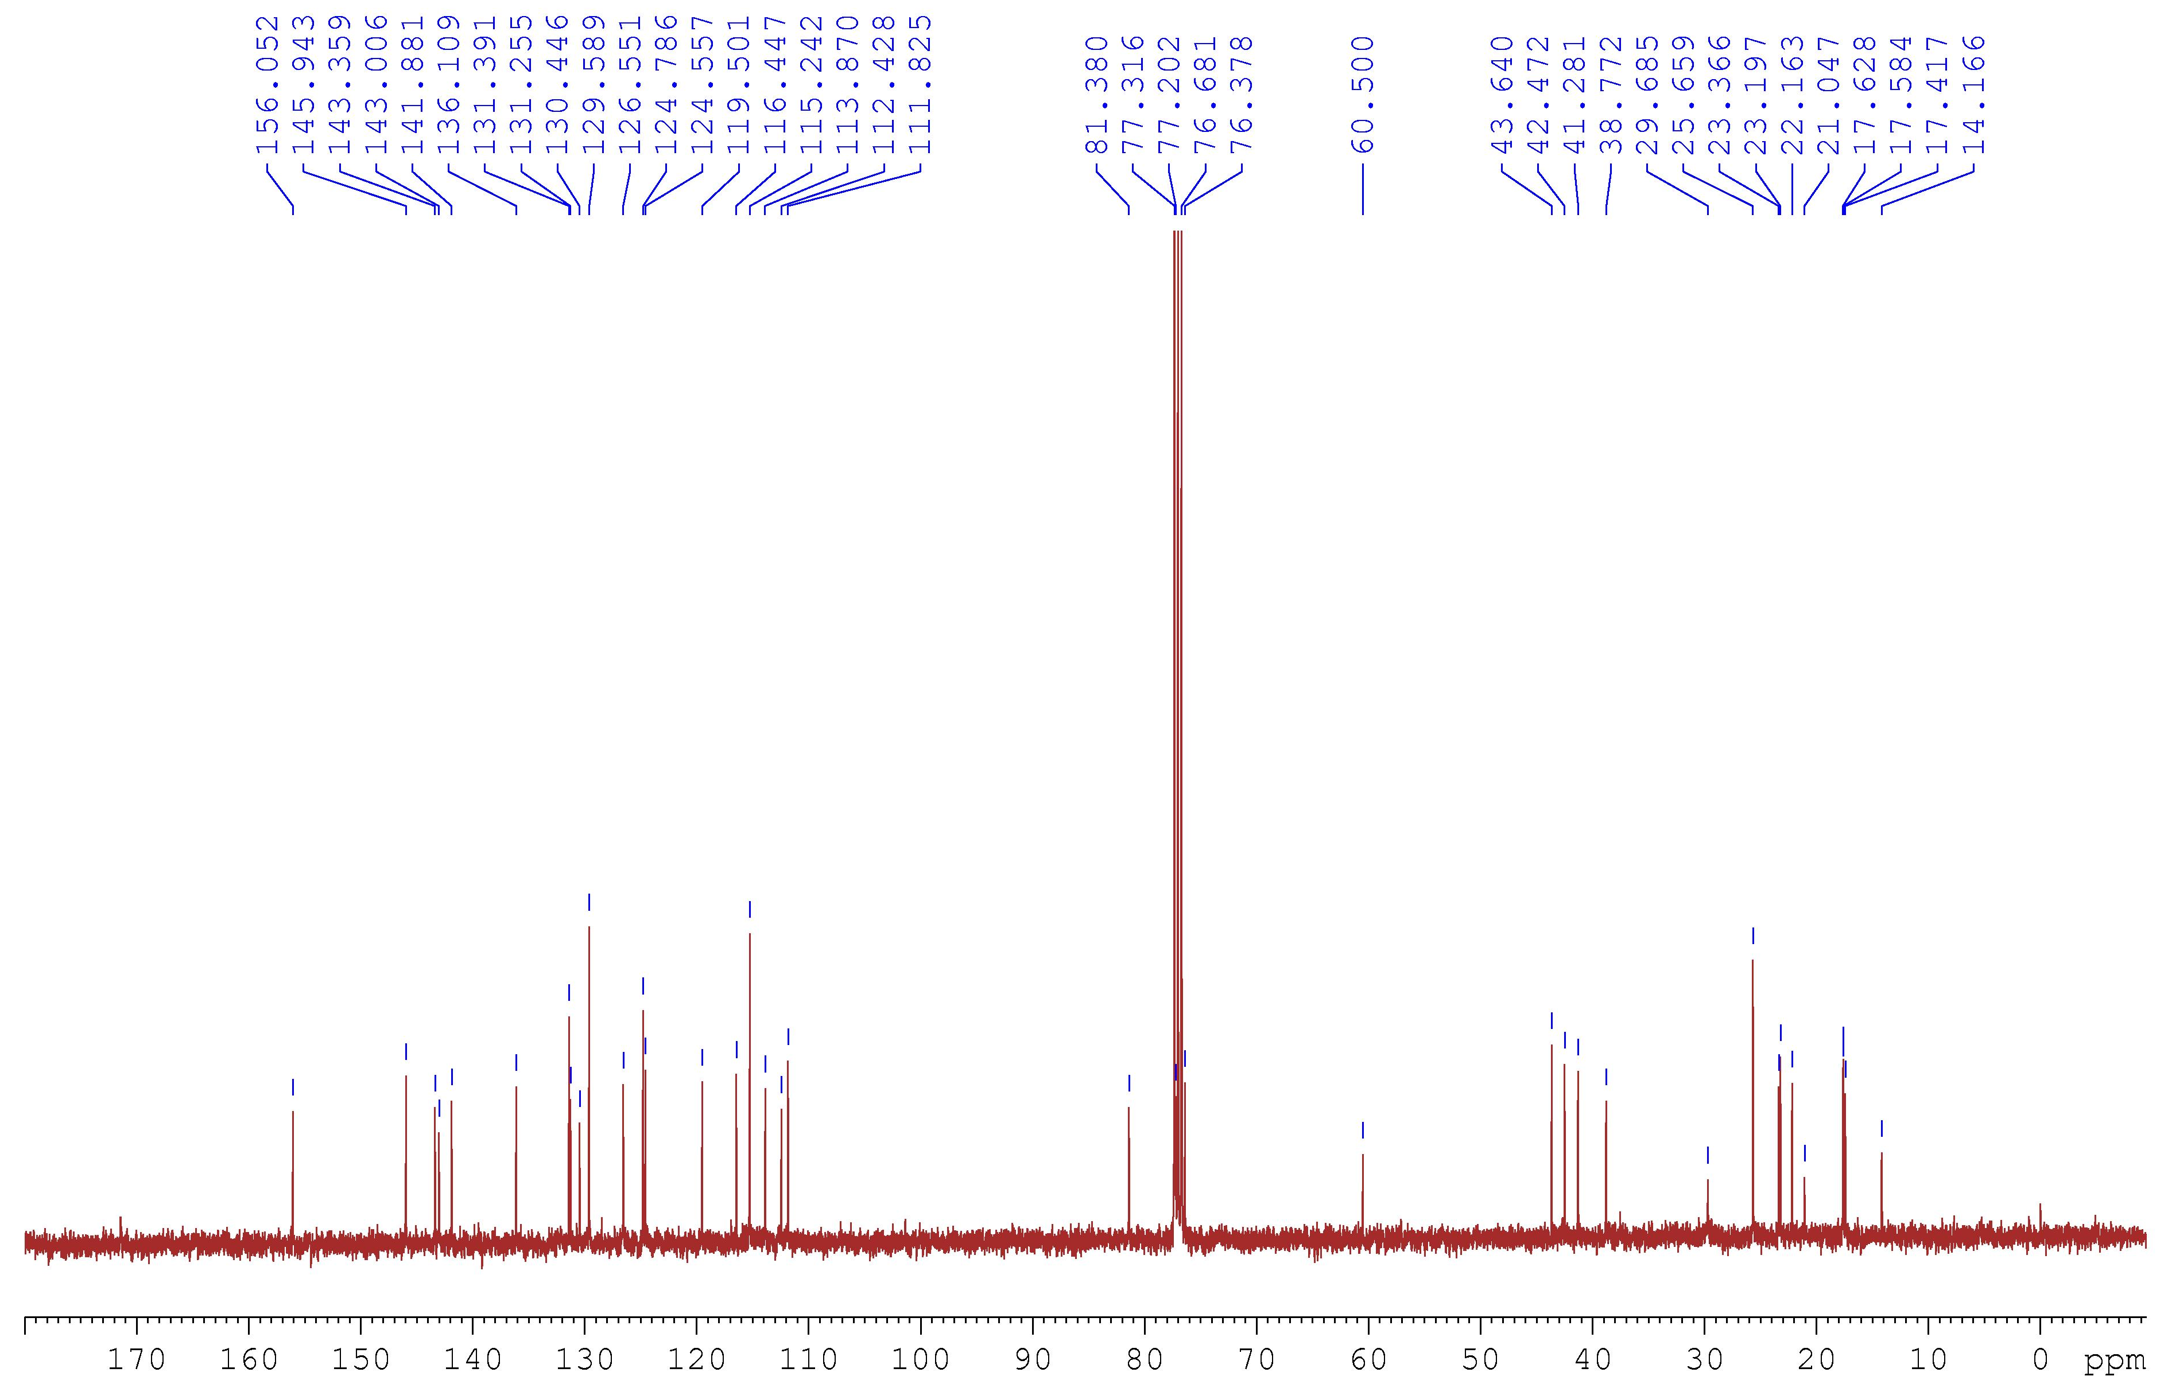
Figure S67. The ¹³C NMR spectrum of 9 in CDCl₃ (100 MHz).

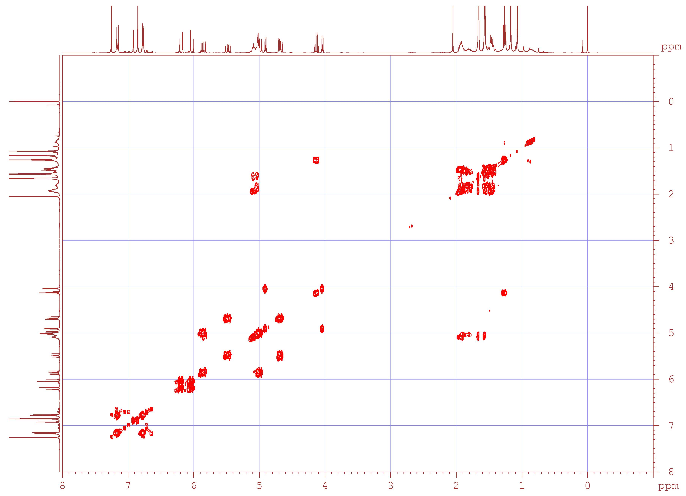
Figure S68. The ¹H–¹H COSY spectrum of 9.

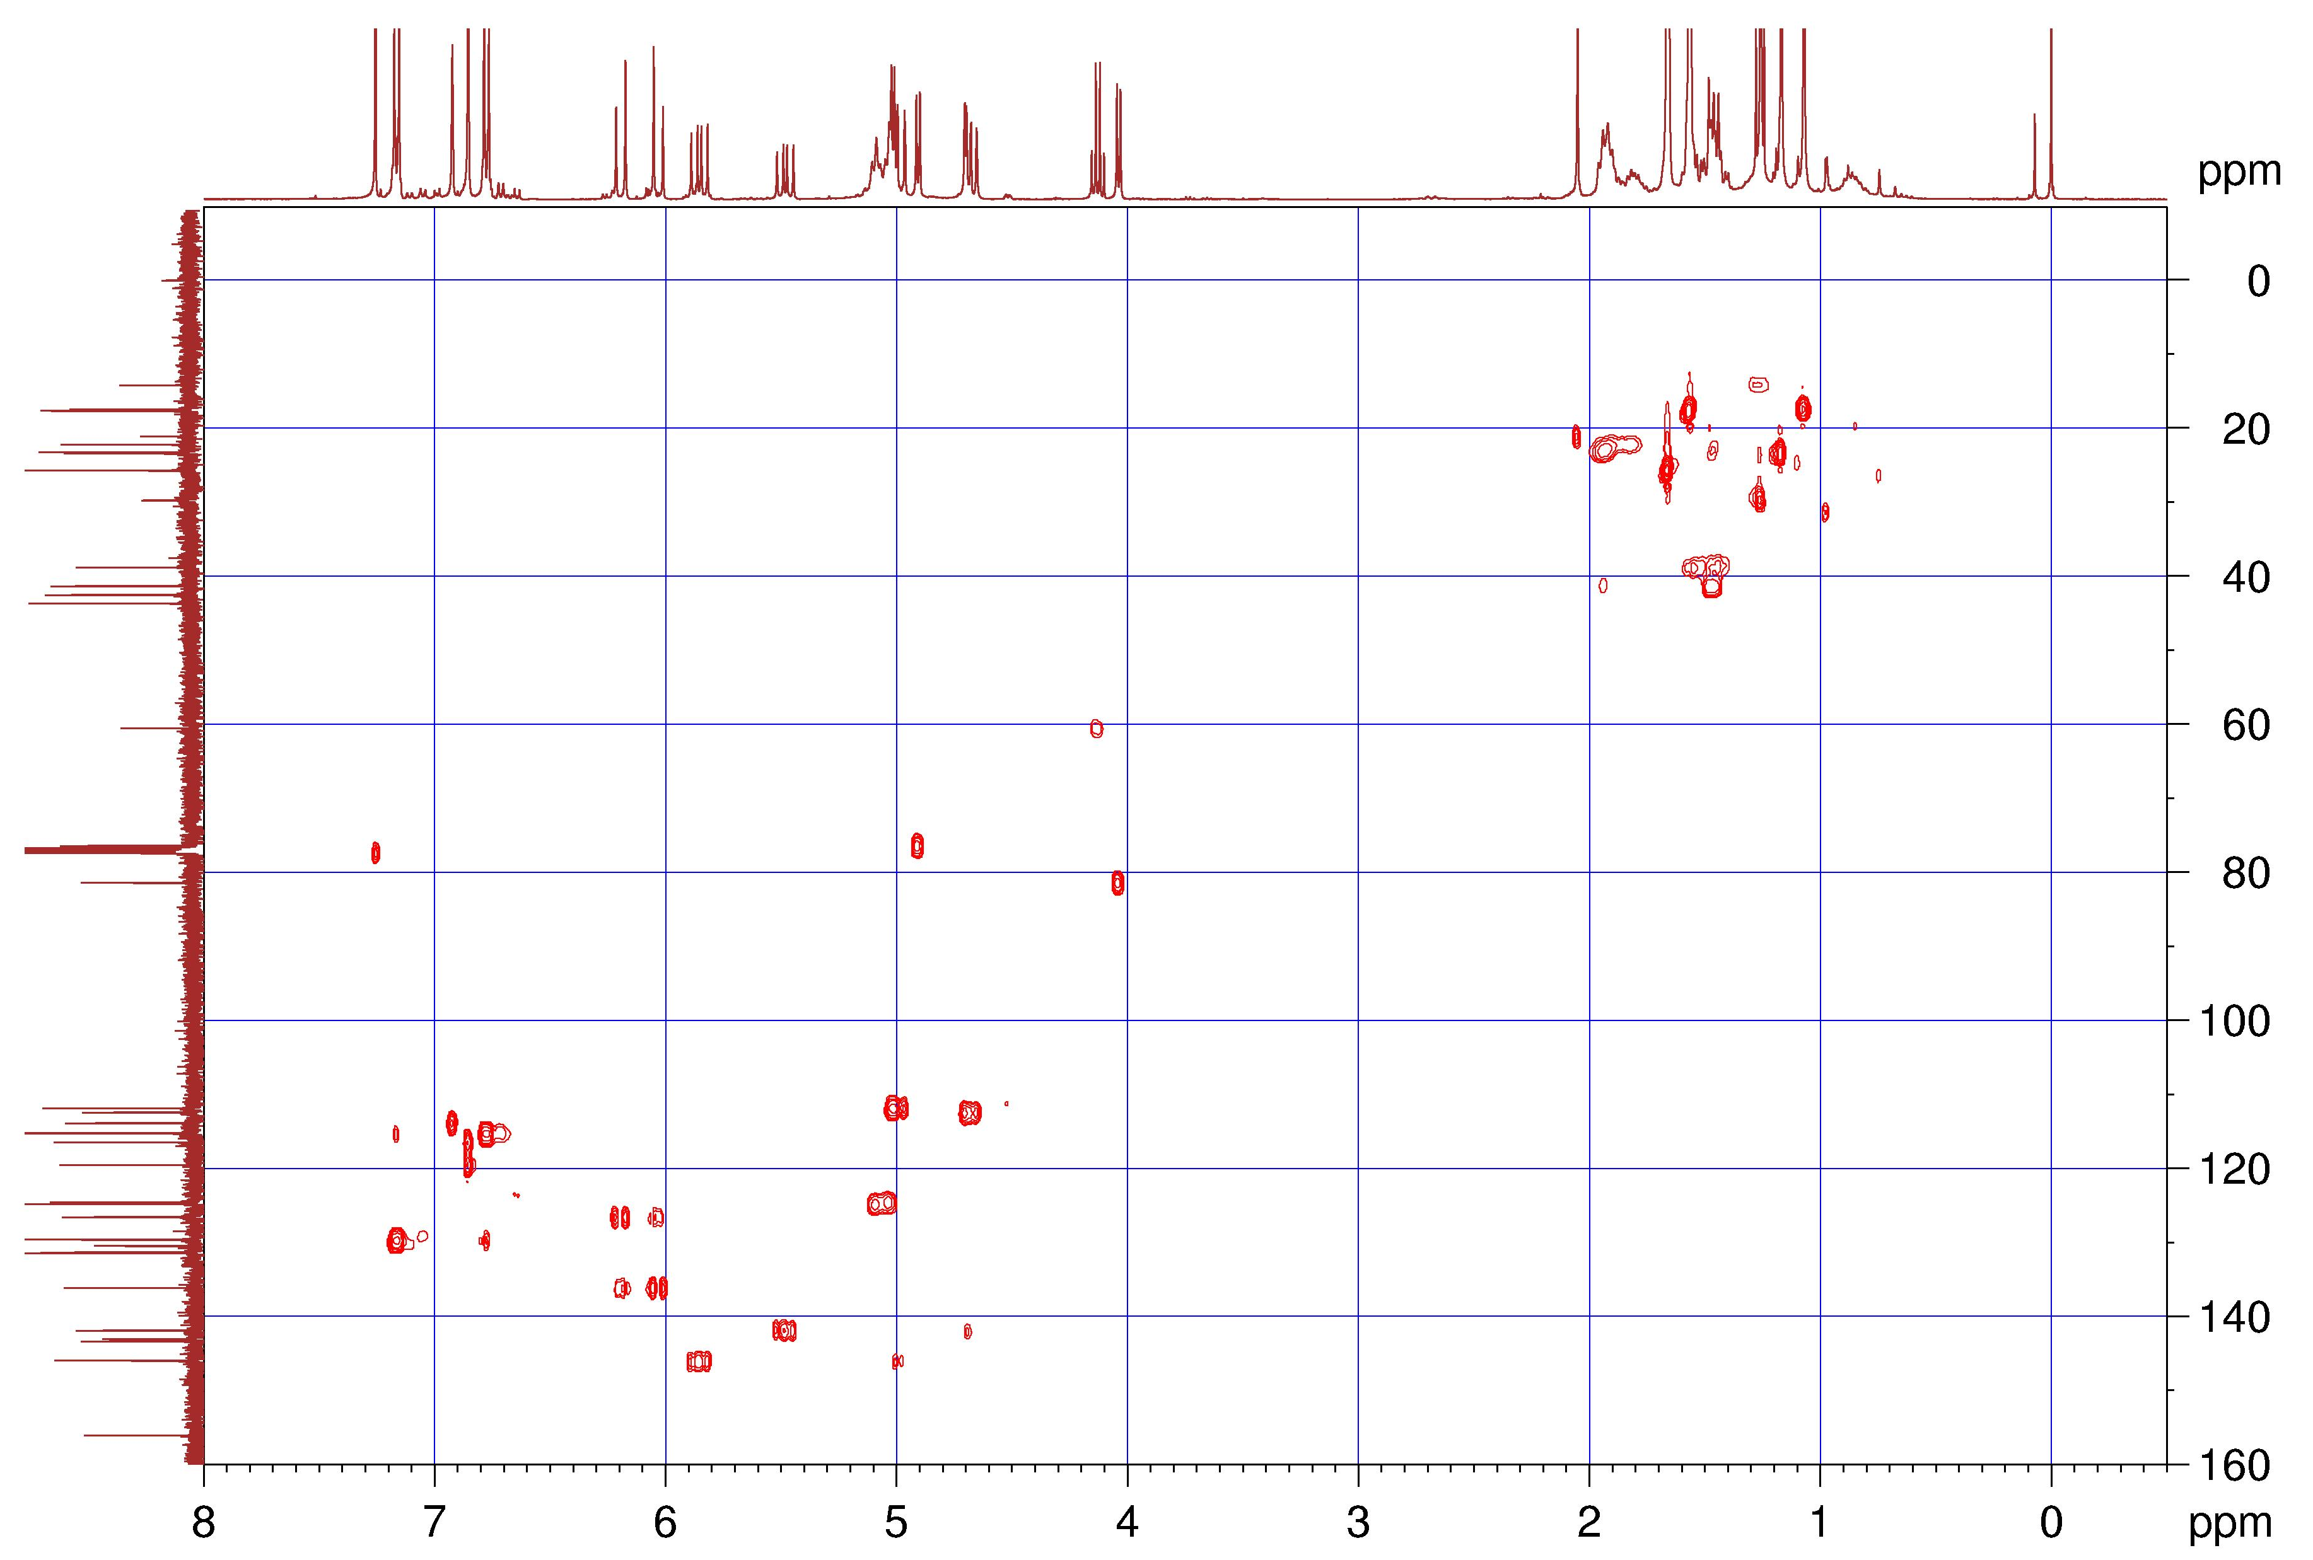
Figure S69. The HSQC spectrum of 9.

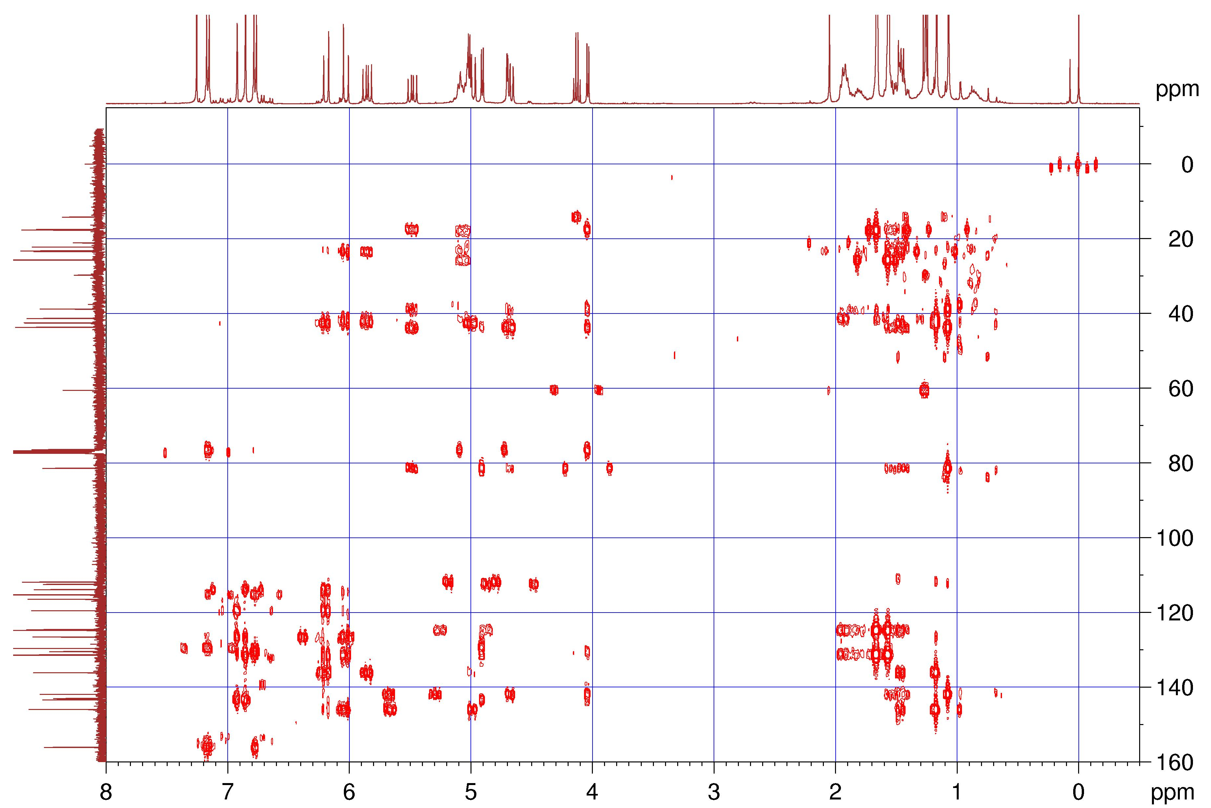
Figure S70. The HMBC spectrum of 9.

Figure S71. The NOESY spectrum of 9.
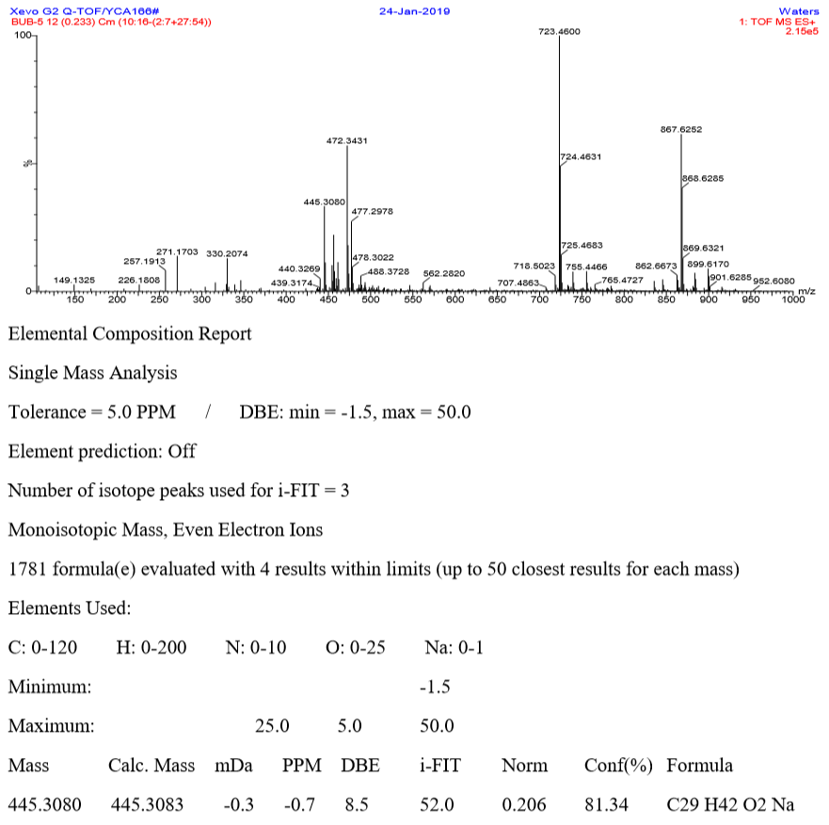
Figure S72. The HRESIMS spectrum of 10.
Figure S73. The IR spectrum of 10.
Figure S74. The ¹H NMR spectrum of 10 in CDCl₃ (400 MHz).
Figure S75. The ¹³C NMR spectrum of 10 in CDCl₃ (100 MHz).

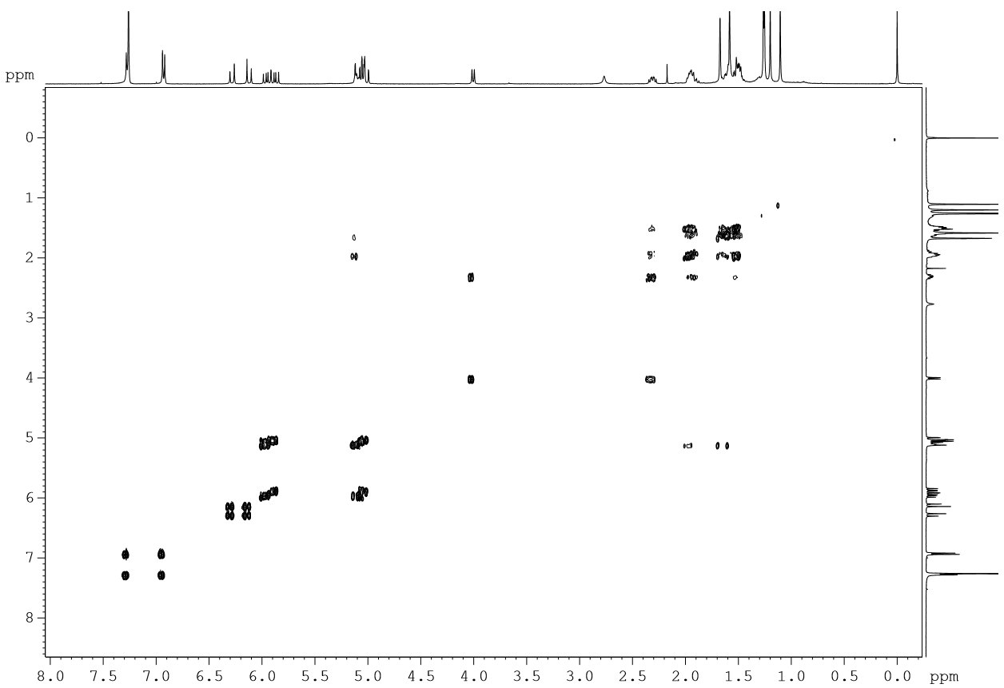
Figure S76. The ¹H–¹H COSY spectrum of 10.

Figure S77. The HSQC spectrum of 10.

Figure S78. The HMBC spectrum of 10.

Figure S79. The NOESY spectrum of 10.
Figure S80. The HRESIMS spectrum of 11.

Figure S81. The IR spectrum of 11.
Figure S82. The ¹H NMR spectrum of 11 in CDCl₃ (400 MHz).

Figure S83. The ¹³C NMR spectrum of 11 in CDCl₃ (100 MHz).

Figure S84. The ¹H–¹H COSY spectrum of 11.

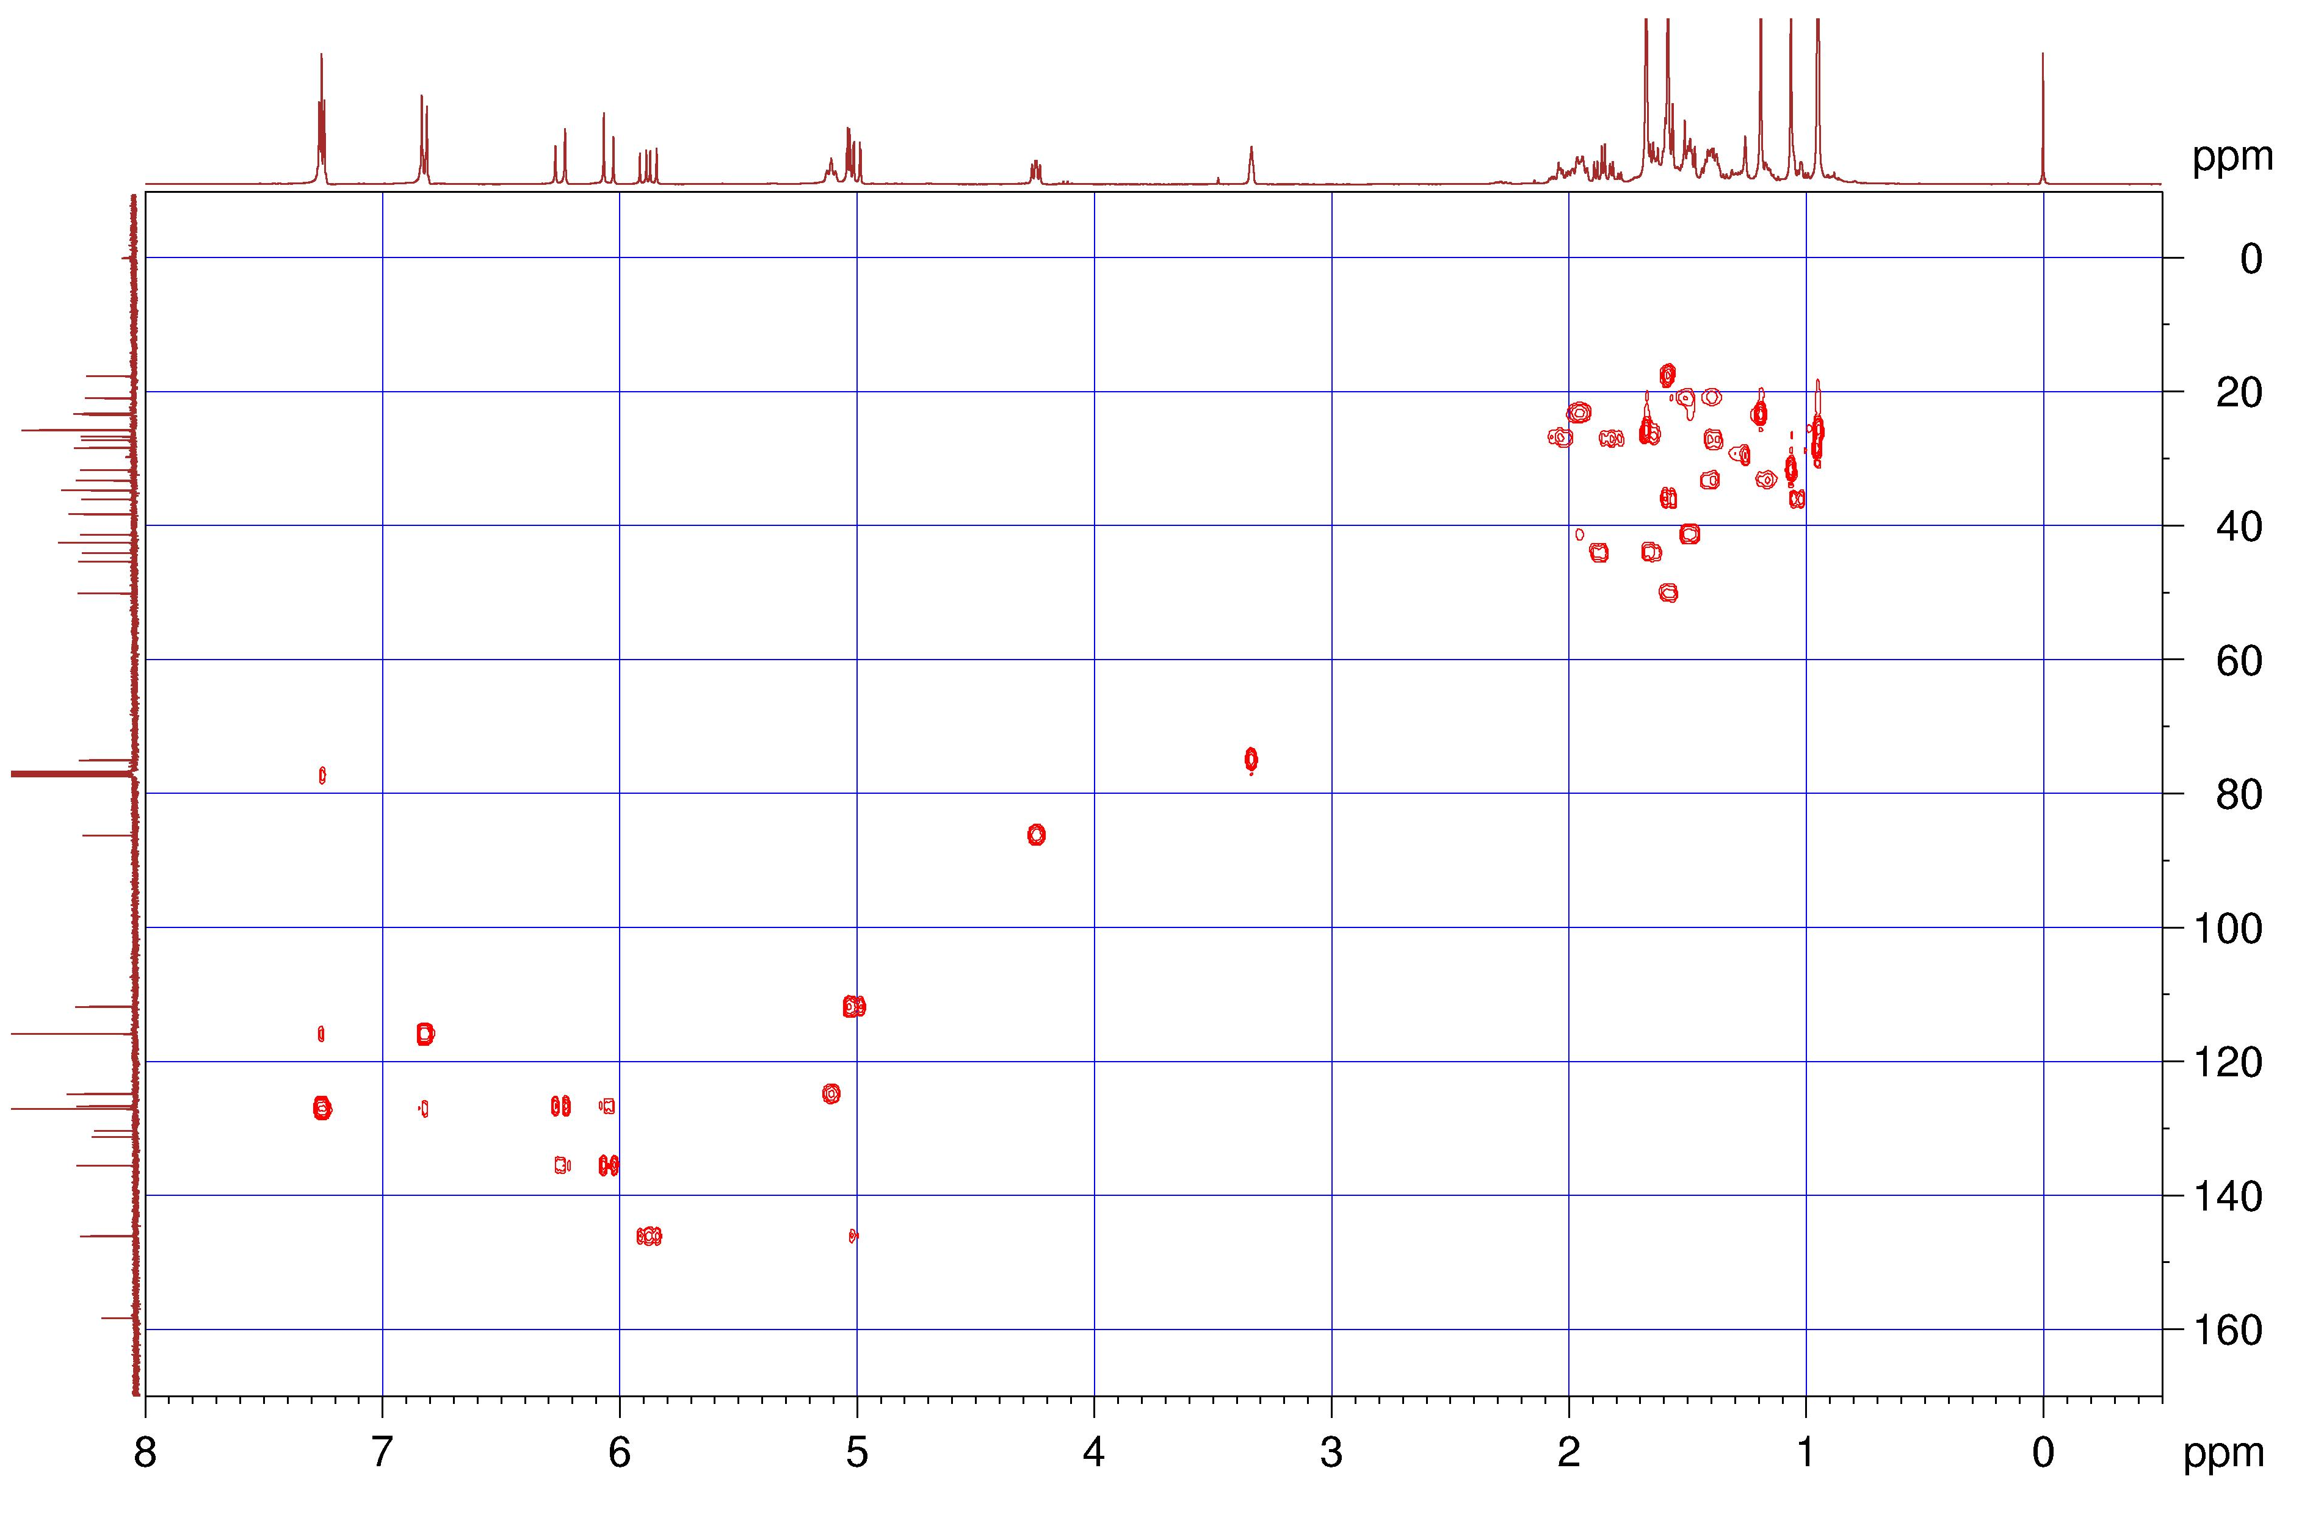
Figure S85. The HSQC spectrum of 11.

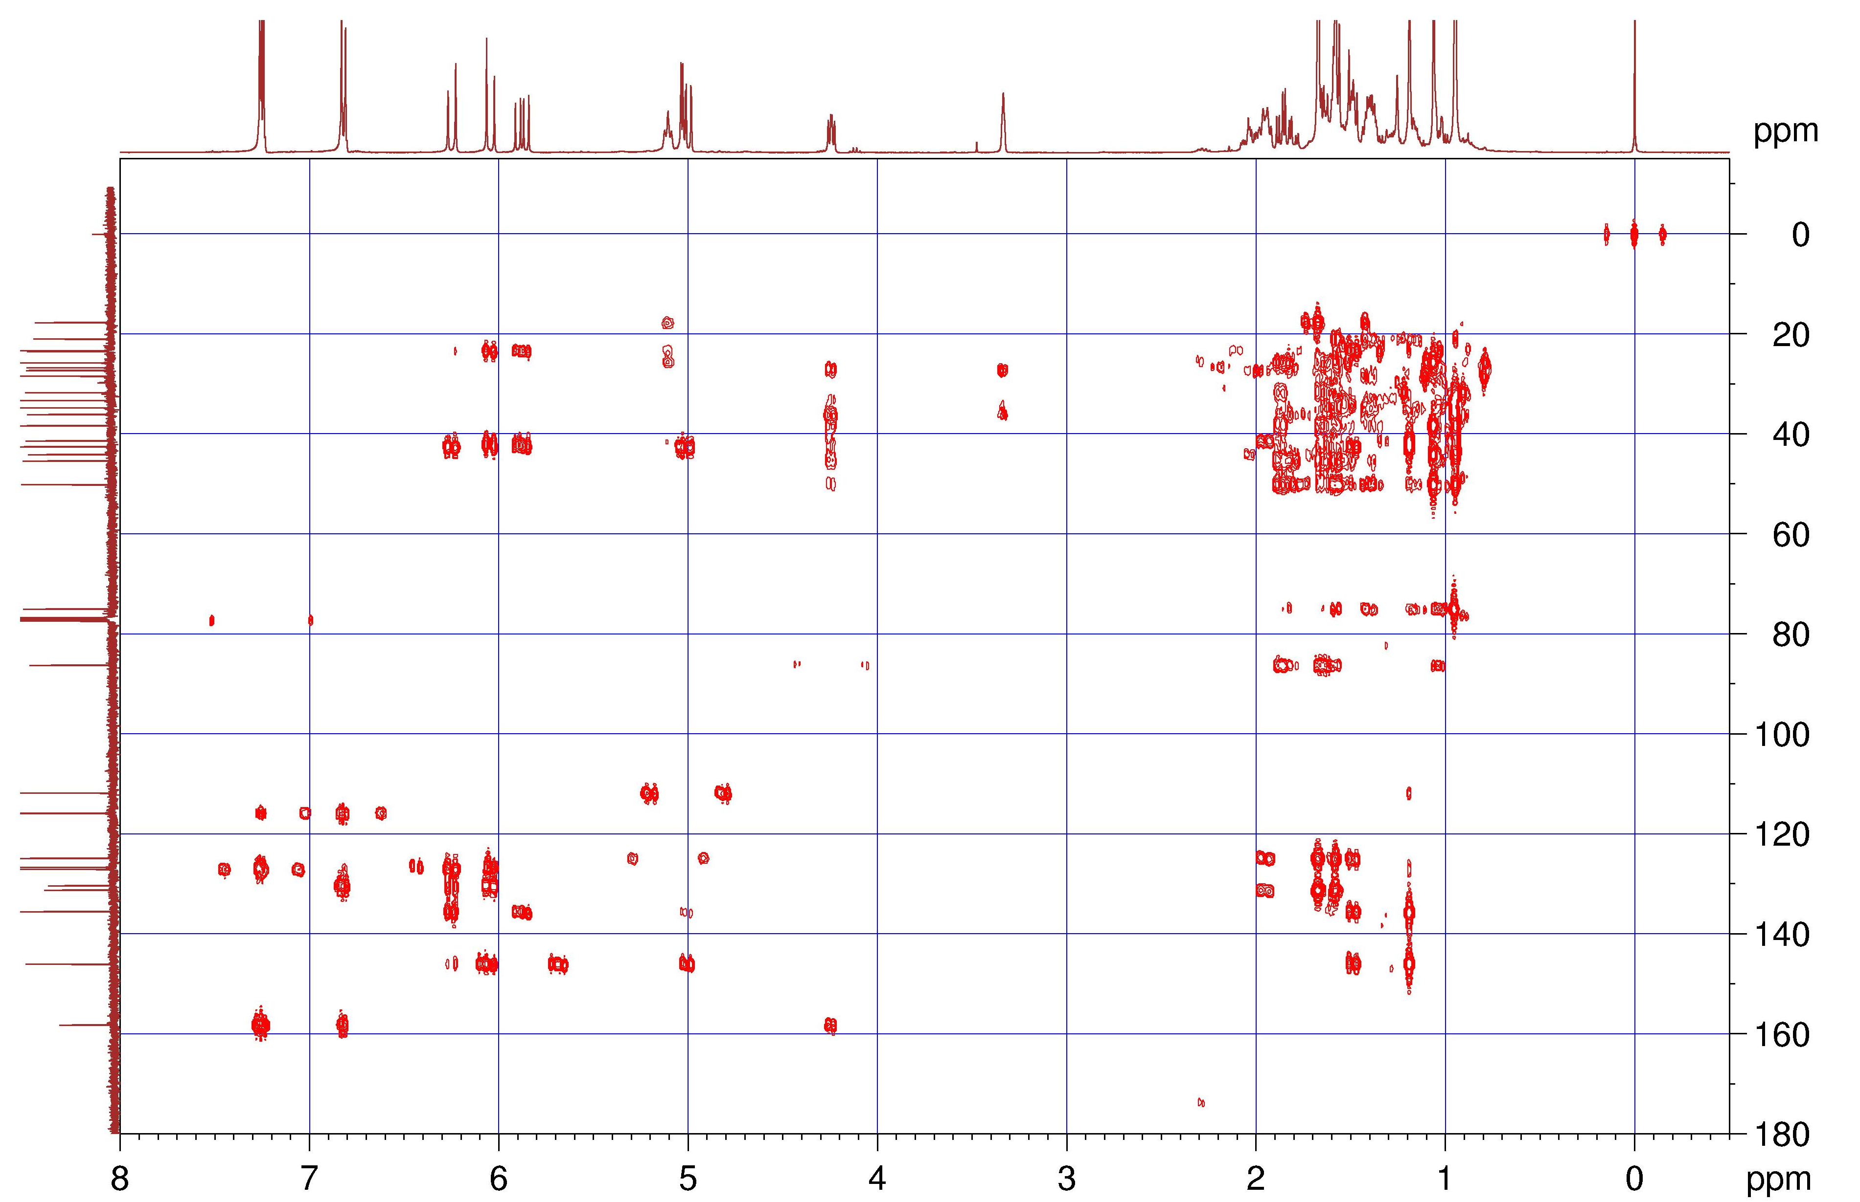
Figure S86. The HMBC spectrum of 11.
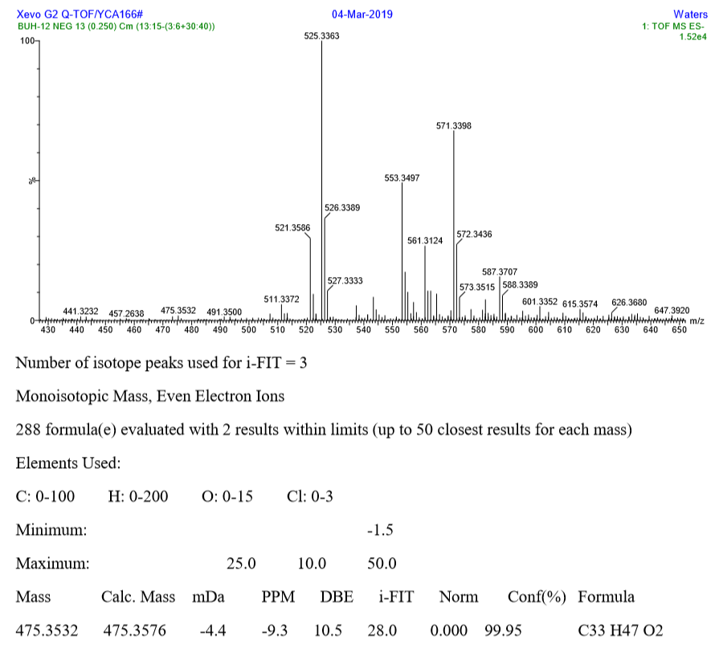
Figure S87. The HRESIMS spectrum of 12.

Figure S88. The IR spectrum of 12.
Figure S89. The ¹H NMR spectrum of 12 in CDCl₃ (400 MHz).

Figure S90. The ¹³C NMR spectrum of 12 in CDCl₃ (100 MHz).

Figure S91. The ¹H–¹H COSY spectrum of 12.

Figure S92. The HSQC spectrum of 12.

Figure S93. The HMBC spectrum of 12.

LC/MS analysis for 1–3, 6–9, and 13–17
1. LC/MS analysis method
1.1 UFLC method
A Shimazu Nexera X2 ultra performance liquid chromatograph system was used. Mobile phase: A,2 mM ammonium acetate aqueous solution; B, 50% acetonitrile + 50% methanol (containing 2 mM ammonium acetate); Gradient elution :0–2min, 30–50% B; 2–12min, 50% B;12–15min, 50–81% B; 15–30min, 81% B; 30–31min, 81–82% B; 31–40min ,82% B; 40–42min, 82–85% B; 42–45min, 85–90% B; 45–47 min, 90% B; 47–50min, 90–10% B; Flow rate: 0.4 ml/min; Column temperature: 27 C; Injection volume :2 µL
1.2 MS method
Scanning method: Multiple reaction monitoring (MRM); Parameters setting: Nebulizing Gas Flow: 3.0 L/min, Drying Gas Flow: 10.0 L/min, Heating Gas Flow:10.0 L/min, InterfaceTemperature:300 ºC, DL Temperature:250 ºC, Interface Voltage: –3.0 kV, Detector voltage: 1.80 KV. Precursor ion species; precursor ion; product ion; quadrupole 1 pre-rod bias (Q1); collision energy (CE); quadrupole 3 pre-rod bias (Q3); dwell time (DT) and retention time (RT) for compounds 1–3, 6–9, and 13–17 see table S1.
Table S1 Retention time and MRM parameter for compounds 1–3, 6–9, and 13–17
Analyte | Precursor  ion species | precursor  ion | Product  ion | Q1  (V) | CE  (V) | Q3  (V) | DT  (msec) | RT  (min)
1 | [M-H]– | 535.55 | 253.1 | 30.0 | 54.0 | 26.0 | 87.0 | 30.537
2 | [M-H]– | 509.7 | 426.25 | 36.0 | 33.0 | 20.0 | 87.0 | 44.576
3 | [M-H]– | 509.6 | 172.25 | 28.0 | 39.0 | 17.0 | 87.0 | 36.362
6 | [M-H]– | 557.65 | 525.3 | 32.0 | 28.0 | 27.0 | 87.0 | 35.489
7 | [M-H]– | 557.65 | 172.2 | 32.0 | 28.0 | 27.0 | 87.0 | 39.05
8 | [M-H]– | 525.7 | 172.25 | 28.0 | 39.0 | 30.0 | 87.0 | 45.889
9 | [M-H]– | 525.7 | 256.3 | 28.0 | 39.0 | 30.0 | 87.0 | 45.693
11 | [M-H]– | 475.4 | 62.37 | -18.0 | -52.0 | -28.0 | 107.0 | 2.22
13 | [M-H]– | 541.7 | 272.25 | 22.0 | 25.0 | 19.0 | 87.0 | 37.453
14 | [M-H]– | 541.7 | 188.1 | 22.0 | 25.0 | 19.0 | 87.0 | 36.348
15 | [M-H]– | 527.65 | 172.2 | 40.0 | 40.0 | 29.0 | 87.0 | 25.498
16 | [M-H]– | 527.65 | 172.2 | 30.0 | 26.0 | 26.0 | 87.0 | 24.848
17 | [M-H]– | 527.65 | 271.3 | 30.0 | 26.0 | 26.0 | 87.0 | 30.093
2. Sample preparation
2.1 Preparation of reference solution
These compounds were accurately weighed and dissolved in methanol to prepare 1.0mg/mL reserve solution. Then above reserve solutions were taken appropriately to prepare mix standard solution.
2.2 Preparation of test solution
In order to exclude the effect of temperature in the extraction process, 1 g of Psoraleae Fructus was extracted by ultrasonics with 20 ml MeOH for 30 min. Then supernatant was filtered through 0.22 μm membranes for LC/MS analysis.
3. LC/MS analysis for reference solution and test solution
Compounds 1–3, 6–9, and 13–17 could be detected from ultrasonic extraction of Psoraleae Fructus by LC/MS analysis (Fig. S94).

Fig. S94 MRM chromatogram (A: reference solution, B: test solution) for compounds 1–3, 6–9, and 13–17

Table S2 ¹H NMR data of known compounds
Position | 13 | 14 | 15 | 16 | 17
1
2 | 7.17 (d, 8.6) | 7.17 (d, 8.4) | 7.13 (d, 8.4) | 6.87 (br s) | 6.90 (d,1.7)
3 | 6.61 (d, 8.6) | 6.64 (d, 8.4) | 6.53 (d, 8.4)
4
5 | 6.61 (d, 8.6) | 6.64 (d, 8.4) | 6.53 (d, 8.4) | 6.90 (d, 8.9) | 6.90 (d, 8.7)
6 | 7.17 (d, 8.6) | 7.17 (d, 8.4) | 7.13 (d, 8.4) | 6.87 (d, 8.9) | 6.87 (d, 8.7)
7 | 6.23 (d, 16.2) | 6.23 (d, 16.2) | 6.22 (d, 16.2) | 6.19 (d, 16.2) | 6.19 (d, 16.2)
8 | 6.06 (d, 16.2) | 6.06 (d, 16.2) | 6.04 (d, 16.2) | 6.05 (d, 16.2) | 6.04 (d, 16.2)
9
10 | 1.48 (m) | 1.47 (m) | 1.47 (m) | 1.46 (m) | 1.46 (m)
11 | 1.94 (m) | 1.94 (m) | 1.93 (m) | 1.93 (m) | 1.93 (m)
12 | 5.10 (br t, 7.0) | 5.09 (br t, 7.2) | 5.09 (br t, 7.2) | 5.09 (br t) | 5.08 (br t)
13
14 | 1.58 (s) | 1.57 (s) | 1.57 (s) | 1.57 (s) | 1.57 (s)
15 | 1.67 (s) | 1.66 (s) | 1.66 (s) | 1.66 (s) | 1.66 (s)
16 | 1.18 (s) | 1.18 (s) | 1.17 (s) | 1.17 (s) | 1.17 (s)
17 | 5.85 (dd, 17.2, 10.4) | 5.86 (dd, 17.4, 10.8) | 5.85 (dd, 17.4, 10.8) | 5.85 (dd, 17.7, 10.7) | 5.85 (dd, 17.7, 10.7)
18a | 5.02 (dd, 17.2, 1.3) | 5.00 (br d, 17.4) | 4.97 (br d, 17.4) | 5.01 (dd, 10.7, 1.3) | 5.02 (dd, 10.7, 1.3)
18b | 5.00 (dd, 10.4, 1.3) | 5.02 (br d, 10.8) | 5.01 (br d, 10.8) | 4.98 (dd, 17.7, 1.3) | 4.99 (dd, 17.7, 1.3)
1′
2′ | 7.24 (d, 8.6) | 7.03 (d, 7.6) | 7.14 (d, 7.8) | 6.87（br s) | 6.87 (br s)
3′ | 6.71 (d, 8.6) | 6.62 (d, 7.6) | 6.67 (d, 7.8)
4′
5′ | 6.71 (d, 8.6) | 6.62 (d, 7.6) | 6.67 (d, 7.8) | 6.73 (br s) | 6.73 (br s)
6′ | 7.24 (d, 8.6) | 7.03 (d, 7.6) | 7.14 (d, 7.8) | 6.71 (br s) | 6.73 (br s)
7′ | 3.03 (dd, 11.7, 1.9) | 2.62 (t, 10.8) | 2.92 (br d, 11.8) | 5.12 (d, 2.5) | 5.07 (d, 2.3)
8′ | 3.28 (br s) | 3.41 (d, 10.8) | 3.33 (br s) | 4.14 (d, 2.5) | 4.13 (d, 2.3)
9′
10′a | 2.07 (m) | 1.90 (m) | 1.82 (td, 14.4, 3.2) | 1.46 (m) | 1.46 (m)
10′b | 1.44 (m) | 1.49 (m) | 1.62, overlapped | 1.46 (m) | 1.46 (m)
11′a | 2.08 (m) | 1.97 (m) | 1.94 (m) | 1.49 (m) | 1.18 (m)
11′b | 1.68 (m) | 1.65 (m) | 1.48 (m) | 1.84 (m) | 1.94 (m)
12′ | 2.62 (td, 11.7, 4.0) | 2.21 (td, 11.7, 3.4) | 2.58 (td, 11.8, 3.5) | 5.04 (br t) | 5.01 (br t)
13′
14′ | 0.89 (s) | 1.05 (s) | 1.07 (s) | 1.55 (s) | 1.57 (s)
15′ | 1.07 (s) | 0.75(s) | 0.83 (s) | 1.66 (s) | 1.66 (s)
16′ | 1.16 (s) | 1.17 (s) | 1.04 (s) | 0.97 (s) | 0.70 (s)
17′ | 5.87 (dd, 17.2, 10.4) | 6.27 (dd, 17.6, 11.1) | 5.90 (dd, 17.8, 11.1) | 5.62 (dd, 17.6, 10.9) | 5.67 (dd, 17.5, 10.9)
18′a | 5.09 (dd, 17.2, 1.3) | 5.19 (br d, 17.6) | 5.17 (br d, 11.1) | 4.75 (dd, 10.9, 1.3) | 5.01 (dd, 10.9, 1.3)
18′b | 5.11 (dd, 10.4, 1.3) | 5.26 (br d, 11.1) | 5.11 (br d, 17.8) | 4.70 (dd, 17.6, 1.3) | 4.90 (dd, 17.5, 1.3)

Table S3 ¹³C NMR data of known compounds
Position | 13 | 14 | 15 | 16 | 17
1 | 132.4, C | 132.5, C | 132.3, C | 132.5, C | 132.5, C
2 | 126.4, CH | 126.4, CH | 126.3, CH | 114.4, CH | 114.5, CH
3 | 123.5, CH | 123.4, CH | 123.5, CH | 143.5, C | 143.6, C
4 | 154.2, C | 154.0, C | 154.6, C | 143.1, C | 143.0, C
5 | 123.5, CH | 123.4, CH | 123.5, CH | 117.0, CH | 117.0, CH
6 | 126.4, CH | 126.4, CH | 126.3, CH | 118.9, CH | 118.9, CH
7 | 126.6, CH | 126.5, CH | 126.6, CH | 126.5, CH | 126.5, CH
8 | 136.3, CH | 136.4, CH | 136.3, CH | 136.4, CH | 136.5, CH
9 | 42.5, C | 42.5, C | 42.5, C | 42.5, C | 42.5, C
10 | 41.2, CH₂ | 41.3, CH₂ | 41.1, CH₂ | 41.2, CH₂ | 41.2, CH₂
11 | 23.2, CH₂ | 23.2, CH₂ | 23.3, CH₂ | 23.2, CH₂ | 23.2, CH₂
12 | 124.7, CH | 124.8, CH | 124.8, CH | 124.8, CH | 124.8, CH
13 | 131.3, C | 131.3, C | 131.2, C | 131.3, C | 131.3, C
14 | 17.6, CH₃ | 17.6, CH₃ | 17.6, CH₃ | 17.6, CH₃ | 17.6, CH₃
15 | 25.7, CH₃ | 25.7, CH₃ | 25.7, CH₃ | 25.7, CH₃ | 25.7, CH₃
16 | 23.3, CH₃ | 23.3, CH₃ | 23.4, CH₃ | 23.3, CH₃ | 23.4, CH₃
17 | 145.9, CH | 145.8, CH | 145.8, CH | 145.9, CH | 145.8, CH
18 | 111.9, CH₂ | 111.9, CH₂ | 111.9, CH₂ | 111.9, CH₂ | 111.9, CH₂
1′ | 136.2, C | 133.4, C | 135.9, C | 130.8, C | 131.1, C
2′ | 131.1, CH | 126.5, CH | 130.6, CH | 115.9, CH | 115.8, CH
3′ | 114.6, CH | 115.0, CH | 115.2, CH | 142.6, C | 142.7, C
4′ | 154.0, C | 155.2, C | 154.1, C | 144.1, C | 144.0, C
5′ | 114.6, CH | 115.0, CH | 115.2, CH | 114.8, CH | 114.8, CH
6′ | 131.1, CH | 126.5, CH | 130.6, CH | 122.5, CH | 122.4, CH
7′ | 45.3, CH | 49.6, CH | 46.7, CH | 76.1, CH | 76.3, CH
8′ | 78.2, CH | 82.2, CH | 79.6, CH | 82.0, CH | 81.8, CH
9′ | 43.3, C | 41.4, C | 41.2, C | 42.2, C | 42.6, C
10 | 27.8, CH₂ | 36.4, CH₂ | 30.1, CH₂ | 38.0, CH₂ | 39.2, CH₂
11′ | 22.6, CH₂ | 22.8, CH₂ | 23.2, CH₂ | 22.3, CH₂ | 22.2, CH₂
12′ | 43.3, CH | 51.1, CH | 42.8, CH | 124.4, CH | 124.4, CH
13′ | 83.4, C | 83.2, C | 83.7, C | 131.6, C | 131.6, C
14′ | 26.1, CH₃ | 24.5, CH₃ | 25.3, CH₃ | 17.5, CH₃ | 17.5, CH₃
15′ | 25.6, CH₃ | 26.3, CH₃ | 25.6, CH₃ | 25.6, CH₃ | 25.7, CH₃
16′ | 22.1, CH₃ | 27.2, CH₃ | 26.9, CH₃ | 18.7, CH₃ | 16.8, CH₃
17′ | 146.9, CH | 140.4, CH | 144.8, CH | 141.4, CH | 141.4, CH
18′ | 113.2, CH₂ | 115.0, CH₂ | 113.3, CH₂ | 113.0, CH₂ | 115.0, CH₂

