Online Resource
A tough nut to crack: multiple indirect pieces of evidence show a temporally and spatially complex invasion process of genus Carnicus in Argentine Patagonia
Biological Invasions
Berenice Trovant, Irina C. Silva, Ivanna H. Tomasco
Facultad de Ciencias, Universidad de La República, Iguá 4225, 11300 Montevideo, Uruguay, ivanna@fcien.edu.uy
Online Resource 2
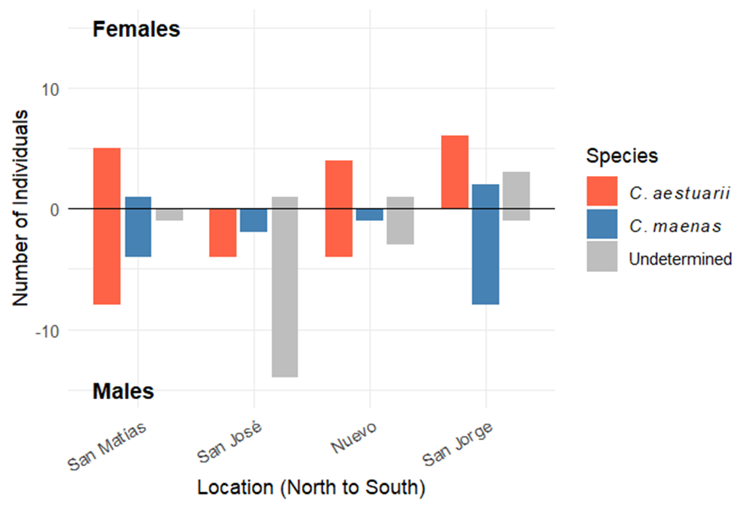
Figure EMS2. Distribution of Carcinus spp. individuals classified by carapace width-to-length ratio (CW/CL) across sampling locations (north to south: Golfo San Matías, Golfo San José, Golfo Nuevo, and Golfo San Jorge).

