Online Resource
A tough nut to crack: multiple indirect pieces of evidence show a temporally and spatially complex invasion process of genus Carnicus in Argentine Patagonia
Biological Invasions
Berenice Trovant, Irina C. Silva, Ivanna H. Tomasco
Facultad de Ciencias, Universidad de La República, Iguá 4225, 11300 Montevideo, Uruguay, ivanna@fcien.edu.uy
Online Resource 1
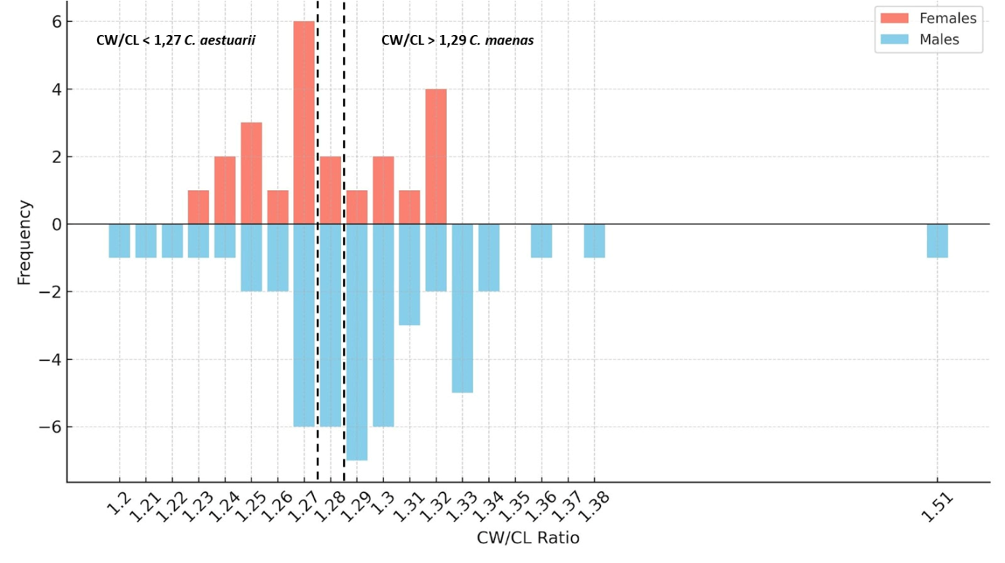
Figure ESM1. Frequency distribution of carapace width-to-length ratio (CW/CL) for C. aestuarii and C. maenas. Vertical dashed lines indicate diagnostic thresholds for species discrimination.

