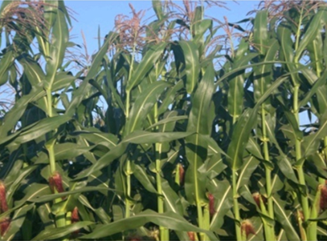
Image of the field experiment depicting the tasseling and silking stages, and ear leaf under sandy soil conditions.

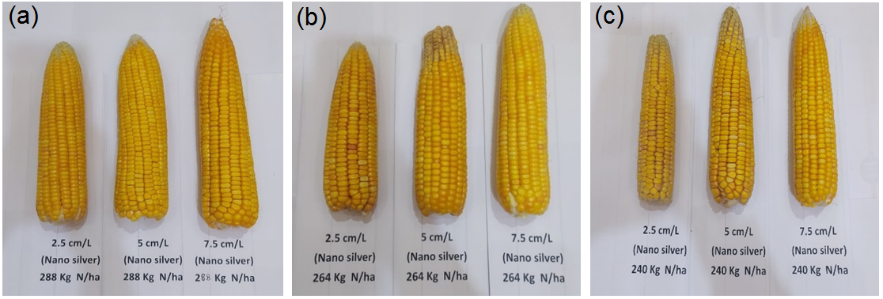
The impact of different N fertilizer rates combined with Ag NPs rates on the shape and size of corn ears. The best size and shape were observed with 288 kg N and 7.5 cm/L of Ag NPs, with minimal differences between 264 kg N with 7.5 cm/L Ag NPs and 288 kg N with three rates of Ag NPs.

