Supplementary material
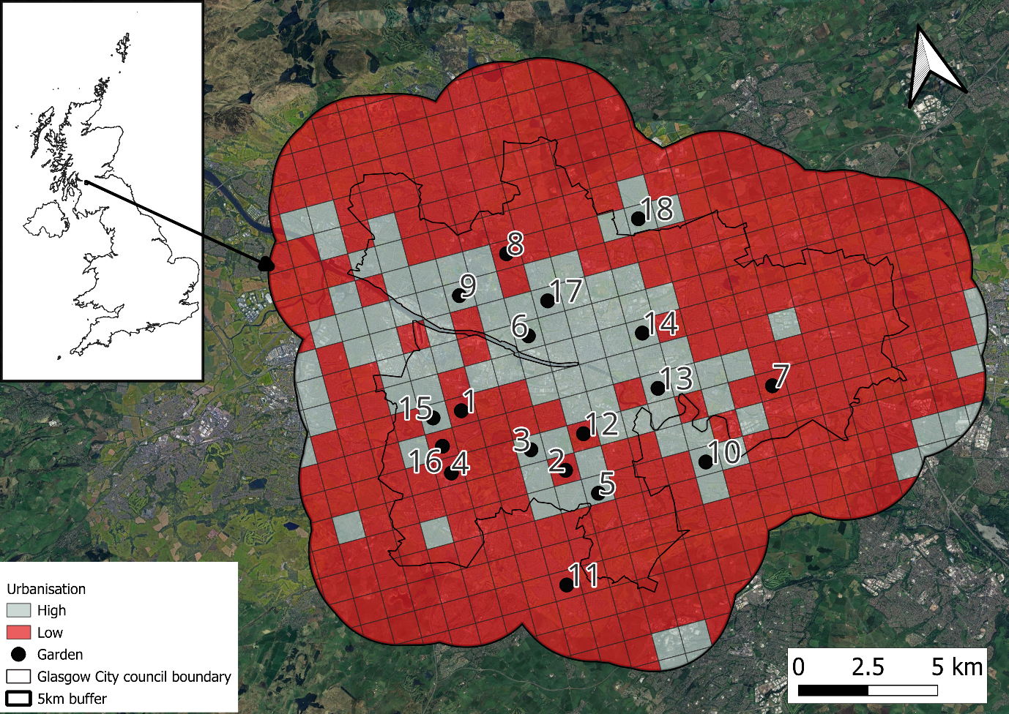
Figure S 1: A map showing the locations of private gardens sampled in the study. Gardens were located across Glasgow City Council including a 5km buffer of the council boundary. Gardens were at least 1km apart from each other and stratified across high(grey) and low (red) urbanisation categories.

Flower visitor | Abundance
Bombus pascuorum | 256
Bombus lucorum.agg. | 174
Episyrphus balteatus | 82
Apis mellifera | 73
Bombus hypnorum | 47
Platycheirus albimanus | 46
Bombus pratorum | 37
Bombus lapidarius | 35
Eristalis tenax | 23
Syrphus ribesii | 23
Syritta pipiens | 22
Eupeodes corollae | 19
Melanostoma scalare | 18
Bombus hortorum | 16
Megachilidae centuncularis | 11
Colletes daviesanus | 9
Erisatlis pertinax | 8
Helophilus pendulus | 8
Syrphus torvus | 8
Syrphus vitripennis | 8
Lasioglossum smeathmanellum | 7
Osmia bicornis | 7
Meliscaeva cinctella | 7
Eupeodes luniger | 6
Lasioglossun fratellum | 5
Syrphus rectus | 5
Meredon equestris | 4
Myathropa florea | 4
Lasioglossum albipes | 3
Lasioglossum leucopus | 3
Sphegina verecunda | 3
Syrphus rectus/vitripennis | 3
Pieris rapae | 3
Lasioglossum calceatum | 2
Baccha elongata | 2
Chrysogaster solstitialis | 2
Dasysryphus albostriatus | 2
Dasysrphus tricinctus | 2
Platycheirus scutatus | 2
Sphaerophoria scripta | 2
Pieris brassicae | 2
Vanessa atalanta | 2
Andrena subopaca | 1
Anthophora furcata | 1
Hylaeus hyalinatus | 1
Megachilidae willughbiella | 1
Sphecodes geoffrellus | 1
Cheilosia bergenstammi | 1
Epistrophe grossulariae | 1
Eristalis horticola | 1
Meligramma guttatum | 1
Meliscaeva auricollis | 1
Melanostoma mellinum | 1
Xylota segnis | 1
Aglais urticae | 1
Table S 1: A list of flower visitor species recorded in private gardens from June until September. The table shows the total abundance of each flower visitor across the study.
Plants | Plant origin | Floral Abundance
Bellis perennis | Native | 1202
Geranium | Native | 407
Lavandula | Non native | 386
Brassica rapa | Native | 280
Lobelia | Native | 184
Salvia | Native | 164
Epilobium | Native | 161
Hydrangea | Non native | 130
Aster | Non native | 129
Ranunculus | Native | 125
Rhinanthus | Native | 118
Trifolium repens | Native | 116
Cymbalaria murialis | Non native | 112
Jacobaea vulgaris | Native | 101
Fallopia baldschuanica | Non native | 97
Jasminum | Non native | 96
Buddleja | Non native | 95
Alchemilla mollis | Native | 92
Mentha | Native | 92
Pelargonium | Non native | 89
Phlox | Non native | 82
Crocosmia | Non native | 77
Origanum vulgare | Native | 75
Eupatorium | Native | 72
Lysimachia vulgaris | Native | 72
Eruca vesicaria | Non native | 71
Ligustrum ovalifolium | Native | 71
Papaver | Native | 71
Digitalis purpurea | Native | 69
Cotoneaster | Native | 65
Campanula | Native | 64
Hieracium | Native | 63
Petunia | Non native | 61
Rosa | Native | 59
Philadelpheus | Non native | 55
Begonia | Non native | 51
Hypericum | Native | 49
Spiraea | Non native | 48
Myosotis arvensis | Native | 43
Prunella vulgaris | Native | 42
Ocimum basilicum | Non native | 39
Borago officinalis | Non native | 38
Pilosella aurantiaca | Native | 38
Erica | Native | 36
Veronica | Native | 35
Fragaria | Native | 32
Geum urbanum | Native | 32
Lupinus | Non native | 32
Leucanthemum vulgare | Native | 31
Clematis | Native | 30
Linaria vulgaris | Native | 30
Eryngium | Native | 27
Impatiens walleriana | Native | 27
Lobularia | Non native | 27
Primula | Native | 27
Raphanus | Native | 26
Silene dioica | Native | 25
Malva | Native | 24
Auberita | Non native | 23
Erysimum | Non native | 23
Fuschia | Non native | 23
Centaurea cyanus | Native | 22
Matthiola | Native | 22
Sambucus | Native | 22
Sedum | Native | 22
Lotus corniculatus | Native | 21
Petrosedum | Native | 21
Solanum lycopersicum | Native | 21
Allium | Native | 20
Astilbe | Non native | 20
Rhododendron | Non native | 19
Bistorta | Non native | 18
Foeniculum vulgare | Non native | 18
Symphyotrichum | Non native | 18
Tropaeolum majus | Non native | 17
Oenothera biennis | Non native | 16
Oxalis acetosella | Native | 16
Rubus | Native | 16
Silene coronaria | Native | 16
Centaurea nigra | Native | 15
Prunella | Native | 15
Achillea millefolium | Native | 14
Antirrhinum majus | Non native | 14
Scabiosa | Native | 13
Delphinium | Non native | 12
Echinops | Non native | 12
Alcea rosea | Non native | 11
Calendula officinalis | Non native | 11
Phedimus | Non native | 11
Libertia grandiflora | Non native | 10
Thymus vulgaris | Native | 10
Aqueliga | Native | 9
Chamaenerion | Native | 9
Daucus carota | Native | 9
Sonchus | Native | 9
Viola tricolor | Native | 9
Chamaemelum | Native | 8
Hedera | Native | 8
Iberis | Native | 8
Anemone | Native | 7
Arabis | Non native | 7
Taraxacum | Native | 7
Celosia argentea | Non native | 6
Helianthus annuus | Non native | 6
Solidago | Native | 6
Tagets patula | Non native | 6
Hylotelephium | Unknown | 5
Lythrum salicaria | Native | 5
Phacelia tanacetifolia | Non native | 5
Stellaria | Native | 5
Cyclamen | Non native | 4
Leycesteria formosa | Non native | 4
Cephalaria gigantea | Non native | 3
Fagopyrum | Non native | 3
Lonicera | Native | 3
Orchis | Native | 3
Trifolium pratenses | Native | 3
Viburnum | Native | 3
Alstroemeria | Non native | 2
Armeria maritima | Native | 2
Lapsana communis | Native | 2
Nepeta | Native | 2
Betonica | Unknown | 1
Calystegia sepium | Native | 1
Cucurbita pepo | Non native | 1
Delosperma | Non native | 1
Geum rivale | Native | 1
Table S 2: A list of plants observed within gardens from June until September. The table shows the total floral abundance recorded for each plant as well as its origin status for Great Britain (Native or Non-native). Plants were identified to the lowest taxonomic level (genus or species).
Plants | Flower visitor | Observed | Null | SES | Native_NonNative | Month
Allium | B..pascuorum | 2 | 0.29 | 3.431 | Native | September
Anemone | S..ribesii | 3 | 0.1 | 8.700 | Native | September
Bistorta | B..pascuorum | 7 | 1.38 | 4.427 | Non native | September
Chamaenerion | B..pascuorum | 4 | 0.11 | 11.272 | Native | September
Fragaria | B..pascuorum | 2 | 0.03 | 11.490 | Native | September
Geranium | E..balteatus | 4 | 0.84 | 3.669 | Native | September
Lavandula | B..pascuorum | 24 | 3.92 | 10.231 | Non native | September
Papaver | B..lucorum.agg. | 2 | 0.05 | 8.902 | Native | September
Papaver | E..balteatus | 2 | 0.14 | 4.357 | Native | September
Pelargonium | C..solstitialis | 2 | 0.14 | 4.939 | Non native | September
Fallopia baldschuanica | E..pertinax | 2 | 0.25 | 3.500 | Non native | September
Fallopia baldschuanica | S..rectus | 2 | 0.09 | 6.641 | Non native | September
Fallopia baldschuanica | A..mellifera | 5 | 0.3 | 8.141 | Non native | September
Scabiosa | B..pascuorum | 3 | 0.1 | 8.700 | Native | September
Sonchus | S..ribesii | 3 | 0.07 | 11.426 | Native | September
Symphyotrichum | E..tenax | 4 | 0.5 | 5.080 | Non native | September
Symphyotrichum | B..pascuorum | 6 | 1.98 | 3.224 | Non native | September
Allium | B..pascuorum | 3 | 0.56 | 3.634 | Native | August
Bistorta | B..pascuorum | 2 | 0.28 | 3.482 | Non native | August
Bistorta | A..mellifera | 2 | 0.09 | 5.953 | Non native | August
Buddleja | A..mellifera | 2 | 0.12 | 5.756 | Non native | August
Chamaenerion | A..mellifera | 6 | 0.11 | 18.730 | Native | August
Chamaenerion | B..lucorum.agg | 3 | 0.17 | 7.015 | Native | August
Echinops | S..vitripennis | 2 | 0 | NA | Non native | August
Echinops | B..pascuorum | 2 | 0.08 | 6.244 | Non native | August
Echinops | A..mellifera | 2 | 0.04 | 9.952 | Non native | August
Fuschia | B..pascuorum | 3 | 0.54 | 3.247 | Non native | August
Geranium | M..scalare | 3 | 0.4 | 4.197 | Native | August
Lavandula | B..lapidarius | 5 | 0.88 | 4.356 | Non native | August
Lavandula | B..pascuorum | 15 | 7.43 | 2.900 | Non native | August
Lavandula | B..lucorum.agg | 17 | 2.67 | 8.841 | Non native | August
Matthiola | B..pascuorum | 2 | 0.15 | 5.155 | Native | August
Mentha | S..pipiens | 3 | 0.36 | 4.715 | Native | August
Mentha | P..albimanus | 9 | 0.46 | 14.000 | Native | August
Reynoutria | M..cinctella | 2 | 0.26 | 3.591 | Non native | August
Reynoutria | S..verecunda | 2 | 0.08 | 7.042 | Non native | August
Scabiosa | B..pascuorum | 2 | 0.03 | 11.490 | Native | August
Solidago | C..daviesanus | 4 | 0 | NA | Native | August
Solidago | S..pipiens | 2 | 0.05 | 8.902 | Native | August
Aqueliga | B..lucorum.agg | 2 | 0.31 | 3.477 | Native | July
Aqueliga | B..hypnorum | 2 | 0.22 | 4.046 | Native | July
Campanula | B..lapidarius | 2 | 0.08 | 7.042 | Native | July
Cotoneaster | B..hypnorum | 4 | 1.33 | 2.444 | Native | July
Delphinium | B..lucorum.agg | 2 | 0.31 | 3.213 | Non native | July
Epilobium | P..albimanus | 2 | 0.12 | 5.278 | Native | July
Epilobium | E..corollae | 2 | 0.2 | 4.221 | Native | July
Geranium | B..pascuorum | 8 | 3.09 | 2.641 | Native | July
Geranium | M..equestris | 3 | 0.31 | 5.312 | Native | July
Hieracium | B..lapidarius | 2 | 0.04 | 9.952 | Native | July
Hypericum | B..hypnorum | 6 | 0.24 | 11.641 | Native | July
Papaver | B..lucorum.agg | 9 | 1.53 | 5.859 | Native | July
Papaver | B..hypnorum | 4 | 0.69 | 4.425 | Native | July
Ranunculus | B..pratorum | 9 | 0.81 | 8.174 | Native | July
Rhododendron | B..pratorum | 3 | 0.31 | 4.377 | Non native | July
Rhododendron | O..bicornis | 2 | 0.07 | 7.526 | Non native | July
Rhododendron | B..hypnorum | 4 | 0.34 | 6.829 | Non native | July
Rubus | B..hypnorum | 4 | 0.2 | 9.452 | Native | July
Rubus | B..pratorum | 4 | 0.16 | 9.724 | Native | July
Salvia | B..pascuorum | 4 | 0.24 | 7.933 | Native | July
Sambucus | B..hypnorum | 3 | 0.43 | 3.287 | Native | July
Taraxacum | B..lucorum.agg | 2 | 0.19 | 4.319 | Native | July
Aqueliga | B..hypnorum | 2 | 0.11 | 5.477 | Native | June
Campanula | B..lapidarius | 2 | 0.02 | 14.072 | Native | June
Epilobium | P..albimanus | 2 | 0.17 | 4.279 | Native | June
Epilobium | E..corollae | 2 | 0.22 | 3.850 | Native | June
Geranium | B..pascuorum | 8 | 2.81 | 3.270 | Native | June
Geranium | M..equestris | 3 | 0.26 | 4.878 | Native | June
Hieracium | B..lapidarius | 2 | 0.03 | 11.490 | Native | June
Hypericum | B..hypnorum | 6 | 0.27 | 12.236 | Native | June
Lupinus | B..lucorum.agg | 4 | 0.96 | 2.810 | Non native | June
Papaver | B..lucorum.agg | 9 | 1.12 | 7.201 | Native | June
Papaver | B..hypnorum | 4 | 0.7 | 4.011 | Native | June
Ranunculus | B..pratorum | 9 | 1.3 | 7.144 | Native | June
Rhododendron | B..pratorum | 3 | 0.35 | 4.033 | Non native | June
Rhododendron | O..bicornis | 2 | 0.04 | 9.952 | Non native | June
Rhododendron | B..hypnorum | 4 | 0.4 | 5.811 | Non native | June
Rubus | B..hypnorum | 4 | 0.23 | 8.914 | Native | June
Rubus | B..pratorum | 4 | 0.17 | 9.494 | Native | June
Salvia | B..lucorum.agg | 2 | 0.37 | 2.996 | Native | June
Salvia | B..pascuorum | 4 | 0.34 | 6.600 | Native | June
Sambucus | B..hypnorum | 3 | 0.5 | 3.354 | Native | June
Taraxacum | B..lucorum.agg | 2 | 0.19 | 4.319 | Native | June
Table S 3: Results from the null model analysis in the econullnetr package, showing the plants species that certain flower visitor species interacted with more than expected based on chance whilst accounting for the floral abundance of each plant. Here networks from each garden were grouped together but separated by month. The observed value shows the number of flower visitors observed visiting the plant, and the expected value is the number of flower visits expected to visit the plant based on its floral abundance. SES is the standard error values with the plant origin (Native or Non-native) and month of the observation shown in the table.
Response | Predictor | DF | Chi Square | P values
Flower visitor interactions
Number of flower visits | Month  Floral richness  Month*Plant origin  Plant Origin* Floral richness  Plant Origin*Floral abundance  Month*Floral richness | 1  1  1  1  1  1 | 41.098  27.636  13.469  8.554  27.475  21.61 | <0.001  <0.001  <0.001  0.003  <0.001  <0.001
Flower visitor richness | Floral richness  Floral abundance/m² *origin  Floral abundance/m²*I(Month) | 1  1  1 | 30.293  4.784  10.875 | <0.001  0.029  <0.001
Number of flower visits per plant | I(Month^2)  Species floral abundance  Month* Plant origin | 1  1  1 | 8.078  34.352  14.441 | 0.004  <0.001  <0.001
Richness of flower visitors per plant | Plant origin  Month  Species floral abundance | 1  1  1 | 3.93  10.102  11.163 | 0.047  0.001  <0.001
Percentage of plant species that received interactions | Plant origin | 1 | 5.851 | 0.016
Floral inventory
Floral abundance | I(Month^2)  Plant origin  I(Month^2) *Origin  Garden size | 1  1  1  1 | 292.05  795.74  13.64  7.065 | <0.001  <0.001  0.001  0.008
Floral richness | Garden size  Plant origin  Month* Plant origin | 1  1  1 | 5.808  43.721  4.794 | 0.016  <0.001  0.002
Percentage of plants interacted with | Plant origin | 1 | 5.851 | 0.016
Network structure
H₂ | I(Month^2) | 1 | 15.81 | <0.001
Interaction evenness | I(Month^2) | 1 | 6.88 | <0.01
NODF | I(Month^2) | 1 | 5.637 | <0.05
Species positions
D' (pollinators) | I(Month^2) | 1 | 4.528 | <0.05
Table S 4: The table shows the explanatory variables selected to explain floral visitation (the number and richness of flower visitors at the community level, the number and richness of flower visitors at the plant species level and the percentage of plants that were interacted with in the community), floral abundance and floral richness in gardens and network structure (H₂, NODF, Interaction evenness and d’ for pollinators). Variables were selected by a backwards step wise selection process. The degrees of freedom (df), chi squared values and p values for which the variables were selected on are displayed in the table.
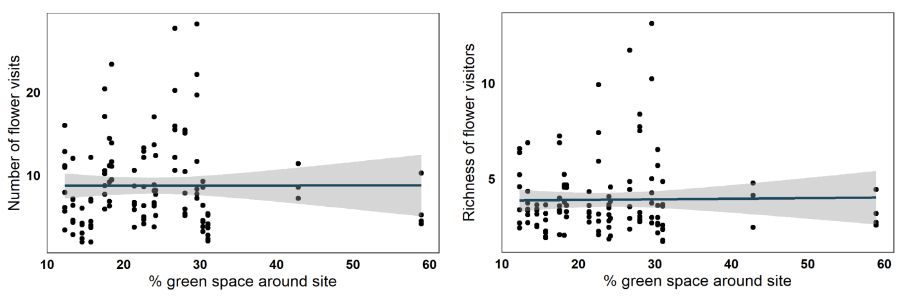
Figure S 2: The amount of green space surrounding a site had no effect on the a) number of floral visits nor b) the richness of flower visitors in the plant-flower visitor networks. Points represent the predicted values of the model output in spp. table 1. The solid line shows the fitted regression with shaded area representing the 95% confidence interval.
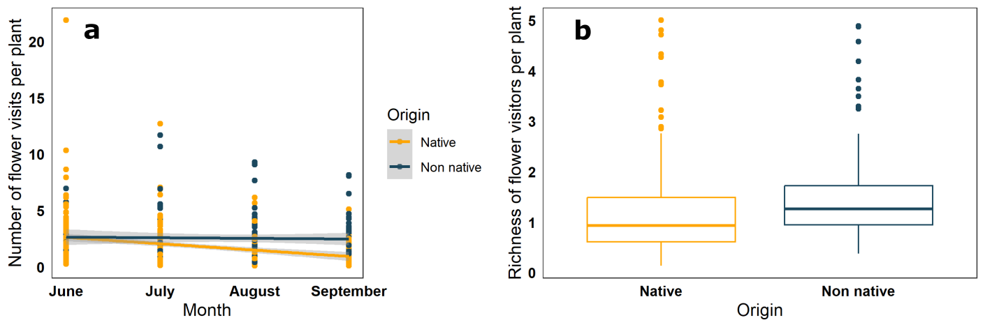
Figure S 3: The graphs show the influence of plant origin (native orange, non-native blue) on a) the number of floral visits to plant species depending on month and b) the richness of flower visits to plant species. Points and lines represent the predictions from the model output in table 1 and the shaded area around the lines of best fit show the 95% confidence intervals.

Model selection of Bombus pascuorum analysis
Response | Predictor | DF | Chi squared | P value
Number of flower visits by B. pascuorum | Month  Month*Origin | 1  1 | 6.691  7.165 | 0.01  0.007
D’ in B.pascuorum | I(Month^2) | 1 | 17.348 | <0.001
Table S 5: The table shows the explanatory variables selected to explain the number of flower visits and species specialisation in Bombus pascuorum. Variables were selected by a backwards step wise selection process. The degrees of freedom (DF), chi squared values and P values for which the variables were selected on are displayed in the table.
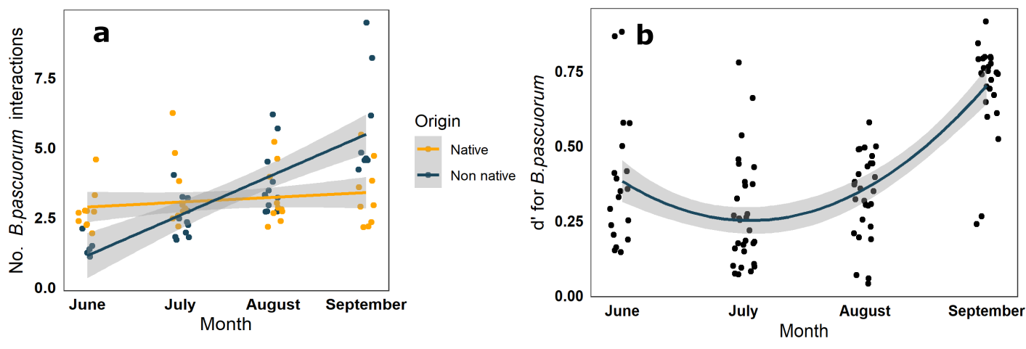
Figure S 4: The graphs detail the interactions of Bombus pascuorum, the most numerous flower visitor in the study (25% of interactions). a) the number of visits to flowers of native (orange) or non-native (blue), by Bombus pascuorum from June to September, here each point represents the predicted total number of flower visits per site per month. b) shows the specialisation scores of B. pascuorum across the four study months. Each point represents the predicted specialisation values calculated for B. pascuorum per site, per month. The solid line shows the fitted regression with shaded area representing the 95% confidence interval.

Model selection of analysis without Bombus pascuorum visits
Response | Predictor | DF | Chi squared | P value
Number of flower visits in the community | Month  Floral richness  Floral abundance m²  Month*Origin  Florala richness*Month  Floral abundance m²*Origin  Floral abundance m² *Month  Floral abundance m² *I(Month^2) | 1  1  1  1  1  1  1  1 | 54.272  63.49  10.668  12.374  5.375  26.259  11.371  4.328 | <0.001  <0.001  <0.001  <0.001  0.02  <0.001  <0.001  0.037
Richness of flower visits in the community | Month  Floral richness  Floral abundance m²  Origin  Floral abundance m²*Origin | 1  1  1  1  1 | 7.305  127.93  4.986  6.932  4.297 | 0.007  <0.001  0.026  0.008  0.038
H2 | Null
Interaction evenness | Null
WNODF | Null
D’ in flower visitors | Null
Table S 6: The table shows the explanatory variables selected to explain floral visitation (the number and richness of flower visitors at the community level and network structure (H₂, NODF, Interaction evenness and d’ for flower visitors) when Bombus pascuorum interactions were removed from networks. Variables were selected by a backwards step wise selection process. The degrees of freedom (DF), chi squared values and P values for which the variables were selected on are displayed in the table.
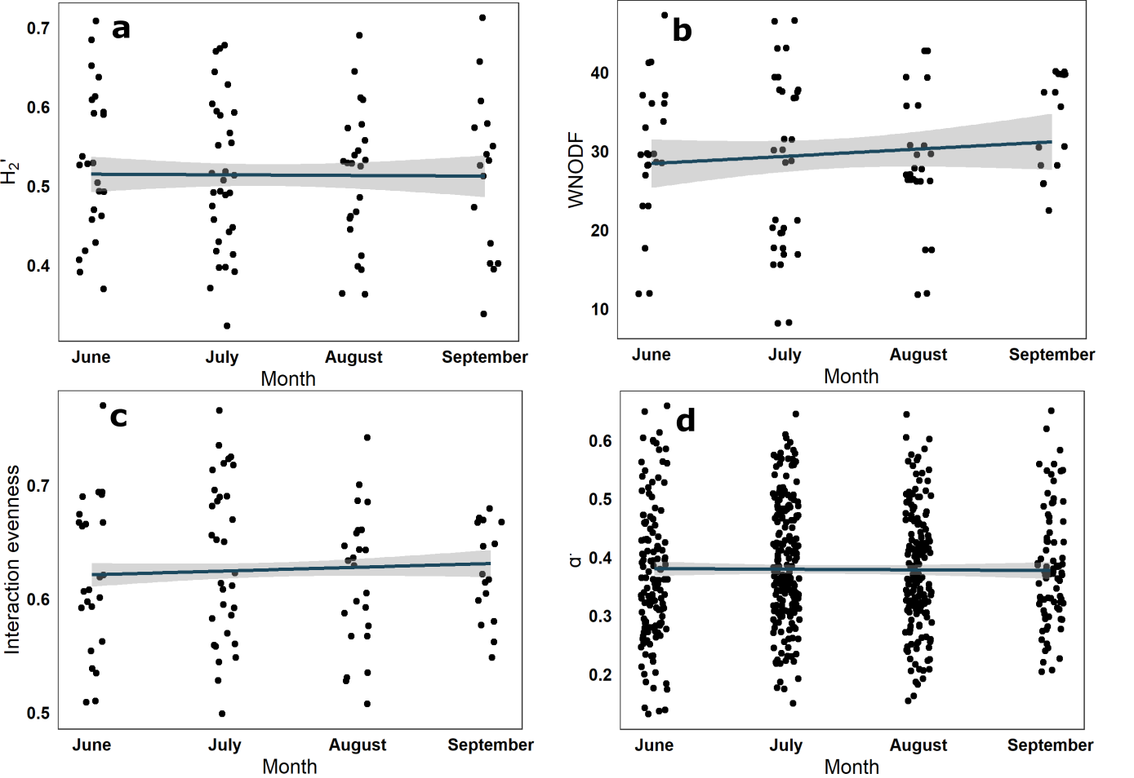
Figure S 5: The graphs show network indices; a) H₂, b) WNODF and c) interaction evenness and d) species specialisation calculated without B. pascuorum flower visits in networks, from June to September. Without B. pascuorum interactions in networks, network indices and flower visitor specialisation did not change across the months of the study. Each point in graphs a-c represents the predicted network values for a per site per month, and graph d shows the predicted specialisation values per species per site per month. The solid line shows the fitted regression with shaded area representing the 95% confidence interval.

