Supplement materials

Simulation Methodology

Two important factors in the PD design are the optical absorption enhanced by the nanostructure and the electric pulse response defined by the electron-hole transport. The optoelectronic simulations consist of two parts: optical simulations that model photon absorption in the material, and electrical simulations that model electron-hole transport. We employ Monte Carlo molecular dynamics simulations to account for electron-hole interactions within complex nanostructured geometries, in particular, to reflect the influence of irregular geometry and dielectric boundaries on charge screening.

1. Optical simulations
The absorption was calculated by a standard FDTD method [1]. The method treats light as an electromagnetic wave and solves Maxwell's equations for the electric (E) and magnetic (H) components of light, which represent Ampere’s and Faraday’s laws.
$$∇×H=ϵ\left(r\right)ϵ_{0}\frac{∂E}{∂t}$$
$$∇×E=-μμ_{0}\frac{∂H}{∂t}$$
(1)

𝜖 is the dielectric permittivity that depends on coordinate r and consists of real and imaginary parts that represent material conductivity and are responsible for the light absorption, μ is the magnetic permeability that is constant in our case, t- time. The dielectric permittivity dependence on the wavelength of the photons is modeled by a set of Lorentz oscillators [1] to match the Ge characteristics for absorption and refractive index.
The absorbed light is calculated by taking the integral Pointing vector that enters the volume and leaves the volume. The incident light was perpendicular to the surface. The Perfect Matching Layers (PML) were used at the boundaries perpendicular to the light incident direction, and periodical boundaries were applied to the other boundaries. A large area of 5x5 unit cells of randomized micro-holes was chosen for FDTD simulation also gives light intensity distribution in the area.

Total absorption (A) in the intrinsic region of the PD is calculated by using the intrinsic layer of PD as the difference between the real parts of the Poynting flux entering the volume ($P_{in}=\operatorname{Re}\left(E×H^{*}\right)$), and the Poynting flux leaving the volume (P_{out}), which is simulated with the FDTD method:
$$A=\frac{P_{in}-P_{out}}{P_{inc}}$$
(2)

where P_{inc} is the Poynting vector of the incident light. The method also gives the light intensity at every point of the photodiode and is related to the number of photons, which is proportional to the generated electron-hole pairs.

2. Electrical simulations
We used the Monte Carlo molecular dynamics method to calculate the pulse response. Recently, several techniques have been used for simulations. Device simulation technology for computer-aided design (TCAD) provides a basis for device modeling by using compact behavioral models and sub-circuits relevant to circuit simulation, realized in commercial packages and drift-diffusion models [1]. As far as we know, for the circuit characteristics in the presence of micro-holes, we need a method that will be based on the physics of the transport that can be described by the Boltzmann transport equation [2] and the statistical distribution of the electrons and holes.

The commercial software Lumerical Charge [3] offers finite element methods to solve the partial differential equations for electron-hole concentration. A recent study [4] showed that electron-hole transport in 3D simulation is a difficult problem, and the finite-element methods could be time-consuming. Instead, the Monte Carlo method offers the microscopic simulation of the motion of individual particles in the presence of external fields and the internal fields related to the crystal lattice and other charges. The method was widely used for molecular dynamics and the thermodynamic properties of liquids and gases. In semiconductors, transport is dominated by random scattering events due to impurities and lattice vibrations, which randomize the momentum and energy of charged particles in time, so the stochastic techniques to model random scattering events are applicable.

The Monte Carlo technique considers random stochastic events in periodic boundary conditions. This is a challenge in programming, and Yamada and Ferry developed a method based on the Ewalt sum, where the Monte-Carlo code was validated against experimental data from the studies [5]. In the Monte-Carlo molecular dynamics method, we generate random electron-hole pairs with a probability proportional to the light intensity that was simulated by FDTD and depends on coordinates. Each hole moves to distance r=r₀ ln(rand) where r₀ is the average distance between scattering events, that is the product of thermal velocity to the average scattering time, and rand is a random number in the interval [0,1]. The carrier current density (j) for every coordinate r is the sum of diffusion, drive, and displacement current.

$$j=j_{diff}+j_{dr}+j_{disp}=$$
$$qD_{e}∇n+qD_{p}∇p+qnμ_{e}E_{s}+qpμ_{p}E_{s}+ϵ_{0}ϵ{∂E_{s}}/{∂t}$$
(3)
Here, q is the electron charge, n and p are the electron and hole concentrations, E_{s} is the electrostatic field produced by the voltage, D_{e} and D_{p} are the electrons and holes diffusion coefficients, 𝜇_{𝑒} and 𝜇_{𝑝} are the electrons and holes mobilities. Thus, the velocity of the electrons and the holes has three components – one is the random scattering that represents diffusion current density 𝑗_{𝑑𝑖𝑓𝑓} that corresponds to diffusion capacitance current in Simon Sze [6]. The second is determined by the electric field applied to the PD that represents drift current density (𝑗_{𝑑𝑟}), and the third is the velocity in the potential charges created by the electron-hole distribution, which represents the displacement current density (𝑗_{𝑑𝑖𝑠𝑝}). The third term is often called the diffusion capacitance current in transistor devices [7]. When an AC signal is applied to forward-biased pn junction devices, AC current flow through the pn junction capacitor. This is called diffusion capacitance current in semiconductor devices. Obviously, this is the same as the displacement current in Eq. (3). The total current (J) is the integral of the current density (j) over the electrode surface. The velocity overall is limited by the thermal velocity.
Instead of solving the finite-element equation for the concentration of electrons and holes in time that has instabilities and is time-consuming, we update the concentration of the carriers by tracking the Monte-Carlo molecular dynamics technique of super-particles that represent a number of individual carriers in this article. The method has a significant numerical stability [5].
The idea is to use large units of charges, superparticles, and update the superparticle locations after successive evaluations of Coulomb forces for all possible binary pairs [5]. The Monte-Carlo molecular dynamics is discussed in detail from the viewpoint of thermodynamics, and it would be of great interest to materials scientists and chemical engineers [5].
The potential (ϕ) distribution of charges and electrical field with the presence of the micro holes is simulated by solving the Poisson equation. The first equation represents net charges, and the second equation represents the electric field. From Maxwell’s equation (div D) = r, we have
$$∇φ=E_{s}$$

$$∆φ=ϵϵ_{0}q\left(n+N-p-P\right)$$
(4)

The boundary conditions are such that the potential is ∇𝜑 = E_{s} across the electrodes and ∇𝜑 = 0 otherwise. We are taking into account the doping N and P, and the electrons and holes n and p

Table S1. Parameters for simulations.

parameter | units | symbol | value
Mobility electrons | cm²V⁻¹ s⁻¹ | μ_{n} | 3900
Mobility holes | cm²V⁻¹ s⁻¹ | μ_{p} | 1900
Diffusion coef. electrons | cm² s⁻¹ | D_{n} | 100
Diffusion coef. holes | cm²s⁻¹ | D_{p} | 50
N doping | cm⁻³ | Ν | 10¹⁹
P doping | cm⁻³ | P | 10¹⁹
Intrinsic n-doping | cm⁻³ | N_{i} | 10¹⁴
Recombination:
Low concern., p lifetime | s | τ_{p} | 10⁻⁴
Low concern., n lifetime | s | τ_{n} | 10⁻³
n capture rate (@300K) | cm⁶ s⁻¹ | C_{n} | 3x10⁻³¹
p capture rate (@300K) | cm⁶ s⁻¹ | C_{p} | 10⁻³¹
Auge recombination coeff (@300K) | cm⁶ s⁻¹ | C_{A} | 10⁻³⁰
surface recombination | cm³/s | R_{s} | 10-10⁶

In optical devices, and also in electrolytic devices, N and P are treated as independent variables and a similar treatment can be seen in Galvanic devices [8]. In these devices, N and P are the cause (input), and n and p are the results (output). However, in transistor devices or pn junction devices, the initial cause N and P bringing about the effect n and p are incorporated into the background electric field, and therefore, N and P do not appear explicitly [9].
Besides the scattering event, the generated electron-hole pair can experience Shockley-Read-Hall (SRH) recombination [8, 10] and/or Auger recombination [8,11], as well as surface recombination [12] if the electron-hole pair reaches the surface. In these cases, the electron-hole pair will disappear, resulting in a smaller absorption. When the electron or hole reaches the electrode, it is calculated as current at the electrode. Initial light could be modeled as a pulse; in this case, we can register a current corresponding to the pulse. The speed of the response can be characterized by the width of the response pulse or by the width at -3 dB of the Fourier transform of the pulse that will represent the bandwidth. Bandwidth also takes into account the response tail, and, thus, is a better parameter.
We assume an intrinsic level for the SRH, with a weighting factor of conduction-valence effective masses. The SRH calibration is done based on the doping of the i-layer. Once the doping is determined (e.g., 10¹⁴ cm⁻³), then the DC conductance is determined through the electron transport properties. This is equivalent to identifying effective resistance. The i-layer thickness gives effective capacitance. Then, we know the impedance as a function of frequency. The information is changed to dielectric permittivity, where experimental data are available.

3. Forward and reverse bias

The Monte Carlo simulations showed that the shape of the micro-holes affects how electrons and holes move, which in turn impacts the device’s speed. Parameters of simulations are represented in Table S1. Fig. S1 represents the solution of the Poisson equation in the presence of micro-holes. A potential, 𝜑, that is formed by the applied bias of -5 V in devices with both large (a) and small (b) holes. The electric field responsible for the drift velocity is the spatial derivative of the potential. The potential has a slope in the i-region, but in the presence of micro-holes, it is distorted, creating a lower gradient area behind the holes.
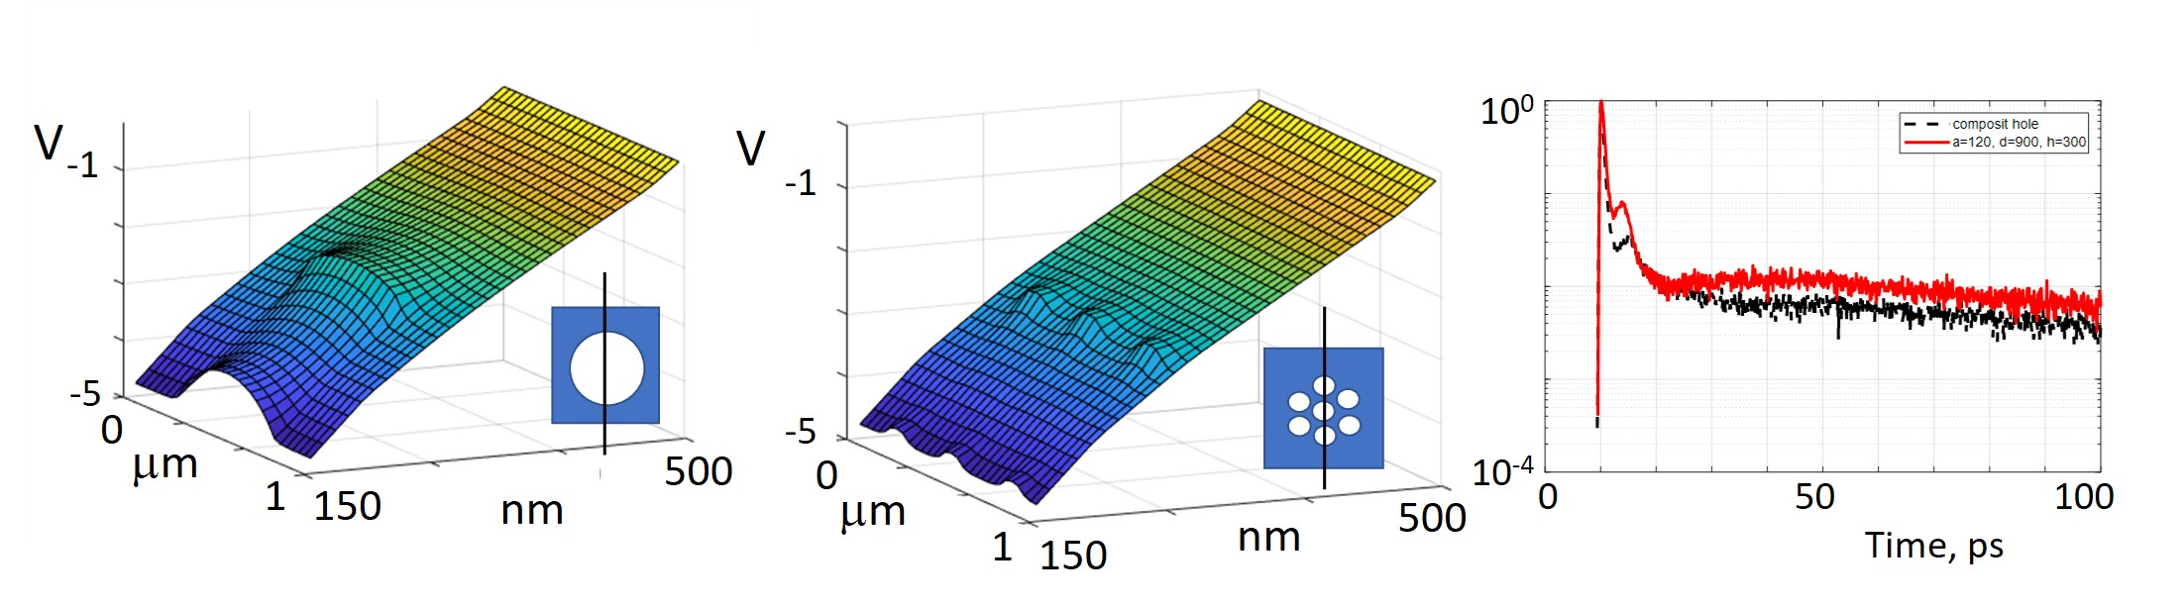
Fig. S1 (a-b) Potential distribution across the micro-holes (only depletion region). (a) A device with a square lattice that has a single micro-hole with diameter d=1200nm, and a period, a=1500nm. (b) A device with a composite hole that consists of 7 nanoholes of 400 nm. (c) The pulse response for devices with a large single (red line) micro-hole and smaller composite (black line) micro-holes.
The Monte-Carlo simulation calculates the pulse response (current J normalized to its maximum), which is shown in Fig. 2c for the larger holes (red curve) and composite holes formed from smaller nano-holes (black curve) in the logarithmic scale. The tail lingers considerably in the devices with larger holes after an initial sharp rise.
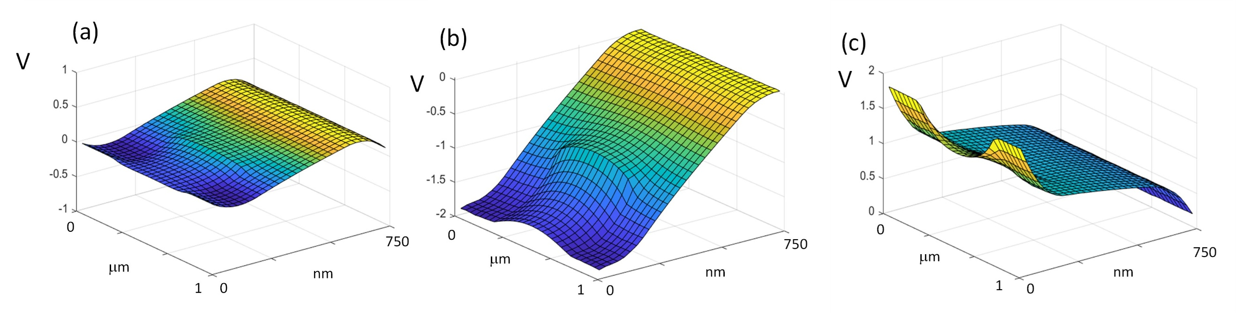
Fig. S2 Potential distribution across in PIN with a micro-hole. (a) zero voltage (b) reverse bias (c) forward bias

The Monte-Carlo simulations show that the PIN structure has a built-in bias due to electrons and holes diffusion without applied voltage. In the standard PD operations, the bias voltage is a large negative number. This is because we want generated electron-hole pairs to be separated in space so that unwanted recombination is reduced, corresponding to (b). If the same PIN structure is used as a solar cell, the standard device voltage is either zero (short circuit condition) or a small positive (open circuit condition), corresponding to (a) and (c). It depends on the doping and thickness of the doped region (Fig.S2a). Application of the reverse voltage produces the potential slope necessary for the generated photo carriers to drift toward electrodes (Fig.S2b). In the case of forward bias (Fig.S2c), the built-in bias is eventually overpowered by the applied voltage, showing a potential gradient and a current. The simulations for Fig.S2 used N-doped Ge 200nm, i-Ge 350nm, and P-doped Ge 200nm, and a micro-hole lattice 1 micron.

- A. Taflove, S. C. Hagness, and M. Piket-May, “Computational electromagnetics: the finite-difference time-domain method,” The Electrical Engineering Handbook, vol. 3, pp. 629–670, (2005).
- www.lumerical
- D. B. Hamadou, et al, 3D Lumerical simulation of silicon photodiodes with microholes for highspeed short-reach intra-datacenter interconnects, Applied Optics 62 (24), 6407-6416 (2023),
- Toshishige Yamada and D. K. Ferry, "Coupled molecular-dynamics Monte Carlo study of the transport properties of lateral surface superlattices," Phys. Rev. B 47 (11), 6416-6426 (1993).
- S. M. Sze, Physics of Semiconductor Devices, 2nd ed. (Wiley, New York, 1981
- J. G. Fossum, “Computer-aided numerical analysis of silicon solar cells,” Solid-State Electron. 19, 269–277 (1976),
- Hall, R.N. "Germanium rectifier characteristics". Physical Review. 83 (1): 228, (1951)
- J. G. Fossum, R. Mertens, D. Lee, and J. Nijs, “Carrier recombination and lifetime in highly doped silicon,” Solid-State Electron. 26, 569–576 (1983),
- J. Bardeen, “Surface States and Rectification at a Metal Semi-Conductor Contact” Phys. Rev. 71, 717 (1947).
- W. Shockley and W. T. Read, Jr. “Statistics of the Recombinations of Holes and Electrons”, Phys.Rev. 87, 835 – Published 1 September 1952.
- V. Fischetti and S. E. Laux, “Monte Carlo Simulation of Submicron Si MOSFETs”, Simulation of Semiconductor Devices and Processes, vol. 3,
- G. Baccarani and M. Rudan Eds. (Technoprint, Bologna, 1988), 349.

