Supplementary Information for

Designing alloy from 100% scrap with multi-modal AI

Chao Yang#, Bo Peng#, Qingzhou Tao, Binhan Sun, Da Shu, Liuliu Han*, Ye Wei*

*Corresponding authors: Liuliu Han (l.han@mpie.de), Ye Wei (ye.wei@cityu.edu.hk)

The PDF file includes:
Supplementary Notes 2
Microstructure analysis 2
Supplementary Figures 4
Supplementary Figure 1: Property distribution of multi-modal dataset and AI-generated designs with unconstrained objective. 4
Supplementary Figure 2: Graphite phase distribution in the DAS-AI designed Alloy #3 and the counterpart alloys by scanning electron microscope (SEM)-energy dispersive X-ray spectroscopy (EDS) analysis. 4
Supplementary Figure 3: Elemental distribution of the nanoparticles in the DAS-AI designed Alloy #3 by transmission electron microscopy (TEM)-energy dispersive X-ray spectroscopy (EDS) analysis. 5
Supplementary Figure 4: Distinct nanoparticle density in counterpart alloys by scanning electron microscopy (SEM)-backscattered electrons (BSE) analysis. 6
Supplementary Figure 5: Elemental distributions at the near-atomic scale by atom probe tomography (APT) analysis. 7
Supplementary Figure 6: Optical image of Alloy #3. 8
Supplementary Figure 7: Graphite nodule comparison between Alloy #3 and QT450 alloys in multi-modal dataset. 8
Supplementary Figure 8: Measuring the phase fractions of IQ map by color threshold segmentation. 9
Supplementary Figure 9: Morphology of Fe₃C in the pearlite of Alloy #3 and interlamellar spacing. 9
Supplementary Figure 10: Model architecture of 1D-CNN for tensile property predictions. 10
Supplementary Figure 11: Model performance of 1D-CNNs through the iterations. 11
Supplementary Tables 12
Supplementary Table 1: Chemical compositions and processing parameters of alloys with and without impurities. 12
Supplementary Table 2: Chemical compositions and processing parameters of AI-designed alloys. 14
Supplementary Table 3: Raw materials and cost for DA1130 wheel hub produced using commercial recycled ductile iron. 17
Supplementary Table 4: Raw materials and cost for DA1130 wheel hub produced by this work. 18
Supplementary References 19

Supplementary Notes
Microstructure analysis
Graphite nodules can absorb energy through elastic deformation under stress, thereby reducing localized stress peaks in the matrix (ferrite/pearlite). The content, size and distribution of graphite nodules are critical to the strength and ductility of ductile iron. It can be found in Supplementary Fig. 6 that the Alloy #3 possesses graphite nodules with the content of 13.2%, the average diameter of 21.25 μm, and the average number density of 292.8 mm⁻², while the ductile cast irons designed by human experts (QT450 in multi-modal dataset, Fig. 2b) possesses graphite nodules with the content of 12.5 ± 1.4%, the diameter of 23.81 ± 2.40 μm, and the average number density of 234.1 ± 34.9 mm⁻². Supplementary Fig. 7 further shows that under similar composition and processing conditions, the Alloy # 3 exhibits graphite nodules with higher content, greater number density, and finer average size compared to human-expert-designed counterparts. Moreover, these characteristics—high volume fraction, elevated number density, and reduced nodule size—fall within the ranges reported in the literatures ^{1–3} as optimal for enhancing the strength-ductility balance in ductile cast irons. This demonstrates that DAS-AI, when designing the recycled ductile iron, fully accounts for the effects of impurity elements based on strength-ductility requirements, thereby optimizing graphite nodule characteristics for the best balance of strength and ductility.
Ferrite enveloping spheroidal graphite creates a synergistic effect on dispersing stress more uniformly and preventing localized brittle fracture, thus allowing the material to achieve a balance of strength and ductility ⁴. When ferrite surrounds spheroidal graphite, it distributes stress uniformly, preventing localized brittle fracture and enabling ductile cast iron to achieve both strength and ductility ⁵. KAM map clearly shows that Alloy #3 exhibits this characteristic microstructure, where no significant localized stress is observed either within the ferrite matrix or at the ferrite/graphite interface. This effectively reduces the microcracks preferentially forming at the interface between the graphite nodules and the matrix, thereby significantly enhancing the ductility of Alloy #3. However, when the ferrite content reaches to 70% or even higher, the ductile cast iron exhibits a significant increase in ductility but a pronounced decrease in strength. The ferrite phase fraction of the Alloy #3 is 56.2%, while the average ferrite phase fraction of QT-450 in multi-modal dataset is 69.4 ± 6.9%. It indicates that DAS-AI has fully considered the volume fraction of ferrite phase in alloy design to meet the requirements of both strength and ductility.
Elemental segregation is an inherent characteristic of the cast iron ⁶. In the recycled ductile cast iron, the higher concentration of impurity elements further leads to the enrichment of solute elements (e.g. C, Si, Cu, Ti, Mn, etc.) at the solid-liquid interface front during solidification ⁷. This results in more significant compositional differences between the initially solidified regions and the later solidified zones, thereby aggravating pronounced segregation of solute elements ⁸. Severe elemental segregation tends to form brittle phases that act as crack initiation sites, reducing the ductility of the recycled ductile cast iron ⁹. Meanwhile, the coexistence of localized hard/brittle phases with soft ferrite phase leads to stress concentration and strength inhomogeneity. Fig. 3d presents the Alloy #3 exhibits almost no elemental segregation of C, Cu, or Ti, with only minimal segregation observed for Si and Mn. This demonstrates that DAS-AI alloy design approach fully accounts for the intrinsic elemental segregation of the recycled ductile cast iron. By optimizing composition and solidification parameters, DAS-AI successfully minimizes elemental segregation-induced degradation without introducing additional processing.
The precipitation of hard ceramic nanoparticles (e.g., TiC/SiC) strengthens ductile cast iron via dispersion hardening, where these particles act as barriers to dislocation movement—a key mechanism for achieving higher strengths. However, the recycled ductile cast iron contains higher levels of impurity elements (e.g., Cr, V), which are typical strong carbide formers ¹⁰. These elements tend to promote the formation of coarse and brittle phases like (Fe,Cr)₃C while simultaneously inhibiting the precipitation of TiC/SiC nanoparticles ¹¹. It is clear from Fig. 3d that the Alloy #3 still retains TiC/SiC nanoprecipitates. This suggests that DAS-AI alloy design strategy deliberately incorporates nano-reinforcement mechanisms, successfully promoting TiC/SiC precipitates within the matrix despite elevated impurity concentrations - a critical factor in achieving superior mechanical performance in the recycled ductile cast iron.
Therefore, the DAS-AI design strategy has led to an alloy containing microstructure features different from those designed by human experts with better mechanical performance and lower cost, as clearly illustrated in Fig. 2d and Fig. 3. Such a multiscale microstructure derived from the recycled ductile iron after complex manufacturing pipeline thus requires a careful DAS-AI aided tailoring to achieve the synergistic effect on solving the strength-ductility trade-off.

Supplementary Figures
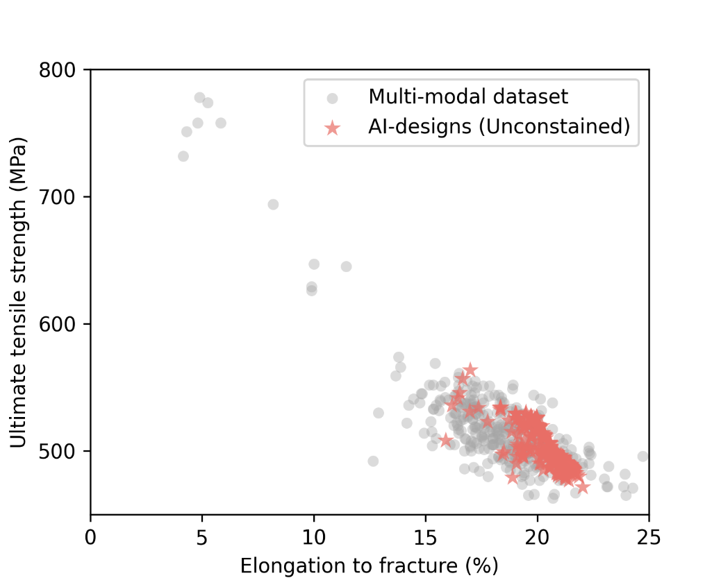

Supplementary Figure 1: Property distribution of multi-modal dataset and AI-generated designs with unconstrained objective.
When the objective is unconstrained, the AI-generated designs (NN-predicted properties) tend to cluster around the original distribution, which is characterized by low tensile strength and high elongation to fracture. This clustering tendency likely arises because the multi-modal data are densely populated in this region, allowing the AI to learn the design rules predominantly from this subset. Consequently, the newly generated designs do not significantly deviate from this area.

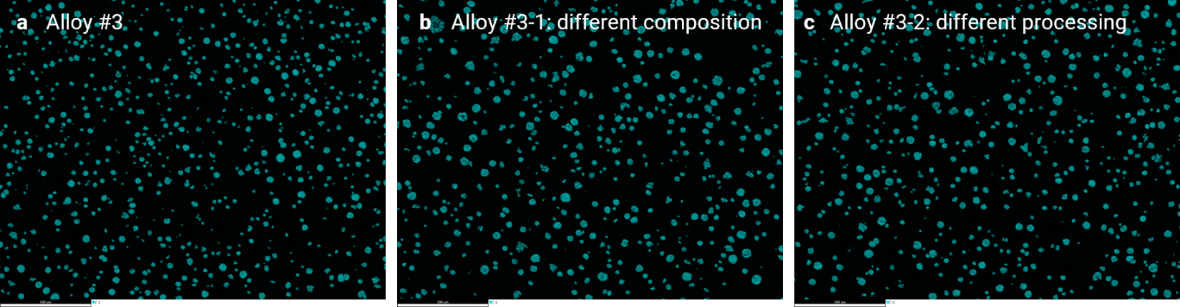

Supplementary Figure 2: Graphite phase distribution in the DAS-AI designed Alloy #3 and the counterpart alloys by scanning electron microscope (SEM)-energy dispersive X-ray spectroscopy (EDS) analysis.
(a), (b) and (c) Low-magnification EDS maps showing the C distribution of the DAS AI-designed alloy and its counterpart alloys with different bulk chemistry and processing, respectively. These results indicate the distribution of the graphite phase in the matrix.

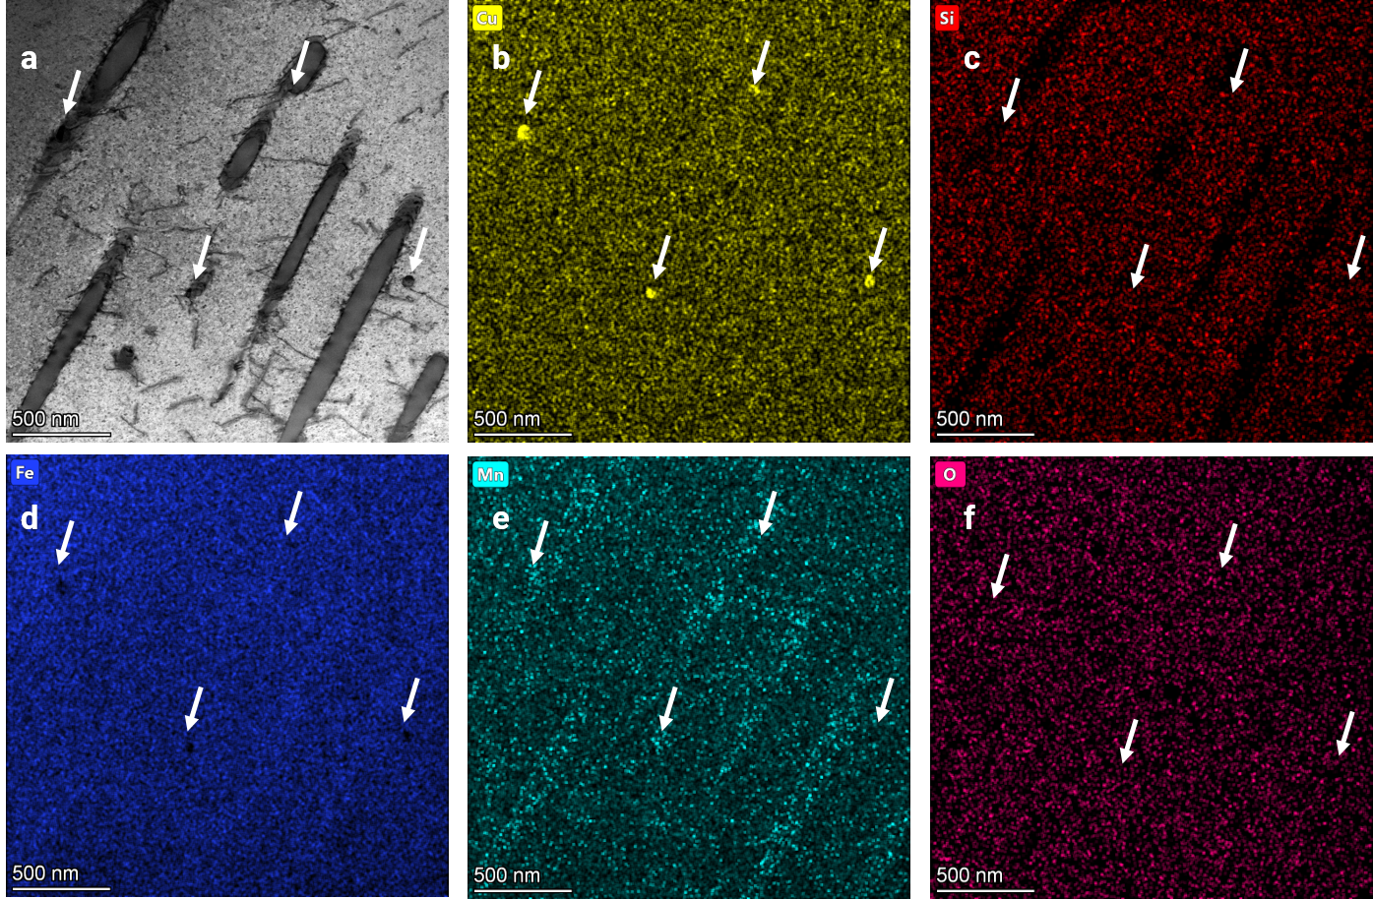

Supplementary Figure 3: Elemental distribution of the nanoparticles in the DAS-AI designed Alloy #3 by transmission electron microscopy (TEM)-energy dispersive X-ray spectroscopy (EDS) analysis.
(a) TEM micrograph showing the typical microstructure of Alloy #3. (b-f) The corresponding TEM-EDS maps of the containing elements. The nanoparticles indicated by while arrows are Cu-rich and S-rich phase.

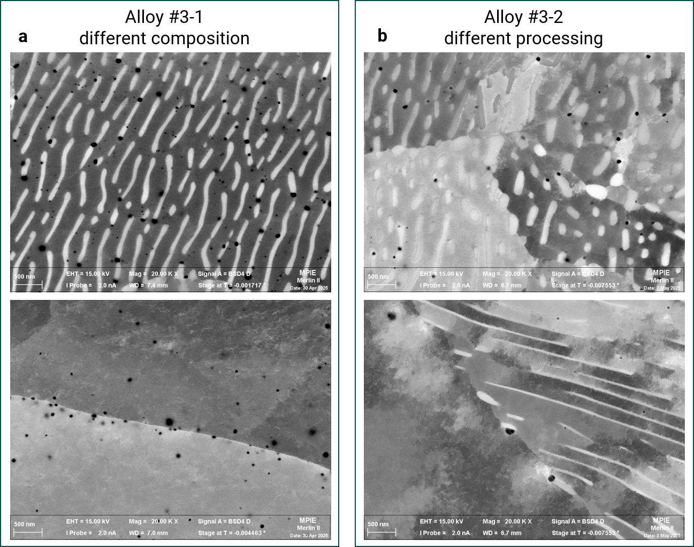

Supplementary Figure 4: Distinct nanoparticle density in counterpart alloys by scanning electron microscopy (SEM)-backscattered electrons (BSE) analysis.
(a) and (b) High-magnification SEM micrographs showing nanoparticle density of the counterpart alloys with different bulk chemistry and processing, respectively.

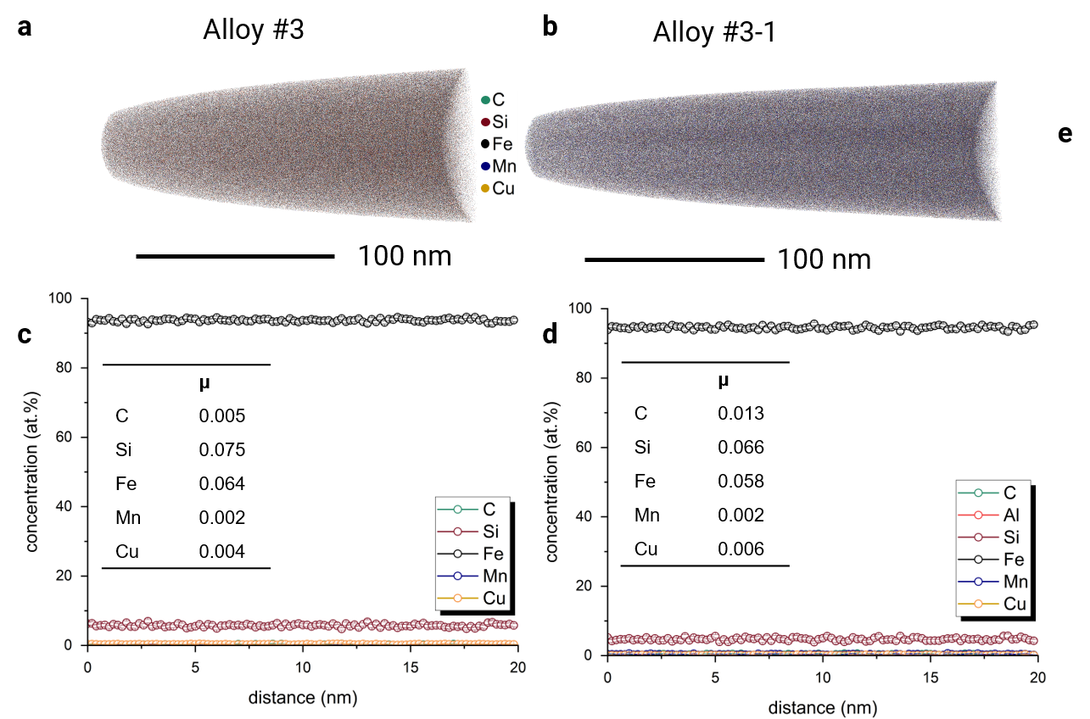

Supplementary Figure 5: Elemental distributions at the near-atomic scale by atom probe tomography (APT) analysis.
(a) and (b) Three-dimensional reconstruction containing all the elements in the ferrite phase in Alloy #3 and Alloy #3-1, respectively. (c) and (d) One-dimensional profiles showing the elemental concentrations in Alloy #3 and Alloy #3-1, respectively. The insets are the statistical analysis showing the normalized homogenization parameter μ for all elements. The values of μ are close to 0 (μ ranges from 0 to 1), confirming the random distribution of elements. (e) The averaged value of the minor elements in the Alloy #3 and composition changed Alloy #3-1.

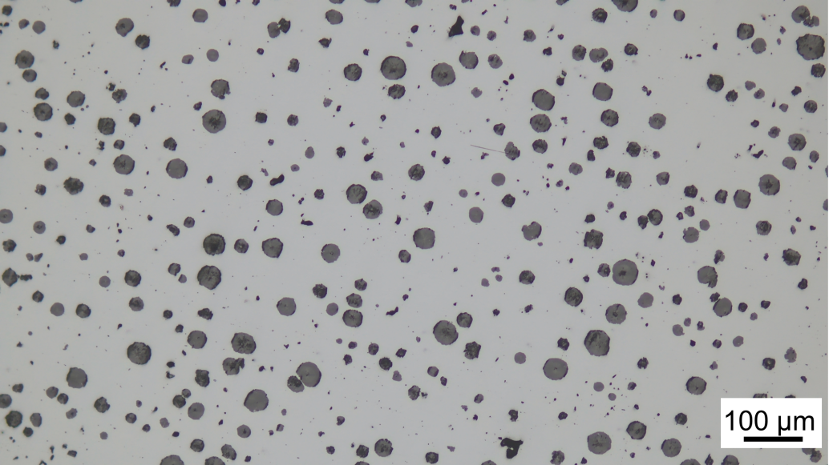

Supplementary Figure 6: Optical image of Alloy #3.

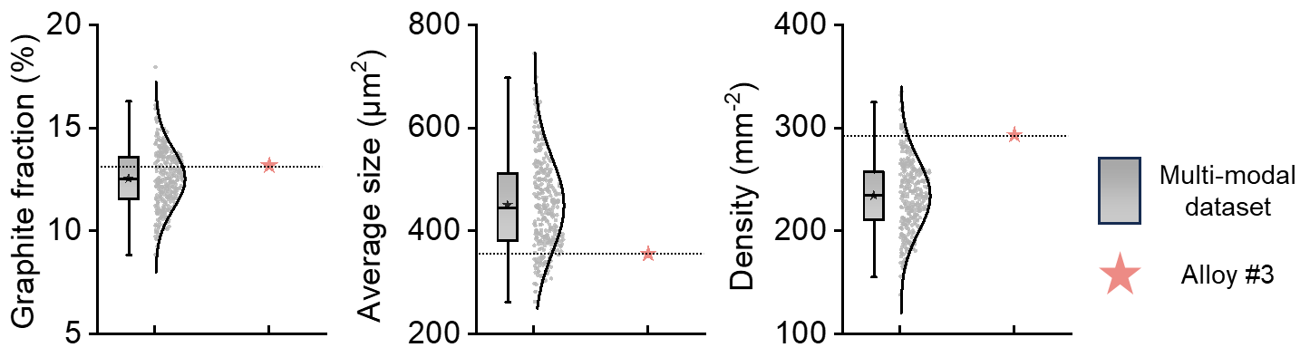

Supplementary Figure 7: Graphite nodule comparison between Alloy #3 and QT450 alloys in multi-modal dataset.

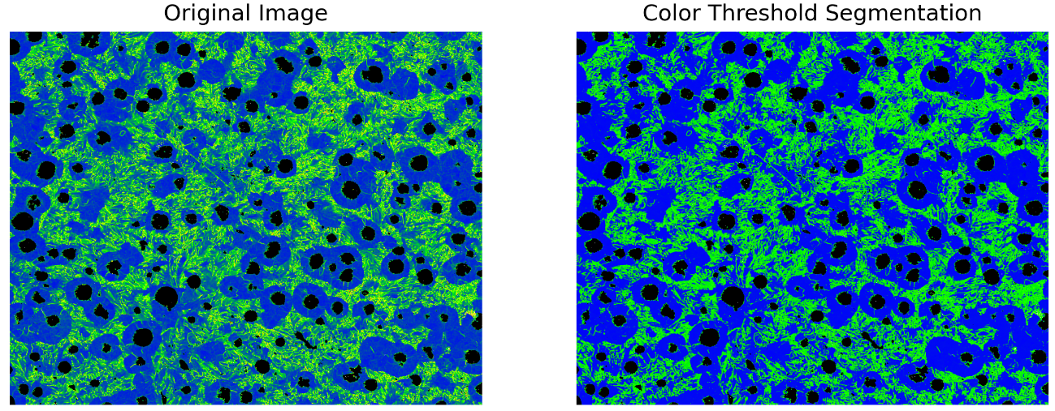

Supplementary Figure 8: Measuring the phase fractions of IQ map by color threshold segmentation.
The original image quality (IQ) map (left) undergoes color threshold segmentation where pixel values are converted as follows: RGB (90-180, 51-255, 51-255) → (0,0,255) [blue: ferrite phase]; RGB (0-89, 51-255, 51-255) → (0,255,0) [green: pearlite phase]; RGB (0-180, 0-50, 0-50) → (0,0,0) [black: graphite spheres]. The resulting segmented image (right) shows ferrite, pearlite, and graphite phases represented by blue, green, and black regions, respectively, which are subsequently used to calculate the phase fractions.

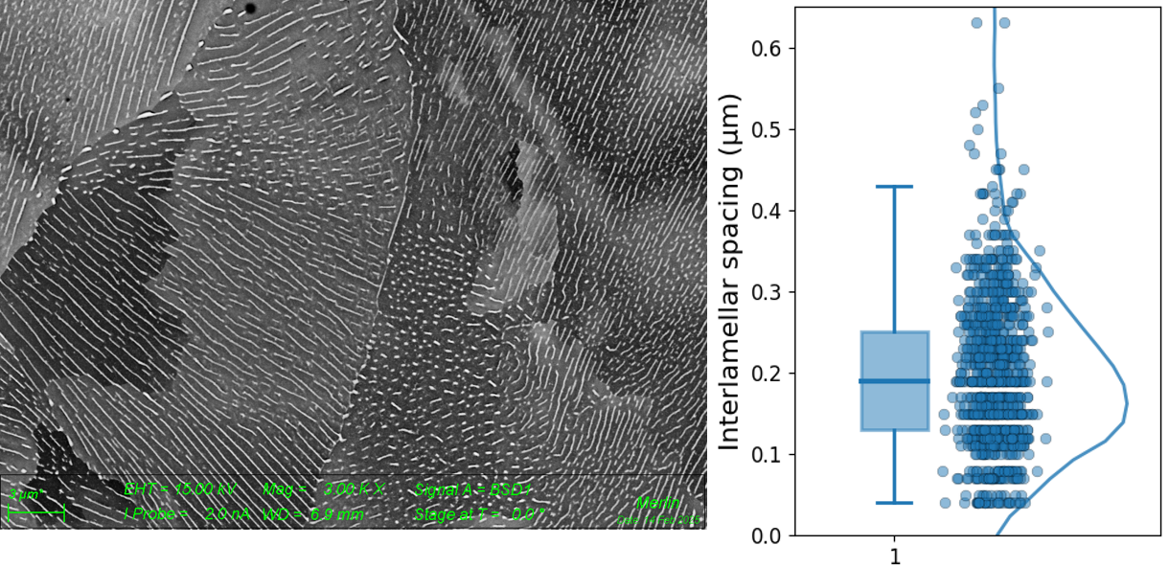

Supplementary Figure 9: Morphology of Fe₃C in the pearlite of Alloy #3 and interlamellar spacing.
The interlamellar spacing was measured via a Nano Measurer 1.2 software.

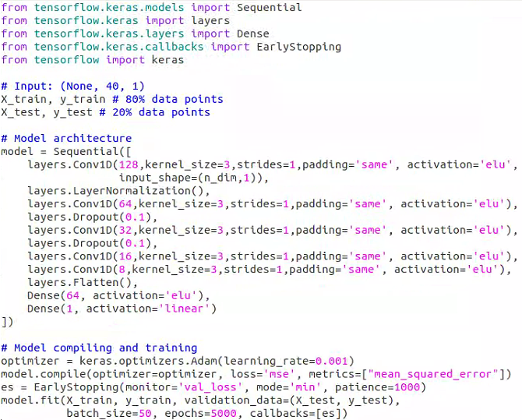

Supplementary Figure 10: Model architecture of 1D-CNN for tensile property predictions.
This figure details the model architectures of 1D convolutional neural networks used for ultimate tensile strength and elongation to fracture predictions of ductile irons. The hyperparameters and model architectures were determined by trial and error.

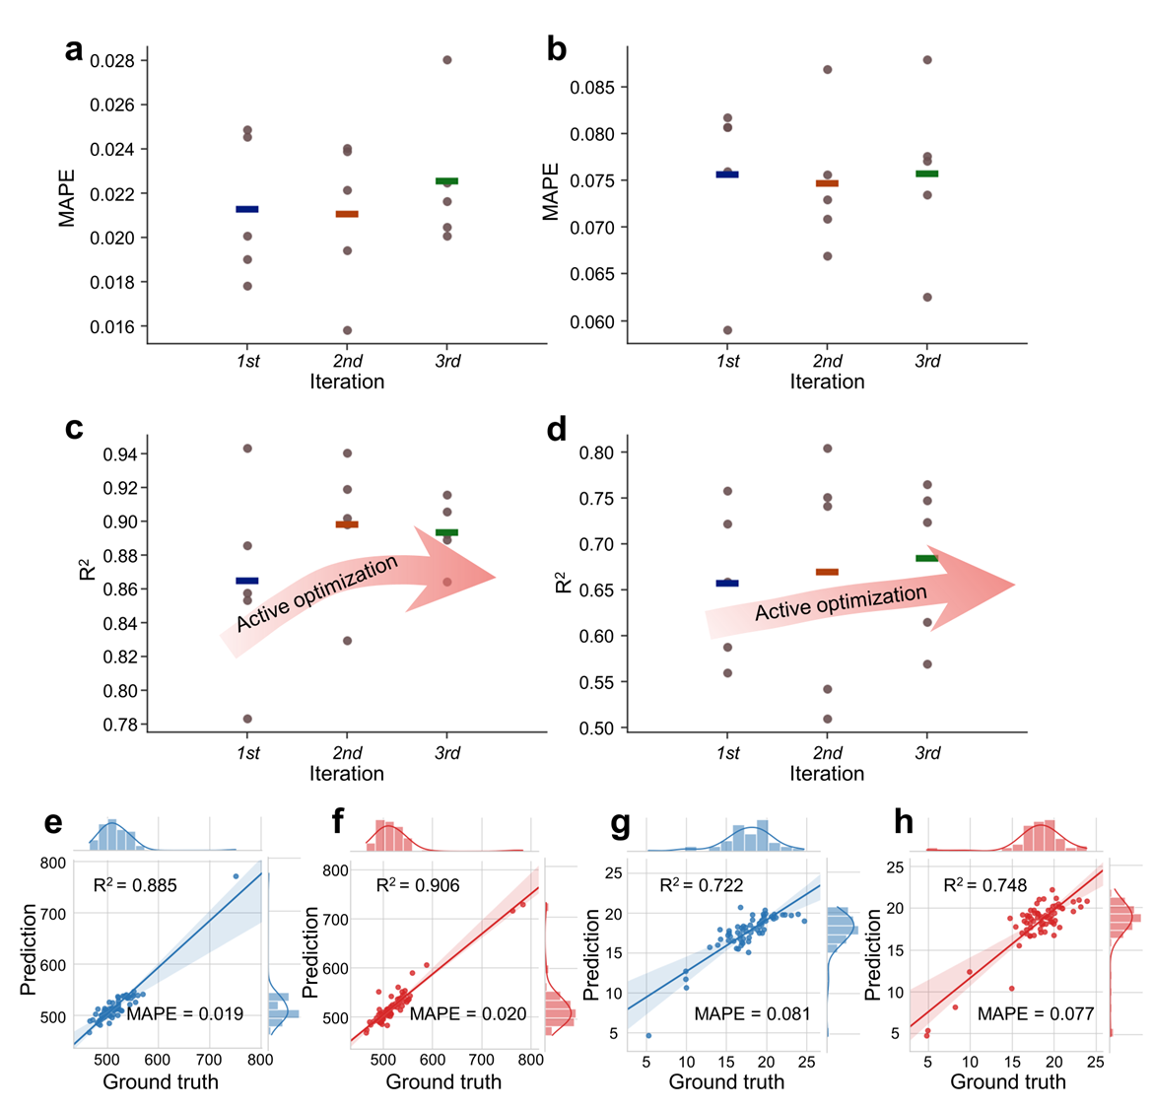

Supplementary Figure 11: Model performance of 1D-CNNs through the iterations.
The 1D-CNNs in this figure are trained on multi-modal dataset, (a, b) MAPE in iteration: Panels (a) and (b) illustrate the MAPE for the ultimate tensile strength and elongation to fracture predictions respectively. The dots indicate the MAPE between experimental results and the model predictions. Five statistically independent (orthogonal) models are utilized for these predictions. (c, d) R² in iteration: Panels (c) and (d) present the R² values for the ultimate tensile strength and elongation to fracture, respectively. The dots depict the R² values comparing experimental results to predictions, demonstrating a rapid increase in R², reminiscent of a natural learning curve. (e, f) Regression plots for ultimate tensile strength predictions: Panels (e) and (f) display regression plots for the 1st and last rounds of iteration, respectively. (g, h) Regression plots for elongation to fracture predictions: Panels (g) and (h) showcase regression plots for the 1st and last rounds of iteration, respectively. All R² and MAPE values are calculated using the validation dataset.

Supplementary Tables

Supplementary Table 1: Chemical compositions and processing parameters of alloys with and without impurities.
No. |  | Chemical compositions (%)
 |  | C | Si | Mn | Cu | P | S | Cr | Sn | Mg | Sb | Ni | Mo | Ti | Al | V | Nb | W | Co | Zr | B | Ca | As | Pb | Bi | Zn | Ce | La | Se | Te | N
1* | Virgin | 3.57 | 2.252 | 0.394 | 0.86 | 0.0204 | 0.001 | 0.052 | 0.061 | 0.054 | 0.00286 | / | / | / | / | / | / | / | / | / | / | / | / | / | / | / | / | / | / | / | /
1* | Recycled | 3.58 | 2.253 | 0.391 | 0.87 | 0.0202 | 0.0099 | 0.051 | 0.063 | 0.053 | 0.00284 | 0.012 | 0.0112 | 0.01 | 0.014 | 0.015 | 0.002 | 0.003 | 0.006 | 0.002 | 0.0007 | 0.0024 | 0.003 | 0.002 | 0.003 | 0.001 | 0.005 | 0.004 | 0.001 | 0.001 | 0.006
2* | Virgin | 3.59 | 2.309 | 0.148 | 0.30 | 0.0128 | 0.0076 | 0.025 | 0.021 | 0.045 | 0.00277 | / | / | / | / | / | / | / | / | / | / | / | / | / | / | / | / | / | / | / | /
2* | Recycled | 3.61 | 2.307 | 0.143 | 0.30 | 0.0127 | 0.0072 | 0.024 | 0.002 | 0.046 | 0.00281 | 0.007 | 0.001 | 0.012 | 0.015 | 0.015 | 0.002 | 0.003 | 0.004 | 0.001 | 0.0004 | 0.0011 | 0.001 | 0.0012 | 0.002 | 0.002 | 0.004 | 0.003 | 0.001 | 0.001 | 0.008
3* | Virgin | 3.60 | 2.653 | 0.287 | 0.028 | 0.0229 | 0.0091 | 0.018 | 0.001 | 0.041 | 0.00267 | / | / | / | / | / | / | / | / | / | / | / | / | / | / | / | / | / | / | / | /
3* | Recycled | 3.61 | 2.654 | 0.286 | 0.028 | 0.0227 | 0.0093 | 0.019 | 0.001 | 0.042 | 0.00268 | 0.008 | 0.001 | 0.016 | 0.019 | 0.008 | 0.002 | 0.003 | 0.005 | 0.002 | 0.0004 | 0.0022 | 0.001 | 0.001 | 0.002 | 0.001 | 0.004 | 0.003 | 0.001 | 0.001 | 0.005
4* | Virgin | 3.55 | 2.679 | 0.284 | 0.065 | 0.0186 | 0.011 | 0.044 | 0.006 | 0.057 | 0.0001 | / | / | / | / | / | / | / | / | / | / | / | / | / | / | / | / | / | / | / | /
4* | Recycled | 3.54 | 2.677 | 0.287 | 0.066 | 0.0184 | 0.0109 | 0.045 | 0.007 | 0.056 | 0.0001 | 0.012 | 0.0058 | 0.021 | 0.014 | 0.003 | 0.002 | 0.003 | 0.004 | 0.002 | 0.0017 | 0.0022 | 0.002 | 0.0011 | 0.001 | 0.002 | 0.005 | 0.004 | 0.001 | 0.001 | 0.008
5* | Virgin | 3.47 | 2.659 | 0.278 | 0.07 | 0.0171 | 0.0111 | 0.042 | 0.016 | 0.054 | 0.0001 | / | / | / | / | / | / | / | / | / | / | / | / | / | / | / | / | / | / | / | /
5* | Recycled | 3.47 | 2.662 | 0.281 | 0.07 | 0.0173 | 0.0109 | 0.044 | 0.018 | 0.057 | 0.0001 | 0.013 | 0.0069 | 0.015 | 0.015 | 0.003 | 0.002 | 0.003 | 0.003 | 0.001 | 0.0011 | 0.0043 | 0.003 | 0.001 | 0.001 | 0.001 | 0.005 | 0.005 | 0.001 | 0.001 | 0.007

No. |  | Processing parameters and properties
 |  | Tap Temperature (°C) | Pouring start temperature  (℃) | Nodularization time (min) | Inoculation time (min) | Pouring time | Ultimate tensile strength (MPa) | Elongation to fracture (%)
1* | Virgin | 1472 | 1379 | 28 | 32 | 7′56″ | 774.8 ± 1.9 | 5.56 ± 0.07
1* | Recycled | 1473 | 1378 | 28 | 32 | 7′58″ | 754.2 ± 4.0 | 5.37 ± 0.08
2* | Virgin | 1442 | 1375 | 31 | 36 | 7′51″ | 688.6 ± 3.9 | 7.68 ± 0.36
2* | Recycled | 1442 | 1374 | 31 | 36 | 7′53″ | 659.9 ± 2.4 | 10.71 ± 0.28
3* | Virgin | 1452 | 1370 | 26 | 32 | 7′35″ | 647.0 ± 2.7 | 8.73 ± 0.16
3* | Recycled | 1450 | 1369 | 26 | 32 | 7′45″ | 628.2 ± 1.9 | 10.06 ± 0.24
4* | Virgin | 1448 | 1367 | 30 | 36 | 7′39″ | 640.8 ± 3.0 | 12.20 ± 0.16
4* | Recycled | 1447 | 1366 | 30 | 36 | 7′41″ | 620.6 ± 2.7 | 13.71 ± 0.11
5* | Virgin | 1483 | 1411 | 30 | 36 | 7′05″ | 541.4 ± 3.8 | 11.94 ± 0.14
5* | Recycled | 1485 | 1412 | 30 | 36 | 7′10″ | 523.4 ± 4.8 | 15.84 ± 0.15

No. |  | Processing parameters
 |  | Moisture content  (%) | Compactibility  (%) | Permeability | Compressive strength (kPa) | Shear strength (kPa) | Sand temperature (℃) | Hot wet tensile strength (kPa) | Gas evolution | Clay content  (%) | AFS fineness number | Loss on ignition
1* | Virgin | 3.39 | 31 | 129 | 164 | 45 | 30.2 | 3.28 | 14.4 | 11.51 | 61.24 | 3.7
1* | Recycled | 3.38 | 31 | 128 | 164 | 45 | 30.2 | 3.28 | 14.4 | 11.52 | 61.25 | 3.7
2* | Virgin | 2.97 | 32 | 126 | 181 | 33 | 40.5 | 6.05 | 14.7 | 9.93 | 55.17 | 3.8
2* | Recycled | 2.98 | 32 | 126 | 182 | 33 | 40.4 | 6.01 | 14.6 | 9.92 | 55.14 | 3.8
3* | Virgin | 3.08 | 31 | 130 | 169 | 35 | 35.2 | 4.25 | 13.8 | 10.27 | 59.71 | 4.3
3* | Recycled | 3.07 | 31 | 129 | 169 | 35 | 35.2 | 4.26 | 13.8 | 10.26 | 59.72 | 4.3
4* | Virgin | 2.84 | 30 | 170 | 182 | 44 | 18.2 | 4.03 | 12.3 | 9.87 | 54.18 | 4.2
4* | Recycled | 2.85 | 29 | 170 | 183 | 45 | 18.2 | 4.02 | 12.3 | 9.85 | 54.16 | 4.2
5* | Virgin | 2.84 | 30 | 171 | 182 | 45 | 18.1 | 4.01 | 12.3 | 9.84 | 54.19 | 4.2
5* | Recycled | 2.85 | 29 | 170 | 183 | 45 | 18.2 | 4.02 | 12.3 | 9.85 | 54.16 | 4.2

Supplementary Table 2: Chemical compositions and processing parameters of AI-designed alloys.
No. | Chemical compositions (%)
No. | C | Si | Mn | Cu | P | S | Cr | Sn | Mg | Sb | Ni | Mo | Ti | Al | V | Nb | W | Co | Zr | B | Ca | As | Pb | Bi | Zn | Ce | La | Se | Te | N
1 | 3.83 | 1.817 | 0.64 | 0.21 | 0.0127 | 0.0072 | 0.024 | 0.002 | 0.046 | 0.00281 | 0.007 | 0.001 | 0.012 | 0.015 | 0.015 | 0.002 | 0.003 | 0.004 | 0.001 | 0.0004 | 0.0011 | 0.001 | 0.0012 | 0.002 | 0.002 | 0.004 | 0.003 | 0.001 | 0.001 | 0.008
2 | 3.51 | 2.889 | 0.50 | 0.15 | 0.0183 | 0.012 | 0.068 | 0.025 | 0.054 | 0.00222 | 0.011 | 0.0111 | 0.02 | 0.02 | 0.007 | 0.002 | 0.003 | 0.004 | 0.001 | 0.0025 | 0.002 | 0.003 | 0.001 | 0.001 | 0.005 | 0.007 | 0.003 | 0.001 | 0.001 | 0.006
3 | 3.46 | 2.884 | 0.49 | 0.16 | 0.0192 | 0.0132 | 0.054 | 0.027 | 0.044 | 0.00182 | 0.009 | 0.0113 | 0.024 | 0.01 | 0.003 | 0.002 | 0.003 | 0.003 | 0.001 | 0.0007 | 0.0026 | 0.003 | 0.001 | 0.001 | 0.001 | 0.004 | 0.004 | 0.001 | 0.001 | 0.011
4 | 3.29 | 2.935 | 0.67 | 0.18 | 0.0183 | 0.0096 | 0.042 | 0.023 | 0.045 | 0.00217 | 0.009 | 0.0052 | 0.024 | 0.022 | 0.013 | 0.002 | 0.003 | 0.004 | 0.002 | 0.0024 | 0.0025 | 0.002 | 0.001 | 0.002 | 0.001 | 0.006 | 0.003 | 0.001 | 0.001 | 0.001
5 | 3.57 | 2.71 | 0.55 | 0.10 | 0.0153 | 0.0072 | 0.038 | 0.009 | 0.05 | 1E-04 | 0.013 | 0.001 | 0.023 | 0.017 | 0.015 | 0.002 | 0.003 | 0.004 | 0.002 | 0.002 | 0.0018 | 0.003 | 0.0018 | 0.002 | 0.002 | 0.006 | 0.004 | 0.001 | 0.001 | 0.008
6 | 3.28 | 1.92 | 0.58 | 0.12 | 0.015 | 0.0088 | 0.042 | 0.011 | 0.045 | 1E-04 | 0.012 | 0.0053 | 0.016 | 0.017 | 0.008 | 0.002 | 0.003 | 0.004 | 0.002 | 0.0018 | 0.0024 | 0.002 | 0.0011 | 0.001 | 0.002 | 0.005 | 0.004 | 0.001 | 0.001 | 0.001
7 | 2.5 | 2.86 | 0.61 | 0.13 | 0.0143 | 0.0083 | 0.042 | 0.008 | 0.047 | 0.00068 | 0.017 | 0.0037 | 0.017 | 0.017 | 0.01 | 0.002 | 0.003 | 0.004 | 0.002 | 0.0017 | 0.0023 | 0.003 | 0.0011 | 0.002 | 0.003 | 0.005 | 0.004 | 0.001 | 0.001 | 0.008
8 | 3.53 | 2.95 | 0.37 | 0.21 | 0.0147 | 0.0068 | 0.036 | 0.009 | 0.05 | 1E-04 | 0.014 | 0.001 | 0.024 | 0.014 | 0.014 | 0.002 | 0.003 | 0.003 | 0.003 | 0.003 | 0.0016 | 0.003 | 0.0019 | 0.0031 | 0.0023 | 0.0071 | 0.0039 | 0.001 | 0.001 | 0.009
9 | 3.45 | 1.57 | 0.51 | 0.24 | 0.0156 | 0.0074 | 0.04 | 0.008 | 0.049 | 0.00012 | 0.015 | 0.0012 | 0.024 | 0.018 | 0.016 | 0.002 | 0.003 | 0.0038 | 0.0022 | 0.0021 | 0.0019 | 0.0031 | 0.0017 | 0.0022 | 0.0021 | 0.0061 | 0.0041 | 0.001 | 0.001 | 0.009
10 | 3.73 | 3.00 | 0.87 | 0.22 | 0.0143 | 0.0081 | 0.044 | 0.008 | 0.05 | 0.00024 | 0.013 | 0.0017 | 0.019 | 0.017 | 0.005 | 0.002 | 0.003 | 0.0039 | 0.0017 | 0.0019 | 0.0023 | 0.0022 | 0.0012 | 0.0013 | 0.0032 | 0.0052 | 0.0042 | 0.001 | 0.001 | 0.012
11 (#3) | 3.31 | 2.77 | 0.30 | 0.27 | 0.0141 | 0.0081 | 0.042 | 0.009 | 0.047 | 0.00072 | 0.018 | 0.0034 | 0.017 | 0.016 | 0.012 | 0.002 | 0.003 | 0.004 | 0.0021 | 0.0016 | 0.0024 | 0.0033 | 0.0013 | 0.0021 | 0.0029 | 0.0052 | 0.0041 | 0.001 | 0.001 | 0.009
12 | 3.37 | 2.94 | 0.41 | 0.03 | 0.0156 | 0.0072 | 0.039 | 0.008 | 0.048 | 0.00014 | 0.014 | 0.0013 | 0.026 | 0.017 | 0.016 | 0.002 | 0.003 | 0.0043 | 0.002 | 0.0018 | 0.0019 | 0.0034 | 0.0018 | 0.0022 | 0.0028 | 0.0067 | 0.0044 | 0.001 | 0.001 | 0.008
13 | 3.45 | 2.99 | 0.47 | 0.86 | 0.0152 | 0.0071 | 0.041 | 0.008 | 0.049 | 0.00015 | 0.015 | 0.0014 | 0.027 | 0.018 | 0.017 | 0.002 | 0.003 | 0.0041 | 0.002 | 0.0019 | 0.0021 | 0.0036 | 0.0019 | 0.0021 | 0.0029 | 0.0069 | 0.0042 | 0.001 | 0.001 | 0.009
14 | 3.49 | 3.01 | 0.48 | 0.19 | 0.0149 | 0.0069 | 0.037 | 0.009 | 0.051 | 0.00013 | 0.014 | 0.0012 | 0.025 | 0.015 | 0.013 | 0.002 | 0.003 | 0.0036 | 0.003 | 0.0027 | 0.0018 | 0.0034 | 0.0019 | 0.0032 | 0.0024 | 0.0073 | 0.0041 | 0.001 | 0.001 | 0.009
15 (#2) | 3.93 | 1.76 | 0.78 | 0.27 | 0.0184 | 0.013 | 0.069 | 0.026 | 0.055 | 0.00226 | 0.012 | 0.0113 | 0.023 | 0.021 | 0.008 | 0.002 | 0.003 | 0.0043 | 0.001 | 0.0024 | 0.0019 | 0.0032 | 0.0016 | 0.0015 | 0.0052 | 0.0071 | 0.0034 | 0.001 | 0.001 | 0.007
16 | 3.69 | 2.95 | 0.62 | 0.25 | 0.0182 | 0.011 | 0.071 | 0.025 | 0.053 | 0.00224 | 0.013 | 0.0112 | 0.021 | 0.023 | 0.007 | 0.002 | 0.003 | 0.0042 | 0.001 | 0.0026 | 0.0022 | 0.0031 | 0.0015 | 0.0014 | 0.0051 | 0.0073 | 0.0033 | 0.001 | 0.001 | 0.006
17 (#1) | 3.63 | 2.97 | 0.58 | 0.92 | 0.0181 | 0.012 | 0.067 | 0.027 | 0.057 | 0.00221 | 0.011 | 0.0115 | 0.022 | 0.022 | 0.006 | 0.002 | 0.003 | 0.0045 | 0.002 | 0.0028 | 0.0021 | 0.0035 | 0.0014 | 0.0013 | 0.0053 | 0.0072 | 0.0032 | 0.001 | 0.001 | 0.008

No. | Processing parameters
No. | Tap Temperature (°C) | Pouring start temperature  (℃) | Nodularization time (min) | Inoculation time (min) | Pouring time  (″)
1 | 1462 | 1374 | 35 | 29 | 413
2 | 1435 | 1395 | 34 | 32 | 415
3 | 1432 | 1398 | 35 | 32 | 418
4 | 1428 | 1372 | 34 | 31 | 412
5 | 1422 | 1400 | 29 | 30 | 390
6 | 1442 | 1340 | 27 | 43 | 470
7 | 1434 | 1406 | 36 | 30 | 390
8 | 1422 | 1408 | 40 | 30 | 414
9 | 1419 | 1405 | 40 | 30 | 435
10 | 1421 | 1406 | 40 | 30 | 498
11 (#3) | 1427 | 1394 | 38 | 32 | 482
12 | 1420 | 1397 | 37 | 30 | 502
13 | 1425 | 1422 | 38 | 31 | 495
14 | 1422 | 1420 | 38 | 30 | 497
15 (#2) | 1419 | 1409 | 39 | 31 | 443
16 | 1417 | 1401 | 35 | 30 | 454
17 (#1) | 1420 | 1416 | 40 | 31 | 425

No. | Processing parameters
No. | Moisture content  (%) | Compactibility  (%) | Permeability | Compressive strength (kPa) | Shear strength (kPa) | Sand temperature (℃) | Hot wet tensile strength (kPa) | Gas evolution | Clay content  (%) | AFS fineness number | Loss on ignition
1 | 2.94 | 32 | 126 | 182 | 33 | 40.4 | 6.01 | 14.6 | 9.92 | 55.14 | 3.8
2 | 2.99 | 31 | 132 | 165 | 38 | 43.8 | 4.76 | 14.4 | 11.76 | 57.52 | 4.6
3 | 2.98 | 30 | 135 | 208 | 52 | 38 | 5.65 | 15.2 | 10.36 | 56.62 | 4.1
4 | 2.97 | 32 | 117 | 174 | 43 | 40.5 | 5.15 | 15.7 | 11.24 | 59.98 | 3.5
5 | 2.99 | 31 | 168 | 183 | 38 | 43.8 | 3.95 | 13.73 | 10.06 | 53.9 | 2.8
6 | 2.98 | 30 | 173 | 167 | 52 | 38 | 4.53 | 13.7 | 11.02 | 53.54 | 4
7 | 2.97 | 32 | 189 | 143 | 43 | 40.5 | 5.37 | 12.75 | 10.88 | 63.45 | 3.2
8 | 2.98 | 30 | 167 | 184 | 52 | 38 | 3.97 | 13.7 | 10.01 | 53.42 | 2.7
9 | 2.97 | 32 | 169 | 181 | 43 | 40.5 | 3.92 | 13.72 | 10.07 | 53.61 | 2.8
10 | 2.99 | 31 | 190 | 147 | 38 | 43.8 | 5.4 | 12.77 | 10.89 | 63.52 | 3.1
11 (#3) | 2.98 | 30 | 191 | 142 | 52 | 38 | 5.38 | 12.74 | 10.87 | 63.47 | 3.2
12 | 2.97 | 32 | 170 | 187 | 43 | 40.5 | 3.97 | 13.72 | 10.08 | 53.91 | 2.8
13 | 2.98 | 30 | 171 | 188 | 52 | 38 | 3.96 | 13.73 | 10.09 | 53.92 | 2.8
14 | 2.97 | 32 | 168 | 185 | 43 | 40.5 | 3.98 | 13.72 | 10.04 | 53.52 | 2.7
15 (#2) | 2.99 | 31 | 132 | 167 | 38 | 43.8 | 4.72 | 14.37 | 11.72 | 57.42 | 4.7
16 | 2.98 | 30 | 134 | 164 | 52 | 38 | 4.78 | 14.38 | 11.78 | 57.56 | 4.6
17 (#1) | 2.97 | 32 | 133 | 166 | 43 | 40.5 | 4.75 | 14.41 | 11.77 | 57.54 | 4.5

No. | Microstructure and properties
No. | Nodularity rate | Pearlite fraction  (%) | Ultimate tensile strength  (MPa) | Elongation to fracture  (%)
1 | 3 | 71 | 663.2 | 11.95
2 | 3 | 87 | 784.5 | 8.75
3 | 3 | 87 | 763.4 | 8.02
4 | 3 | 64 | 718.3 | 10.2
5 | 3 | 75 | 680 | 12.67
6 | 3 | 75 | 558.3 | 15.6
7 | 3 | 65 | 587.5 | 13.68
8 | 3 | 85 | 635.1 | 15.85
9 | 3 | 80 | 633.3 | 15.86
10 | 3 | 75 | 615.3 | 16.16
11 (#3) | 3 | 60 | 593.0 | 19.48
12 | 3 | 45 | 551.3 | 21.53
13 | 3 | 90 | 651.3 | 15.91
14 | 3 | 90 | 629.9 | 18.006
15 (#2) | 3 | 85 | 689 | 13.43
16 | 3 | 85 | 685.9 | 13.47
17 (#1) | 3 | 95 | 782 | 8.75

Supplementary Table 3: Raw materials and cost for DA1130 wheel hub produced using commercial recycled ductile iron.
No. | Raw material | Price for raw material  (CNY t ⁻¹) | Percentage  (%) | Cost for final product (CNY t ⁻¹) | Total cost for final product  (CNY t ⁻¹)
1 | Scrap steel | 3230 | ~70 | 2237.08 | 4528.34
2 | Pig iron Q10 | 3410 | ~30 | 1011.28 | 4528.34
3 | Barium-Silicon inoculant for stream addition 0.2-0.7 | 9380 | ~0.14 | 12.97 | 4528.34
4 | Barium-Silicon inoculant 3-8mm | 8670 | ~0.38 | 32.57 | 4528.34
5 | Inoculation cored wire Φ13 | 9730 | ~1.18 | 114.44 | 4528.34
6 | Nodularizing cored wire Φ13 | 11020 | ~1.11 | 121.91 | 4528.34
7 | SiC 1-5mm | 8580 | ~0.41 | 35.62 | 4528.34
8 | Ferrosilicon 10-50mm | 7520 | ~1.26 | 94.71 | 4528.34
9 | High-Carbon Ferromanganese 10-30mm | 6680 | ~0.29 | 19.44 | 4528.34
10 | Carbon raiser 1-5mm | 6770 | ~2.80 | 189.58 | 4528.34
11 | Other materials | - | - | 658.75 | 4528.34

Supplementary Table 4: Raw materials and cost for DA1130 wheel hub produced by this work.
No. | Raw material | Price for raw material  (CNY t ⁻¹) | Percentage  (%) | Cost for final product (CNY t ⁻¹) | Total cost for final product  (CNY t ⁻¹)
1 | Scrap steel | 3230 | ~30 | 969.03 | 4160.68
2 | Recycled ductile cast iron | 3070 | ~50 | 1533.19 | 4160.68
3 | Recycled iron chips | 3070 | ~20 | 613.27 | 4160.68
4 | Barium-Silicon inoculant for stream addition 0.2-0.7 | 9380 | ~0.10 | 9.38 | 4160.68
5 | Barium-Silicon inoculant 3-8mm | 8670 | ~0.35 | 30.35 | 4160.68
6 | Inoculation cored wire Φ13 | 9730 | ~1.10 | 107.08 | 4160.68
7 | Nodularizing cored wire Φ13 | 11020 | ~1.10 | 121.19 | 4160.68
8 | High-Carbon Ferromanganese 10-30mm | 6680 | ~0.05 | 3.34 | 4160.68
9 | Carbon raiser 1-5mm | 6770 | ~1.70 | 115.09 | 4160.68
10 | Other materials | - | - | 658.75 | 4160.68

Supplementary References
1. Zhang, Y. B. et al. Three-dimensional local residual stress and orientation gradients near graphite nodules in ductile cast iron. Acta Mater 121, 173–180 (2016).
2. Liu, C. et al. Formation of Ultrafine Graphite Nodules in Ductile Iron and its Effects on Mechanical Properties. J Mater Eng Perform 33, 10485–10494 (2024).
3. Liu, C. et al. Effects of graphite nodule count on mechanical properties and thermal conductivity of ductile iron. Mater Today Commun 31, 103522 (2022).
4. Mohammed, E. S. M. The Effect of Compacted Graphite Iron Microstructure on Fracture and Machining. (2011).
5. Mahto, B. P. Characterization of ductile iron through fractographic study. (2014).
6. Tewary, U. et al. The origin of graphite morphology in cast iron. Acta Mater 226, 117660 (2022).
7. Boeri, R. E. The solidification of ductile cast iron. (University of British Columbia, 1989).
8. Tiedje, N. S. Solidification, processing and properties of ductile cast iron. Materials Science and Technology 26, 505–514 (2010).
9. Melado, A. C., Nishikawa, A. S., Goldenstein, H., Giles, M. A. & Reed, P. A. S. Effect of microstructure on fatigue behaviour of advanced high strength ductile cast iron produced by quenching and partitioning process. Int J Fatigue 104, 397–407 (2017).
10. Jain, A.-S., Chang, H., Tang, X., Hinckley, B. & Zhang, M.-X. Refinement of primary carbides in hypereutectic high-chromium cast irons: a review. J Mater Sci 56, 999–1038 (2021).
11. Ngqase, M. & Pan, X. An overview on types of white cast irons and high chromium white cast irons. J Phys Conf Ser 1495, 12023 (2020).

