Table 1. Specifications of EBT3 Radiochromic film
Name of Film GAFChromic EBT3 Film
Structure of the Film | 28 μm active layer sandwiched between 125 μm surface matte polyester layers |  | 125 μm’lik yüzeydeki mat polyester katmanlar arasında sandviç şeklindeki 28 μm’lik aktif katman
Size | 8"x10" (~ 20x25 cm) |  | 8"x10" (~ 20x25 cm)
Dynamic Dose Range | 0.1 Gy – 20 Gy |  | 0,1 Gy – 20 Gy
Dependence of Energy | The difference in optical density is less than 5% when irradiated between 100 keV and 18 MeV |  | 100 keV ile 18 MeV arasında ışınlandığında optik yoğunluktaki fark %5’den küçük
Dependence of dose rate | The difference in optical density when 10 Gy is irradiated between dose rates of 3.4 Gy/min and 0.034 Gy/min is less than 5% |  | 3,4 Gy/dak ile 0,034 Gy/dak doz hızları arasında 10 Gy ışınlandığındaki optik yoğunluk farkı %5’den küçük
Stability Under Light | The optical density change under 1000 lx (lux) daily illumination intensity is less than 5x10-3 |  | Günlük 1000 lx(lüks) aydınlanma şiddeti altındaki optik yoğunluk değişimi 5x10-3’ den küçük

Table 2. Specification of Anthropomorphic Paediatric Phantom and Dimensions
Parts of phantom | Includes | Weight (kg) | Dimensions
Head  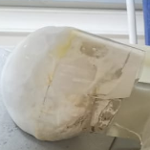 | Skull, Sinus Cavities, Ear Canals, Mandibula and Maxilla, Representative Teeth | 2 kg | H: 17 cm  W:14 cm  D: 17 cm
Trunk  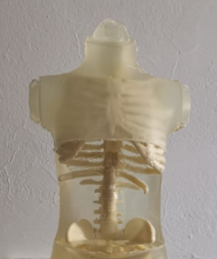 | Chest, Rib Bones, Spinal Discs, Trachea, Scapula, Clavicle, Humerus Head, Pelvis, Femur Head, Lungs | 2 kg  “This section is left blank to allow different organs to be studied with different materials.” | H: 34 cm  W:21 cm
Arms  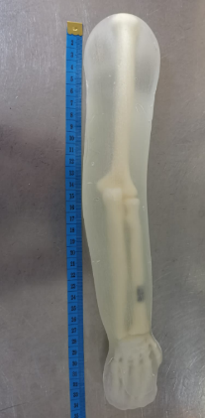 | Humerus, Ulna and Radius Bones  Hands and arms are designed in a natural hand position. | Weight of each arm:0.67 kg | H: 34 cm  W:8 cm  D: 5 cm
Right and Left leg  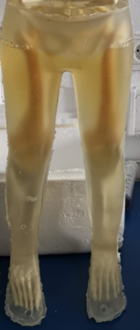 | Femur, Tibia, Fibula and Foot (Talus, Metatarsal, Cuboid)  The feet are designed in a dorsiflexion foot position. | Weight of each leg :2.3 kg | H: 42 cm  W:9 cm  D: 18 cm

Table 3. CTDIvol and DLP values ​​of the paediatric phantom in the specified protocols
Exam | Tuve Voltage (kVp) | Tube Current (mA) | Pitch | CTDI_{vol} (mGy) | DLP (mGy.cm) | DE (mSv)
Head | 120 | 100 | 1.01 | 38.9 | 455.53 | 1.82
Head | 100 | 100 | 1.01 | 33.4 | 393.69 | 1.57
Abdomen and Pelvis | 120 | 100 | 1.22 | 5.5 | 219.5 | 4.39
Abdomen and Pelvis | 100 | 100 | 1.22 | 5.1 | 115.78 | 2.32
Thorax | 120 | 100 | 1.22 | 4.4 | 106.71 | 1.92
Thorax | 100 | 100 | 1.22 | 4.2 | 86.9 | 1.74
*DE: Dose Estimation

Table 4. Dose conversion factors for adult and paediatric patients per DLP
Body region | k (mSv. mGy⁻¹cm⁻¹)
 | 0 age | 1 age | 5 age | 10 age | Adult
Head and Neck | 0.013 | 0.0085 | 0.0057 | 0.0042 | 0.0031
Head | 0.011 | 0.0067 | 0.004 | 0.0032 | 0.0021
Neck | 0.017 | 0.012 | 0.011 | 0.0079 | 0.0059
Chest | 0.039 | 0.026 | 0.018 | 0.013 | 0.014
Abdomen and Pelvis | 0.049 | 0.03 | 0.02 | 0.015 | 0.015
Body | 0.044 | 0.028 | 0.019 | 0.014 | 0.015

Table 5. Comparison of paediatric phantom dose estimates with literature values
 |  | CTDIvol |  |  |  | DLP
CT Protokol | Age | This study | Galanski et al. (2005) | Shrimpton et al. (2003) | Gao et al. (2018) | This study | Galanski et al. (2005) | Shrimpton et al. (2003) | Gao et al. (2018)
Head | 1˗5 | 36 | 36 | 34 | 34 | 424.6 | 452 | 383 | 594
Head | 6˗10 | 36 | 44 | 44 | 36 | 424.6 | 582 | 508 | 599
Abdomen and Pelvis | 1˗5 | 5.3 | 4 | 4 | 4 | 167.6 | 162 | NA | 162
Abdomen and Pelvis | 6˗10 | 5.3 | 6 | 6 | 6 | 167.6 | 247 | NA | 247
Thorax | 1˗5 | 4.3 | 3 | 11 | 3 | 96.8 | 61 | 198 | 89
Thorax | 6˗10 | 4.3 | 5 | 14 | 4 | 96.8 | 102 | 303 | 124

