Supplementary Materials

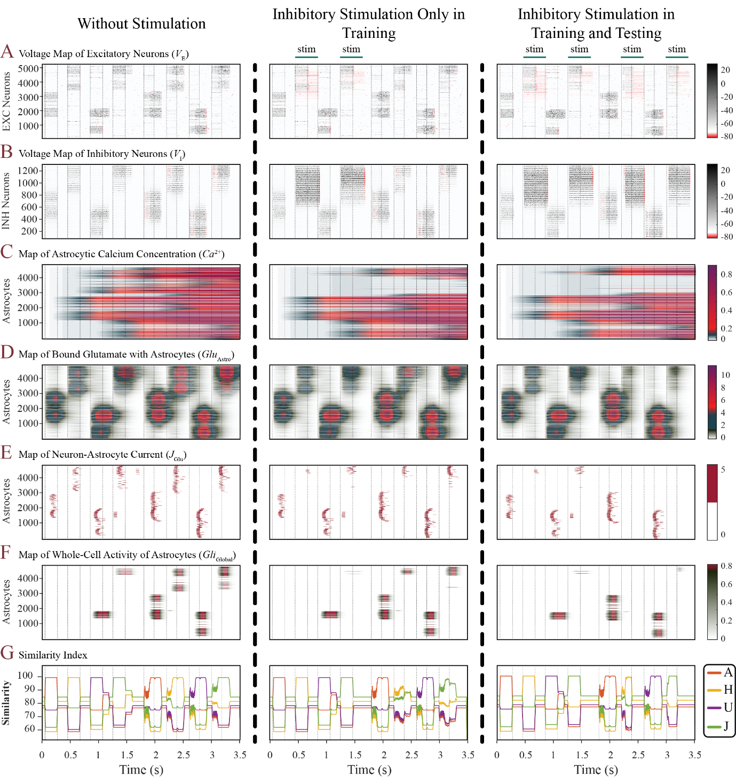
Figure S1: Activity Maps of Key Model Variables in Experiment 2 for Working Memory Disruption. Inhibitory stimulation diminishes working memory (WM) performance across all variables. As the iteration of inhibitory stimulation increases from “only in train” to “both train and test”, the performance of all activity maps further diminishes.
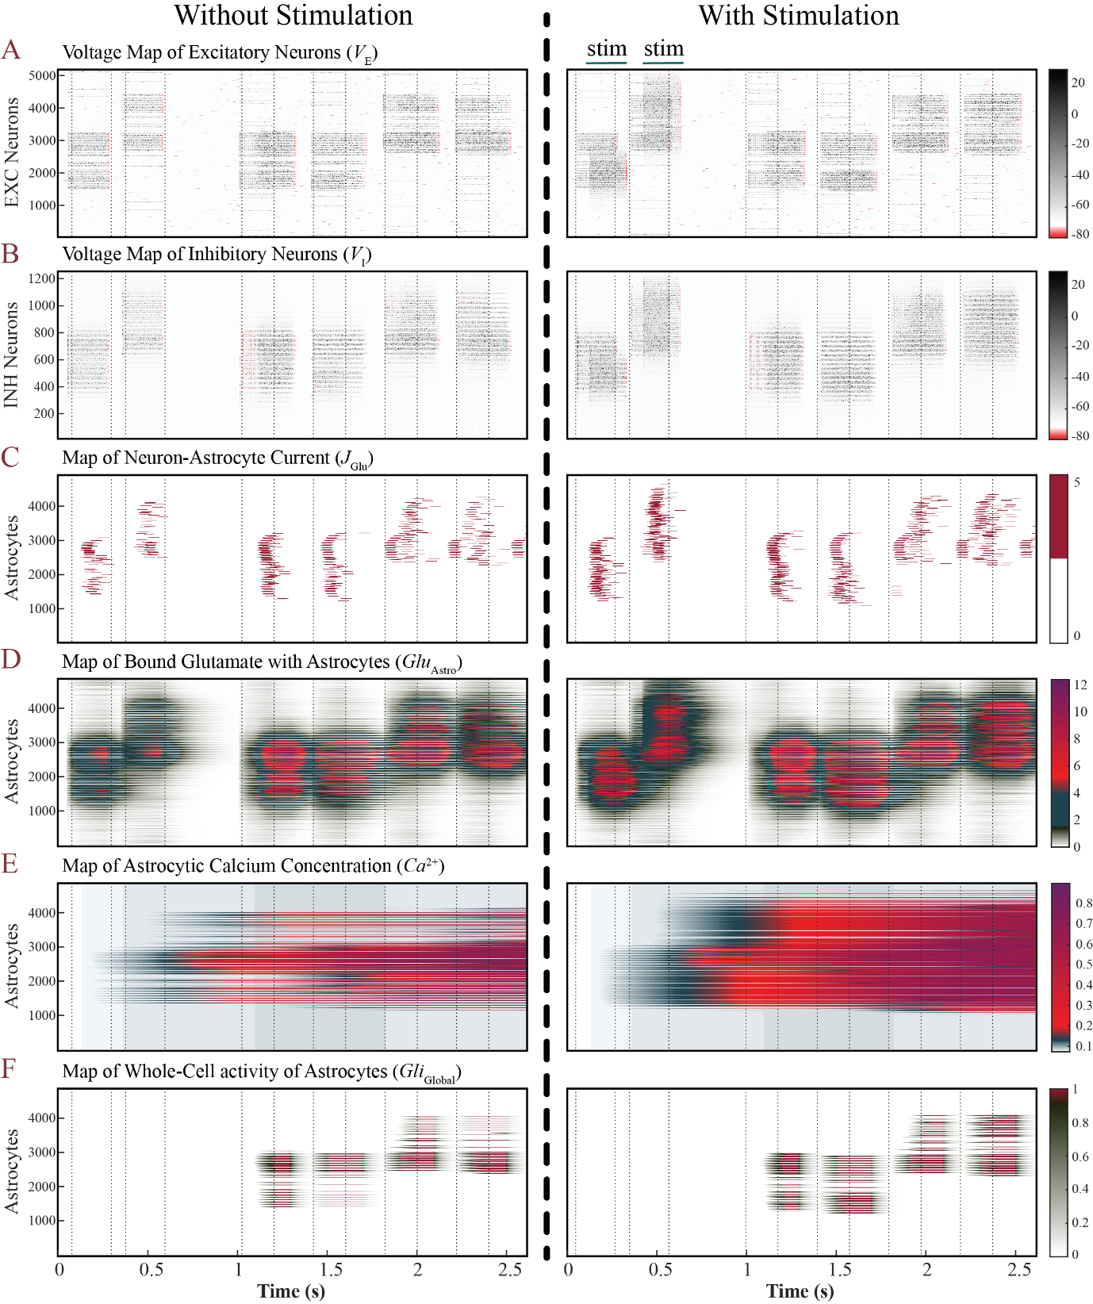
Figure S2: Activity Maps of Key Model Variables in Experiment 3 for Working Memory Augmentation. Excitatory stimulation enhances WM performance across all variables.

Table S1. Neural network parameters.
Parameter | Description | Value
$$i×j$$ | Grid size of the excitatory neural network. | 71 $×$ 71
$$p×q$$ | Grid size of the inhibitory neural network. | 35 $×$ 35
$$a$$ | Time scale of the recovery variable. | 0.1
$$b$$ | The recovery variable’s sensitivity to the sub-threshold fluctuations of the membrane potential. | 0.2
$$c$$ | Post-spike membrane potential reset level. | $-65$ mV
$$d$$ | Post-spike reset point of the recovery variable. | 2
$$η_{{Syn}_{EE}}$$ | Synaptic weight within excitatory synapses. | 0.015
$$η_{{Syn}_{EI}}$$ | Synaptic weight between excitatory-inhibitory synapses. | 0.1
$$η_{{Syn}_{IE}}$$ | Synaptic weight between inhibitory-excitatory synapses. | 0.15
$$η_{WM}$$ | Strength of astrocyte-mediated synaptic weight modulation. | 25
$$E_{Syn_{E}}$$ | Synaptic reversal potential for excitatory synapses. | 0 mV
$$E_{Syn_{I}}$$ | Synaptic reversal potential for Inhibitory synapses. | -90 mV
$$S_{Syn}$$ | Slope of the synaptic activation function. | 0.2 mV
$$N_{Out_{EE}}$$ | Number of efferent (outward) connections per presynaptic neuron within the excitatory network. | 40
$$N_{Out_{EI}}$$ | Number of efferent connections per presynaptic excitatory neuron to the inhibitory network. | 10
$$N_{Out_{IE}}$$ | Number of efferent connections per presynaptic inhibitory neuron to the excitatory network. | 30
$$λ_{EE}$$ | The mean of the exponential distribution of synaptic connection distances within the excitatory network. | 4
$$λ_{EI}$$ | The mean of the exponential distribution of synaptic connection distances from excitatory to inhibitory neurons. | 2
$$λ_{IE}$$ | The mean of the exponential distribution of synaptic connection distances from inhibitory to excitatory neurons. | 3
$$τ_{Glu}$$ | Glutamate clearance rate. | 0.1
$$r_{Glu}$$ | Glutamate release rate operating with SoI. | 450 $μ$M s⁻¹

Table S2. Astrocyte network parameters.
Parameter | Description | Value
$$m×n$$ | Size of astrocytic network grid. | 70 $×$ 70
$$c_{0}$$ | Cytosolic Ca²⁺ concentration. | 2.0 $μ$M
$$c_{1}$$ | ER-to-cytosol volume ratio. | 0.185
$$v_{1}$$ | Max Ca²⁺ channel flux. | 6 s⁻¹
$$v_{2}$$ | Ca²⁺ leak flux constant. | 0.11 s⁻¹
$$v_{3}$$ | Maximum Ca²⁺ uptake rate. | 2.2 $μ$M s⁻¹
$$v_{4}$$ | Maximum IP₃ production rate. | 0.3 $μ$M s⁻¹
$$v_{6}$$ | Maximum rate of activation-dependent calcium influx. | 0.2 $μ$M s⁻¹
$$k_{1}$$ | Ca²⁺ extrusion rate constant. | 0.5 s⁻¹
$$k_{2}$$ | Half-saturation constant for agonist-dependent calcium entry. | 1 $μ$M
$$k_{3}$$ | ATP-Ca²⁺ pump activation constant. | 0.1 $μ$M
$$k_{4}$$ | Dissociation constant for Ca²⁺ stimulation of IP₃ production. | 1.1 $μ$M
$$d_{1}$$ | IP₃ dissociation constant. | 0.13 $μ$M
$$d_{2}$$ | Dissociation constant for Ca²⁺ inhibition. | 1.049 $μ$M
$$d_{3}$$ | IP₃ receptor dissociation constant. | 943.4 nM
$$d_{5}$$ | Ca²⁺ activation constant. | 82 nM
$$α$$ | - | 0.8
$$τ_{r}^{-1}$$ | Rate constant for loss of IP₃. | 0.14 s⁻¹
$$IP_{3}^{*}$$ | Steady state concentration of IP₃. | 0.16 $μ$M
$$d_{Ca}$$ | Ca²⁺ diffusion rate. | 0.05 s⁻¹
$$d_{{IP}_{3}}$$ | IP₃ diffusion rate. | 0.05 s⁻¹
$$ζ_{Global}$$ | Efficacy of the Ca²⁺ depletion for whole-cell astrocytic activity. | 0.1

Table S3. Neuron-astrocyte bidirectional interaction parameters.
Parameter | Description | Value
$$N_{a}$$ | Number of neurons interacting with a single astrocyte. | 4, 2 $×$ 2
$$A_{Glu}$$ | IP₃ production rate through the released neurotransmitter. | 5 $μ$M s⁻¹
$$t_{Glu}$$ | IP₃ production duration through the released neurotransmitter. | 60 ms
$${Glu}_{Thr\left(mem\right)}$$ | Threshold of astrocyte-bound glutamate required to trigger IP₃-mediated mechanisms of memory encoding. | $$3.4 μM$$
$${Glu}_{Thr\left(rec\right)}$$ | Threshold of astrocyte-bound glutamate required to initiate astrocyte whole-cell activity associated with recall in working memory. | $$1.6 μM$$
$${\left[Ca^{2+}\right]}_{Thr(WM)}$$ | Required Ca²⁺ concentration to initiate whole-cell activity (gliotransmitter release) for WM mechanism. | 0.15 $μ$M
$$t_{WM}$$ | Extension of the working memory time window ($W_{WM}$) beyond the time point $t_{Con}$. | 100 ms
$$τ_{Gli}$$ | Gliotransmitter clearance rate. | 0.1 s⁻¹
$$r_{Gli}$$ | Gliotransmitter release rate. | 15 $μ$M s⁻¹

Table S4. Input layer parameters.
Parameter | Description | Value
$$f_{bg}$$ | Rate of background activity. | 1.4 Hz
$$A_{Train}$$ | Amplitude of current for input patterns during training phase. | 12 $μA$
$$t_{Train}$$ | Duration of current for input patterns during training phase. | 220 ms
- | Standard deviation of noise added to training samples. | 2 %
$$A_{Test}$$ | Amplitude of current for input patterns during testing phase. | 8 $μA$
$$t_{Test}$$ | Duration of current for input patterns during testing phase. | 200 ms
- | Standard deviation of noise added to test stimuli. | 5 %
$$A_{Noise}$$ | Amplitude of current for background noise activity. | 5 $μA$

Table S5. Recording and stimulating electrodes parameters.
Parameter | Description | Value
$$I_{Stim_{E}}$$ | Excitatory stimulation amplitude. | 20 $μA$
$$I_{Stim_{I}}$$ | Inhibitory stimulation amplitude. | 50 $μA$
$$t_{Enhance}$$ | Duration of excitatory stimulation for WM enhancement in experiment 1. | 400 ms
$$t_{Disrupt}$$ | Duration of inhibitory stimulation for WM disruption in experiment 2. | 200 ms
$$t_{Augment}$$ | Duration of excitatory stimulation for WM augmentation in experiment 3. | 200 ms
$$E_{Record}$$ | Number of recording electrodes. | 64, 8 $×$ 8
$$E_{Stim}$$ | Number of stimulating electrodes. | 16, 4 $×$ 4
$$λ_{Rec}$$ | Spatial extent of Gaussian function for sensitivity of recording electrodes. | 2.5
$$λ_{Stim}$$ | Spatial extent of Gaussian function for sensitivity of stimulating electrodes. | 5.5
$$x_{\text{Offset}}$$ | X-axis offset of electrode positions from the edges. | 2.5
$$y_{\text{Offset}}$$ | Y-axis offset of electrode positions from the edges. | 2.5

