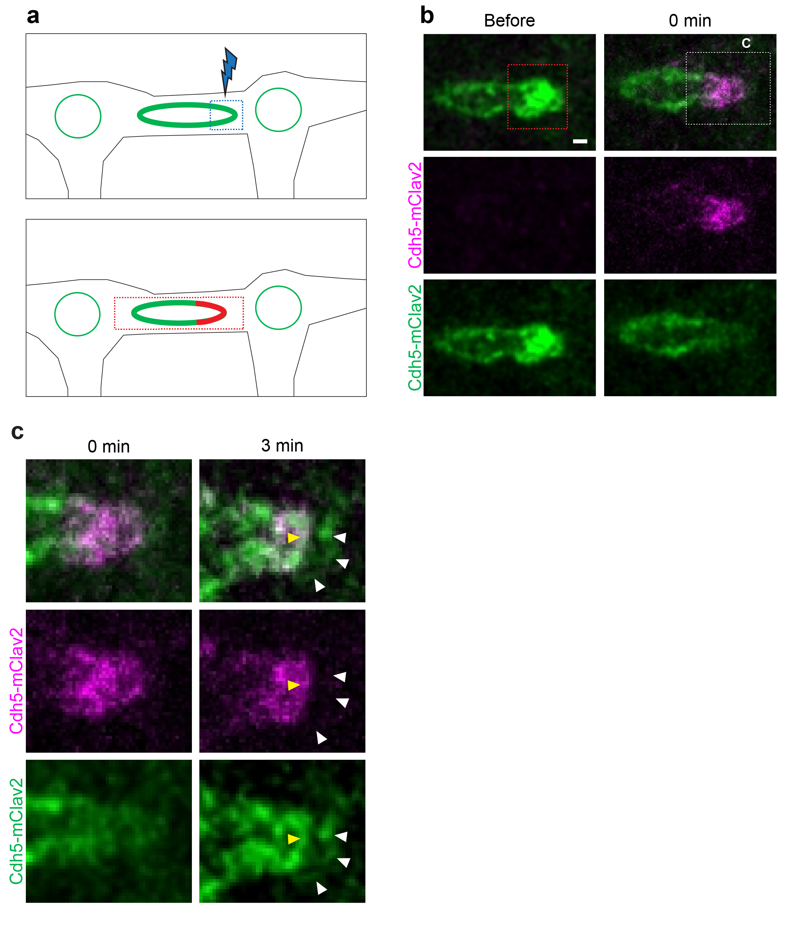
Supplementary Figure 1: The distal junctions form de novo. a: Schematic representation of the experimental design. At first mClav2 labeled VE-cad is photoconverted in one pole of the junctional ring. Then time lapse imaging is performed on the half-converted ring. b: Time-lapse (Supplementary movie 7) of a DLAV junctional ring of an embryo expressing Cdh5-mClav2 before and right-after photoconversion. The red dashed square delimitates the photoconverted area. White dashed square demarcates the zoomed-in area of c. c: Time-lapse of the zoomed in junctional ring pole. right-after photoconversion and 4 min later. White and yellow arrowheads point distal and proximal junction respectively. Distal junction is labeled by green, non-photoconverted VE-cad; but not by red photoconverted VE-cad.

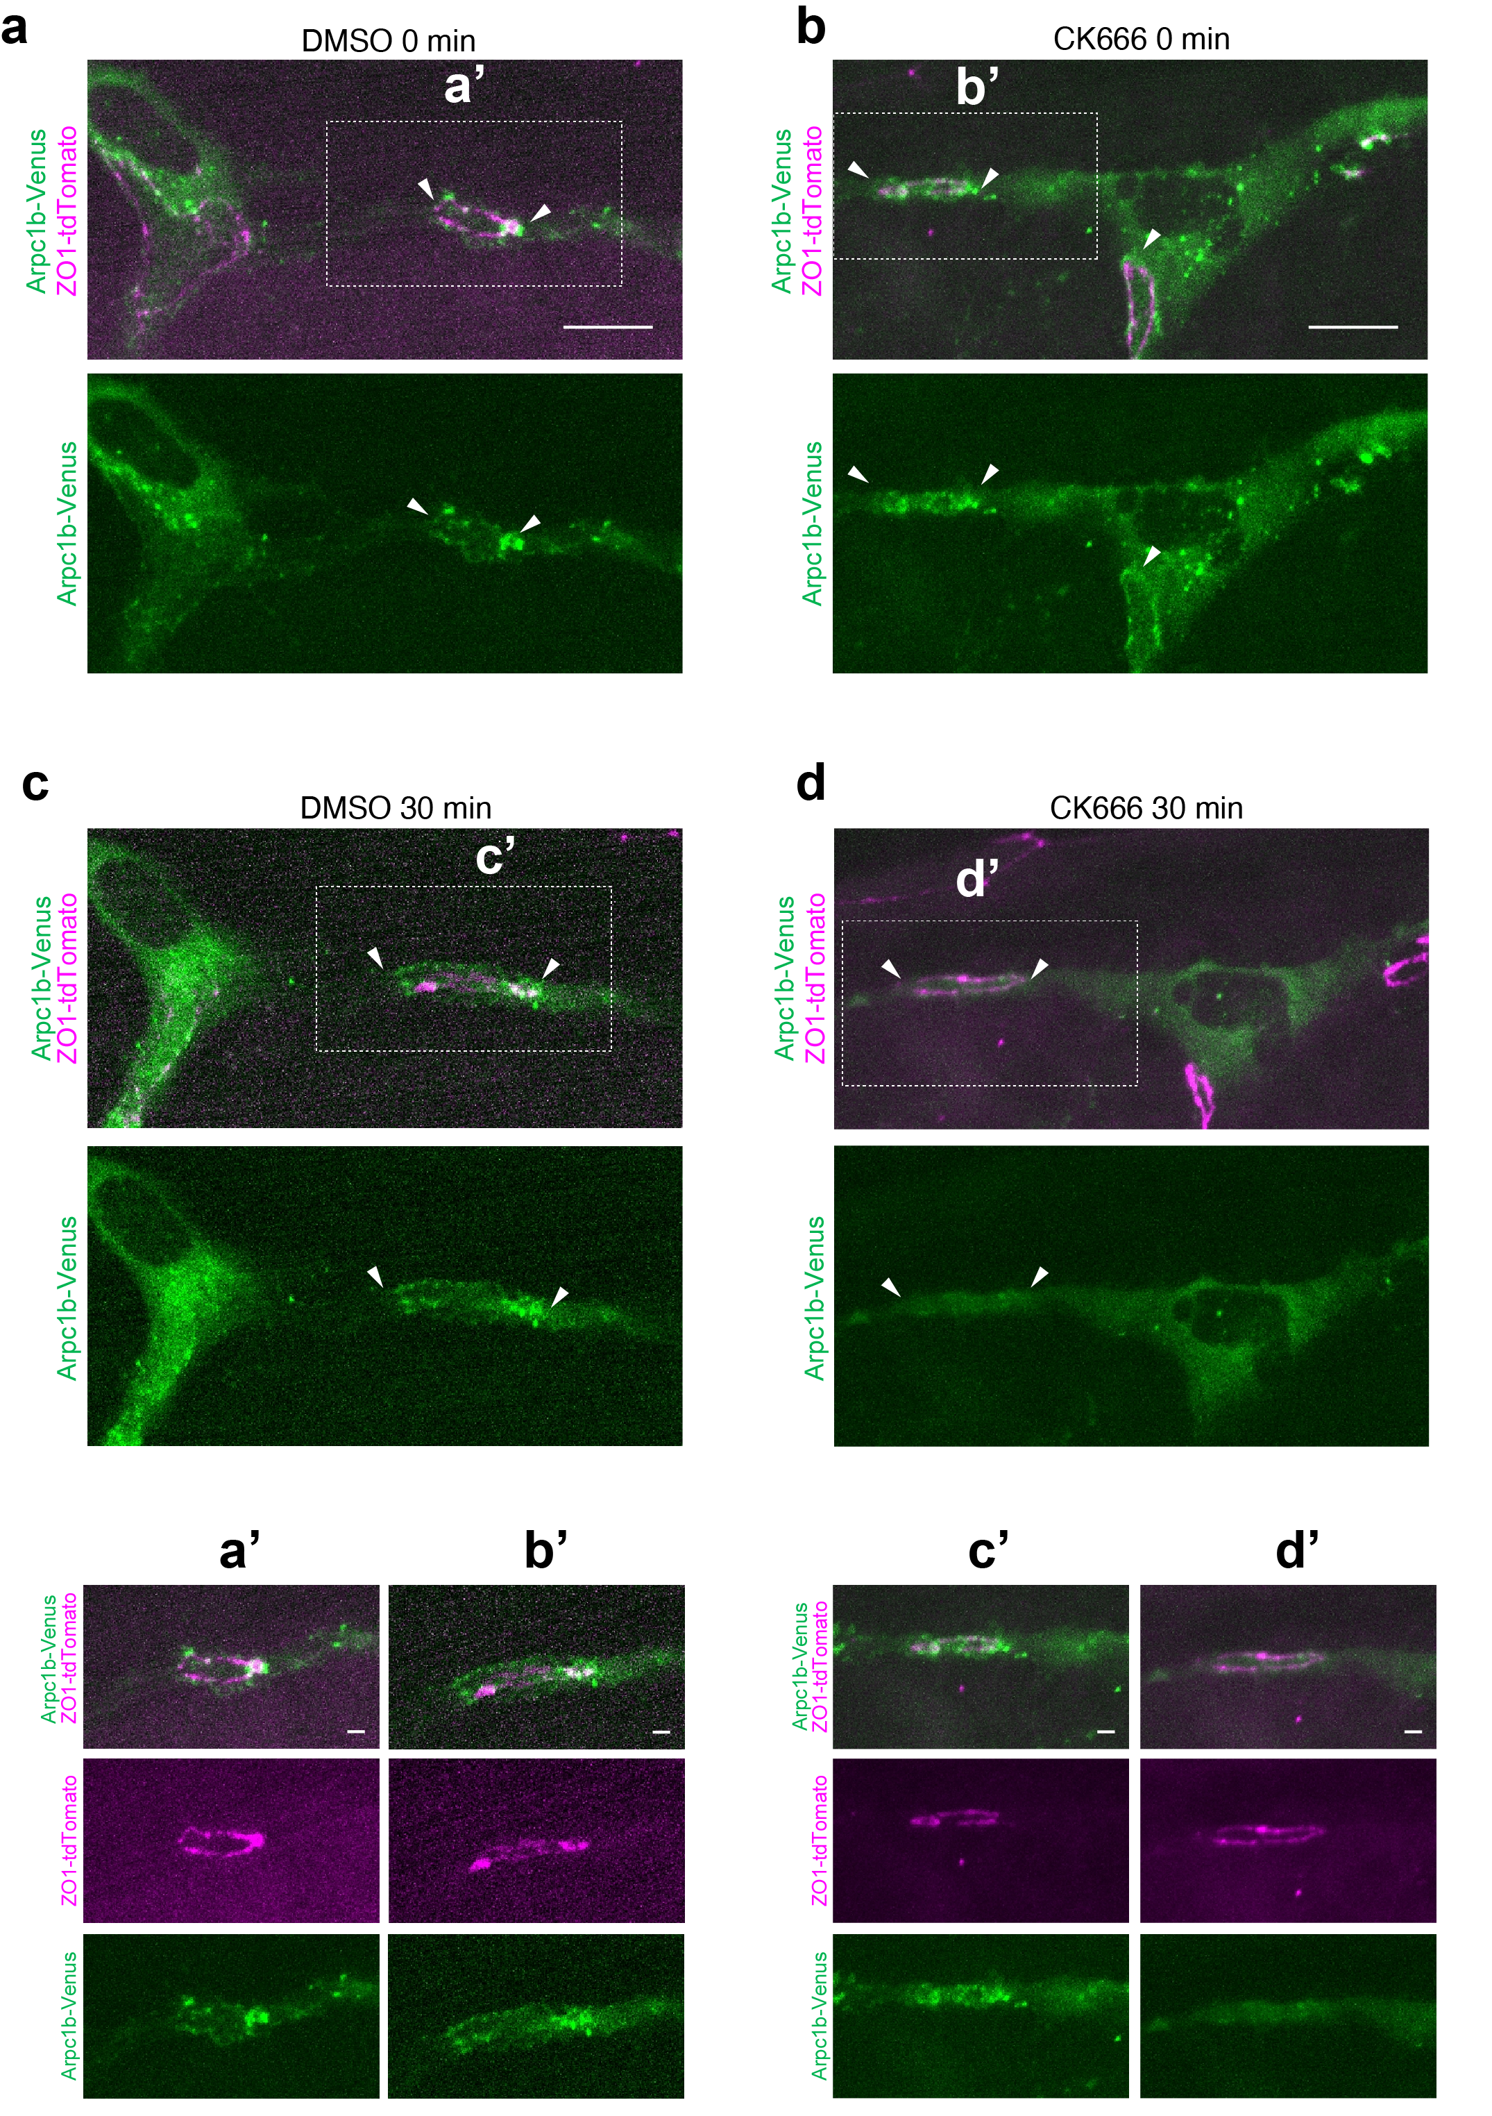Supplementary Figure 2: CK666 disrupts Arp2/3 localization in DLAV anastomotic junctions. Stills of Arpc1b-Venus and ZO1-td tomato before (a, c) and after 30 min treatment with DMSO 1% c (n=17) and CK666 200 µM d (n=25). T0 around 30 hpf n>20. White arrow heads are pointing at junctional poles. a’, b’, c’, d’ are magnifications of the white dashed square delimited areas.

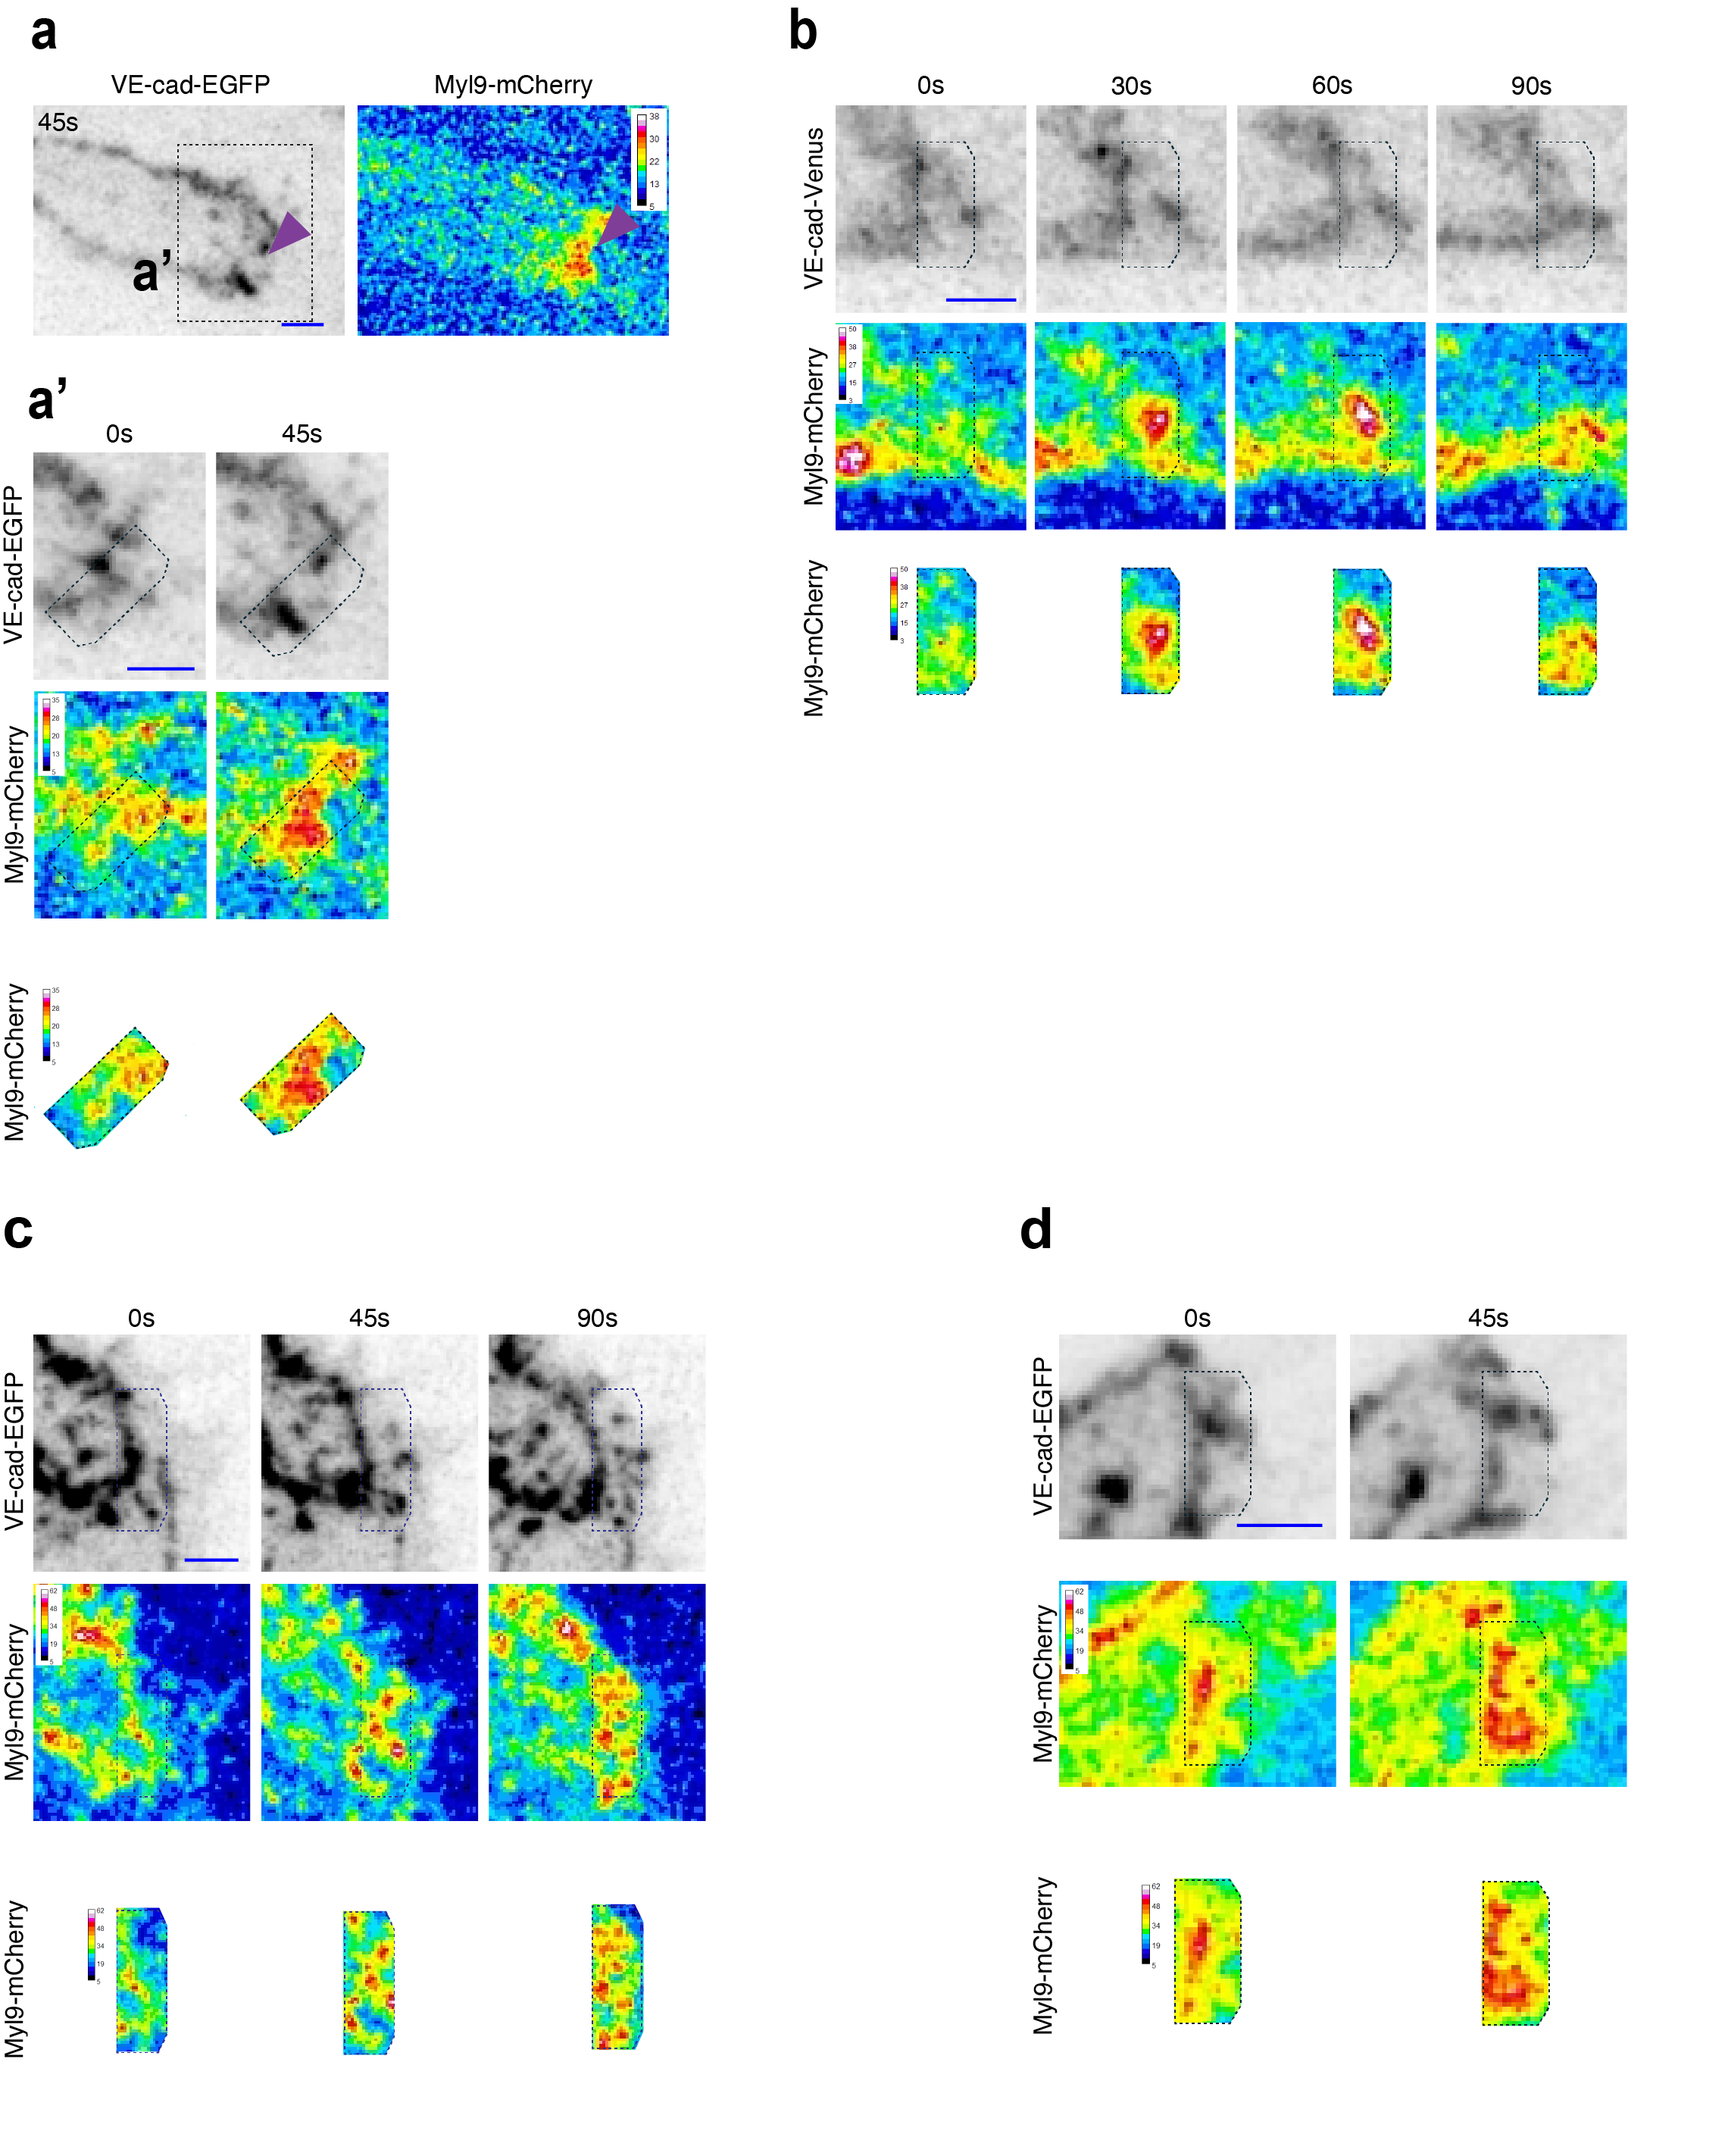
Supplementary Figure 3: Myosin light-chain recruitment at the interjunctional space during merging.
a, a’: Time-lapse of Cdh5ΔC-EGFP and Myl9b-mCherry during doble junction state (Supplementary movie 17). a: Still-image showing polarized accumulation of MLC during ‘’double junction’’ state. a’: Still-images showing recruitment of MLC between proximal and distal junction. b: Still-images from a time-lapse (Supplementary movie 18) of VE-cad-Venus and Myl9b-mCherry showing increase of MLC in the junctional space prior to proximodistal junction mergence. c, d: Time-lapses of Cdh5ΔC-EGFP and Myl9b-mCherry (Supplementary movies 19, 20) showing recruitment of MLC between proximal and distal junction during ‘’double junction’’ state.

