Supplementary Information

Goodness of fit of the spatial Poisson models

Eggs
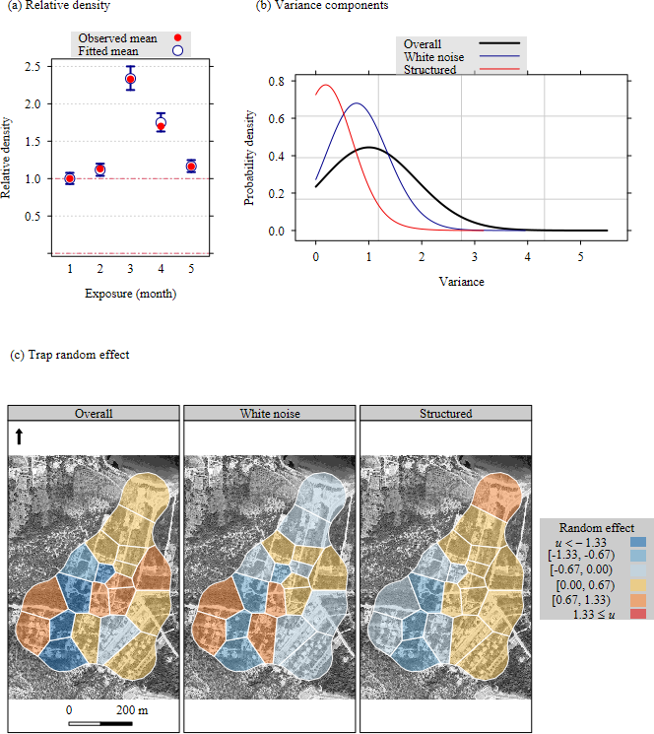
Figure S1: Fitted relative density and spatial random effect for a spatial Poisson model of relative density of eggs of Aedes albopictus monitored with ovi-position traps during a boosted-SIT field experiment implemented from May to November 2023 in Vravrona (Attica, Greece). The white-border polygons were defined by a Voronoi tessellation of trap locations. The background maps in graphs a and b were retrieved from the Google Maps Platform https://mapsplatform.google.com/, using functions available in the ggmap package for R https://github.com/features/packages version 4.0.0, together with a private API key.

Adults
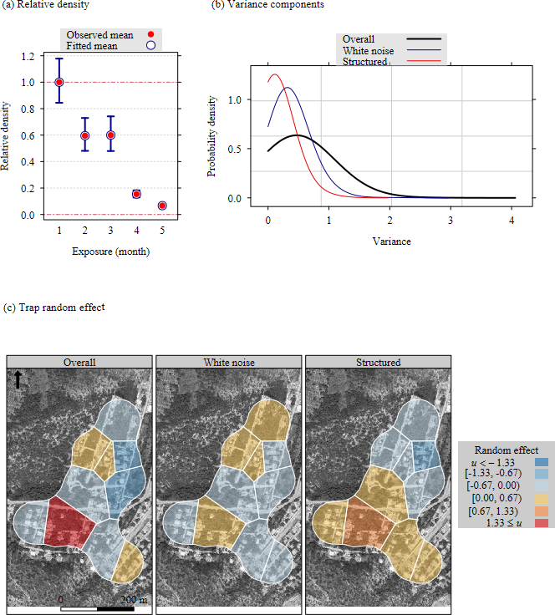
Figure S2: Fitted relative density and spatial random effect for a spatial Poisson model of relative density of adult Aedes albopictus monitored with human landing catches during a boosted-SIT field experiment implemented from May to November 2023 in Vravrona (Attica, Greece). The white-border polygons were defined by a Voronoi tessellation of trap locations. The background maps in graphs a and b were retrieved from the Google Maps Platform https://mapsplatform.google.com/, using functions available in the ggmap package for R https://github.com/features/packages version 4.0.0, together with a private API key.

