Development of an atrazine immunoassay based on highly catalytically active Au@PtNPs and specific nanobody

Jia Kang,^{a#} Meng Qi,^{b#} YasenWang,ª Linchun Li,ª Xinda Zhou,ª Xiaoshuo An,ª Bruce D. Hammock,^{c} Jinlin Zhang,^{a*} Jingqian Huo^{a*}
ª College of Plant Protection, Hebei Agricultural University, Baoding 071001, P. R. China.
^{B} Langfang Normal University, Langfang 065000, P. R. China.
^{C} Department of Entomology and Nematology and UCD Comprehensive Cancer Center, University of California, Davis, California 95616.
# These authors contribute equally to this work

_______________________________________________
*Corresponding author: Prof. Jingqian Huo and Jinlin Zhang
Tel: +86-13731261831
Fax: +86-0312-7528166
E-mail address: huojingqian@hebau.edu.cn, zhangjinlin@hebau.edu.cn
Nanobody-based ic-ELISA
The plate was coated with 100 μL of 2e-BSA overnight at 4°C and then the blocking buffer (3% skimmed milk in 1×PBS, 200 μL/well) was added and incubated for 1 h at room temperature after the plate washed three times with PBST (0.05% Tween-20 in 1×PBS). 50 μL of atrazine standard solutions and 50 μL of Nanobody-26 diluted in 1×PBS were added to the plate after the blocking buffer was removed and the plate was washed three times with PBST. After 1 h of the competitive reaction, the plate was washed five times with PBST and then HRP Anti-6X His tag® antibody was added (1/10000 dilution; 100 μL/well) and incubated for 1 h at room temperature. After washing five times with PBST, TMB two-component substrate solution was added (100 μL/well) and incubated for 15 min at room temperature. Finally, the reaction was stopped by addition of 2 M H2SO4 (50 μL/well), and the absorbance was measured at 450 nm.
Synthesis of AuNPs
200 μL of HAuCl4 (48 mmol/L) and 9.8 mL of ultrapure water were added to a round-bottom flask, and the chloroauric acid solution was heated to boiling using a heating stirrer, followed by the rapid addition of 1% trisodium citrate solution (1 mL). The above reaction mixture was stirred and mixed thoroughly under the condition of continuous heating until the color of the solution was changed from light yellow to pink, and then was cooled to room temperature. The prepared colloidal gold was centrifuged at 12000 rmp and the precipitate was re-dissolved with 0.02% trisodium citrate solution (or filtered through 220 nm microporous membrane) which was stored at 4°C for future use. The concentration of AuNPs solution (about 18 nM) was calculated according to Lambert's law and the initial gold concentration as well as the size of gold nanoparticles.
Au@PtNPs-nanobody probe-based dc-ELISA
The plate was coated with 100 μL of 2e-BSA overnight at 4°C and then the blocking buffer (1% BSA in 1×PBS, 200 μL/well) was added and incubated for 1 h at room temperature after the plate washed three times with PBST (0.05% Tween-20 in 1×PBS). After removing the blocking buffer and washing the plate three times with PBST, 50 μL of atrazine standard solution and 50 μL of Au@PtNPs-nanobody probe diluted with 1×PBS were added to start the competition reaction for 1 h. Then the plate was washed 5 times with PBST, and TMB two-component substrate solution (100 μL/well) was added and incubated for 15 min at room temperature. Finally, the reaction was stopped by the addition of 2 M H₂SO₄ (50 μL/well), and the absorbance was measured at 450 nm.

Table S1 Information of primers for nanobody gene amplification and sequencing
Primer | Sequences
CALL001 | 5’-GTC CTG GCT GCT CTT CTA CAA GG-3’
CALL002 | 5’-GGT ACG TGC TGT TGA ACT GTT CC-3’
VHH-F | 5’-CAT GCC ATG ACT GT GGCCCAGGCGGCC CAG KTG CAG CTC GTG GAG TC-3’
R3 | 5’-CAT GCC ATG ACT CGC GGCCGGCCTGGCC ATG GGG GTC TTC GCT GTG GTG CG-3’
R4 | 5’-CAT GCC ATG ACT CGC GGCCGGCCTGGCC GTC TTG TGG TTT TGG TGT CTT GGG-3’
JH | 5’-CCA CGA TTC TGGCCGGCCTGGCC TGA GGA GAC RGT GAC CTG GGT CC-3’
gback | 5’-GCCCCCTTATTAGCGTTTGCCATC-3’

Table S2 Results of the spike and recovery study based on test strips
Samples | Spiked concentration（ng/g） | Test strip results
Samples | Spiked concentration（ng/g） | Results (n=3)
Tap water | 0 | - | - | -
Tap water | 20 | + | + | +
Tap water | 50 | + | + | +
Tap water | 100 | + | + | +
River water | 0 | - | - | -
River water | 20 | - | - | -
River water | 50 | + | + | +
River water | 100 | + | + | +
Soil | 0 | - | - | -
Soil | 50 | - | - | -
Soil | 100 | + | + | +
Soil | 200 | + | + | +
Notes: +: positive; -: negative

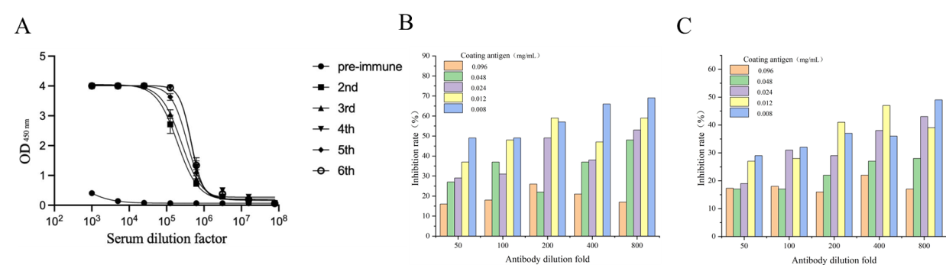
Fig.S1 (A)Titers of serum; (B) Effect of different concentrations of 2e-BSA and antibody on the sensitivity of ic-ELISA; (C) Effect of different concentrations of 2e-OVA and antibody on the sensitivity of ic-ELISA

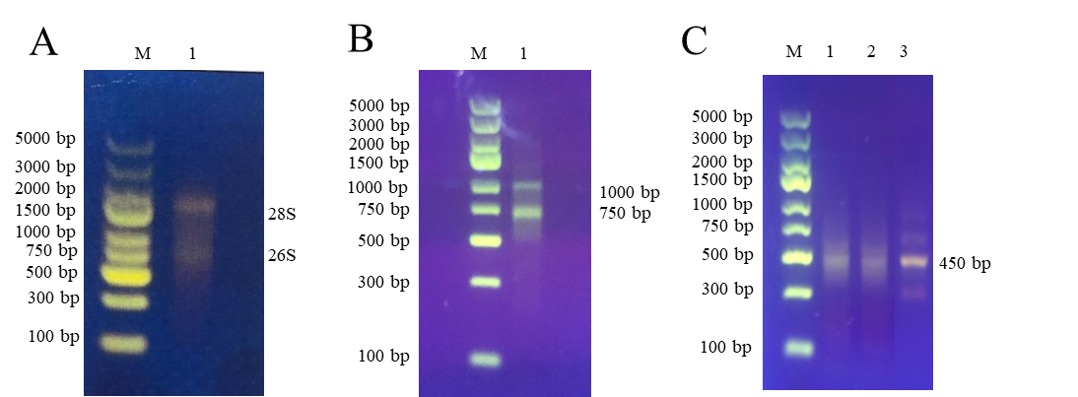
Fig.S2 Construction of phage-displayed nanobody libraries
(A) Total RNA extracted from lymphocyte, M: marker, lane 1: total RNA; (B) Bank of nanobody gene, the amplification production of first (lane 1) RT-PCR; (C) Bank of nanobody gene, the amplification production of second (lane 3) RT-PCR.

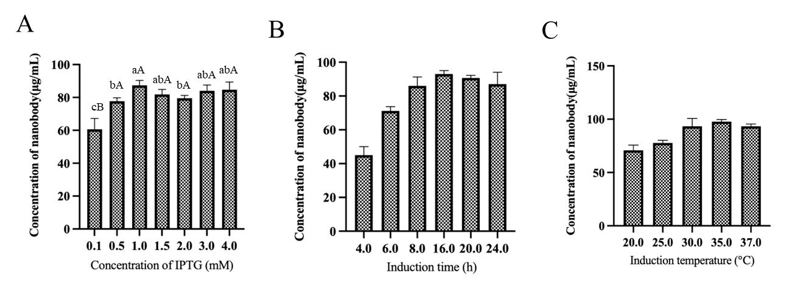
Fig.S3 Conditions optimization for nanobody expression
(A) Effect of different IPTG concentration on the expression of nanobodies; (B) Effect of different induction times on the expression of nanobodies; (C) Effect of different induction temperatures on the expression of nanobodies

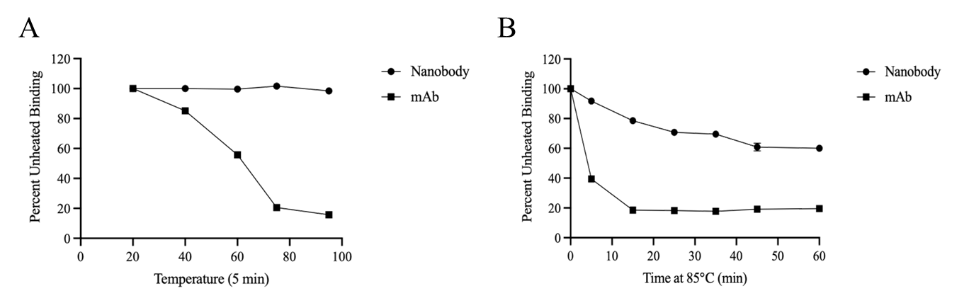
Fig.S4 Comparison of thermal stability between nanobody and monoclonal antibody
(A) Comparison of thermal stability of nanobody and monoclonal antibody treated at different temperatures for 5 minutes; (B) Comparison of thermal stability of nanobody and monoclonal antibody treated at 85 ℃ for different times

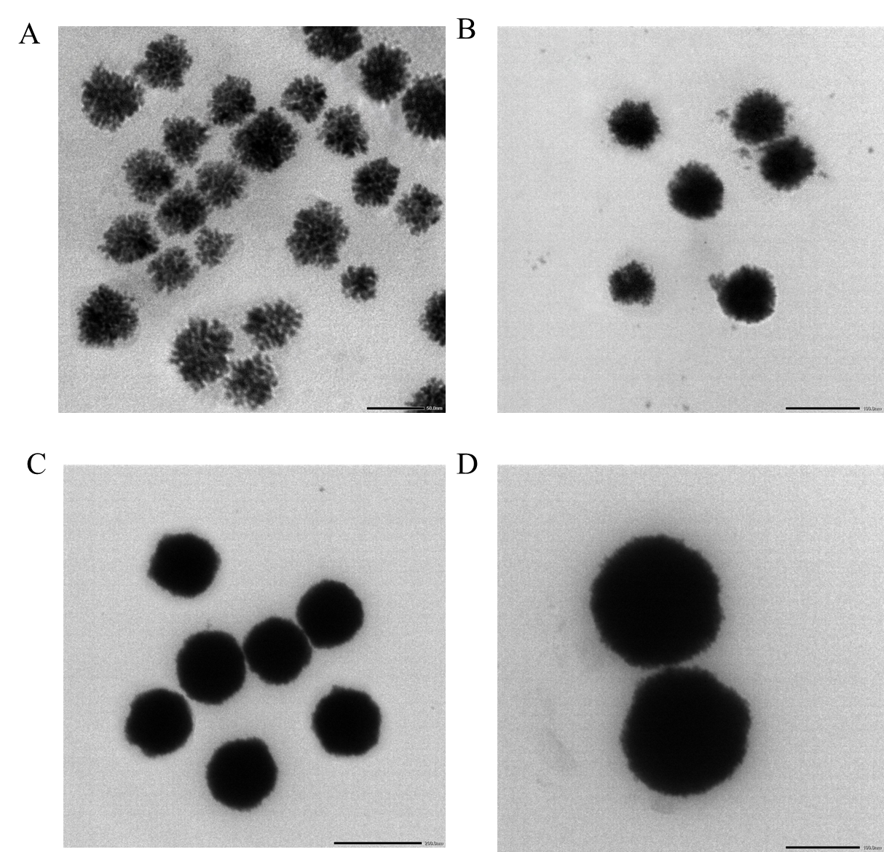
Fig.S5 TEM images of Au@PtNPs with different particle sizes
(A)70 nm; (B) 95 nm; (C)135 nm; (D)165 nm

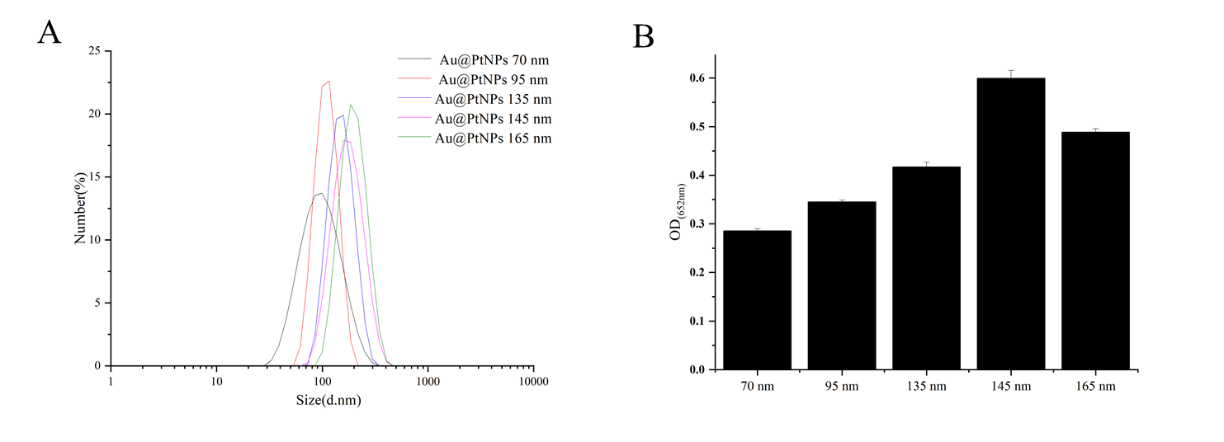
Fig.S6 The performance of Au@PtNPs with different particle sizes
(A) Water dispersibility of Au@PtNPs with different particle sizes; (B) Catalytic activities of Au@PtNPs with different particle sizes

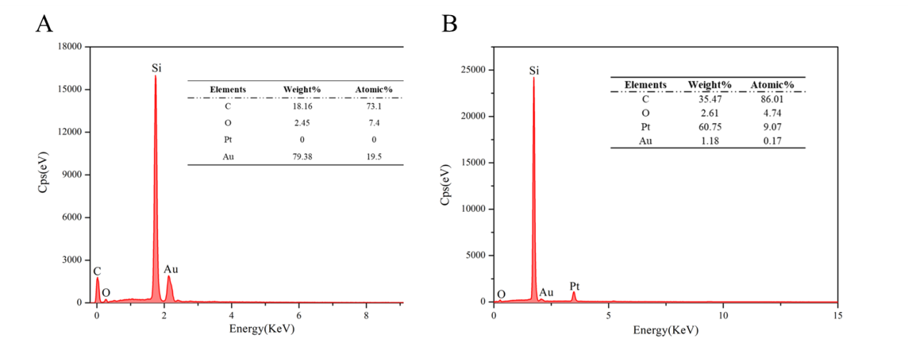
Fig.S7 The EDS mapping of AuNPs (A) and Au@PtNPs-145 nm (B);
EDS energy spectrum of Au@PtNPs(C).

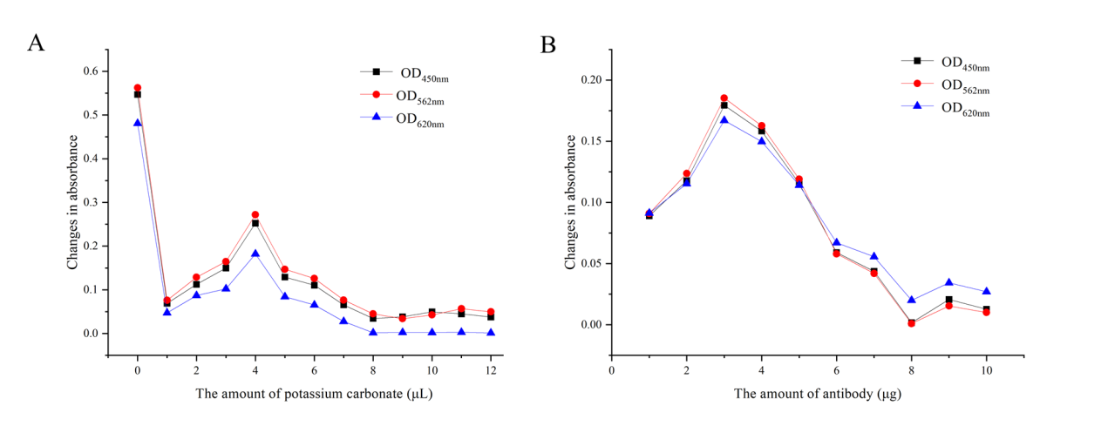
Fig.S8 Optimization of coupling conditions for Au@PtNPs and nanobodies
(A) Effect of pH on the coupling results; (B) Effect of antibody concentration on the coupling results
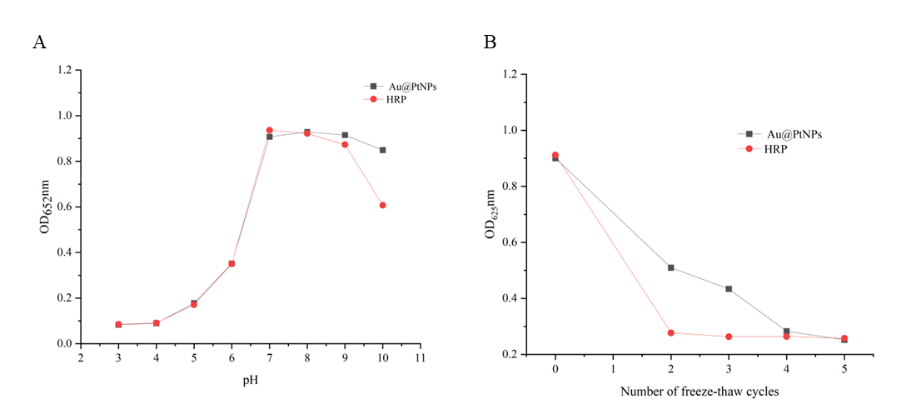

Fig.S9 Stability Comparison of Au@PtNPs and HRP
(A)pH stability;(B) Freeze-thaw cycle stability

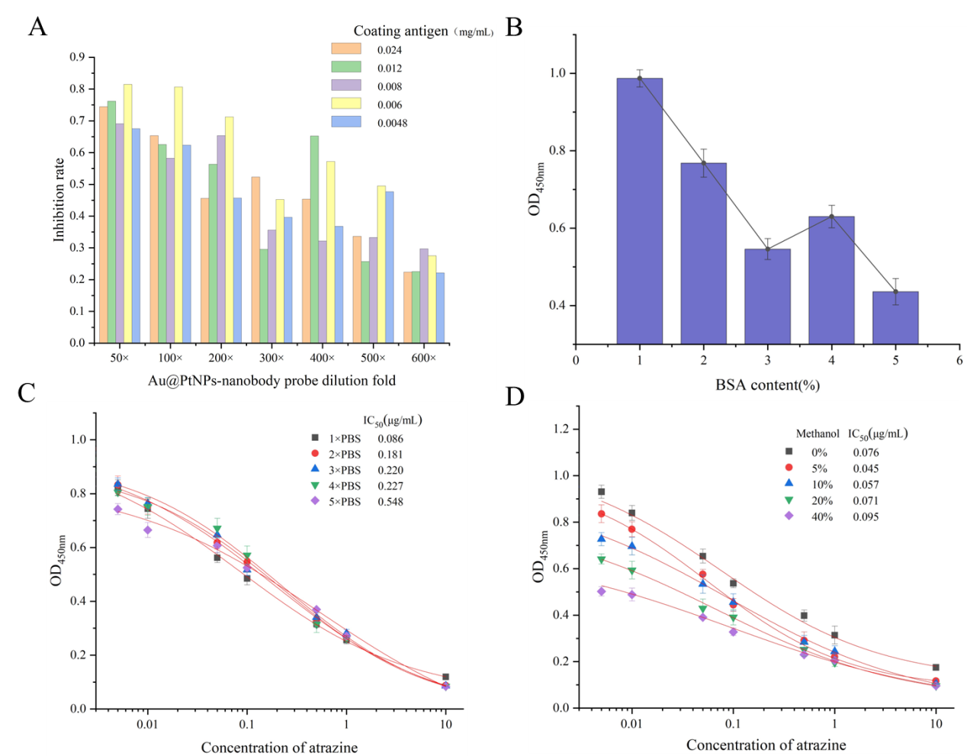
Fig.S10 Optimization of dc-ELISA conditions based on Au@PtNPs-nanobody probes
(A) Screening of optimal concentrations of coating antigen and Au@PtNPs-nanobody; (B) Screening of optimal concentration of BSA; (C) Effect of different Na+ concentrations on the sensitivity of the dc-ELISA; (D) Effect of different methanol concentrations on the sensitivity of the dc-ELISA

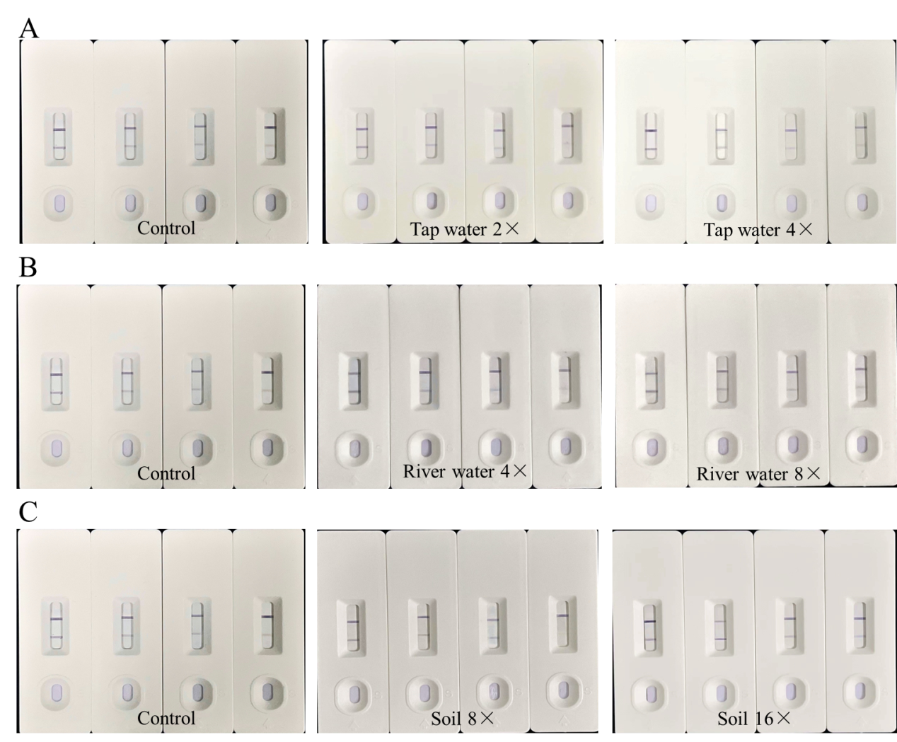
Fig.S11 Effect of different matrix on the detection sensitivity of test strips (the concentrations of atrazine in each group of four test strips processed from left to right were 0, 10, 25, 50 ng/mL). (A) tap water; (B) river water; (C) soil

