Appendix 1. Evaluation questions by phase and results.

Phase A. Training.

Content evaluation test.
E1: Components of Photovoltaic Power Plants
- Match the items in the left column with those in the right column by writing the corresponding number of the matched item in the blank box. (5 items)
- The following figure shows a cross-section view of the MV (Medium Voltage) cell. Match the labeled elements in the figure with the names listed below by writing in each circle the number corresponding to the appropriate item on the list. (7 items)
- The following figure shows an aisle of an HV (High Voltage) substation yard. Match the labeled elements in the figure with the names listed below by writing the corresponding number in each circle. (6 items)
- The following figure shows a GIS (Gas-Insulated Substation) bay. Match the labeled elements in the figure with the names listed below by writing in each circle the corresponding number from the list. Note: some numbers may appear more than once. (7 items)
- Draw the single-line diagrams for the positions shown in the three previous points. (3 diagrams)
- Match the items in the left column with those in the right column by writing the corresponding number in the blank box. (7 items)
E2: Switching Elements
- Mark T if the statement is true or F if it is false in the corresponding box. (12 statements)
- Match the items in the left column with those in the right column by writing the corresponding number in the blank box. (8 items)
- Fill in the missing words in the following text. (8 words)
- Arrange the following sequence of operations in logical order by writing the correct step number in the right-hand column. (2 sequences, each with 7 steps)
- Match the items in the left column with those in the right column by writing the corresponding number in the blank box. (6 items)
E3: Risk Prevention and Operational Maneuvers
- Mark T if the statement is true or F if it is false in the corresponding box. (9 statements)
- Match the items in the left column with those in the right column by writing the corresponding number in the blank box. (5 items)
- Fill in the missing words in the following text. (12 words)
- On the following page, match the items in the left column with those in the right column by writing the corresponding number in the blank box. (5 items)
- What is the minimum legal distance from the energized installation that qualified workers in the following figure are strictly prohibited from crossing with any part of their body or any tool? (provide exact numerical value)
- In the field, how would you ensure that this distance is not exceeded? (choose from 3 options)
- In the previous figure, what should be done to paint the part of the structure located within the hazardous zone? (choose from 3 options)

Individualized results by participant and question.
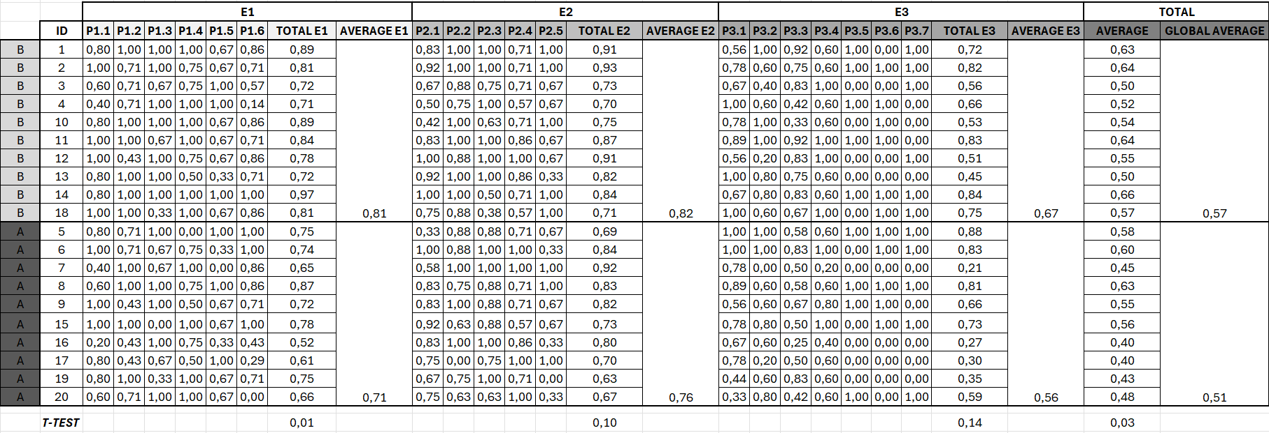
Fig. 13: Results obtained from the quantitative evaluation in exams E1, E2, and E3.
The figure 13 shows the result of the exam evaluation. The last row presents the t-test analysis to highlight the statistically significant differences between both groups.

Satisfaction survey.
1. Course Organization. 1.1 The course was well organized (information, adherence to dates and schedules, material delivery). 1.2 The number of students in the group was appropriate for the effective development of the course.
2. Course Content and Teaching Methodology. 2.1 The course content met my training needs. 2.2 There was an adequate balance between theoretical instruction and practical application.
3. Duration and Schedule. 3.1 The course duration was sufficient given its objectives and content. 3.2 The schedule facilitated attendance at the course.
4. Trainers. 4.1 The trainers' teaching or tutoring methods facilitated learning. 4.2 The trainers demonstrated in-depth knowledge of the subjects taught.
5. Didactic Materials (guides, manuals, worksheets, etc.). 5.1 The documentation and materials provided were clear and appropriate. 5.2 The didactic materials were up to date.
6. Facilities and Technical Resources (whiteboard, screen, projector, TV, video, computer, software, machines, tools, etc.) 6.1 The classroom, workshop, or facilities were appropriate for the course. 6.2 The technical resources were adequate for delivering the course content (computers, whiteboard, projector, TV, machines).
7. Online Performance. 7.1 The tutorial guides and didactic materials facilitated course completion (printed materials, applications). 7.2 Adequate support resources were available (individual tutoring, email and distribution lists, teleconferencing, virtual library, search engines).
8. Mechanisms for Learning Evaluation. 8.1 Evaluation and self-assessment tests were available, allowing me to gauge my level of learning. 8.2 The course provided a certificate recognizing my qualification.
9. Overall Course Assessment. 9.1 This course may contribute to my entry into the job market. 9.2 The course has enabled me to acquire new skills/capabilities applicable to my job. 9.3 It has improved my opportunities for career advancement, either within my company or elsewhere. 9.4 I have expanded my knowledge to progress in my professional career. 9.5 The course has supported my personal development.

10. Satisfaction with the Course. 10.1 Would you recommend this course?
Results of the Survey by Participant and Question. Yes/No questions were weighted with values of 4 and 0, respectively. Non-responses were also weighted with a value of 0.
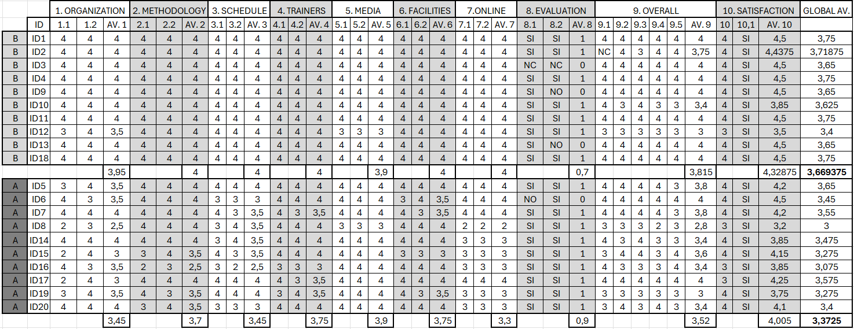
Fig. 14: Satisfaction survey results by participants and questions.
Figure 14 presents the individual results of each participant for the training satisfaction survey, broken down by each individual question. The survey received an average score of 3.67 out of 5 from Group B (theoretical training + VR), compared to an average score of 3.37 out of 5 from Group A (theoretical training only). The difference was statistically significant (p > 0.05, t-test).

Phase B. Evaluation questionnaire.
Comprehension and Knowledge Retention (Scale: 1–5)
- Do you believe that the training helped you better memorize the components and their layout within the electrical substation?
- Do you perceive that the training improved your ability to visually identify key high-risk equipment in a substation?
- Do you think the training facilitated your understanding of operational and safety procedures in high-voltage areas?
- Did the training help you clearly visualize the different work areas within the substation?
- Did the training enhance your understanding of the proper use of personal protective equipment (PPE)?
Risk Perception and Safety Procedures (Scale: 1–5)
- Do you feel more capable of identifying high-risk areas within the plant after completing the training?
- Did the training help you better understand the importance of maintaining safety distances in high-voltage zones?
- Do you feel that the training allowed you to better assimilate safety procedures, such as grounding and voltage verification?
- Do you consider that the training improved your ability to follow the “five golden rules” in substation operations?
- Did the training enable you to identify risks accurately and safely during specific maneuvers such as switching operations?

Confidence and Anticipation in Real-Life Scenarios (Scale: 1–5)
- Has the training provided you with greater confidence to face electrical hazard situations in the plant?
- Do you feel that the training improved your ability to react quickly to unexpected events?
- Do you believe that the training adequately prepared you to act in the event of an electrical failure or emergency in the substation?
- Do you think the training enabled you to develop a clear sequence of steps to follow during an emergency?
- Did the training give you more confidence to make safe decisions in a real work environment?
- Do you feel that the training has helped you become familiar with the stress conditions you may face during risk situations?
- Do you perceive that the training helped you understand when and how to alert your colleagues in a critical situation?
- Did you find the training useful for anticipating risks and implementing preventive measures during maintenance operations?
- Do you believe the training reduced uncertainty about how to respond to an emergency in the plant?
- Do you feel that the training has had a positive impact on your level of preparedness and personal safety in plant operations?
What would you add to the training experience, what did you feel was missing, and how would you improve it?
Individualized Results by Participant and Question.
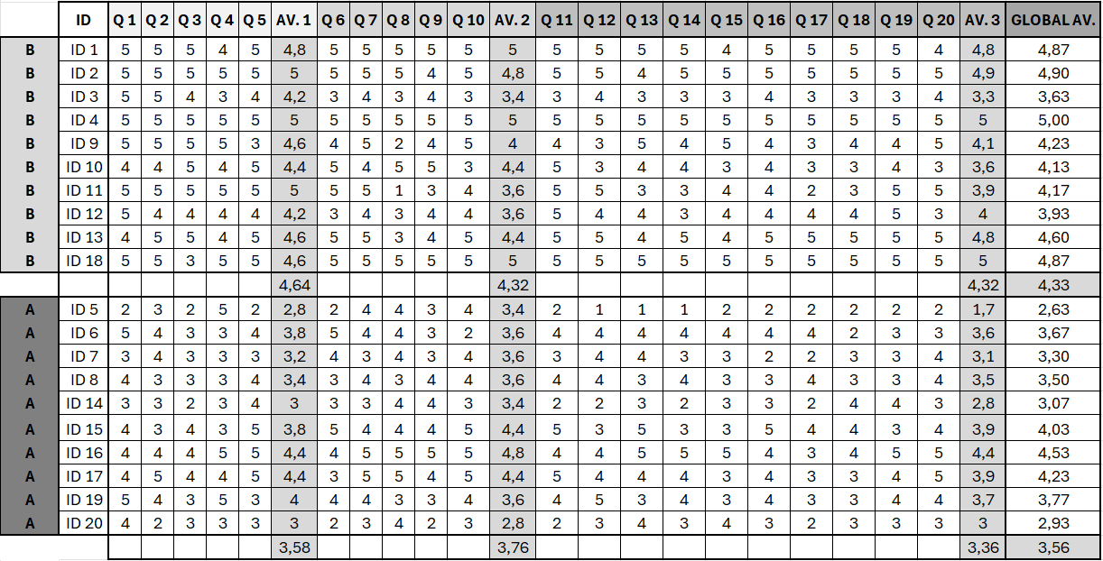
Fig. 15: weighted evaluation questionnaire.
Figure 15 shows the scores of each participant for each question in the questionnaire. For each block of questions, the average score was calculated, as reflected in the table, along with the corresponding percentage of that score relative to the total possible score for each block. The results indicate that Group B (theoretical training + VR) rated the overall training with an average score of 4.33, compared to 3.56 awarded by Group A (theoretical training only)

Phase C. Fire risk in controlled environment.
Controlled environment: fuel tray scenario. Pulse analysis data during the first test measured at 5-second intervals for each participant. Calculation of average values by group, standard deviation per individual, and pulse variance. Figure 16 shows the data collected form the workers in fuel tray scenario.
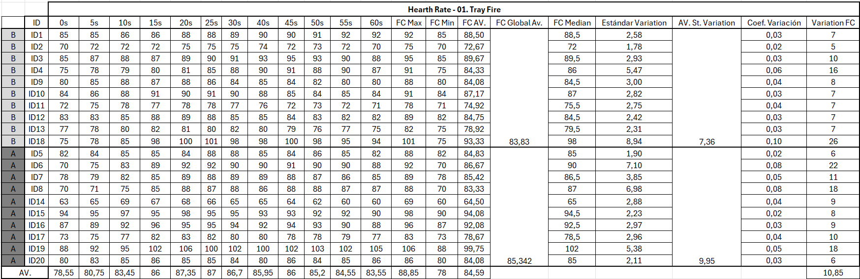Fig. 16: Cardiac biometric data measured per subject during the first test.
Controlled environment: electrical panel scenario. Pulse analysis data during the first test measured at 5-second intervals for each participant. Calculation of average values by group, standard deviation per individual, and pulse variance. Figure 17 shows the data collected form the workers in electrical panel scenario.
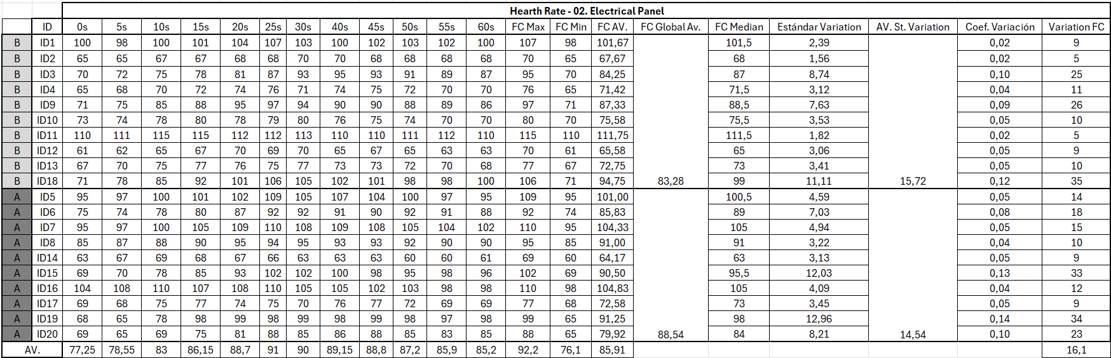
Fig. 17: Cardiac biometric data measured per subject during the second test.

