Part I: Data Card
The dataset includes nearly 10,000 infertile men and 13 features with continuous values. Below, you will find a detailed description of each feature:
- Semen Volume (ml): The total ejaculate volume produced.
- Sperm Concentration (10⁶/ml): The concentration of sperm cells per milliliter of semen.
- Total Motility (%): The percentage of sperm that show any type of motility.
- Progressive Motility (%): The percentage of sperm that move actively in a straight line or large circles.
- Non-progressive Motility (%): The percentage of sperm that exhibit movement without forward progression.
- Immotile Sperm (%): The percentage of sperm that do not show any movement.
- Abnormal Morphology (%): The percentage of sperm with abnormal shape or structure.
- Age (years): The age of the male partner in years.
- Sperm Count (10⁶): The total number of sperm cells in the entire ejaculate.
- TMS (10⁶): the total number of motile sperm celss in the entire ejaculate
- DNA Fragmentation Index (DFI) (%): The percentage of sperm cells with fragmented DNA in a semen sample. It is also derived from the Sperm Chromatin Structure Assay (SCSA).
- TUNEL (%): The percentage of sperm showing DNA fragmentation using the TUNEL assay, which detects DNA strand breaks.
- Case Number: A unique identifier assigned to each patient record for organizational purposes.
The last item contained no clinical information and was removed during the analysis to ensure confidentiality. Additionally, some features have mathematical relationships that are worth noting. For instance, Sperm Count is calculated by multiplying Semen Volume and Sperm Concentration; Total Motility is the sum of Progressive Motility and Non-progressive Motility; Immotile Sperm is calculated as 100 minus Total Motility, while Abnormal Morpholgy is equivalent to 100 minus Normal Morphology. In most studies, the percentage of Normal Morphology is reported; however, in our study, we focus on Abnormal Morphology since all participants in our cohort are infertile men. This allows us to better understand its impact on our analyses. TMS is calculated by multiplying semen volume, sperm concentration, and progressive motility.
Examination and Processing of semen parameters for each patient were performed according to the WHO laboratory manual. The patients were instructed to follow an abstinent behavior for two to seven days. Then, their semen samples were obtained through masturbation into sterile containers. After the liquefaction of the sample, the numerical parameters, including ejaculate volume, sperm concentration, sperm count, sperm motility, and sperm morphology, were calculated. A Computer Assisted Sperm Analysis (CASA) system with a curvilinear velocity (VCL) setting was used for sperm motility evaluation. VCL below 5 µm/S, and VCL equal to or above 5 µm/S were considered non-progressive and progressive spermatozoa, respectively. For assessing SDF markers for each patient, two widely known assays were used: SCSA and TUNEL using flow cytometry. The specific protocol for implementation of the tests is described in [1]. All data were fully anonymized before analysis and public sharing.
Part II: EDA
To identify true outliers, we implemented 3 advanced methods: Mahalanobis Distance (MD), Isolation Forest (IF), and Local Outlier Factor (LOF). Mahalanobis Distance (MD), proposed by Mahalanobis [2], is a covariance-based distance metric. It measures the distance between a data point and the distribution of the data. Unlike Euclidean distance, it considers both the correlations between features and the variance within the data. It is particularly useful for detecting multivariate outliers, as it incorporates the data distribution. For a dataset $X$ with a mean vector $μ$ and covariance matrix $Σ$, the Mahalanobis Distance (MD) is defined in Equation 1. A chi-squared distribution with 97.5% confidence level (p < 0.025), was used for identifying outliers.
$MD\left(X\right)= \sqrt{{\left(X-μ\right)}^{T}Σ^{-1}\left(X-μ\right)}$ (1)
Isolation Forest (IF) is an unsupervised approach for anomaly detection [3]. The algorithm leverages the principle that outliers are rare and distinct, making them easier to isolate compared to normal data points. Unlike most statistical methods, IF does not rely on any predefined distance metrics, making it computationally efficient and well-suited for large datasets. The contamination level was set at 0.05, which means we assume approximately 5% of our data are true outliers.
Local Outlier Factor (LOF) is another unsupervised machine learning algorithm designed for outlier detection. Unlike Isolation Forest, which isolates outliers based on random partitioning, LOF identifies outliers by measuring the local density deviation of a data point with respect to its neighbors [4]. Similar to IF, we set the contamination level at 0.05, and the number of neighbors at 20.
MD identified 489 patients as outliers, while IF and LOF identified 436 patients. Throughout this process, we created three features: MD_outlier, IF_outlier, and LOF_outlier. These features take the value of True if a patient is identified as an outlier by the respective method, and False otherwise. We also created a feature named Common_outlier, which is True if a patient is identified as an outlier by all three methods, and False otherwise. A total of 105 common outliers were identified.
Since outliers in this study, represent valid yet extreme cases, it is necessary to reduce their influence without eliminating them. To mitigate this challenge, we employed the RobustScaler from sklearn library. Robust scaling transforms the data by centering it around the median and scaling it based on the Interquartile Range (IQR). The IQR is the range between the 25th percentile (Q1) and the 75th percentile (Q3). Mathematically, robust scaling is defined in Equation 2 and is less sensitive to outliers compared to popular methods sich as StandardScaler or MinMaxScaler. We employed this scaling method consistently across the entire analysis in the paper.
$Scaled Value=\frac{X-Median}{IQR}​$ (2)
Based on Table I in the original manuscript, we also categorized semen parameters into two classes: Normal and Abnormal. The analyzed data was saved for subsequent stages.

Part III: CDSS Outcome (Training-validation Set)
To better understand the CDSS, we selected 20 random samples: 7 from patients with low fragmentation, 6 from those with medium fragmentation, and 7 from patients with high fragmentation. We then visualized the predicted range alongside the actual values of these samples. As illustrated in Fig. 1, the predictions for TUNEL are more precise than those for DFI, given its narrower intervals and more accurate predictions. The model performs well for patients with medium fragmentation levels, but struggles with predicting extremely high values. Additionally, the model is better at predicting low TUNEL values compared to low DFI values.
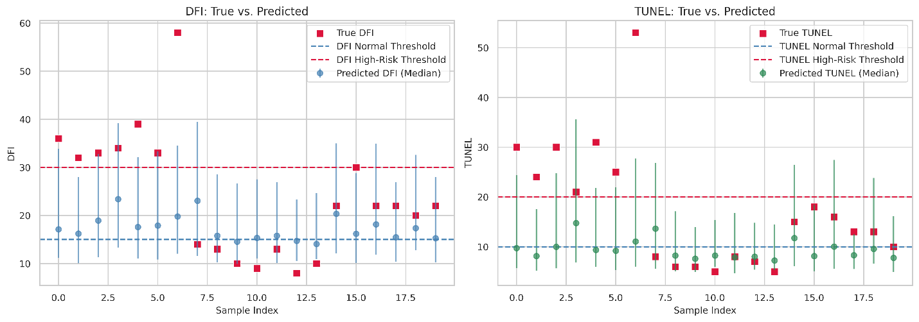
Fig. 1: Quantile Plots

Part IV: Confusion Matrices for CDSS
The confusion matrices for the DFI Testing Decision and TUNEL Testing Decision are illustrated in Fig. 2 (training set) and Fig.3 (test set).
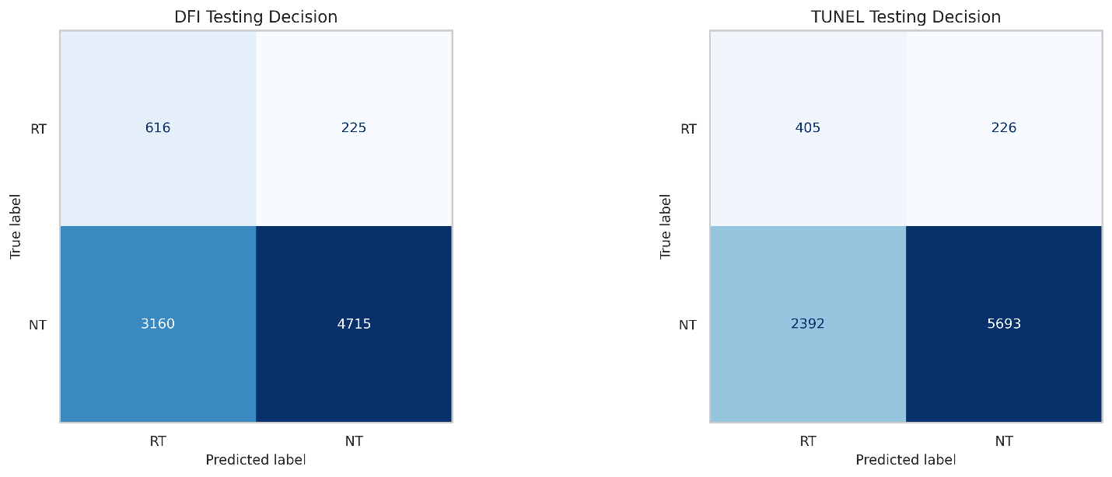
Fig. 2: Confusion matrices for DFI Testing Decision and TUNEL Testing Decision (training set)

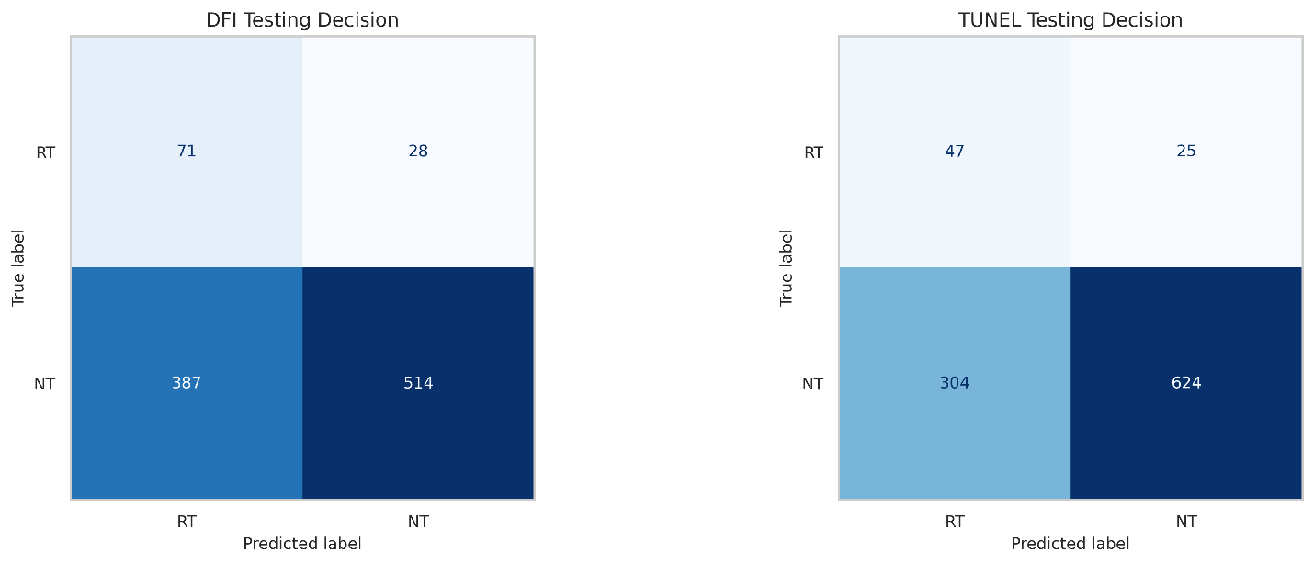
Fig. 3: Confusion matrices for DFI Testing Decision and TUNEL Testing Decision (test set)

Part V:
In this Part, we translated the CDSS tool into a clinician-friendly decision table, which can be found in Table 1.
Table 1. Clinician-friendly decision table
Patient ID | Patient A | Patient B | Patient C | Patient D
Actual DFI Value | 15% | 43% | 17% | 33%
Actual TUNEL Value | 7% | 29% | 8% | 21%
Predicted DFI Interval | [10.4,26.4] | [12.5,34.9] | [11.3,28.3] | [13.8,38.7]
Predicted TUNEL Interval | [5.1, 16.0] | [5.7,23.10] | [5.6,15.2] | [6.5,18.7[]
DFI Testing Decision | NT | RT | RT | RT
TUNEL Testing Decision | NT | RT | RT | NT
Final Decision (Human Expert) | To be Filled | To Be Filled | To Be Filled | To Be Filled

Suppose the actual SDF tests for patients have not been revealed yet. Our CDSS recommends NT for Patient A, and RT for Patients B and C. In some cases, such as for Patient D, the tool may suggest mixed decisions—RT based on DFI and NT based on TUNEL, or vice versa. This table is then given to a fertility expert. He/She reviews the patient's profiles and makes a final verdict.

Part VI: Error Analysis
To gain deeper insights into the developed models and to identify the specific reasons for their underperformance, we conducted an error analysis for both the XGBoost regressor. We examined the regressor using residuals, learning curves, and the bias versus variance trade-off. The residual for both targets, as depicted in Fig. 4 (left), appeared more tightly packed on the left (lower predicted values) but spread out more on the right. This pattern suggests that the model suffers from heteroscedasticity, meaning that the model's error variance is not constant across different levels of predicted values. There are also extreme residuals, which highlight that the model struggles to accurately predict valid biological outliers. The learning curve graph, illustrated in Fig. 4 (right), suggests that the model struggles to capture patterns in the data effectively, as the training RMSE keeps increasing while the validation RMSE remains almost constant. Normally, if more data significantly reduced validation error, it would indicate data scarcity. However, since validation RMSE remains high, the issue is likely due to low-informative features. This implies that the available features do not contain sufficient information to capture strong predictive patterns. Additionally, we compared the training and test performance of our model. Despite overall weak predictive power, which indicates an underfitted model, some signs of overfitting are still present. This is seen in the gap between the training and testing scores. The model does not suffer from classic overfitting due to excessive complexity but rather from the fact that the dataset itself lacks strong predictive signals.
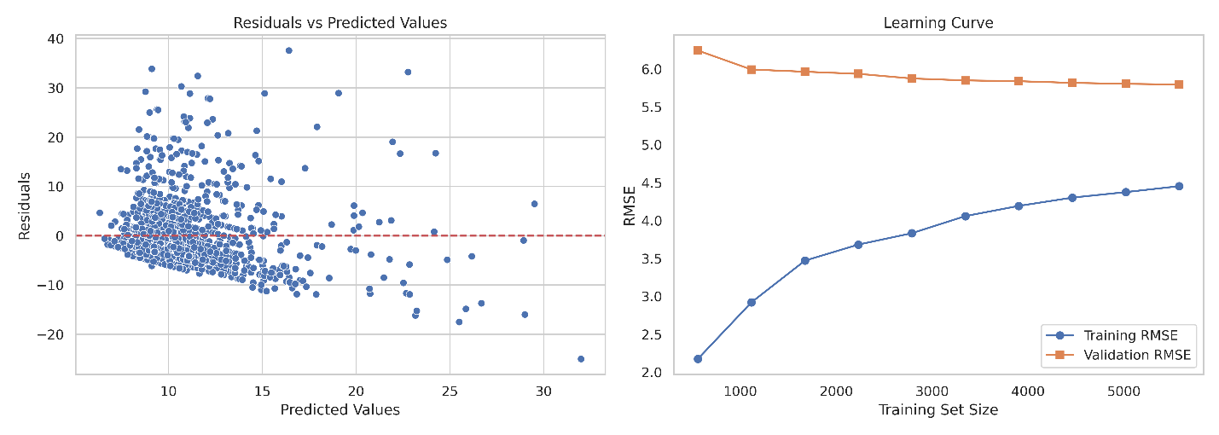
Fig. 4: Residual and learning curve plots for regression task

We established our findings as a benchmark to encourage future studies that explore alternative modeling strategies and improve data collection efforts. Future research should consider incorporating additional biological markers, including oxidative stress levels, DNA methylation patterns, hormonal profiles, and relevant demographic information such as lifestyle factors.

Part VII: DFI Testing Decision
In Table 2, we compared our tool’s decisions with actual labels based on the DFI Testing Decision component.
Table 2. Interpretation of the DFI Testing Decision by using the tool on 1,000 cases
Metric | Formula | Confusion Matrix | Value (%) | Interpretation
Specificity | $$\frac{TN}{TN+FP}$$ | $$\left[\begin{matrix}TN & FP \\ FN & TP\end{matrix}\right]=\left[\begin{matrix}514 & 387 \\ 28 & 71\end{matrix}\right]$$ | 57.04 | 514 out of 901 low-risk patients are correctly identified
Sensitivity | $$\frac{TP}{TP+FN}$$ |  | 71.71 | 71 out of 99 high-risk patients are correctly identified
PPV | $$\frac{TP}{TP+FP}$$ |  | 15.50 | 71 out of 458 high-risk flagged patients were truly high-risk
NPV | $$\frac{TN}{TN+FN}$$ |  | 94.83 | 514 out of 542 low-risk flagged patients were truly low-risk

Appendix A
Algorithm I: Regression Pipeline
Inputs:
- $X∈R^{n×p}$: Input matrix with $n$ samples and $p$ features
- $Y∈R^{n×t}$: Target matrix with $n$ samples and $t$ features.
- $M=\left\{M_{1},M_{2},…,M_{m}\right\}$: Set of regression models
- $k$: Number of folds for cross-validation (default $k=10$)
- $Θ$: Hyperparameters for each model $M_{i}$
Output:
- $R$: Dictionary containing mean evaluation metrics for each model and target.
Initialize:
- $M_{i}$ and $Θ_{i}$
- $D_{metrics}^{\left(i,l\right)}, l=\left\{1,2,…,t\right\}$ , Dictionary to store metrics for each target
for $M_{i}∈M$ do:
$$M_{i}^{multi}=MultiOutputRegressor\left(M_{i}\left(Θ_{i}\right)\right)$$
Cross-Validation: $F={\left\{\left(X_{train}^{(j)},X_{test}^{(j)}\right),\left(Y_{train}^{(j)},Y_{test}^{(j)}\right)\right\}}_{j=1}^{k}$
for $j∈\left\{1,2,…,k\right\}$ do:
Split the data: $X_{train}=X_{train}^{\left(j\right)} , X_{test}=X_{test}^{\left(j\right)} , Y_{train}=Y_{train}^{\left(j\right)} , Y_{test}=Y_{test}^{\left(j\right)}$
Fit the model: $M_{i}^{multi}.fit\left(X_{train},Y_{train}\right)$
Predict: ${\hat{Y}}_{test}=M_{i}^{multi}.predict\left(X_{test}\right)$
Calculate metrics: ${MAE}^{(j)}, {MSE}^{(j)}$
Append metrics to $D_{metrics}^{\left(j\right)}$
end for
for each target $l$ do:
Compute $mean of each metric across all k folds$
$$R^{(l)}=\{mean MAE=\frac{1}{k}\sum_{i=1}^{k}{{MAE}_{i}^{\left(l\right)}}, mean MSE=\frac{1}{k}\sum_{i=1}^{k}{{MSE}_{i}^{\left(l\right)}}\}$$
end for
end for
Return $R=\left\{R^{\left(1\right)},R^{\left(2\right)},…,R^{(t)}\right\}$

References
[1] Behdarvandian P, Nasr-Esfahani A, Tavalaee M, Pashaei K, Naderi N, Darmishonnejad Z, Hallak J, Aitken RJ, Gharagozloo P, Drevet JR, Nasr-Esfahani MH (2023) Sperm chromatin structure assay (SCSA®) and flow cytometry-assisted TUNEL assay provide a concordant assessment of sperm DNA fragmentation as a function of age in a large cohort of approximately 10,000 patients. Basic Clin Androl 33(1):33. https://doi.org/10.1186/s12610-023-00208-9.
[2] Mahalanobis, P. C. (2018). On the generalized distance in statistics. Sankhyā: The Indian Journal of Statistics, Series A (2008-), 80, S1–S7. https://www.jstor.org/stable/48723335.
[3] Liu, F. T., Ting, K. M., & Zhou, Z. -H. (2008). Isolation Forest. In 2008 Eighth IEEE International Conference on Data Mining (pp. 413–422). IEEE. https://doi.org/10.1109/ICDM.2008.17.
[4] Breunig, M. M., Kriegel, H.-P., Ng, R. T., & Sander, J. (2000). LOF: Identifying density-based local outliers. In Proceedings of the 2000 ACM SIGMOD International Conference on Management of Data (pp. 93–104). ACM. https://doi.org/10.1145/342009.335388.

