Supplementary information
Journal: Landscape Ecology
Title: A journey through space and time: impact of forest planning approaches on spatio-temporal habitat connectivity.
Authors: Juliette Hunault-Fontbonne^{1, *}, Rémi Duflot^{2,3}, Kyle Eyvindson^{1, 4}
¹ Norwegian University of Life Sciences (NMBU), Faculty of Environmental Sciences and Natural Resource Management, Høgskoleveien 12, 1433 Ås, Norway
² Department of Biological and Environmental Science, University of Jyväskylä, P.O. Box 35, 40014 Jyväskylä, Finland
³ School of Resource Wisdom, University of Jyväskylä, P.O. Box 35, 40014 Jyväskylä, Finland
⁴ Natural Resource Institute Finland (LUKE), Laatokartanonkaari 9, 00790 Helsinki, Finland
*Corresponding author, PhD candidate, juliette.hunault@nmbu.no
Supplementary Figure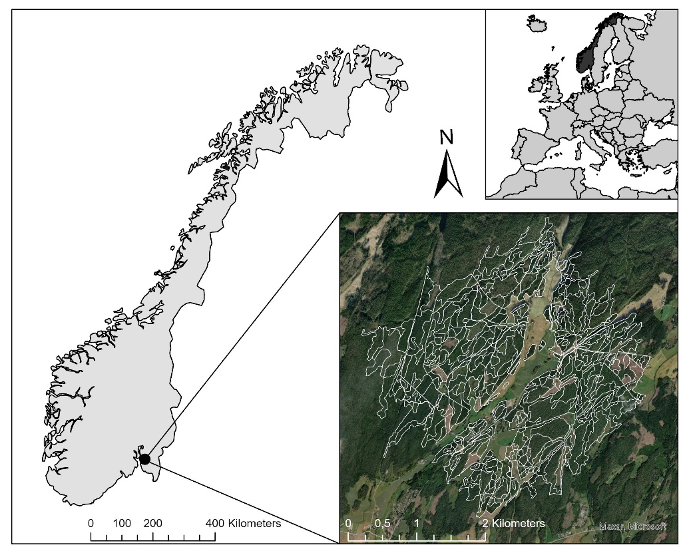
Figure S1. Map of the study area located in in Våler municipality, Østfold county, southeastern Norway

Supplementary Tables
Table S1. Average stand age and tree diameter for each scenario at the beginning, the middle and the end of the planning horizon. The highest numbers for each metrics are in bold.
Metrics | Scenarios | Period 2 | Period 6 | Period 10
Stand age (years) | S1 SEG | 57 | 49 | 58
Stand age (years) | S2 SEG-spatial | 44 | 31 | 42
Stand age (years) | S3 TRIAD | 61 | 73 | 60
Stand age (years) | S4 TRIAD-spatial | 54 | 55 | 39
Tree diameter (cm) | S1 SEG | 27 | 22 | 25
Tree diameter (cm) | S2 SEG-spatial | 19 | 12 | 15
Tree diameter (cm) | S3 TRIAD | 30 | 30 | 25
Tree diameter (cm) | S4 TRIAD-spatial | 25 | 19 | 13

Tab S2. Proportion of the overall spatio-temporal landscape connectivity achieved by PCstep, PCdirect, and PCintra for each species and scenario.
Scenarios | LTT |  |  | HAZ |  |  | TTWP
 | Step | Direct | Intra | Step | Direct | Intra | Step | Direct | Intra
S1 SEG | 11 | 45 | 44 | 21 | 67 | 12 | 3 | 95 | 2
S2 SEG-spatial | 10 | 46 | 44 | 21 | 62 | 17 | 1 | 93 | 5
S3 TRIAD | 12 | 46 | 41 | 21 | 67 | 12 | 3 | 95 | 2
S4 TRIAD-spatial | 16 | 47 | 37 | 18 | 70 | 12 | 3 | 94 | 4

Supplementary information: probability rules
The factors applied to spatial probabilities to include the temporal element depend on the type of link between two nodes with two main types: essential and auxiliary links. Essential links are going from a node with habitat at $t_{n}$ to a node with habitat at $t_{n+1}$ and do not require steppingstones (Table S3).
Table S3. Temporal essential links adapted from Martensen et al. (2017)
 |  | Destination node at t_{n+1}
 |  | STABLE | LOSS | GAIN
Source node at t_{n} | STABLE | 1 | 0 | 1
Source node at t_{n} | LOSS | 1 | 0 | 0.5
Source node at t_{n} | GAIN | 0 | 0 | 0
Auxiliary links require the use of one or several temporal steppingstones (Table S4), they are divided in two types:
- Links going to a loss node at time $t_{x}$ from any other node type. This type of links requires at least one other link to reach a patch with habitat in $t_{n+1}$.
- Links going from gain at time $t_{x}$ to any other node type. This type of link requires at least one other link from a patch with habitat at $t_{n}$.
Table S4. Temporal auxiliary links adapted from Martensen et al. (2017)
 |  | Destination node at t_{y}
 |  | STABLE | LOSS | GAIN
Source node at t_{x} | STABLE | n/a | 1 | n/a
Source node at t_{x} | LOSS | n/a | 1 | n/a
Source node at t_{x} | GAIN | 1 | 0.5 | 1
For movements from LOSS to GAIN and from GAIN to LOSS the probability is multiplicated by a factor of 0.5 due to the assumption that transitioning nodes can potentially coexist as habitats at tx or ty.
Reference:
Martensen, A. C., Saura, S., & Fortin, M. J. (2017). Spatio-temporal connectivity: assessing the amount of reachable habitat in dynamic landscapes. Methods in Ecology and Evolution, 8(10), 1253–1264. https://doi.org/10.1111/2041-210X.12799

Supplementary information: Equations for scenarios formulations
Scenario S1 SEG
Step 1a
Objective function:
[1] | $$\max{\sum_{s∈S}{\sum_{r∈R_{s}}{v_{sr}^{ECOL}x_{sr}}}}$$
Subject to:
[2] | $$x_{sr}∈\left\{0,1\right\}$$
[3] | $$\sum_{r∈R_{s}}{x_{sr}}≤1,∀ s∈S$$  For each stand, at most 1 regime is selected.
[4] | $$\sum_{s∈S}{\sum_{r∈R_{s}}{x_{sr}} . a_{s}≥}\left(0.295\sum_{s∈S}{a_{s}}\right)$$  The area of stands managed for the ecological objective is greater than 29.5% of total area.
[5] | $$\sum_{s∈S}{\sum_{r∈R_{s}}{x_{sr}}}. a_{s}≤\left(0.305\sum_{s∈S}{a_{s}}\right)$$  The area of stands managed for the ecological objective is lesser than 30.5% of total area.

Step 1b
Objective function:
[6] | $$\max{\sum_{s∈S}{\sum_{r∈R_{s}}{v_{sr}^{ECON}x_{sr}}}}$$
Subject to:
[7] | $$\sum_{r∈R_{s}}{x_{sr}}=1, ∀ s∈S$$  For each stand, 1 regime is selected.
[8] | $$x_{sr}≥x_{sr}^{1a*}, ∀ s∈S,r∈R_{s}$$  Stands and regimes selected in step 1a are unchanged.
And to equation [2]

Scenario S2 SEG-spatial
Step 2a
Objective function:
[9] | $$max\sum_{c∈C}{z_{c}-\sum_{s∈S}{\sum_{r∈R_{s}}{x_{sr}}}*ϵ}$$
Subject to:
[10] | $$y_{c}∈\left\{0,1\right\}$$
[11] | $$z_{c}≥0$$
[12] | $$\sum_{c∈C}{y_{c}}=1$$  Only 1 cluster is selected.
[13] | $$\sum_{s∈{Cl}_{c}}{{\sum_{r∈R_{s}}{x_{sr} ≥ y_{c}} . \#CL}_{c}}$$  All stands in selected cluster c are selected.
[14] | $$z_{c}≤\sum_{s∈{Cl}_{c}}{\sum_{r∈R_{s}}{v_{sr}^{ECOL}x_{sr}}} , for all c∈C$$  Auxiliary variable z_{c} is lesser than or equal to the ecological value of the cluster c.
[15] | $$z_{c}≥\sum_{s∈{Cl}_{c}}{\sum_{r∈R_{s}}{v_{sr}^{ECOL}x_{sr}}}-G^{ECOL} . (1-y_{c}), for all c∈C$$  When cluster c is selected, the auxiliary variable should be greater than or equal to the ecological value of cluster c. Combined with equation [14], this constraint ensures that the auxiliary variable z_{c} is equal to the ecological value of cluster c.
[16] | $$z_{c}≤G^{ECOL} . y_{c }, for all c∈C$$  Auxiliary variable z_{c} is lesser than or equal to the maximum value of the ecological objective.
And to equations [2], [3]

Step 2b
Objective function:
Same as [6] | $$\max{\sum_{s∈S}{\sum_{r∈R_{s}}{v_{sr}^{ECON}x_{sr}}}}$$
Subject to:
[17] | $$x_{sr}≥x_{sr}^{2a*}, ∀ s∈S,r∈R_{s}$$  Stands and regimes selected in step 2a are unchanged.
And to equations [2], [7]

Scenario S3 TRIAD
Step 3a
Objective function:
[18] | $$\max{\sum_{s∈S}{\sum_{r∈R_{s}^{SA}}{v_{sr}^{ECOL}x_{sr}}}}+{(p}_{SA}+n_{SA})*Ω$$
Subject to:
[19] | $$w_{SA}∈\left\{0,1\right\}$$
[20] | $$p_{SA}≥0$$
[21] | $$n_{SA}≥0$$
[22] | $$w_{SA} . \sum_{s∈S}{a_{s}}-\sum_{s∈S}{\sum_{r∈R_{s}^{SA}}{x_{sr}}}. a_{s}+{p_{SA}-n_{SA}}=0$$  The area of stands set aside is equal to $w_{SA}$% of total area (with small deviation allowed), in this case $w_{SA}=20\%$.
And to equations [2], [3]

Step 3b
Objective function:
[23] | $$\max{\sum_{s∈S}{\sum_{r∈R_{s}^{EXT}}{{(v}_{sr}^{ECOL}.v_{sr}^{ECON}{.x}_{sr})}}}-(p_{SA}+n_{SA}+p_{EXT}+n_{EXT})*Ω$$
Subject to:
[24] | $$w_{EXT}∈\left\{0,1\right\}$$
[25] | $$p_{EXT}≥0$$
[26] | $$n_{EXT}≥0$$
[27] | $$w_{EXT} . \sum_{s∈S}{a_{s}}-\sum_{s∈S}{\sum_{r∈R_{s}^{EXT}}{x_{sr}}}. a_{s}+{p_{EXT}-n_{EXT}}=0$$  The area of stands set aside is equal to $w_{EXT}$% of total area (with small deviation allowed), in this case $w_{EXT}=20\%$.
[28] | $$\sum_{s∈S}{\sum_{r∈R_{s}^{INT}}{x_{sr}}}.a_{s}=0$$  No stand is selected for intensive management in this step.
[29] | $$x_{sr}≥x_{sr}^{3a*}, ∀ s∈S,r∈R_{s}$$  Stands and regimes selected in step 3a are unchanged.
And to equations [2], [7], [19], [20], [21], [22]

Step 3c
Objective function:
[30] | $$\max{\sum_{s∈S}{\sum_{r∈R_{s}^{INT}}{v_{sr}^{ECON}x_{sr}}}}$$
Subject to:
[31] | $$x_{sr}≥x_{sr}^{3b*}, ∀ s∈S,r∈R_{s}$$  Stands and regimes selected in step 3b are unchanged.
And to equations [2], [7]

Scenario S4 TRIAD-spatial
Step 4a
Objective function:
[32] | $$max\sum_{c∈C}{z_{c}-\left[\sum_{s∈S}{\sum_{r∈R_{s}^{SA}}{x_{sr}*ϵ+p_{SA}+n_{SA}}}\right]*Ω}$$
Subject to:
[33] | $$z_{c}≤\sum_{s∈{Cl}_{c}}{\sum_{r∈R_{s}^{SA}}{v_{sr}^{ECOL}x_{sr}}} , for all c∈C$$  Auxiliary variable z_{c} is lesser than or equal to the ecological value of the cluster c.
[34] | $$z_{c}≥\sum_{s∈{Cl}_{c}}{\sum_{r∈R_{s}^{SA}}{v_{sr}^{ECOL}x_{sr}}}-G^{ECOL} . (1-y_{c}), for all c∈C$$  When cluster c is selected, the auxiliary variable should be greater than or equal to the ecological value of cluster c. Combined with equation [14], this constraint ensures that the auxiliary variable z_{c} is equal to the ecological value of cluster c.
And to equations [2], [3], [10], [11], [12], [13], [16], [19], [20], [21], [22]

Step 4b
Objective function:
[35] | $$max\sum_{c∈CL}{z_{c}-\left[\sum_{s∈S}{\sum_{r∈R_{s}}{x_{sr}*ϵ+\sum_{m∈M}{{(p}_{EXT}+n_{EXT})}}}\right]*Ω}$$
Subject to:
[36] | $$w_{EXT} . \sum_{s∈S}{a_{s}}-\sum_{s∈{Cl}_{c}}{\sum_{r∈R_{s}^{EXT}}{x_{sr}}}. a_{s}+{p_{EXT}-n_{EXT}}=0$$  The area of stands from the extensively managed cluster is equal to 20% of total area (with small deviation allowed).
[37] | $$z_{c}≤\sum_{s∈{Cl}_{c}}{\sum_{r∈R_{s}^{EXT}}{v_{sr}^{ECOL}{.v_{sr}^{ECON}.x}_{sr}}} , for all c∈C$$  Auxiliary variable z_{c} is lesser than or equal to the combined ecological and economic value of cluster c.
[38] | $$z_{c}≥\sum_{s∈{Cl}_{c}}{\sum_{r∈R_{s}^{EXT}}{v_{sr}^{ECOL}{.v_{sr}^{ECON}.x}_{sr}}}-(1-y_{c}).\sum_{e∈\{ECOL,ECON\}}{{(G}^{e})} , for all c∈C$$  When cluster c is selected, the auxiliary variable should be greater than or equal to the combined ecological and economic value of cluster c. Combined with equation [37], this constraint ensures that the auxiliary variable z_{c} is equal to the combined ecological and economic value of cluster c.
[39] | $$z_{c}≤G^{ECOL+ECON} . y_{c }, for all c∈C$$  Auxiliary variable z_{c} is lesser than or equal to the maximum value of the combined objectives.
[40] | $$x_{sr}≥x_{sr}^{4a*}, ∀ s∈S,r∈R_{s}$$  Stands and regimes selected in step 4a are unchanged.
And to equations [2], [3], [10], [11], [12], [13], [24], [25], [26]

Step 4c
Objective function:
Same as [30] | $$\max{\sum_{s∈S}{\sum_{r∈R_{s}^{INT}}{v_{sr}^{ECON}x_{sr}}}}$$
Subject to:
[41] | $$x_{sr}≥x_{sr}^{6b*}, ∀ s∈S,r∈R_{s}$$
[42] | $$x_{sr}≥x_{sr}^{6a*}, ∀ s∈S,r∈R_{s}$$
And to equations [2], [7]

Table S5. Description of notation used in model formulation of the four optimization scenarios
Symbol | Description
Sets
S | The set of stands
$$R_{s}$$ | The set of management regimes for stand s
C | The set of clusters
$${Cl}_{c}$$ | The set of stands in cluster c
M | The set of intensity categories (SA, INT, EXT)
$$R_{s}^{m}$$ | Set of management regimes for stand s that belong to either intensity category $m∈SA , EXT or INT$
Variables
$$v_{sr}^{ECON}$$ | Economic value from conducting management regime r on stand s
$$v_{sr}^{ECOL}$$ | Ecological value from conducting management regime r on stand s
$$a_{s}$$ | Area of stand s
$$p_{m}, n_{m}$$ | Positive and negative deviation from either intensity category $m∈SA or EXT$
$$x_{sr}$$ | The binary decision variable for stand s and management regime r (=1 if regime r is selected for stand s)
$$y_{c}$$ | The binary decision variable for cluster c (=1 if cluster c is selected)
$$z_{c}$$ | Continuous auxiliary variable for cluster c
$${\#CL}_{c}$$ | Number of stands in cluster c
Parameters
$$w_{m}$$ | Proportion of the landscape managed according to either intensity category $m∈SA or EXT$
$$G^{e}$$ | Represents the maximum value of the objective for either $e∈ECOL or ECON$
$$Ω$$ | A very large value
$$ϵ$$ | A very small value

