Supporting Information for: Legacy effects of climate extremes on deep soil water storage and water use efficiency across different land-use systems
By Mengqi Wu, et al.
Including:
- Figure S1-8 and Table S1-4
Fig. S1 Water retention characteristics were measured with the evaporation method (Hyprop, METER Group) and the dew point hygrometer method (WP4C, METER Group). The volumetric water content at pF1.8 and pF4.2 represent the field capacity and permanent wilting point.
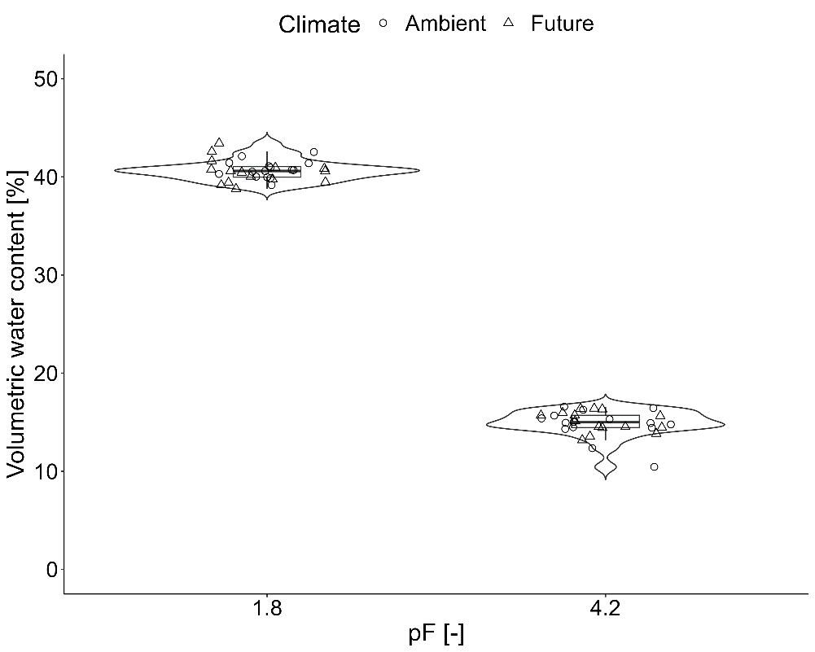

Fig. S2 Violin plots showing relative proportion of fresh roots across five land use types and two years. Box plots represent the 0, 25, 50, 75, and 100 percentile and cross symbols the arithmetic mean (n = 10). CF, OF, IM, EM and EP represent conventional farming, organic farming, intensive meadow, extensive meadow and extensive pasture, respectively. Significant differences between land use, climate, year, interaction of land use and climate, land use and year are indicated * (P < 0.05), ** (P < 0.01), and *** (P < 0.001).
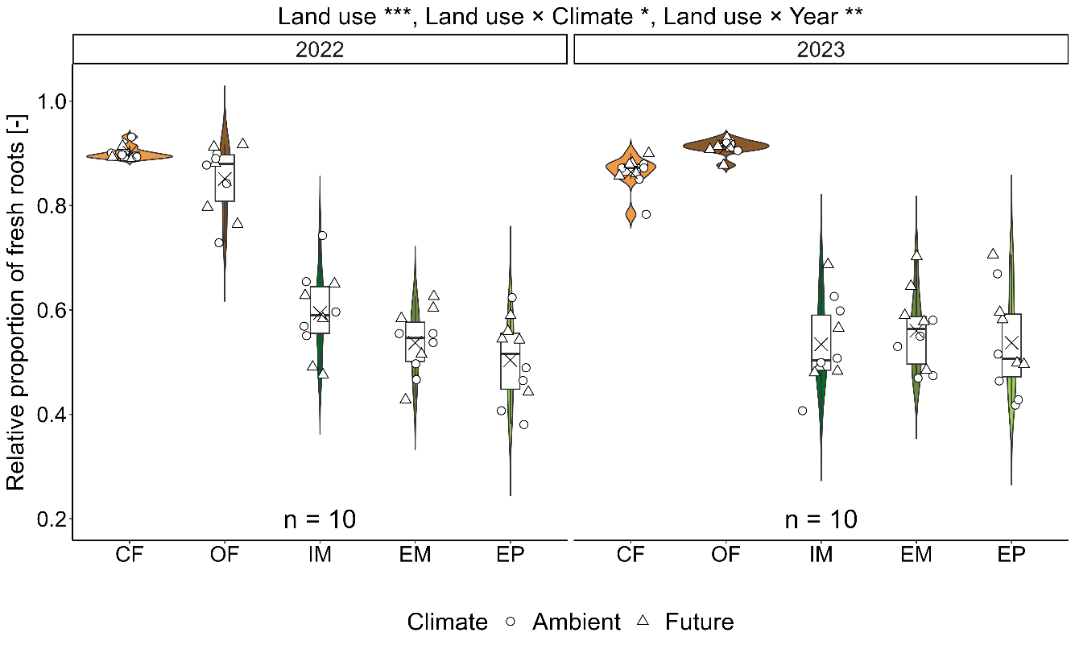

Fig. S3 Initial structural equation model depicting how soil water storage and root length density affect water use efficiency and yield driven by land use, climate and climate extremes. Numbers next to arrows indicate standardized path coefficients (robust standard errors of coefficients). Lines indicate potential pathways. Lines with double sided arrow indicate potential relationship between covariances. Prior to scaling, the categorical levels of land use were ordered as CF, IM, OF, and EM to reflect the gradient of land-use intensity. All variables included in the model are continuous measures. The parameters of model are Fisher’s C = 20.145, p = 0.000, df = 4.
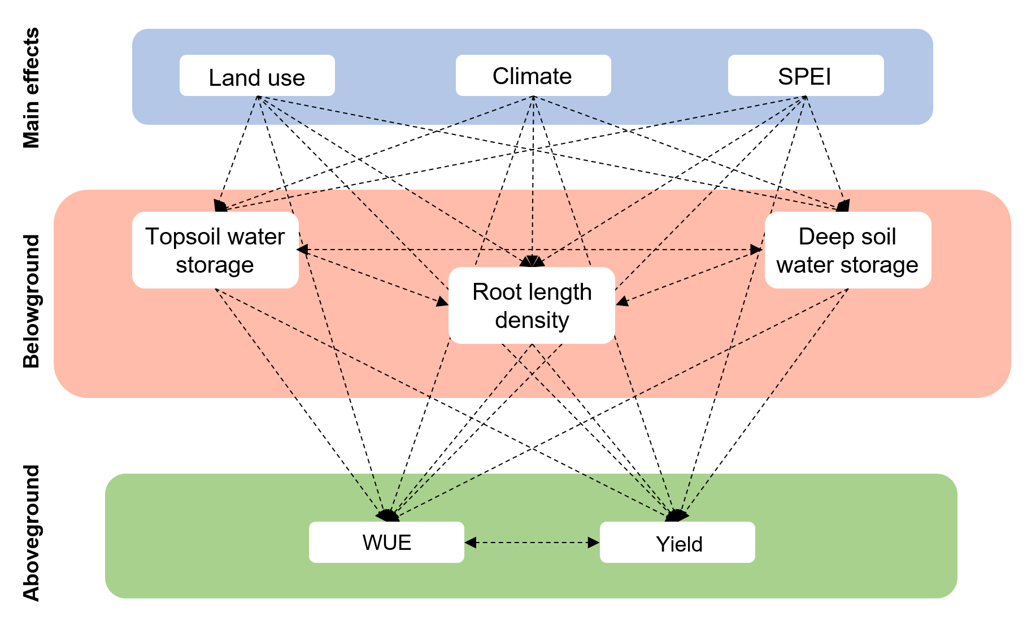

Fig. S4 Linear regression between shallow soil water content (0-20 cm) and meteorological aridity index or water deficit. (a) Standardized precipitation-evapotranspiration index (SPEI) with a 3-month timescale. (b) meteorological water deficit.
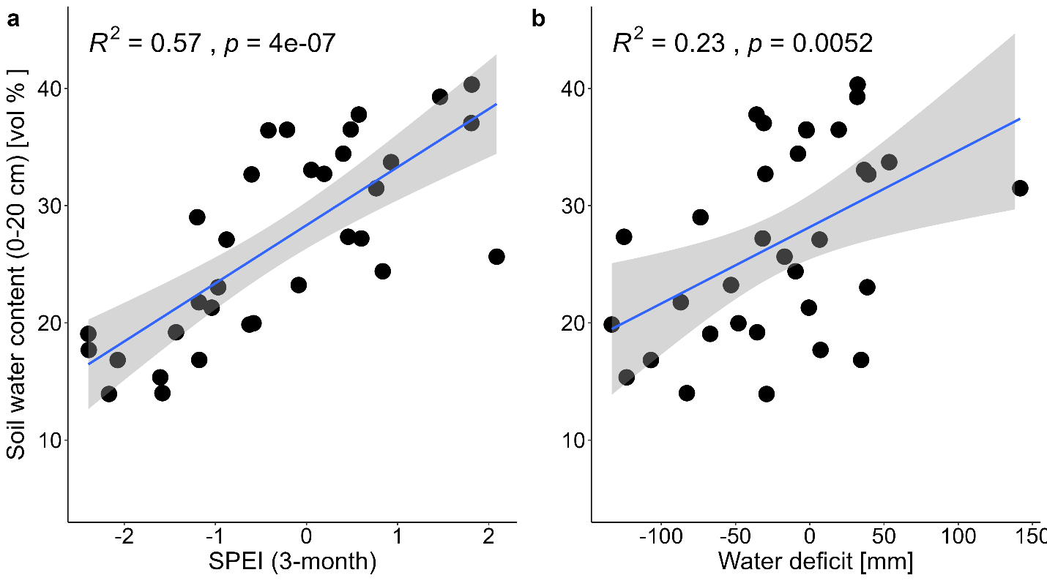

Table S1 Overview of soil water content on different soil layers and their results of linear mixed-effects models (LMMs). Values are arithmetic mean ± standard error (n = 5). Significant p values (p < 0.05) are in bold.
 | Land use | Climate | 0-10 cm | 10-20 cm | 20-30 cm | 30-50 cm | 50-70 cm | 70-90 cm | 90-110 cm
Treatment | Cropland | Ambient | 24.34±0.81 | 25.71±0.66 | 26.6±0.6 | 23.63±0.79 | 21.07±1.14 | 21.54±1.12 | 23.05±1.24
Treatment | Cropland | Future | 24.01±0.59 | 25.66±0.52 | 26.45±0.54 | 23.2±0.53 | 22.49±0.53 | 23.15±0.97 | 23.99±0.96
Treatment | Grassland | Ambient | 26.4±0.53 | 24.72±0.43 | 23.91±0.32 | 20.85±0.47 | 17.89±0.59 | 17.7±0.74 | 17.89±0.88
Treatment | Grassland | Future | 25.99±0.66 | 24.32±0.5 | 23.79±0.38 | 20.03±0.7 | 17.64±0.75 | 18.87±0.98 | 18.18±1.03
LMMs | Land use | χ2 | 11.306 | 6.303 | 40.302 | 23.996 | 29.058 | 19.180 | 29.860
LMMs | Land use | p value | <0.000 | 0.012 | <0.001 | <0.001 | <0.001 | <0.001 | <0.001
LMMs | Climate | χ2 | 0.411 | 0.327 | 0.097 | 1.113 | 0.325 | 2.179 | 0.315
LMMs | Climate | p value | 0.522 | 0.567 | 0.756 | 0.292 | 0.569 | 0.140 | 0.575
LMMs | Land use * Climate | χ2 | 0.005 | 0.140 | 0.001 | 0.101 | 1.246 | 0.055 | 0.106
LMMs | Land use * Climate | p value | 0.945 | 0.709 | 0.974 | 0.751 | 0.264 | 0.814 | 0.745
Treatment | Conventional farming | Ambient | 25.24±1.19 | 25.72±1.01 | 25.93±0.79 | 23.05±1.37 | 20.07±2.08 | 20.11±2.07 | 21.52±2.21
Treatment | Conventional farming | Future | 23.82±1.12 | 25.24±0.99 | 25.99±0.91 | 22.44±0.4 | 22.07±0.69 | 22.59±1.6 | 23.1±1.23
Treatment | Organic farming | Ambient | 23.49±1.11 | 25.99±1 | 27.59±0.88 | 24.58±0.89 | 22.78±1.03 | 23.7±0.6 | 25.09±0.94
Treatment | Organic farming | Future | 24.32±0.57 | 26.42±0.39 | 27.38±0.62 | 24.55±0.85 | 23.66±0.81 | 24.37±1.24 | 25.4±1.49
LMMs | Land use | χ2 | 1.046 | 1.696 | 7.225 | 4.673 | 3.638 | 4.400 | 4.647
LMMs | Land use | p value | 0.306 | 0.193 | 0.007 | 0.031 | 0.056 | 0.036 | 0.031
LMMs | Climate | χ2 | 0.101 | 0.001 | 0.019 | 0.145 | 1.639 | 1.515 | 0.483
LMMs | Climate | p value | 0.750 | 0.974 | 0.890 | 0.703 | 0.200 | 0.218 | 0.487
LMMs | Land use * Climate | χ2 | 3.338 | 0.649 | 0.056 | 0.118 | 0.248 | 0.501 | 0.221
LMMs | Land use * Climate | p value | 0.068 | 0.420 | 0.813 | 0.731 | 0.618 | 0.479 | 0.639
Treatment | Intensive meadow | Ambient | 23.22±0.59 | 22.11±0.45 | 22.10±0.52 | 20.73±0.67 | 19.59±0.58 | 21.15±0.55 | 22.26±0.65
Treatment | Intensive meadow | Future | 22.37±1.19 | 21.56±0.97 | 22.29±0.66 | 19.62±1.06 | 18.27±1.19 | 20.64±1.25 | 20.15±1.08
Treatment | Extensive meadow | Ambient | 25.71±0.92 | 23.90±0.81 | 22.93±0.76 | 20.08±0.46 | 17.03±0.82 | 15.77±0.86 | 15.74±0.85
Treatment | Extensive meadow | Future | 25.19±1.24 | 23.49±0.90 | 21.93±0.93 | 18.03±1.52 | 15.65±1.34 | 16.75±1.75 | 16.90±1.74
Treatment | Extensive pasture | Ambient | 25.37±0.96 | 23.29±0.82 | 22.08±0.38 | 18.50±1.03 | 15.10±0.68 | 15.37±0.62 | 15.64±0.93
Treatment | Extensive pasture | Future | 24.80±0.89 | 23.19±0.89 | 22.71±0.82 | 18.86±1.32 | 16.66±1.38 | 17.85±1.94 | 17.09±2.22
LMMs | Land use | χ2 | 10.619 | 6.945 | 0.159 | 4.728 | 12.388 | 20.448 | 23.817
LMMs | Land use | p value | 0.005 | 0.031 | 0.924 | 0.094 | 0.002 | <0.001 | <0.001
LMMs | Climate | χ2 | 0.796 | 0.340 | 0.015 | 1.141 | 0.246 | 1.116 | 0.022
LMMs | Climate | p value | 0.372 | 0.560 | 0.904 | 0.285 | 0.620 | 0.291 | 0.881
LMMs | Land use * Climate | χ2 | 0.041 | 0.101 | 1.792 | 2.913 | 3.222 | 1.721 | 2.942
LMMs | Land use * Climate | p value | 0.980 | 0.951 | 0.408 | 0.233 | 0.200 | 0.423 | 0.230

Table S2 Linear mixed-effects models (LMMs) on the effects of climate, land use, year and their interactions on root, vegetation cover and functional group dependence, yield and water related properties. Significant p values (p < 0.05) are in bold.
Properties | Land use |  |  | Climate |  | Year |  |  | Land use * Climate |  |  |  | Land use * Year |  |  |  | Climate * Year |  | Land use * Climate * Year
Properties | χ2 | p value |  | χ2 | p value | χ2 | p value |  | χ2 | p value |  |  | χ2 | p value |  |  | χ2 | p value | χ2 | p value
Evapotranspiration | 94.81 |  | <0.001 | 13.89 | <0.001 | 2604.84 |  | <0.001 | 1.66 |  | 0.797 | 103.42 |  |  | <0.001 | 33.97 |  | <0.001 | 8.69 | <0.001
Yield | 1096.62 |  | <0.001 | 2.54 | 0.111 | 190.69 |  | <0.001 | 11.27 |  | 0.010 | 58.49 |  |  | <0.001 | 1.05 |  | 0.590 | 34.85 | <0.001
Water use efficiency | 695.76 |  | <0.001 | 0.13 | 0.723 | 86.71 |  | <0.001 | 6.27 |  | 0.099 | 86.88 |  |  | <0.001 | 4.37 |  | 0.112 | 32.23 | <0.001
Topsoil water storage | 22.43 |  | 0.004 | 1.59 | 0.902 | 215.45 |  | <0.001 | 1.45 |  | 0.835 | 10.01 |  |  | 0.040 | 0.01 |  | 0.979 | 4.00 | 0.407
Deep soil water storage | 41.40 |  | <0.001 | 3.55 | 0.616 | 43.26 |  | <0.001 | 3.33 |  | 0.504 | 5.42 |  |  | 0.247 | 0.08 |  | 0.782 | 3.18 | 0.528
Change of topsoil water storage | 36.82 |  | <0.001 | 5.10 | 0.403 | 6.86 |  | 0.008 | 5.01 |  | 0.286 | 29.22 |  |  | <0.001 | 0.02 |  | 0.881 | 7.43 | 0.115
Change of deep soil water storage | 159.84 |  | <0.001 | 16.55 | 0.005 | 188.52 |  | <0.001 | 1.43 |  | 0.839 | 34.38 |  |  | <0.001 | 0.86 |  | 0.353 | 0.35 | 0.986
Root length density (0-15 cm) | 293.56 |  | <0.001 | 1.09 | 0.296 | 0.05 |  | 0.816 | 2.09 |  | 0.719 | 8.29 |  |  | 0.082 | 0.81 |  | 0.367 | 0.90 | 0.924
Root length density (15-30 cm) | 149.11 |  | <0.001 | 0.71 | 0.399 | 0.16 |  | 0.690 | 2.51 |  | 0.643 | 8.97 |  |  | 0.062 | 0.85 |  | 0.356 | 5.09 | 0.279
Root length density (30-50 cm) | 172.66 |  | <0.001 | 0.09 | 0.761 | 16.81 |  | <0.001 | 4.56 |  | 0.336 | 11.07 |  |  | 0.026 | 0.03 |  | 0.854 | 4.18 | 0.383
Root length density (0-50 cm) | 100.04 |  | <0.001 | 0.13 | 0.718 | 0.13 |  | 0.721 | 0.14 |  | 0.998 | 2.59 |  |  | 0.629 | 0.04 |  | 0.848 | 0.40 | 0.982
Corrected root length density | 223.42 |  | <0.001 | 0.39 | 0.533 | 2.13 |  | 0.144 | 0.45 |  | 0.979 | 20.64 |  |  | <0.001 | 0.13 |  | 0.724 | 1.33 | 0.857
Root length in < 0.1 mm diameter | 267.87 |  | <0.001 | 0.61 | 0.434 | 0.18 |  | 0.672 | 1.14 |  | 0.889 | 9.90 |  |  | 0.042 | 0.38 |  | 0.537 | 0.52 | 0.972
Root length in 0.1-0.2 mm diameter | 311.08 |  | <0.001 | 0.15 | 0.701 | 1.53 |  | 0.216 | 0.27 |  | 0.992 | 6.61 |  |  | 0.158 | 0.03 |  | 0.870 | 2.11 | 0.716
Root length in 0.2-0.3 mm diameter | 485.12 |  | <0.001 | 0.00 | 0.976 | 3.48 |  | 0.062 | 1.25 |  | 0.869 | 12.14 |  |  | 0.016 | 0.26 |  | 0.613 | 5.34 | 0.254
Root length in 0.3-0.4 mm diameter | 366.45 |  | <0.001 | 0.12 | 0.735 | 9.19 |  | 0.002 | 1.50 |  | 0.827 | 22.21 |  |  | <0.001 | 0.00 |  | 0.984 | 3.25 | 0.517
Root length in 0.4-0.5 mm diameter | 280.98 |  | <0.001 | 0.76 | 0.382 | 12.25 |  | <0.001 | 4.29 |  | 0.368 | 13.57 |  |  | 0.009 | 0.32 |  | 0.573 | 2.68 | 0.614
Root length in > 0.5 mm diameter | 198.36 |  | <0.001 | 4.93 | 0.026 | 12.89 |  | <0.001 | 3.51 |  | 0.476 | 7.72 |  |  | 0.102 | 0.98 |  | 0.322 | 1.79 | 0.773
Net change in water content | 65.20 |  | <0.001 | 0.00 | 0.997 | 1106.39 |  | <0.001 | 7.63 |  | 0.105 | 19.60 |  |  | <0.001 | 5.89 |  | 0.015 | 5.82 | 0.213
Total vegetation cover | 1.78 |  | 0.411 | 0.07 | 0.792 | 12.85 |  | <0.001 | 3.62 |  | 0.164 | 1.92 |  |  | 0.382 | 2.30 |  | 0.129 | 2.06 | 0.357
Functional group dependence | 618.05 |  | <0.001 | 1.17 | 0.279 | 22.22 |  | <0.001 | 7.84 |  | 0.020 | 3.99 |  |  | 0.136 | 0.24 |  | 0.625 | 0.11 | 0.947

Table S3 Overview of root, yield and water related properties. Values are arithmetic mean ± standard error (n = 5). CF, OF, IM, EM and EP represent conventional farming, organic farming, intensive meadow, extensive meadow and extensive pasture, respectively. RA of grass: relative abundance of grass, RA of forb: relative abundance of forb, RA of grass: relative abundance of forb, RLD _{0-15 cm}: root length density on 0-15 cm depth, RLD _{15-30 cm}: root length density on 15-30 cm depth, RLD _{30-50 cm}: root length density on 30-50 cm depth, RLD _{0-50 cm}: root length density on 0-50 cm depth, RLD _{corrected}: corrected root length density, P + ΔS: net change in water content during peak growth.
Year | Climate | Land-use | Total vegetation cover [%] | RA of grass  [%] | RA of forb  [%] | RA of legume  [%] | RLD _{0-15 cm}  [cm cm⁻³] | RLD _{15-30 cm}  [cm cm⁻³] | RLD _{30-50 cm}  [cm cm⁻³] | RLD _{0-50 cm}  [cm cm⁻³] | RLD _{corrected}  [cm cm⁻³] | P + ΔS  [mm]
2022 | Ambient | CF | - | - | - | - | 4.38±0.37 | 3.60±0.77 | 2.05±0.33 | 3.22±0.23 | 2.90±0.21 | -75.81±0.83
2022 | Ambient | OF | - | - | - | - | 2.78±0.22 | 1.78±0.42 | 0.93±0.19 | 1.74±0.12 | 1.48±0.10 | -61.98±3.09
2022 | Ambient | IM | 68.6±3.71 | 96.7±2.0 | 3.3±2.0 | - | 32.01±7.99 | 10.63±2.37 | 3.66±0.53 | 14.25±3.16 | 8.47±1.88 | -59.67±1.49
2022 | Ambient | EM | 71.1±2.16 | 45.0±6.5 | 35.7±6.1 | 19.3±5.5 | 36.47±4.55 | 11.97±2.24 | 3.42±0.63 | 15.90±1.96 | 8.54±1.05 | -63.68±3.19
2022 | Ambient | EP | 76.0±4.52 | 63.3±6.3 | 31.1±6 | 5.6±1.4 | 32.92±4.78 | 12.13±0.74 | 3.16±0.47 | 14.78±1.51 | 7.45±0.76 | -60.16±1.35
2022 | Future | CF | - | - | - | - | 4.83±0.33 | 2.42±0.18 | 1.60±0.27 | 2.81±0.16 | 2.54±0.14 | -70.64±1.57
2022 | Future | OF | - | - | - | - | 3.20±0.31 | 1.66±0.13 | 1.25±0.08 | 1.96±0.14 | 1.67±0.12 | -62.19±1.09
2022 | Future | IM | 81.9±2.35 | 99.2±0.6 | 0.8±0.6 | - | 30.00±2.92 | 12.99±4.23 | 3.81±0.82 | 14.42±2.08 | 8.57±1.23 | -61.60±1.80
2022 | Future | EM | 71.3±2.27 | 44.9±4.2 | 40.3±3.6 | 14.8±3.7 | 34.65±4.86 | 11.07±2.93 | 2.91±0.27 | 14.88±2.15 | 7.99±1.15 | -72.97±2.81
2022 | Future | EP | 74.3±3.06 | 76.2±4.3 | 18.1±3.7 | 5.7±2.2 | 31.66±2.89 | 13.14±3.53 | 3.55±0.56 | 14.86±1.68 | 7.49±0.85 | -68.63±1.84
2023 | Ambient | CF | - | - | - | - | 7.64±1.11 | 3.31±0.48 | 2.77±0.37 | 4.39±0.13 | 3.80±0.11 | -113.06±4.05
2023 | Ambient | OF | - | - | - | - | 7.99±0.79 | 3.13±0.29 | 1.78±0.06 | 4.05±0.29 | 3.69±0.26 | -112.20±3.44
2023 | Ambient | IM | 84.8±4.53 | 97.2±0.6 | 2.7±0.6 | - | 25.69±2.29 | 9.64±0.81 | 3.79±0.39 | 12.11±0.8 | 6.47±0.43 | -95.36±4.81
2023 | Ambient | EM | 83.8±3.20 | 39.0±5.2 | 25.2±3.5 | 35.8±5.1 | 36.97±5.33 | 11.95±1.59 | 4.56±0.23 | 16.50±1.80 | 9.24±1.01 | -112.42±1.65
2023 | Ambient | EP | 83.4±5.19 | 49.0±6.4 | 30.3±7.1 | 20.6±4.5 | 38.89±8.47 | 10.14±2.33 | 3.87±0.66 | 16.26±3.10 | 8.73±1.67 | -105.13±2.34
2023 | Future | CF | - | - | - | - | 8.00±0.36 | 2.98±0.48 | 1.89±0.30 | 4.05±0.18 | 3.50±0.16 | -108.19±5.34
2023 | Future | OF | - | - | - | - | 7.92±1.14 | 3.84±0.64 | 1.17±0.23 | 4.00±0.45 | 3.64±0.41 | -110.62±2.69
2023 | Future | IM | 80.9±4.63 | 97.1±0.8 | 2.8±0.7 | - | 21.17±4.61 | 8.97±1.21 | 3.85±0.40 | 10.58±1.78 | 5.65±0.95 | -92.05±2.07
2023 | Future | EM | 80.1±4.65 | 34.9±5.3 | 29.1±5.4 | 35.9±3.9 | 32.72±5.34 | 18.41±3.41 | 5.18±0.53 | 17.41±2.68 | 9.75±1.50 | -105.03±5.21
2023 | Future | EP | 77.7±3.91 | 61.5±7.0 | 17.4±4.8 | 20.9±5.8 | 29.45±4.78 | 12.00±1.89 | 4.28±0.42 | 14.15±1.31 | 7.60±0.71 | -107.50±3.89

Table S4 Overview of yield and water related properties. Values are arithmetic mean ± standard error (n = 5). CF, OF, IM, EM and EP represent conventional farming, organic farming, intensive meadow, extensive meadow and extensive pasture, respectively. ET: evapotranspiration, WUE: water use efficiency, Δ water _{0-30 cm}: change of topsoil water storage, Δ water _{30-110 cm}: change of deep soil water storage.
Climate | Land use | Year | ET | Yield | WUE | Topsoil storage [mm/mm] | Deep soil storage [mm/mm] | Δ water _{0-30 cm} [mm] | Δ water _{30-110 cm} [mm]
Climate | Land use | Year | [mm] | [kg ha⁻¹] | [kg m⁻¹]
Ambient | CF | 2022 | 161.82±3.96 | 9.33±0.42 | 5.78±0.29 | 0.184±0.002 | 0.200±0.010 | -8.71±0.19 | -13.41±0.89
Ambient | CF | 2023 | 198.22±4.74 | 13.07±0.43 | 6.60±0.21 | 0.201±0.013 | 0.182±0.026 | -16.28±0.62 | -12.06±0.74
Ambient | CF | 2024 | 264.21±12.33 | 11.89±1.06 | 4.48±0.30 | 0.293±0.014 | 0.287±0.009 | 2.47±0.69 | -2.89±2.17
Ambient | OF | 2022 | 128.26±4.86 | 6.10±0.22 | 4.78±0.24 | 0.212±0.008 | 0.243±0.014 | -6.59±0.98 | -7.12±0.69
Ambient | OF | 2023 | 198.77±4.53 | 4.91±0.37 | 2.48±0.22 | 0.202±0.009 | 0.241±0.008 | -18.88±0.89 | -4.72±0.71
Ambient | OF | 2024 | 266.94±3.60 | 9.36±0.45 | 3.51±0.19 | 0.285±0.015 | 0.275±0.007 | 2.97±0.68 | -5.19±1.22
Ambient | IM | 2022 | 123.63±5.19 | 5.98±0.18 | 4.85±0.11 | 0.168±0.007 | 0.227±0.012 | -4.70±0.53 | -5.87±0.60
Ambient | IM | 2023 | 158.97±5.58 | 7.24±0.17 | 4.58±0.19 | 0.200±0.004 | 0.200±0.009 | -13.62±0.97 | -0.24±0.68
Ambient | IM | 2024 | 265.18±2.72 | 8.29±0.30 | 3.13±0.11 | 0.285±0.005 | 0.292±0.005 | 0.86±0.45 | 0.64±0.80
Ambient | EM | 2022 | 126.46±2.17 | 3.17±0.31 | 2.51±0.27 | 0.187±0.009 | 0.199±0.012 | -5.39±0.62 | -7.57±0.47
Ambient | EM | 2023 | 175.64±5.58 | 4.07±0.42 | 2.33±0.27 | 0.220±0.006 | 0.167±0.007 | -15.48±0.43 | -6.86±1.56
Ambient | EM | 2024 | 262.88±2.55 | 4.98±0.26 | 1.89±0.09 | 0.299±0.008 | 0.271±0.005 | 1.66±0.62 | 0.06±1.35
Ambient | EP | 2022 | 134.22±4.65 | - | - | 0.185±0.009 | 0.174±0.015 | -4.78±0.41 | -8.55±0.93
Ambient | EP | 2023 | 172.88±8.55 | - | - | 0.216±0.006 | 0.160±0.011 | -14.56±0.51 | -4.49±0.85
Ambient | EP | 2024 | 265.26±3.40 | - | - | 0.289±0.006 | 0.275±0.004 | 0.27±0.66 | 0.40±0.59
Future | CF | 2022 | 158.39±9.62 | 8.73±0.20 | 5.58±0.31 | 0.165±0.017 | 0.200±0.012 | -7.08±0.40 | -11.37±0.56
Future | CF | 2023 | 215.96±14.00 | 11.30±0.39 | 5.34±0.45 | 0.205±0.011 | 0.215±0.015 | -15.41±0.71 | -10.94±2.46
Future | CF | 2024 | 236.02±6.79 | 13.13±0.71 | 5.57±0.29 | 0.284±0.011 | 0.285±0.005 | 0.45±1.07 | -1.31±1.33
Future | OF | 2022 | 120.56±3.00 | 5.17±0.39 | 4.30±0.35 | 0.198±0.007 | 0.231±0.017 | -8.15±0.60 | -4.82±0.57
Future | OF | 2023 | 205.17±5.84 | 5.39±0.42 | 2.65±0.27 | 0.210±0.004 | 0.249±0.010 | -18.44±0.78 | -4.98±0.86
Future | OF | 2024 | 243.22±5.08 | 6.74±0.66 | 2.79±0.30 | 0.290±0.005 | 0.285±0.005 | 0.01±0.65 | -3.13±1.34
Future | IM | 2022 | 116.69±3.79 | 5.36±0.13 | 4.62±0.21 | 0.162±0.013 | 0.207±0.019 | -4.51±0.42 | -4.49±0.35
Future | IM | 2023 | 153.82±5.72 | 7.43±0.3.1 | 4.84±0.19 | 0.204±0.008 | 0.200±0.013 | -13.48±0.25 | 1.53±0.89
Future | IM | 2024 | 247.51±2.65 | 8.55±0.35 | 3.45±0.14 | 0.277±0.005 | 0.280±0.007 | -0.12±0.30 | 0.72±0.39
Future | EM | 2022 | 135.53±0.81 | 3.44±0.41 | 2.54±0.31 | 0.197±0.011 | 0.206±0.023 | -7.79±0.50 | -7.48±0.36
Future | EM | 2023 | 174.34±3.75 | 4.85±0.10 | 2.78±0.03 | 0.216±0.007 | 0.174±0.018 | -15.35±1.16 | -2.78±0.88
Future | EM | 2024 | 243.56±6.21 | 5.10±0.29 | 2.09±0.10 | 0.285±0.011 | 0.264±0.014 | 0.28±1.21 | -0.68±1.06
Future | EP | 2022 | 126.26±6.33 | - | - | 0.195±0.014 | 0.207±0.027 | -5.74±0.71 | -5.47±0.58
Future | EP | 2023 | 176.62±4.46 | - | - | 0.214±0.005 | 0.187±0.018 | -16.36±0.71 | -1.60±0.82
Future | EP | 2024 | 241.43±4.73 | - | - | 0.292±0.007 | 0.264±0.014 | 0.36±0.87 | 1.52±0.34

Fig. S5 Relative proportion of root length ranges (≤ 0.2 mm and > 0.2 mm) across five land-use types and two years. CF, OF, IM, EM and EP represent conventional farming, organic farming, intensive meadow, extensive meadow and extensive pasture, respectively.
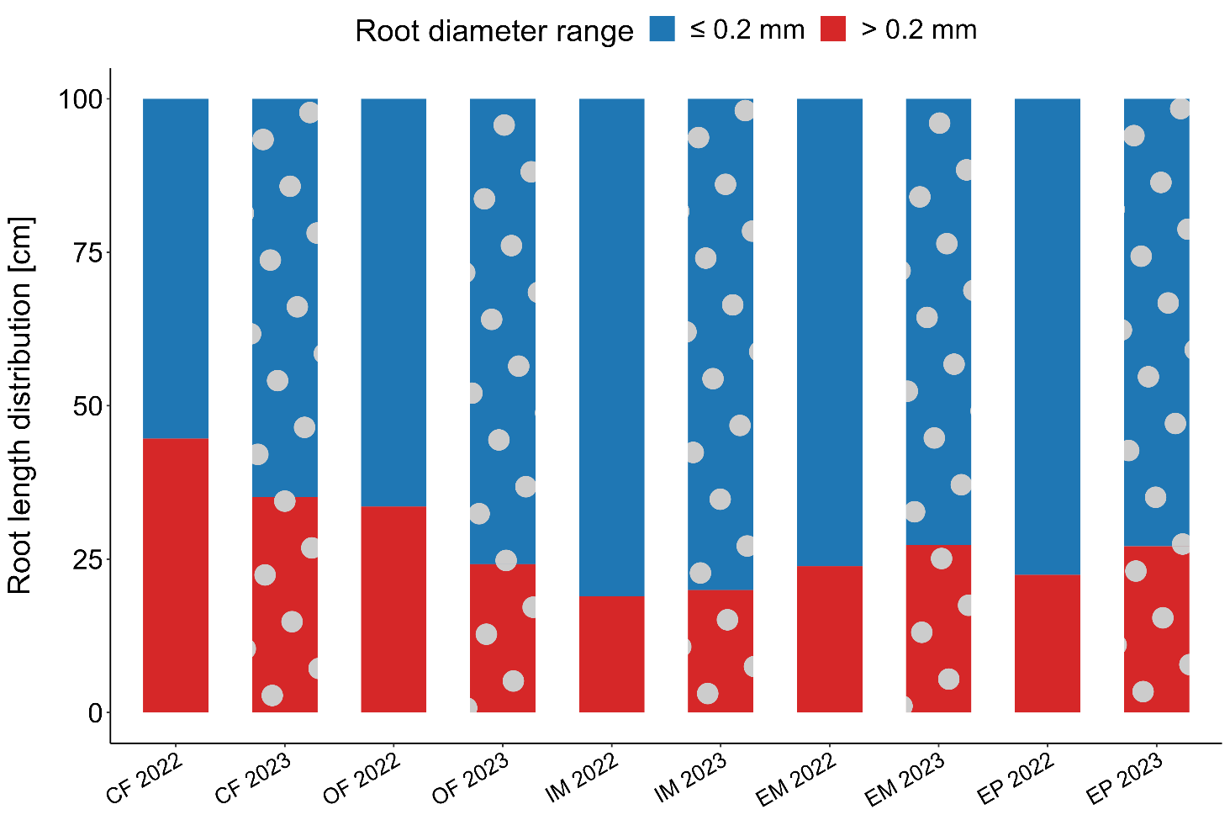

Fig. S6 Summed cover per plant functional groups (grass, forb, and legume) across three grassland types and two years. IM, EM and EP represent intensive meadow, extensive meadow and extensive pasture, respectively.
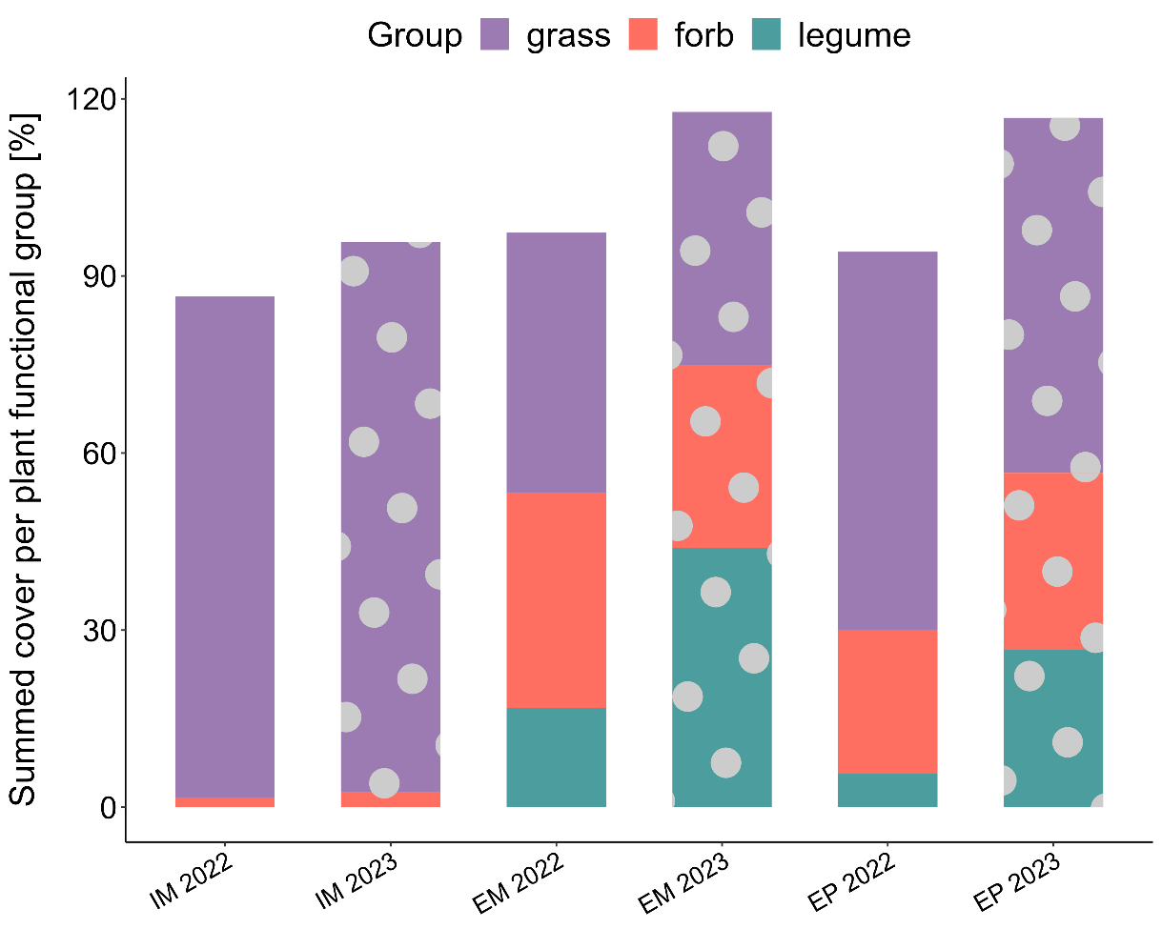

Fig. S7 Changes in soil water storage during growing season under different land-use types and future climate scenario across three years. (a) change of topsoil (0-30 cm) water storage, (b) change of deep soil (30-110 cm) water storage. Box plots represent the 0, 25, 50, 75, and 100 percentiles, and cross symbols represent the arithmetic mean (n = 10). Growing season refers to the period from when daily mean temperatures consistently exceed 5 °C until crop harvest. Box plots represent the 0, 25, 50, 75, and 100 percentile and cross symbols the arithmetic mean (n = 10). Significant differences between land use, climate, year, interaction of land use and year, land use, climate and year are indicated ** (p < 0.01) and *** (p < 0.001). CF, OF, IM and EM represent conventional farming, organic farming, intensive meadow, and extensive meadow, respectively.
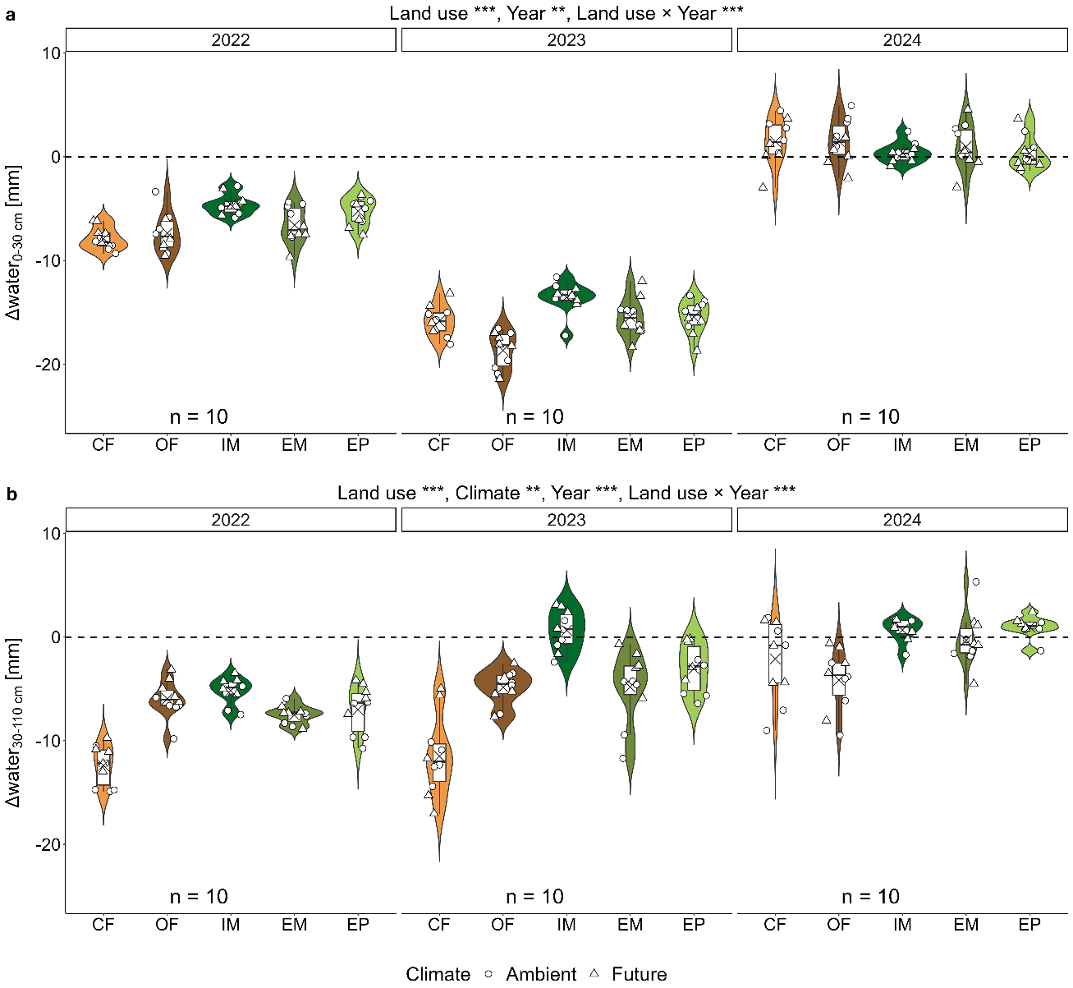

Fig. S8 Effect of land use, future climate scenario on annual yield across three years. CF, OF, IM and EM represent conventional farming, organic farming, intensive meadow, and extensive meadow respectively.
