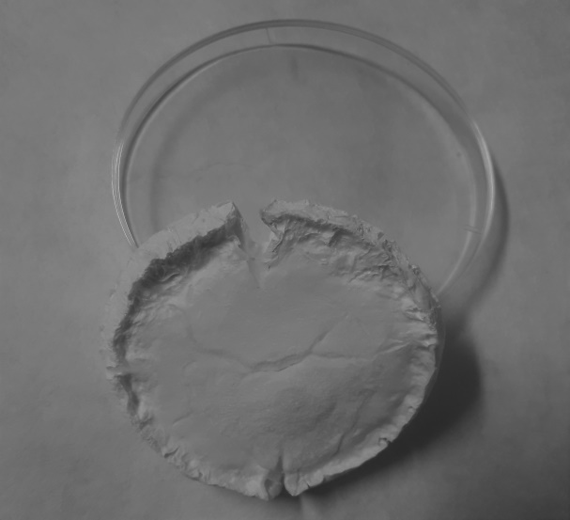 | 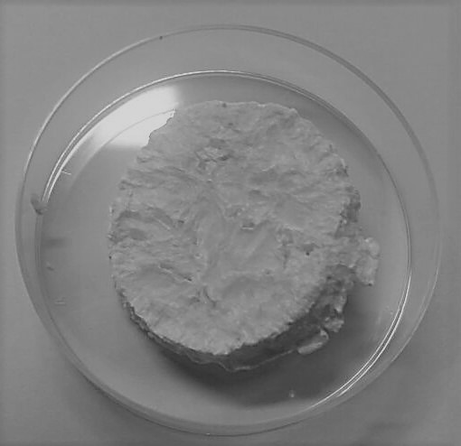

SI₁: Photographs of freeze dried Alg/Ch semi-IPN gels without addition of nanocelluloses.
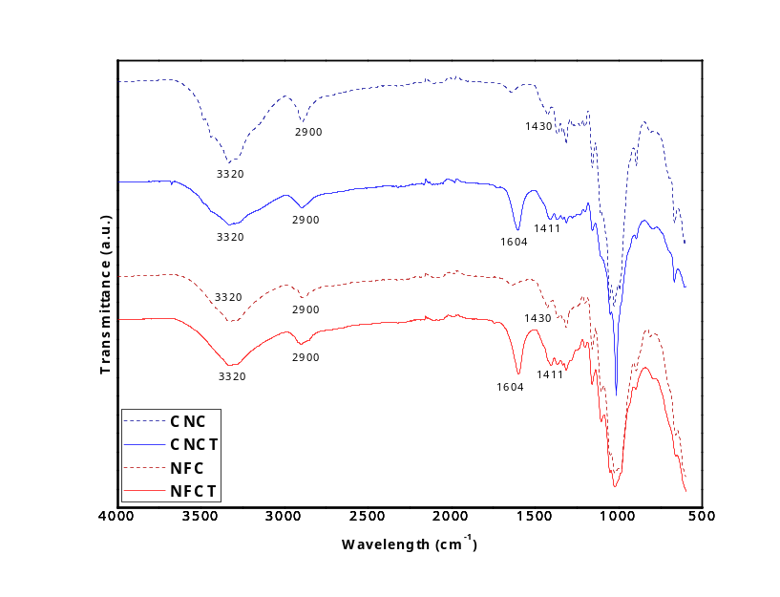
SI₂. FTIR spectra at ATR mode of un- and modified nanocelluloses.

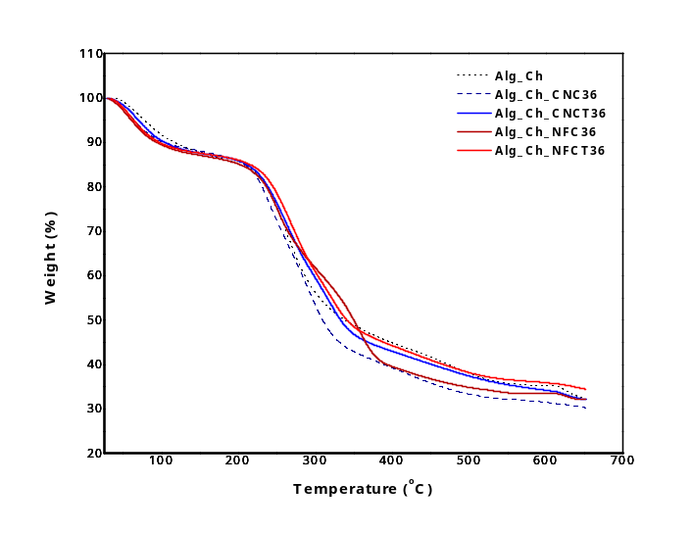
(A)
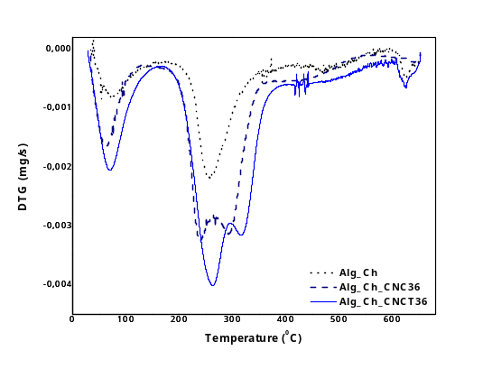  (B) | 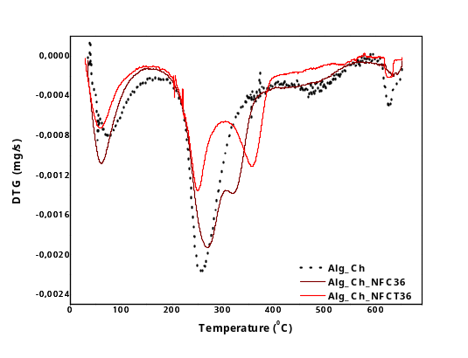  (C)

SI₃. (A) Curves obtained by thermogravimetry analyses (TGA); (B) and (C) first derivative of TG curves (DTG) of Alg/Ch CNC and CNCT semi-IPN gels and Alg/Ch NFC and NFCT semi-IPN gels, respectively.

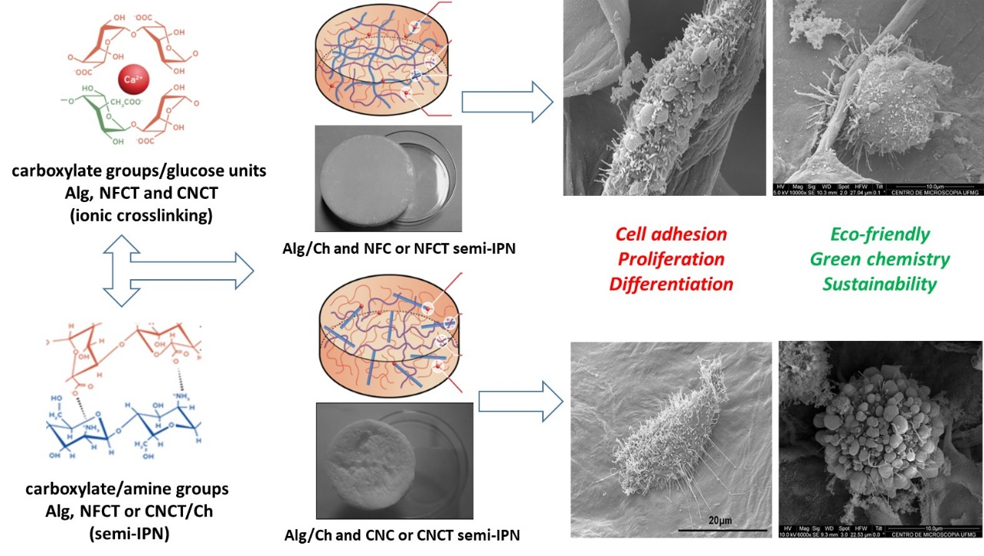
SI₄: Graphical abstract

