Table. S1 Parentage, origin and TA of ninety-seven sweet cherry varieties.
Code | Cultivar/Selection | Parentage | Origin | TA(%)
1 | 98-1 | - | China | 0.52
2 | 13-33 | - | China | 0.55
3 | Ruixiang | Summit×13-33 | China | 0.57
4 | Royalton | NY1725(Gaint×Emperor Francis)×o.p.* | USA | 0.58
5 | Baxing | - | China | 0.60
6 | Katalin | Germersdorfer×Podjebrad | Hungary | 0.61
7 | Solymari | - | Russia | 0.65
8 | Santina | Summit×Stella | Canada | 0.68
9 | Chunxiu | Bing×Jiahong | China | 0.69
10 | Chunlu | Van×o.p.* | China | 0.69
11 | Tieton | Stella×Early Burlat | USA | 0.70
12 | Sunburst | Van×Stella | Canada | 0.71
13 | Lala star | Lambert compact×Lapins | Italy | 0.71
14 | Sylvia | Van×Sam | Canada | 0.71
15 | Jiahong | Bing×Xiangjiao | China | 0.72
16 | Ruby | Hardy Giant×Bush Tartartan | USA | 0.72
17 | Brooks | Rainier×Early Burlat | USA | 0.73
18 | Shandong54 | - | China | 0.73
19 | Hongmi | Napoleon×Governor Wood | China | 0.74
20 | Nanyo | Napoleon×o.p.* | Japan | 0.75
21 | Youyi (Дружба) | - | Ukraine | 0.75
22 | Chunlei | Hongdeng×Van | China | 0.75
23 | New Star | Van×Stella | Canada | 0.77
24 | 16-1 | - | China | 0.78
25 | Hongbaoshi | - | - | 0.78
26 | Longxu | Napoleon×Black Tartarian | China | 0.78
27 | Shuijing | - | China | 0.78
28 | Sandra Rose | (Star×Van)×Sunburst | Canada | 0.79
29 | 02-1 | - | China | 0.79
30 | Micui | Juhong×o.p.* | China | 0.79
31 | Royal Lee | - | USA | 0.81
32 | Early star | Burlat×Stella compact | Italy | 0.82
33 | Beni temari | - | Japan | 0.82
34 | Hongyan | Napoleon×Governor Wood | China | 0.82
35 | Kordia | - | Czech Republic | 0.83
36 | Kurozatou nishiki | - | Japan | 0.84
37 | Bigarreau Moreau | - | France | 0.84
38 | Hedelfinger | - | Germany | 0.84
39 | Rainier | Bing×Van | USA | 0.84
40 | 4hao | - | China | 0.85
41 | Beni sayaka | Sato nishiki×Seneca | Japan | 0.85
42 | Lapins | Van×Stella | Canada | 0.85
43 | Schneiders | - | Germany | 0.85
44 | Sam | (Windsor×o.p.*）×o.p.* | Canada | 0.87
45 | Zaohongzhu | Bing×o.p.* | China | 0.87
46 | Сгорлри | - | Ukraine | 0.88
47 | Summit | Van×Sam | Canada | 0.88
48 | 98-2 | - | China | 0.88
49 | Hongzhenzhu | - | China | 0.88
50 | Italy3 | - | Italy | 0.88
51 | Sato nishiki | Napoleon×Governor Wood | Japan | 0.90
52 | Caihong | - | China | 0.90
53 | Lizhu | Rainier×8-100 | China | 0.90
54 | Sweetheart | Van× (Van×Lapins) | Canada | 0.90
55 | Toko nishiki | Napoleon×o.p.* | Japan | 0.91
56 | 9-19 | - | China | 0.91
57 | Gil peck | Napoleon×Giant | China | 0.91
58 | Sawaya | - | - | 0.91
59 | 06-1 | - | China | 0.92
60 | 13-48 | - | China | 0.92
61 | Sparkle | Empress Eugenie×o.p.* | Canada | 0.93
62 | Longbao | Napoleon×Black Tartarian | China | 0.94
63 | Star | Deacon×o.p.* | Canada | 0.94
64 | Regina | Schneiders Späte Knorpelkirsche×Rube | Germany | 0.95
65 | Jijia(Валерии Чкалов) | - | Ukraine | 0.96
66 | Shengli(Приусадебная) | - | Ukraine | 0.97
67 | Margit | Germersdorfer×o.p.* | Ukraine | 0.97
68 | Chunxiao | - | China | 0.98
69 | 3-106 | - | China | 0.98
70 | 7-155 | - | China | 0.98
71 | Zhifuhong | - | China | 0.98
72 | Stella | Lambert×JI 2420 | Canada | 0.99
73 | Chunhui | Van×o.p.* | China | 0.99
74 | Zaodaguo(Рннаакрулноплодна) | - | Ukraine | 0.99
75 | 7-101 | - | China | 1.00
76 | 13-53 | - | China | 1.01
77 | Italy1 | - | Italy | 1.02
78 | Wanhongzhu | Bing×Richu | China | 1.02
79 | Blaze star | Lapins×Durone Compatto di Vignola | Italy | 1.02
80 | Xiuzhu | Wanhongzhu×13-33 | China | 1.03
81 | Juhong | Napoleon×Governor Wood | China | 1.04
82 | Wumeijizao(Скороспелка) | - | Ukraine | 1.05
83 | Weika(Винка) | - | Ukraine | 1.07
84 | Hongdeng | - | China | 1.09
85 | Black Tartarian E | - | USA | 1.09
86 | 90-8 | - | China | 1.09
87 | Chunyan | Rainier×Hongdeng | China | 1.11
88 | B02 | - | - | 1.11
89 | Mingzhu | (Napoleon×Zaofeng)×o.p.* | China | 1.15
90 | Napoleon | - | Germany | 1.15
91 | B06 | - | - | 1.17
92 | Bing | Black Republican×o.p.* | USA | 1.18
93 | Van | Empress Eugenie×o.p.* | Canada | 1.19
94 | Longguan | Napoleon×Black Tartarian | China | 1.25
95 | Isabella | Starking Hardy Giant×Stella | Italy | 1.28
96 | Yuzhou(Космическая) | - | Ukraine | 1.28
97 | 15-3 | - | China | 1.30

Table. S2 Sequences of qRT-PCR primers for genes related to malate metabolism and transport.
Gene | Primer
PavMDH1 | F: ACTGGAGCCGCAGGACAA
 | R: AGAGGGAAAGCAGCATCG
PavME2 | F: AAGTGGCGGATACTGAACC
 | R: TTCTGGCAAACAAGACCTAC
PavPEPC3 | F: CCGAGGAAGTTCAGATTG
 | R: GTAGGATGTGCCGTTAGG
PavVHA-A | F: AGATAAGTTACACCCTAATC
 | R: CAAGAGCACGGAAACCAC
PavVHA-B2 | F: CTTCCTCCTCTTCTGCTT
 | R: ATATGATCGGACGGTTGC
PavVHA-C | F: TACCCGTTGATTCATACCTTA
 | R: ATTAAGTTGACTGCGGACAT
PavVHA-d2 | F: TTCAGCCCTGTCAGATAA
 | R: ATGCCCATAGAAAGTAGC
PavVHP1 | F: CTGTTTGGTGCCTTTGTC
 | R: TTGAACTGCCTGCGGACT
PavPHA4 | F: GTTGTTGCCCTTGTTTGA
 | R: AAGTCGTCGCCCTGTCTC
PavALMT6 | F: GGACGCTCTGATGGGATT
 | R: TGACAAAGATGGCAAGGA
PavALMT9 | F: AAAATGGAGATCGTGGTTTC
 | R: GAGGCTGGAAGTAATAAAG
Histone2 | F: GGTGTGCTTCCGCAGATAA
 | R: TCCTCCTTGGGTGGTGAAT

Table. S3 Evaluation and statistics of RNA-seq data of ‘LG’ and ‘RX’.
Sample | Raw reads | Clean reads | Reads mapped(%) | Q20(%) | Q30(%) | GC(%)
LG1_1 | 40587548 | 39327732 | 92.57 | 97.62 | 93.2 | 45.44
LG1_2 | 46219774 | 45061244 | 92.41 | 97.69 | 93.38 | 45.37
LG1_3 | 42465570 | 41336108 | 92.67 | 97.69 | 93.42 | 45.35
LG2_1 | 46619664 | 45419496 | 94.76 | 97.71 | 93.37 | 45.99
LG2_2 | 45279432 | 43757228 | 95.01 | 97.75 | 93.46 | 45.98
LG2_3 | 43415246 | 41988266 | 94.66 | 97.75 | 93.48 | 46.11
LG3_1 | 40383014 | 39209136 | 95.36 | 97.56 | 93.04 | 46.17
LG3_2 | 42792706 | 41523324 | 95.36 | 97.66 | 93.26 | 46.25
LG3_3 | 45534230 | 44182318 | 95.71 | 97.63 | 93.19 | 46.26
RX1_1 | 45736188 | 44175502 | 93.72 | 97.67 | 93.36 | 45.28
RX1_2 | 41160822 | 39980646 | 94.25 | 97.71 | 93.38 | 45.39
RX1_3 | 43431050 | 42090462 | 94.15 | 97.49 | 92.84 | 45.38
RX2_1 | 46828164 | 45394486 | 95.65 | 97.53 | 92.96 | 46.01
RX2_2 | 44276352 | 42914920 | 95.91 | 97.7 | 93.28 | 46.04
RX2_3 | 43981952 | 42769906 | 95.72 | 97.7 | 93.33 | 45.95
RX3_1 | 42918344 | 41483496 | 96.04 | 97.75 | 93.45 | 46.03
RX3_2 | 41145482 | 39701764 | 95.2 | 97.54 | 93.06 | 45.95
RX3_3 | 45227094 | 43761598 | 95.78 | 97.78 | 93.56 | 46.28
Table. S4 Candidate genes and TFs for malate accmulation in sweet cherry fruits.
gene_id | LG1 | LG2 | LG3 | RX1 | RX2 | RX3 | gene_description
Pav_sc0000158.1_g060.1.mk/PavVHA-A | 170.04 | 385.77 | 287.71 | 172.05 | 414.30 | 317.73 | V-type proton ATPase catalytic subunit A
Pav_sc0000373.1_g750.1.mk/PavVHA-B2 | 149.86 | 208.53 | 167.83 | 130.21 | 226.24 | 188.51 | V-type proton ATPase subunit B2
Pav_sc0000044.1_g760.1.mk/PavVHA-C | 96.70 | 94.02 | 101.12 | 110.21 | 107.25 | 75.14 | V-type proton ATPase synthase subunit C
Pav_sc0001080.1_g400.1.mk/PavVHA-C | 74.07 | 158.14 | 123.32 | 78.53 | 143.94 | 153.59 | V-type proton ATPase subunit C
Pav_sc0000195.1_g620.1.mk/PavVHA-C | 99.17 | 148.06 | 132.08 | 108.84 | 162.67 | 158.87 | V-type proton ATPase synthase subunit C
Pav_sc0002208.1_g030.1.mk/PavVHA-C | 258.45 | 298.62 | 259.19 | 305.51 | 273.92 | 223.44 | V-type proton ATPase synthase subunit C
Pav_sc0000175.1_g090.1.mk/PavVHA-C | 275.10 | 240.89 | 274.18 | 285.37 | 208.26 | 249.47 | V-type proton ATPase synthase subunit C
Pav_sc0000754.1_g080.1.mk/PavVHA-E | 184.49 | 335.61 | 272.75 | 200.69 | 301.10 | 344.30 | V-type proton ATPase subunit E
Pav_sc0002318.1_g420.1.mk/PavVHA-E2 | 1.38 | 0.08 | 0.40 | 9.64 | 0.04 | 0.09 | V-type proton ATPase subunit E2
Pav_sc0000659.1_g020.1.mk/PavVHA-F | 38.99 | 38.70 | 55.78 | 48.12 | 37.05 | 35.12 | V-type proton ATPase subunit F
Pav_sc0001265.1_g100.1.mk/PavVHA-F | 63.61 | 98.87 | 107.61 | 61.92 | 99.81 | 89.41 | V-type proton ATPase subunit F
Pav_sc0000362.1_g060.1.mk/PavVHA-G | 150.64 | 228.60 | 229.20 | 138.08 | 195.53 | 159.47 | V-type proton ATPase subunit G1
Pav_sc0001084.1_g400.1.mk/PavVHA-H | 167.97 | 100.77 | 104.16 | 159.72 | 97.74 | 64.93 | V-type proton ATPase subunit e1
Pav_sc0000636.1_g460.1.mk/PavVHA-H | 54.74 | 81.30 | 74.25 | 50.57 | 76.22 | 71.02 | V-type proton ATPase subunit H
Pav_sc0000323.1_g760.1.mk/PavVHA-a1 | 27.28 | 28.37 | 30.70 | 30.72 | 24.90 | 32.00 | V-type proton ATPase subunit a1
Pav_sc0001518.1_g560.1.mk/PavVHA-a3 | 78.87 | 124.61 | 144.72 | 76.78 | 133.27 | 174.70 | V-type proton ATPase subunit a3
Pav_sc0002208.1_g170.1.mk/PavVHA-a3 | 19.49 | 12.87 | 14.38 | 24.92 | 12.51 | 7.67 | V-type proton ATPase subunit a3
Pav_co4044415.1_g010.1.mk/PavVHA-a3 | 5.88 | 9.47 | 12.11 | 5.62 | 9.85 | 11.15 | V-type proton ATPase subunit a3
Pav_sc0001623.1_g020.1.mk/PavVHA-c'' | 62.45 | 83.54 | 80.60 | 61.53 | 86.22 | 76.23 | V-type proton ATPase subunit c''
Pav_sc0000299.1_g070.1.mk/PavVHA-d2 | 60.76 | 76.86 | 63.85 | 62.40 | 67.84 | 56.81 | V-type proton ATPase subunit d2
Pav_sc0001369.1_g090.1.mk/PavVHP1 | 112.67 | 447.73 | 341.35 | 143.27 | 286.32 | 170.60 | Vacuolar proton pyrophosphatase 3
Pav_sc0000311.1_g860.1.mk/PavVHP2 | 190.41 | 372.00 | 391.53 | 290.49 | 383.25 | 493.98 | Vacuolar H⁺-pyrophosphatase
Pav_sc0000907.1_g440.1.mk/PavVHP3 | 291.00 | 95.98 | 215.00 | 290.00 | 278.49 | 307.89 | Vacuolar proton pyrophosphatase 3
Pav_sc0006812.1_g020.1.mk/PavPHA1 | 10.73 | 28.72 | 30.82 | 7.30 | 37.01 | 52.57 | Cation-transporting P-type ATPase
Pav_sc0003562.1_g280.1.mk/PavPHA2 | 89.47 | 100.98 | 121.96 | 83.34 | 110.46 | 126.02 | Cation-transporting P-type ATPase
Pav_sc0004405.1_g040.1.mk/PavPHA3 | 1.20 | 0.28 | 1.28 | 11.05 | 0.19 | 3.11 | Cation-transporting P-type ATPase
Pav_sc0000843.1_g540.1.mk/PavPHA4 | 84.41 | 661.47 | 457.83 | 79.71 | 788.23 | 863.12 | Plasma membrane-type ATPase 10
Pav_sc0000299.1_g230.1.mk/PavPHA5 | 24.17 | 316.10 | 452.71 | 55.46 | 340.50 | 706.92 | Plasma membrane ATPase 1
Pav_sc0000549.1_g1100.1.mk/PavPHA6 | 15.58 | 7.12 | 8.58 | 10.42 | 11.87 | 4.41 | Plasma membrane-type ATPase 11
Pav_sc0000259.1_g380.1.mk/PavPHA7 | 196.67 | 173.68 | 166.18 | 181.56 | 156.86 | 130.06 | Plasma membrane-type ATPase 11
Pav_sc0000119.1_g390.1.mk/PavMDH1 | 385.51 | 960.58 | 731.44 | 386.01 | 881.79 | 684.11 | Malate dehydrogenase
Pav_sc0001124.1_g270.1.mk/PavMDH2 | 191.58 | 270.55 | 184.51 | 218.18 | 248.56 | 377.80 | Malate dehydrogenase
Pav_sc0002264.1_g190.1.mk/PavMDH3 | 92.34 | 336.32 | 291.90 | 97.51 | 352.56 | 296.84 | Malate dehydrogenase
Pav_sc0003709.1_g060.1.mk/PavMDH4 | 74.97 | 135.18 | 158.73 | 72.35 | 143.01 | 135.52 | Malate dehydrogenase
Pav_sc0000009.1_g100.1.mk/PavMDH5 | 48.08 | 85.08 | 175.95 | 49.32 | 77.65 | 151.87 | Malate dehydrogenase
Pav_sc0001125.1_g130.1.mk/PavMDH6 | 17.29 | 118.62 | 47.24 | 11.68 | 165.17 | 92.37 | Malate dehydrogenase
Pav_sc0000762.1_g100.1.mk/PavMDH7 | 50.39 | 41.28 | 54.62 | 65.12 | 114.53 | 92.22 | Malate dehydrogenase
Pav_sc0000877.1_g830.1.mk/PavMDH8 | 55.44 | 59.75 | 54.03 | 60.11 | 64.49 | 78.51 | Malate dehydrogenase
Pav_sc0002524.1_g090.1.mk/PavMDH9 | 30.16 | 60.10 | 64.28 | 32.61 | 64.66 | 75.99 | Malate dehydrogenase
Pav_sc0004779.1_g020.1.mk/PavMDH10 | 22.74 | 44.79 | 49.03 | 29.64 | 45.58 | 58.39 | Malate dehydrogenase
Pav_sc0000243.1_g150.1.mk/PavMDH11 | 29.92 | 27.12 | 34.31 | 19.41 | 24.82 | 17.34 | Malate dehydrogenase
Pav_sc0007253.1_g090.1.mk/PavMDH12 | 10.93 | 23.04 | 17.74 | 12.59 | 25.69 | 21.84 | Malate dehydrogenase
Pav_sc0000568.1_g370.1.mk/PavMDH13 | 7.08 | 1.90 | 1.27 | 10.65 | 5.51 | 1.35 | Malate dehydrogenase
Pav_sc0000736.1_g050.1.mk/PavMDH15 | 0.40 | 0.09 | 0.10 | 1.38 | 0.49 | 6.88 | Malate dehydrogenase
Pav_sc0000119.1_g330.1.mk/PavPEPC1 | 73.74 | 1.32 | 1.06 | 73.23 | 1.27 | 0.46 | Phosphoenolpyruvate carboxylase kinase 1
Pav_sc0000588.1_g830.1.mk/PavPEPC2 | 12.93 | 21.83 | 21.95 | 13.14 | 25.30 | 16.86 | Phosphoenolpyruvate carboxylase 4
Pav_sc0000067.1_g570.1.mk/PavPEPC3 | 37.92 | 198.81 | 171.96 | 33.43 | 110.35 | 135.16 | Phosphoenolpyruvate carboxylase 2
Pav_co4059685.1_g010.1.mk/PavPEPC4 | 30.75 | 176.96 | 148.37 | 30.45 | 100.41 | 120.51 | Phosphoenolpyruvate carboxylase 2
Pav_sc0012489.1_g010.1.mk/PavPEPC5 | 29.81 | 171.74 | 146.03 | 31.80 | 97.35 | 120.38 | Phosphoenolpyruvate carboxylase 2
Pav_sc0000257.1_g620.1.mk/PavPEPC6 | 22.63 | 19.14 | 17.77 | 23.59 | 16.66 | 26.97 | Phosphoenolpyruvate carboxylase 2
Pav_sc0000617.1_g090.1.mk/PavPEPC7 | 32.04 | 70.71 | 36.59 | 37.01 | 64.68 | 87.42 | Phosphoenolpyruvate carboxylase
Pav_sc0000396.1_g540.1.mk/PavPEPC8 | 22.01 | 64.13 | 27.07 | 16.23 | 46.93 | 140.77 | Phosphoenolpyruvate carboxylase kinase 1
Pav_sc0000212.1_g790.1.mk/PavME1 | 147.78 | 123.25 | 140.04 | 152.16 | 304.11 | 313.25 | NADP-dependent malic enzyme
Pav_sc0002266.1_g140.1.mk/PavME2 | 71.95 | 122.35 | 125.45 | 55.97 | 91.69 | 136.35 | NADP-dependent malic enzyme
Pav_sc0000759.1_g180.1.mk/PavME3 | 93.04 | 81.88 | 81.92 | 103.36 | 41.36 | 105.68 | NADP-dependent malic enzyme
Pav_sc0000675.1_g730.1.mk/PavME4 | 37.64 | 54.45 | 43.03 | 36.29 | 40.63 | 45.72 | NADP-dependent malic enzyme
Pav_sc0000800.1_g540.1.mk/PavME5 | 19.68 | 1.33 | 0.94 | 21.12 | 1.55 | 5.40 | NADP-dependent malic enzyme
Pav_sc0000567.1_g980.1.mk/PavALMT1 | 11.58 | 26.47 | 28.21 | 11.72 | 22.58 | 35.65 | Aluminum-activated malate transporter 4
Pav_sc0000383.1_g530.1.mk/PavALMT3 | 15.21 | 14.13 | 13.71 | 21.02 | 19.98 | 22.25 | Aluminum-activated malate transporter 9
Pav_sc0000383.1_g520.1.mk/PavALMT6 | 9.52 | 9.06 | 7.79 | 11.81 | 10.27 | 14.43 | Aluminum-activated malate transporter 9
Pav_sc0001331.1_g080.1.mk/PavALMT9 | 2.41 | 81.87 | 37.98 | 11.01 | 32.91 | 29.86 | Aluminum-activated malate transporter 2
Pav_sc0002233.1_g100.1.mk/PavtDT1 | 155.08 | 168.36 | 75.70 | 137.34 | 158.74 | 78.04 | Tonoplast dicarboxylate transporter
Pav_sc0000866.1_g320.1.br/PavtDT2 | 11.80 | 10.28 | 11.73 | 6.93 | 10.91 | 8.91 | Tonoplast dicarboxylate transporter
Pav_sc0000464.1_g130.1.br/PavMYB10.1 | 0.14 | 1715.23 | 1892.92 | 0.09 | 407.85 | 406.55 | Transcription factor MYB10.1
Pav_sc0000877.1_g610.1.mk/PavMYB306 | 8.50 | 50.27 | 86.03 | 6.90 | 23.31 | 16.11 | MYB-related protein 306
Pav_sc0001341.1_g540.1.mk/PavWRKY33 | 7.35 | 4.21 | 11.38 | 6.99 | 4.85 | 43.25 | WRKY transcription factor 33
Pav_sc0000907.1_g220.1.mk/PavbHLH49 | 63.45 | 328.11 | 223.46 | 148.77 | 382.11 | 269.23 | Transcription factor bHLH149

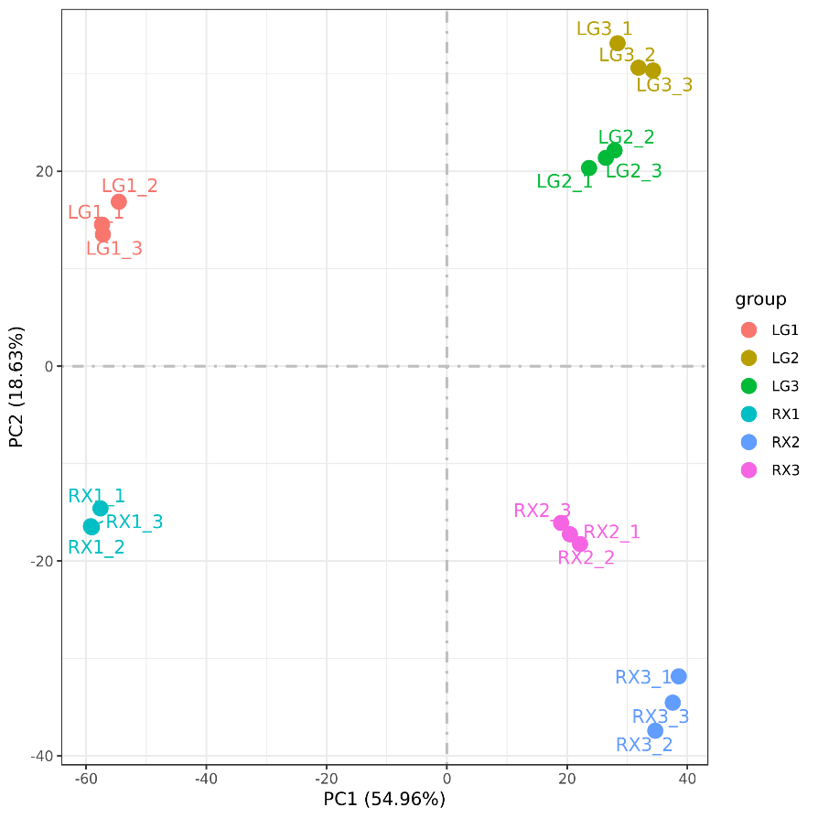
Fig. S1 Principal component analysis (PCA) was conducted on transcriptome profiles from distinct fruit developmental stages of two sweet cherry cultivars: 'LG' and 'RX'. Sampling time points were designated as LG1 (21 DAF), LG2 (42 DAF), and LG3 (49 DAF) for 'LG'; RX1 (21 DAF), RX2 (42 DAF), and RX3 (49 DAF) for 'RX'.
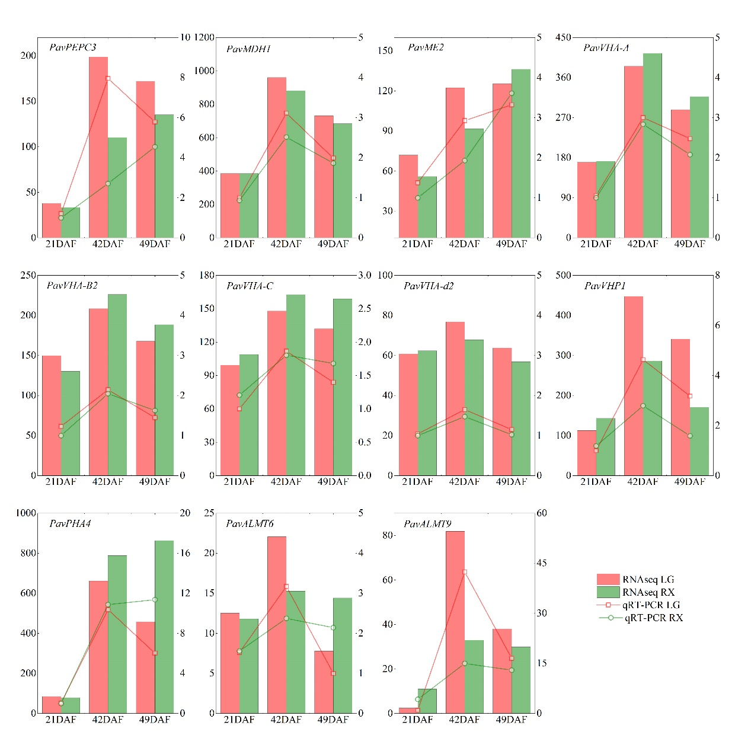
Fig. S2 Comparative analysis of RNA-seq and qRT-PCR data validated the expression patterns of eleven genes functionally associated with malate metabolism and transmembrane transport. Histograms depict RNA-seq expression levels (left y-axis, FPKM values), while lines denote qRT-PCR quantification (right y-axis, actin-normalized relative expression). Each panel displays three developmental stages: 21 DAF, 42 DAF, and 49 DAF. qRT-PCR values represent means ± SD of three technical replicates.

