Respiratory effects of trunk inclination in obese and non-obese patients mechanically ventilated for ARDS

Martín H. Benites, Shailesh Bihari, Romina Battiato, Alejandro Bruhn, Guillermo Bugedo, Eduardo L. V. Costa, Jean Dellamonica, Claude Guérin, Thomas Langer, John J. Marini, Francesco Marrazzo, Mehdi Mezidi, John Selickman, Ubbo F. Wiersema, and Jaime Retamal

^{ONLINE ADDITIONAL FILE}

Table 1. Designs and Methodological Characteristics of the Analyzed Studies

 | Study | Population | Design | Mechanical ventilation mode  (data register) | Time PEEP setting | Tool Used to Set PEEP at Baseline | Body Position at the Time of PEEP Setting | Ventilator Settings at Baseline | Protocol Phases
1 | Mezidi et al. (2019), Intensive Care Medicine | 24 ARDS patients | Quasy-experimental | Volume-controlled ventilation.  Analogic signals were recorded with Biopac 150 (Biopac, USA) with a 200 Hz sample rate. | Immediately before the onset of the study | PEEP/FiO2 table ARMA trial | 30° | Tidal volume was 0.385 (0.357-0.414) L or 5.9 (5.7-6.1) mL/kg predicted body weight, PEEP 11 (10-12) cmH₂O, and respiratory rate 31 (29-33) breaths/min | Two 10-minute phases in supine position:- SP30°: Supine with 30° head-up, - SP0°: Supine flat
2 | Selickman et al. (2022), Critical Care Medicine | 17 ARDS patients | Quasi-experimental | Volume-controlled ventilation | Before the onset of the study | Prescribed by the clinical team prior to study enrollment | 30° | Tidal volume: mean 5.6 (±0.9) mL/kg PBW, PEEP: mean 10.2 (±3) cmH₂O | Two measurement phases:- Baseline: Supine (head of bed 30°) ; - Intervention: Bed inclined by 15° (reverse Trendelenburg)
3 | Marrazzo et al. (2022), American Journal of Respiratory and Critical Care Medicine | 20 patients with acute respiratory failure | Experimental;physiological crossover study | Volume-controlled ventilation | Immediately before the onset of the study | Recruitment maneuver followed by a decremental PEEP trial to determine best respiratory system compliance (CRS) | 40° | VT 5.9 (5.7-6.3) ml/kg of predicted body weight, PEEP 14 (12-14) cm H₂O | Three 15-minute steps: Step 1: Semi-recumbent (40° head up, baseline), Step 2: Supine-flat (0°), Step 3: Return to semi-recumbent (40° head up)
4 | Marrazzo et al. (2023), Respiratory Care | 15 patients with acute respiratory failure | Experimental;physiological crossover study | Volume-controlled ventilation | Immediately before the onset of the study | Recruitment maneuver followed by a decremental PEEP trial to determine best respiratory system compliance (CRS) | 40° | Tidal volume of 6.0±0.6 ml/kg of predicted body weight, PEEP of 14±3 cmH₂O | Three 15-minute steps:- Step 1: Semi-recumbent (40° head up)  - Step 2: Supine-flat (0°)  - Step 3: Return to semi-recumbent (40° head up)
5 | Benites et al. (2023), Intensive Care Medicine Experimental | 22 patients with acute respiratory failure | Quasi-experimental, single-group study with repeated measures | Pressure-controlled ventilation.  Analogic signals were recorded with FluxMed device. | Sixty minutes before initiation of the study protocol | Diagnostic View software (EIT) to set optimal PEEP using visualization of regional lung overdistention and collapse | 45° | Tidal volume of 6 ml/kg PBW, respiratory rate 20 [18–24] per minute, inspiration-to-expiration ratio of 1:1, PEEP set was 10 [8–12] mmHg | Three 60-minute steps: - Step 1: 45° trunk inclination (baseline)  - Step 2: 10° trunk inclination (intervention)  - Step 3: Return to 45° trunk inclination (control)
6 | Bihari et al. (2024), CHEST | 40 ARDS patients | Experimental study; randomized study | Volume-controlled ventilation | Immediately before the onset of the study | Prescribed by the clinical team prior to study enrolment | It was 30.0 (9.5) in BMI ≥ 30 group and 26.6 (9.6) in BMI <30 group | PEEP: Obese 8.9 (3.6) cm H₂O, Non-obese 9.8 (3.4) cm H₂O. Tidal volume: Obese 6.5 (0.8) mL/kg IBW, Non-obese 6.2 (0.4) mL/kg IBW | Two 15-minute phases:- Semi-recumbent (40° head up)  - Supine-flat (0°). Patients were randomized to either sequence (Semi-recumbent→Supine or Supine→Semi-recumbent)
7 | Chen et al. (2024), Intensive & Critical Care Nursing | 17 ARDS patients | Prospective physiologic study | Volume-controlled ventilation | Thirty min before initiating the study | PEEP was optimized through a stepwise decrease PEEP trial | No data | Lung protective ventilation (tidal volume 6-8 mL/kg PBW, plateau pressure <28 cmH₂O, driving pressure <14 cmH₂O). FiO₂ set to achieve SpO₂ 92-97% | Three 30-minute sequential steps:- Supine-1 (S1) baseline  - Sitting position (SP) with 70° inclination with legs allowed to droop  - Supine-2 (S2) return to baseline position

Respiratory mechanics:
CRS was calculated in all studies as the tidal volume divided by the plateau pressure minus the total PEEP (PEEPTOT = external PEEP + auto-PEEP) using a rapid airway occlusion technique. When available, partitioned respiratory mechanics (lung (CL) and chest wall compliance (CCW)) were registered as previously defined (1, 2). The ratio between lung and chest wall elastance and respiratory system elastance (EL/ERS-ECW/ERS) was also calculated to evaluate the contribution of pulmonary and extrapulmonary tissue to the mechanical properties of the respiratory system in obese and non-obese patients. Respiratory system elastance (ERS) is defined as the reciprocal of compliance (1/CRS).

Oxygenation, EELV, and ventilatory variables:
PaO2/F_{I}O₂, PaCO₂, and VR were measured at the end of each step using arterial blood samples. When available, ventilatory inefficiency (Bohr dead space), ventilation-perfusion ratio assessed by the slope of phase III of the capnogram normalized to the expired fraction of CO2 (SnIII), and EELV were recorded using volumetric capnography and nitrogen washout/washin techniques, respectively (3, 4).

Table 2-A. Compliance of Respiratory System in patients with BMI ≥ 30 kg/m²

BMI ≥ 30 kg/m2 (n=65) | Compliance of Respiratory System
 | Supine position | Semirecumbent / Head-up
Bihari et al. (n= 20) | 36 (6 ) | 30 (5)
Benites et al. (n=12) | 42 (10) | 34 (9)
Mezidi et al. (n=9) | 56 (16) | 46 (13)
Marrazzo et al. 1 (n=10) | 37 (5) | 27 (6)
Marrazzo et al. 2 (n=7) | 42 (8) | 31 (9)
Selickman et al. (n=7) | 32 (10) | 30 (12)
Mean (SD) | 40.2 (9.2) | 32.6 (8.6)

Table 2-B. Compliance of Respiratory System in patients with BMI < 30 kg/m²

BMI < 30 kg/m2 (n=94) | Compliance of Respiratory System
 | Supine position | Semirecumbent / Head-up
Bihari et al. (n= 20) | 35 (6) | 35 (6)
Benites et al. (n=10) | 40 (12) | 36 (12)
Chen et al. (n=17) | 41 (10) | 40 (9)
Mezidi et al. (n=15) | 44 (14) | 35 (11)
Marrazzo et al. 1 (n=10) | 38 (13) | 28 (10)
Marrazzo et al. 2 (n=8) | 38 (15) | 28 (11)
Selickman et al. (n=14) | 27 (11) | 24 (12)
Mean (SD) | 37.4 (11.2) | 33 (10)

Table 3-A. Lung Compliance in patients with BMI ≥ 30 kg/m²

BMI ≥ 30 kg/m² (n=46) | Lung Compliance
 | supine-flat position | semirecumbent / Head-up
Bihari et al. (n= 20) | 48.8 (9.8) | 41.5 (9.3)
Mezidi et al. (n=9) | 78.1 (32.3) | 68.5 (33.3)
Marrazzo et al. 1 (n=10) | 43.5 (9) | 35.7 (10.2)
Marrazzo et al. 2 (n=7) | 55.5 (15.4) | 43.5 (15)
Mean (SD) | 54.4 (17.1) | 45.8 (17.5)

Table 3-B. Lung Compliance in patients with BMI < 30 kg/m²

BMI < 30 kg/m2 (n= 53) | Lung Compliance
 | supine-flat position | semirecumbent / Head-up
Bihari et al. (n= 20) | 47.4 (11.5) | 48.1 (11.3)
Mezidi et al. (n=15) | 59.2 (24.9) | 49.3 (23.8)
Marrazzo et al. 1 (n=10) | 47.6 (20.4) | 34.5 (14)
Marrazzo et al. 2 (n=8) | 45.5 (18.5) | 34.5 (16.6)
Mean (SD) | 50.5 (19) | 43.8 (17)

Table 4-A. Chest Wall Compliance in patients with BMI ≥ 30 kg/m²

BMI ≥ 30 kg/m² (n=46) | Chest Wall Compliance
 | supine-flat position | semirecumbent / Head-up
Bihari et al. (n= 20) | 142.9 (38.8) | 113.6 (29.7)
Mezidi et al. (n=9) | 188.7 (57.0) | 138.9 (32.8)
Marrazzo et al. 1 (n=10) | 200 (80) | 125 (47)
Marrazzo et al. 2 (n=7) | 166 (55) | 111 (24)
Mean (SD) | 167.8 (55.7) | 120.6 (34.1)

Table 4-B. Chest Wall Compliance in patients with BMI < 30 kg/m²

BMI < 30 kg/m2 (n= 53) | Chest Wall Compliance
 | supine-flat position | semirecumbent / Head-up
Bihari et al. (n= 20) | 131.6 (45.0) | 126.6 (40.1)
Mezidi et al. (n=15) | 172.4 (92.2) | 119.0 (53.9)
Marrazzo et al. 1 (n=10) | 200 (120) | 142 (61)
Marrazzo et al. 2 (n=8) | 250 (125) | 125 (46)
Mean (SD) | 173.9 (90) | 127.1 (49.1)

Table 5-A. The ratio between Lung Elastance and Respiratory system Elastance (E_{L}/E_{RS}) in patients with BMI ≥ 30 kg/m²

BMI ≥ 30 kg/m² (n=26) | EL/E_{RS}
 | supine-flat position | semirecumbent / Head-up
Mezidi et al. (n=9) | 0.68 (0.14) | 0.64 (0.15)
Marrazzo et al. 1 (n=10) | 0.82 (0.07) | 0.77 (0.08)
Marrazzo et al. 2 (n=7) | 0.8 (0.1) | 0.7 (0.07)
Mean (SD) | 0.77 (0.11) | 0.71 (0.11)

Table 5-B. The ratio between Lung Elastance and Respiratory system Elastance in patients with BMI < 30 kg/m²
BMI <30 kg/m² (n=33) | EL/E_{RS}
 | supine-flat position | semirecumbent / Head-up
Mezidi et al. (n=15) | 0.74 (0.13) | 0.68 (0.15)
Marrazzo et al. 1 (n=10) | 0.79 (0.11) | 0.78 (0.07)
Marrazzo et al. 2 (n=8) | 0.8 (0.1) | 0.8 (0.1)
Mean (SD) | 0.78 (0.11) | 0.75 (0.11)

Supplementary Figure 1. Forest Plot of E_{L}/E_{RS} in patients with BMI ≥ 30 kg/m² vs. BMI < 30 kg/m². Transitioning from a supine-flat to a semirecumbent or seated position

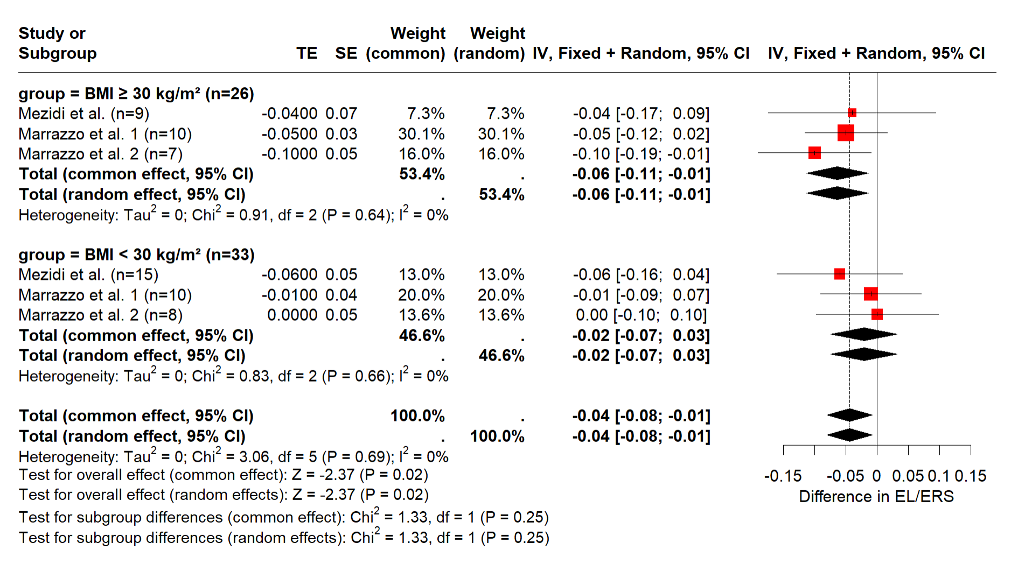

Table 6-A. The ratio between Chest Wall Elastance and Respiratory system Elastance (E_{CW}/E_{RS}) in patients with BMI ≥ 30 kg/m²

BMI ≥ 30 kg/m² (n=26) | E_{CW}/E_{RS}
 | supine-flat position | semirecumbent / Head-up
Mezidi et al. (n=9) | 0.32 (0.14) | 0.36 (0.15)
Marrazzo et al. 1 (n=10) | 0.18 (0.07) | 0.23 (0.08)
Marrazzo et al. 2 (n=7) | 0.23 (0.1) | 0.29 (0.07)
Mean (SD) | 0.24 (0.11) | 0.29 (0.11)

Table 6-B. The ratio between Chest Wall Elastance and Respiratory system Elastance (E_{CW}/E_{RS}) in patients with BMI < 30 kg/m²

BMI < 30 kg/m2 (n= 33) | E_{CW}/E_{RS}
 | supine-flat position | semirecumbent / Head-up
Mezidi et al. (n=15) | 0.26 (0.13) | 0.32 (0.15)
Marrazzo et al. 1 (n=10) | 0.21 (0.11) | 0.22 (0.07)
Marrazzo et al. 2 (n=8) | 0.17 (0.09) | 0.23 (0.1)
Mean (SD) | 0.22 (0.12) | 0.27 (0.12)

Supplementary Figure 2. Forest Plot of E_{CW}/E_{RS} in patients with BMI ≥ 30 kg/m² vs. BMI < 30 kg/m². Transitioning from a supine-flat to a semirecumbent or seated position

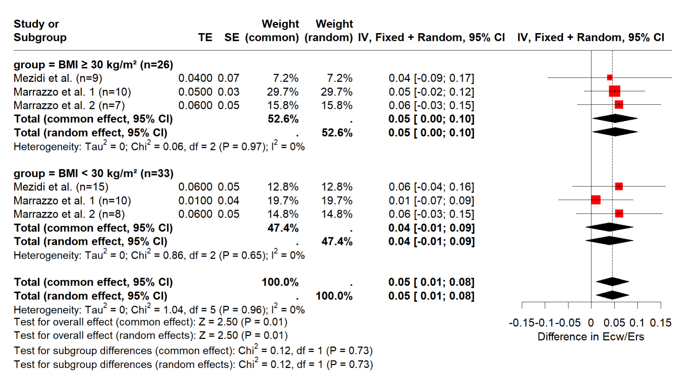

Table 7-A. Driving pressure in patients with BMI ≥ 30 kg/m²

BMI ≥ 30 kg/m2 (n=53) | Driving pressure
 | Supine position | Semirecumbent / Head-up
Bihari et al. (n= 20) | 11.4 (2.6) | 14.0 (2.4)
Mezidi et al. (n=9) | 10 (3.4) | 12.7 (4.2)
Marrazzo et al. 1 (n=10) | 10 (1) | 13 (2)
Marrazzo et al. 2 (n=7) | 9 (2) | 12 (3)
Selickman et al. (n=7) | 13.3 (5.8) | 15.3 (7.5)
Mean (SD) | 10.8 (3) | 13.5 (3.7)

Table 7-B. Driving pressure in patients with BMI < 30 kg/m²

BMI < 30 kg/m2 (n=67) | Driving pressure
 | Supine position | Semirecumbent / Head-up
Bihari et al. (n= 20) | 13.8 (1.4) | 13.9 (1.8)
Mezidi et al. (n=15) | 8.1 (2.4) | 9.8 (2.9)
Marrazzo et al. 1 (n=10) | 10 (2) | 14 (3)
Marrazzo et al. 2 (n=8) | 9 (2) | 14 (4)
Selickman et al. (n=14) | 16 (6.8) | 19.2 (9.2)
Mean (SD) | 11.8 (3.5) | 14.1 (4.8)

Supplementary Figure 3. Forest Plot of Driving pressure of respiratory system in patients with BMI ≥ 30 kg/m² vs. BMI < 30 kg/m². Transitioning from a supine-flat to a semirecumbent or seated position

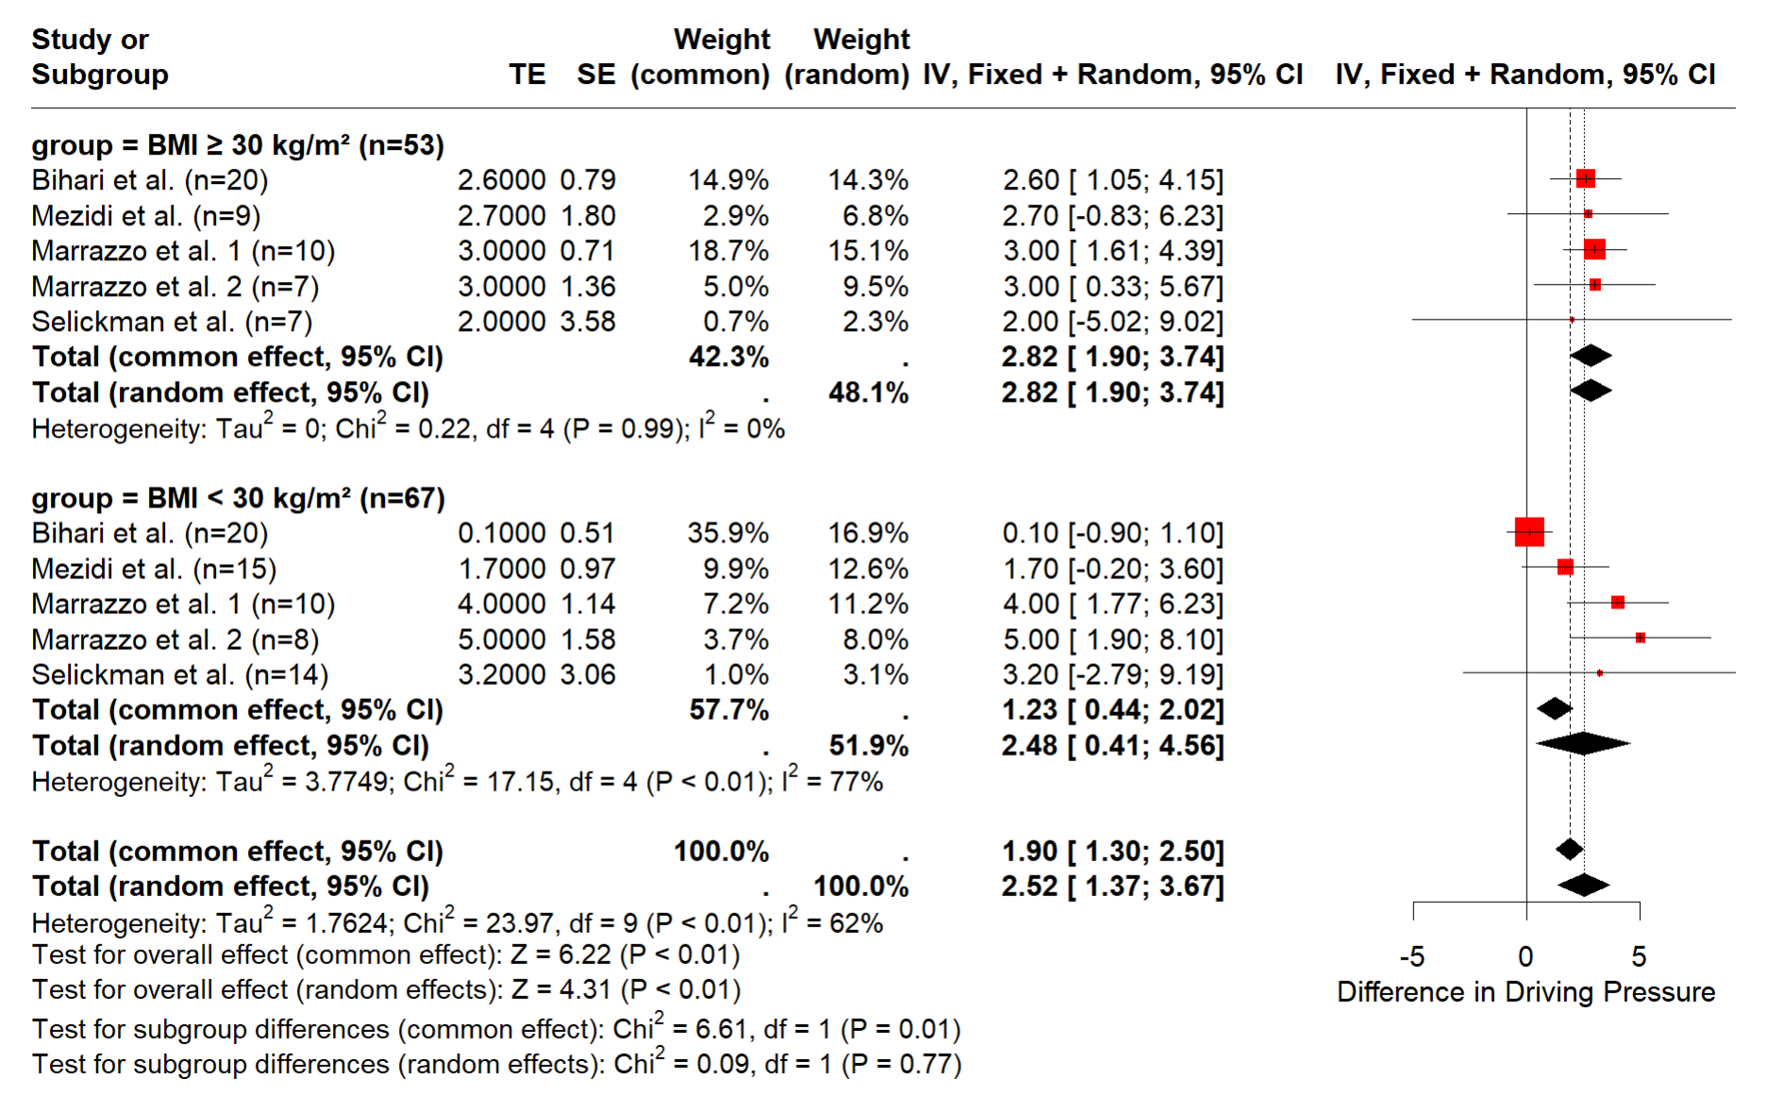

Table 8-A. PaO₂/F_{I}O₂ ratio in patients with BMI ≥ 30 kg/m²

BMI ≥ 30 kg/m² (n= 49) | PaO₂/FIO₂
 | supine-flat position | semirecumbent / Head-up
Bihari et al. (n= 20) | 132 (40) | 133 (47)
Benites et al. (n=12) | 181 (36) | 197 (35)
Marrazzo et al. 1 (n=10) | 130 (46) | 145 (47)
Marrazzo et al. 2 (n=7) | 152 (44) | 179 (38)
Mean (SD) | 146 (41) | 158 (43)

Table 8-B. PaO₂/F_{I}O₂ ratio in patients with BMI < 30 kg/m²

BMI < 30 kg/m2 (n= 65) | PaO₂/FIO₂
 | supine-flat position | semirecumbent / Head-up
Bihari et al. (n= 20) | 143 (44) | 143 (46)
Benites et al. (n=10) | 197 (29) | 194 (31)
Chen et al. (n=17) | 96 (53) | 102 (59)
Marrazzo et al. 1 (n=10) | 158 (58) | 150 (52)
Marrazzo et al. 2 (n=8) | 150 (55) | 152 (82)
Mean (SD) | 142 (48) | 142 (54)

Supplementary Figure 4. Forest Plot of PaO₂/F_{I}O₂ in patients with BMI ≥ 30 kg/m² vs. BMI < 30 kg/m². Transitioning from a supine-flat to a semirecumbent or seated position

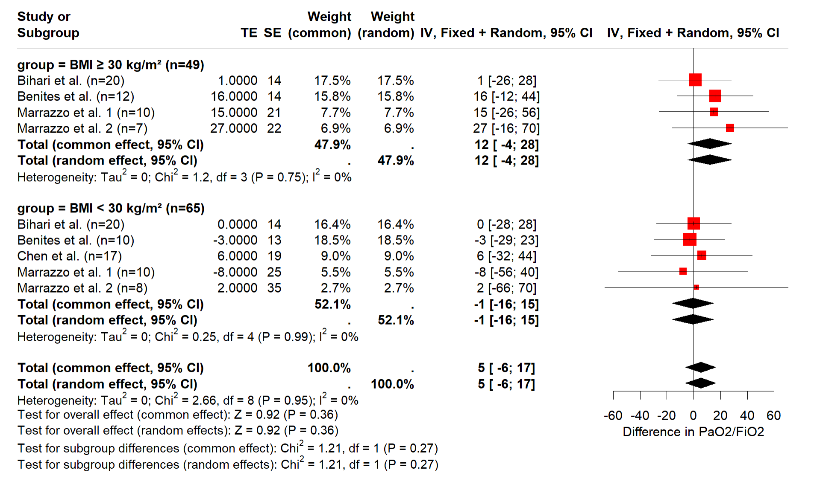

Table 9-A. PaCO₂ in patients with BMI ≥ 30 kg/m²

BMI > 30 kg/m2 (n= 49) | PaCO₂
 | supine-flat position | semirecumbent / Head-up
Bihari et al. (n= 20) | 48 (6) | 50 (6)
Benites et al. (n=12) | 35 (4) | 43 (4)
Marrazzo et al. 1 (n=10) | 50 (5) | 52 (6)
Marrazzo et al. 2 (n=7) | 46 (4) | 52 (6)
Mean (SD) | 44.9 (5.1) | 49 (5.6)

Table 9-B. PaCO₂ in patients with BMI < 30 kg/m²

BMI < 30 kg/m2 (n= 48) | PaCO₂
 | supine-flat position | semirecumbent / Head-up
Bihari et al. (n= 20) | 50 (8) | 50 (8)
Benites et al. (n=10) | 38 (7) | 43 (6)
Marrazzo et al. 1 (n=10) | 50 (8) | 53 (10)
Marrazzo et al. 2 (n=8) | 47 (7) | 51 (10)
Mean (SD) | 47 (7.7) | 49.3 (8.4)

Supplementary Figure 5. Forest Plot of PaCO₂ in patients with BMI ≥ 30 kg/m² vs. BMI < 30 kg/m². Transitioning from a supine-flat to a semirecumbent or seated position

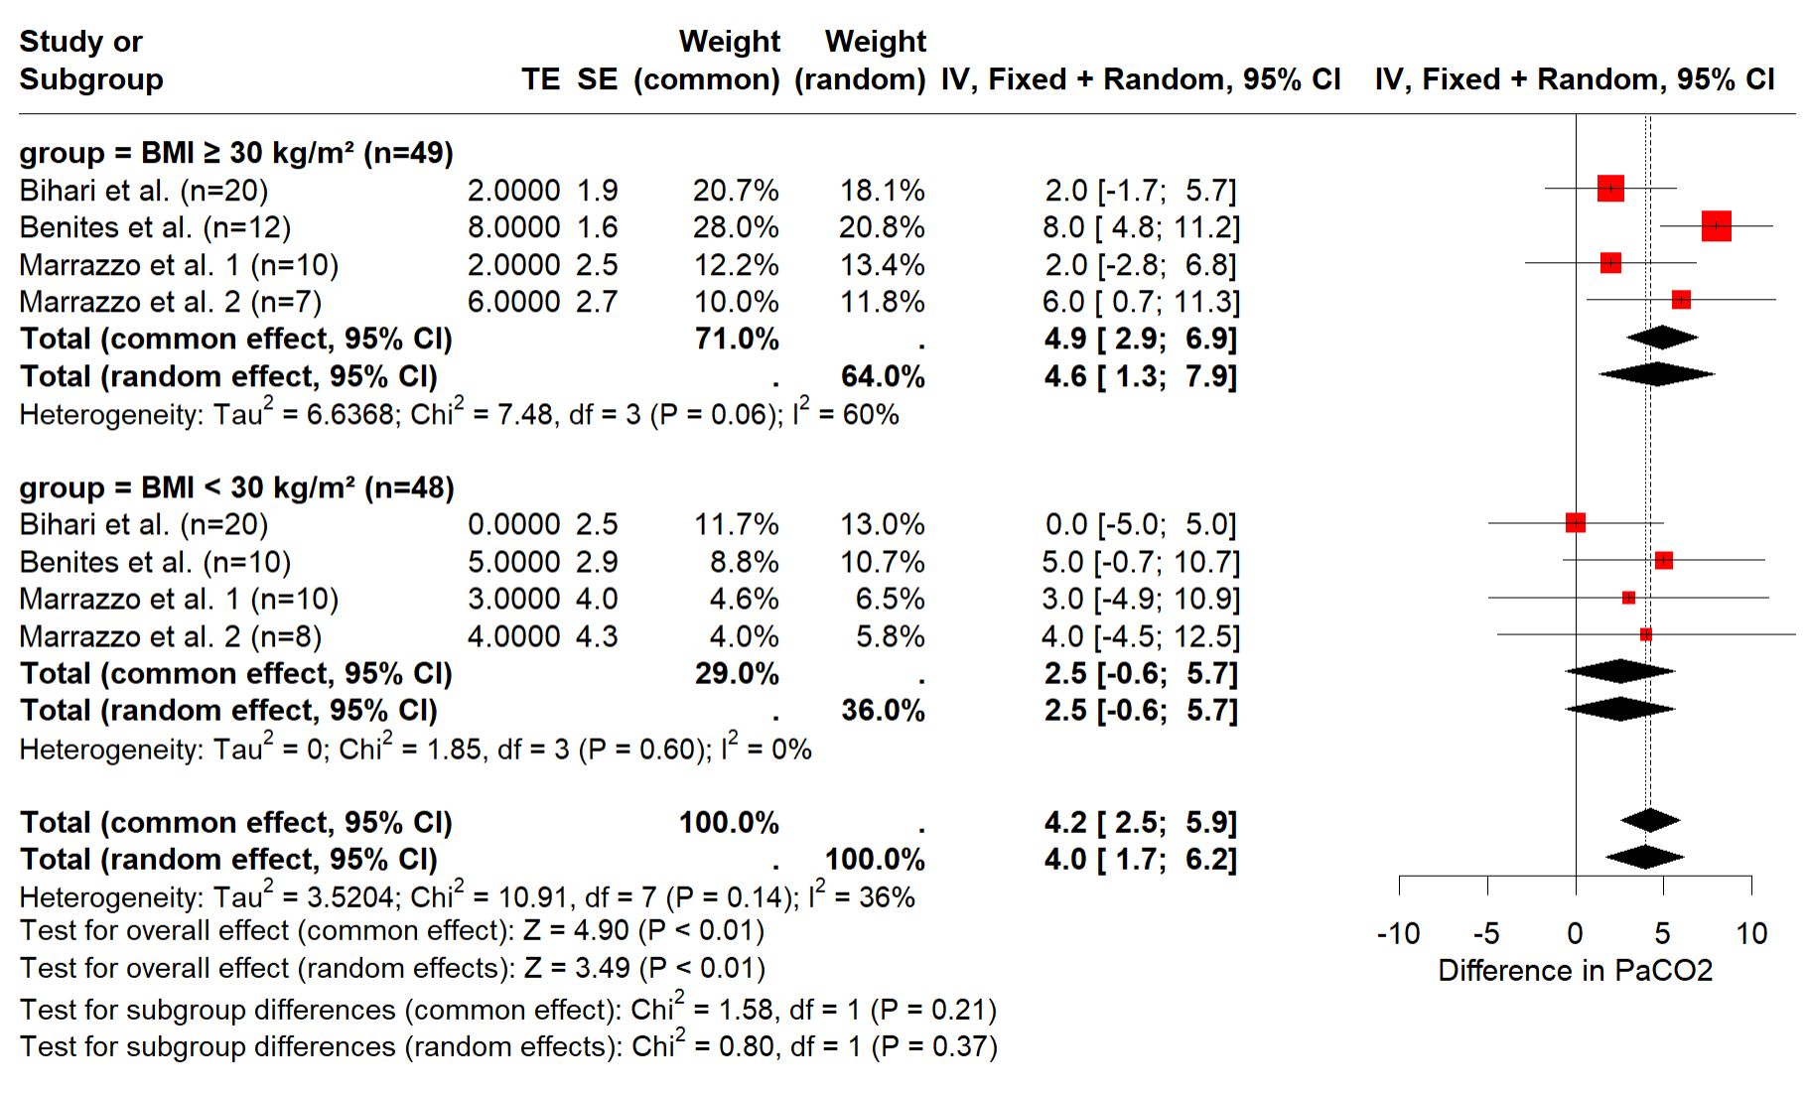

Table 10-A. Ventilatory ratio (VR) in patients with BMI ≥ 30 kg/m²

BMI > 30 kg/m² (n= 49) | VR
 | supine-flat position | semirecumbent / Head-up
Bihari et al. (n= 20) | 1.81 (0.43) | 1.90 (0.42)
Benites et al. (n=12) | 1.56 (0.30) | 1.63 (0.35)
Marrazzo et al. 1 (n=10) | 1.7 (0.3) | 1.8 (0.3)
Marrazzo et al. 2 (n=7) | 1.6 (0.3) | 1.8 (0.4)
Mean (SD) | 1.7 (0.36) | 1.8 (0.38)

Table 10-B. Ventilatory Ratio (VR) in patients with BMI < 30 kg/m²

BMI < 30 kg/m² (n= 48) | Ventilatory Ratio (VR)
 | supine-flat position | semirecumbent / Head-up
Bihari et al. (n= 20) | 1.74 (0.33) | 1.74 (0.33)
Benites et al. (n=10) | 1.28 (0.26) | 1.33 (0.27)
Marrazzo et al. 1 (n=10) | 1.6 (0.38) | 1.7 (0.44)
Marrazzo et al. 2 (n=8) | 1.6 (0.3) | 1.7 (0.4)
Mean (SD) | 1.58 (0.32) | 1.63 (0.35)

Supplementary Figure 6. Effects of trunk inclination from 10 to 45° in Dead space – Bohr fraction (VD_{Bohr}/VT). Obese patients

Supplementary Figure 7. Effects of trunk inclination from 10 to 45° in Dead space – Bohr fraction (VD_{Bohr}/VT). Non-obese patients

Supplementary Figure 8. Effect of trunk inclination from 10 to 45° in slope of phase III of the capnogram normalized to the expired fraction of CO2 (SnIII). Obese patients

Supplementary Figure 9. Effects of trunk inclination from 10 to 45° in slope of phase III of the capnogram normalized to the expired fraction of CO2 (SnIII). Non-obese patients

Table 10. End-Expiratory Lung Volume (EELV) in patients with BMI > 30 kg/m² and BMI < 30 kg/m²

 | Supine-flat (SP0°) | 30° head-up | P value
EELV BMI ≥ 30 kg/m² | 1430 (579) | 1570 (677) | 0.976
EELV BMI < 30 kg/m² | 1067 (397) | 1252 (452) | 0.398

P-value. Mean differences. Paired t-test

References

1-. Akoumianaki E, Maggiore SM, Valenza F, Bellani G, Jubran A, Loring SH, et al. The application of esophageal pressure measurement in patients with respiratory failure. Am J Respir Crit Care Med. 2014;189:520-31.
2. Stenqvist O. Transpulmonary pressure monitoring in critically ill patients: pros and cons-correction of description of the non-invasive PEEP-step method for separation of lung and chest wall mechanics. Crit Care. 2024;28(1):355.
3. Benites MH, Torres D, Poblete F, Labbe F, Bachmann MC, Regueira TE, et al. Effects of changes in trunk inclination on ventilatory efficiency in ARDS patients: quasi-experimental study. Intensive Care Med Exp. 2023;11(1):65.
4. Dellamonica J, Lerolle N, Sargentini C, Hubert S, Beduneau G, Di Marco F, et al. Effect of different seated positions on lung volume and oxygenation in acute respiratory distress syndrome. Intensive Care Med. 2013;39:1121–7.

