SUPPLEMENTARY INFORMATION

Impact of environmental gradients on juvenile coral demography across the Great Barrier Reef and Torres Strait

Coral Reefs

Christopher Doropoulos¹, Mariana Alvarez-Noriega², Katharina Fabricius², Renata Ferrari², Peter J Mumby³, Sam HC Noonan², Melanie Orr¹, Kinam Salee¹
¹ CSIRO Environment, St Lucia, QLD 4067, Australia
² Australian Institute of Marine Sciences, Townsville, QLD 4810, Australia
³ Marine Spatial Ecology Lab, School of The Environment, The University of Queensland, St. Lucia, QLD 4072, Australia
Corresponding author: christopher.doropoulos@csiro.au

ORCID: CD 0000-0001-8038-2771; MAN 0000-0003-1295-6897; KF 0000-0001-7671-4358; RF 0000-0002-5056-1178; PJM 0000-0002-6297-9053; SHCN 0000-0002-0392-6197; MO 0000-0002-2635-067X; KS 0000-0002-7416-3780
Table S1 Number of sites and fixed quadrats established in 2021 and resurveyed in 2022 and 2023 per reef. Each quadrat had ≥1 juvenile coral when established in 2021.
 |  |  |  | Quadrats
Latitude | Reef Cluster | Reef | Sites | 2021 | 2022 | 2023
Far North | Far northern | Aukane | 5 | 27 | 28 | 26
Far North | Far northern | Dungeness | 5 | 24 | 22 | 17
Far North | Far northern | Masig | 6 | 25 | 32 | 33
North | Northern offshore | Lizard | 5 | 19 | 18 | 18
North | Northern offshore | Moore | 6 | 21 | 22 | 22
Central | Central inshore | Orpheus | 1 | 7 | 6 | 4
Central | Central inshore | Pelorus | 3 | 12 | 14 | 13
Central | Central offshore | Chicken | 3 | 15 | 15 | 16
Central | Central offshore | Davies | 7 | 35 | 37 | 39
Central | Central offshore | Little Broadhurst | 3 | 16 | 16 | 16
South | Southern inshore | Great Keppel | 1 | 5 | 4 | 3
South | Southern inshore | North Keppel | 1 | 1 | 2 | 2
South | Southern offshore | Heron | 5 | 23 | 22 | 20
South | Southern offshore | Lady Musgrave | 5 | 24 | 25 | 24
 |  | Totals | 56 | 254 | 263 | 253

Table S2 List of environmental variables extracted from eReefs biogeochemical (GBR4, version 3.1). and hydrodynamic (GBR1, version 2.0) models
Variable code | Variable name | Units | eReefs model
alk | Total alkalinity | mmol m⁻³ | biogeochemical
Chl_a_sum | Total Chlorophyll | mg Chl m⁻³ | biogeochemical
Current_speed | Current speed | m s⁻¹ | hydrodynamic
DetBL_N | Labile detrital Nitrogen Benthic | mg N m⁻³ | biogeochemical
DetPL_N | Labile Detrital Nitrogen Planktonic | mg N m⁻³ | biogeochemical
DetR_N | Refractory Detrital Nitrogen | mg N m⁻³ | biogeochemical
DIC | Dissolved Inorganic Carbon | mg C m⁻³ | biogeochemical
DIN | Dissolved Inorganic Nitrogen | mg N m⁻³ | biogeochemical
DIP | Dissolved Inorganic Phosphorus | mg P m⁻³ | biogeochemical
DOR_N | Dissolved Organic Nitrogen | mg N m⁻³ | biogeochemical
DOR_P | Dissolved Organic Phosphorus | mg P m⁻³ | biogeochemical
Dust | Dust | kg m⁻³ | biogeochemical
EpiPAR_sg | Light intensity above seagrass | mol photon m⁻² d⁻¹ | biogeochemical
EPO | Ecology Particulate Organics | kg m⁻³ | biogeochemical
FineSed | Fine Sediment | kg m⁻³ | biogeochemical
Fluorescence | Simulated fluorescence | mg chla m⁻³ | biogeochemical
Kd_490 | Vertical attenuation at 490nm | m⁻¹ | biogeochemical
mixed_layer | Mixed layer depth | m | biogeochemical
month_EpiPAR_sg | Monthly dose light above seagrass | mol photon m⁻² | biogeochemical
MPB_N | Microphytobenthos N | mg N m⁻³ | biogeochemical
MPB_N_sed | Microphytobenthos N sediment | mg N m⁻³ | biogeochemical
Mud.mineral | Mud mineral | kg m⁻³ | biogeochemical
NH4 | Ammonia | mg N m⁻³ | biogeochemical
NO3 | Nitrate | mg N m⁻³ | biogeochemical
omega_ar_expose | Aragonite saturation exposure | day | biogeochemical
omega_ar | Aragonite saturation state | mmol m⁻³ | biogeochemical
Oxygen | Dissolved Oxygen | mg O m⁻³ | biogeochemical
PAR | Average PAR in layer | mol photon m⁻² s⁻¹ | biogeochemical
PAR_z | Downwelling PAR at top of layer | mol photon m⁻² s⁻¹ | biogeochemical
pco2surf | Oceanic pCO2 | ppmv | biogeochemical
PH | pH | log(mM) | biogeochemical
Secchi | Secchi depth | m | biogeochemical
TC | Total carbon | mg C m⁻³ | biogeochemical
TN | Total Nitrogen | mg N m⁻³ | biogeochemical
TP | Total phosphorus | mg P m⁻³ | biogeochemical
Turbidity | Simulated turbidity vs. bp_590 relationship | NTU | biogeochemical
salt | Salinity | psu | hydrodynamic
temp | Temperature | ˚ C | hydrodynamic

SUPPLEMENTARY FIGURES
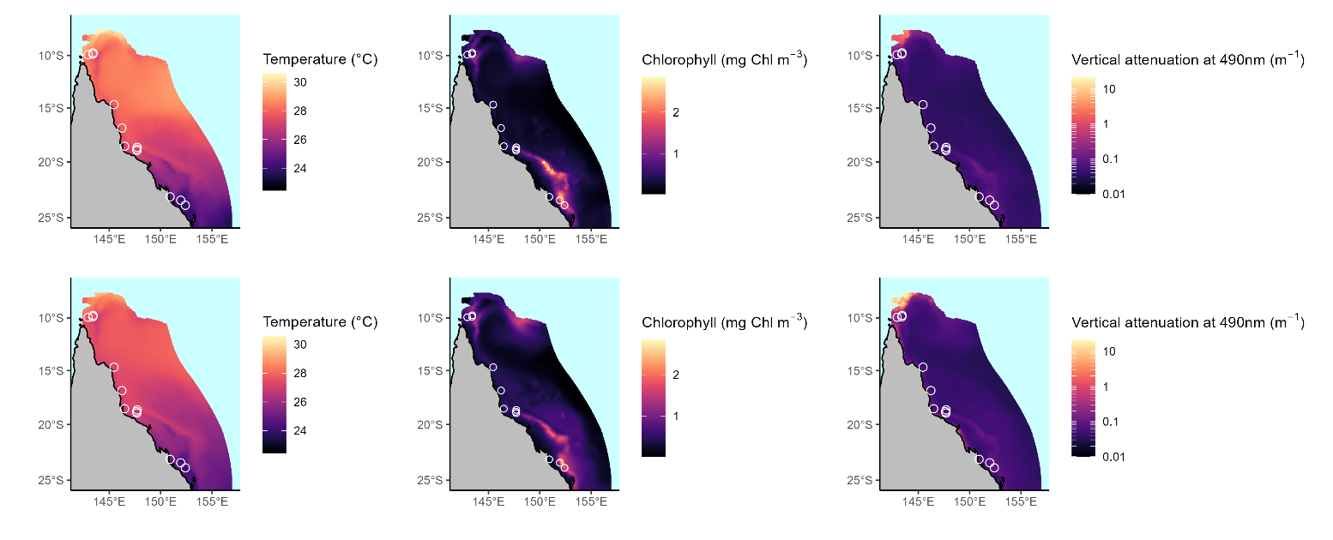
Figure S1 Annual mean temperature (left), chlorophyll a (centre) and vertical attenuation (right) levels as derived from eReefs model outputs at 5 m depth in 2022 (top) and 2023 (bottom) across the study region. Open circles within each plot indicate study reefs.
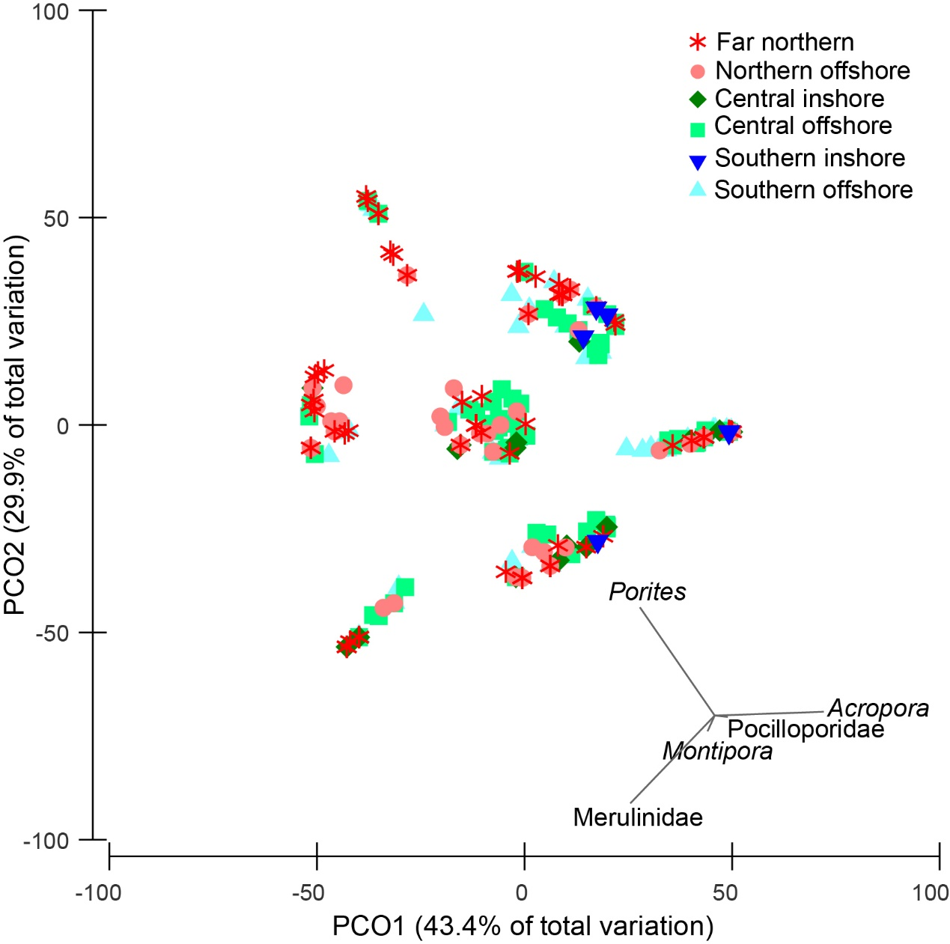
Figure S2 Juvenile coral (≤40 mm) community composition from within the fixed quadrats.
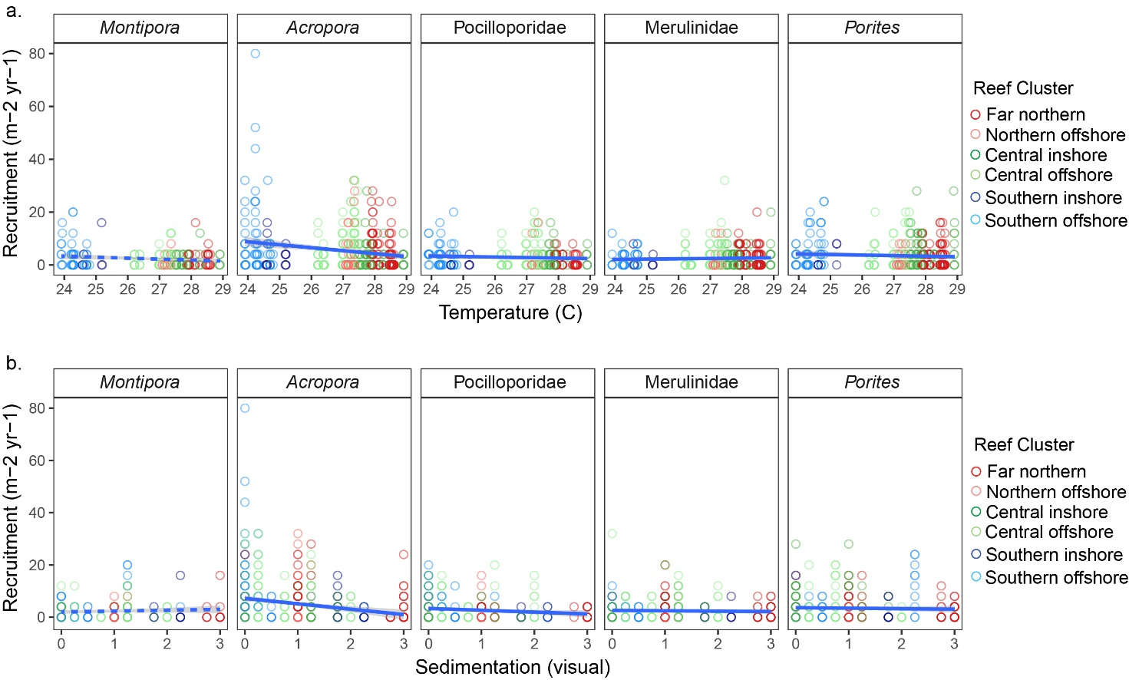
Figure S3 Annual recruitment rates as a function of (a) temperature and (b) sedimentation for each major taxon across reef clusters.
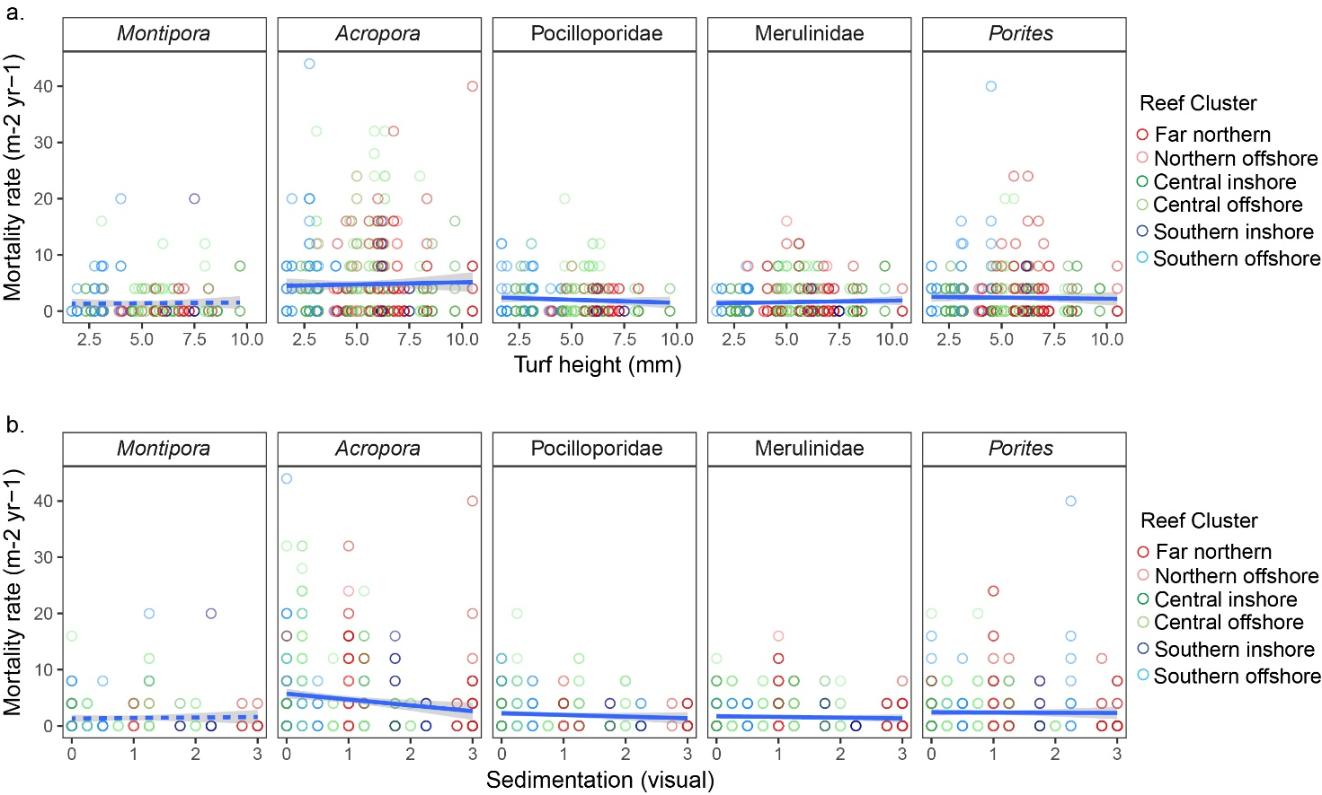
Figure S4 Annual mortality rates as a function of (a) turf height and (b) sedimentation for each major taxon across reef clusters.
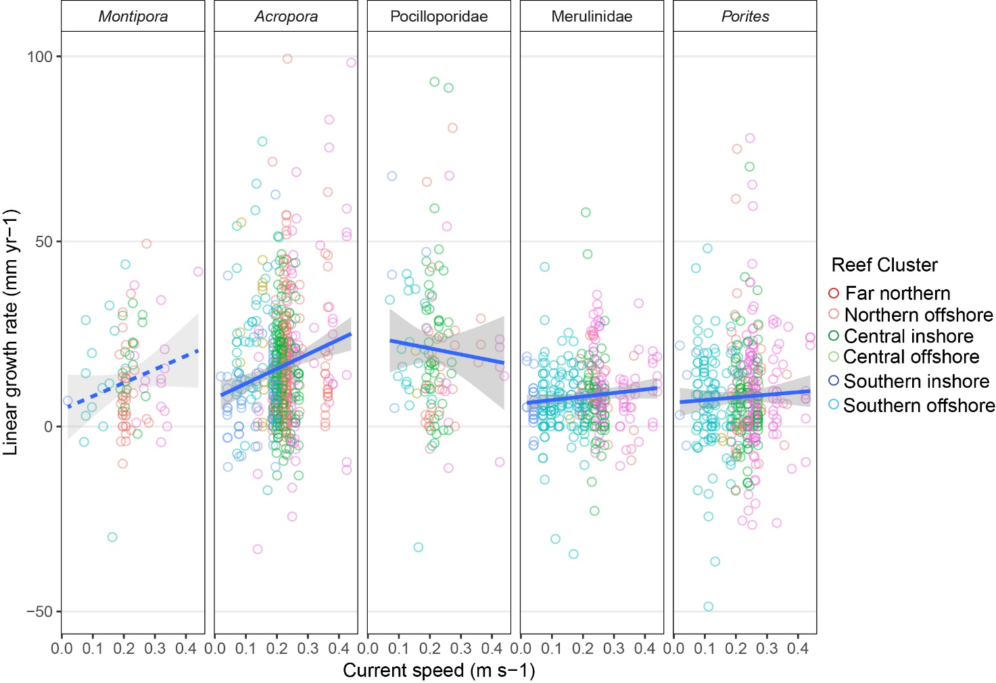
Figure S5 Annual growth rates (mm yr⁻¹) of juvenile corals as a function of current speed for each major taxon across reef clusters.
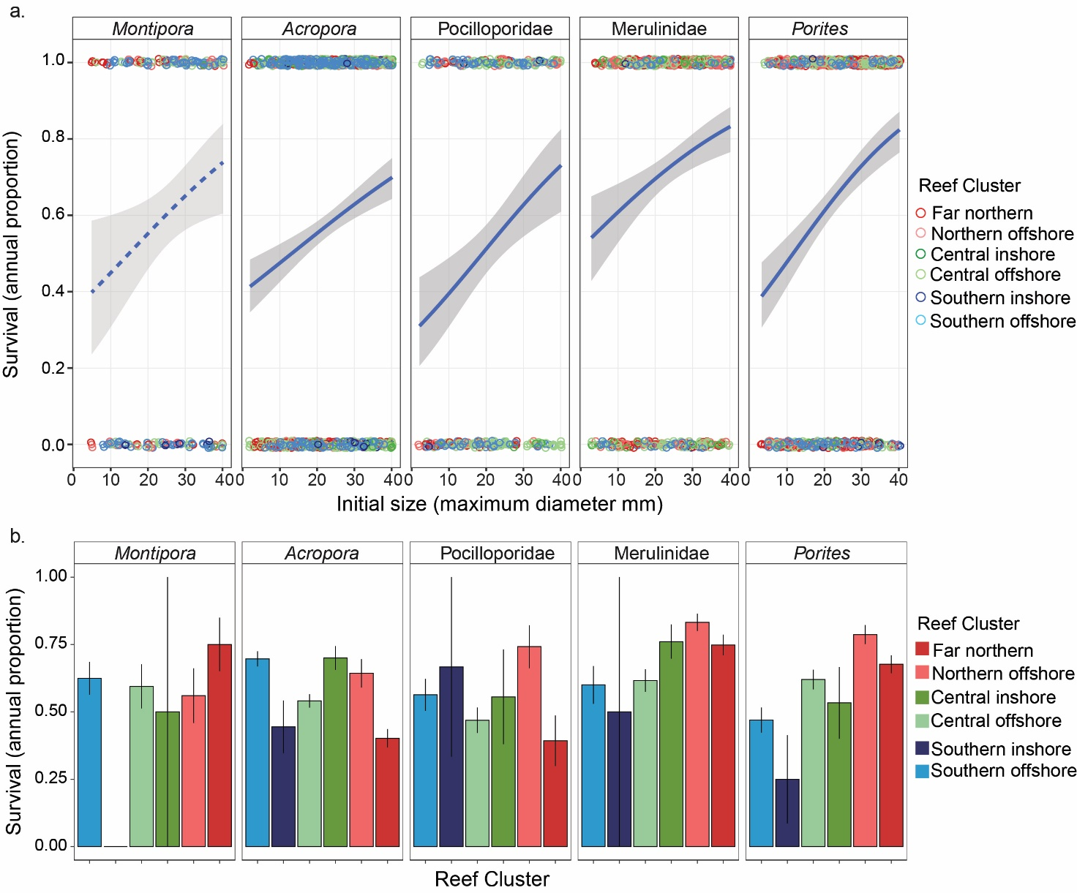
Figure S6 Juvenile coral survival rates for each major taxon as a function of (a) size and (b) reef cluster.

