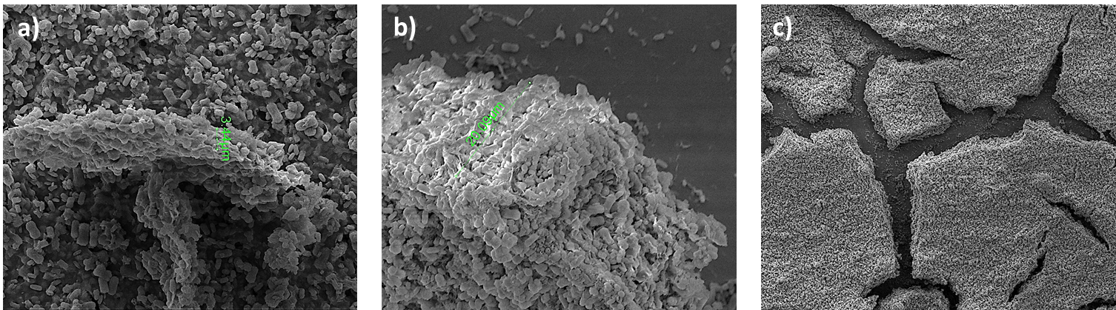
Supplementary Figure. SEM images showed coated thickness of surface by applied a) 60V for 1 min, b) 60V for 5 min.

