Supplementary information

Predicting onset of symptomatic Alzheimer disease
with a plasma %p-tau217 clock
by Petersen et al.

Supplemental tables
Supplementary Table 1. Characteristics of longitudinal plasma %p-tau217 cohort.
Supplementary Table 2. Characteristics of individuals used to develop models of symptom onset.
Supplementary Table 3. Models of the age at AD symptom onset based on the estimated age at plasma %p-tau217 positivity.
Supplementary Table 4. Models of the age at AD symptom onset based on the estimated age at plasma %p-tau217 positivity including covariates.
Supplementary Table 5. Characteristics table for participants who were cognitively unimpaired at baseline, with at least one plasma %p-tau217 sample, and longitudinal clinical assessments.
Supplementary Table 6. Characteristics table for participants with at least one plasma %p-tau217 sample and longitudinal clinical assessments.

Supplemental figures
Supplementary Figure 1. Estimated age of %p-tau217 positivity using different clock models.
Supplementary Figure 2. Estimated age of %p-tau217 positivity in different cohorts.
Supplementary Figure 3. Probability of remaining cognitively unimpaired from AD is related to age at plasma %p-tau217 positivity.
Supplementary Figure 4. Models for time from plasma %p-tau217 positivity to symptom onset based on estimated age at plasma %p-tau217 positivity.
Supplementary Figure 5. Models for age at symptom onset based on estimated age at plasma %p-tau217 positivity.
Supplementary Figure 6. Clinical diagnosis as a function of estimated age at plasma %p-tau217 positivity and years from %p-tau217 positivity for initially cognitively unimpaired individuals.
Supplementary Figure 7. Relationships between cognitive impairment and %p-tau217 positivity by SILA using the Knight ADRC dataset.
Supplementary Figure 8. Relationships between cognitive impairment and %p-tau217 positivity by TIRA using the ADNI dataset.
Supplementary Figure 9. Relationships between cognitive impairment and %p-tau217 positivity by SILA using the ADNI dataset.
Supplementary Figure 10. C2N Diagnostics’ PrecivityAD2 plasma p-tau217 and symptom onset models based on estimated years from p-tau217 positivity.
Supplementary Figure 11. Fujirebio Diagnostics’ Lumipulse plasma p-tau217 and symptom onset models based on estimated years from p-tau217 positivity.

Reference for positivity thresholds:
1 Schindler, S. E. et al. Head-to-head comparison of leading blood tests for Alzheimer's disease pathology. Alzheimer's & dementia : the journal of the Alzheimer's Association 20, 8074-8096, doi:10.1002/alz.14315 (2024).

Supplementary Table 1. Characteristics of longitudinal plasma %p-tau217 cohort. Individuals were included who had two or more plasma %p-tau217 measurements at least one year apart. Values are presented as the median (interquartile range) for continuous variables and n (%) for categorical variables. The significance of differences between cohorts was evaluated by Chi-square tests for categorical values and Wilcoxon ranked sum tests for continuous values.

 | Full Cohort |  | Knight ADRC |  | ADNI
Characteristic | n | Values | n | n | Values | n | p=
Age (Years) | 912 | 69.8 (65.0-75.0) | 506 | 67.7 (61.7-72.4) | 406 | 72.7 (67.9-78.0) | <0.0001
Sex (% Female) | 912 | 474, 52% | 506 | 274, 54.2% | 406 | 200, 49.3% | 0.10
APOE ε4 carriers (% carrier) | 912 | 320, 35.1% | 506 | 181, 35.8% | 406 | 139, 34.2% | 0.60
Years of Education | 912 | 16 (15-18) | 506 | 16 (15-18) | 406 | 16 (14-18) | 0.88
Cognitive impairment (% CDR>0) | 912 | 239, 26.2% | 506 | 43, 8.5% | 406 | 196, 48.3% | <0.0001
CDR Sum of Boxes | 912 | 0 (0-0.5) | 506 | 0 (0-0) | 406 | 0.5 (0-1) | <0.0001
Follow-up Time (Years) | 912 | 6.04 (4.05-8.59) | 506 | 7.12 (4.95-11) | 406 | 5 (4.01-6.54) | <0.0001
Number of %p-tau217 values included | 912 | 3 (3-3) | 506 | 3 (2-4) | 406 | 3 (3-3) | 0.02975
First %p-tau217 included | 895 | 1.67 (0.62-3.94) | 506 | 0.96 (0.19-2.41) | 389 | 2.77 (1.53-5.71) | <0.0001

Supplementary Table 2. Characteristics of individuals used to develop models of symptom onset. Individuals were included who were initially cognitively unimpaired but diagnosed with cognitive impairment due to AD at their last assessment and who developed symptoms after estimated plasma %p-tau217 positivity.

 | Knight ADRC |  | ADNI
 | TIRA | SILA | TIRA | SILA
Number of individuals | 59 | 61 | 20 | 22
Sex (% female) | 30 (50.8%) | 30 (49.2%) | 10 (50.0%) | 11 (50.0%)
APOE ε4 carriers (% carrier) | 29 (49.2%) | 29 (47.5%) | 8 (40.0%) | 8 (36.4%)
Years of education | 16 (14-18) | 16 (14-18) | 16 (14.5-19.25) | 16 (15-18.75)
Estimated age of %p-tau217  positivity (years) | 71.0  (66.4-76.5) | 72.2  (67.8-78.1) | 67.5  (63.4-73.5) | 73.7  (70.0-77.5)
Clinical follow-up time (years) | 13.2  (9.0-14.6) | 13.0  (9.0-14.3) | 10.1  (8.4-11.4) | 10.1  (8.6-11.9)
Clinical assessments (n) | 11 (7.5-13) | 11 (8-13) | 10.5 (9-12.25) | 10.5 (9-12.75)
Age (years) | 73.1  (67.0-79.3) | 73.1  (67.5-79.2) | 73.3  (71.7-77.2) | 73.2  (71.2-77.0)
Baseline visit to estimated  age of positivity (years) | 1.2 (-2.8-5.3) | 0.3 (-4.1-3.8) | 7.7 (1.9-11.3) | 2.1 (-4.2-3.7)

Supplementary Table 3. Models of the age at AD symptom onset based on the estimated age at plasma %p-tau217 positivity. Linear regression coefficient and model fit metrics are reported. In all models, Estimated age at %p-tau217 positivity was significant. Linear regression coefficient and model fit metrics are reported.

 |  | TIRA |  |  |  |  |  |  |  | SILA
 |  | Knight ADRC |  |  |  | ADNI |  |  |  | Knight ADRC |  |  |  | ADNI
 |  | Beta | SE | t-value | p | Beta | SE | t-value | p | Beta | SE | t-value | p | Beta | SE | t-value | p
Coef. | (Intercept) | 37.41 | 4.724 | 7.92 | <0.001 | 54.21 | 8.243 | 6.58 | <0.001 | 35.29 | 4.743 | 7.44 | <0.001 | 41.25 | 9.026 | 4.57 | <0.001
Coef. | Estimated age at  %p-tau217 positivity | 0.61 | 0.066 | 9.35 | <0.001 | 0.39 | 0.119 | 3.26 | 0.004 | 0.64 | 0.065 | 9.78 | <0.001 | 0.54 | 0.122 | 4.43 | <0.001
Model fit | Residual SE | 4.362 |  |  |  | 4.583 |  |  |  | 4.164 |  |  |  | 3.926
Model fit | Adj. R-squared | 0.599 |  |  |  | 0.3366 |  |  |  | 0.612 |  |  |  | 0.470
Model fit | F-statistic (p) | F(1,57)=87.49  (<0.001) |  |  |  | F(1,18)=10.64  (0.004) |  |  |  | F(1,59)=95.61  (<0.001) |  |  |  | F(1,20)=19.61  (<0.001)

Supplementary Table 4. Models of the age at AD symptom onset based on the estimated age at plasma %p-tau217 positivity including covariates. Linear regression coefficient and model fit metrics are reported. In all models, estimated age at %p-tau217 positivity was significant. Also, in all models, covariates were found to be not significant except APOE ε4 carrier status in the TIRA-Knight ADRC model. Additional analysis was performed on this model that found only a small proportion of unique variance determined by APOE ε4 carrier status (semi-partial R² = 0.018, partial eta squared = 0.05). Sex and years of education contributed even less unique variance (semi-partial R² = 0.016 and 0, respectively), meaning their inclusion did not meaningfully improve the model. Overall, these results suggest that while APOE ε4 carrier status may have a minor role in predicting age of symptom onset, the covariates offer little additional predictive value beyond estimated age of %p-tau217.

 |  | TIRA |  |  |  |  |  |  |  | SILA
 |  | Knight ADRC |  |  |  | ADNI |  |  |  | Knight ADRC |  |  |  | ADNI
 |  | Beta | SE | t-value | p | Beta | SE | t-value | p | Beta | SE | t-value | p | Beta | SE | t-value | p
Coefficients | (Intercept) | 42.43 | 6.564 | 6.46 | <0.001 | 21.67 | 20.253 | 1.07 | 0.302 | 37.35 | 6.556 | 5.70 | <0.001 | 19.65 | 16.445 | 1.20 | 0.248
Coefficients | Estimated age at  %p-tau217 positivity | 0.57 | 0.072 | 7.88 | <0.001 | 0.57 | 0.151 | 3.76 | 0.002 | 0.61 | 0.072 | 8.44 | <0.001 | 0.68 | 0.145 | 4.70 | <0.001
Coefficients | Female | 1.30 | 1.171 | 1.11 | 0.273 | 6.75 | 3.860 | 1.75 | 0.101 | 1.81 | 1.126 | 1.61 | 0.114 | 3.82 | 2.610 | 1.47 | 0.161
Coefficients | APOE ε4 carrier | -2.78 | 1.212 | -2.30 | 0.026 | 3.47 | 2.414 | 1.44 | 0.171 | -1.99 | 1.160 | -1.71 | 0.092 | 2.99 | 1.977 | 1.51 | 0.148
Coefficients | Years of education | -0.05 | 0.209 | -0.26 | 0.800 | 0.96 | 0.652 | 1.47 | 0.163 | -0.01 | 0.201 | -0.05 | 0.958 | 0.50 | 0.456 | 1.09 | 0.291
Model fit | Residual SE | 4.185 |  |  |  | 4.484 |  |  |  | 4.021 |  |  |  | 3.884
Model fit | Adj. R-squared | 0.630 |  |  |  | 0.3652 |  |  |  | 0.638 |  |  |  | 0.481
Model fit | F-statistic (p) | F(4,54) = 25.74  (<0.001) |  |  |  | F(4,15)=3.732  (0.027) |  |  |  | F(4,56) = 27.45  (<0.001) |  |  |  | F(4,17) = 5.865  (0.0037)

Supplementary Table 5. Characteristics table for participants who were cognitively unimpaired at baseline, with at least one plasma %p-tau217 sample, and longitudinal clinical assessments. General and baseline characteristics for longitudinal clinical assessments.

 | Knight ADRC |  | ADNI
 | TIRA | SILA | TIRA | SILA
Number of individuals | 686 | 682 | 199 | 198
Sex (% Female) | 389 (56.7%) | 386 (56.6%) | 108 (54.3%) | 107 (54.0%)
APOE ε4 carriers (% carrier) | 254 (37.4%) | 253 (37.5%) | 58 (29.1%) | 58 (29.3%)
Years of education | 16 (15-18) | 16 (15-18) | 16 (15-18) | 16 (15-18)
Estimated age of %p-tau217  positivity (years) | 79.14  (72.2-85.9) | 77.0  (70.9-81.8) | 82.1  (72.8-89.6) | 79.1  (73.0-84.4)
Clinical follow-up time (years) | 8.9  (5.2-14.1) | 8.9  (5.2-14.1) | 9.5  (7.2-11.3) | 9.5  (7.1-11.3)
Clinical assessments (n) | 8  (5-12) | 8  (5-12) | 9  (7-10.5) | 9  (7-10.75)
Age (years) | 68.1  (63.6-72.7) | 68.1  (63.5-72.8) | 71.9  (68.4-76.5) | 71.7  (68.4-76.5)
Baseline visit to estimated  age of positivity (years) | -12.1  (-18.9 to -4.2) | -9.7  (-14.4 to -3.8) | -10.7  (-18.1 to -0.1) | -8.1  (-11.8 to -1.7)
CDR (0/0.5/1/2) | 686/0/0/0 | 682/0/0/0 | 199/0/0/0 | 198/0/0/0
CDR-SB score | 0 (0-0) | 0 (0-0) | 0 (0-0) | 0 (0-0)
Number of progressors (n) | 82 (12.0%) | 82 (12.0%) | 28 (14.1%) | 28 (14.1%)

Supplementary Table 6. Characteristics table for participants with at least one plasma %p-tau217 sample and longitudinal clinical assessments. General and baseline characteristics for longitudinal clinical assessments.

 | Knight ADRC |  | ADNI
 | TIRA | SILA | TIRA | SILA
Number of individuals | 830 | 825 | 371 | 370
Sex (% Female) | 442 (53.3%) | 439 (53.2%) | 190 (51.2%) | 190 (51.4%)
APOE ε4 carriers (% carrier) | 328 (39.9%) | 326 (39.9%) | 122 (32.9%) | 122 (33.0%)
Years of education | 16 (14-18) | 16 (14-18) | 16 (14-18) | 16 (14-18)
Estimated age of %p-tau217  positivity (years) | 78.5  (70.5-85.4) | 76.5  (70.4-81.6) | 80.7  (70.4-88.4) | 77.7  (71.3-82.6)
Clinical follow-up time (years) | 8.0  (5.0-14.0) | 8.0  (5.0-14.0) | 9.2  (6.2-11.3) | 9.2  (6.2-11.3)
Clinical assessments (n) | 7  (4-11) | 7  (4-11) | 9  (7-11) | 9  (7-11)
Age (years) | 68.7  (64.7-73.7) | 68.7  (64.7-73.7) | 71.0  (66.8-75.9) | 71.0  (66.8-75.9)
Baseline visit to estimated  age of positivity (years) | -11.1  (-18.2 to -1.5) | -8.9  (-13.7 to -1.8) | -10.6  (-18.1 to 3.0) | -7.6  (-11.4 to 0.1)
CDR (0/0.5/1/2) | 686/128/15/1 | 682/127/15/1 | 199/171/1/0 | 198/171/1/0
CDR-SB score | 0 (0-0) | 0 (0-0) | 0 (0-1) | 0 (0-1)
Number of progressors (n) | 82 (9.9%) | 82 (9.9%) | 28 (7.5%) | 28 (7.6%)

Supplementary Figure 1. Estimated age of %p-tau217 positivity using different clock models. Scatter plots show the associations in a cross-cohort comparison between estimated ages of %p-tau217 positivity based on models created using the TIRA (A) and SILA (B) approaches in the Knight ADRC and ADNI cohorts. Green points represent values from Knight ADRC participants; black points represent values from ADNI participants. The dashed red line indicates perfect agreement between models.

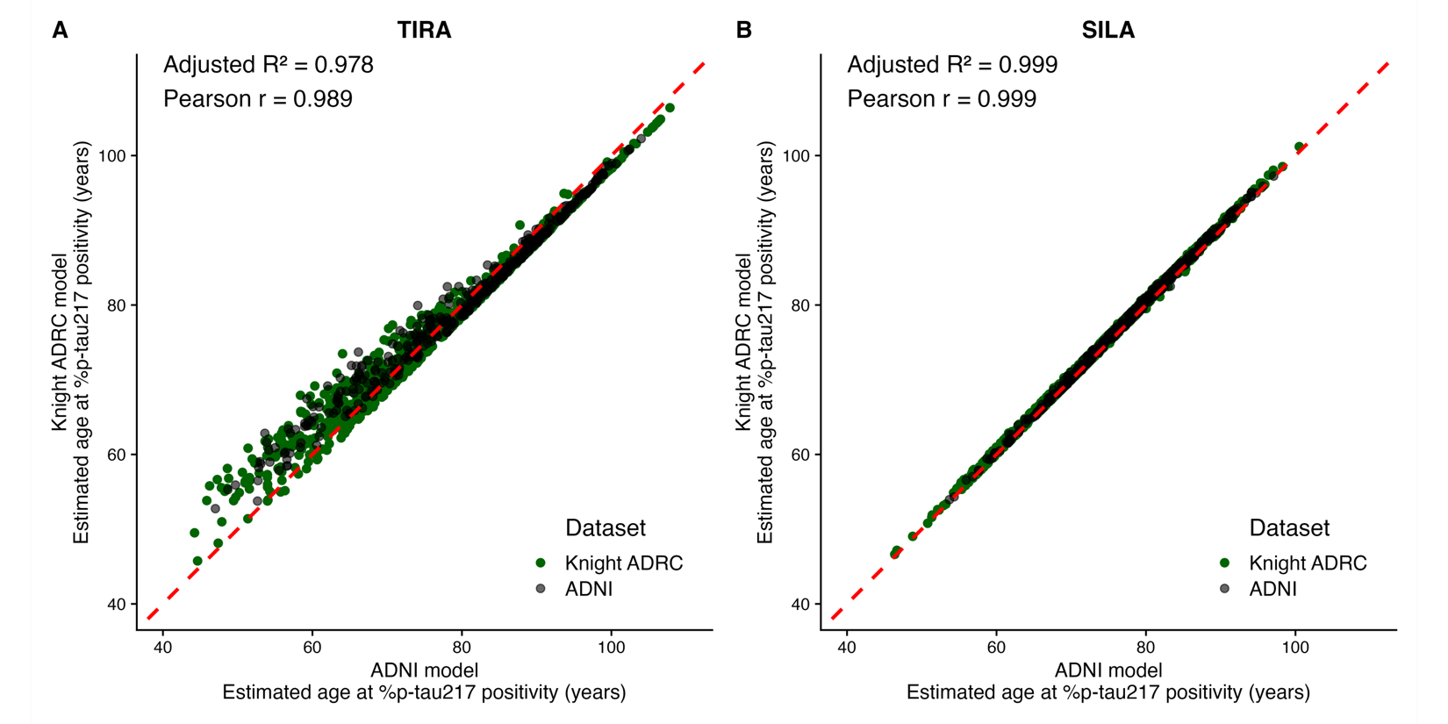

Supplementary Figure 2. Estimated age of %p-tau217 positivity in different cohorts. Scatter plots show the associations between estimated ages of %p-tau217 positivity based on models created using the TIRA and SILA approaches in the Knight ADRC (A) and ADNI (B) cohorts. The dashed red line indicates perfect agreement between models.

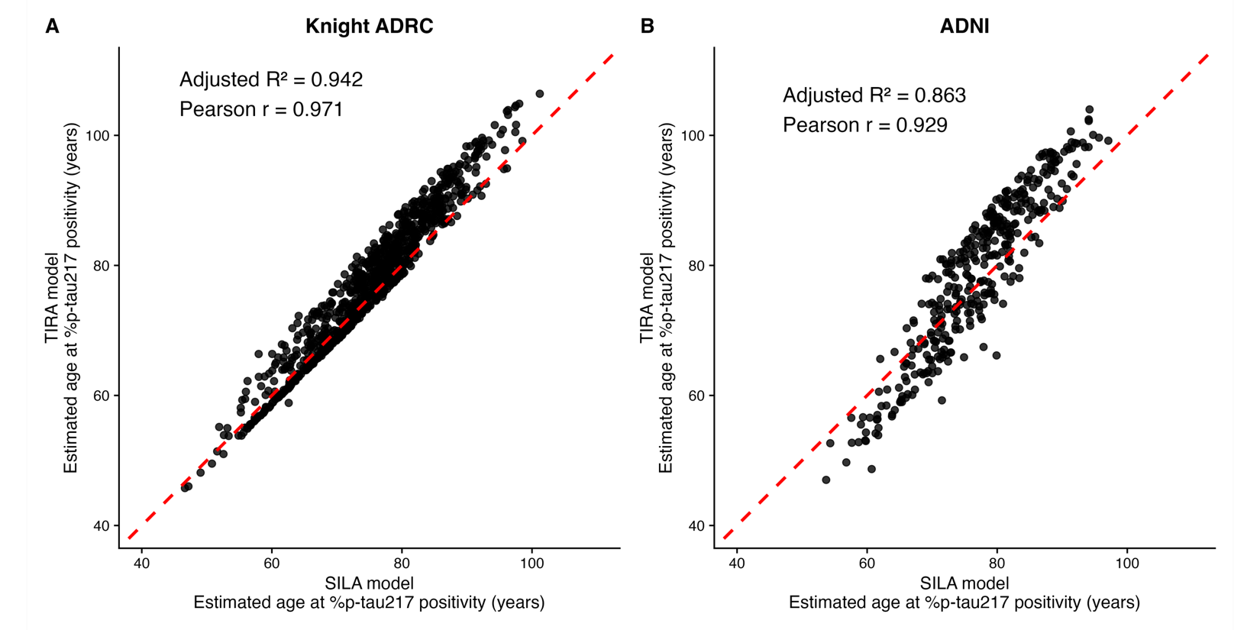
Supplementary Figure 3. Probability of remaining cognitively unimpaired from AD is related to age at plasma %p-tau217 positivity. For all individuals, including those who were cognitively impaired at baseline in the Knight ADRC (A, B) or ADNI (C, D) cohorts, Cox models evaluated the probability of remaining cognitively unimpaired from AD as a function of age, stratified by the age at %p-tau217 positivity based on TIRA (A, C) or SILA (B, D).

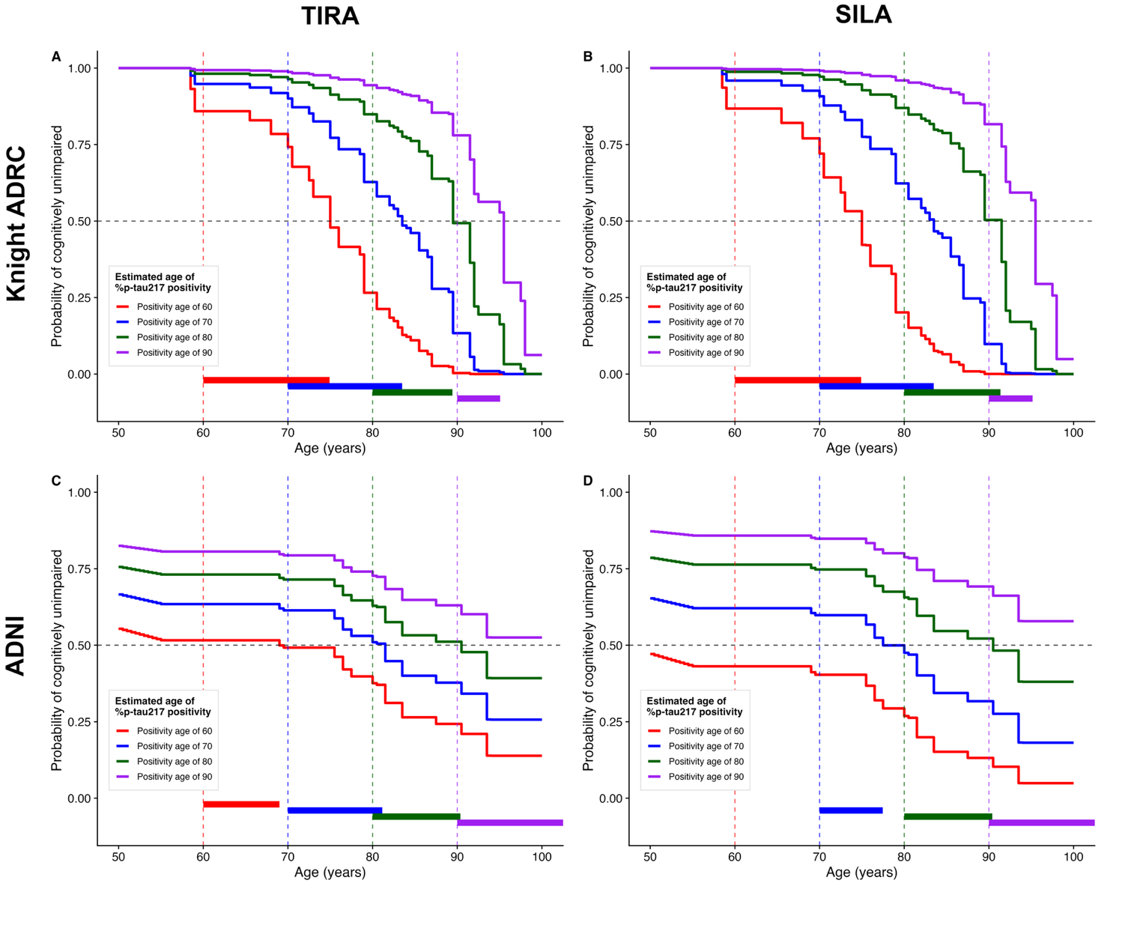

Supplementary Figure 4. Models for time from plasma %p-tau217 positivity to symptom onset based on estimated age at plasma %p-tau217 positivity. Individuals were included who were initially cognitively unimpaired but had a typical AD syndrome at their last assessment and developed symptoms after estimated plasma %p-tau217 positivity. Age at %p-tau217 positivity was estimated using TIRA (A) or SILA (B) models in the Knight ADRC (green points) or ADNI (black points) cohorts. The time interval was calculated as the difference between age at first diagnosis of cognitive impairment due to AD and the estimated age at %p-tau217 positivity. Linear regression lines with 95% confidence intervals are shown for each dataset, with black lines representing ADNI data and green lines representing Knight ADRC data.

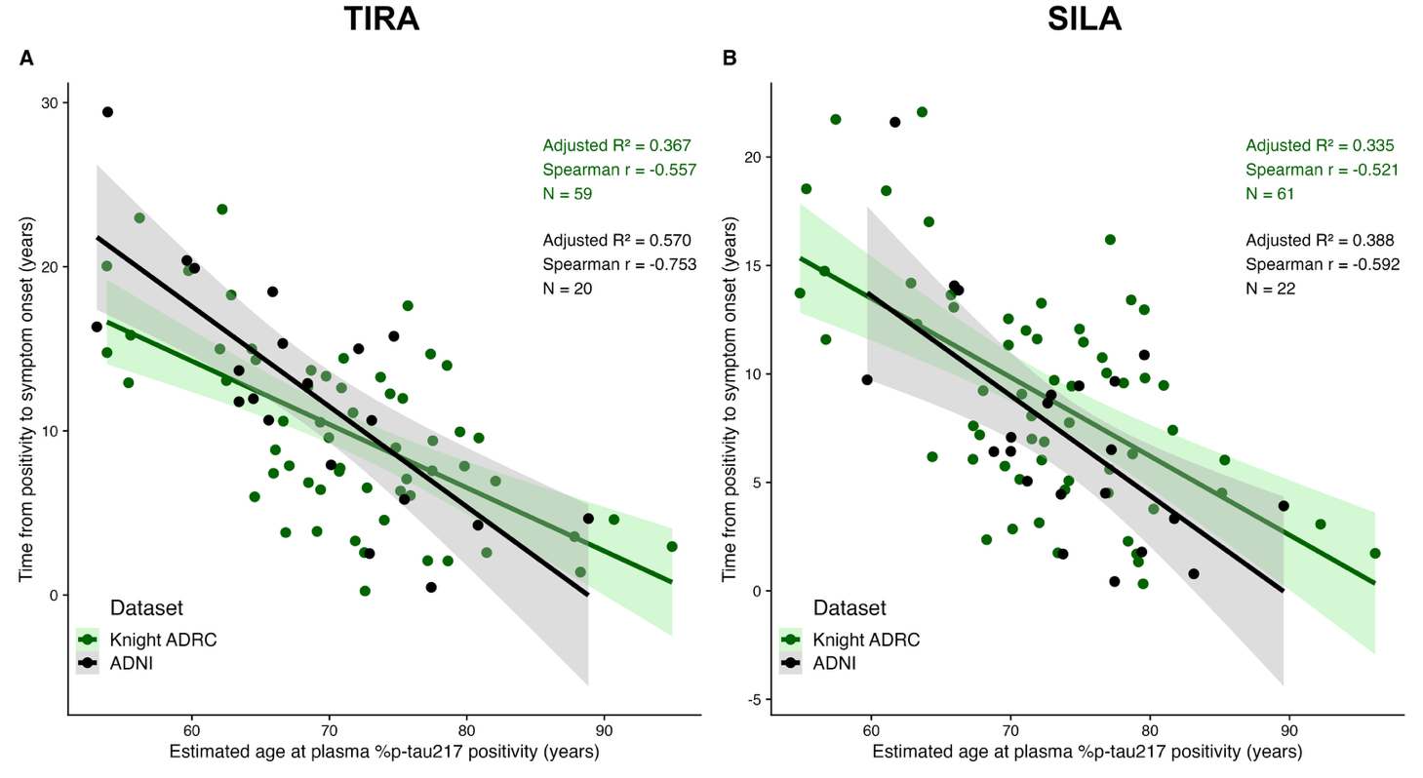

Supplementary Figure 5. Models for age at symptom onset based on estimated age at plasma %p-tau217 positivity. Individuals were included who were initially cognitively unimpaired but had a typical AD syndrome at their last assessment. Individuals who developed symptoms before estimated plasma %p-tau217 positivity, who were excluded in the models described in Figure 4, were included in these models. Age at %p-tau217 positivity was estimated using TIRA (A) or SILA (B) models in the Knight ADRC (green points) or ADNI (black points) cohorts. Linear regression lines with 95% confidence intervals are shown for each dataset, with black lines representing ADNI data and green lines representing Knight ADRC data.

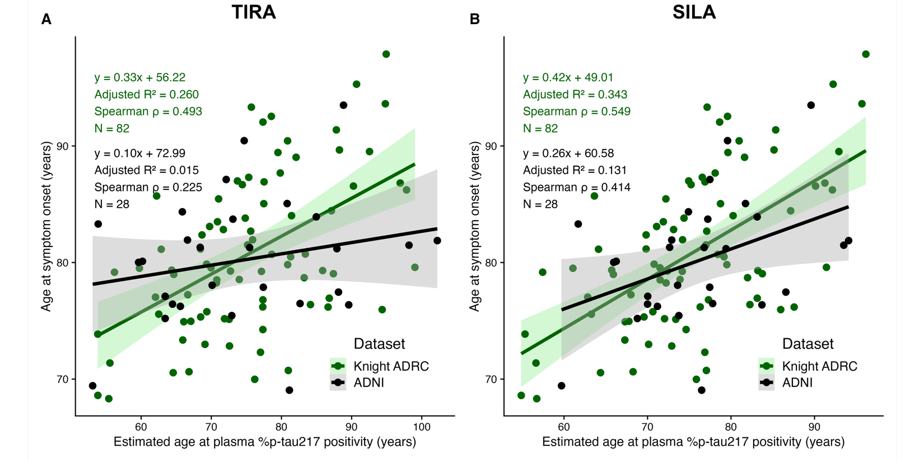

Supplementary Figure 6. Clinical diagnosis as a function of estimated age at plasma %p-tau217 positivity and years from %p-tau217 positivity for initially cognitively unimpaired individuals. In the Knight ADRC (A, B) and ADNI (C, D) cohorts, age at plasma %p-tau217 positivity was estimated using either the TIRA (A, C) or SILA (B, D) models. Each row represents the longitudinal clinical diagnoses for one individual by estimated years from %p-tau217 positivity (x-axis). Individuals are sorted vertically by estimated age at %p-tau217 positivity (y-axis). The point color denotes the clinical diagnosis: blue was cognitively unimpaired at the assessment; red (AD syndrome/biomarker positive) was cognitively impaired at the assessment and had a diagnosis of symptomatic AD at their last assessment with symptoms starting after %p-tau217 positivity; purple (AD syndrome/biomarker negative) was cognitively impaired at the assessment and had a diagnosis of symptomatic AD at their last assessment with symptoms starting before %p-tau217 positivity; orange (non-AD syndrome) was cognitively impaired and had a non-AD diagnosis at their last assessment. Vertical dashed lines at 0 represent the estimated time of %p-tau217 positivity. Brown lines indicate the estimated relationship between %p-tau217 positivity age and predicted symptom onset based on the Knight ADRC models in Figure 4.

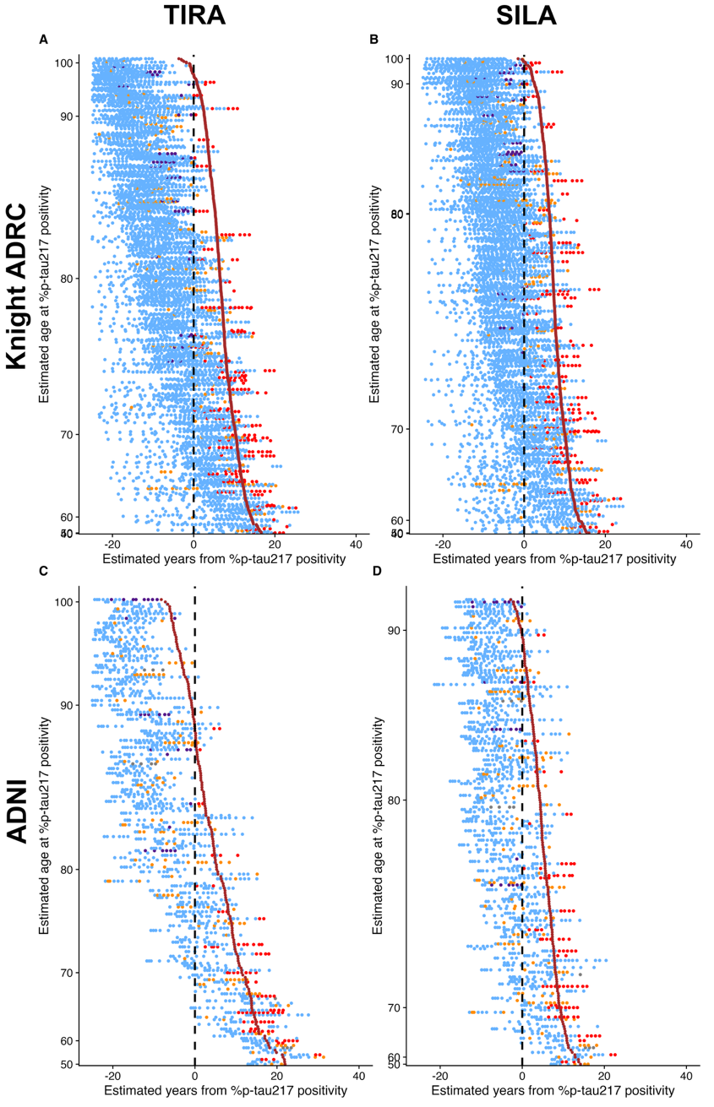
Supplementary Figure 7. Relationships between cognitive impairment and %p-tau217 positivity by SILA using the Knight ADRC dataset. For initially cognitively unimpaired individuals, three groups were examined: red (AD syndrome/biomarker positive) had a diagnosis of symptomatic AD at their last assessment with symptoms starting after %p-tau217 positivity; purple (AD syndrome/biomarker negative) had a diagnosis of symptomatic AD at their last assessment with symptoms starting before %p-tau217 positivity; orange (non-AD syndrome) had a non-AD diagnosis at their last assessment. Kaplan-Meier curves show the probability for each group of remaining cognitively unimpaired as a function of time from first positive %p-tau217 collection (A, D), estimated years from %p-tau217 positivity (B, E), or estimated years from symptom onset (C, F). Density plots and points beneath Kaplan Meier curves (A-C) represent the onset of symptoms for individuals in each group. For the red group (AD syndrome/biomarker positive), Kaplan-Meier curves are shown for individuals binned by estimated age of %p-tau217 positivity (blue, <70 years; cyan, 70-80 years; green, ≥ 80 years) (D-F).

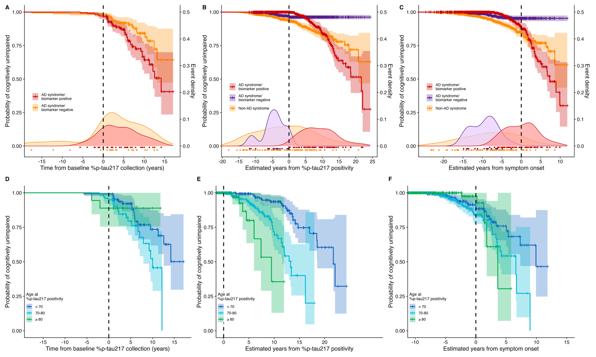

Supplementary Figure 8. Relationships between cognitive impairment and %p-tau217 positivity by TIRA using the ADNI dataset. For initially cognitively unimpaired individuals, three groups were examined: red (AD syndrome/biomarker positive) had a diagnosis of symptomatic AD at their last assessment with symptoms starting after %p-tau217 positivity; purple (AD syndrome/biomarker negative) had a diagnosis of symptomatic AD at their last assessment with symptoms starting before %p-tau217 positivity; orange (non-AD syndrome) had a non-AD diagnosis at their last assessment. Kaplan-Meier curves show the probability for each group of remaining cognitively unimpaired as a function of time from first positive %p-tau217 collection (A, D), estimated years from %p-tau217 positivity (B, E), or estimated years from symptom onset (C, F). Density plots and points beneath Kaplan Meier curves (A-C) represent the onset of symptoms for individuals in each group. For the red group (AD syndrome/biomarker positive), Kaplan-Meier curves are shown for individuals binned by estimated age of %p-tau217 positivity (blue, <70 years; cyan, 70-80 years; green, ≥ 80 years) (D-F).

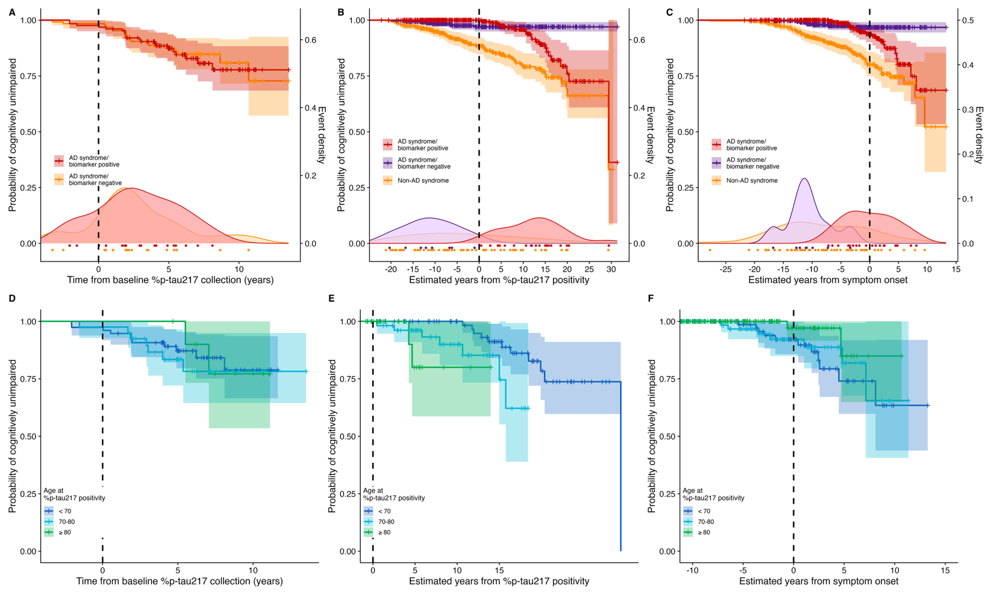

Supplementary Figure 9. Relationships between cognitive impairment and %p-tau217 positivity by SILA using the ADNI dataset. For initially cognitively unimpaired individuals, three groups were examined: red (AD syndrome/biomarker positive) had a diagnosis of symptomatic AD at their last assessment with symptoms starting after %p-tau217 positivity; purple (AD syndrome/biomarker negative) had a diagnosis of symptomatic AD at their last assessment with symptoms starting before %p-tau217 positivity; orange (non-AD syndrome) had a non-AD diagnosis at their last assessment. Kaplan-Meier curves show the probability for each group of remaining cognitively unimpaired as a function of time from first positive %p-tau217 collection (A, D), estimated years from %p-tau217 positivity (B, E), or estimated years from symptom onset (C, F). Density plots and points beneath Kaplan Meier curves (A-C) represent the onset of symptoms for individuals in each group. For the red group (AD syndrome/biomarker positive), Kaplan-Meier curves are shown for individuals binned by estimated age of %p-tau217 positivity (blue, <70 years; cyan, 70-80 years; green, ≥ 80 years) (D-F).

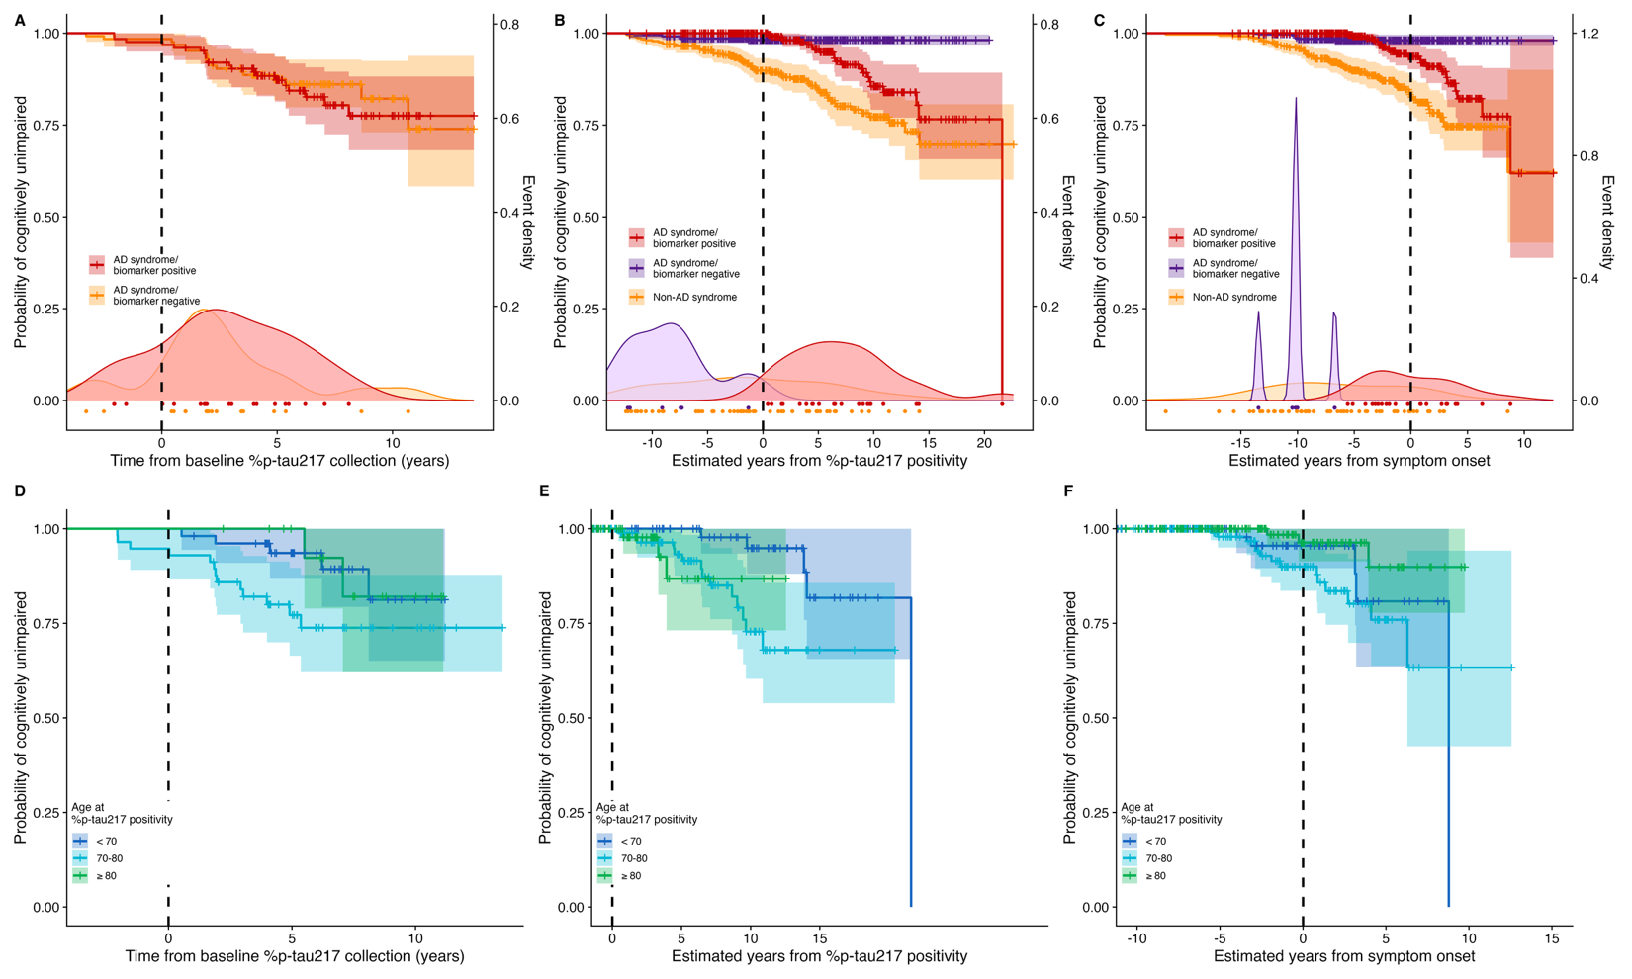

Supplementary Figure 10. C2N Diagnostics’ PrecivityAD2 plasma p-tau217 and symptom onset models based on estimated years from p-tau217 positivity. Longitudinal plasma p-tau217 data from ADNI is shown as a function of age (A) or estimated years from p-tau217 positivity by TIRA (B) or SILA clock models (C). Thick black lines represent the clock models; red lines represent individuals with at least one plasma p-tau217>2.34 pg/ml and grey lines represent individuals with no plasma p-tau217>2.34 pg/ml. The horizontal black dashed lines represent the plasma p-tau217 threshold of 2.34 pg/ml¹. Models for age at symptom onset included individuals who were initially cognitively unimpaired but had a typical AD syndrome at their last assessment and developed symptoms after estimated plasma p-tau217 positivity. Age at p-tau217 positivity was estimated using TIRA (D) or SILA (E) models. Linear regression lines with 95% confidence intervals are shown.

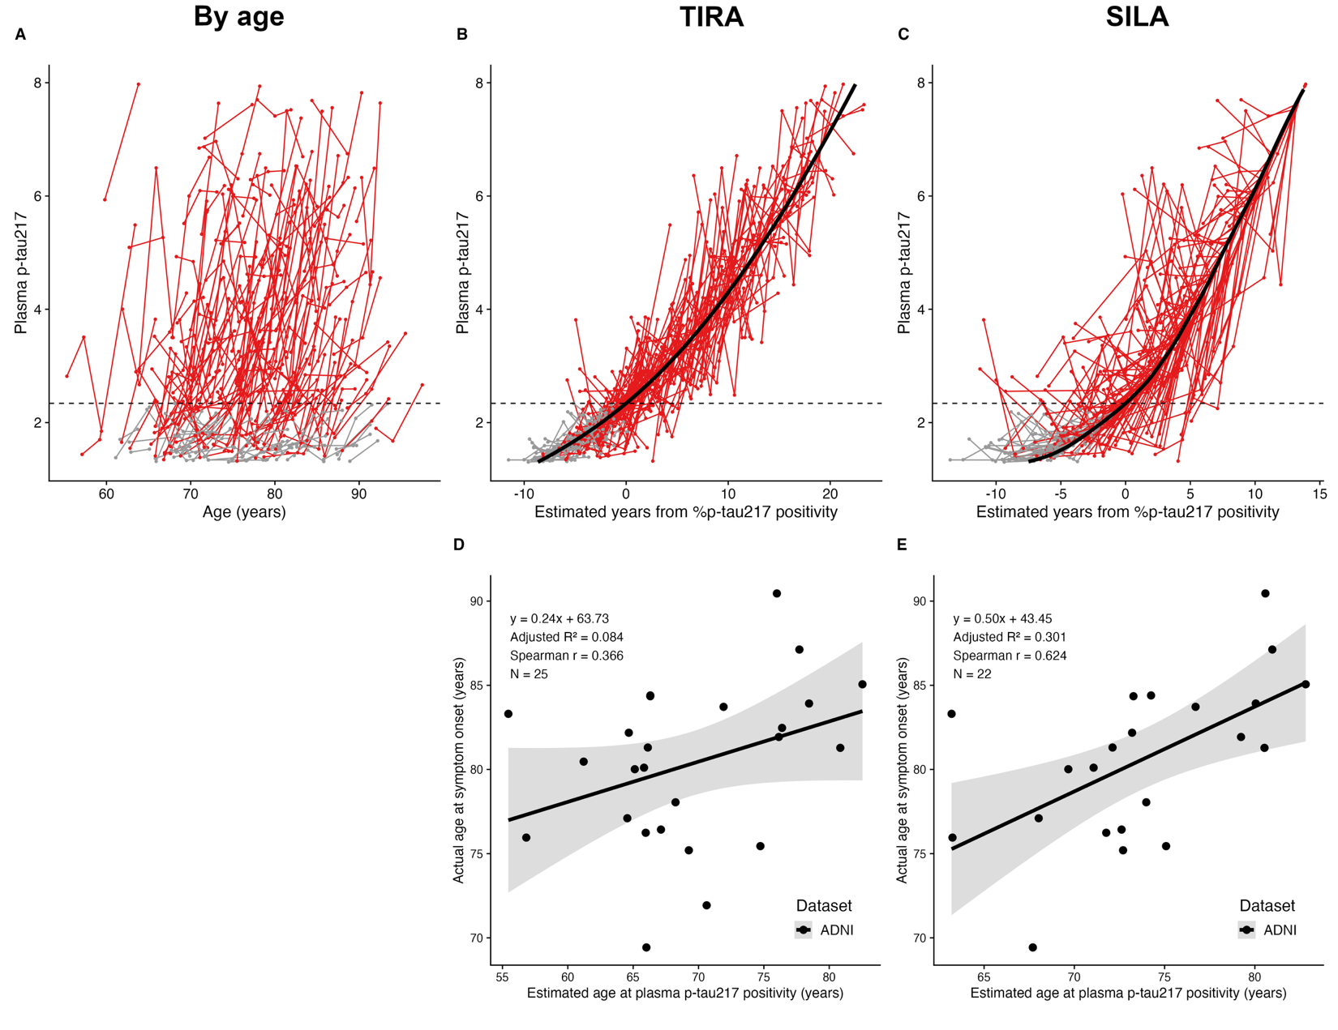

Supplementary Figure 11. Fujirebio Diagnostics’ Lumipulse plasma p-tau217 and symptom onset models based on estimated years from p-tau217 positivity. Longitudinal plasma p-tau217 data from ADNI is shown as a function of age (A) or estimated years from p-tau217 positivity by TIRA (B) or SILA clock models (C). Thick black lines represent the clock models; red lines represent individuals with at least one plasma p-tau217>0.158 pg/ml and grey lines represent individuals with no plasma p-tau217>0.158 pg/ml. The horizontal black dashed lines represent the plasma p-tau217 threshold of 0.158 pg/ml¹. Models for age at symptom onset included individuals who were initially cognitively unimpaired but had a typical AD syndrome at their last assessment and developed symptoms after estimated plasma p-tau217 positivity. Age at p-tau217 positivity was estimated using TIRA (D) or SILA (E) models. Linear regression lines with 95% confidence intervals are shown.

