Extended Table 1. Characteristics of clock model development cohorts. Individuals were included who had two or more plasma %p-tau217 measurements between 1.06% to 10.45% that were at least one year apart. Values are presented as the median (interquartile range) for continuous variables and n (%) for categorical variables. The significance of differences between cohorts was evaluated by Chi-square tests for categorical values and Wilcoxon ranked sum tests for continuous values.

 | Full Cohort |  | Knight ADRC |  | ADNI
Characteristic | n | Values | n | Values | n | Values | p=
Age (Years) | 603 | 71.2 (67-76.7) | 258 | 70.0 (65.8-74.2) | 345 | 72.7 (67.8-78.1) | <0.0001
Sex (% Female) | 603 | 300, 49.8% | 258 | 133, 51.6% | 345 | 167, 48.4% | 0.40
APOE ε4 carriers (% carrier) | 603 | 217, 36% | 258 | 106, 41.1% | 345 | 111, 32.2% | 0.02
Years of education | 603 | 16 (14-18) | 258 | 16 (15-18) | 345 | 16 (14-18) | 0.53
Cognitive impairment (% CDR>0) | 603 | 179, 29.7% | 258 | 18, 7.0% | 345 | 161, 46.7% | <0.0001
CDR Sum of Boxes | 603 | 0 (0-0.5) | 258 | 0 (0-0) | 345 | 0 (0-1) | <0.0001
Estimated age of  %-ptau217 positivity (Years) | 603 | 79.8 (72.1-86.5) | 258 | 78.8 (72.2-83.5) | 345 | 81.0 (71.5-88.5) | 0.0070
Follow-up time (Years) | 603 | 5.5 (4.0-7.5) | 258 | 6.5 (3.9-9.8) | 345 | 4.5 (4.0-6.3) | <0.0001
Number of %p-tau217 values included | 603 | 3 (2-3) | 258 | 2 (2-3) | 345 | 3 (3-3) | <0.0001
First %p-tau217 included | 603 | 2.33 (1.54-4.12) | 258 | 2.22 (1.58-3.44) | 345 | 2.49 (1.53-4.74) | 0.068

Extended Table 2. Clock models estimating time between plasma %p-tau217 levels. The time in years was estimated for plasma %p-tau217 values from 1.06% to 10.40%. Data are shown for two methods (TIRA and SILA) across two cohorts (Knight ADRC and ADNI). Both the interval time between adjacent levels and the cumulative time from the 4.06% reference point are shown and demonstrate differences across methods and cohorts. Negative time intervals correspond to times before %p-tau217 positivity.

 |  | TIRA | SILA
 |  | Knight ADRC |  | ADNI |  | Knight ADRC |  | ADNI
Beginning  %p-tau217 | Ending  %p-tau217 | Interval | Cumulative  (from 4.06%) | Interval | Cumulative  (from 4.06%) | Interval | Cumulative  (from 4.06%) | Interval | Cumulative  (from 4.06%)
1.06 | 2.06 | 10.3 | -10.7 | 10.9 | -12 | 5.0 | -7.0 | 6.5 | -6.3
2.06 | 3.06 | 6.2 | -4.5 | 6.9 | -5.1 | 4.0 | -3.0 | 3.5 | -2.8
3.06 | 4.06 | 4.5 | 0 | 5.1 | 0 | 3.0 | 0 | 2.8 | 0
4.06 | 5.06 | 3.5 | 3.5 | 4.3 | 4.3 | 2.5 | 2.5 | 2.8 | 2.8
5.06 | 6.06 | 2.9 | 6.4 | 3.9 | 8.2 | 2.5 | 5.0 | 2.5 | 5.3
6.06 | 7.06 | 2.4 | 8.8 | 3.7 | 11.9 | 2.2 | 7.2 | 2.0 | 7.3
7.06 | 8.06 | 2.1 | 10.9 | 3.7 | 15.6 | 2.2 | 9.4 | 2.2 | 9.5
8.06 | 9.06 | 1.9 | 12.8 | 3.8 | 19.4 | 2.0 | 11.4 | 2.5 | 12.0
9.06 | 10.06 | 1.7 | 14.5 | 3.9 | 23.3 | 1.8 | 13.2 | 2.5 | 14.5
10.06 | 10.40 | 0.6 | 15.1 | 1.2 | 24.5 | 0.5 | 13.7 | 0.5 | 15.0

Extended Table 3. Validation of estimated age at symptom onset. Metrics are shown for linear models estimating the age at symptom onset based on the estimated age at %p-tau217 positivity using either TIRA or SILA clocks. Metrics are shown for internal validation (same model and test cohort) and external validation (different model and test cohort): Spearman correlation, adjusted R², non-parametric concordance correlation coefficient (CCC), root mean squared error (RMSE), mean absolute error (MAE), and median absolute error (MdAE).

Check Type | Model  cohort | Test  cohort | Method | No. of  converters | Spearman  correlation | Adjusted R² | CCC | RMSE | MAE | MdAE
Internal validation (within cohort) | Knight ADRC | Knight ADRC | TIRA | 59 | 0.752 | 0.599 | 0.839 | 4.3 | 3.5 | 3.1
Internal validation (within cohort) | Knight ADRC | Knight ADRC | SILA | 61 | 0.765 | 0.612 | 0.837 | 4.1 | 3.4 | 3.1
Internal validation (within cohort) | ADNI | ADNI | TIRA | 20 | 0.522 | 0.337 | 0.771 | 4.4 | 3.8 | 3.5
Internal validation (within cohort) | ADNI | ADNI | SILA | 22 | 0.673 | 0.470 | 0.814 | 3.7 | 3.2 | 3.0
External validation  (independent cohort) | Knight ADRC | ADNI | TIRA | 20 | 0.595 | 0.467 | 0.805 | 4.0 | 3.3 | 3.0
External validation  (independent cohort) | Knight ADRC | ADNI | SILA | 22 | 0.611 | 0.463 | 0.801 | 4.0 | 3.5 | 3.2
External validation  (independent cohort) | ADNI | Knight ADRC | TIRA | 59 | 0.669 | 0.509 | 0.808 | 4.9 | 4.0 | 3.6
External validation  (independent cohort) | ADNI | Knight ADRC | SILA | 62 | 0.736 | 0.577 | 0.820 | 4.5 | 3.8 | 3.7

Extended Figure 1. Relationship between estimated age at plasma %p-tau217 positivity and age of observed conversion to %p-tau217 positive. The estimated age at plasma %p-tau217 positivity based on clock models is shown as a function of the observed conversion age, which is the average of the age at last negative and first positive %p-tau217. Clock models in the Knight ADRC (A, B) and ADNI cohorts (C, D) were created with the TIRA (A, C) and SILA (B, D) approaches.

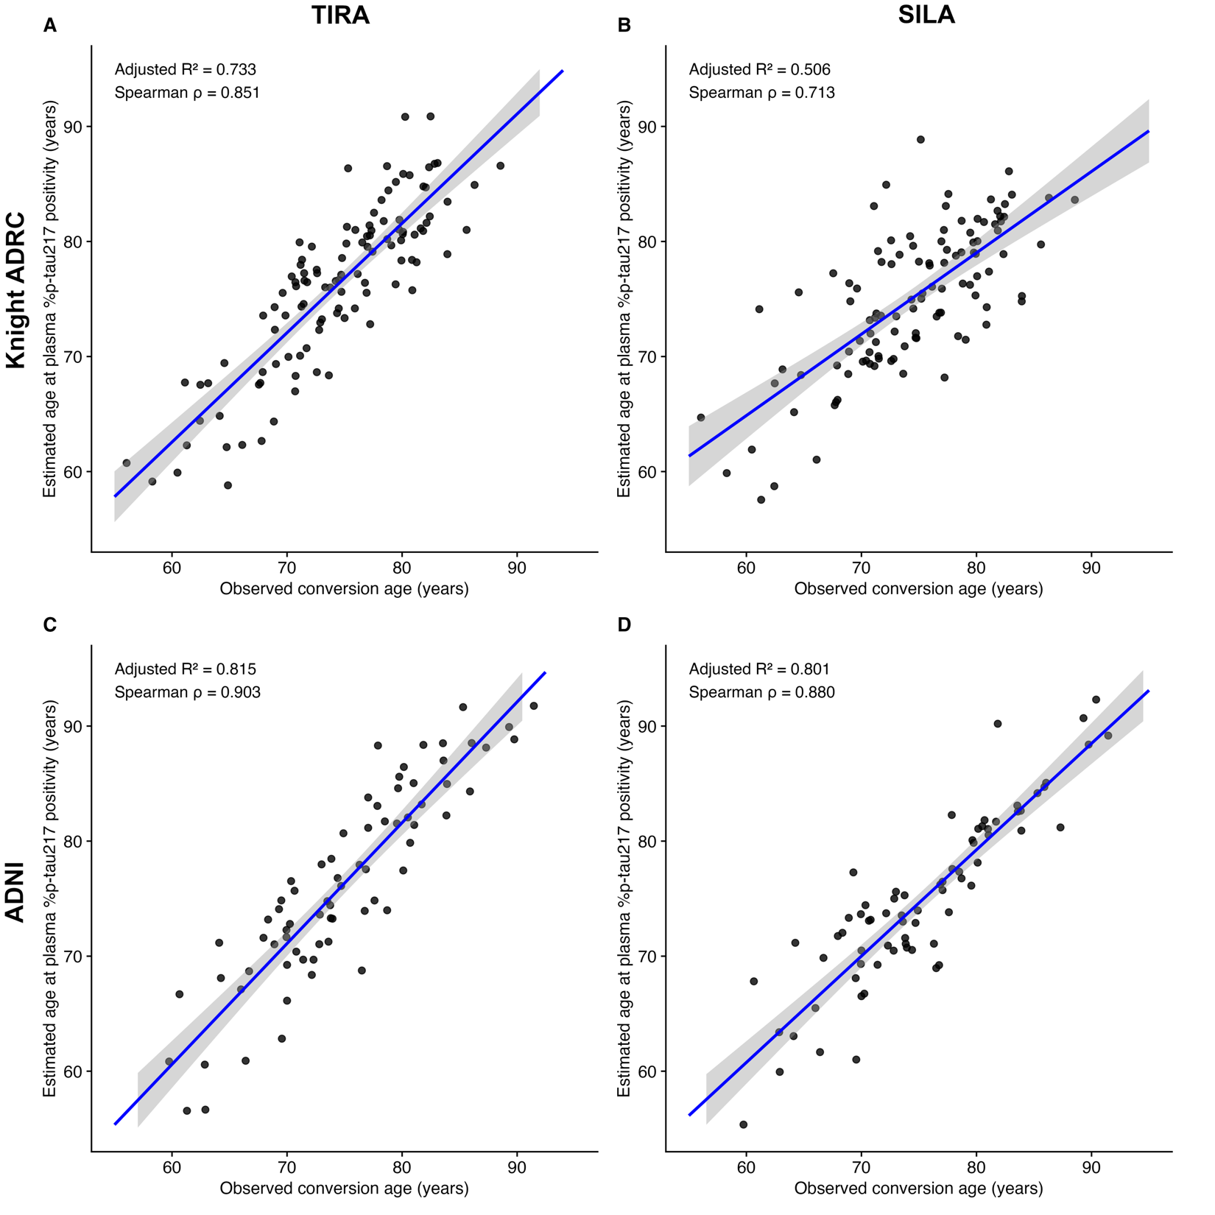

Extended Figure 2. Probability of remaining cognitively unimpaired from AD is related to age at plasma %p-tau217 positivity. For individuals who were cognitively unimpaired at baseline in the Knight ADRC (A, B) or ADNI (C, D) cohorts, Cox models evaluated the probability of remaining cognitively unimpaired from AD as a function of age, stratified by the age at %p-tau217 positivity based on TIRA (A, C) or SILA (B, D).

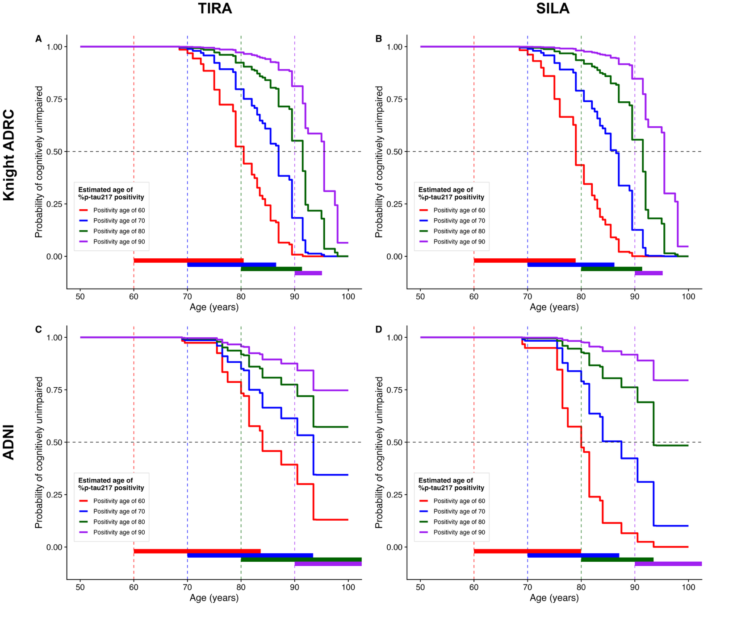

Extended Figure 3. Clinical diagnosis as a function of estimated age at plasma %p-tau217 positivity and years from %p-tau217 positivity. For individuals in the Knight ADRC (A, B) and ADNI (C, D) cohorts, age at plasma %p-tau217 positivity was estimated using either the TIRA (A, C) or SILA (B, D) models. Each row represents the longitudinal clinical diagnoses for one individual by estimated years from %p-tau217 positivity (x-axis). Individuals are sorted vertically by estimated age at %p-tau217 positivity (y-axis). The point color denotes the clinical diagnosis: blue was cognitively unimpaired at the assessment; red (AD syndrome/biomarker positive) was cognitively impaired at the assessment and had a diagnosis of symptomatic AD at their last assessment with symptoms starting after %p-tau217 positivity; purple (AD syndrome/biomarker negative) was cognitively impaired at the assessment and had a diagnosis of symptomatic AD at their last assessment with symptoms starting before %p-tau217 positivity; orange (non-AD syndrome) was cognitively impaired and had a non-AD diagnosis at their last assessment. Vertical dashed lines at 0 represent the estimated time of %p-tau217 positivity. Brown lines indicate the estimated relationship between %p-tau217 positivity age and predicted symptom onset based on the Knight ADRC models in Figure 4.

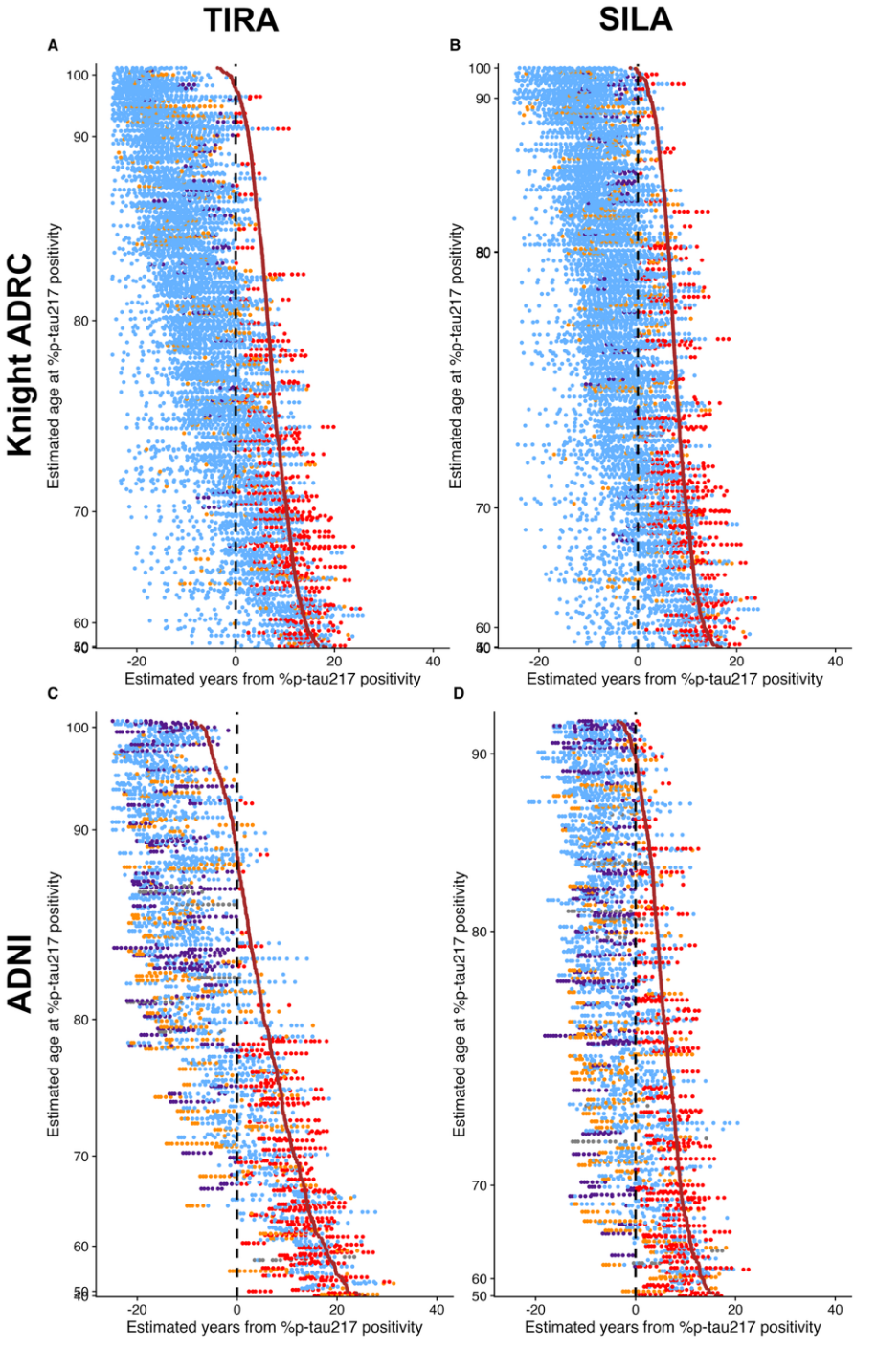

Extended Figure 4. Plasma %p-tau217 level, estimated years since %p-tau217 positivity, and years since estimated symptom onset across amyloid and tau PET-defined stages. Using data from ADNI, raincloud plots show plasma %p-tau217 levels (A), estimated years since %p-tau217 positivity by TIRA (B) and SILA (C), and years since estimated symptom onset by TIRA (D) and SILA (E) stratified by amyloid and tau PET-defined groups: amyloid-negative (A− T_{early}−T_{late}−), amyloid-positive and early tau-negative (A+T_{early}−T_{late}−), amyloid-positive and early tau-positive but late tau-negative (A+T_{early}+T_{late}−), and amyloid-positive with both early and late tau positivity (A+T_{early}+T_{late}+). Individual data points, distributions, and group means with 95% confidence intervals are shown. Significant group differences are indicated by asterisks (*p<0.05, **p<0.01, ***p<0.001).

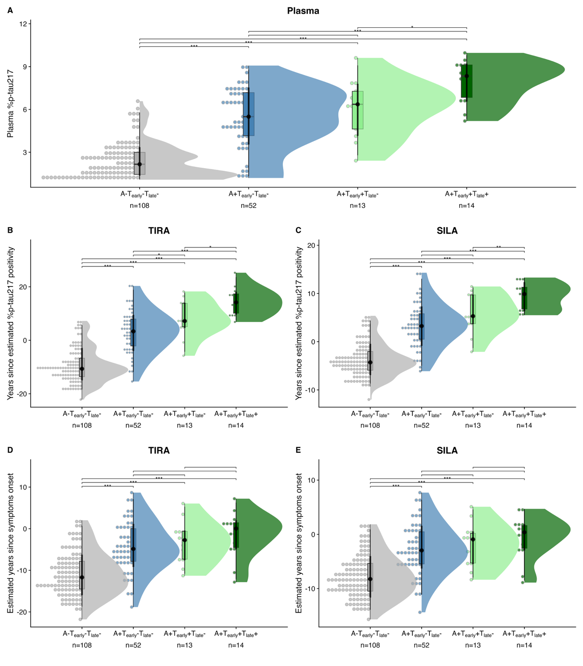
Extended Figure 5. Fujirebio Diagnostics’ Lumipulse plasma p-tau217/Aβ42 clock and symptom onset models based on estimated years from p-tau217/Aβ42 positivity. Longitudinal plasma p-tau217/Aβ42 data from ADNI is shown as a function of age (A) or estimated years from p-tau217/Aβ42 positivity by TIRA (B) or SILA clock models (C). Thick black lines represent the clock models, red lines represent individuals with at least one plasma p-tau217/Aβ42>0.006312, and grey lines represent individuals with no plasma p-tau217/Aβ42>0.006312. The horizontal black dashed lines represent the plasma p-tau217/Aβ42 threshold of 0.006312¹. Models for age at symptom onset included individuals who were initially cognitively unimpaired but had a typical AD syndrome at their last assessment and developed symptoms after estimated plasma p-tau217/Aβ42 positivity. Age at p-tau217/Aβ42 positivity was estimated using TIRA (D) or SILA (E) models. Linear regression lines with 95% confidence intervals are shown.

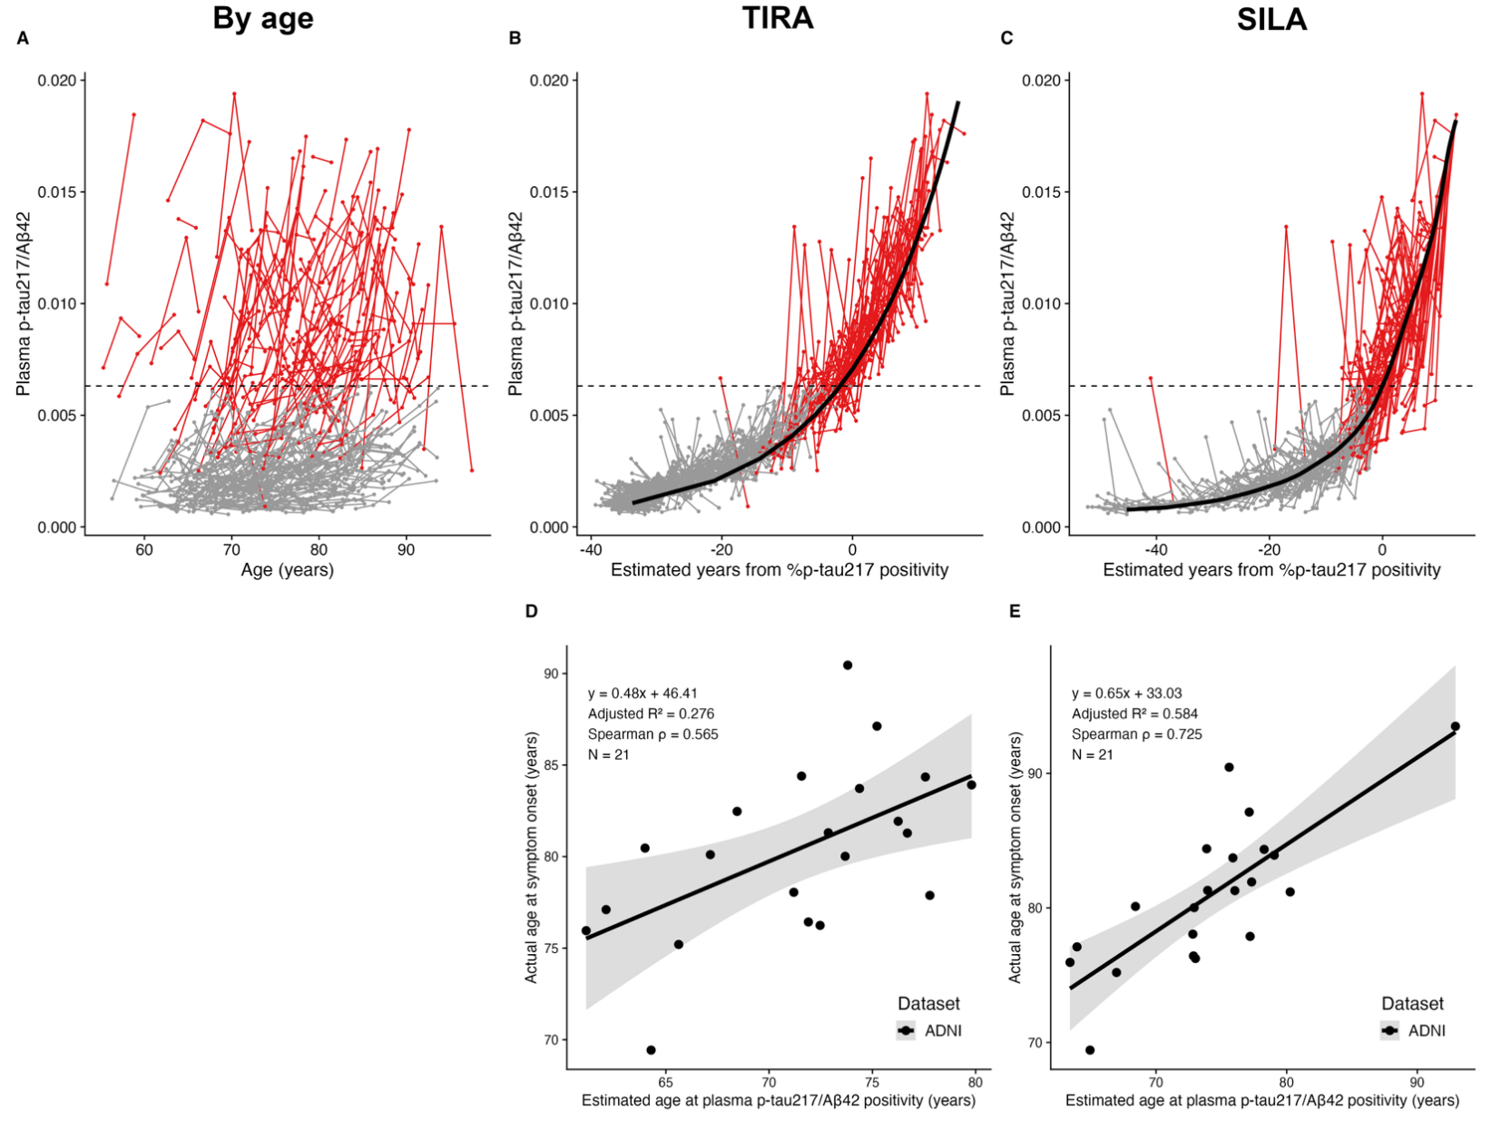
Extended Figure 6. Janssen’s LucentAD Quanterix plasma p-tau217 and symptom onset models based on estimated years from p-tau217 positivity. Longitudinal plasma p-tau217 data from ADNI is shown as a function of age (A) or estimated years from p-tau217 positivity by TIRA (B) or SILA clock models (C). Thick black lines represent the clock models; red lines represent individuals with at least one plasma p-tau217>0.0615 pg/ml and grey lines represent individuals with no plasma p-tau217>0.0615 pg/ml. The horizontal black dashed lines represent the plasma p-tau217 threshold of 0.0615 pg/ml¹. Models for age at symptom onset included individuals who were initially cognitively unimpaired but had a typical AD syndrome at their last assessment and developed symptoms after estimated plasma p-tau217 positivity. Age at p-tau217 positivity was estimated using TIRA (D) or SILA (E) models. Linear regression lines with 95% confidence intervals are shown.

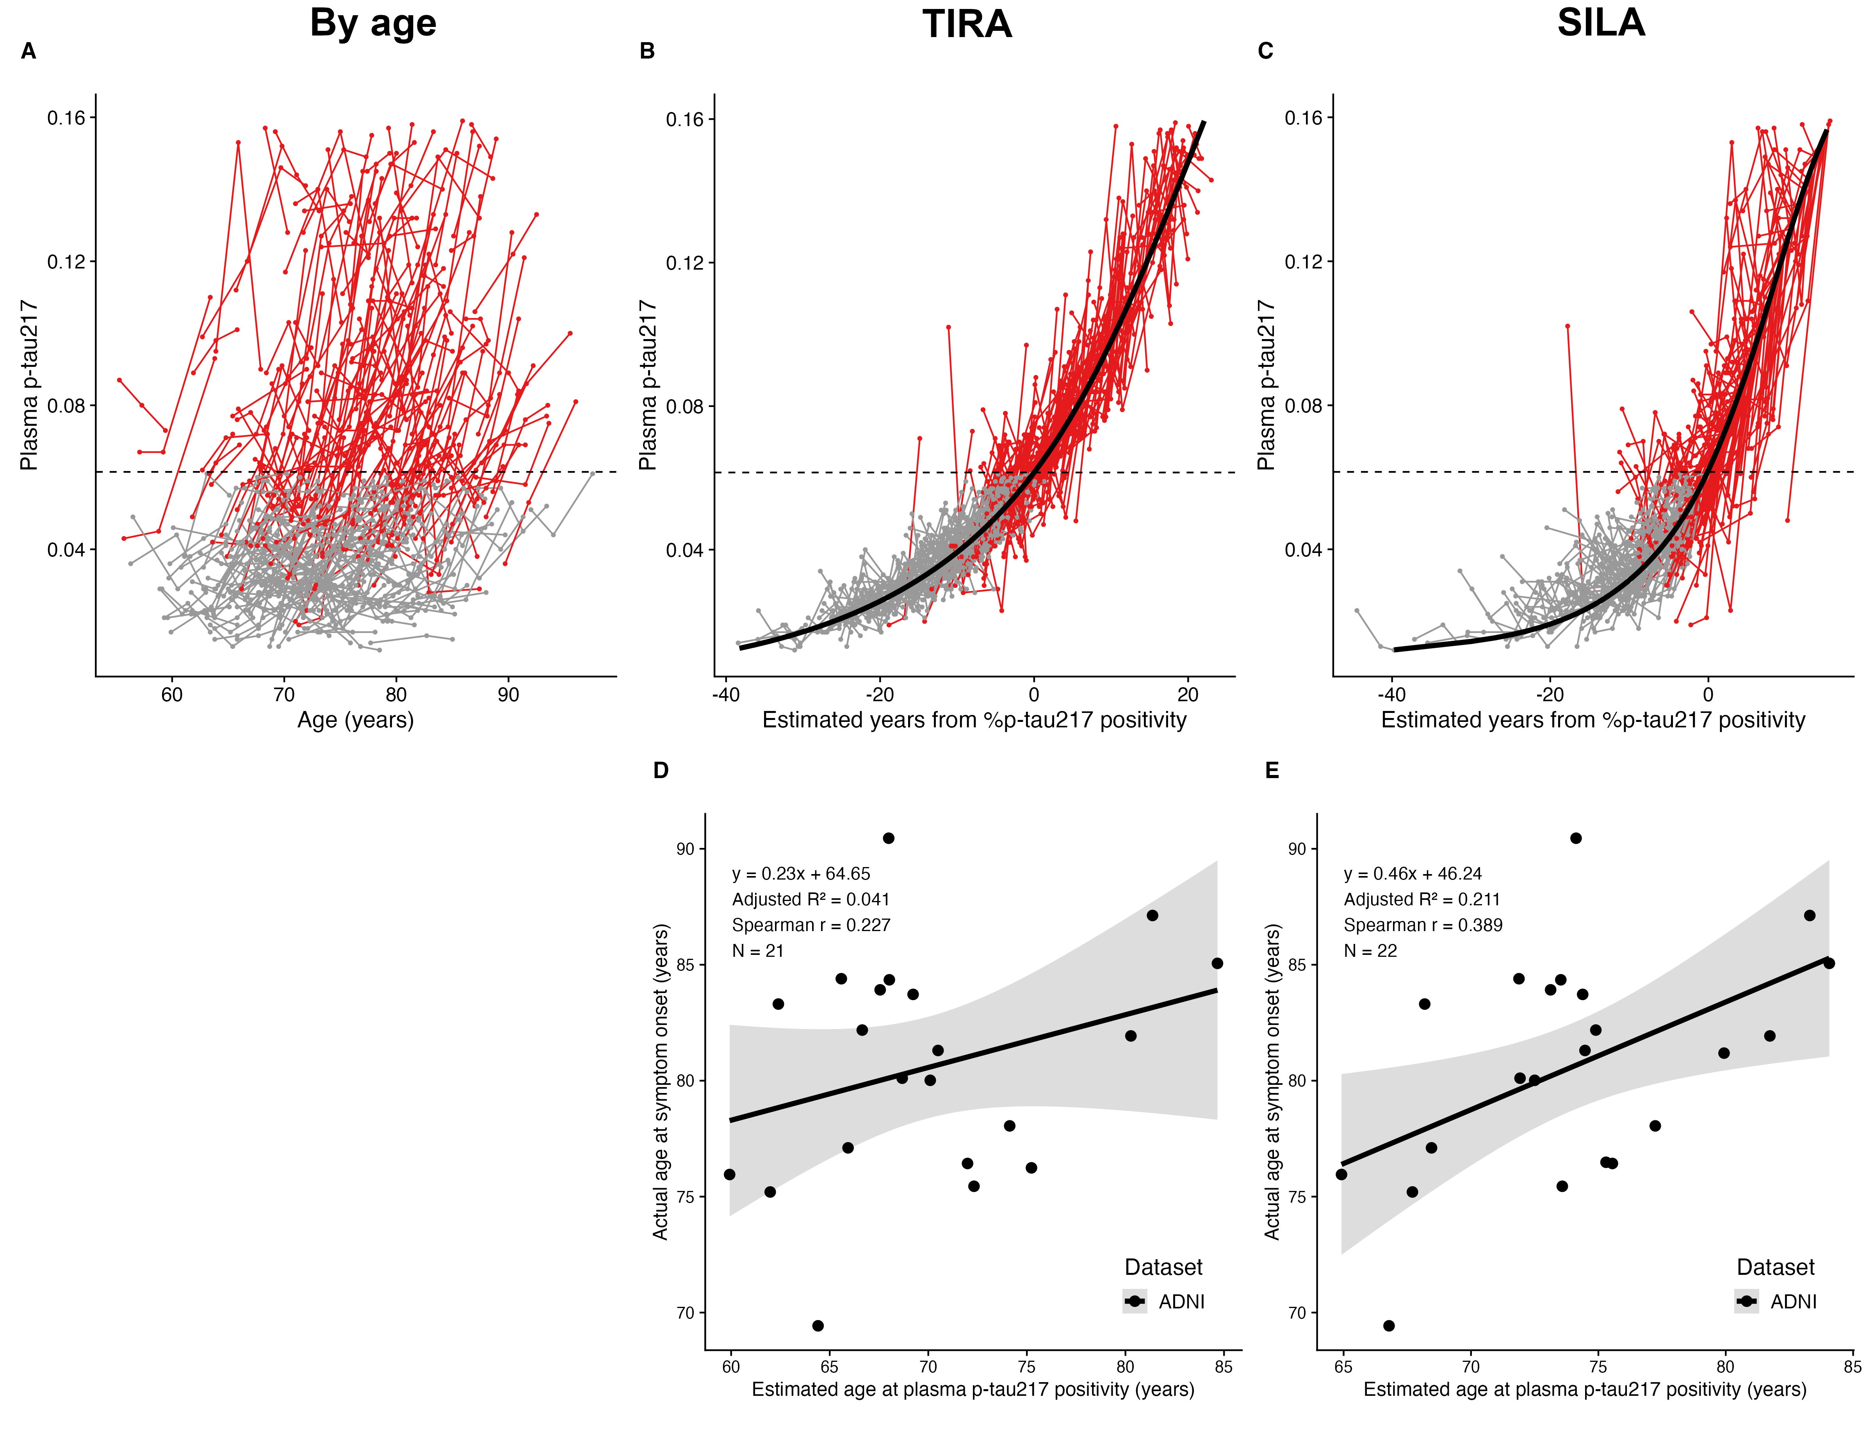

Extended Figure 7. ALZpath’s Quanterix plasma p-tau217 and symptom onset models based on estimated years from p-tau217 positivity. Longitudinal plasma p-tau217 data from ADNI is shown as a function of age (A) or estimated years from p-tau217 positivity by TIRA (B) or SILA clock models (C). Thick black lines represent the clock models; red lines represent individuals with at least one plasma p-tau217>0.444 pg/ml and grey lines represent individuals with no plasma p-tau217>0.444 pg/ml. The horizontal black dashed lines represent the plasma p-tau217 threshold of 0.444 pg/ml¹. Models for age at symptom onset included individuals who were initially cognitively unimpaired but had a typical AD syndrome at their last assessment and developed symptoms after estimated plasma p-tau217 positivity. Age at p-tau217 positivity was estimated using TIRA (D) or SILA (E) models. Linear regression lines with 95% confidence intervals are shown.

