New γ-pyrone derivative from Helichrysum sanguineum (L.) and its Anti-Helicobacter pylori activity
Adel M Mahdi*, Taha A Kedra, Muhamad Abd-Elraouf, Usama Shaheen, Ezzat A. M. Genady.
Affiliation
Department of Pharmacognosy, Faculty of Pharmacy, Al-Azhar University, Cairo, Egypt.
Corresponding author:
Adel M Mahdi
Department of Pharmacognosy, Faculty of Pharmacy, Al-Azhar University, Cairo, Egypt
Nasr city, Cairo, Egypt.
Phone: +20-01208915508
adelmahdy26@gmail.com
Contents
Figure no | Title
1 | Authentication report of the plant sample of H.sanguineum.
2 | ¹³C NMR (100 MHz, DMSO-d6) of compound 1 (Kadipyrone)
3 | ¹H NMR (400 MHz, DMSO-d6) of compound (1).
4 | ¹H NMR (400 MHz, DMSO-d6) of compound 1 (expanded 1)
5 | ¹H NMR (400 MHz, DMSO-d6) of compound 1 (expanded 2)
6 | ¹H NMR (400 MHz, DMSO-d6) of compound 1 (expanded 3)
7 | HSQC spectrum of compound 1
8 | HSQC spectrum of compound 1 (expanded 1)
9 | HSQC spectrum of compound 1 (expanded 2)
10 | HMBC spectrum of compound 1
11 | HMBC spectrum of compound 1 (expanded 1)
12 | HMBC spectrum of compound 1 (expanded 2)
13 | HMBC spectrum of compound 1 (expanded 3)
14 | HR-ESI-MS of compound 1 283.1551 [M+FA-H]⁻
15 | ESI-MS: m/z 277.1198 [M+K]⁺ of compound 1.
16 | ESI-MS: m/z 261.1420 [M+Na]⁺ of compound 1
17 | ¹³C NMR of compound 2 (100 MHz, DMSOd6).
18 | ¹H NMR of compound 2 (400 MHz, DMSOd6)
19 | ESI-MS: m/z 285.1595 [M-H]⁻ of compound 2
20 | APT ¹³ C NMR of compound 3 (100 MHz, DMSOd6)
21 | ¹H NMR of compound 3 (400 MHz, DMSOd6)
22 | ESI-MS: 303.0482 [M+H]⁺ of compound 3
23 | APT-¹³ C NMR of compound 4 (100 MHz, DMSO-d6)
24 | ¹H NMR (400 MHz, DMSO-d6) of compound 4
25 | ¹H NMR (400 MHz, DMSO-d6) of compound 4 (expanded).
26 | ESI-MS: m/z 139.0235 [M+H] ⁺ of compound 4

Authentication report
Figure 1: Authentication report of the plant sample of H.sanguineum.
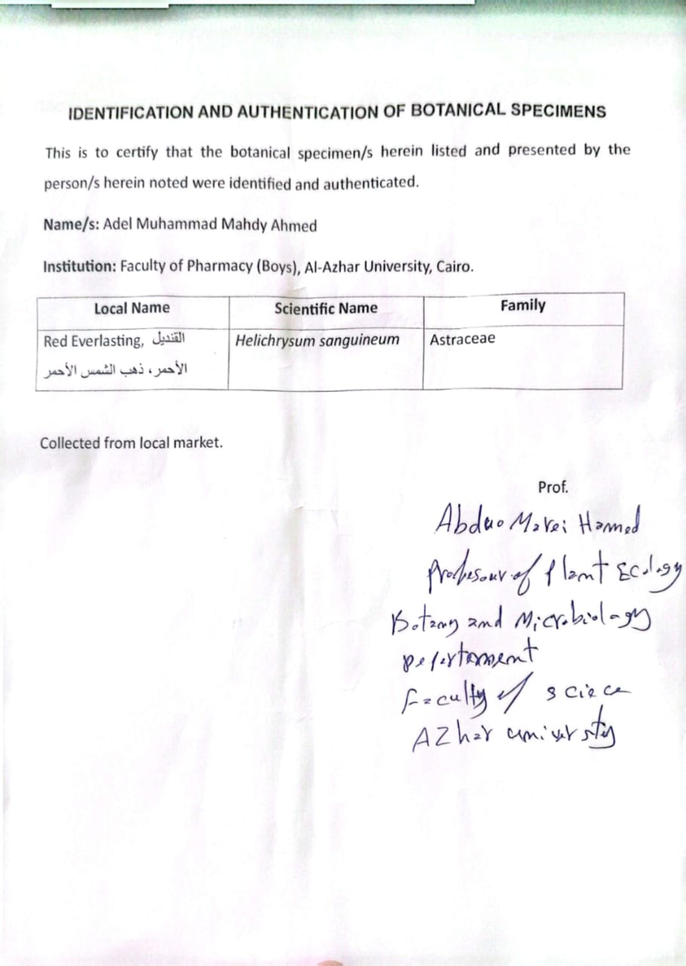

Figure 2: ¹³C NMR (100 MHz, DMSO-d6) of compound 1 (Kadipyrone)
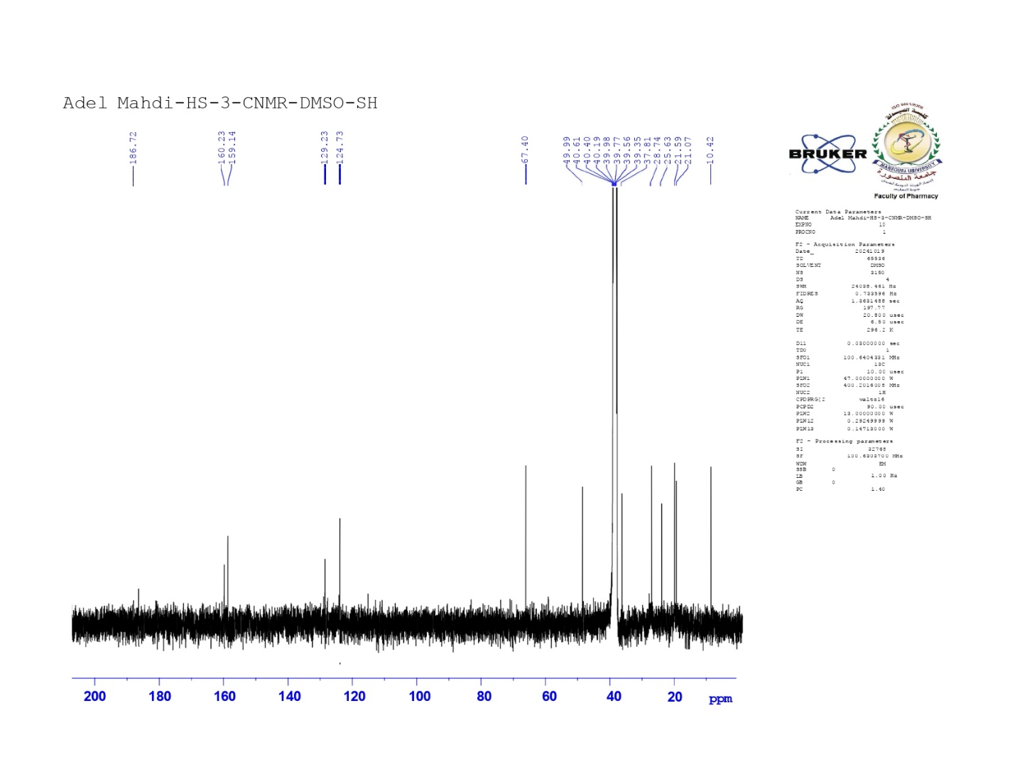

Figure 3: ¹H NMR (400 MHz, DMSO-d6) of compound (1).
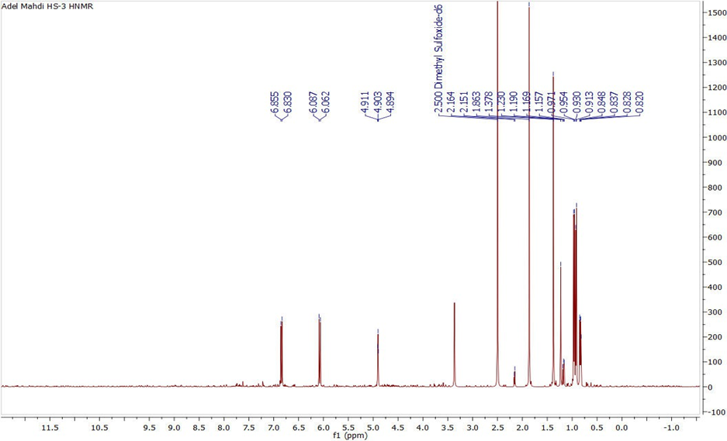
Figure 4: ¹H NMR (400 MHz, DMSO-d6) of compound 1 (expanded 1)
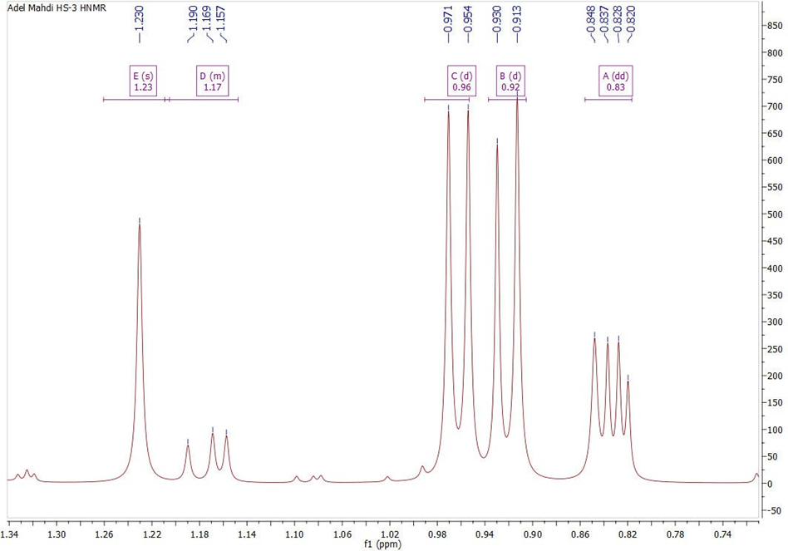

Figure 5: ¹H NMR (400 MHz, DMSO-d6) of compound 1 (expanded 2)
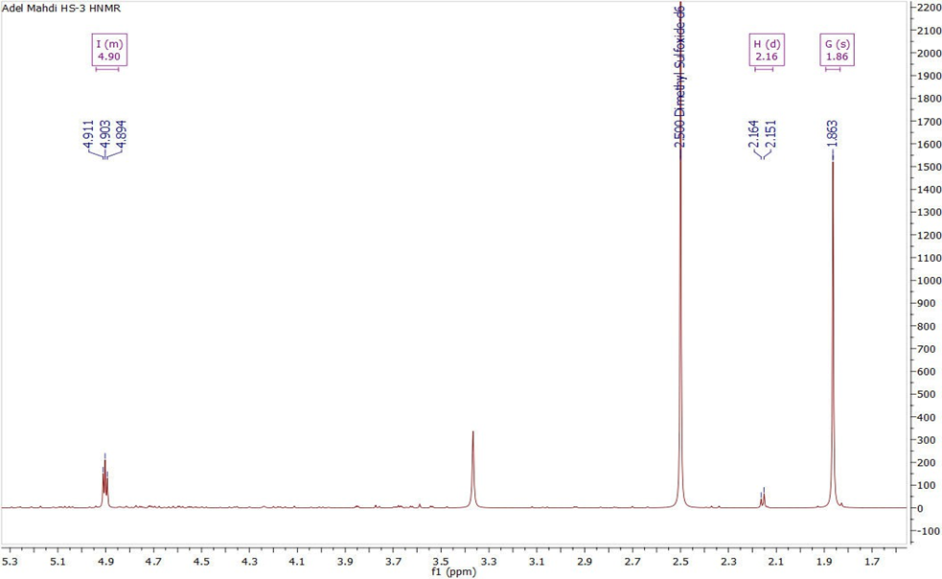
Figure 6: ¹H NMR (400 MHz, DMSO-d6) of compound 1 (expanded 3)
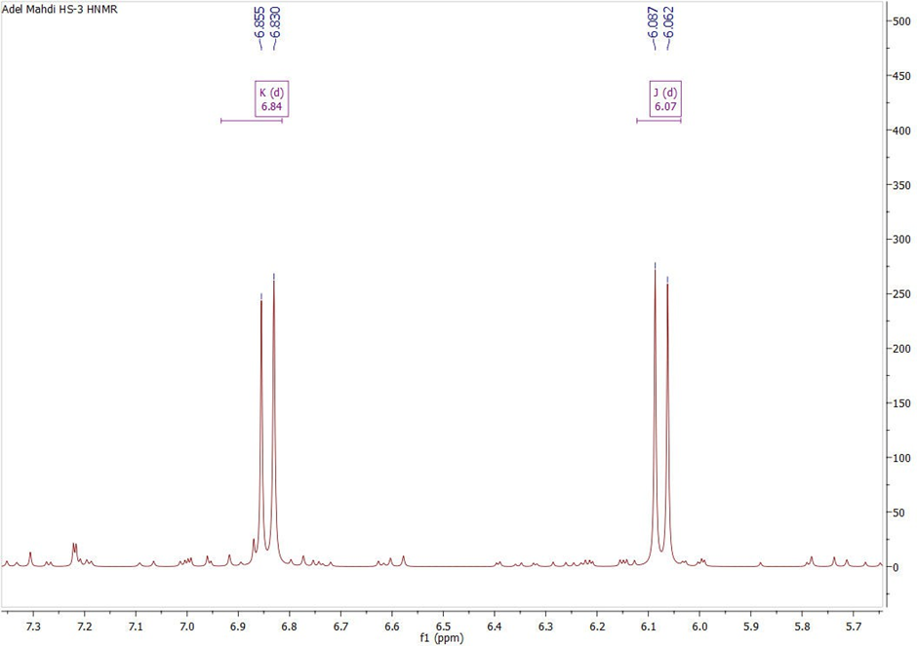

Figure 7: HSQC spectrum of compound 1
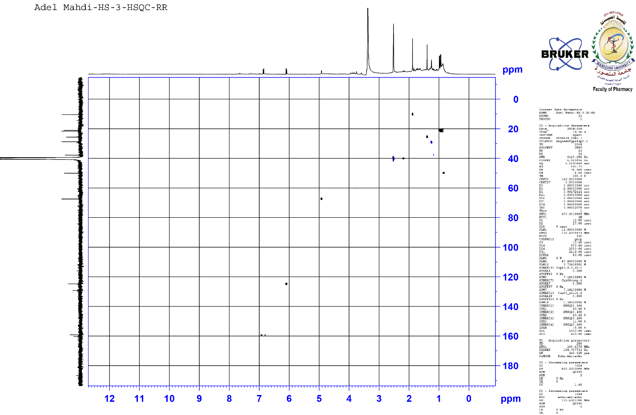
Figure 8: HSQC spectrum of compound 1 (expanded 1)
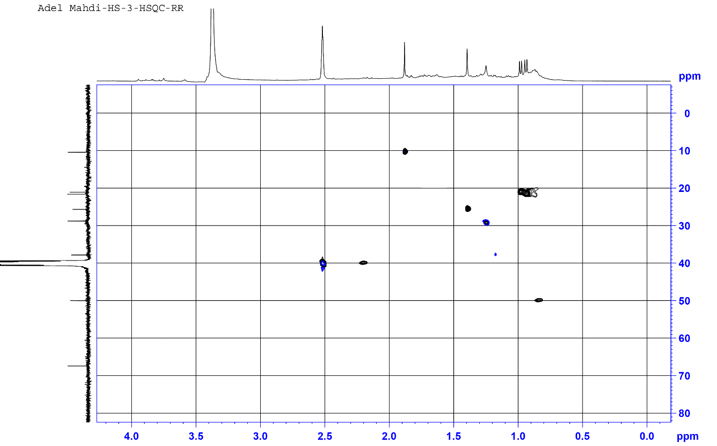

Figure 9: HSQC spectrum of compound 1 (expanded 2)
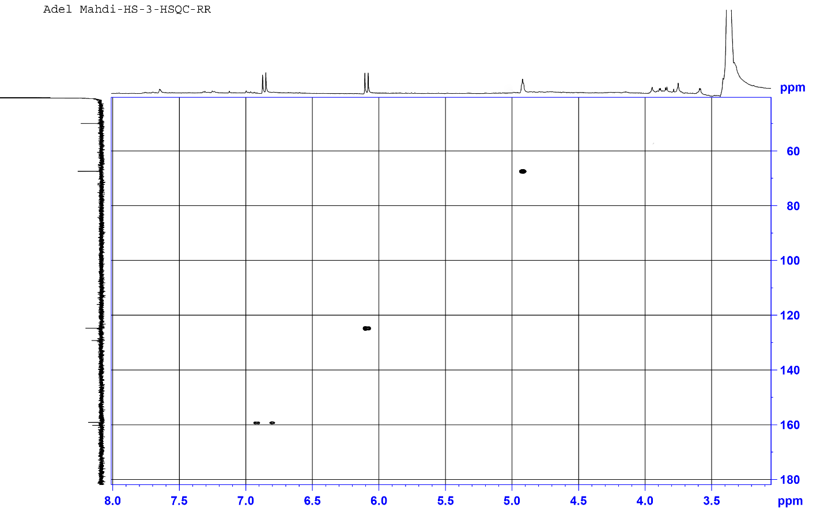

Figure 10: HMBC spectrum of compound 1
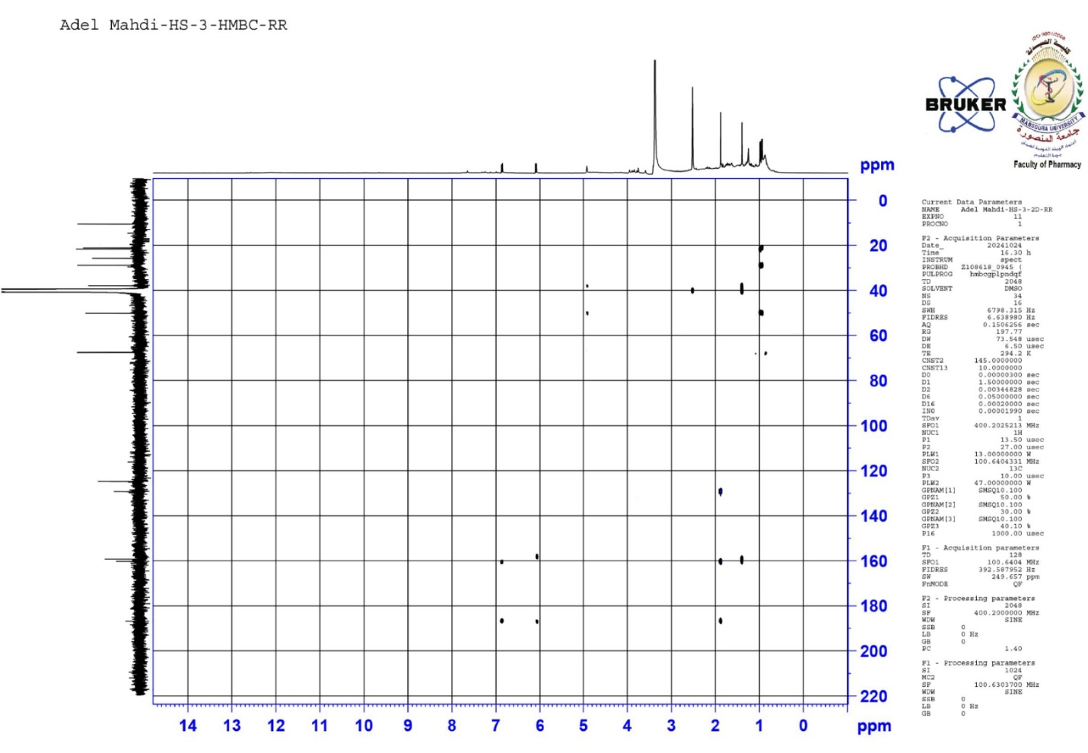
Figure 11: HMBC spectrum of compound 1 (expanded 1)
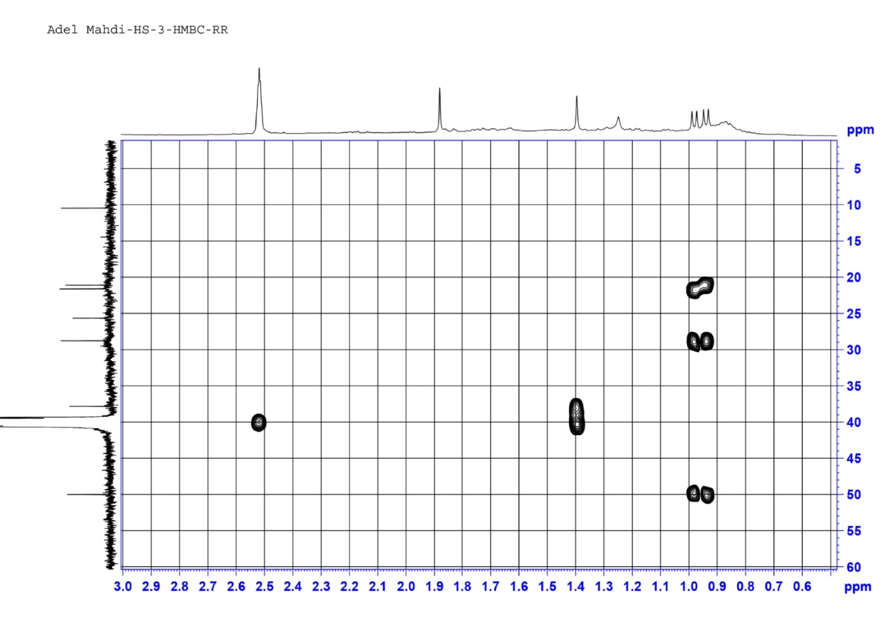
Figure 12: HMBC spectrum of compound 1 (expanded 2)
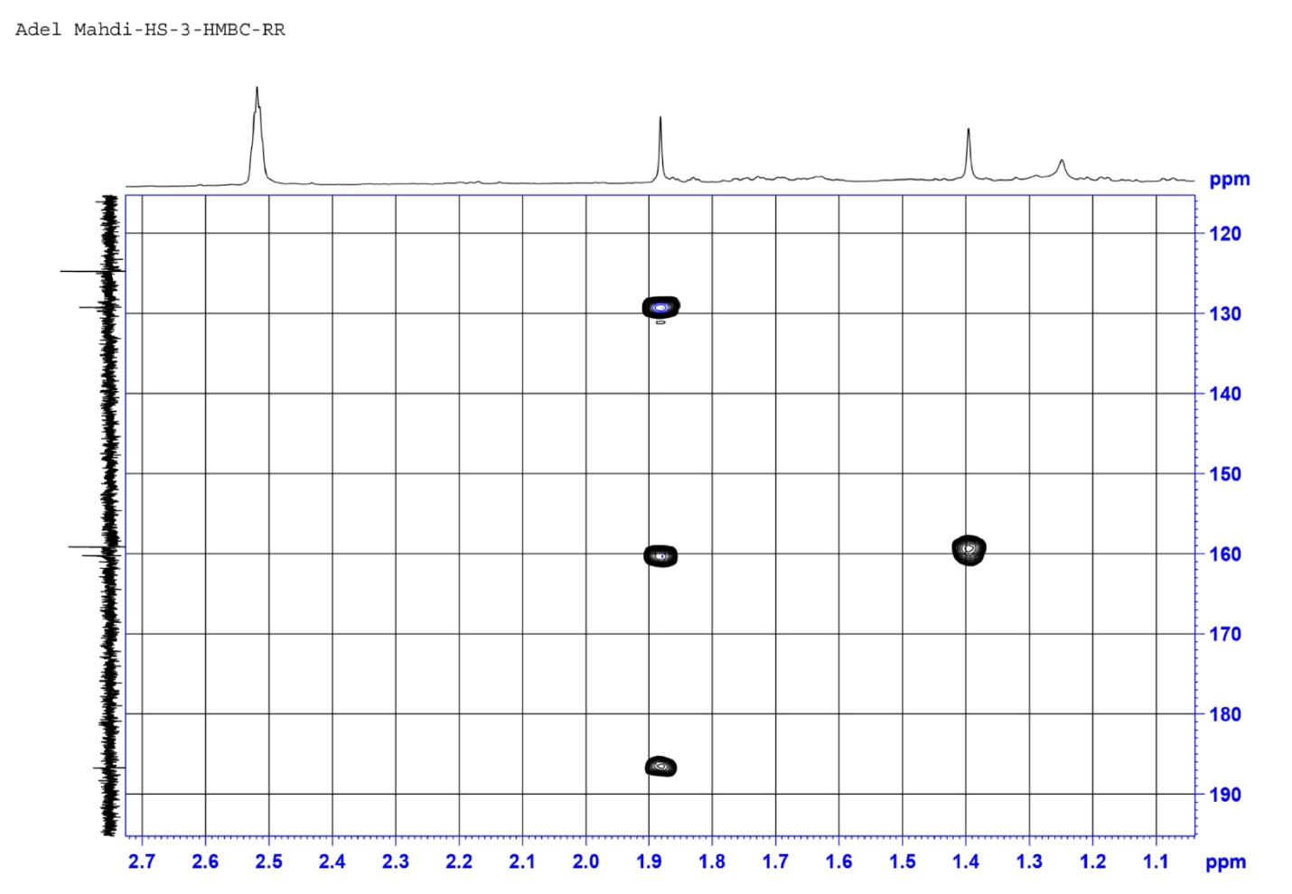

Figure 13: HMBC spectrum of compound 1 (expanded 3)
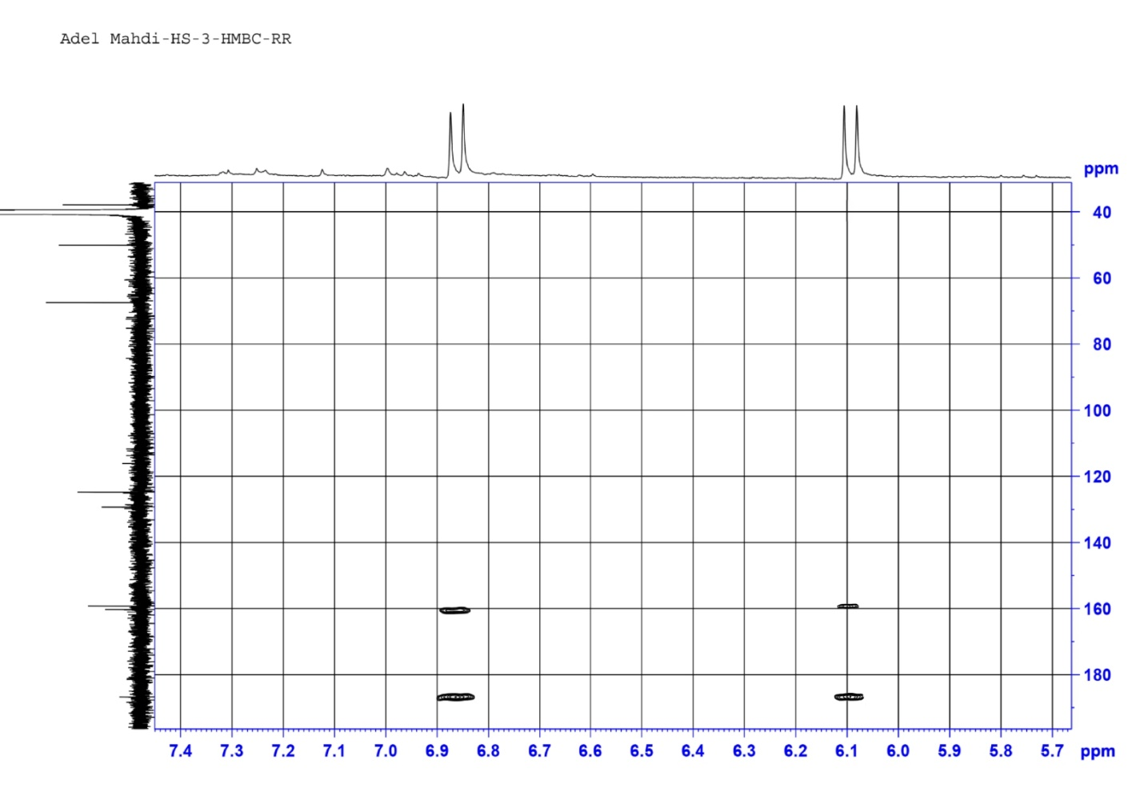

Figure 14: HR-ESI-MS of compound 1 283.1551 [M+FA-H]⁻
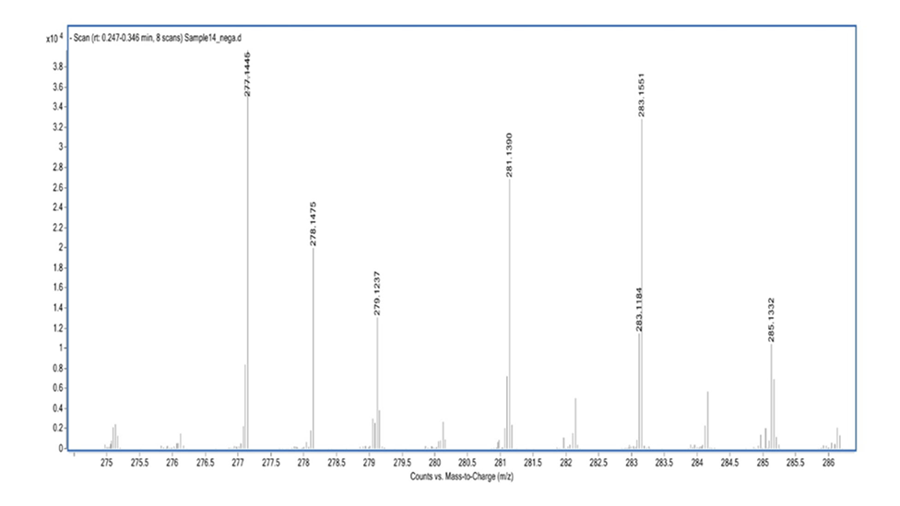

Figure 15 : ESI-MS: m/z 277.1198 [M+K]⁺ of compound 1.
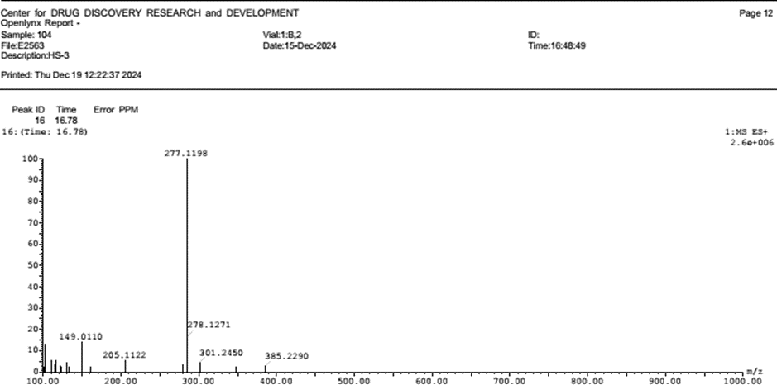

Figure 16: ESI-MS: m/z 261.1420 [M+Na]⁺ of compound 1
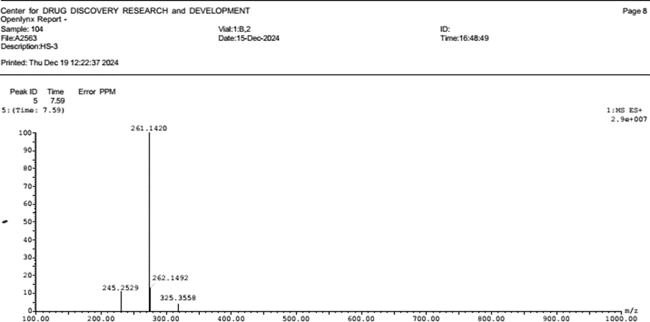

Spectroscopic data of compound 2 (Luteolin)
Figure 17:¹³C NMR of compound 2 (100 MHz, DMSOd6).
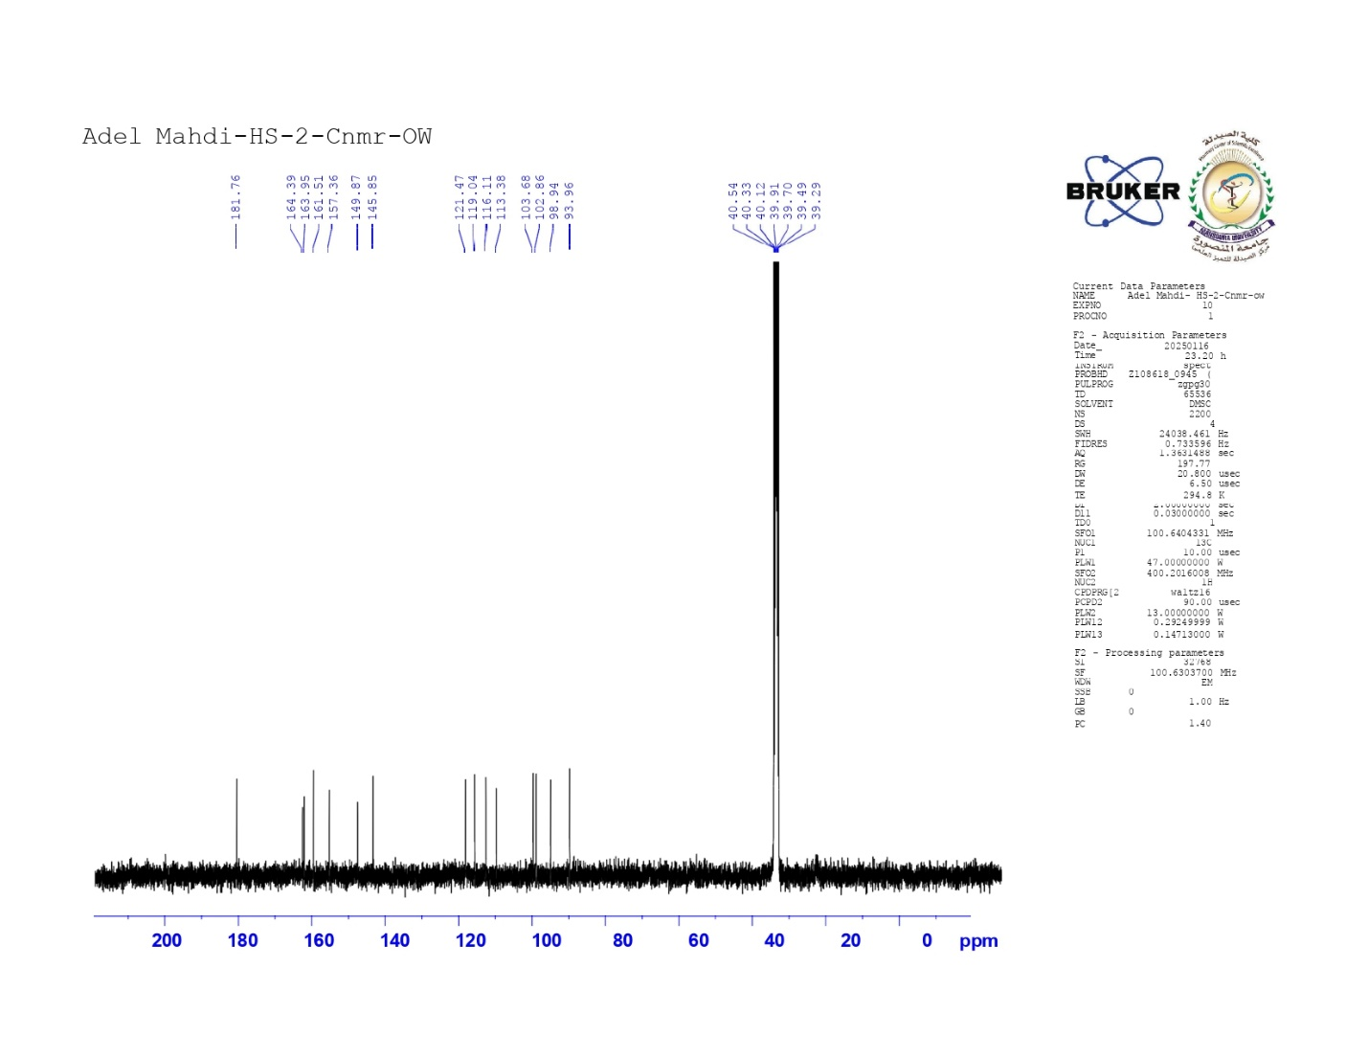
Figure 18:¹H NMR of compound 2 (400 MHz, DMSOd6)
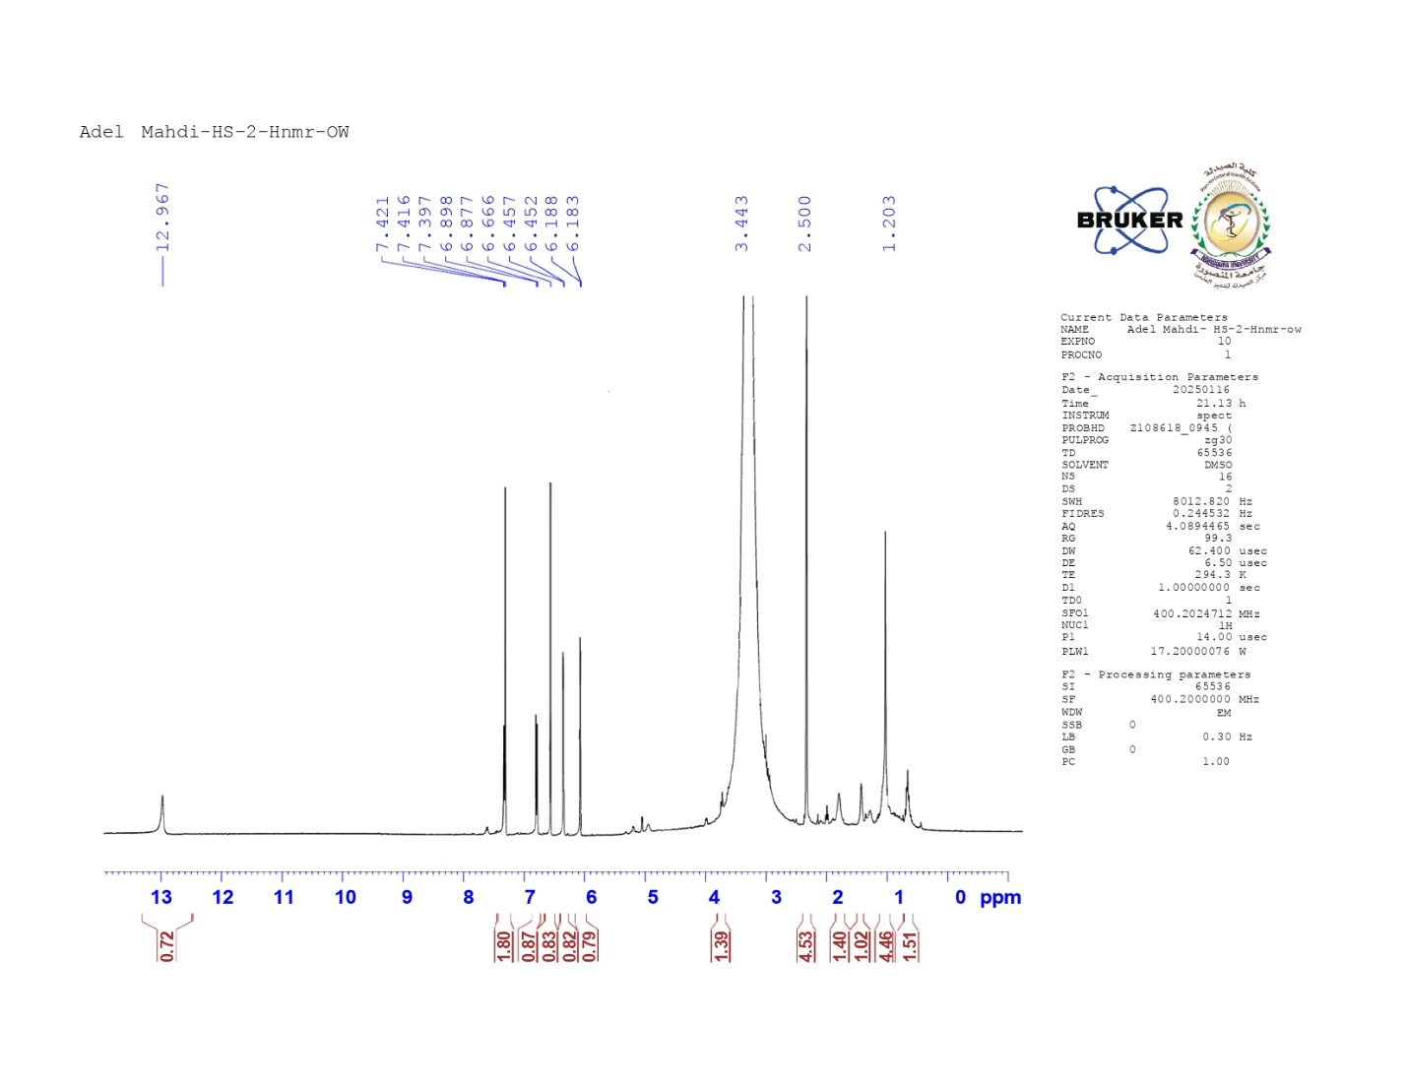

Figure 19: ESI-MS: m/z 285.1595 [M-H]⁻ of compound 2
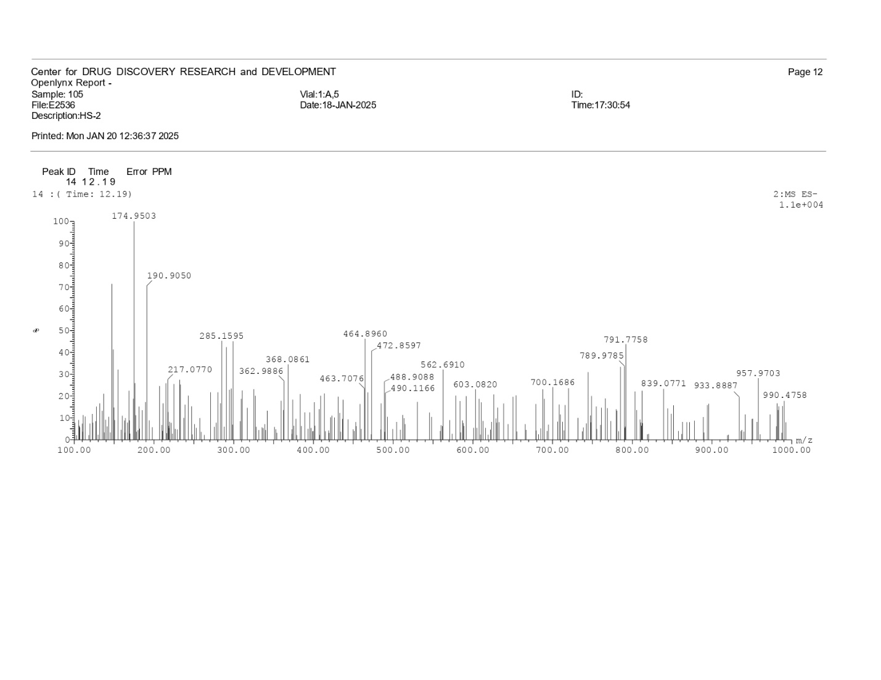

Spectroscopic data of compound 3 (quercetin)
Figure 20: APT ¹³ C NMR of compound 3 (100 MHz, DMSOd6)
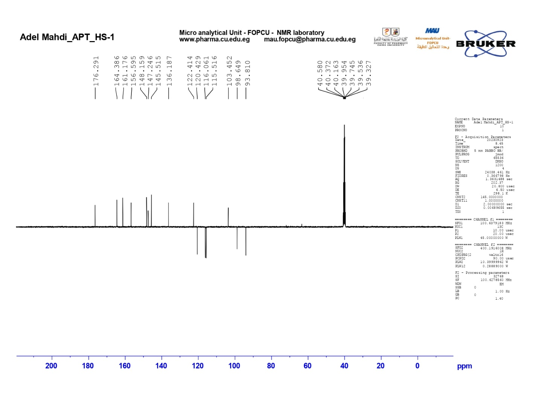
Figure 21:¹H NMR of compound 3 (400 MHz, DMSOd6)
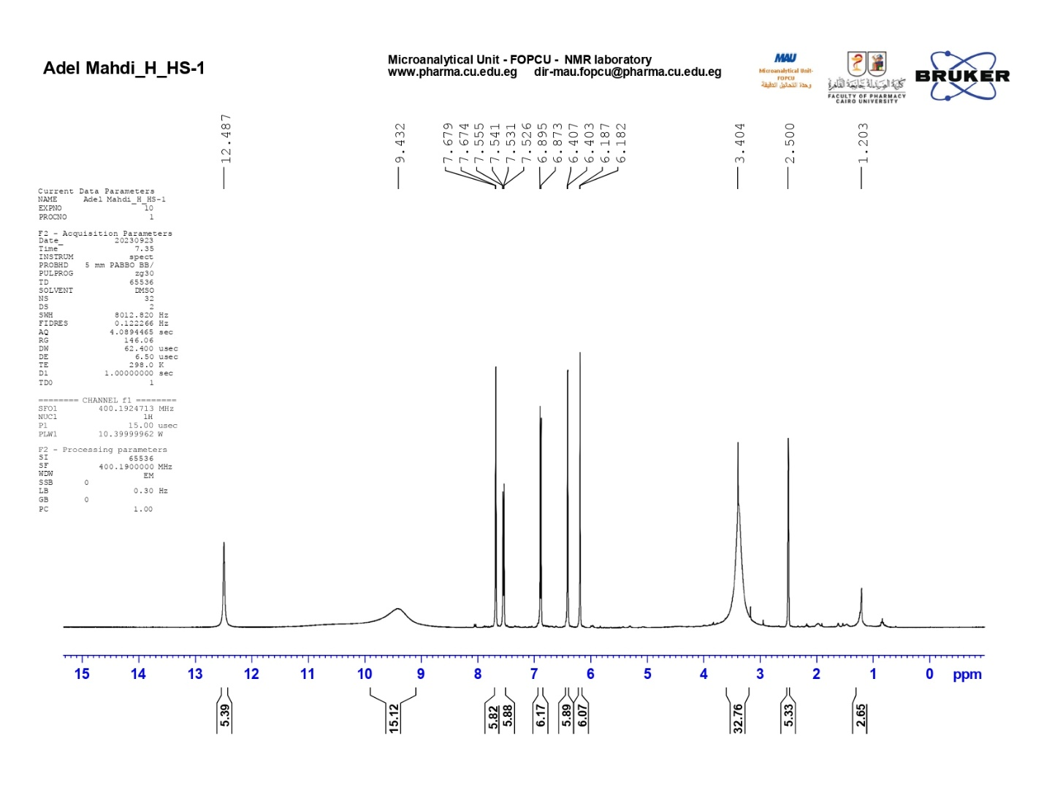
Figure 22: ESI-MS: 303.0482 [M+H]⁺ of compound 3
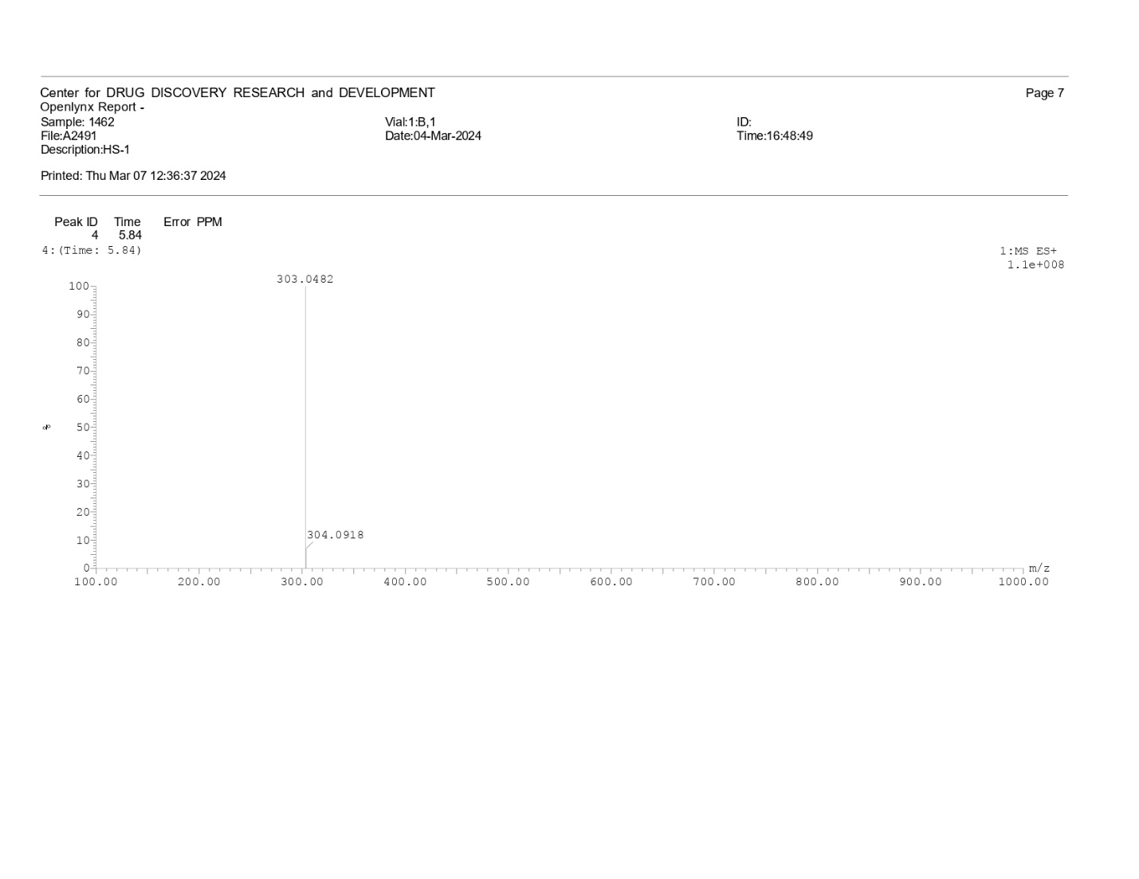

Spectroscopic data of compound 4 (para hydroxy benzoic acid)
Figure 23: APT-¹³ C NMR of compound 4 (100 MHz, DMSO-d6)
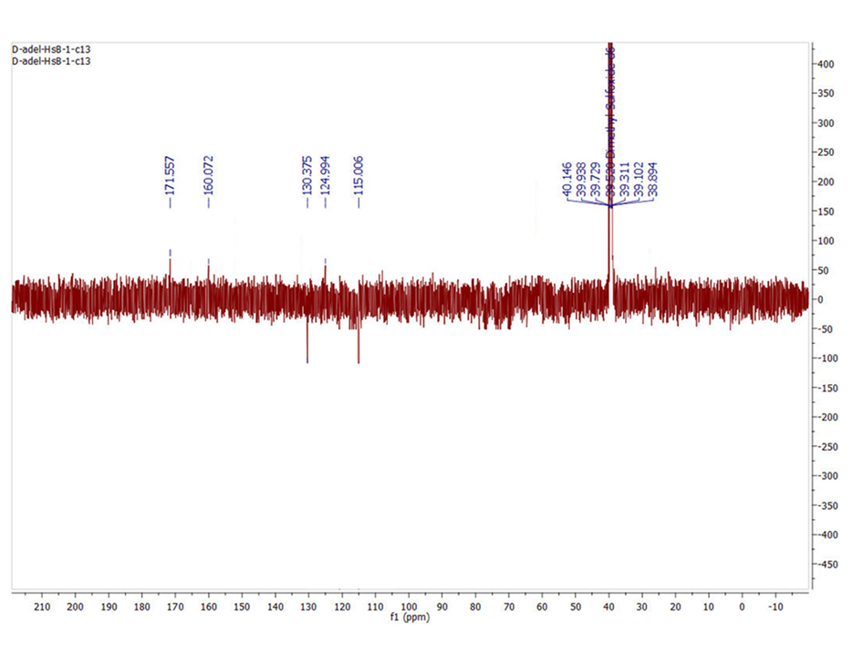

Figure 24 : ¹H NMR (400 MHz, DMSO-d6) of compound 4
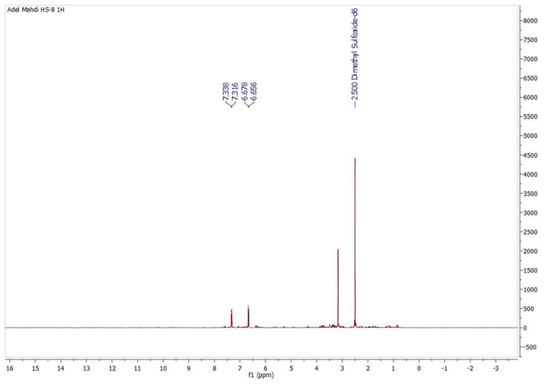
Figure 25: ¹H NMR (400 MHz, DMSO-d6) of compound 4 (expanded)
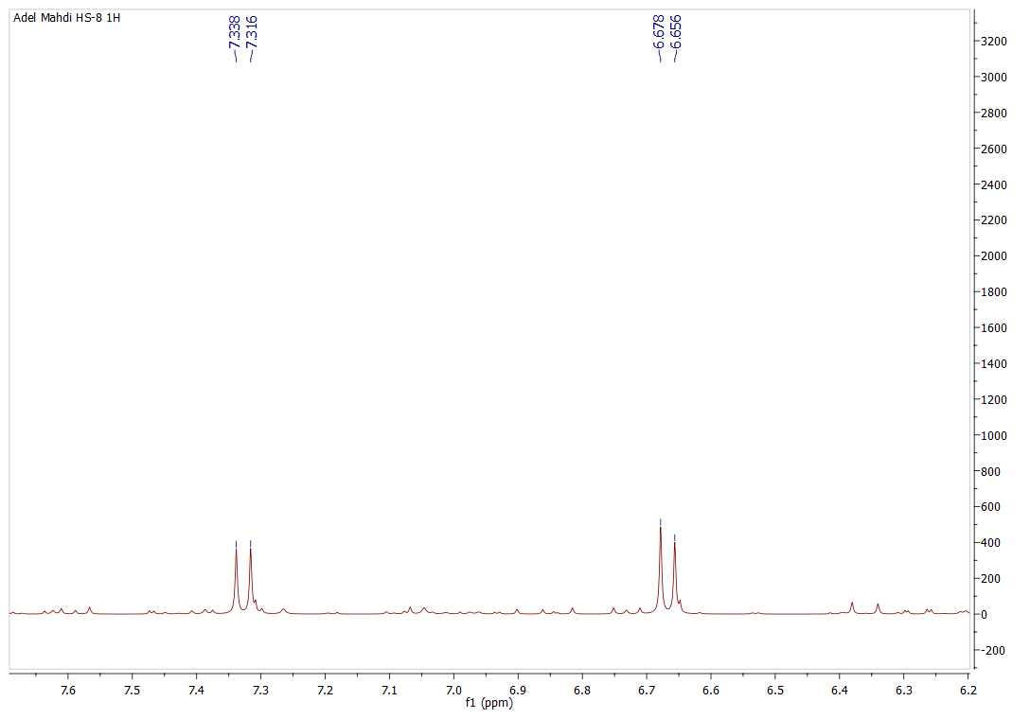

Figure 26: ESI-MS: m/z 139.0235 [M+H] ⁺ of compound 4
