Supplementary Information

North Atlantic influence explaining model-observation discrepancy in the tropical Pacific warming pattern

Yueh-Chi Lin^{1*}, Masahiro Watanabe¹

1: Atmosphere and Ocean Research Institute, University of Tokyo, Chiba, Japan

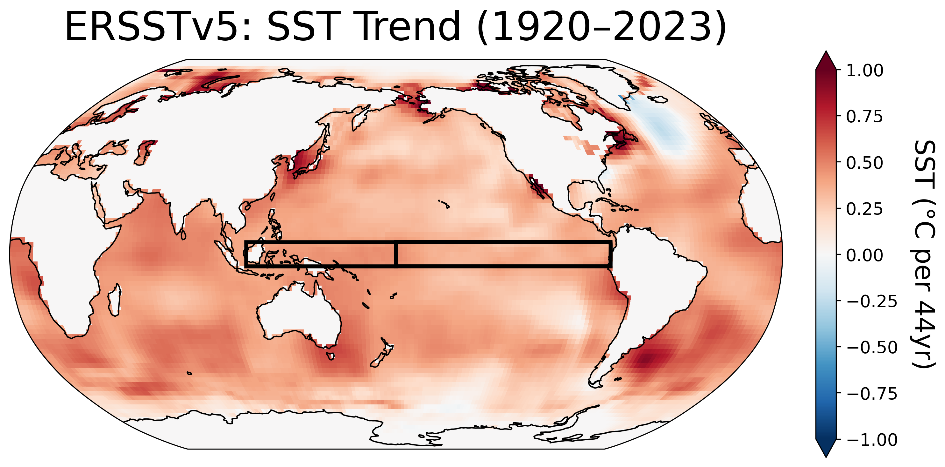

Supplementary Figure 1 | Observed pattern of SST trends for 1920–2023.
The linear trends (°C per 44 years) are calculated using annual-mean SST anomalies from ERSSTv5. The black boxes indicate the Western Pacific (WP: 5°S–5°N, 110°E–180°E) and Eastern Pacific (EP: 5°S–5°N, 180°–80°W) regions used to calculate the zonal SST gradient (WP minus EP).

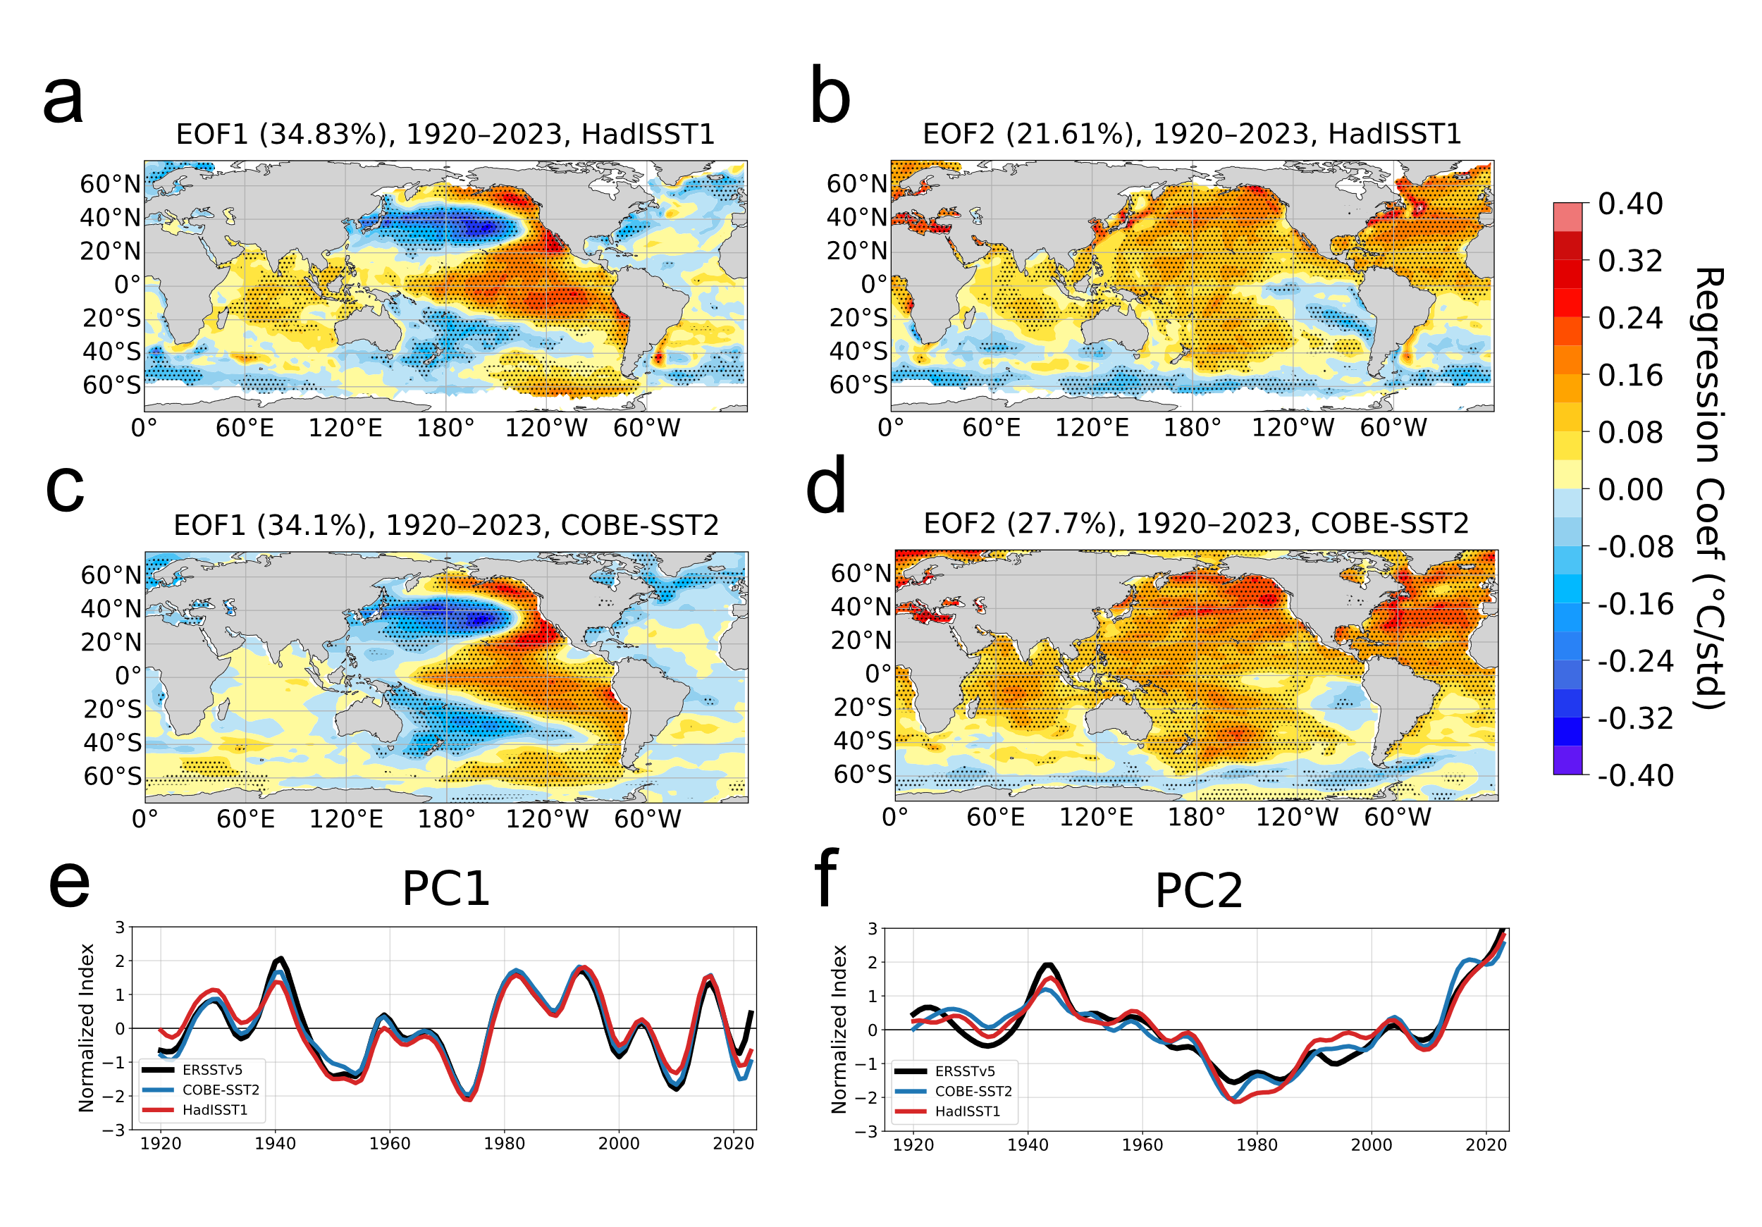
Supplementary Figure 2 | Leading patterns of the observed Pacific low-frequency SST variability for 1920–2023 in HadISST1 and COBE-SST2.
Same as Fig. 1 but for (a, b) HadISST1 and (c, d) COBE-SST2. Local standard deviations in COBE-SST2 have been adjusted to match ERSSTv5 (see Methods). Panels show regression maps of SST anomalies onto PC1 (a, c) and PC2 (b, d), with stippling indicating regions statistically significant at the 95% level. (e, f) PC1 and PC2 time series from ERSSTv5 (black), COBE-SST2 (blue), and HadISST1 (red), respectively.

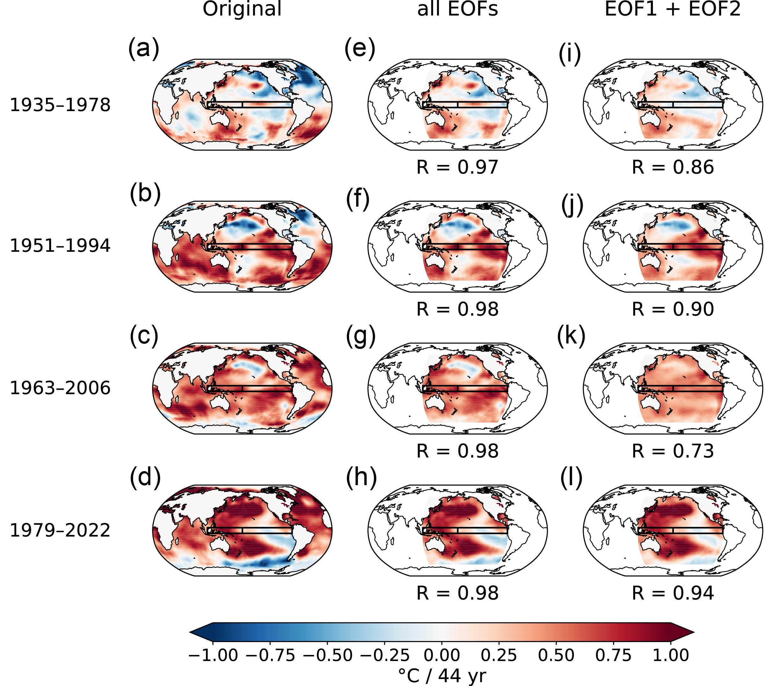
Supplementary Figure 3 | Observed and EOF-reconstructed 44-year SST trends in ERSSTv5.
(a–d) Linear trends (°C per 44 yr) of annual-mean SST anomalies for 1935–1978, 1951–1994, 1963–2006 and 1979–2022; black rectangles indicate the western (WP) and eastern (EP) equatorial Pacific boxes. (e–h) Trends reconstructed from the sum of all EOFs plus the long-term trend (1920–2023). (i–l) Trends reconstructed with only EOF1 and EOF2 added to the long-term trend. Spatial correlations between the observed and reconstructed trends are shown at the bottom of panels (e-l).

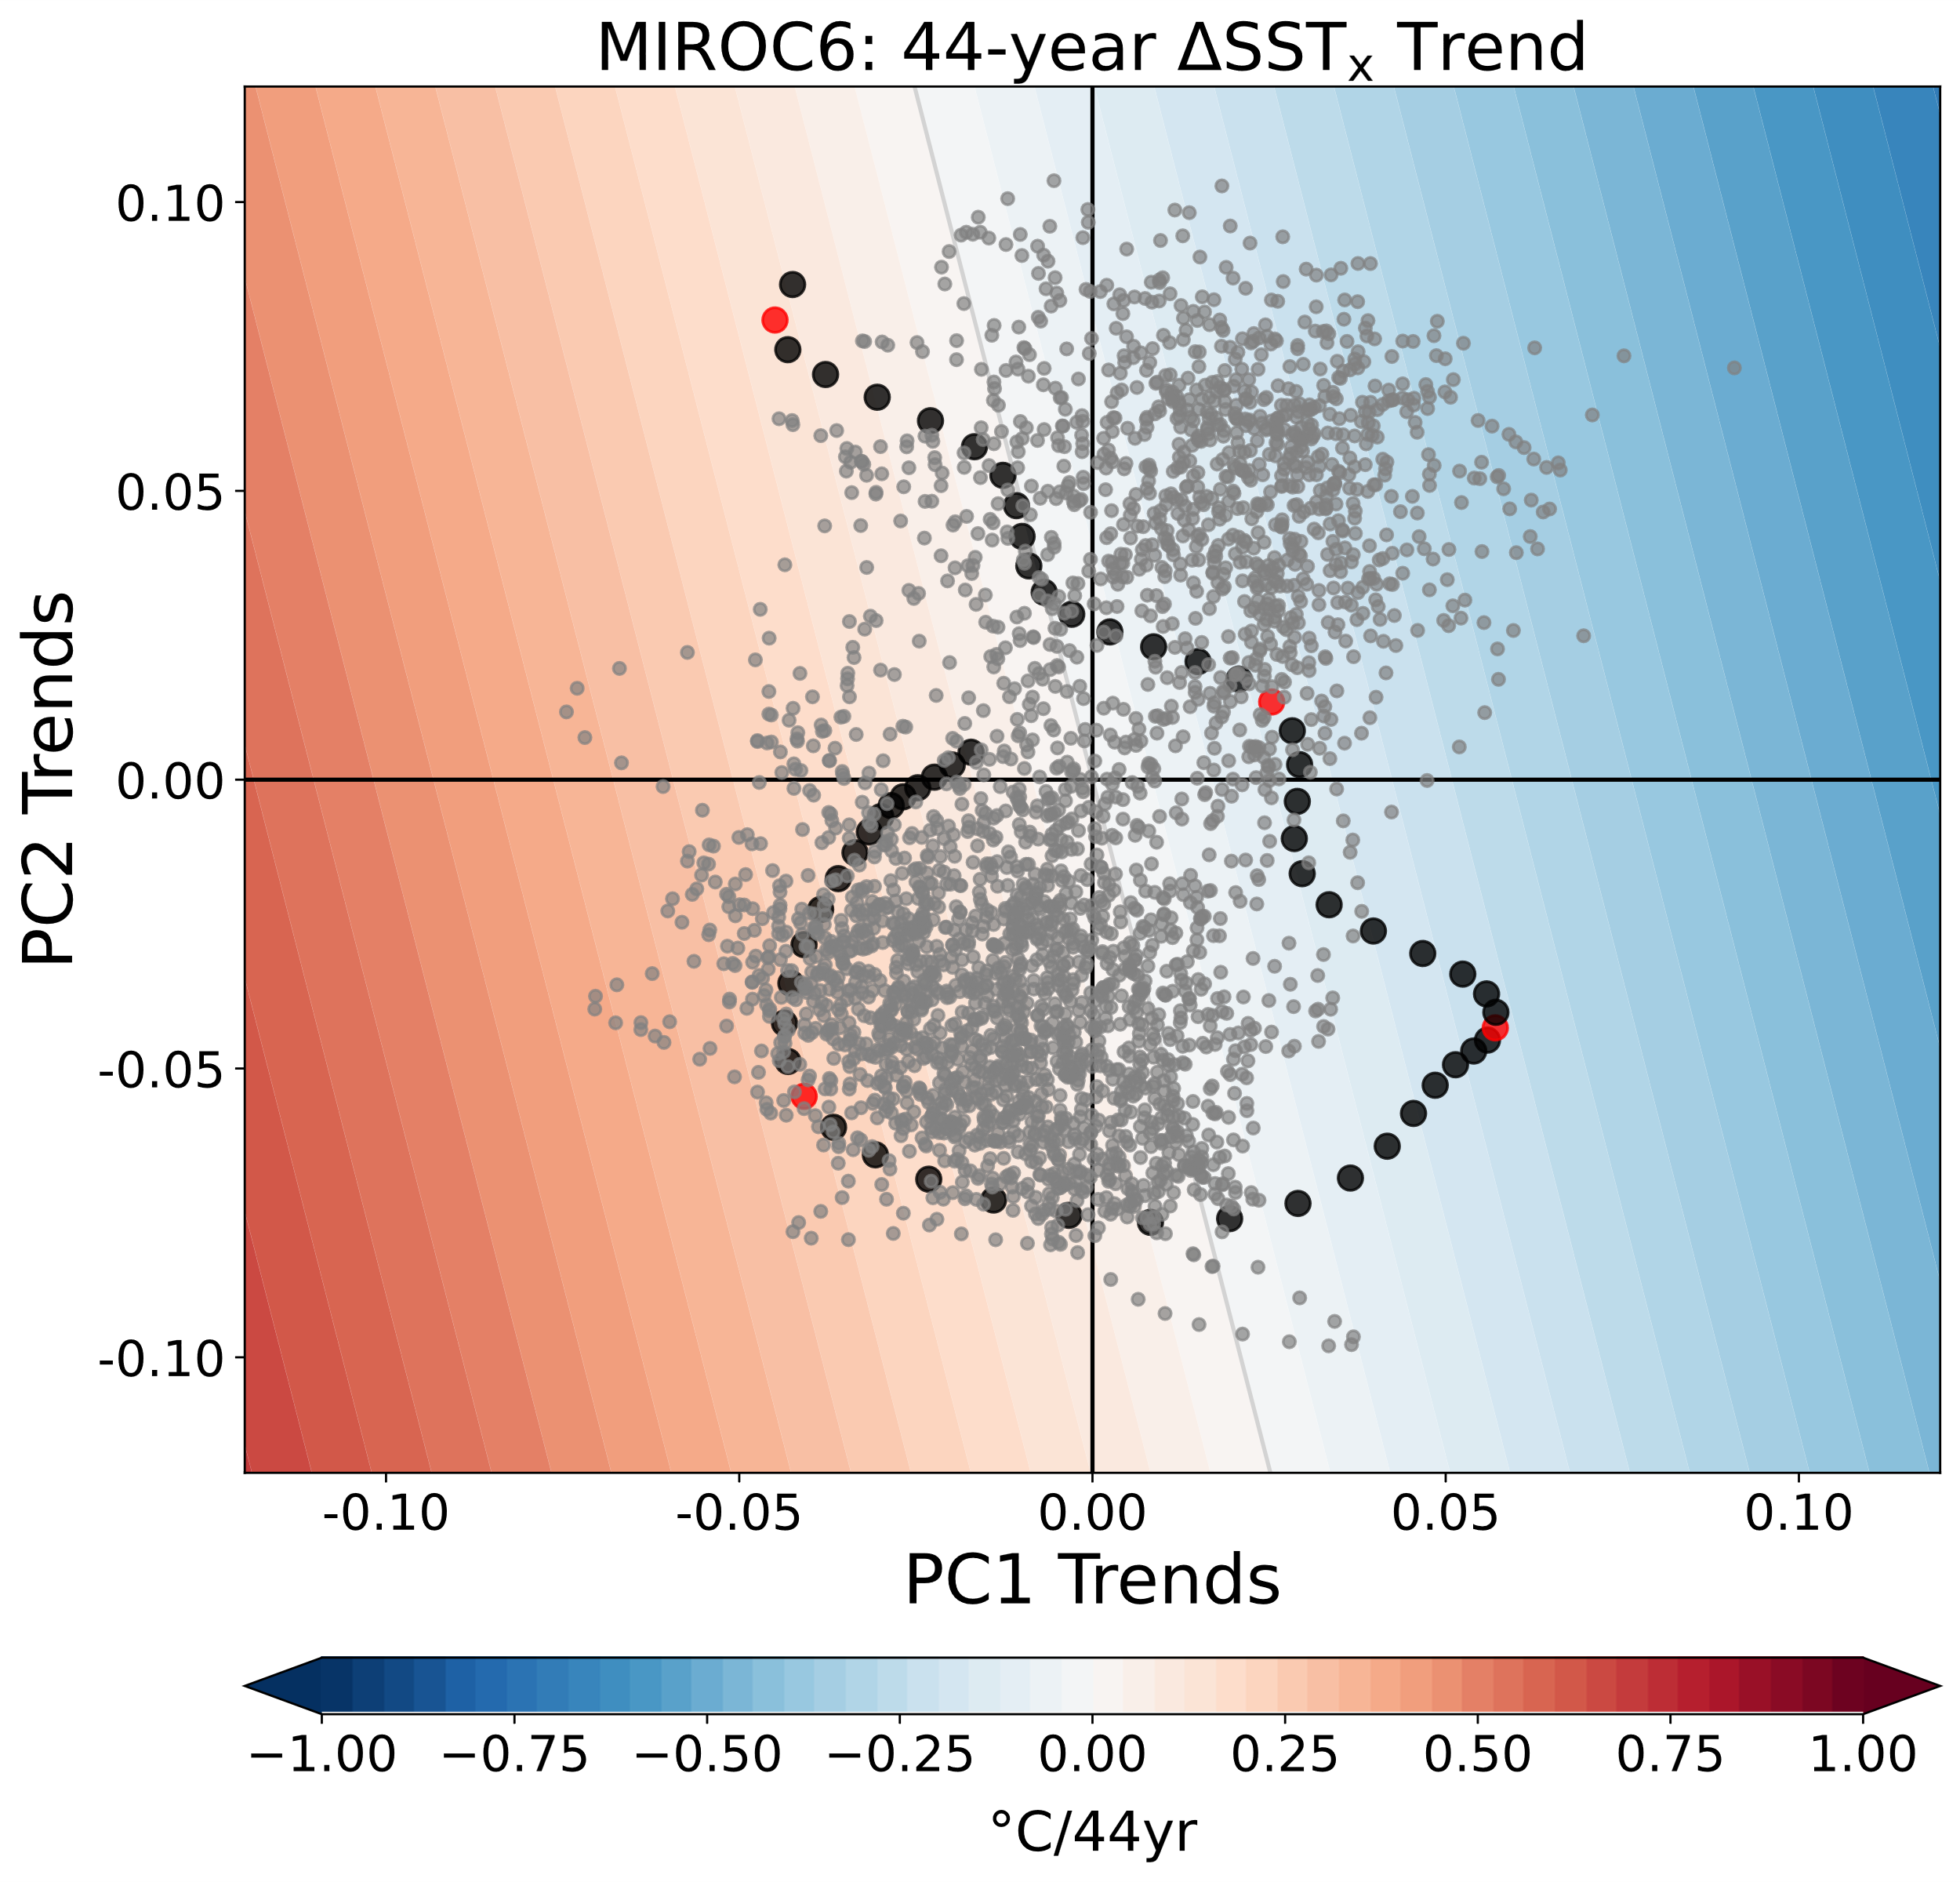
Supplementary Figure 4 | 44-year trends in ΔSST_{x} varying with the phases of the IPO and AMV-related patterns in the MIROC6 large ensemble.
The background shading shows ΔSST_{x} (°C per 44 yr) reconstructed from the MIROC6 large-ensemble mean SST using the leading two EOF patterns (EOF1 + EOF2); values are plotted as a function of the 44-year trends of PC-1 (x-axis) and PC-2 (y-axis). Grey points represent every 44-year PC-trend pair from individual MIROC6 ensemble members. The black dots show the observed trajectory in Fig, 2a, and the four red points mark the observed positions for 1935–1978, 1951–1994, 1963–2006 and 1979–2022.
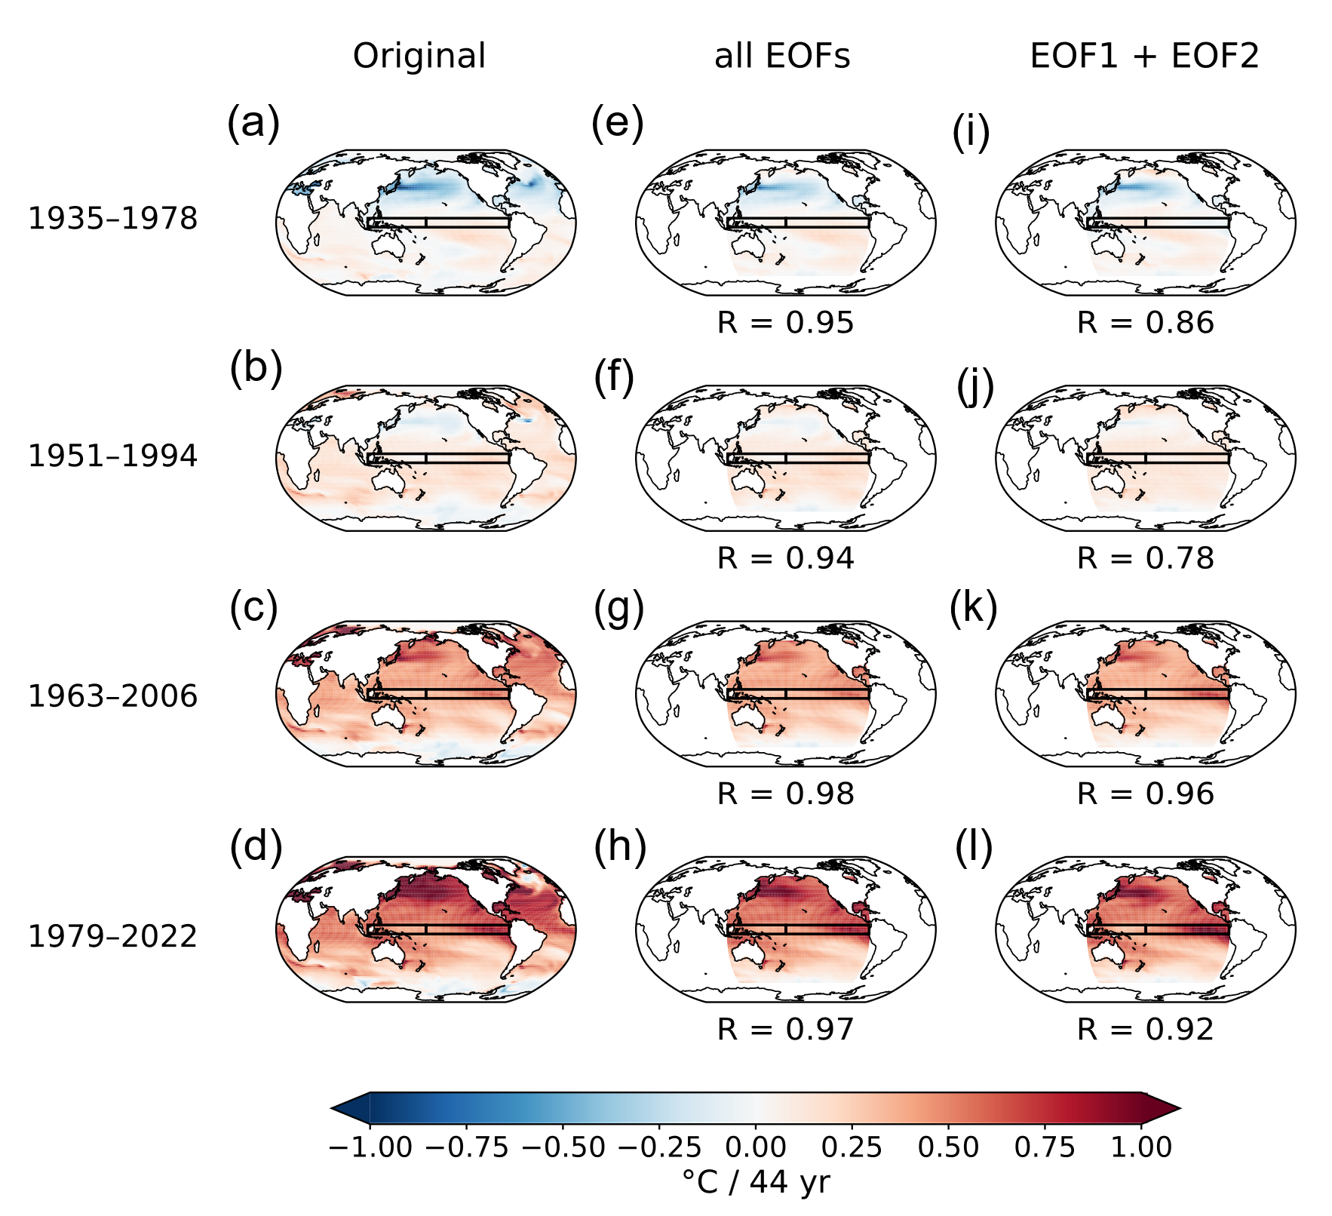
Supplementary Figure 5 | Ensemble-mean and EOF-reconstructed 44-year SST trends in the MIROC6 large ensemble.
Same as Supplementary Figure 2 but for the linear trends in the MIROC6 ensemble mean.

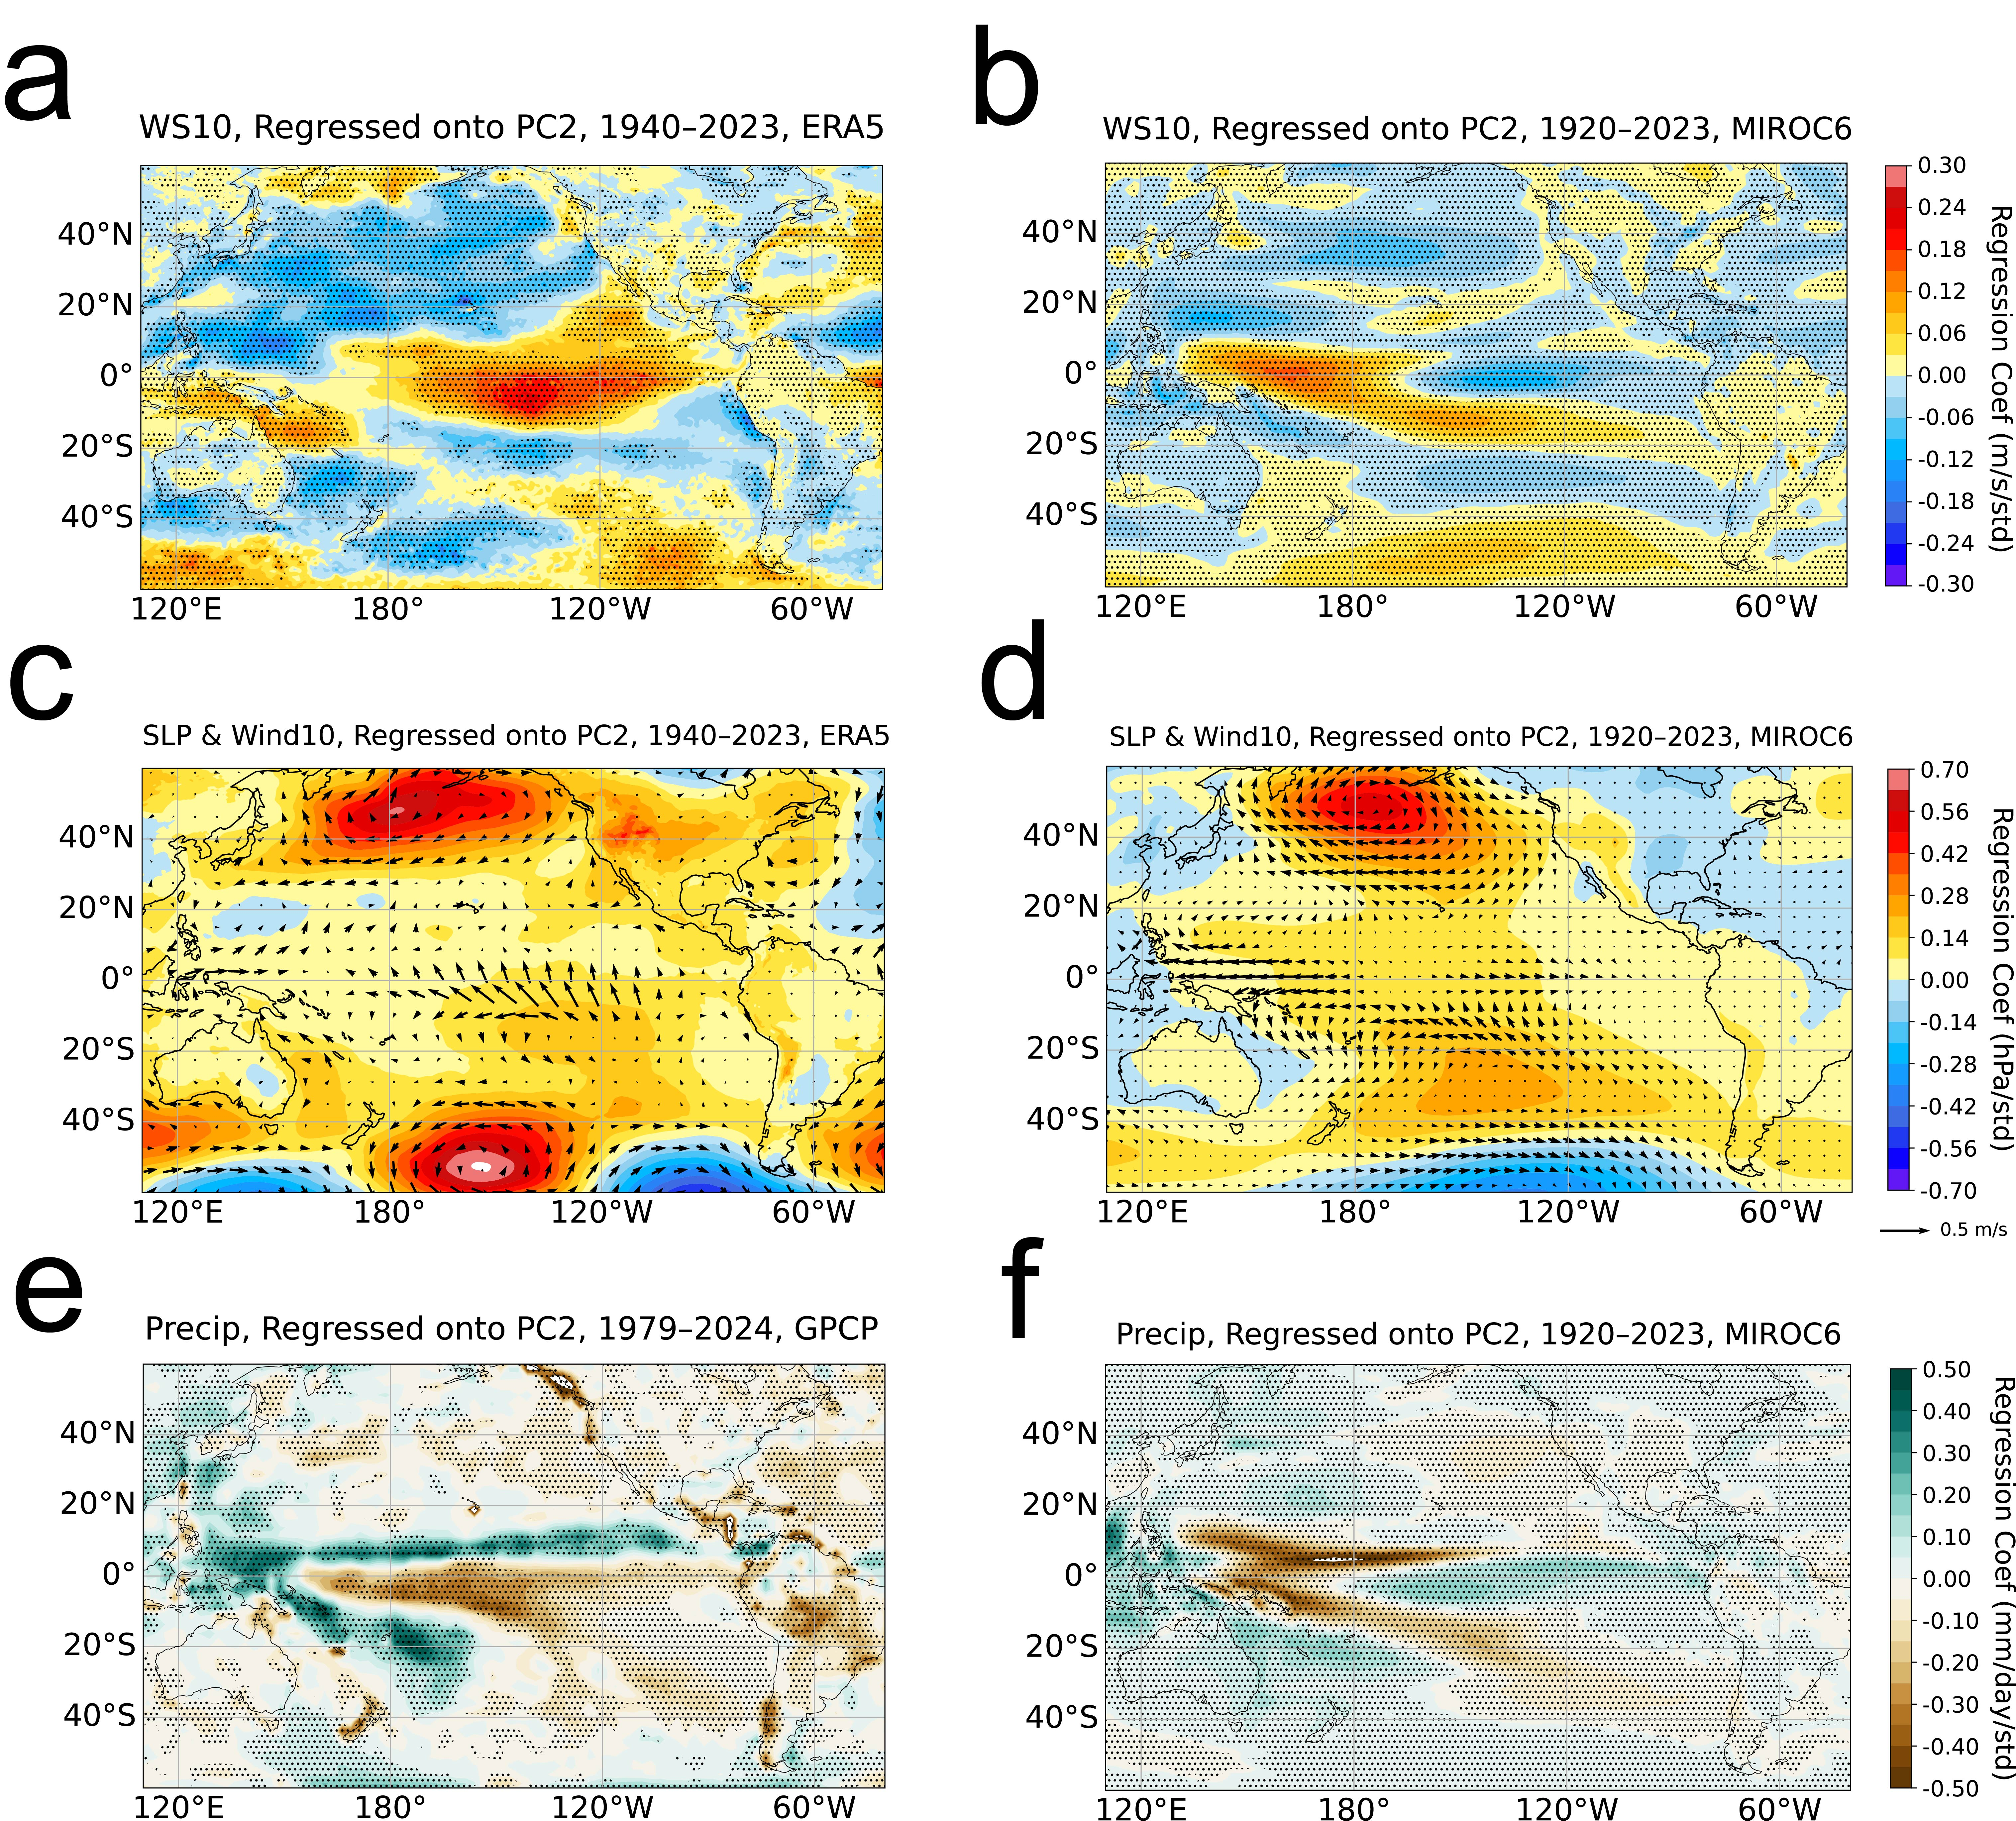

Supplementary Figure 6 | Atmospheric and precipitation patterns associated with PC2.

(a–c) show results from reanalysis and observations regressed onto the observed PC2 from ERSSTv5: (a) ERA5 10-m wind speed, (c) ERA5 sea-level pressure (shading) with 10-m wind vectors, and (e) GPCP precipitation. (b, d, f) show corresponding MIROC6 regression maps onto the model’s own PC2: (b) 10-m wind speed, (d) sea-level pressure with wind, and (f) precipitation. Stippling indicates significance at the 95 % confidence level (p < 0.05). Units are m s⁻¹ per std for wind, hPa per std for SLP, and mm day⁻¹ per std for precipitation.
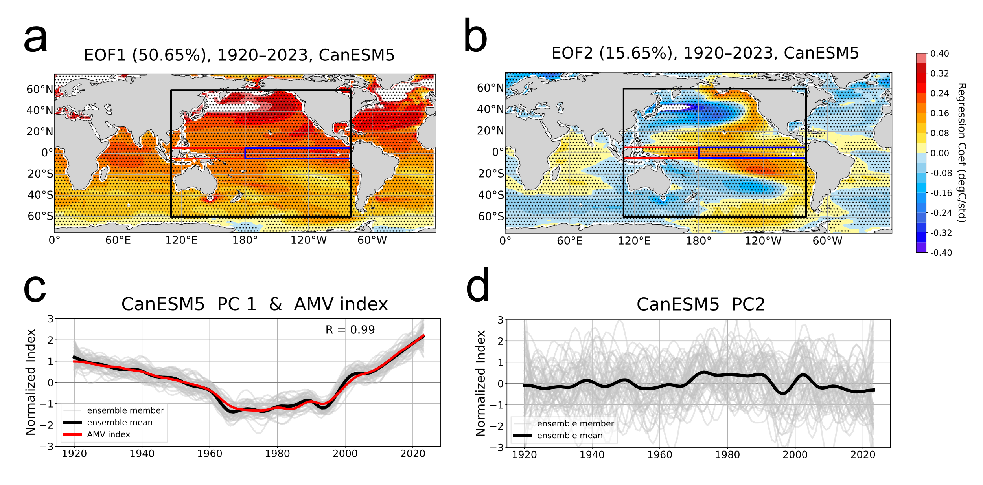
Supplementary Figure 7 | Leading patterns of low-frequency Pacific SST variability (1920–2023) in the CanESM5 large ensembles.
Same as Fig. 3 but for CanESM5.

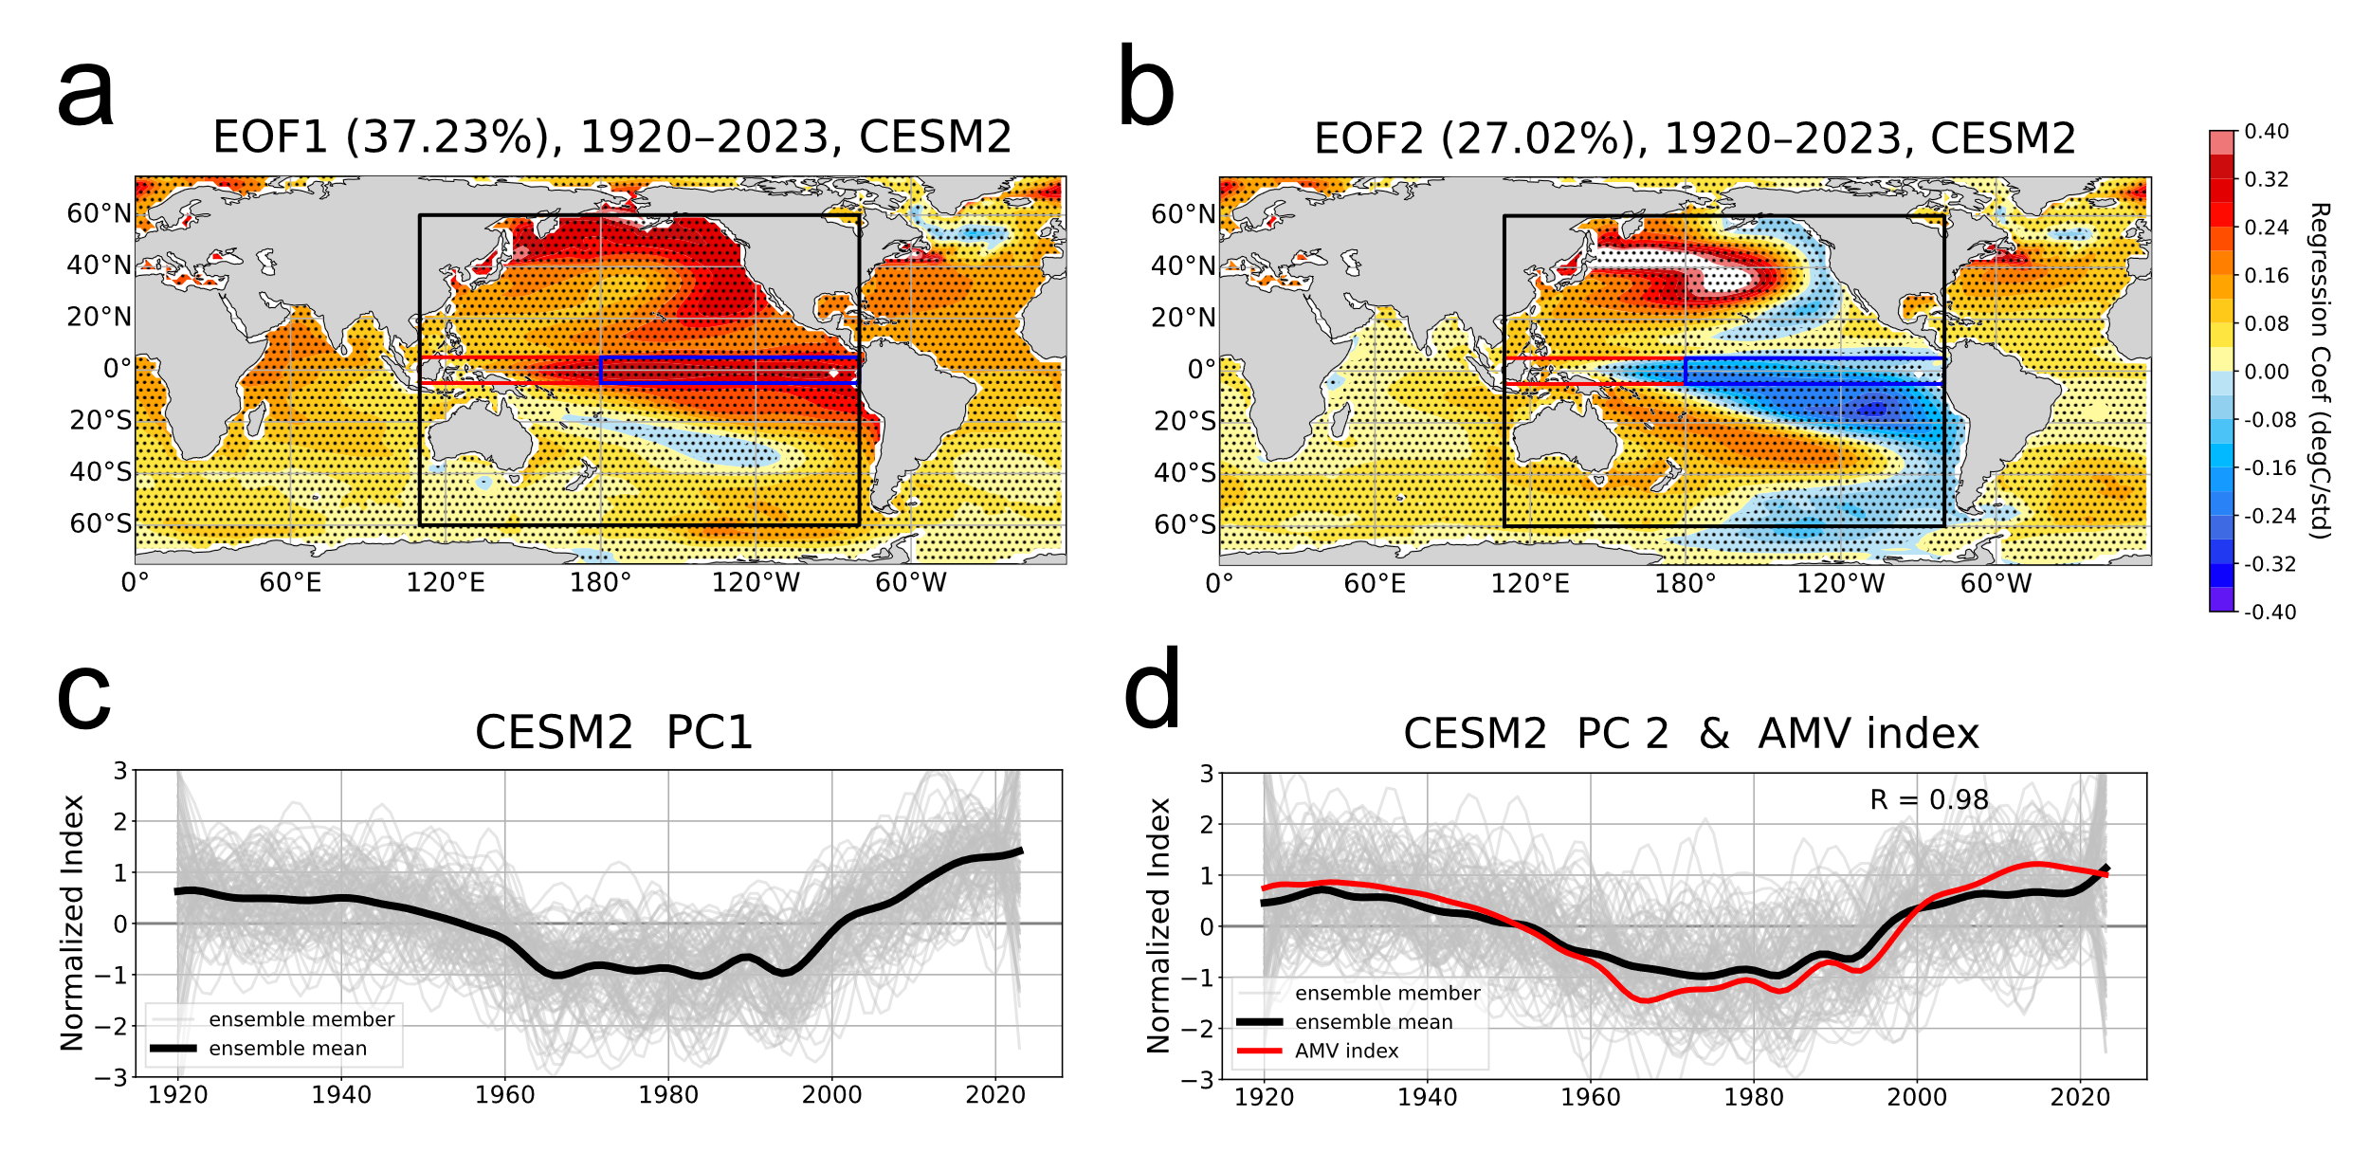
Supplementary Figure 8 | Leading patterns of low-frequency Pacific SST variability (1920–2023) in the CESM2 large ensembles.
Same as Fig. 3 but for CESM2.

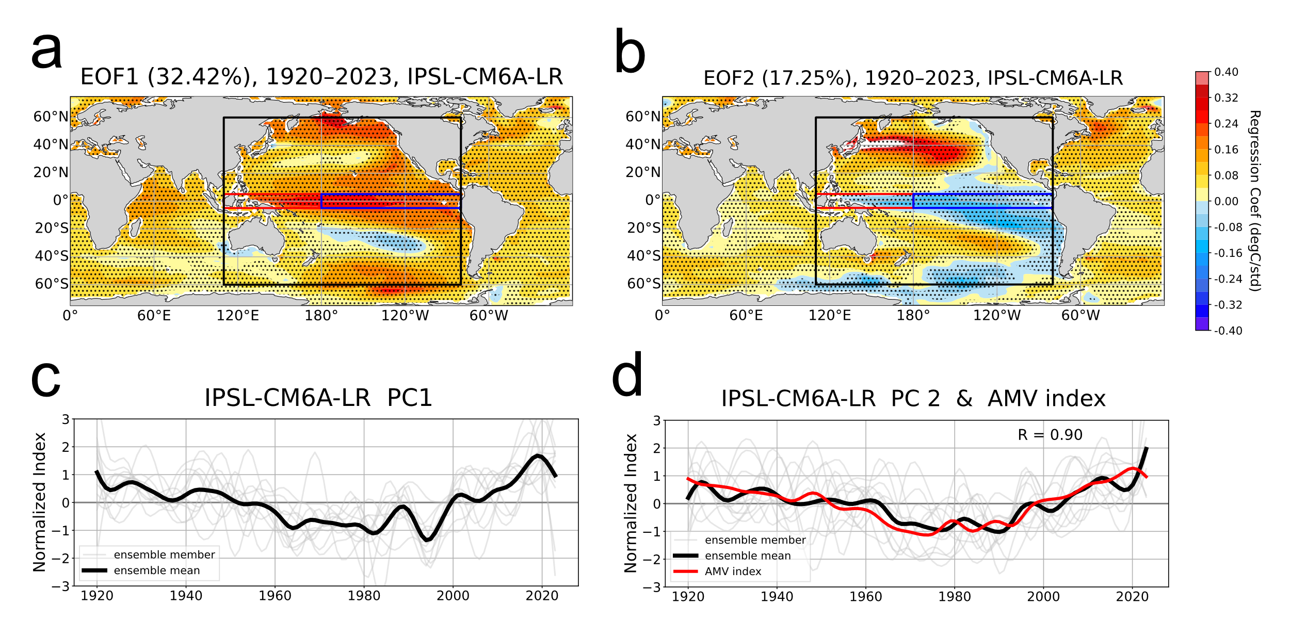
Supplementary Figure 9 | Leading patterns of low-frequency Pacific SST variability (1920–2023) in the IPSL-CM6A-LR large ensembles.
Same as Fig. 3 but for IPSL-CM6A-LR.

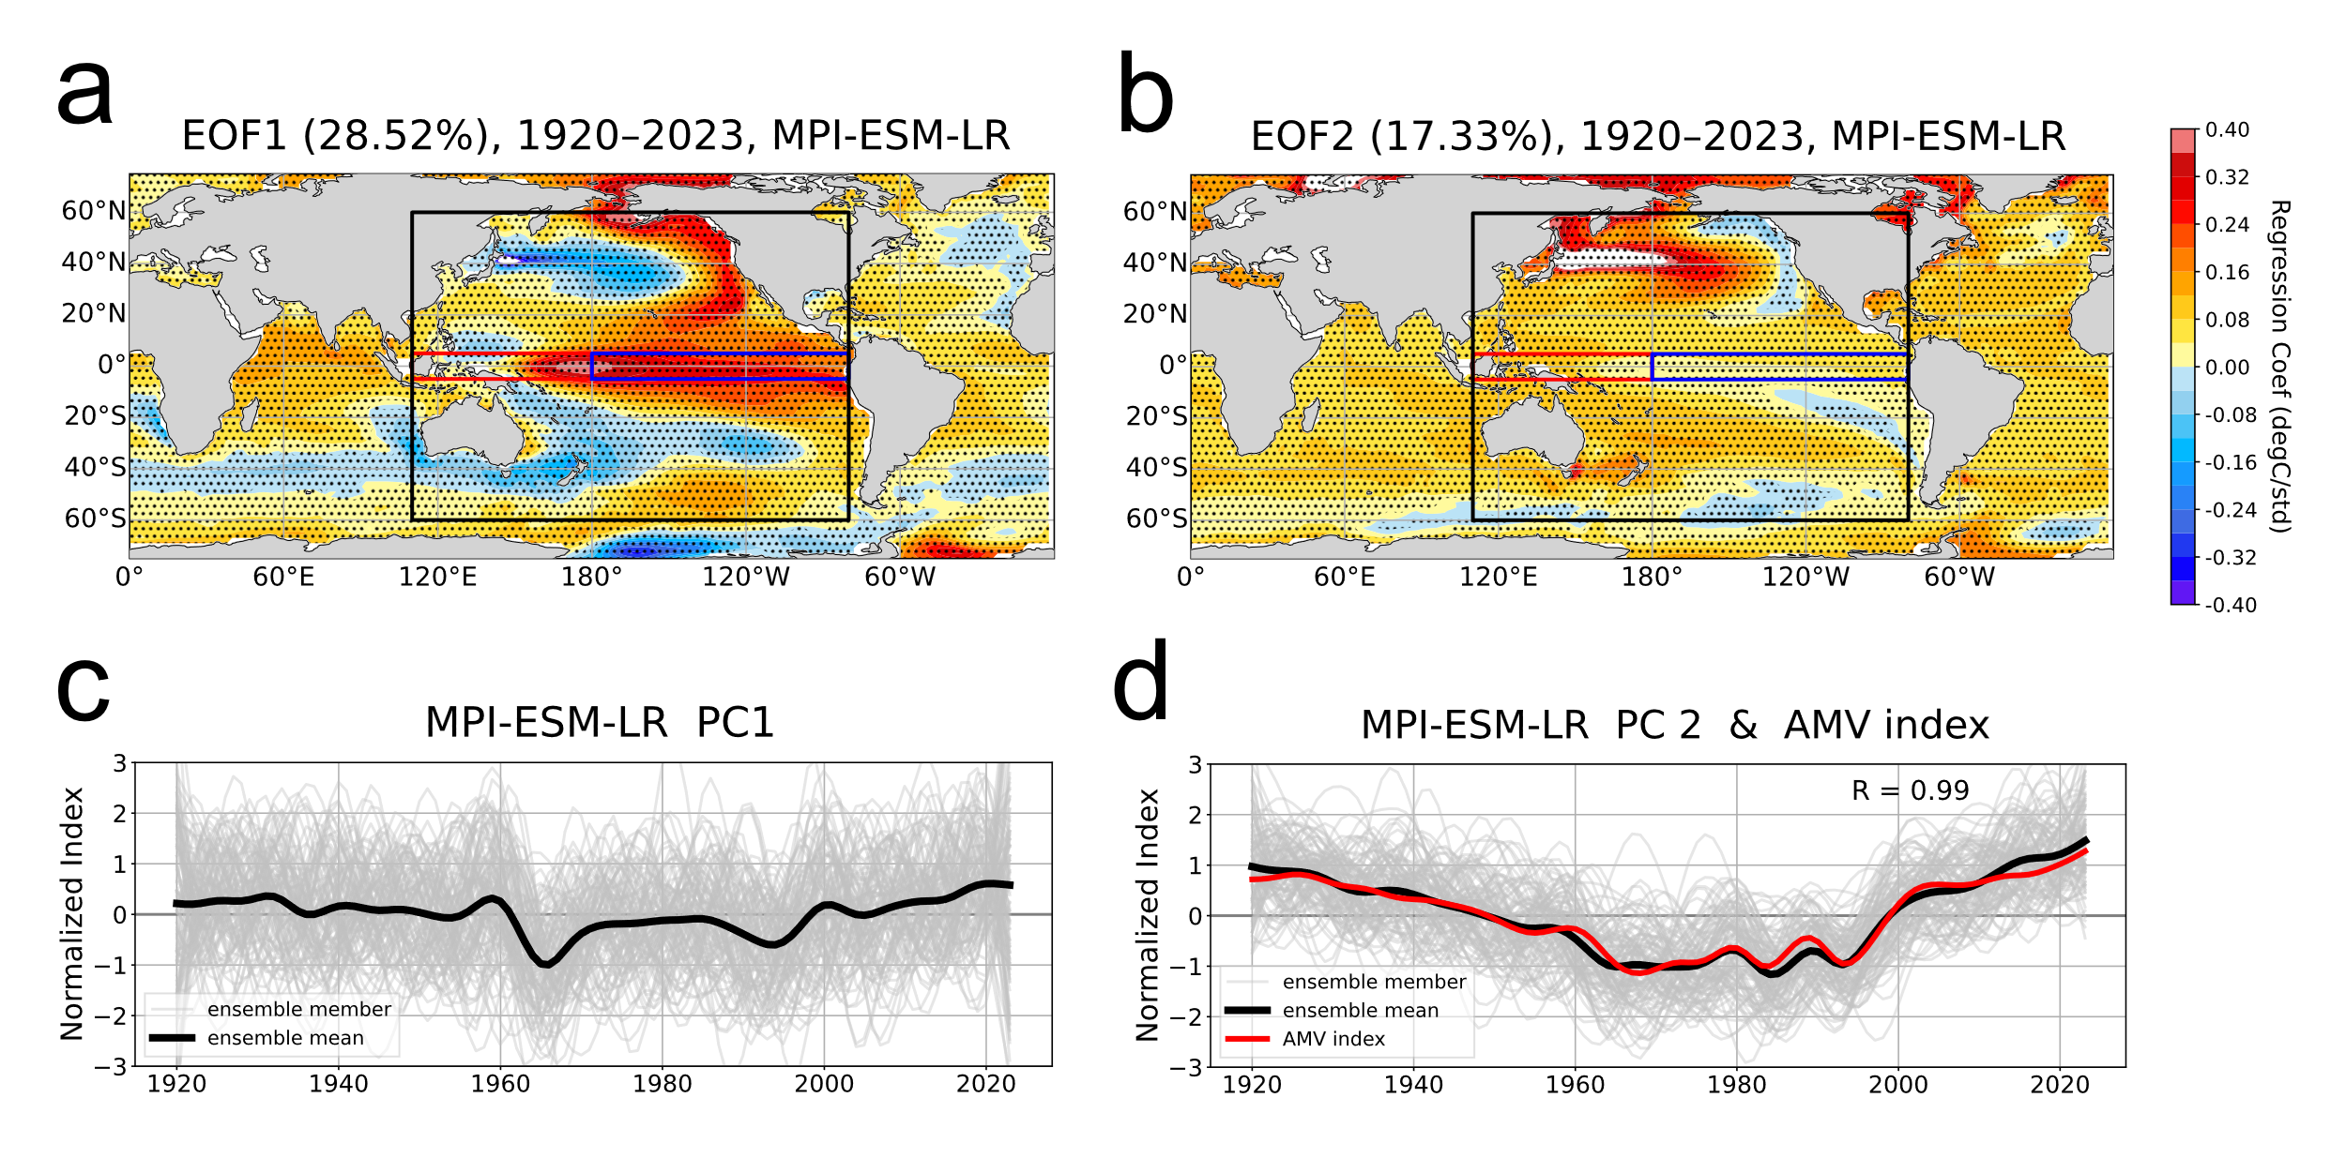
Supplementary Figure 10 | Leading patterns of low-frequency Pacific SST variability (1920–2023) in the MPI-ESM-LR large ensembles.
Same as Figure 3 but for MPI-ESM-LR.

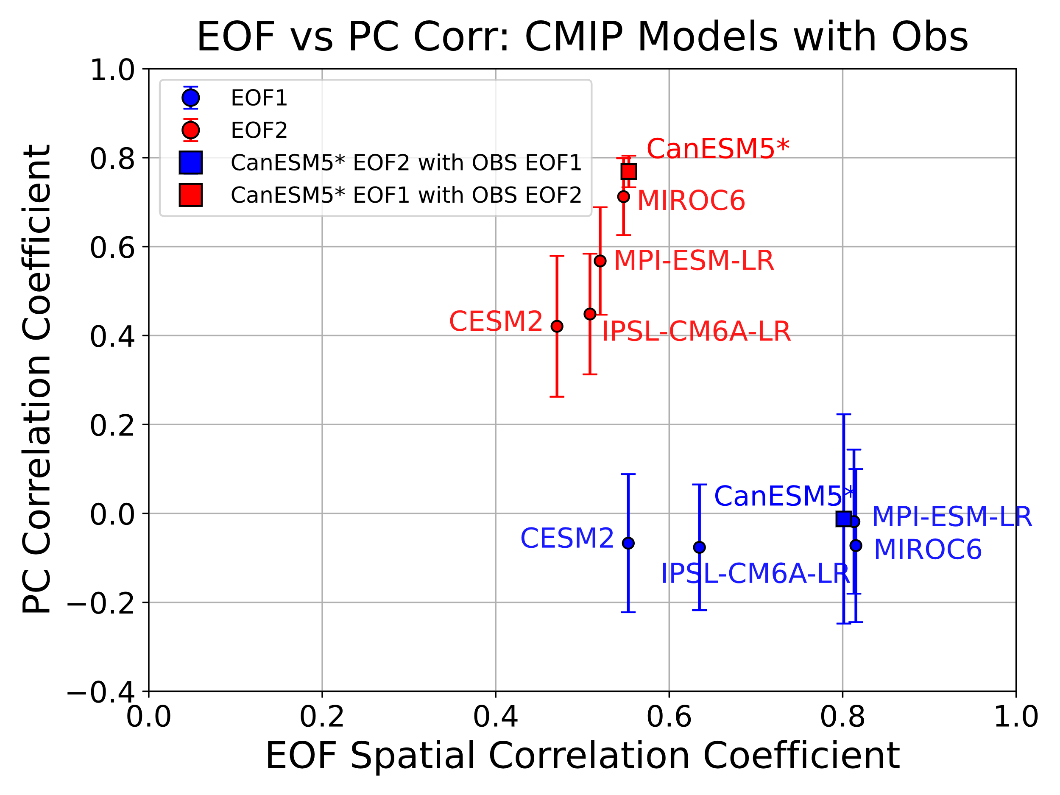
Supplementary Figure 11 | Spatial and temporal correlations between observed and simulated EOFs and PCs.
The x-axis is the spatial correlation between an EOF pattern from each CMIP large ensemble and the corresponding pattern from ERSSTv5, while the y-axis shows the correlation between their PC time series. Blue symbols are for the EOF1 and PC1, and red symbols are for the EOF2 and PC2. In CanESM5 the two modes appear in the opposite order, so the filled squares show the correlations obtained after pairing the model’s EOF2 with the observed EOF1 (blue square) and the model’s EOF1 with the observed EOF2 (red square). Error bars indicate the ensemble spread.

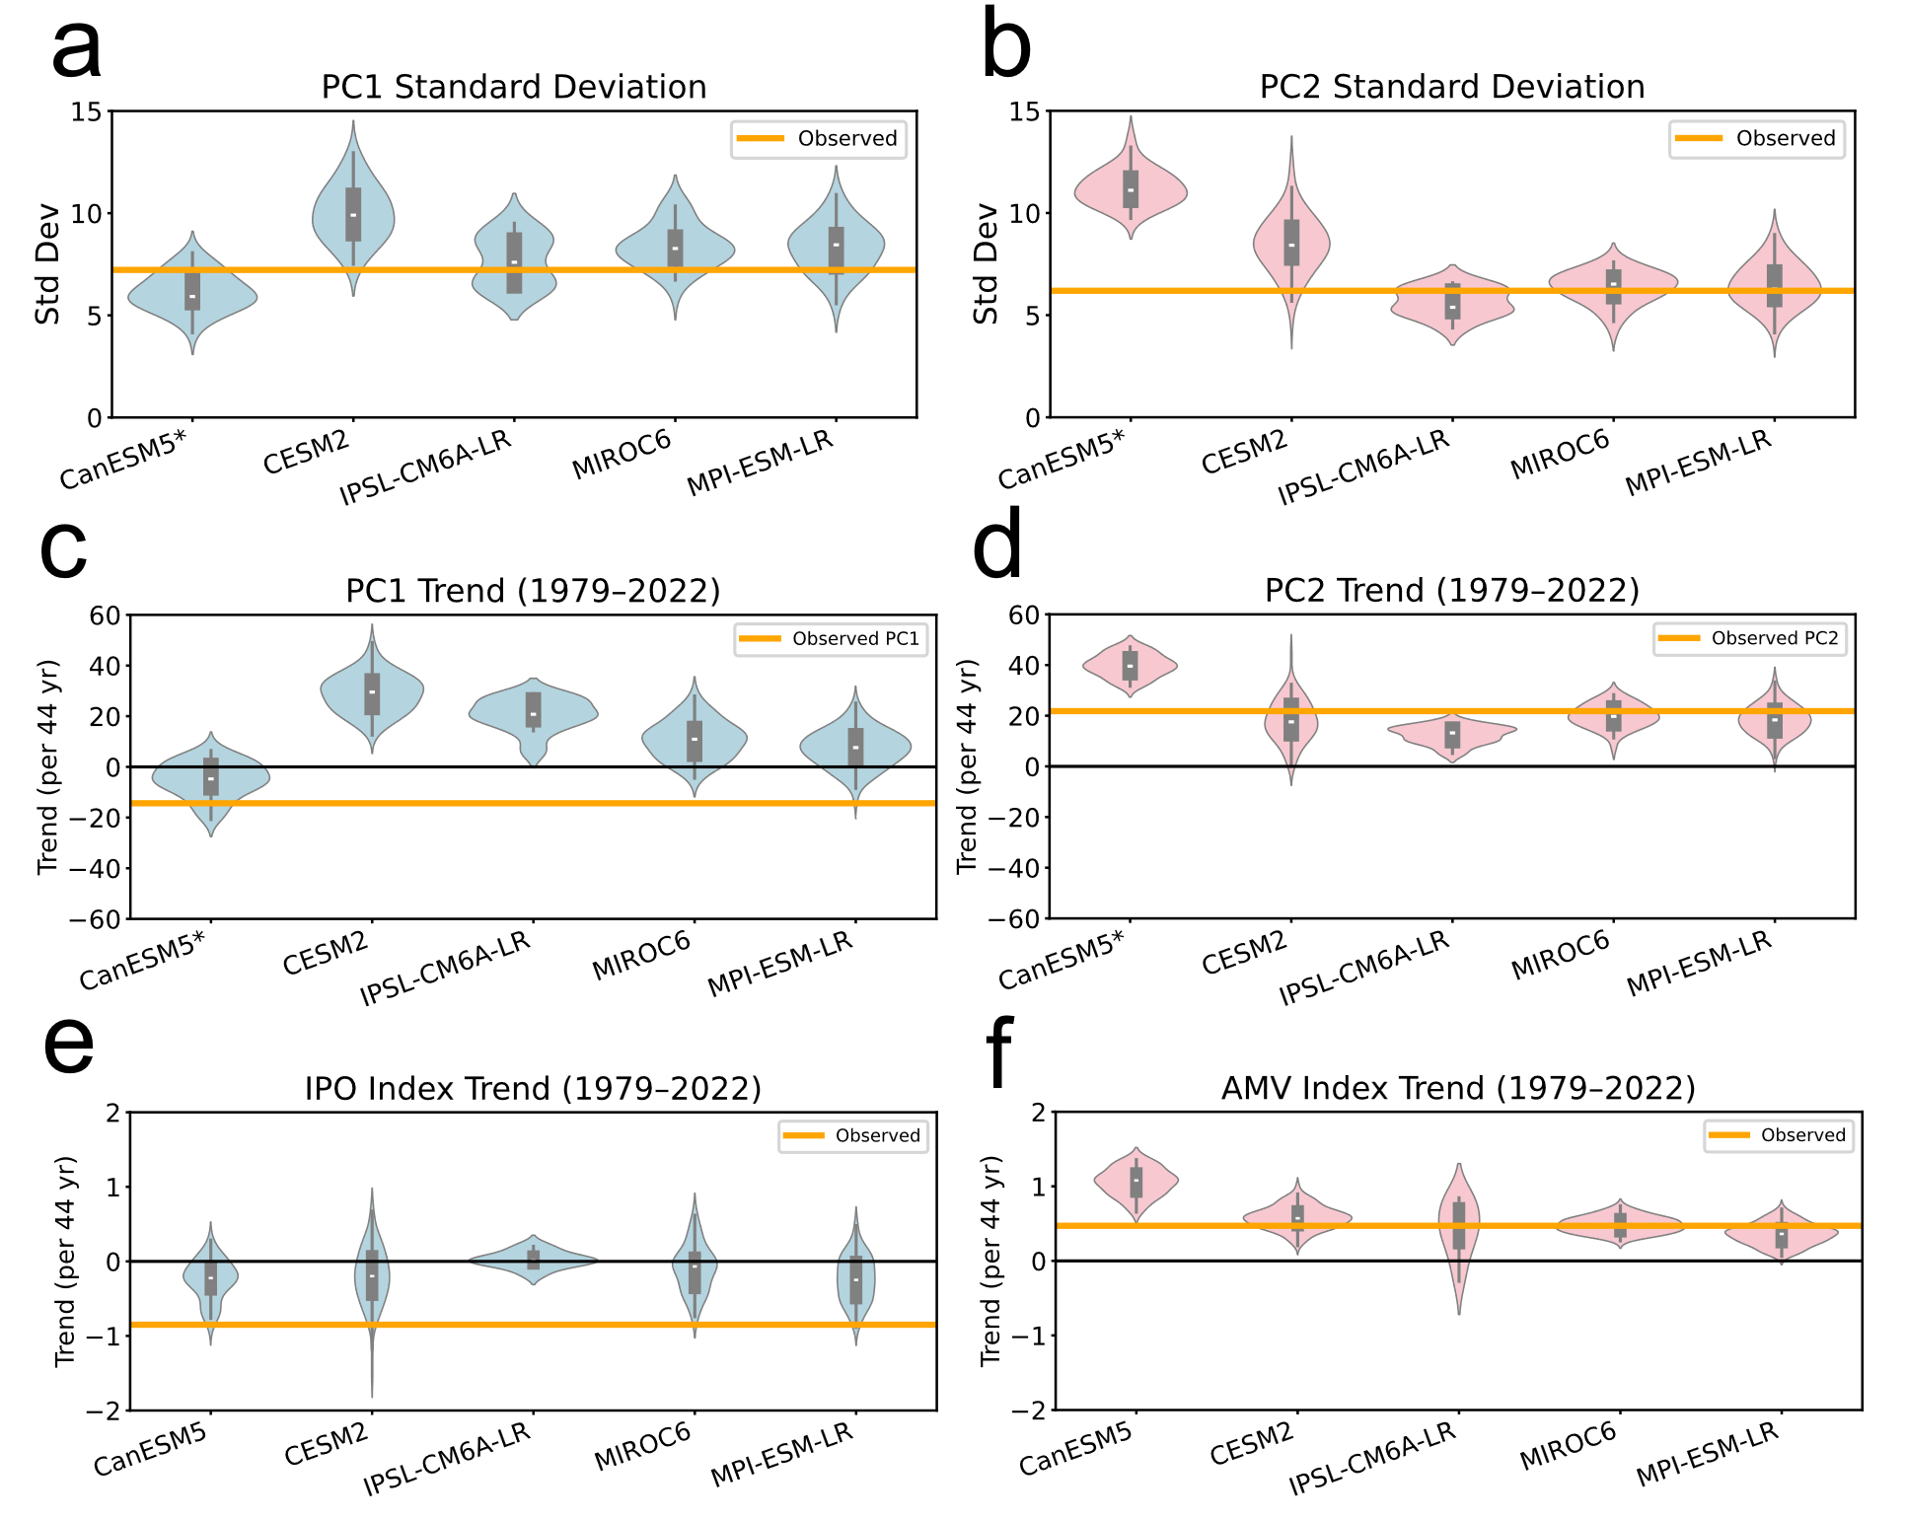

Supplementary Figure 12 | Amplitude of the IPO and AMV and trends for 1979–2022 in large ensembles.
Panels (a) and (b) show the standard deviation of the PC1 and PC2, respectively, computed from the full 1920–2023 time series. Panels (c) and (d) show the 1979–2022 linear trends of the PC1 and PC2. Panels (e) and (f) show the 1979–2022 linear trends of the TPI and AMV index, respectively. For each model ensemble, the violin plots depict the probability distribution, and the box and whisker indicate the ensemble range as in Fig. 5. The orange horizontal line shows the observed value. Note: For CanESM5, PC1 and PC2 are swapped in panels (a–d) to match the physical interpretation that PC1 represents the IPO and PC2 stands for the AMV-related pattern; this swap does not apply to the actual TPI and AMV indices shown in panels (e–f).
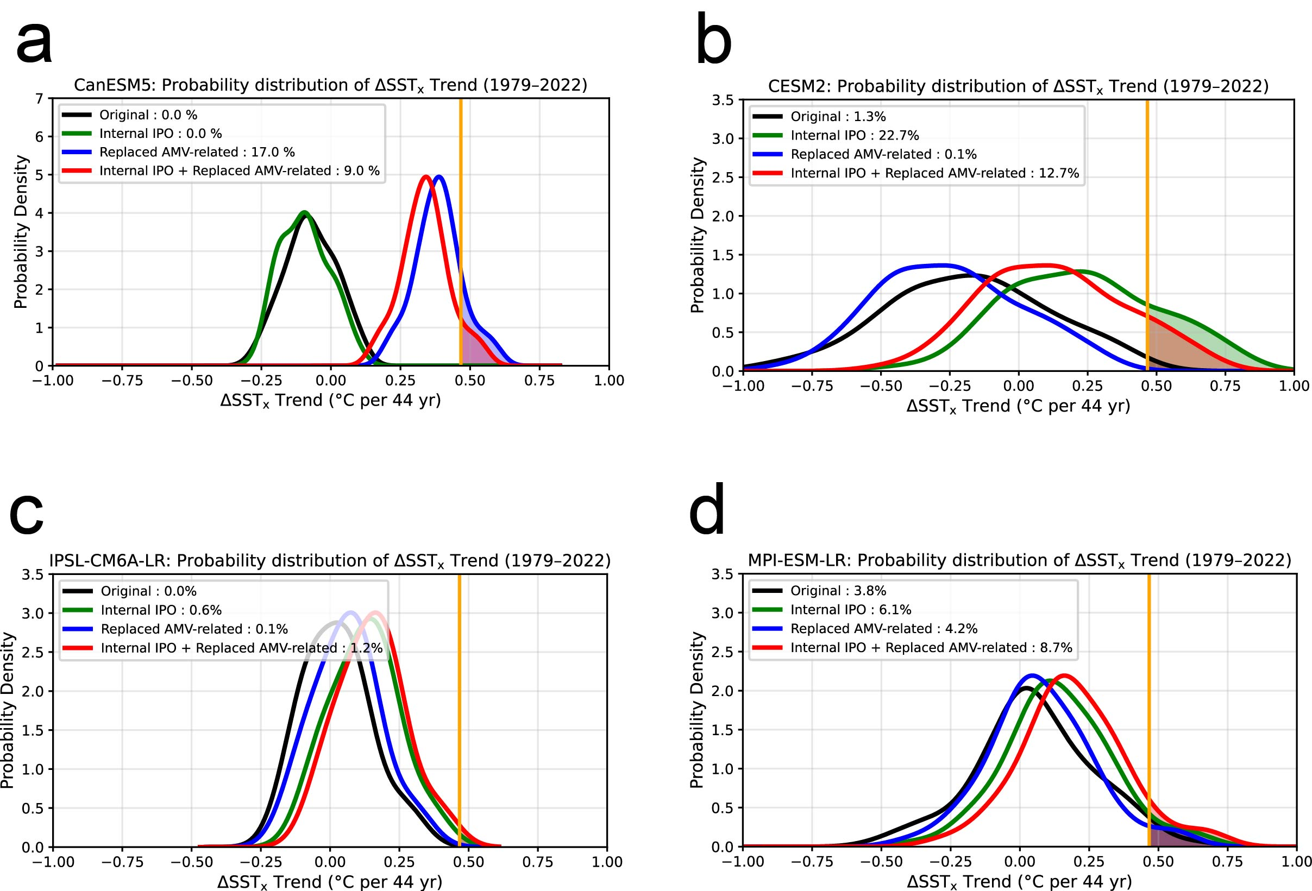

Supplementary Figure 13 | Probability distributions of the 1979–2022 equatorial-Pacific zonal SST-gradient trend (ΔSST_{x}) in four CMIP large ensembles.
Same as Fig. 4 but for (a) CanESM5, (b) CESM2, (c) IPSL-CM6A-LR, and (d) and MPI-ESM-LR.

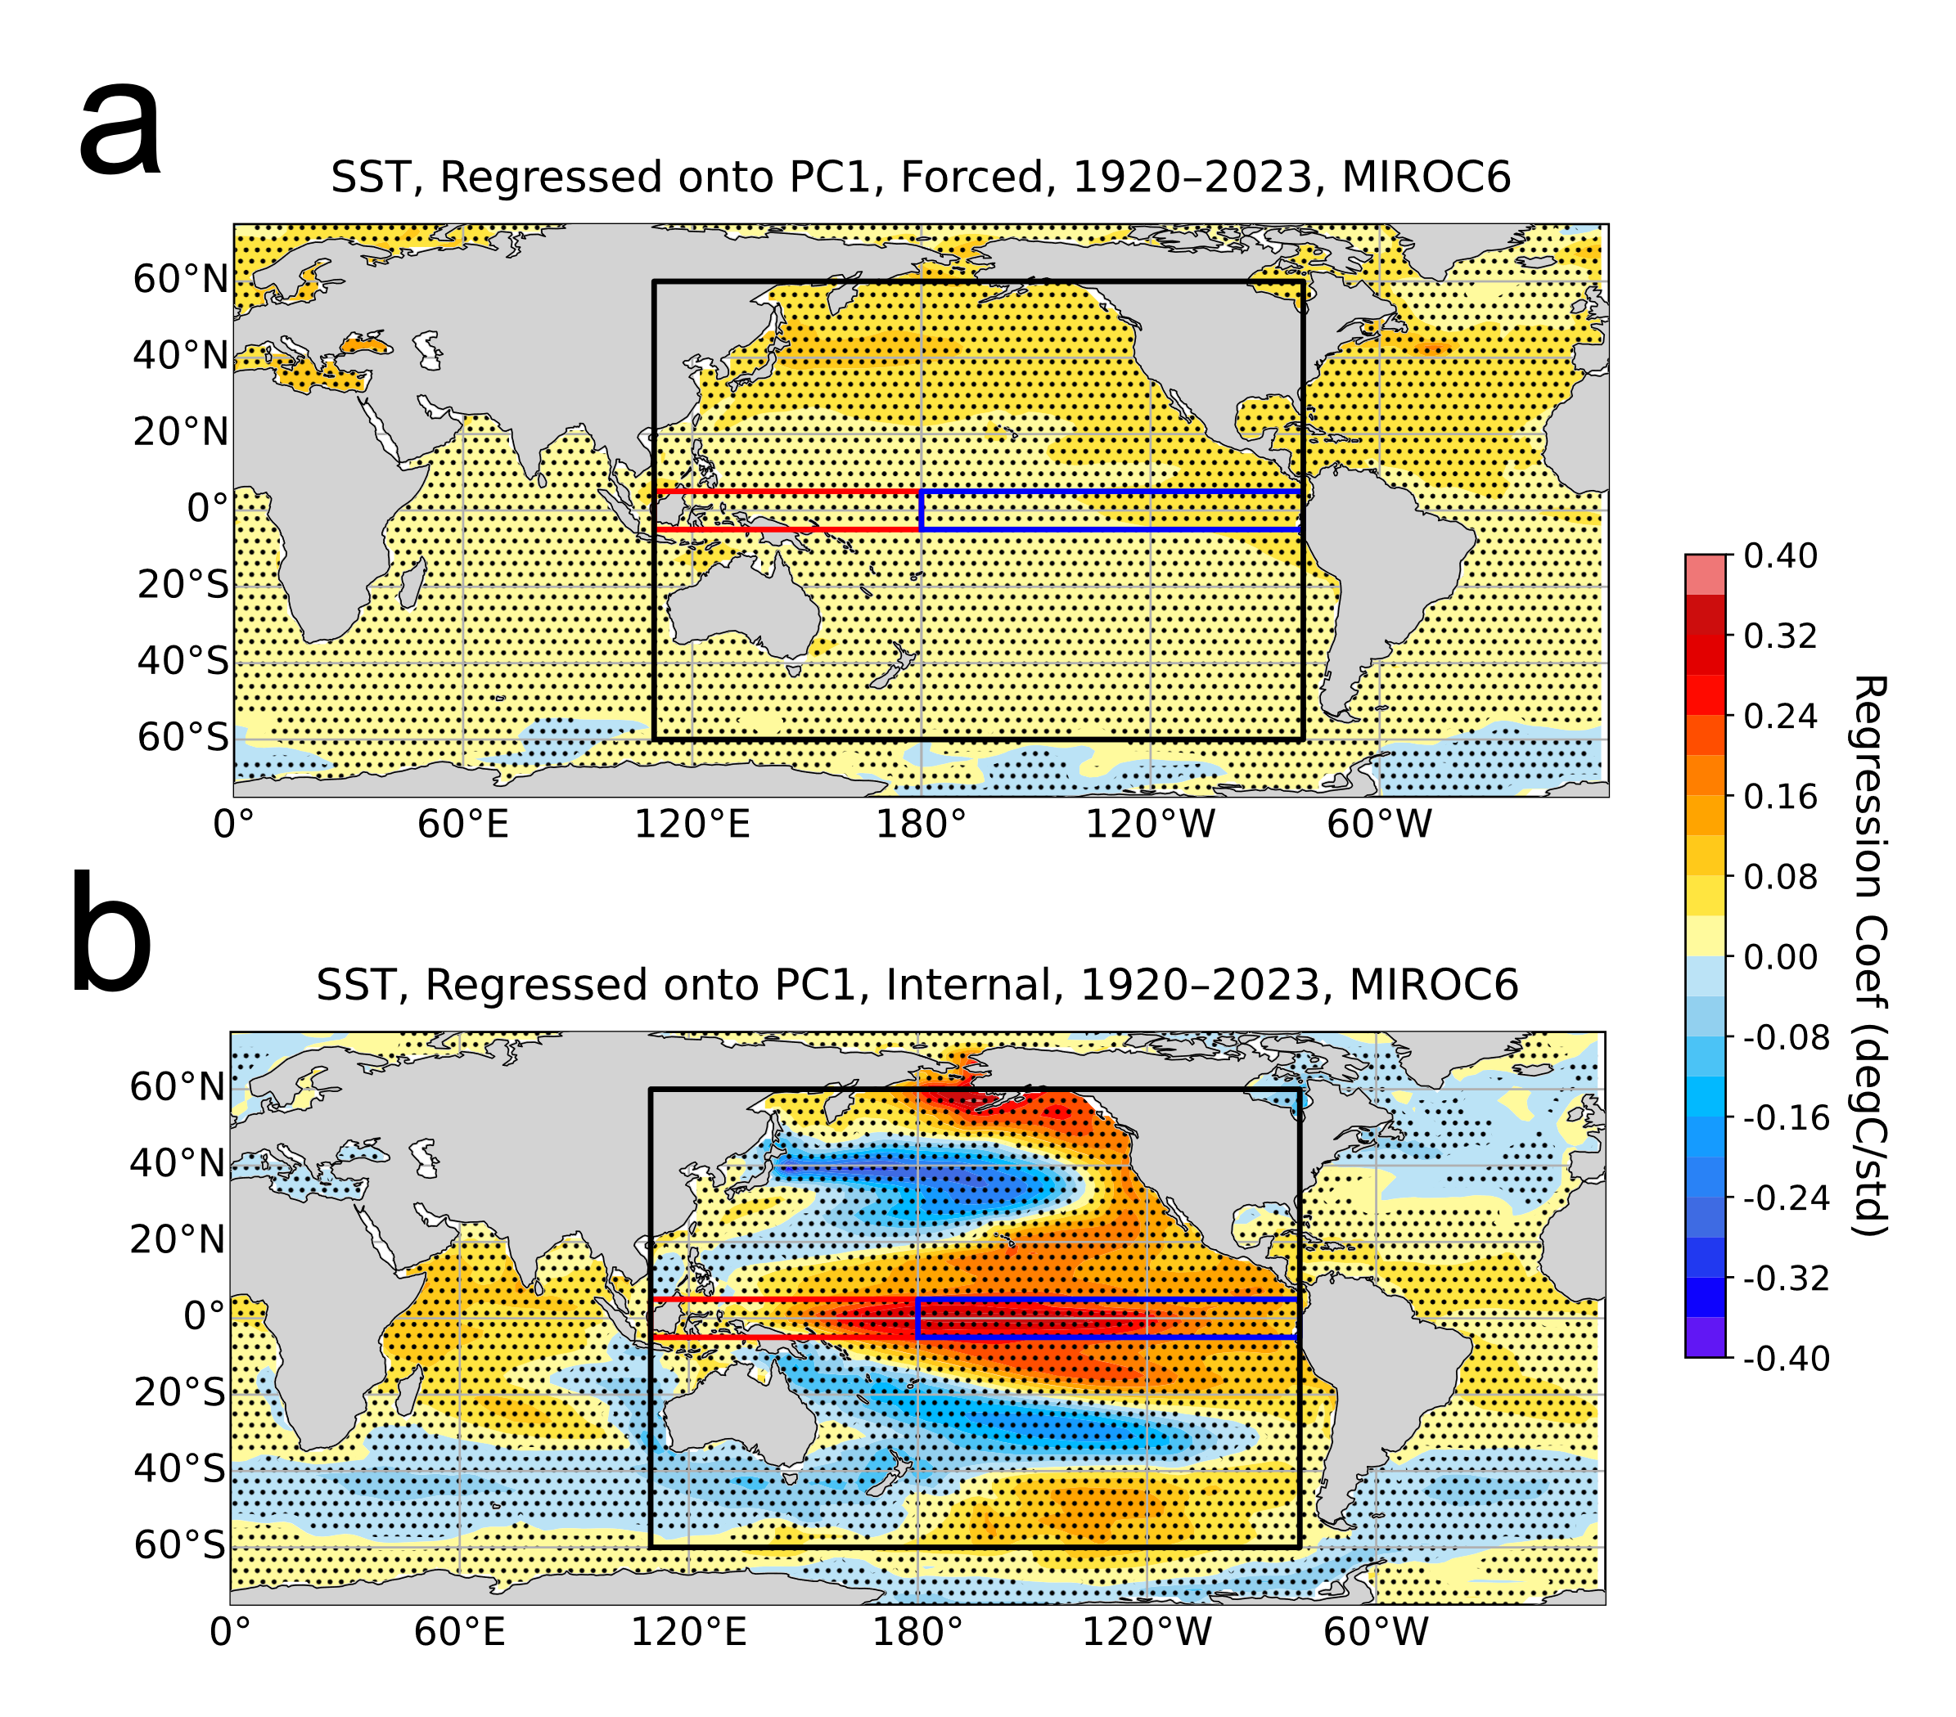

Supplementary Figure 14 | Decomposition of regression map of Pacific SST onto PC1 in the MIROC6 large-ensemble simulations.
(a) Regression of ensemble-mean SST anomalies (1920–2023) onto the ensemble-mean PC1, representing the forced component, from the MIROC6 large ensemble. (b) As in (a), but using deviations from the ensemble mean for both SST and PC1, representing the internal component.
Stippling indicates regions where the regression coefficient is statistically significant at the 95 % confidence level (p < 0.05). The total regression pattern is shown in Figure 3a.

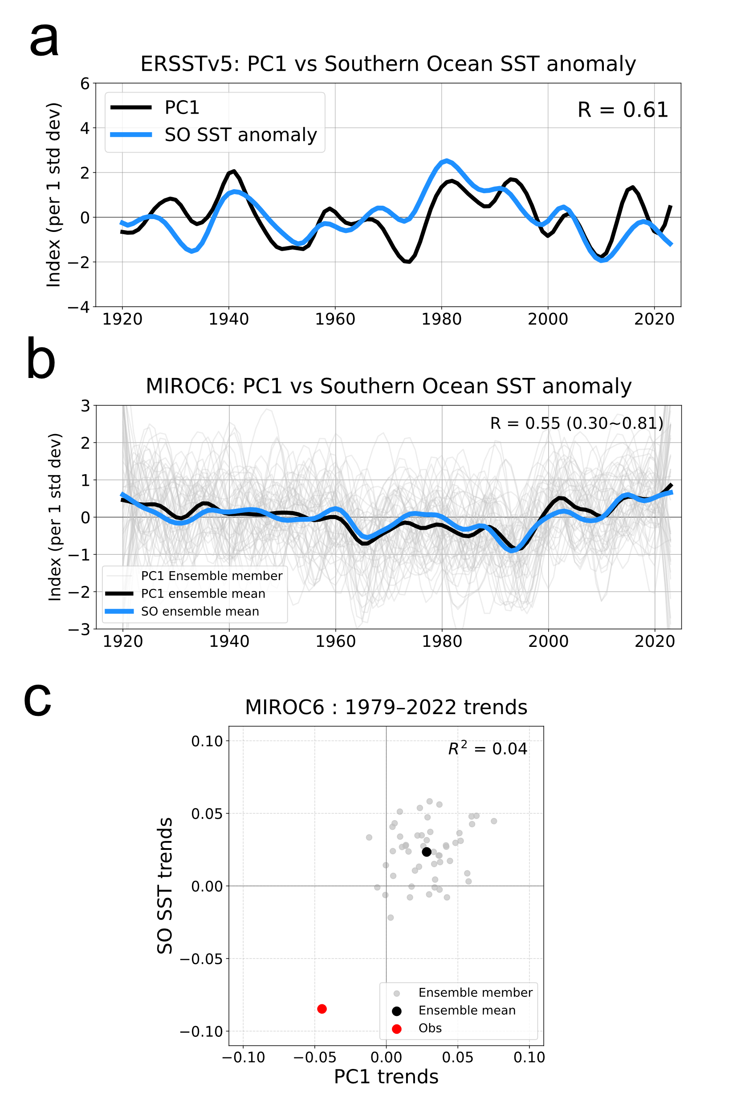
Supplementary Figure 15 | Link between Pacific PC1 and Southern Ocean SST anomaly.
(a) 10-year low-pass filtered Southern Ocean (SO; 75°S–45°S, 110°E–280°E) SST anomaly (black) and PC1 from ERSSTv5 (blue) for 1920–2023. The correlation coefficient is r = 0.61. (b) Same as (a), but for the MIROC6 large ensemble. Grey lines show PC1 of individual members; black and blue lines are the ensemble means of PC1 and SO SST anomaly, respectively. The average correlation between PC1 and SO SST anomaly across members is r = 0.55, ranging from 0.30 to 0.81. (c) Trends of PC1 and SO SST anomaly over 1979–2022 for each MIROC6 member (grey), ensemble mean (black), and ERSSTv5 (red). The inter-member squared correlation is R² = 0.04.

Supplementary Table 1 | The observed trends in the WP SST, EP SST, and ΔSST_{x} for 1979–2022.
The table compares the contributions of EOF1, EOF2, and their combination (EOF1+EOF2) to the trends (°C per 44 years). The numbers in the parenthesis in the rightmost column represent the fractional percentages against the original SST trends.

ERSSTv5 | WP | EP | Zonal gradient  WP - EP
EOF1 | -0.11 | -0.32 | 0.22 (46%)
EOF2 | 0.28 | 0.13 | 0.15 (32.7%)
EOF1+ EOF2 | 0.58 | 0.17 | 0.40 (86.3%)
All EOFs | 0.59 | 0.12 | 0.47 (99.9%)
Original SST trend | 0.59 | 0.1 | 0.47 (100%)

