Supplementary materials

Fig. S1 Quality overview of ONT reads and assembled genome of Arthrobacter sp. FMD, (a) ONT read length distribution plot; (b) genome assembly assessment.

Table S1 General properties and statistics of Arthrobacter sp. FMD genome.
Features | Description
Length | 4050930
Count | 4
GC | 64.1
N50 | 3882188
N90 | 3882188
N ratio | 0.0
coding density | 88.0
tRNAs | 71
tmRNAs | 1
rRNAs | 19
ncRNAs | 2
ncRNA regions | 24
CRISPR arrays | 0
CDSs | 3726
pseudogenes | 7
hypotheticals | 388
sORFs | 3
gaps | 0
oriCs | 1
oriVs | 0
oriTs | 0

Super DNA Marker（CW2583M）
DC 150V 1h
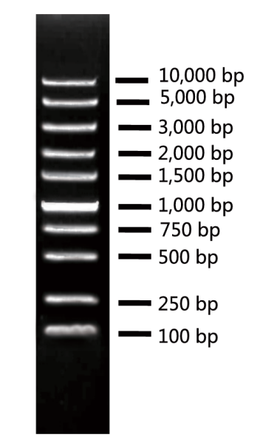
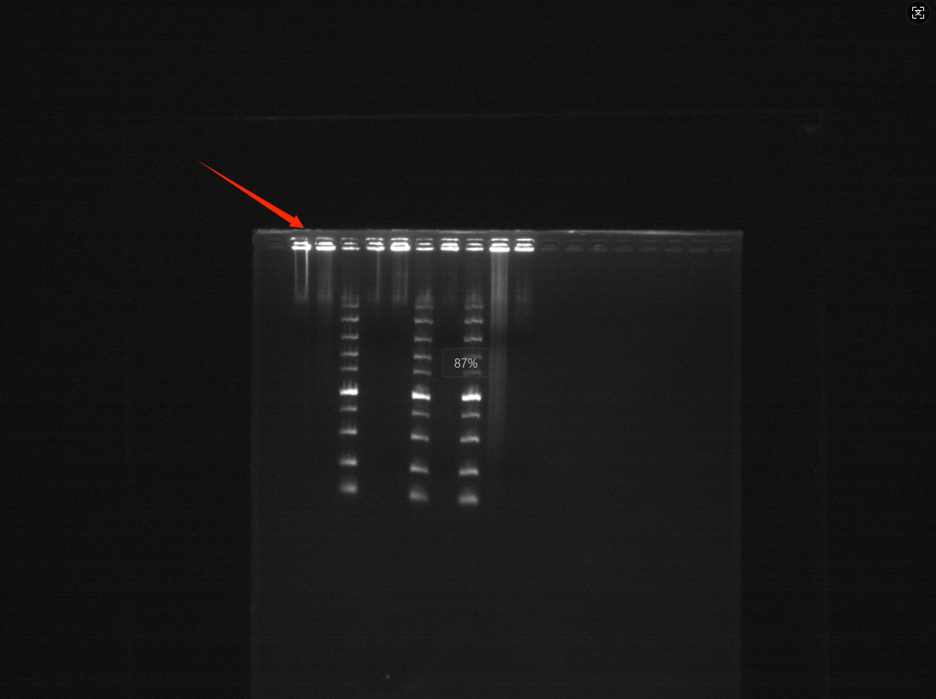
Fig. S2 Agarose gel electrophoresis. DNA samples were analysed by 0.7 % agarose pulsed-field gel electrophoresis (PFGE). Lane numbers are indicated above each well. M: Super DNA Marker (CW2583M). Lane 2 corresponds to the DNA sample used in this study. Each sample was loaded at 200 ng, as quantified by Qubit.

