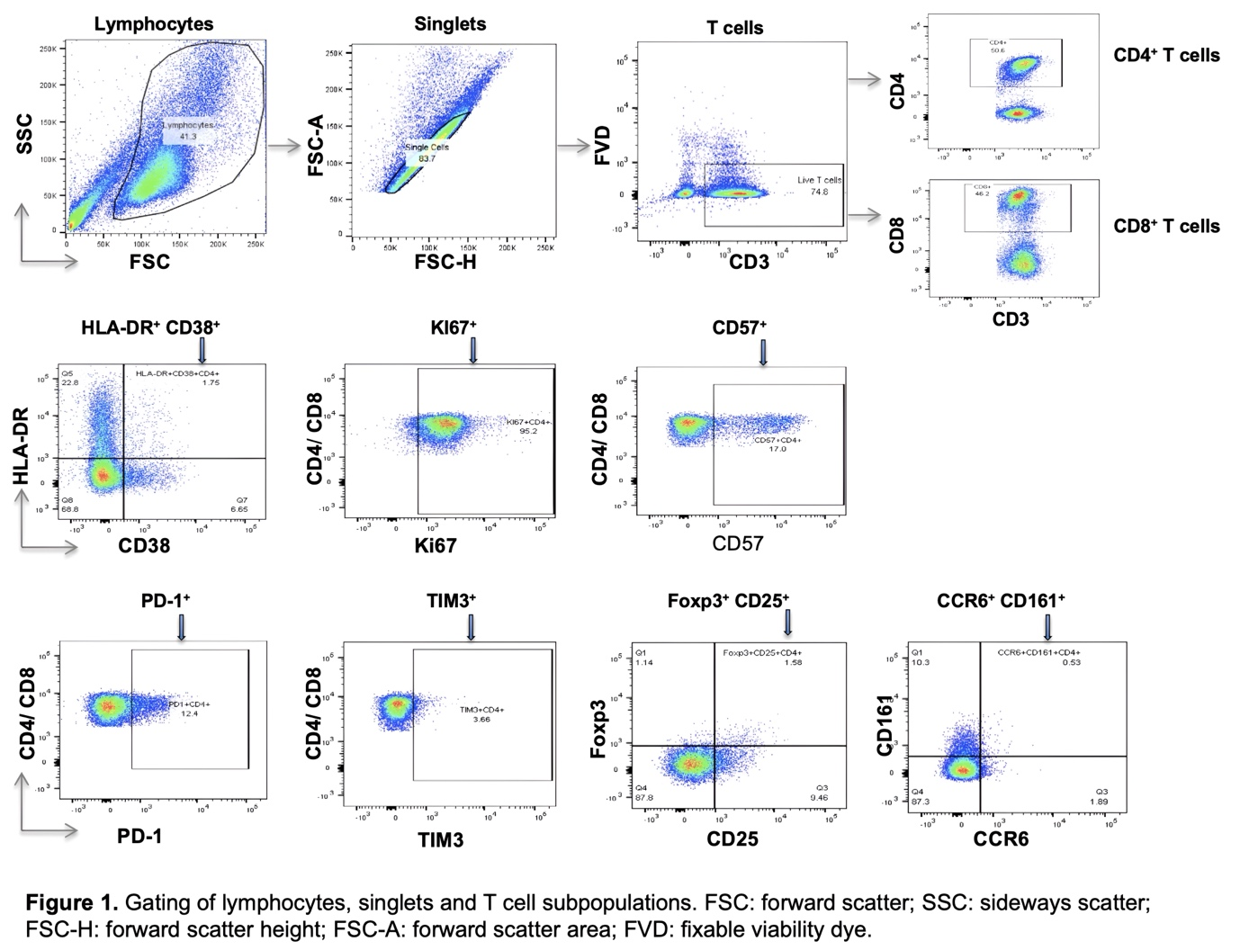
Supplementary Fig. 1. Gating of lymphocytes, singlets and T cell subpopulations. FSC: forward scatter; SSC: sideways scatter; FSC-H: forward scatter height; FSC-A: forward scatter area; FVD: fixable viability dye.

