Statistical Test Results Data

Figures and tables of statistical test calculation results using SmartPLS version 3.0 in Obstacles and Benefits: Understanding the Low Utilization of NCD IHSP by Workers in Industrial Estates with the Health Belief Model Theory Approach.

The first step in testing the data is to perform an external loading test to obtain each indicator’s loading factor (LF) value against its variable. The results are shown in the following image:
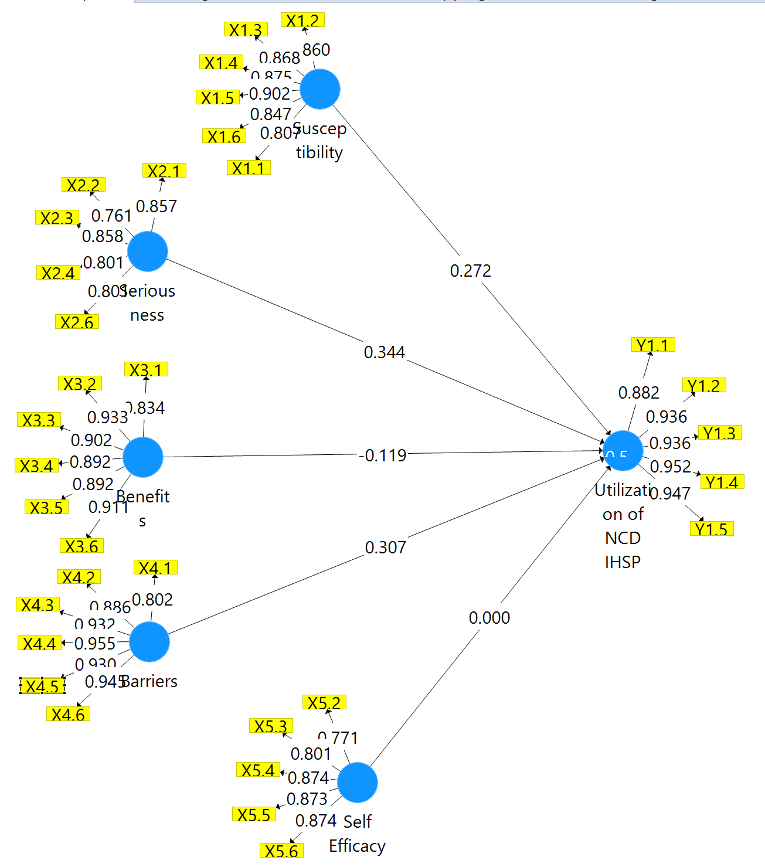

Figure 1. Outer Model testing to see the loading factor of all indicators >0.7

The image explains that all indicators have met the set criteria (>0.7), so based on these values, it can be explained that the existing indicators have reflected their respective variables.

Next, entering the second stage of testing, which is a calculation to obtain the reliability and validity values of the model, namely Cronbach’s alpha (ca), composite reliability (cr), and average variance extracted (ave) values, where if the values of ca and cr >0.7 mean good and consistent reliability, while if ave>0.5 means valid. The results are shown in table 1 below.

Table 1 Construct Reliability and Validity Results
 | Cronbach’s Alpha | rho_A | Composite Reliability | Average Variance Extracted (AVE)
Barriers | 0,958 | 0,959 | 0,966 | 0,828
Benefits | 0,950 | 0,956 | 0,960 | 0,800
Self Efficacy | 0,898 | 0,918 | 0,923 | 0,705
Seriousness | 0,877 | 0,913 | 0,909 | 0,667
Susceptibility | 0,930 | 0,933 | 0,945 | 0,740
Utilization of NCD IHSP | 0,961 | 0,963 | 0,970 | 0,866

Table 1 above shows that the results of the reliability and validity calculations obtained show that the constructed model in this study has excellent internal consistency and convergent validity so that it can be used for further analysis in this study.

Table 2 R-Squares Values

 | R Square | R Square Adjusted
Utilization of NCD IHSP | 0,520 | 0,513

Table 2 above, namely the results of the calculation of R Square and R Square Adjusted in the analysis using SmartPLS, shows that the tested model has a relatively good level of compatibility in explaining the variance of the dependent variable Utilization of NCD IHSP. An R-Square value of 0.520 indicates that about 52% of the variance in the Utilization of NCD IHSP can be explained by the independent variables involved in the model. This statistical result shows that the model used has a relatively moderate predictive power in explaining the factors affecting NCD IHSP use.

F-Square (f²) measures the effect or strength of influence of an independent variable on a dependent variable in a structural model. This f-squared value is used to assess the magnitude of the influence or contribution of changes in independent variables to changes in dependent variables, as described in the table below.

Table 3 Value of f-squares

 | Barriers |  | Benefits |  | Self Efficacy |  | Seriousness |  | Susceptibility |  | Utilization of NCD IHSP
Barriers |  |  |  |  |  |  |  |  |  |  | 0,054
Benefits |  |  |  |  |  |  |  |  |  |  | 0,011
Self Efficacy |  |  |  |  |  |  |  |  |  |  | 0,000
Seriousness |  |  |  |  |  |  |  |  |  |  | 0,140
Susceptibility |  |  |  |  |  |  |  |  |  |  | 0,053
Utilization of NCD IHSP

Table 3 above explains that the results of the f-square calculation show that Seriousness is the factor that has the most significant impact on the Utilization of NCD IHSP. At the same time, Barriers, Benefits, Self-efficacy, and Susceptibility make a more minor or insignificant contribution to the analyzed model.

Table 4 Path Coefficients in the inner model
 | Original Sample (O) | Sample Mean (M) | Standard Deviation (STDEV) | T Statistics (|O/STDEV|) | P Values
Barriers -> Utilization of NCD IHSP | 0,307 | 0,304 | 0,056 | 5,467 | 0,000
Benefits -> Utilization of NCD IHSP | -0,119 | -0,110 | 0,058 | 2,074 | 0,039
Self-Efficacy -> Utilization of NCD IHSP | 0,000 | 0,002 | 0,040 | 0,002 | 0,998
Seriousness -> Utilization of NCD IHSP | 0,344 | 0,344 | 0,040 | 8,584 | 0,000
Susceptibility -> Utilization of NCD IHSP | 0,272 | 0,268 | 0,062 | 4,386 | 0,000

From Table 4, it can be concluded that the results of the calculation of Path Coefficients in the inner model obtained from the SmartPLS analysis illustrate the direct relationship between the constructs in this study model and their influence on the Utilization of NCD IHSP. This path coefficient describes the strength and direction of the relationship between independent and dependent variables in the model.
Barriers showed a path coefficient value of 0.307 with a T Statistics of 5.467 and a P-Value of 0.000, which is very significant (P < 0.05). This table shows that barriers have a significant positive influence on the utilization of NCD IHSP. In other words, the greater the obstacles felt, the greater the possibility of using NCD IHSP.
Benefits have a path coefficient value of -0.119 with a T Statistics of 2.074 and a P-Value of 0.039, which is also significant (P < 0.05). Despite the adverse effect, these results show that Benefits have a significant but small effect on the Utilization of NCD IHSP, meaning that the greater the benefits felt, the less likely it is to use NCD IHSP.
Self-efficacy has a path coefficient value of 0.000 with a T Statistics of 0.002 and a P-Value of 0.998, which is insignificant (P > 0.05). This table shows that Self-efficacy has no effect on the Utilization of NCD IHSP, and its role in this model is minimal, not even statistically significant.
Seriousness showed a path coefficient value of 0.344 with a T Statistics of 8.584 and a P-Value of 0.000, which was very significant (P < 0.05). This table shows that Seriousness has a strong positive influence on the Utilization of NCD IHSP, meaning that the more serious the problem faced, the greater the likelihood of utilization of NCD IHSP.
Susceptibility has a path coefficient value of 0.272 with a T Statistics of 4.386 and a P-Value of 0.000, which is also significant (P < 0.05). This table shows that Susceptibility has a relatively strong positive influence on the Utilization of NCD IHSP, which means that the greater the level of vulnerability, the greater the likelihood of utilization of NCD IHSP.
Overall, the calculation results of these path coefficients show that Seriousness and Barriers have a significant and considerable influence on the Utilization of NCD IHSP, while Benefits provide a significant but more minor negative influence. Susceptibility also showed a significant positive influence, whereas Self-efficacy had no significant influence on this model. The final step is to look at the results of the model suitability test, as shown in the following table 5.

Table 5. Fitness Test Results of the Model

 | Saturated Model | Estimated Model
SRMR | 0,084 | 0,084
d_ULS | 3,981 | 3,981
d_G | 2,888 | 2,888
Chi-Square | 4686,181 | 4686,181
NFI | 0,717 | 0,717

The results of calculating the fit model in the analysis using SmartPLS showed that the tested model had a good fit based on several indices used to measure the fit model (fit model). Some of the leading indices to look out for include SRMR (Standardized Root Mean Square Residual), d_ULS (Unweighted Least Squares Distance), d_G (Geodesic Distance), Chi-Square, and NFI (Normed Fit Index).
SRMR is one of the indices used to assess how well the generated model matches the observed data. The SRMR value in this model is 0.084, which is lower than the generally accepted threshold value of 0.08. This table indicates that the model has a good fit because the smaller the SRMR value, the better the model’s fit with the data.
d_ULS and d_G describe the fit between the estimated model and the actual data. These two values, namely d_ULS 3.981 and d_G 2.888, did not change between the saturated and estimated models, indicating that the model was consistent and stable in explaining the data.
Chi-Square is also an important indicator in measuring the model’s goodness-of-fit, with a value of 4686.181 in both models (saturated and estimated). Although there is no change between the two models, a high Chi-Square value can often indicate that the tested model is a good fit when compared to the degree of freedom and significance values.
The NFI (Normed Fit Index) on this model has a value of 0.717, which indicates that the model has a moderate match with the existing data. An NFI value above 0.7 indicates that this model is acceptable, although there is room for improvement.
Overall, the fit model calculation results show that the model used in the analysis matches the existing data, with most indicators showing values that match the standard of fit model evaluation in SmartPLS-based studies. However, an NFI value that is slightly below the ideal value may indicate the potential for improvements that can be made to the model to achieve a more optimal fit.

