Profiler: A Next-Generation Platform for Streamlined Omics Data Analysis
Yanis Zirem¹, Léa Ledoux¹, Isabelle Fournier^{1,2}, Michel Salzet^{1,2}
¹Univ. Lille, Inserm, CHU Lille, U1192 - Protéomique Réponse Inflammatoire Spectrométrie de Masse – PRISM, F-59000 Lille, France
²Institut Universitaire de France (IUF), Paris, France

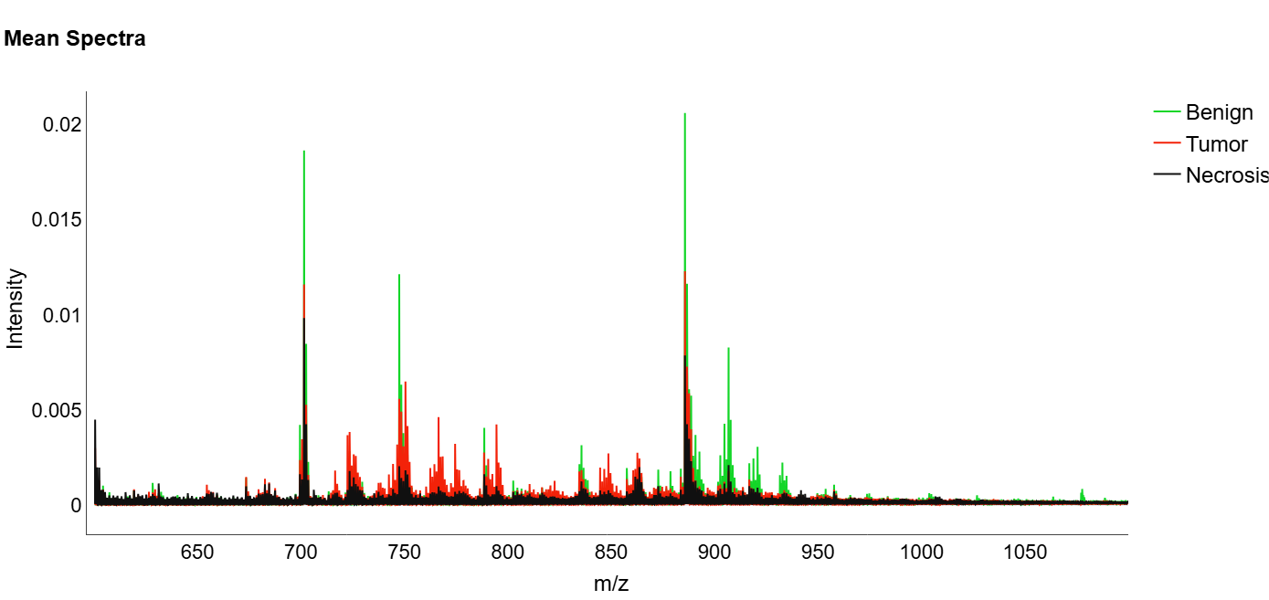
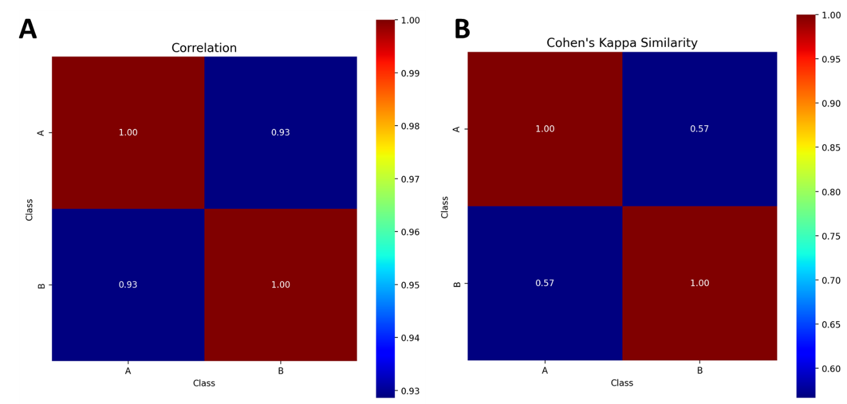
Figure S1. Display of a mean mass spectrum acquired using a conventional mass spectrometer (from Waters), showing intensity profiles across m/z for three tissue types: benign, tumor, and necrotic.
Figure S2. Results using the correlation and similarity module of Profiler. A) Spearman correlation matrix and B) Cohen’s kappa Similarity matrix with 6 discretization levels.

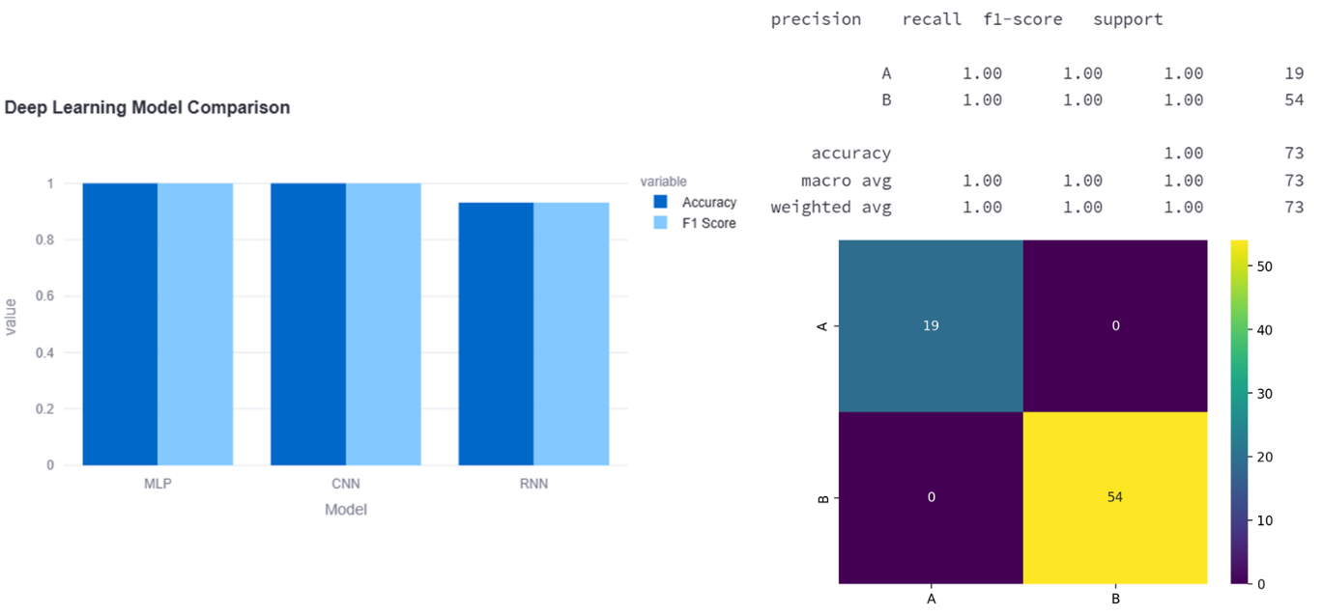
Figure S3. Deep Learning results where three model accuracies are compared, classification metrics and the confusion matrix for the best-performing model is detailed

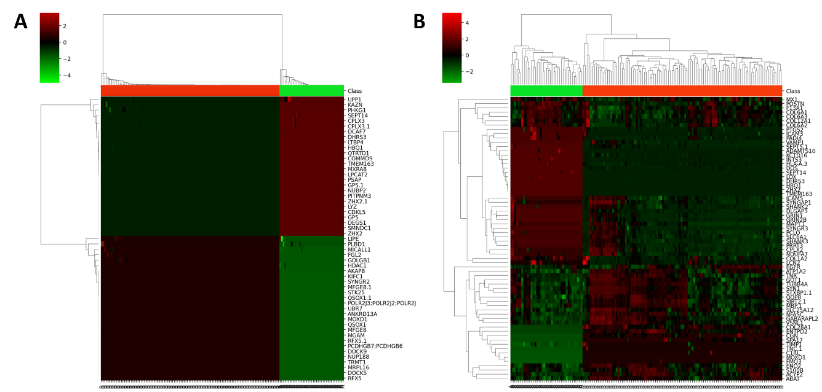
Figure S4. Heatmap made with a p-value of 0.01 based on A) volcano plot biomarkers or B) AI explainaibility biomarkers.

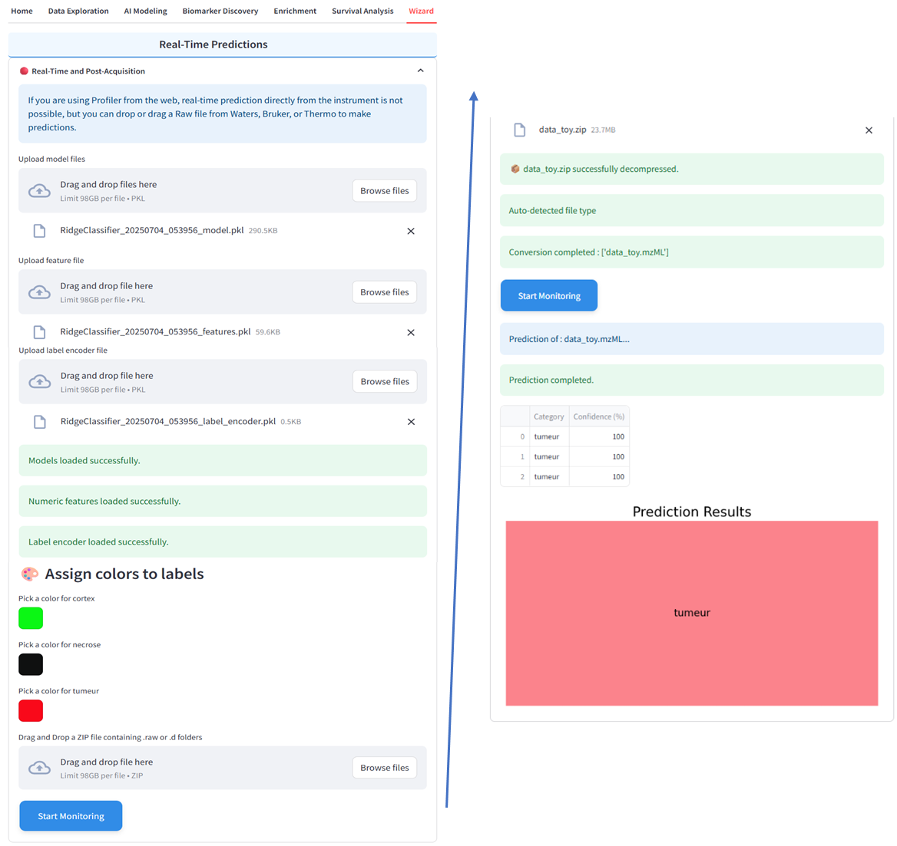
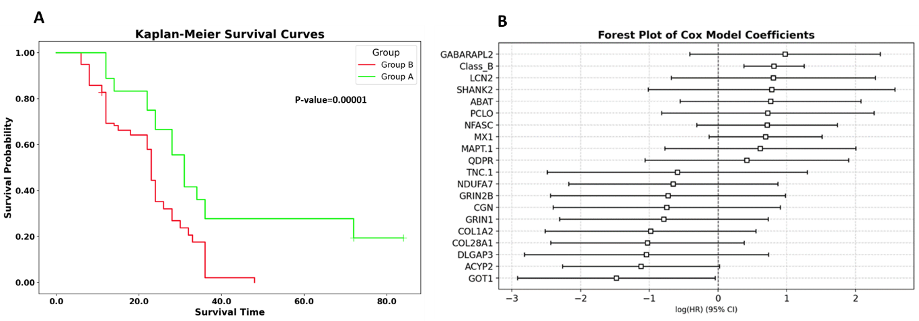
Figure S5. A) Survival curves (Kaplan Meier analysis) of all 50 patients according to the two groups. B) Forest plot of Cox model coefficients made with top 20 contributing biomarkers to the survival outcome.
Figure S6. Blind results using the Wizard module of Profiler, especially the real-time and post-acquisition one.

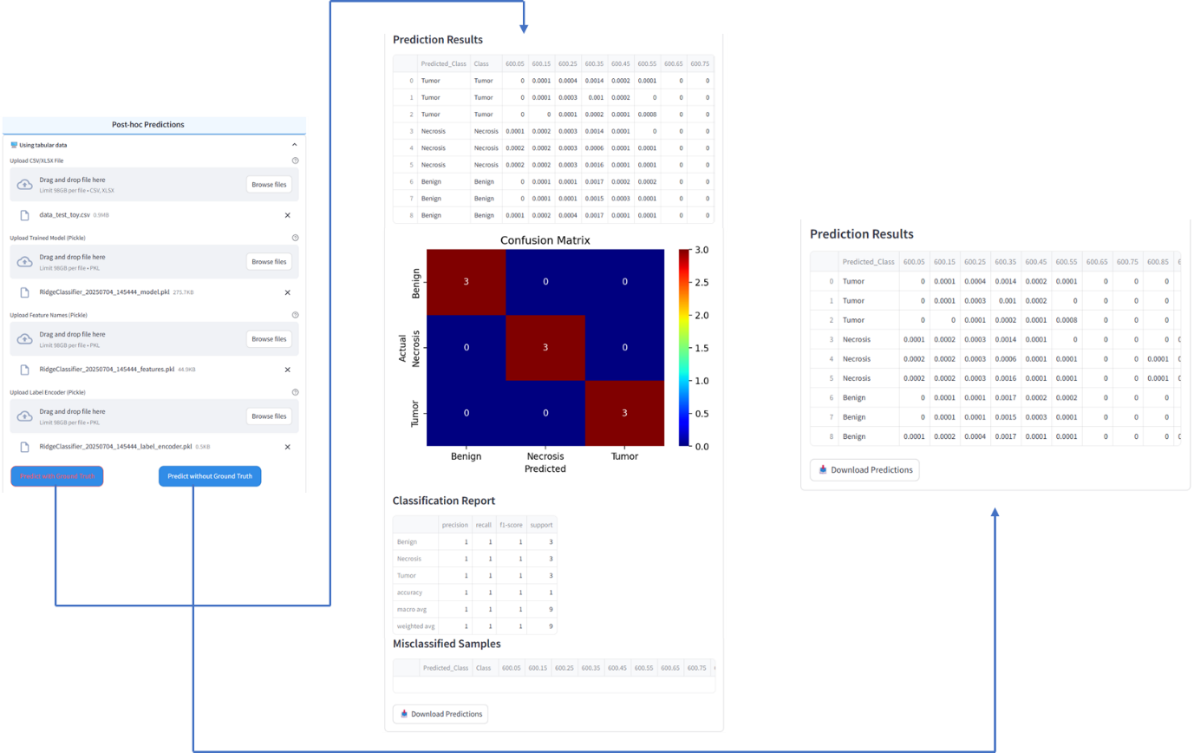
Figure S7. Blind results using the Wizard module of Profiler, especially post-hoc one.

