Cdkn2a/p16INK4A Loss Impairs Spatial Memory in Young Adult Mice Independently of Alzheimer ’s-Associated Genetic Pathways

Authors
Pauline Stephan¹, Damien Plassard¹, William M Keyes¹, Yann Herault^{1,2}

Affiliations
- Université de Strasbourg, CNRS, INSERM, Institut de Génétique et de Biologie Moléculaire et Cellulaire (IGBMC), Department of Translational Medicine and Neurogenetics, 1 rue Laurent Fries 67404 Illkirch-Graffenstaden, France; Université de Strasbourg, CNRS, INSERM, 1 rue Laurent Fries 67404 Illkirch-Graffenstaden, France.
- Université de Strasbourg, CNRS, INSERM, CELPHEDIA, PHENOMIN-Institut Clinique de la Souris (PHENOMIN-ICS), 1 rue Laurent Fries 67404 Illkirch-Graffenstaden, France.

Corresponding author
Dr. Yann Hérault herault@igbmc.fr.

Keywords
Cellular Senescence, Morris Water Maze Test, Hippocampus,

SUPPLEMENTARY FIGURE
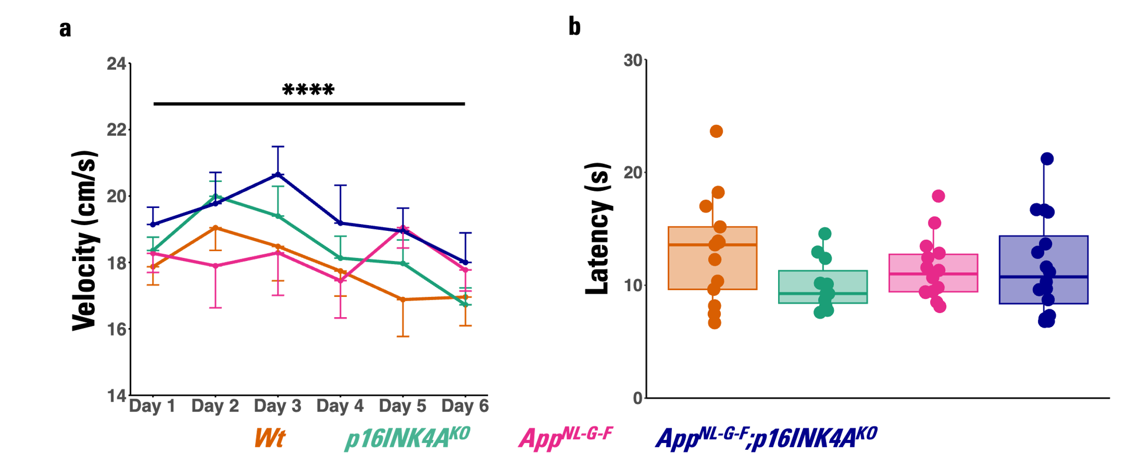
Supplementary Figure 1. Control measures for motor and visual performance. (a) Swim velocity varied significantly across training days (Type III test on the fixed effect, F(5, 254.71) = 7.76, p = 8.11x10⁻⁷), but no genotype effect (Type III test on the fixed effect, F(3, 50.44) = 1.09, p = 0.36) or genotype × day interaction (Type III test on the fixed effect, F(15, 254.70) = 0.66, p = 0.82) was detected. (b) The visible platform test on Day 15 confirmed that all genotypes were able to locate the platform using proximal cues (one-way [OW] ANOVA: F(3, 50) = 1.27, p = 0.29).

SUPPLEMENTARY DATA
Supplementary Data 1. Statistical analysis of Morris Water Maze (MWM) behavioural performance
Supplementary Data 2 . Differential gene expression analysis (DEGs) from bulk RNA-seq
Supplementary Data 3. STRING-based protein-protein interaction (PPI) network clustering analysis.
Supplementary Data 4. Likelihood Ratio Test (LRT) results from DESeq2 comparing full and reduced models to assess genotype effects and interactions.
Supplementary Data 5. Comprehensive results of Gene Set Enrichment Analyses (GSEA) performed for each genotype comparison and interaction model.

