Task Complexity Amplifies the Stroke-Induced Temporal and Spatial Asymmetry in Muscle Synergy Plasticity

Rui Sun¹*⁺, Yong Wang¹⁺, Lingling Zhong¹, Dantong Liao¹, Haoyang Song¹, Qiye Meng¹, Peng Cao², Song Rong³, Raymond Kai-Yu Tong⁴

- Department of Rehabilitation Sciences, Faculty of Health and Social Sciences, The Hong Kong Polytechnic University, Hong Kong SAR, China
- Xuanwu Hospital, Capital Medical University, Beijing, China
- Department of Biomedical Engineering, Sun Yat-sen University, China
- Department of Biomedical Engineering, The Chinese University of Hong Kong, Hong Kong SAR, China

⁺: These authors contributed equally to this work

Supplementary Table 1. Demographic characteristics of participants. The data are expressed as mean ± SD.

Variables | Stroke Group  (N=12) | Healthy Group  (N=20) | Sig.(p)
Gender (m/f) | 8/4 | 7/13 | 0.08
Affected side (R/L) | 6/6 | ---- | ----
Dominant hand (R/L) | ---- | 20/0 | ----
Age (yrs) | 64.33 ±6.94 | 64.4 ±6.54 | 0.61
Time since stroke (months) | 70.58 ±47.48 | ---- | ----
FMA-UE total | 52.5 ±7.3 | ---- | ----
FMA-UE shoulder | 27.08 ±3.94 | ---- | ----
FMA-UE wrist | 7.67 ±1.87 | ---- | ----
FMA-UE finger | 11.75 ±4.33 | ---- | ----
MMSE | 28.75 ±2.59 | ---- | ----
ARAT | 43.75 ±14.09 | ---- | ----
ARAT grasp | 14.42 ±5.07 | ---- | ----
ARAT grip | 10 ±3.1 | ---- | ----
ARAT pinch | 11.5 ±5.87 | ---- | ----
ARAT gross | 7.75 ±1.35 | ---- | ----

Abbreviation: m = male; f = female; R = right side; L = left side; yrs = years; FMA-UE = Fugl-Meyer Assessment- Upper Extremity; MMSE = Mini-Mental State Examination; ARAT: Action Research Arm Test.

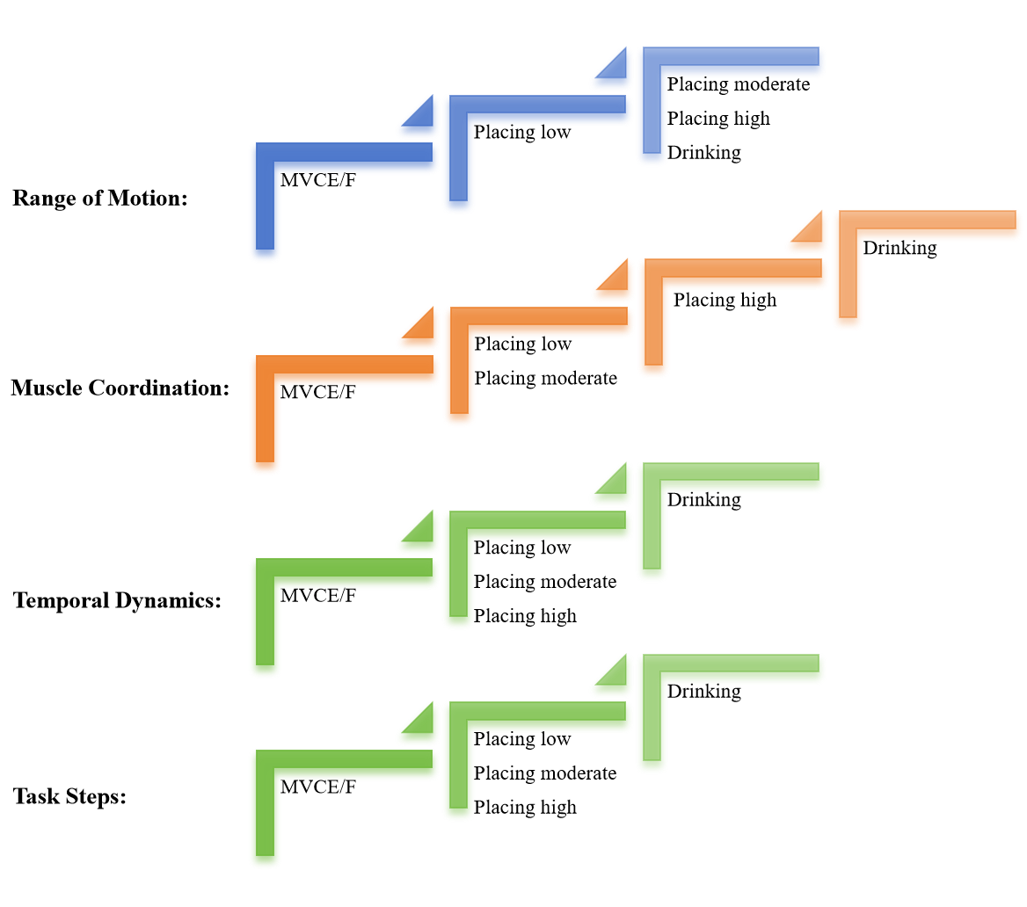
Supplementary Figure 1 Complexity levels based on motion, muscle coordination, dynamics, and steps for the five task in this study

Supplementary Figure 2. The centroids of synergies from healthy dominant limbs in five different tasks

Supplementary Figure 3. The differences in synergy numbers of: A. Preservation, B. Merging, C. Fractionation, D. Mutation between the affected and unaffected limbs across five tasks (MVCE/F, placing 10cm, placing 20cm, placing 30cm, drinking).

