Supplementary Material

Supplementary Figures
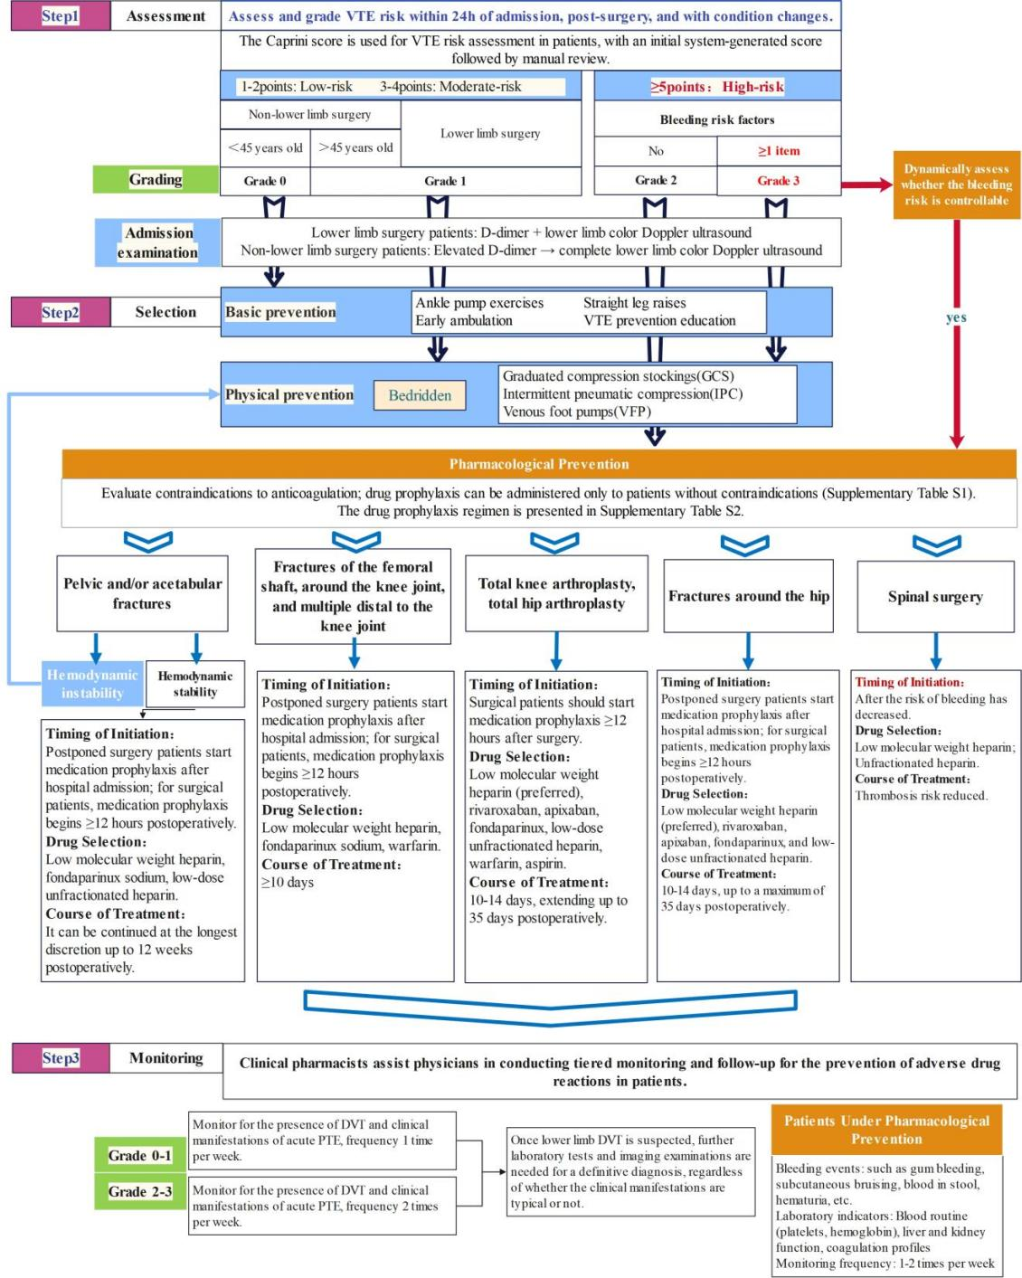

Supplementary Figure 1. The Clinical Pathway for VTE Prevention Management in the Perioperative Period of Orthopedic Surgery.

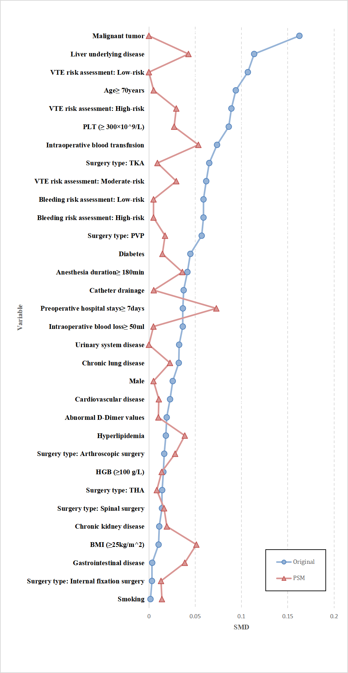
Supplemental Figure 2. Standardized mean differences (SMDs) between the no VTE-CPC group and the VTE-CPC group before and after propensity score matching (PSM).
VTE-CPC, Venous thromboembolism clinical pharmaceutical care; IQR, interquartile range; BMI, body mass index; VTE, Venous thromboembolism; PVP, percutaneous vertebroplasty; THA, Hip Arthroplasty; TKA, Total knee arthroplasty.

Supplementary Tables
Supplementary Table 1. Contraindications for Anticoagulant Medication
Contraindications for Anticoagulant Medication ^{a,b,c,d} | 1. Recent active bleeding and coagulation disorders;  2. Compartment syndrome;  3. Severe head trauma or acute spinal cord injury;  4. Platelet count < 20×10^9/L;  5. History of heparin-induced thrombocytopenia, contraindicated for heparin and low molecular weight heparin;  6. Warfarin is teratogenic, contraindicated in pregnant women.
Relative Contraindications for Anticoagulant Medication ^{a,b,c,d} | 1. Recent history of intracranial or gastrointestinal bleeding;  2. Acute intracranial injury or tumor;  3. Thrombocytopenia with platelet count reduced to 20×10^9/L to 100×10^9/L;  4. Rheumatoid retinopathy, with a risk of fundus hemorrhage.
a. Falck-Ytter Y, Francis CW, Johanson NA et al. Prevention of VTE in orthopedic surgery patients: Antithrombotic Therapy and Prevention of Thrombosis, 9th ed: American College of Chest Physicians Evidence-Based Clinical Practice Guidelines. Chest 2012; 141: e278S-e325S. DOI: 10.1378/chest.11-2404
b. Uzel K, Azboy İ, Parvizi J. Venous thromboembolism in orthopedic surgery: Global guidelines. Acta orthopaedica et traumatologica turcica 2023; 57: 192-203. DOI: 10.5152/j.aott.2023.23074
c. Branch CMAO. Prevention of venous thromboembolism after major orthopaedic surgery. Chinese Journal of Orthopaedics 2016; 36: 65-71.
d. Lin Q, Yang M, Hou ZJCJOT. Guidelines for prevention of perioperative venous thromboembolism in Chinese orthopedic trauma patients (2021). 2021; 23: 185-192.

Supplement Table 2. Standard Prophylaxis Dose of Anticoagulant Medication.
Anticoagulant Medication | Standard Prophylaxis Dose
Enoxaparin ^{a,b,c,d} | 4000 IU subcutaneously once daily (qd), starting after hospital admission. Continue with the routine dose until 12 hours before surgery, then discontinue. Resume 12 hours postoperatively (for patients with delayed removal of an epidural catheter, resume 2 to 4 hours after catheter removal).
Dalteparin ^{a,b,c,d} | 5000 IU subcutaneously once daily (qd), starting after hospital admission. Continue with the routine dose until 12 hours before surgery, then discontinue. Resume 12 hours postoperatively (for patients with delayed removal of an epidural catheter, resume 2 to 4 hours after catheter removal).
Bemiparin ^{a,b,c,d} | 3500 IU subcutaneously once daily (qd), starting after hospital admission. Maintain the routine dose until 12 hours before surgery, at which time it should be discontinued. Resume the medication 12 hours postoperatively (for patients with delayed removal of an epidural catheter, resume 2 to 4 hours after catheter removal).
Low Molecular Weight Heparin Sodium ^{a,b,c,d} | 2500-5000 IU subcutaneously once daily (qd), starting after hospital admission. Maintain the routine dose until 12 hours before surgery, at which time it should be discontinued. Resume the medication 12 hours postoperatively (for patients with delayed removal of an epidural catheter, resume 2 to 4 hours after catheter removal).
Nadroparin ^{a,b,c,d} | For patients weighing less than 50 kg: 2050 IU subcutaneously once daily (qd).  For patients weighing between 50 kg and 70 kg: 3075 IU subcutaneously once daily (qd).  For patients weighing 70 kg or more: 4100 IU subcutaneously once daily (qd).
Apixaban ^{a,b,c,d} | Take 2.5 mg by mouth twice a day (bid).  Administer the medication 12 to 24 hours after surgery (5 hours after removal of the epidural catheter).
Rivaroxaban ^{a,b,c,d} | Take 10 mg by mouth once daily (qd).  Start the medication 6 to 10 hours after surgery (6 hours after removal of the epidural catheter).
Fondaparinux Sodium ^{a,b,c,d} | Administer 2.5 mg subcutaneously once daily (qd).  Start the medication 6 to 24 hours after surgery.  For patients with delayed removal of the epidural catheter, start the medication 2 to 4 hours after catheter removal.
Warfarin ^{a,b,c,d} | Oral administration, monitor INR, with a target of 2.5, and maintain the range between 2.0 to 3.0.
a. Falck-Ytter Y, Francis CW, Johanson NA et al. Prevention of VTE in orthopedic surgery patients: Antithrombotic Therapy and Prevention of Thrombosis, 9th ed: American College of Chest Physicians Evidence-Based Clinical Practice Guidelines. Chest 2012; 141: e278S-e325S. DOI: 10.1378/chest.11-2404
b. Uzel K, Azboy İ, Parvizi J. Venous thromboembolism in orthopedic surgery: Global guidelines. Acta orthopaedica et traumatologica turcica 2023; 57: 192-203. DOI: 10.5152/j.aott.2023.23074
c. Branch CMAO. Prevention of venous thromboembolism after major orthopaedic surgery. Chinese Journal of Orthopaedics 2016; 36: 65-71.
d. Lin Q, Yang M, Hou ZJCJOT. Guidelines for prevention of perioperative venous thromboembolism in Chinese orthopedic trauma patients (2021). 2021; 23: 185

Supplemental Table 3. Comparison of adverse events in the propensity score-matched cohort
 | Overall  (n=812) | No VTE-CPC service (n=406) | VTE-CPC service (n=406) | P
Non-major bleeding event | 1 (0.20) | 0 (0.00) | 1 (0.25) | >0.999
Thrombocytosis | 280 (34.48) | 149 (36.70) | 131 (32.27) | 0.209
Thrombocytopenia | 14 (1.72) | 6 (1.48) | 8 (1.97) | 0.788
Anemia | 343 (42.24) | 177 (43.60) | 166 (40.89) | 0.477
Elevated ALT | 115 (14.16) | 64 (15.76) | 51 (12.56) | 0.227
Elevated AST | 123 (15.15) | 65 (16.01) | 58 (14.29) | 0.557
Elevated serum creatinine | 110 (13.55) | 63 (15.52) | 47 (11.58) | 0.124
VTE-CPC: venous thromboembolism clinical pharmaceutical care, ALT: alanine aminotransferase; AST: aspartate aminotransferase.

