Title: Effects of algal utilization of dissolved organic phosphorus by Microcystis aeruginosa on its adaptation capability to ambient ultraviolet radiation

Authors: Lingxiao Ren^{a,*}, Jing Huang^{b}, Junpan Zhuª, Ning Qi^{c}, Keqiang Dingª, Yi Wangª

Institute or laboratory of origin:
ªCollege of Environmental Engineering, Nanjing Institute of Technology, 211167, Nanjing, PR China
^{b}Three Gorges Beijing Enterprises Nanjing Water Group Co., Ltd., 210000, Nanjing, PR China
^{c}College of Environment and Resources, Chongqing Technology and Business University, 400067, Chongqing, PR China

Contents of Supplementary Information

Procedures for the irradiation experiment on algae

Photosynthetic efficiency of M. aeruginosa

Photosynthetic pigments in single cells

ROS production and algal SOD activity

Kinetic parameters of DOP uptake by M. aeruginosa

Fig. S1 The spectral power distribution and weighted UV radiation of UV-A lamps (PL-L 36W/09/4P, Philips)

Fig. S2 The spectral power distribution and weighted UV radiation of UV-B lamps (TL20W/01RS, Philips)

Fig. S3 The energy-based flux of sun spectrum at solar noon (13:00 pm) in the summer of Nanjing, Jiangsu and the absorbance of M. aeruginosa-derived alkaline phosphatase (APase, 0.84 μmol L⁻¹ h⁻¹)

Fig. S4 Average values of the hourly UV-B dosage in Nanjing, China in spring (April) and summer (July). Dashed horizontal line indicates the hourly irradiation of 0.5 and 1.0 W m⁻² UV-B in spring and summer, respectively

Fig. S5 The stability of glucose-6-phosphate (initial DOP concentration of 2.5 mg L⁻¹) under different irradiation (70 W m⁻² PAR, 30 W m⁻² UV-A and 1.0 W m⁻² UV-B)

Fig. S6 Schematic diagram of the irradiation experiments on M. aeruginosa

Table S1 The composition of DOP-rich medium in our study

Procedures for the irradiation experiment on algae
After enlarge cultivation and preservation, the prepared M. aeruginosa cells were collected (5000 g for 10 min) and transferred into DOP-free BG₁₁ medium and modified BG₁₁ medium with DOP in high concentrations (glucose-6-phosphate, 2.5 mg P L⁻¹). The inoculation density was 1 × 10⁶ cells mL⁻¹ and the initial volume of the cultures was 450 mL, with adjusting pH to 8.0.
After slightly shaking the flasks, algal cultures were transferred into sterilized petri dishes with quartz glass covers (20 cm in diameter) for irradiation. The exposure time was 5 h and three light conditions were used as PAR control, UV-A treatment, and UV-B treatment. In PAR control, petri dishes were maintained in the illumination incubator (GZX-250BS-II) and continuously irradiated with PAR. In UV-A and UV-B treatments, dishes were stored in clean chambers and subjected to irradiation from high-pressure mercury ultraviolet lamps. UV-A and UV-B lamps in our experiment were narrowband and their dominant wavelength was 360 nm and 313 nm, respectively (Figures S1-S2). The biological spectral weighting function was adopted¹, and the effective irradiation intensities were 70, 30, and 1.0 W m⁻² for PAR, UV-A, and UV-B, respectively. It was in accordance with natural conditions at noon in the middle and lower reaches of the Yangtze River². The vertical sides of dishes were covered with aluminum foil to ensure vertical radiation and the irradiance in our study was measured by using a miniature fiber optic spectrometer (FLA4000A+, Flight, China). After light exposure, algal cultures were returned to their flasks and incubated under 40 μmol photons m⁻² s⁻¹ PAR for 10 days.
For comparison, the prepared DOM solutions were added into half the petri dishes before irradiation experiment, representing four experimental groups: without DOM in DOP-rich medium (NM-P group), with DOM in DOP-rich medium (M-P group), without DOM in DOP-free medium (NM-NP group), with DOM in DOP-free medium (M-NP group). Since humic substances are known as the main pool of DOM³, DOM solution was obtained using humic acids (HA) from Sigma-Aldrich in our study. The final content of DOM in the culture medium of M-P and M-NP groups was 5.0 mg TOC L⁻¹, which was in accordance with natural conditions in the freshwater waters in China.

Photosynthetic efficiency of M. aeruginosa
Based on Chl-a fluorescence quenching, a phytoplankton analyzer (Phyto-PAM, Walz, Germany) was used to measure algal photosynthetic efficiency. After a short dark adaptation of 15 min, 3 mL of algal sample was directly put into the measuring chambers. The effective quantum yield (F_{v}/F_{m}) of photosystem II (PS II) was calculated. F_{m} is the maximum fluorescence of algae cells after dark acclimation and F₀ is the fluorescence of dark-adapted cells stimulated by a weak probe light.
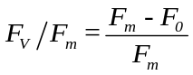

.
Photosynthetic pigments in single cells
At the beginning and after 5 h of light exposure, a subsample of algal cultures (10 mL) was collected and filtrated through 0.22-μm GF/C filters (Whatman). Afterwards, the filters with retained cells were extracted with a 90% acetone solution for 24-h in the dark and absorbency of the supernatant was determined at 662, 645 and 470 nm using a UV-visible spectrophotometer, respectively. The Chlorophyll a (Chl-a) and carotenoid (CAR) contents in the supernatant were calculated using the following equation⁴.
After repeated freeze-thaw cycles in liquid N₂ and a 0.05-mol L⁻¹ phosphate buffer (pH 6.7), the homogenate solution was centrifuged at 4000 g for 15 min and absorbency of the supernatant was measured at 615 and 652 nm^{4, 5}. Afterwards, the phycocyanin content (PC) contents were calculated by using the following equation.

ROS production and algal SOD activity
M. aeruginosa was collected by centrifugation (5000 g for 10 min, 4°C), washed with phosphate-buffered saline (PBS, 50 mmol L⁻¹, pH 8.0), and suspended in 1.5 mL PBS solution buffer. The generation of reactive oxygen species (ROS) was monitored using the ROS sensitive fluorescence probe 2’ 7’-dichlorohydrofluorescein diacetate (DCFH-DA)⁶. Cells were incubated with 10 μmol L⁻¹ DCFH-DA (Sigma Aldrich, USA), which could diffuse into cells and its acetate groups were cleaved by intracellular esterases to produce 2′ 7′-dichlorohydrofluorescein (DCFH). Afterwards, intracellular ROS can oxidize DCFH to the highly fluorescent 2′ 7′-dichlorofluorescein (DCF), and the fluorescence intensity is proportional to the amount of ROS produced by the cells. After incubation for 15 min at 37°C in the dark, algae cells were washed twice with PBS (pH 8.0) and fluorescence intensity was measured with the excitation at 488 nm and emission at 525 nm⁵.
M. aeruginosa cells were collected by filtration of 10 mL algal solution using 0.2-μm mixed cellulose ester filters (ME, Whatman) and were re-suspended in 20 mL PBS solution (50 mmol L⁻¹, pH 8.0). The cells were disrupted by an ultrasonic cell pulverizer surrounded by ice bags. After centrifugation (5000 g for 10 min, 4°C), the supernatant was used as crude enzyme solution for estimating superoxide dismutase (SOD) activity with a Total Superoxide Dismutase Assay Kit. The enzyme activity was calculated on the protein content basis by using a Bradford Protein Assay Kit. All assay kits used in our study were produced by Jiancheng Bioengineering Institute, Nanjing, China.

Kinetic parameters of DOP uptake by M. aeruginosa
Based on Fu et al.⁷, initially prepared and irradiance-treated M. aeruginosa cells were rinsed with ultrapure water and immediately transferred into colorimetric tubes with a modified BG₁₁ culture medium containing DOP (glucose-6-phosphate) at initial concentrations of 0.1, 0.2, 0.5, 1.0, 2.0, and 5.0 mg L⁻¹. The tubes were incubated under 40 μmol photons m⁻² s⁻¹ PAR at 25 °C for 1 h.
Cell density in all treatments did not change significantly after 1-h of incubation, and algal DOP uptake rate was determined by directly measuring the disappearance of glucose-6-phosphate from the culture medium. The maximum uptake rate (V_{max}, μg P mg⁻¹ DW h⁻¹) and half-saturation constant (K_{m}, μg P L⁻¹) were estimated based on the following equation, where V is DOP uptake rate in different tubes and dry weight (DW) of cells was measured by the freeze-drying method.
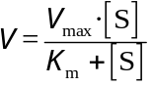

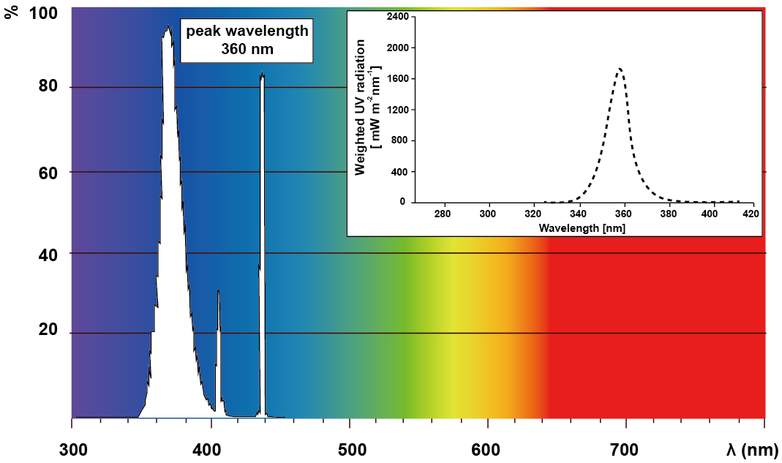
Fig. S1 The spectral power distribution and weighted UV radiation of UV-A lamps (PL-L 36W/09/4P, Philips).

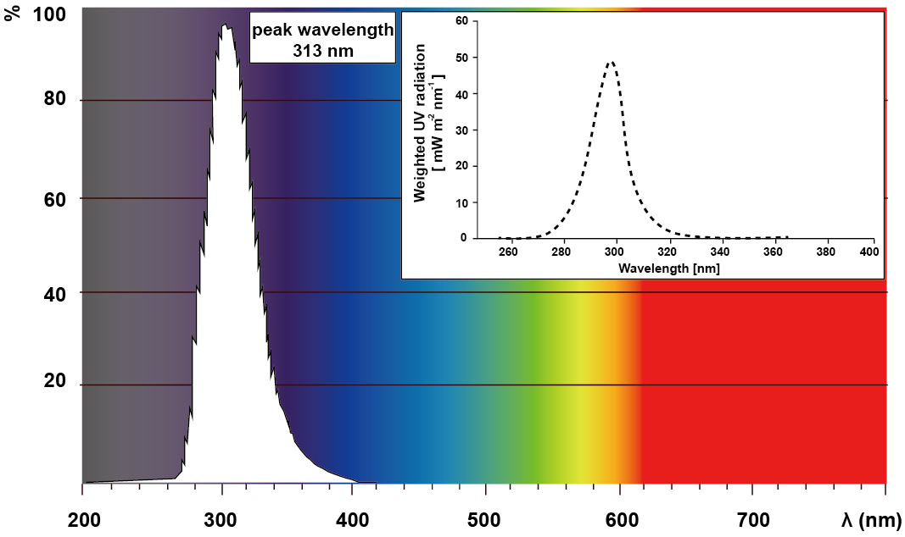
Fig. S2 The spectral power distribution and weighted UV radiation of UV-B lamps (TL20W/01RS, Philips).

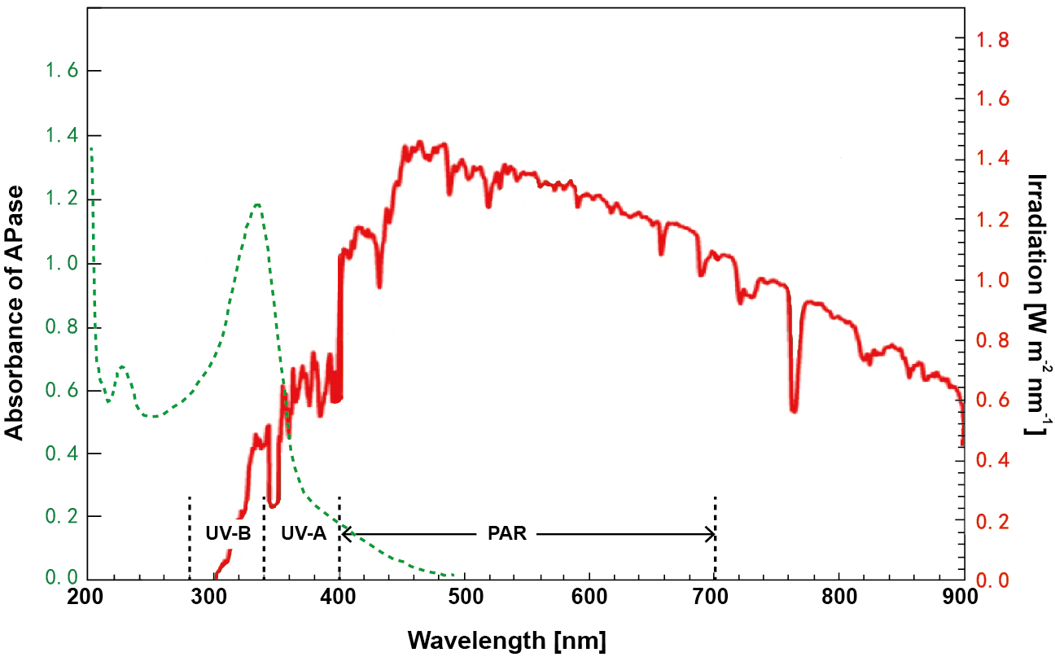
Fig. S3 The energy-based flux of sun spectrum at solar noon (13:00 pm) in the summer of Nanjing, Jiangsu and the absorbance of M. aeruginosa-derived alkaline phosphatase (APase, 0.84 μmol L⁻¹ h⁻¹).

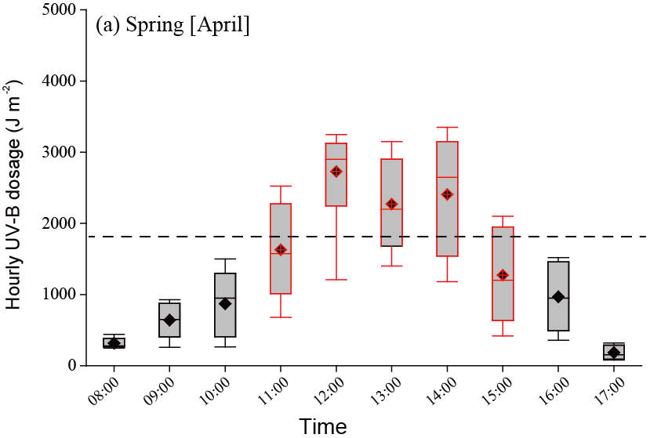
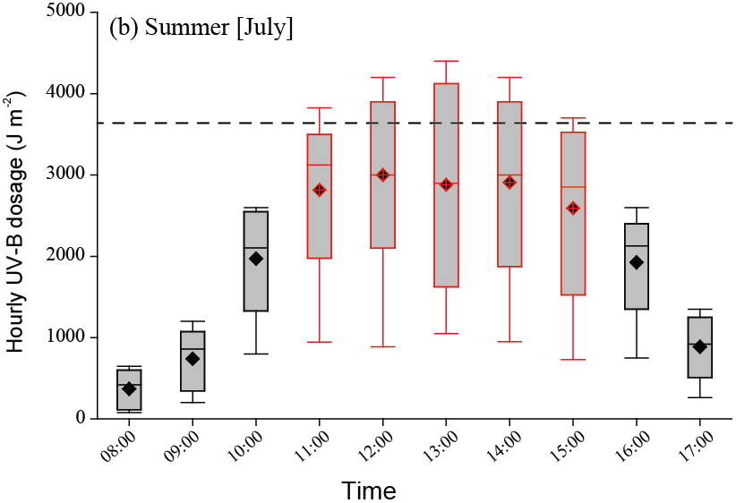
Fig. S4 Average values of the hourly UV-B dosage in Nanjing, China in spring (April) and summer (July). Dashed horizontal line indicates the hourly irradiation of 0.5 and 1.0 W m⁻² UV-B in spring and summer, respectively.

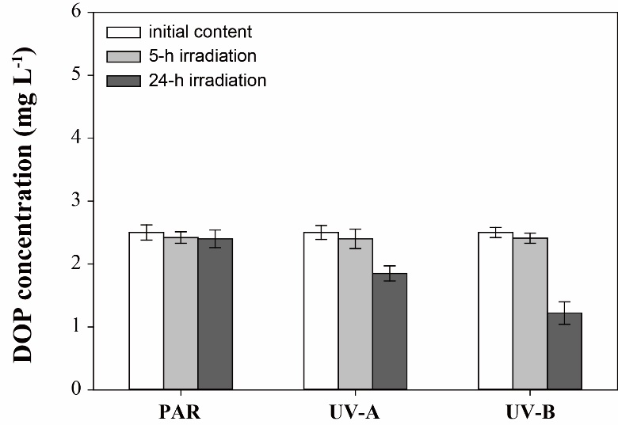
Fig. S5 The stability of glucose-6-phosphate (initial DOP concentration of 2.5 mg L⁻¹) under different irradiation (70 W m⁻² PAR, 30 W m⁻² UV-A and 1.0 W m⁻² UV-B).

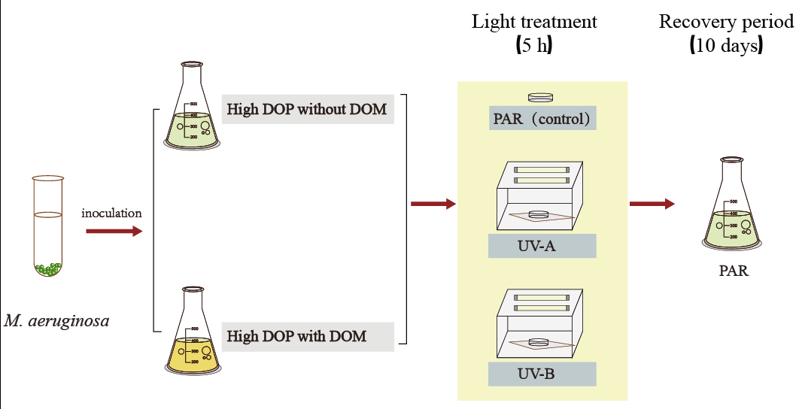
Fig. S6 Schematic diagram of the irradiation experiments on M. aeruginosa.

Table S1 The composition of DOP-rich medium in our study.
Stock solution |  | Dosage  [mL/L culture medium]
Composition | Concentration [g/100 mL] | Dosage  [mL/L culture medium]
Glucose-6-phosphate | 2.94 | 0.5 mL
MgSO₄·7H₂O | 7.5 | 1 mL
CaCl₂·2H₂O | 3.6 | 1 mL
Citric Acid | 0.6 | 1 mL
Ammonium ferric citrate  (C₆H₈FeNO₇) | 2 | 1 mL
EDTA-Na₂ | 0.1 | 1 mL
Na₂CO₃ | 2 | 1 mL
NaNO₃ | 2 | 1.5 mL
A₅ solution:
H₃BO₃ | 2.86 g/L | 1 mL
MnCl₂·4H₂O | 1.86 g/L | 1 mL
ZnSO₄·7H₂O | 0.22 g/L | 1 mL
CuSO₄·5H₂O | 80 mg/L | 1 mL
(NH₄)₂MoO₄·3H₂O | 0.39 g/L | 1 mL
Co(NO₃)₂·6H₂O | 0.05 g/L | 1 mL

1. S. D. Flint and M. M. Caldwell, Physiologia Plantarum, 2003, 117, 137-144.
2. L. X. Ren, P. F. Wang, C. Wang, H. W. Paerl and H. Y. Wang, Environmental pollution, 2020, 256, 113441.
3. L. P. Canellas, F. L. Olivares, N. O. Aguiar, D. L. Jones, A. Nebbioso, P. Mazzei and A. Piccolo, Scientia Horticulturae, 2015, 196, 15-27.
4. U. H. Lüder, J. Knoetzel and C. Wiencke, Polar Biology, 2001, 24, 598-603.
5. Y. Zhang, H. B. Jiang and B. S. Qiu, Journal of Phycology, 2013, 49, 318-328.
6. Y. Y. He and D. P. Häder, Journal of Photochemistry & Photobiology B Biology, 2002, 66, 73-80.
7. F. X. Fu, Y. H. Zhang, Y. Y. Feng and D. A. Hutchins, European Journal of Phycology, 2006, 41, 15-28.

