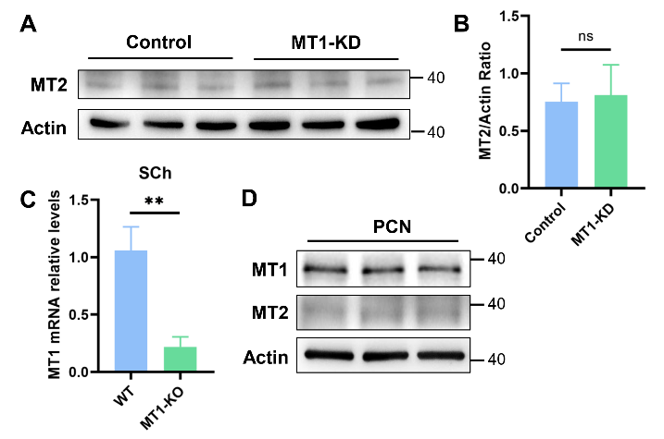
FIGURE S1. MT1 or MT2 expression in cells and mice primary cortical neurons
(A) Representative blots of MT2 from Control and MT1-KD SH-SY5Y cells. (B) Quantification of MT2 protein levels from (A) (n=6). (C) Statistical analysis of MT1 mRNA levels from WT or MT1-KO mice SCN (n=5). (D) Representative blots of MT1 and MT2 from mouse primary cortical neurons (PCN). Unpaired t-test analysis, **p<0.01. ns, not significant.

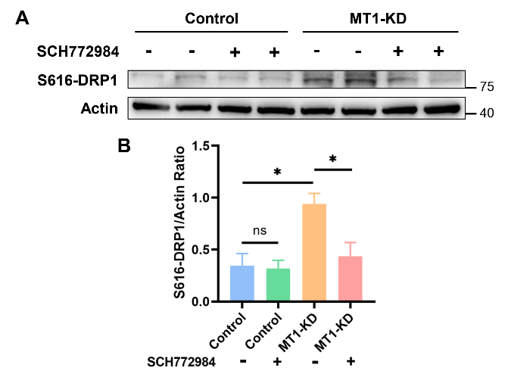
FIGURE S2. ERK1/2 inhibitor SCH772984 treatment rescued the aberrant DRP1-S616 phosphorylation caused by MT1-KD
(A) Representative blots of S616-DRP1 from SH-SY5Y cells divided into Control, SCH772984, MT1-KD and MT1-KD + SCH772984 four groups. (B) Quantification of S616-DRP1 protein levels from western blots (n=4). Two-way ANOVA analysis, *p<0.05. ns, not significant.

