Supplemental materials
Figure S1 Distribution of duration from onset to endpoint events or last visit
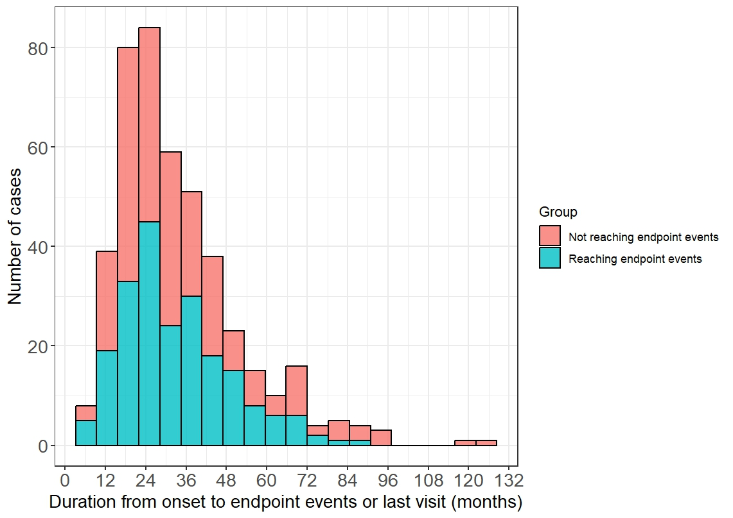
Note: For patients who did not reach endpoint events, duration from onset to last visit (months) was presented.

Figure S2 Scatter plots for correlations between duration from onset to endpoint events (months) and selected variables
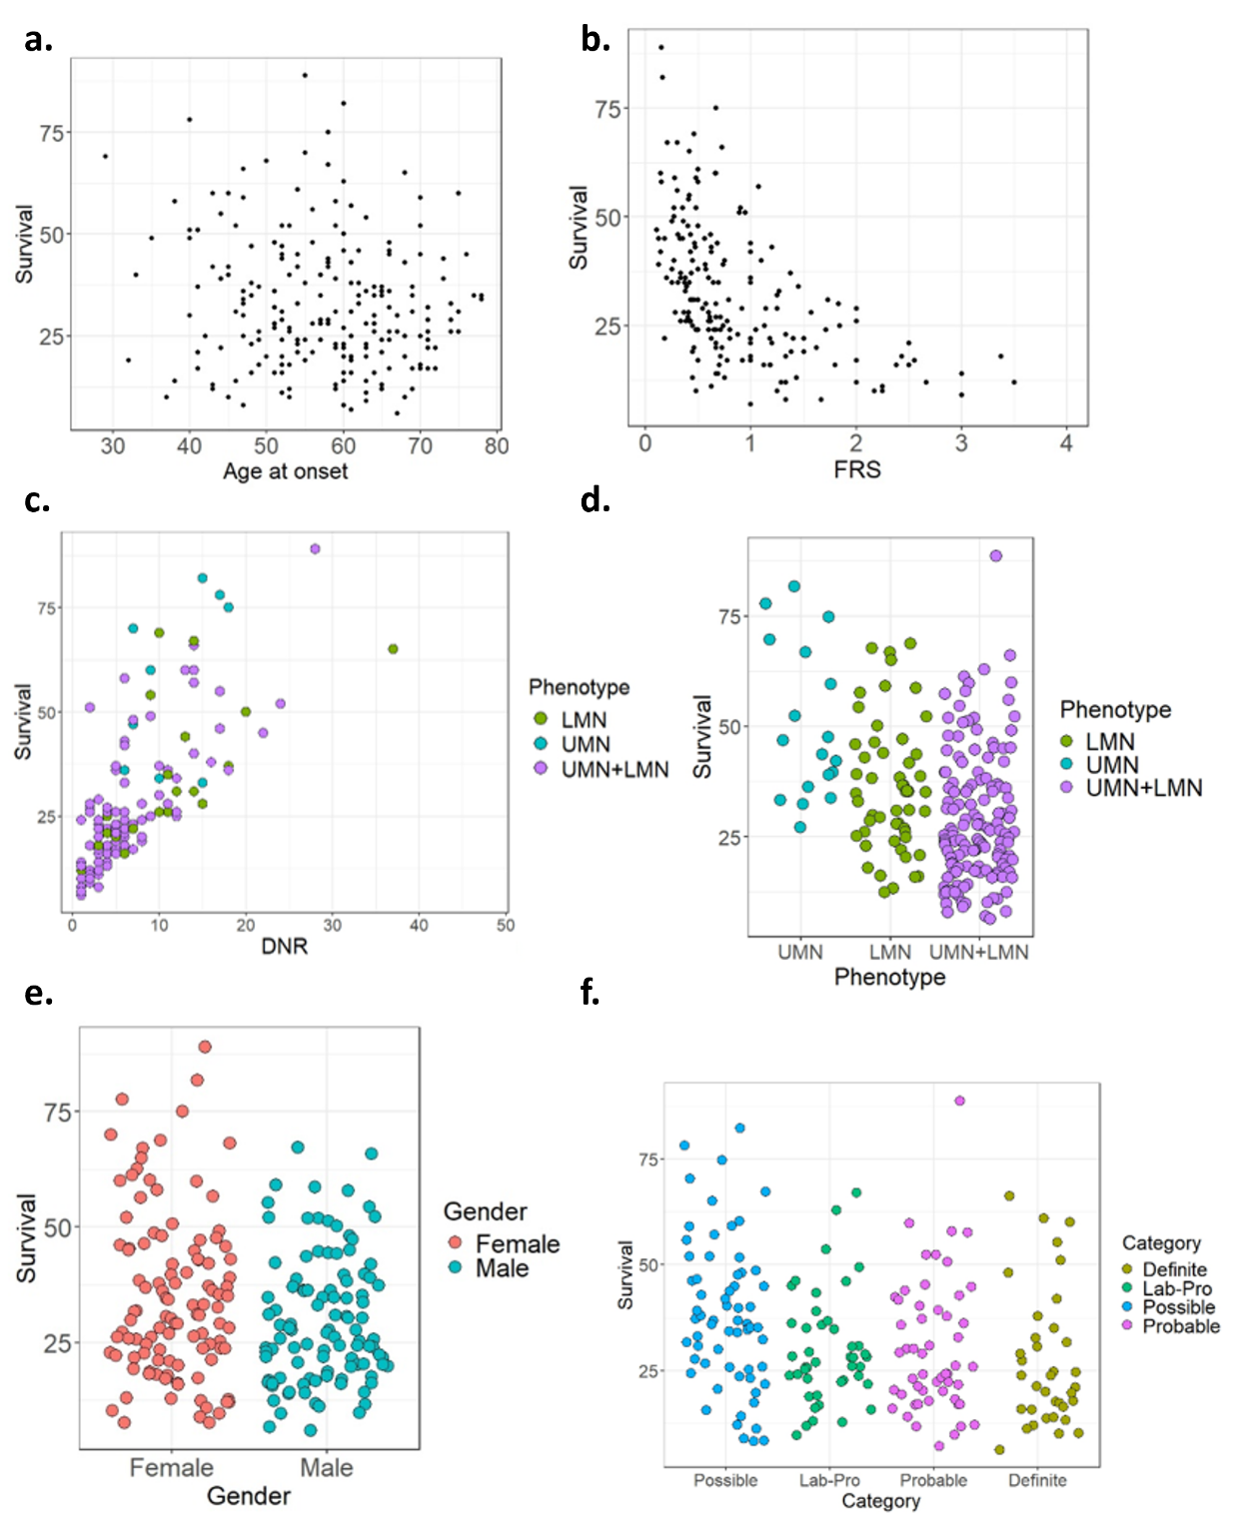
Abbreviations: FRS = (ALSFRS-R at assessment– 48) / Disease duration at assessment; Lab-Pro, Laboratory supported clinically probable; UMN, upper motor neuron; LMN, lower motor neuron; DNR, duration from onset to next region.
Note: Endpoint events refer to decease, tracheotomy and permanent NIPPV.

Figure S3 Correlations between age at onset and age at endpoint events (years)
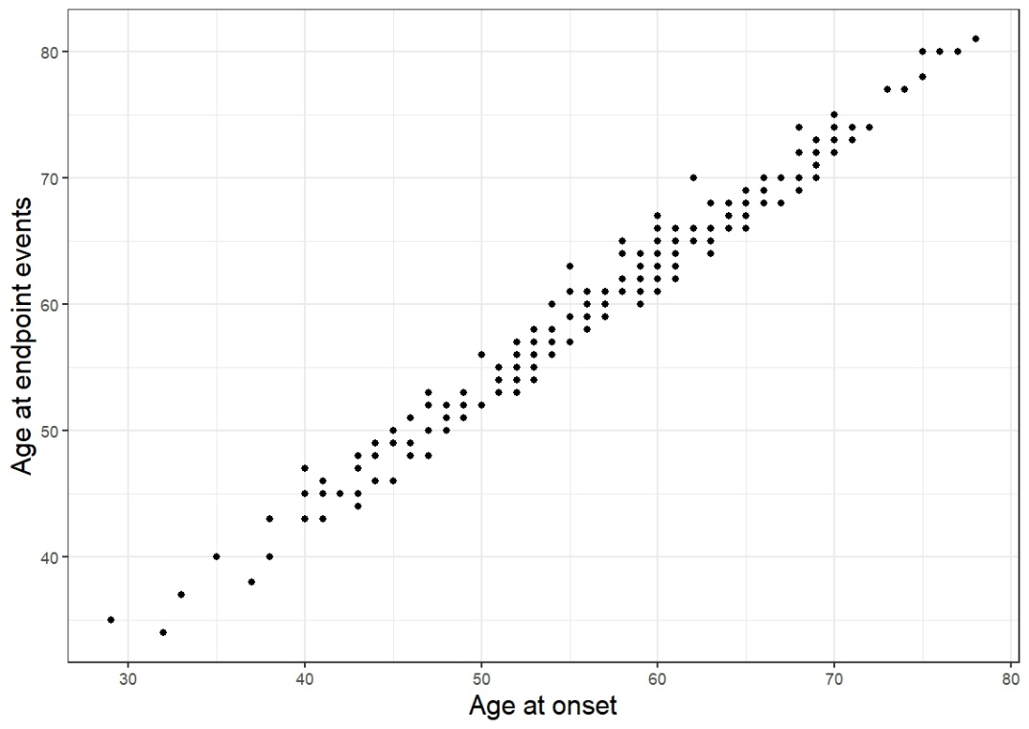

Figure S4 DNR cut-off points for each clinical phenotype (months)
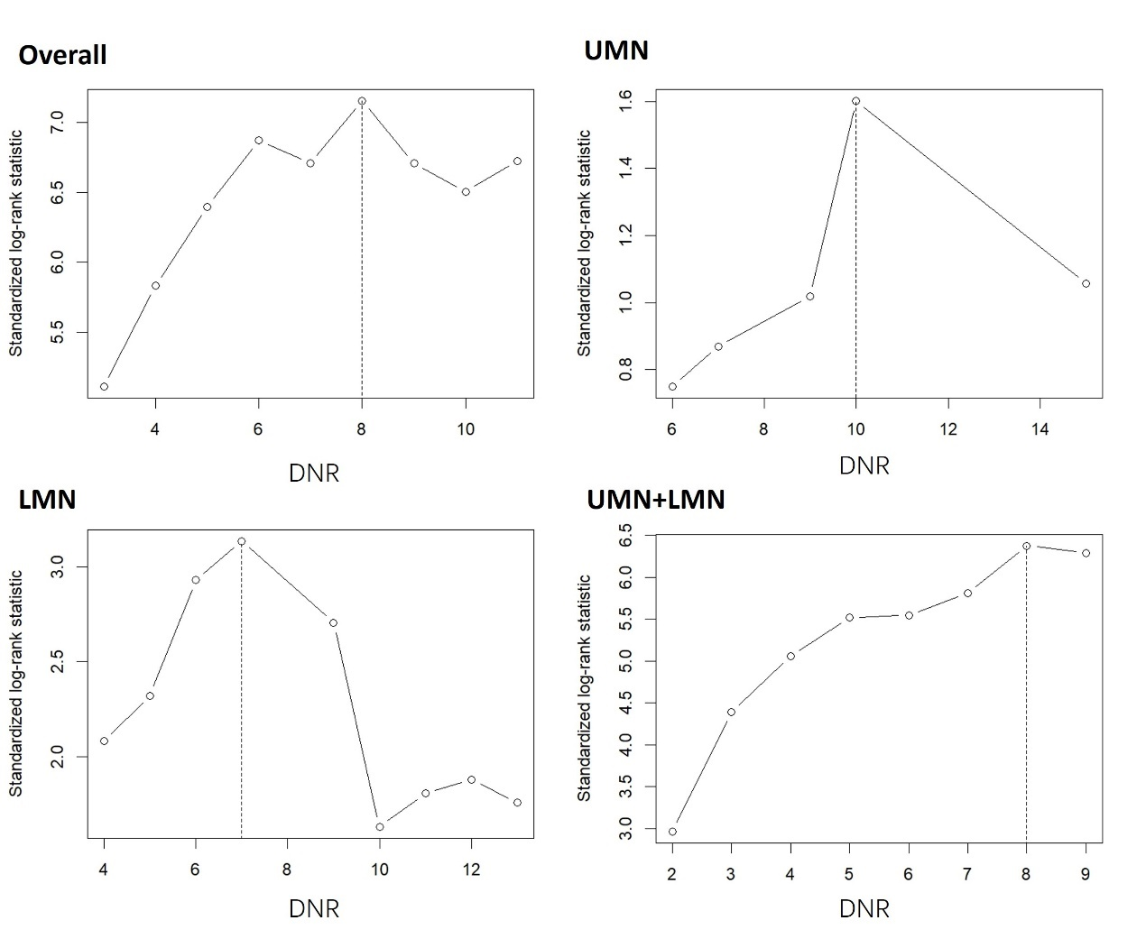
Abbreviations: DNR, duration from onset to next region; UMN, upper motor neuron; LMN, lower motor neuron.
Note: Cut-off points were obtained by maximum selected log-rank statistics in R software (packages: maxstat, minprop=0.2, maxprop=0.8)

Table S1 Univariate and multivariate COX regression for survival analysis (Total n = 441)
 | Univariate |  | Multivariate
Variables | HR (95%CI) | P value | HR (95%CI) | P value
Gender Female  Male | 0.770 (0.588, 1.009)  1 | 0.058 | 0.837 (0.571, 1.227)  1 | 0.362
Onset age (years) | 1.021 (1.007, 1.035) | 0.002 | 1.027 (1.007, 1.047) | 0.009
ALSFRS-R | 0.997 (0.972, 1.023) | 0.816 | - | -
FRS | 0.432 (0.354, 0.526) | <0.001 | 0.600 (0.443, 0.812) | 0.001
DNR | 0.877 (0.846, 0.910) | <0.001 | 0.912 (0.874, 0.951) | <0.001
Phenotype UMN  LMN  UMN+LMN | 0.358 (0.218, 0.591)  0.660 (0.480, 0.906)  1 | <0.001  0.010 | 0.313 (0.116, 0.846)  0.802 (0.476, 1.350)  1 | 0.022  0.406
Abbreviations: FRS = (ALSFRS-R at assessment– 48) / disease duration at assessment; DNR, duration from onset to next region; UMN, upper motor neuron; LMN, lower motor neuron.
Note: Survival referred to decease, tracheotomy and permanent-NIPPV.
Table S2 Comparisons with previous studies
 | PUMCH | PUTH [1-3] | PLAGH [4] | Italy [5, 6] | Northern Ireland [7] | Oxford [8] | India [9] | Australia [10]
Cases with  bulbar onset | 441 | 227 [1], 154 [2], 115 [3] | 96 | 653 [5],  456 [6] | 102 | 49 | 312 | 429
Time period of data collected  (years) | 2014-2023 | 2003-2012 [1]  2009-2013 [2, 3] | 2015-2018 | 2009-2013 [5]  1995-2004 [6] | 2015-2019 | 2003-2009 | 1976-2005 | 2005-2015
Female: Male  (n or ratio) | 242:199 | 98:129 [1] | 53:43 | 374:279 [5], 1:0.98 [6] | N.A. | 1.7:1 | 119:193 | 1:1
Age at onset (years) | 57 (27, 78)  56.6±10.3 | 53 (22, 79) [1] | 56 (28, 77) | 69.9 (N.A.) [6]  68.8±9.7 [6] | N.A. | N.A. (43, 90)  68±11 | N.A. (18, 85)  52.9±11.6 | 66 (N.A.)
Definition of  endpoint events | Decease  Tracheotomy  P-NIPPV | Decease  Tracheotomy | Decease  Tracheotomy | Decease  Tracheotomy | Decease | Decease | Decease | Decease
DNR (months) | 6 (1, 48) | 9 (1, 39) [3] | 7 (0, 38) | N.A. | N.A. | 11 (1, 41) | N.A. | N.A.
DOE (months)  Overall  DNR≥7  DNR < 7 | 29 (6, 89)  41 (16, 89)  24 (6, 61) | 48 (N.A.) [1]  38.5 (12, 80) [2]  29 (11, 89) [2] | N.A.  52 (N.A.)  31 (N.A.) | 33[5], 24 [6] (N.A.) | 23 (20, 26) | 27 (6, 84) | 56 (N.A.) | 24 (N.A.)
Abbreviation: P-NIPPV, permanent non-invasive positive pressure ventilation; DOE, duration from onset to endpoint events; DNR, duration from onset to next region.
Note: Data are shown as median (range) or mean±SD; PUTH and PLAGH are two MND centers in China.
References
1. Chen L, Zhang B, Chen R, Tang L, Liu R, Yang Y, Yang Y, Liu X, Ye S, Zhan S, and Fan D (2015) Natural history and clinical features of sporadic amyotrophic lateral sclerosis in China. J Neurol Neurosurg Psychiatry 86: 1075-81 https://doi.org/10.1136/jnnp-2015-310471.
2. Zhang HG, Chen L, Tang L, Zhang N, and Fan DS (2017) Clinical Features of Isolated Bulbar Palsy of Amyotrophic Lateral Sclerosis in Chinese Population. Chin Med J (Engl) 130: 1768-1772 https://doi.org/10.4103/0366-6999.211538.
3. Zhang H, Chen L, Tian J, and Fan D (2021) Disease duration of progression is helpful in identifying isolated bulbar palsy of amyotrophic lateral sclerosis. BMC Neurol 21: 405 https://doi.org/10.1186/s12883-021-02438-8.
4. He Z, Sun B, Feng F, Bai J, Wang H, Wang H, Yang F, Cui F, and Huang X (2022) Time of symptoms beyond the bulbar region predicts survival in bulbar onset amyotrophic lateral sclerosis. Neurol Sci 43: 1817-1822 https://doi.org/10.1007/s10072-021-05556-w.
5. Calvo A, Moglia C, Lunetta C, Marinou K, Ticozzi N, Ferrante GD, Scialo C, Sorarù G, Trojsi F, Conte A, Falzone YM, Tortelli R, Russo M, Chiò A, Sansone VA, Mora G, Silani V, Volanti P, Caponnetto C, Querin G, Monsurrò MR, Sabatelli M, Riva N, Logroscino G, Messina S, Fini N, and Mandrioli J (2017) Factors predicting survival in ALS: a multicenter Italian study. J Neurol 264: 54-63 https://doi.org/10.1007/s00415-016-8313-y.
6. Chiò A, Calvo A, Moglia C, Mazzini L, and Mora G (2011) Phenotypic heterogeneity of amyotrophic lateral sclerosis: a population based study. J Neurol Neurosurg Psychiatry 82: 740-6 https://doi.org/10.1136/jnnp.2010.235952.
7. McCluskey G, Duddy W, Haffey S, Morrison K, Donaghy C, and Duguez S (2022) Epidemiology and survival trends of motor neurone disease in Northern Ireland from 2015 to 2019. Eur J Neurol 29: 707-714 https://doi.org/10.1111/ene.15172.
8. Turner MR, Scaber J, Goodfellow JA, Lord ME, Marsden R, and Talbot K (2010) The diagnostic pathway and prognosis in bulbar-onset amyotrophic lateral sclerosis. J Neurol Sci 294: 81-5 https://doi.org/10.1016/j.jns.2010.03.028.
9. Nalini A, Thennarasu K, Gourie-Devi M, Shenoy S, and Kulshreshtha D (2008) Clinical characteristics and survival pattern of 1,153 patients with amyotrophic lateral sclerosis: experience over 30 years from India. J Neurol Sci 272: 60-70 https://doi.org/10.1016/j.jns.2008.04.034.
10. Talman P, Duong T, Vucic S, Mathers S, Venkatesh S, Henderson R, Rowe D, Schultz D, Edis R, Needham M, Macdonnell R, McCombe P, Birks C, and Kiernan M (2016) Identification and outcomes of clinical phenotypes in amyotrophic lateral sclerosis/motor neuron disease: Australian National Motor Neuron Disease observational cohort. BMJ Open 6: e012054 https://doi.org/10.1136/bmjopen-2016-012054.

