Supplementary Information
Figure S1. Venn diagram of non-volatile (A) and volatile (B) differential metabolites.
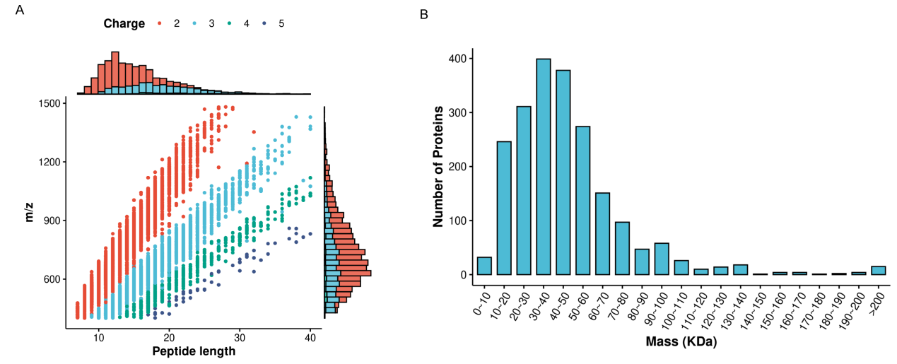
Figure S2. Distribution of peptide lengths(A) and Distribution plot of protein molecular weights(B)
Figure S3. KEGG functional categorization of differentially expressed proteins. DJF vs NF(A), JZF vs NF(B), XMF vs NF(C).

