Fig. S1 Heatmap of kindship matrix illustrating the degree of genetic relatedness or co-ancestry level between the 238 sweet fig banana accessions. The accessions were clustered into three groups. The histogram in the color key represents the number of coefficient values within the corresponding color bar.

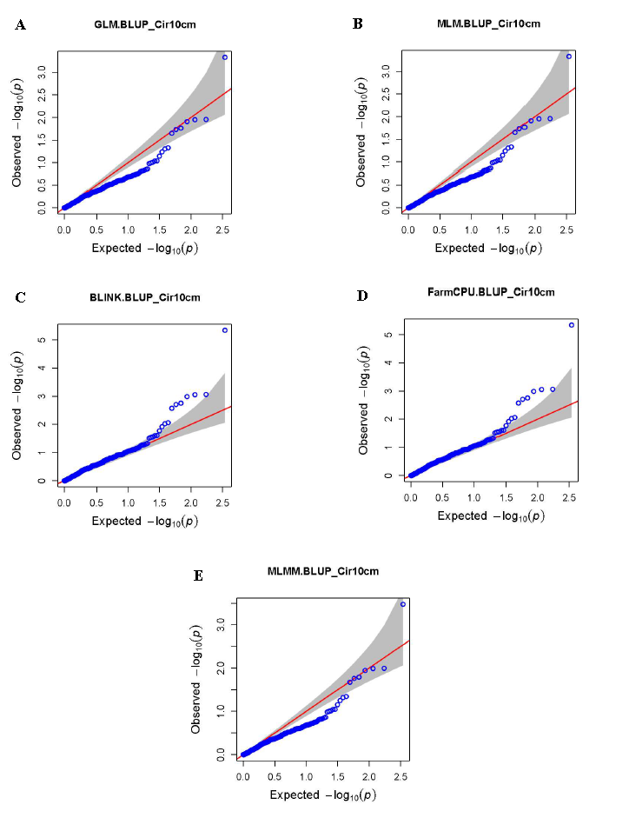
Fig. S2 Quantile-quantile (QQ) plots of the SNP-based association mappings for the circumference of sweet fig banana plants’ (Cir10cm) with (A) GLM, (B) MLM, (C) BLINK, (D) FarmCUP and (E) MLMM models.
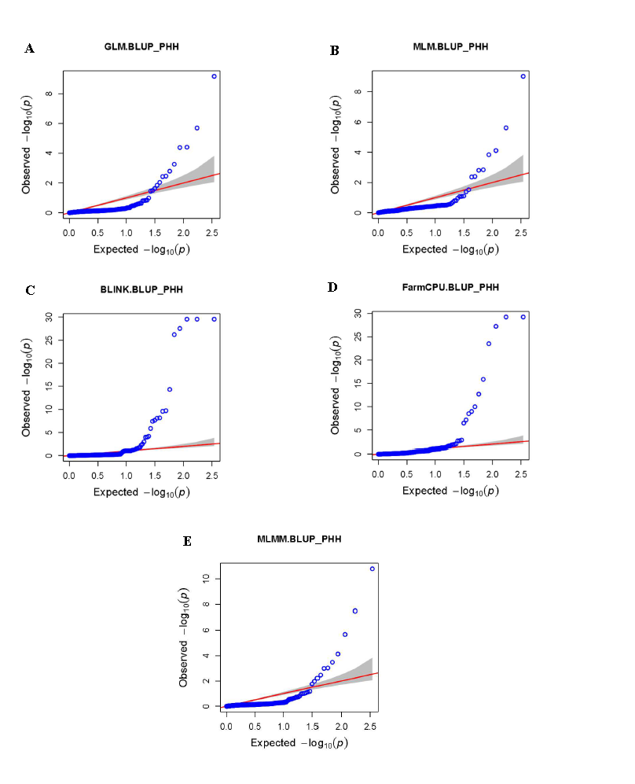
Fig. S3 Quantile-quantile (QQ) plots of the SNP-based association mappings for plant height at harvest (PHH) in 238 sweet fig banana accessions with (A) GLM, (B) MLM, (C) BLINK, (D) FarmCUP and (E) MLMM models.
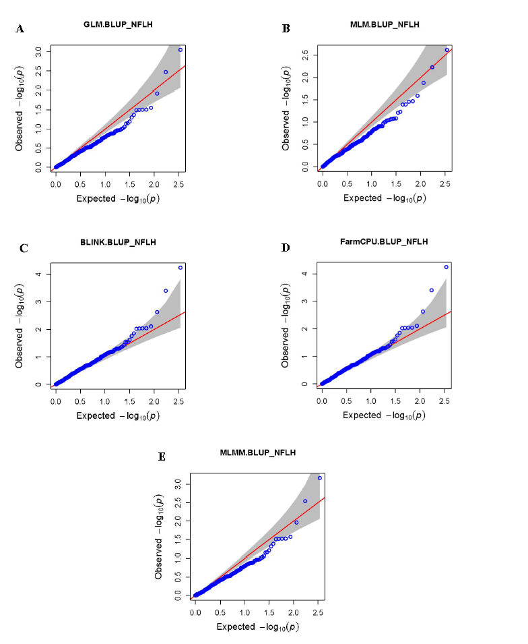
Fig. S4 Quantile-quantile (QQ) plots of the SNP-based association mappings for the number of functional leaves at the harvest trait (NFLH) with (A) GLM, (B) MLM, (C) BLINK, (D) FarmCUP and (E) MLMM models.
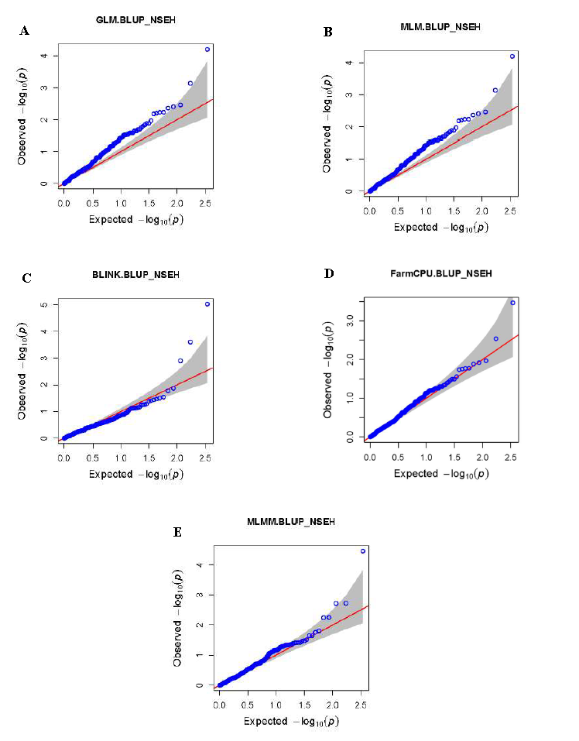

Fig. S5 Quantile-quantile (QQ) plots of the SNP-based association mappings for SNP-based association mappings for the number of suckers emitted (NSEH) trait with (A) GLM, (B) MLM, (C) BLINK, (D) FarmCUP and (E) MLMM models.
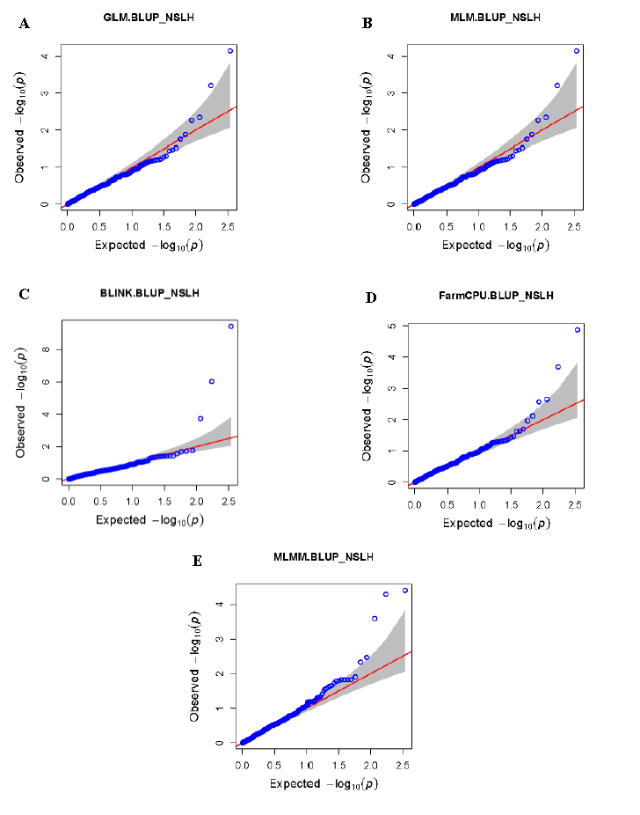
Fig. S6 Quantile-quantile (QQ) plots of the SNP-based association mappings for the number of suckers with more than 30 cm of length (NSLH) trait with (A) GLM, (B) MLM, (C) BLINK, (D) FarmCUP and (E) MLMM models.

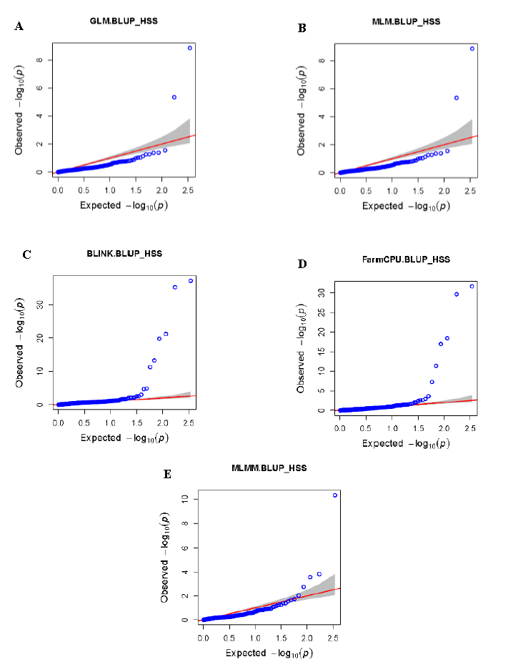
Fig. S7 Quantile-quantile (QQ) plots of the SNP-based association mappings for the length of the tallest/successor sucker trait (HSS) with (A) GLM, (B) MLM, (C) BLINK, (D) FarmCUP and (E) MLMM models.

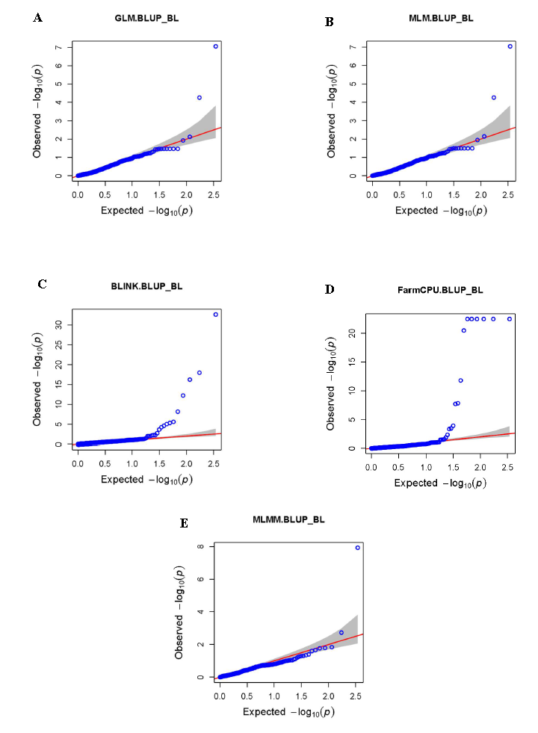
Fig. S8 Manhattan plots of the SNP-based association mappings for the bunch length (BL) in 238 sweet fig banana accessions, with (A) GLM, (B) MLM, (C) BLINK, (D) FarmCUP and (E) MLMM models.
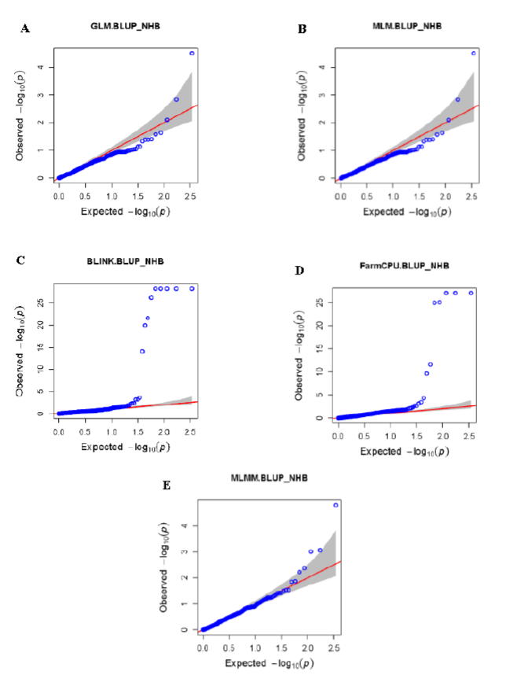
Fig. S9 Quantile-quantile (QQ) plots of the SNP-based association mappings for the number of hands per bunch (NHB) in 238 sweet fig banana accessions, with (A) GLM, (B) MLM, (C) BLINK, (D) FarmCPU and (E) MLMM models.
Fig. S10 Quantile-quantile (QQ) plots of the SNP-based association mappings for fruit weight (WFM) in 238 accessions of sweet fig banana with (A) GLM, (B) MLM, (C) BLINK, (D) FarmCUP and (E) MLMM models.

