Supplementary material Table: 1 List of PCR Primes used in present investigation
Oligo name | Sequence (5' > 3')
27_FP | AGAGTTTGATCCTGGCTCAG
1492_RP | TACGGYTACCTTGTTACGACTT
NemA_FP | TAGTCCGAGAGCGAAAGGGA
NemA_RP | AGCAATAATCGTCCCGCCTT
16S_FP | CAAGGCGACGATCCATAGCT
16S_RP | AGGAGTTTGGGCCGTGTCT
List of oligonucleotide primers used in the study. Sequences are shown in 5’ to 3’ direction

Supplementary material Figure: 1
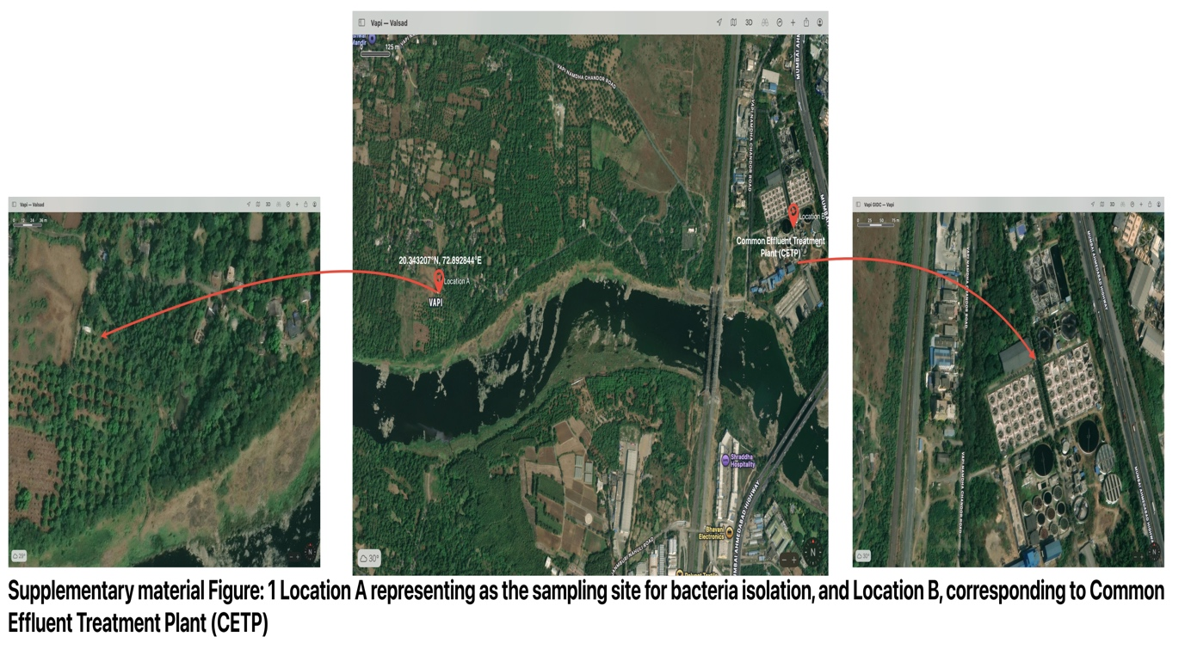

Supplementary material Figure: 2
