Supplementary Information

High-Resolution Geomechanical Modeling Reveals Accelerating Infrastructure Risks from Permafrost Degradation in Northern Alaska
Ziyi Wang¹; Ming Xiao²; and Dmitry Nicolsky³
¹Postdoctoral Fellow, Department of Civil and Environmental Engineering, Colorado School of Mines, Golden, CO 80401, United States of America. Email: ziyi.wang@mines.edu.
²Professor, Department of Civil and Environmental Engineering, The Pennsylvania State University, University Park, PA 16802, United States of America. Email: mzx102@psu.edu.
³Research Associate Professor, Geophysical Institute, University of Alaska Fairbanks, Fairbanks, AK 99775, United States of America. Email: djnicolsky@alaska.edu.

1 Study regions
The study region (Supplementary Fig. 1) is primarily covered with Quaternary unconsolidated surficial deposits, consisting mainly of silty sand (Wilson et al. 2015). Continuous permafrost (90%-100% of the area underlain by perennially frozen ground) underlies the region with a thickness ranging from 200 m to more than 600 m (Osterkamp & Payne 1981). Ice-rich permafrost is widely distributed in the region (Kanevskiy et al. 2013). The four coastal communities in northern Alaska are experiencing increased infrastructure challenges due to permafrost degradation. These communities are Utqiaġvik, Wainwright, Point Lay, and Kaktovik. The study region is ideal for geohazard assessment due to high-density observations of permafrost characteristics and the importance of Indigenous communities and regional socioeconomics.

Supplementary Fig. 1 Study region in northern Alaska. The locations of the four coastal communities—Utqiaġvik, Wainwright, Point Lay, and Kaktovik—are indicated as white markers on the surficial geology map (modified from Jorgenson et al. 2008). The extent of Alaska Arctic Coastal Plain is adapted from the polygonal tundra map (Lara et al. 2020). The digital elevation map is adapted from Polar Geospatial Center (Porter et al. 2018). Locator map shows the Arctic Coastal Plain (filled with red) in northern Alaska (right).

2 Input data for geomechanical modeling
Supplementary Fig. 2 shows the input data for geomechanical modeling. Soil information, including soil bulk density and clay content, were adapted from SoilGrids (Hengl et al. 2017). Excess ice content data in northern Alaska was adapted from Jorgenson et al. (2014). We only considered massive ice content and used the upper value of each range. The permafrost characteristics, including mean annual ground temperature, active layer thickness, and talik thickness, were simulated using the GIPL-2.0 model (Nicolsky et al. 2017).

Supplementary Fig. 2 Soil properties and permafrost characteristics. a-b, Maps of bulk density and clay content derived from SoilGrids (Hengl et al. 2017). c, Map of excess ice distribution (modified from Jorgenson et al. 2014). Only massive ice content is considered in excess ice. Our analysis uses the upper value of each classified range. d-i, Permafrost characteristics at 30-m resolution simulated by the GIPL2.0 model for the 2050s and 2090s using RCP8.5 climate forcing scenario.

Soil compressibility properties on the Alaska Arctic Coastal Plain are shown in Supplementary Fig. 3. Supplementary Figs. a, c, and e depict the spatial distribution of the frozen void ratio (e_{f}), thawed void ratio (e_{th}), and compressibility index (C_{c}*). Supplementary Figs. b, d, and f contain the corresponding histograms of each property.

Supplementary Fig. 3 Permafrost compressibility properties on the Arctic Coastal Plain. a, b, Spatial distribution of frozen void ratio and its data distribution. c, d, Thawed void ratio estimated from the frozen void ratio using an empirical equation derived from experimental data (Dumais and Konrad 2019). e, f, Spatial distribution of the permafrost compressibility index and its data distribution.

Supplementary Fig. 4 depicts the spatial patterns of creep parameters of Glen’s flow law and long-term strength of permafrost on the Arctic Coastal Plain. Supplementary Figs. a, b, and c show the creep parameters A and n and long-term strength σ_{th} for the 2020s under the RCP8.5 climate forcing scenario. Supplementary Figs. d, e, and f show the creep parameters and long-term strength for the 2050s, and Supplementary Figs. g, h, and i show those for the 2090s under the RCP8.5 scenario.

Supplementary Fig. 4 Spatiotemporal distributions of creep parameters of Glen’s flow law and long-term strength of permafrost on the Arctic Coastal Plain. a-c, Projections for the 2020s. d-f, Projections for the 2050s. g-i, Projections for the 2090s. Permafrost dynamics are simulated under RCP8.5 climate forcing. Grid cells with mean annual ground temperatures above 0°C are excluded.

The histograms of the creep parameters and long-term strength of permafrost on the Arctic Coastal Plain are shown in Supplementary Fig. 5. The histograms contain calculated parameters for the 2020s, 2050s, and 2090s under the RCP8.5 climate forcing scenario.

Supplementary Fig. 5 Histograms of creep parameters of Glen’s flow law and long-term strength of permafrost on the Arctic Coastal Plain. a-c, Projections for the 2020s. d-f, Projections for the 2050s. g-i, Projections for the 2090s. All projections are based on RCP8.5 climate forcing.

3 Infrastructure risk assessment
Supplementary Fig. 6 illustrates the flow chart of infrastructure risk assessment. The raster cells within each of the community’s polygons were extracted from the hazard maps for analysis. The infrastructure risk assessment was performed using ArcGIS Pro software (ESRI 2024).

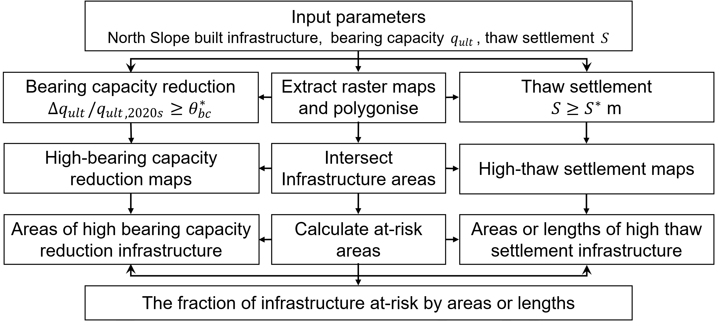
Supplementary Fig. 6 Flow chart of infrastructure risk assessment. Geospatial data on projected bearing capacity and thaw settlement is used as input to identify at-risk areas of civil infrastructure. Each step is performed in the ArcGIS Pro software (ESRI 2024).

4 Source of uncertainties in the infrastructure hazard assessment framework
Cryolithology plays a crucial role in thaw settlement estimates, yet mapping of excess ground ice remains coarse. Vegetation and snow cover, organic layer thickness, lithology, and salinity also strongly influence ground thermal regimes; however, these variables are not well constrained at the community scale. We recommend systematic geotechnical and geophysical surveys to improve the spatial resolution of input parameters.

We consider the ultimate settlement from the drainage of excess melt water and pore water in our thaw settlement estimation. However, the time required for pore water drainage and to reach ultimate settlement is not considered in the current framework. Future research can incorporate the time factor in thaw consolidation (Wang et al. 2023b) to improve the accuracy of settlement predictions.

In our bearing capacity estimation, we apply a standard 5-m deep circular footing to represent general conditions in permafrost regions. To assess potential variation, we explicitly compare deep circular footings and shallow strip footings in Supplementary Fig. 7, where the x-axis represents the ultimate bearing capacity of circular pile foundation, and the y-axis represents the ultimate bearing capacity of shallow strip foundation. The bearing capacity was calculated across the Arctic Coastal Plain. The results indicate that bearing capacity differences between the two foundation types are negligible below 2000 kPa. Since 2000 kPa is considered high for most civil infrastructure, using the standard pile foundation for regional-scale analysis is reasonable.

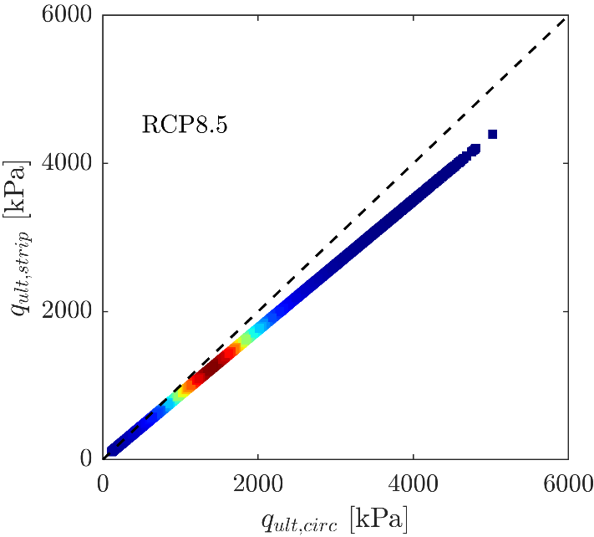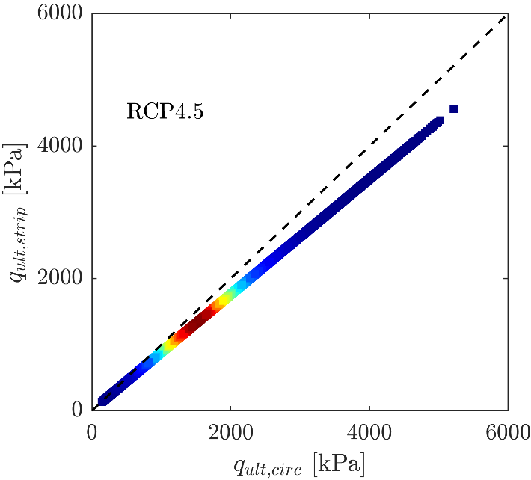
(a) (b)
Supplementary Fig. 7 Comparison of bearing capacity estimates for deep circular footings and shallow strip footings. Scatter plots of bearing capacity for the two types of foundations by the 2050s under (a) RCP8.5 and (b) RCP4.5. Point color indicates local data density—warmer colors denote higher densities. Each data point represents a raster cell across the Arctic Coastal Plain.

Cryopegs are layers of perennially cryotic (< 0℃) soils that remain unfrozen due to high salinity (Everdingen 2005). Cryopegs are commonly observed in Arctic deltas and coastal regions (e.g., in the marine silt coastal areas of the Beaufort Sea) (Stephani et al. 2020). Cryopegs pose challenges to infrastructure stability because unfrozen, high-salinity soils exhibit significantly lower strength than permafrost. However, the current framework does not consider the role of cryopegs in infrastructure hazard assessment. Future hazard mapping can integrate cryopeg-probability analysis to better support land-use planning and inform engineering projects in cryopeg-prone regions.

Supplementary Table 1 Symbol and definition.
Symbol | Definition
$\overline{S_{e}}$ | Mean thaw subsidence
$\dot{S_{e}}$ | Thaw subsidence rate
${\overline{q}}_{ult}$ | Mean ultimate bearing capacity
$C_{c}^{*}$ | Coefficient of compressibility
$C_{v}$ | Volumetric heat capacity
$I_{risk}$ | Proportion of infrastructure at risk
$N_{cells}$ | Number of grid cells across the Arctic Coastal Plain
$N_{q}$, $N_{c}$ | Bearing capacity factors
$\overline{S}$ | Mean thaw settlement
$S^{*}$ | Thaw settlement threshold
$S_{c}$ | Settlement related to compression of the soil skeleton
$S_{e}$ | Subsidence related to excess ice melt
$S_{p}$ | Settlement related to phase change
$e_{f}$ | Frozen void ratio
$e_{i}^{*}$ | Initial thawed void ratio
$e_{th}$ | Thawed void ratio
$p_{0}$ | Ground overburden pressure
$q_{ult,circ}$ | Bearing capacity of deep circular footing
$q_{ult,strip}$ | Bearing capacity of shallow strip footing
$q_{ult}$ | Ultimate bearing capacity
$t_{f}$ | Service life of civil infrastructure
$θ_{bc}^{*}$ | Bearing capacity reduction threshold
$θ_{excess,ice}$ | Volumetric content of excess ice
$θ_{s}$ | Volumetric soil particle fraction
$θ_{w}$ | Volumetric water content
$σ_{0}^{'}$ | Residual stress
$σ_{lt}$ | Long-term strength
$ϵ_{f}$ | Failure strain
$∆Z$ | Changes in the permafrost table
$∆q$ | Vertical stress
$A$, $n$ | Empirical parameters of Glen’s flow law
$ALT$ | Active layer thickness
$L$ | Volumetric latent heat of fusion
$S$ | Total thaw settlement
$T$ | Ground temperature
$TT$ | Talik thickness
$c$ | Long-term cohesion
$e$ | Void ratio
$z$ | Depth from the soil or snow surface
$λ$ | Thermal conductivity

5 References
Dumais, S. & Konrad, J. M. Large-strain nonlinear thaw consolidation analysis of the Inuvik warm-oil experimental pipeline buried in permafrost. J. Cold Reg. Eng. 33, 04018014 (2019).
ESRI. ArcGIS Pro (Version 3.X) [Computer software] (Esri, 2024); https://www.esri.com/en-us/arcgis/products/arcgis-pro/overview
Hengl, T. et al. SOILGRIDS250M: Global gridded soil information based on machine learning. PLoS ONE 12, e0169748 (2017).
Jorgenson, M. T. et al. Permafrost characteristics of Alaska. Proc. 9th Int. Conf. Permafrost 3, 121–122 (2008).
Jorgenson, M. T. et al. Permafrost database development, characterization, and mapping for northern Alaska (Univ. Alaska Fairbanks, 2014); http://hdl.handle.net/11122/10373
Kanevskiy, M. et al. Ground ice in the upper permafrost of the Beaufort Sea coast of Alaska. Cold Reg. Sci. Technol. 85, 56–70 (2013).
Lara, M. J. et al. Local-scale Arctic tundra heterogeneity affects regional-scale carbon dynamics. Nat. Commun. 11, 4925 (2020).
Nicolsky, D. J. et al. Applicability of the ecosystem type approach to model permafrost dynamics across the Alaska North Slope. J. Geophys. Res. Earth Surf. 122, 50–75 (2017).
Osterkamp, T. E. & Payne, M. W. Estimates of permafrost thickness from well logs in northern Alaska. Cold Reg. Sci. Technol. 5, 13–27 (1981).
Porter, C. et al. ArcticDEM (Version 3) [Dataset]. Harvard Dataverse (2018); https://doi.org/10.7910/DVN/OHHUKH
Stephani, E., Drage, J., Miller, D., Jones, B. M. & Kanevskiy, M. Taliks, cryopegs, and permafrost dynamics related to channel migration, Colville River Delta, Alaska. Permafrost Periglac. Process. 31, 239–254 (2020).
van Everdingen, R. O. (ed.) Multi-language Glossary of Permafrost and Related Ground-Ice Terms (Arctic Institute of North America, 1998; revised 2005).
Wang, Z. et al. Arctic coastal hazard assessment considering permafrost thaw subsidence, coastal erosion, and flooding. Environ. Res. Lett. 18, 104003 (2023b).
Wilson, F. H., Hults, C. K., Mull, C. G. & Karl, S. M. Geologic map of Alaska. U.S. Geol. Surv. Sci. Invest. Map 3340 (2015); https://doi.org/10.3133/sim3340

