TABLES
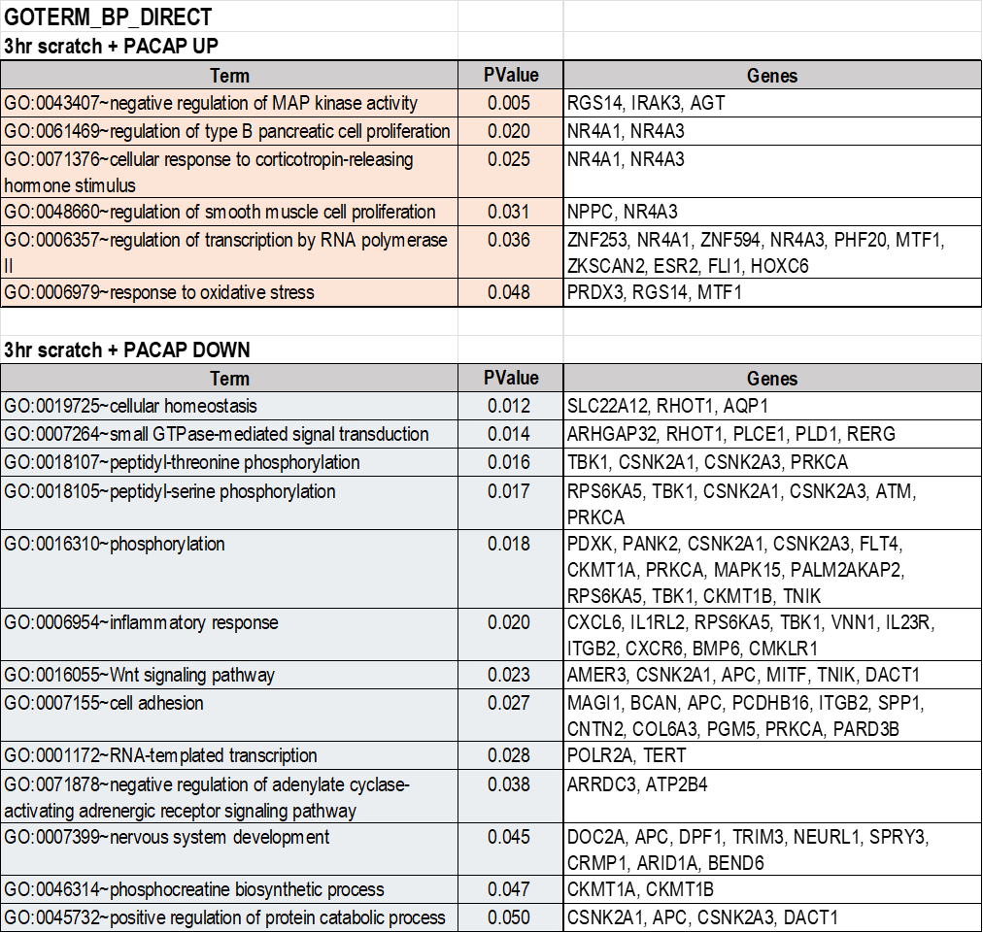
Table 1. Enrichment analysis of genes whose expression changed 3 hours after the addition of PACAP to HCEC2 cell culture medium. The list of genes showing altered expression was classified into GOTERM_BP_DIRECT using the DAVID tool. Only terms with a p value <0.05 by the DAVID tool are shown.

Table 2. Enrichment analysis of the genes whose expression changed 3 hours after the addition of PACAP to HCEC2 cell culture medium. The list of genes showing altered expression was classified into GOTERM_MF_DIRECT using the DAVID tool. Only terms with a p value <0.05 by the DAVID tool are shown.
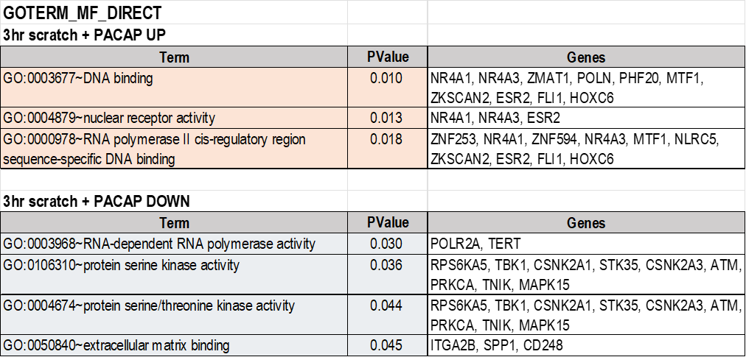

Table 3. Enrichment analysis of the genes whose expression changed 18 hours after the addition of PACAP to HCEC2 cell culture medium. The list of genes showing altered expression was classified into GOTERM_BP_DIRECT using the DAVID tool. Only terms with a p value <0.05 by the DAVID tool are shown.
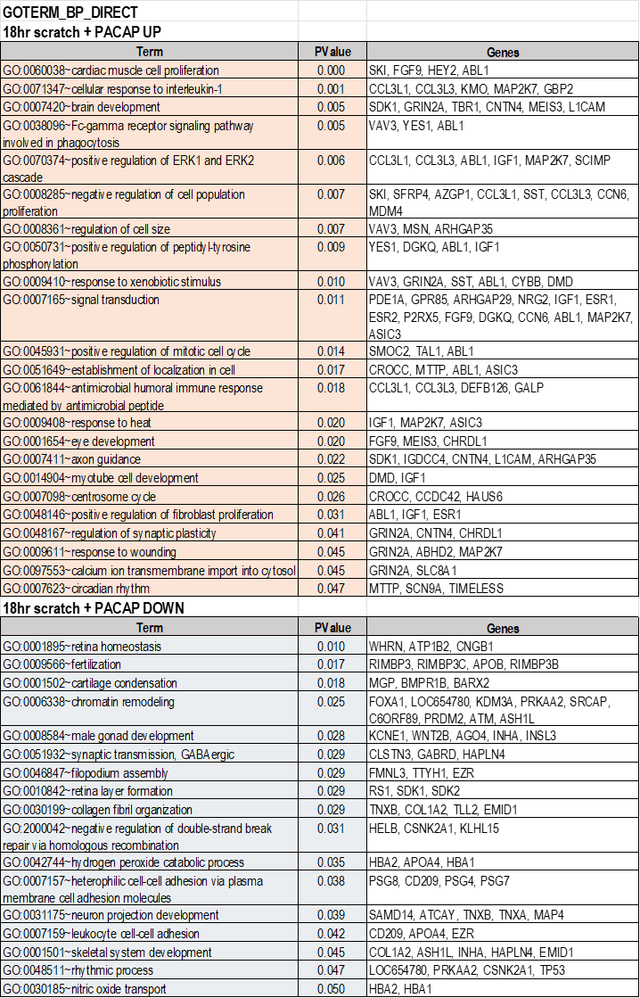

Table 4. Enrichment analysis of the genes whose expression changed 18 hours after the addition of PACAP to HCEC2 cell culture medium. The list of genes showing altered expression was classified into GOTERM_MF_DIRECT using the DAVID tool. Only terms with a p value <0.05 by the DAVID tool are shown.
