SUPPLEMENTARY INFORMATION
Supplemental Fig. 1. Effect of PACAP eye drops on tear secretion in lacrimal gland-removed mice.

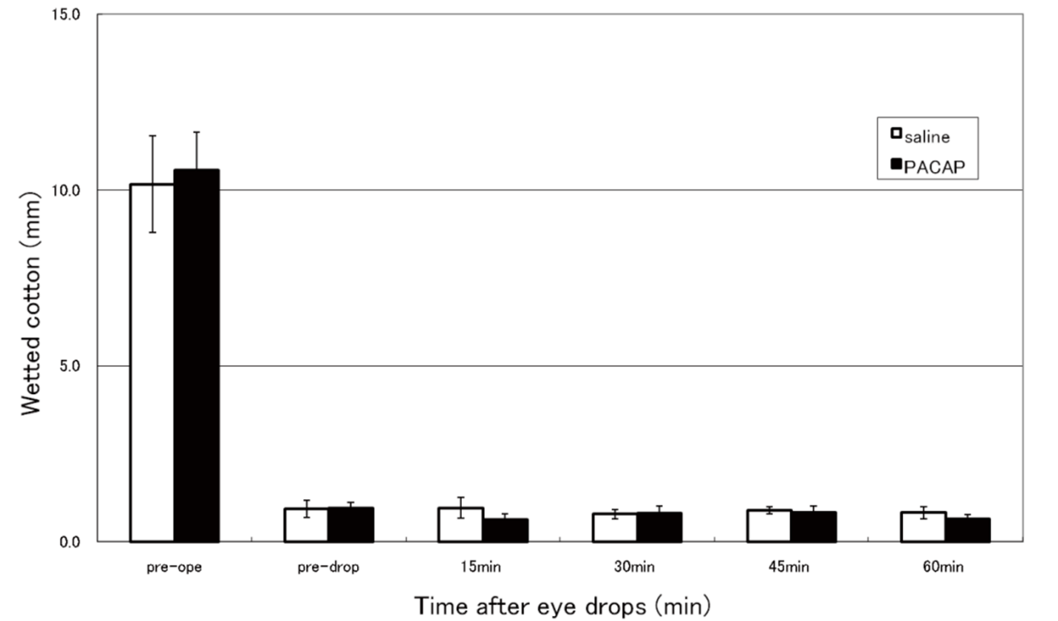

Supplemental Fig. 2. In vitro scratch injury on cultured monolayer of SV40-human corneal epithelium cell line. Typical images of injury site (A) and graph of injury area (B) at 6 h timepoint following PACAP treatment.

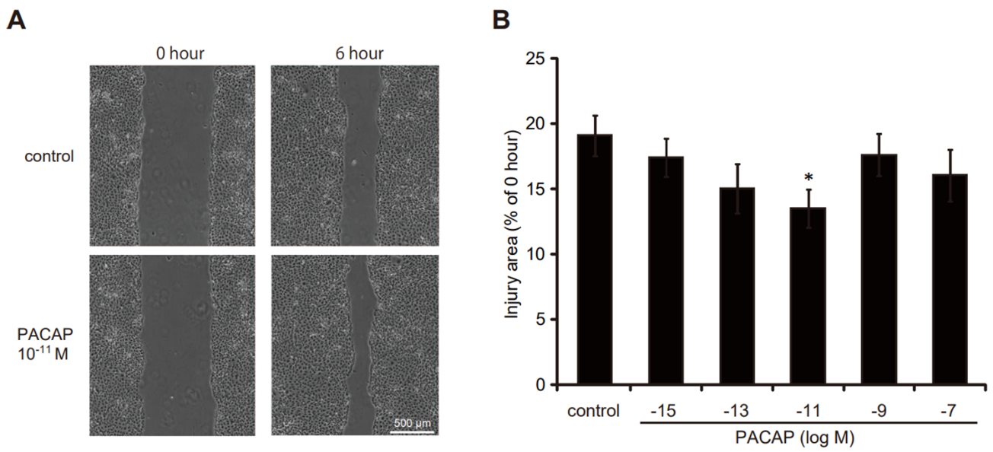

Supplemental Fig. 3. Number of genes in the HCEC2 cell scratch assay showing variable expression by DNA microarray analysis. The number of genes that changed in the 3 hours after PACAP addition was 336 (up-regulated) and 209 (down-regulated) genes in the PACAP group, compared to 114 (up-regulated) and 337 (down-regulated) genes in the PACAP + scratch group. Eighteen hours after PACAP addition, there was 117 (up-regulated) and 681 (down-regulated) genes in the PACAP group, compared to 173 (up-regulated) and 352 (down-regulated) genes in the PACAP + scratch group.

