Supplementary Materials for
Modular-level alterations of single-subject gray matter networks in schizophrenia

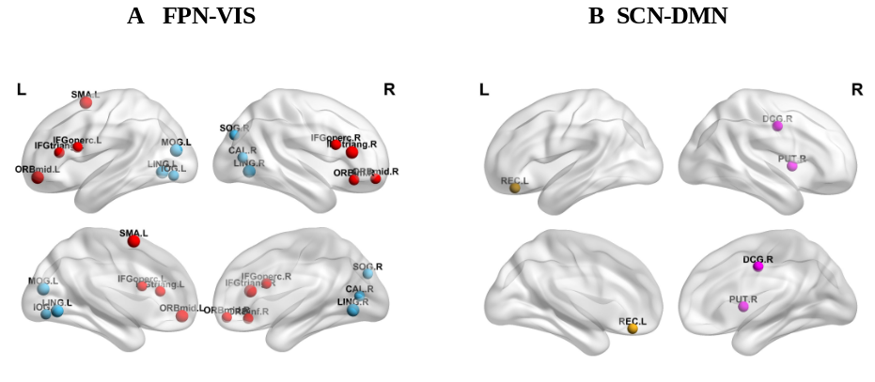
Figure S1 Intermodule nodal strength exhibiting significant alterations in schizophrenia versus control participants. Left figure is schizophrenia exhibited decreased FPN-VIS intermodule nodal strength and right figure is SCN-DMN. Abbreviations: ORBmid: middle frontal gyrus(orbital part); IFGoperc: inferior frontal gyrus(opercular part) ; IFGtriang: inferior frontal gyrus(triangular part); ORBinf: inferior frontal gyrus(orbital part); SMA: supplementary motor area ; CAL: calcarine fissure ; LING: lingual gyrus; SOG: superior occipital gyrus; MOG: middle occipital gyrus; IOG: inferior occipital gyrus; REC: gyrus rectus; MCG median cingulate and paracingulate gyri ;PUT: lenticular nucleus, putamen.

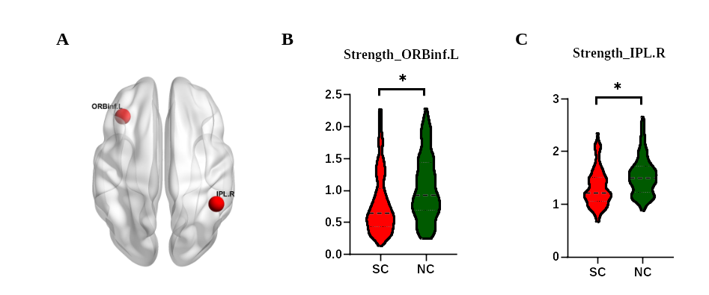
Figure S2 Intramodule nodal strength exhibiting significant alterations in schizophrenia versus control participants. Abbreviations: ORBinf: orbital part of middle frontal gyrus; IPL: Inferior parietal, but supramarginal and angular gyri.

Table S1 Mapping between ROI names and experiential function networks in AAL template
ROI | Regions | Network | ROI | Regions |  | ROI | Regions | Network
1 | Precentral_L | DMN | 31 | Cingulum_Ant_L | DMN | 61 | Parietal_Inf_L | FPN
2 | Precentral_R | DMN | 32 | Cingulum_Ant_R | DMN | 62 | Parietal_Inf_R | FPN
3 | Frontal_Sup_L | DMN | 33 | Cingulum_Mid_L | SCN | 63 | SupraMarginal_L | SMN
4 | Frontal_Sup_R | DMN | 34 | Cingulum_Mid_R | SCN | 64 | SupraMarginal_R | SMN
5 | Frontal_Sup_Orb_L | DMN | 35 | Cingulum_Post_L | DMN | 65 | Angular_L | FPN
6 | Frontal_Sup_Orb_R | DMN | 36 | Cingulum_Post_R | DMN | 66 | Angular_R | FPN
7 | Frontal_Mid_L | FPN | 37 | Hippocampus_L | SCN | 67 | Precuneus_L | DMN
8 | Frontal_Mid_R | FPN | 38 | Hippocampus_R | SCN | 68 | Precuneus_R | DMN
9 | Frontal_Mid_Orb_L | FPN | 39 | ParaHippocampal_L | SCN | 69 | Paracentral_Lobule_L | SMN
10 | Frontal_Mid_Orb_R | FPN | 40 | ParaHippocampal_R | SCN | 70 | Paracentral_Lobule_R | SMN
11 | Frontal_Inf_Oper_L | FPN | 41 | Amygdala_L | SCN | 71 | Caudate_L | SCN
12 | Frontal_Inf_Oper_R | FPN | 42 | Amygdala_R | SCN | 72 | Caudate_R | SCN
13 | Frontal_Inf_Tri_L | FPN | 43 | Calcarine_L | VIS | 73 | Putamen_L | SCN
14 | Frontal_Inf_Tri_R | FPN | 44 | Calcarine_R | VIS | 74 | Putamen_R | SCN
15 | Frontal_Inf_Orb_L | FPN | 45 | Cuneus_L | VIS | 75 | Pallidum_L | SCN
16 | Frontal_Inf_Orb_R | FPN | 46 | Cuneus_R | VIS | 76 | Pallidum_R | SCN
17 | Rolandic_Oper_L | SMN | 47 | Lingual_L | VIS | 77 | Thalamus_L | SCN
18 | Rolandic_Oper_R | SMN | 48 | Lingual_R | VIS | 78 | Thalamus_R | SCN
19 | Supp_Motor_Area_L | FPN | 49 | Occipital_Sup_L | VIS | 79 | Heschl_L | SMN
20 | Supp_Motor_Area_R | SMN | 50 | Occipital_Sup_R | VIS | 80 | Heschl_R | SMN
21 | Olfactory_L | SCN | 51 | Occipital_Mid_L | VIS | 81 | Temporal_Sup_L | SMN
22 | Olfactory_R | DMN | 52 | Occipital_Mid_R | VIS | 82 | Temporal_Sup_R | SMN
23 | Frontal_Sup_Medial_L | DMN | 53 | Occipital_Inf_L | VIS | 83 | Temporal_Pole_Sup_L | FPN
24 | Frontal_Sup_Medial_R | DMN | 54 | Occipital_Inf_R | VIS | 84 | Temporal_Pole_Sup_R | SMN
25 | Frontal_Mid_Orb_L | DMN | 55 | Fusiform_L | VIS | 85 | Temporal_Mid_L | DMN
26 | Frontal_Mid_Orb_R | DMN | 56 | Fusiform_R | VIS | 86 | Temporal_Mid_R | DMN
27 | Rectus_L | DMN | 57 | Postcentral_L | SMN | 87 | Temporal_Pole_Mid_L | SCN
28 | Rectus_R | DMN | 58 | Postcentral_R | SMN | 88 | Temporal_Pole_Mid_R | SCN
29 | Insula_L | SMN | 59 | Parietal_Sup_L | SMN | 89 | Temporal_Inf_L | FPN
30 | Insula_R | SMN | 60 | Parietal_Sup_R | SMN | 90 | Temporal_Inf_R | DMN

Table S2 Patients with schizophrenia exhibited decreased intermodule nodal strength of FPN-VIS
brain regions (FPN-VIS) | NC | SC | p value (FDR)
left middle frontal gyrus, orbital part | 0.37±0.04 | 0.21±0.03 | 0.006
right middle frontal gyrus, orbital part | 0.43±0.05 | 0.26±0.03 | 0.015
left inferior frontal gyrus, opercular part | 0.26±0.04 | 0.14±0.02 | 0.016
righ inferior frontal gyrus, opercular part | 0.71±0.07 | 0.47±0.05 | 0.016
left inferior frontal gyrus, triangular part | 1.06±0.08 | 0.75±0.07 | 0.015
righ inferior frontal gyrus, triangular part | 1.43±0.09 | 1.06±0.07 | 0.006
righ inferior frontal gyrus, orbital part | 1.95±0.07 | 1.68±0.07 | 0.020
left supplementary motor area | 1.83±0.09 | 1.43±0.08 | 0.006
righ calcarine fissure and surrounding cortex | 0.86±0.06 | 0.66±0.05 | 0.024
left lingual gyrus | 1.66±0.05 | 1.39±0.05 | 0.003
righ lingual gyrus | 1.8±0.06 | 1.5±0.05 | 0.003
righ superior occipital gyrus | 1.87±0.05 | 1.67±0.05 | 0.015
left middle occipital gyrus | 1.56±0.04 | 1.37±0.04 | 0.006
left inferior occipital gyrus | 1.7±0.04 | 1.56±0.04 | 0.025

Table S3 Patients with schizophrenia exhibited decreased intermodule nodal strength of SCN-DMN
brain regions (SCN-DMN) | NC | SC | p value (FDR)
left gyrus rectus | 0.89±0.06 | 0.63±0.05 | 0.018
right median cingulate and paracingulate gyri | 1.22±0.07 | 0.93±0.06 | 0.037
right lenticular nucleus, putamen | 0.93±0.05 | 0.66±0.06 | 0.018

