Patterns, Drivers, and Trends of Urban Cooling Demand across Global Cities

Section 1

- Data sources
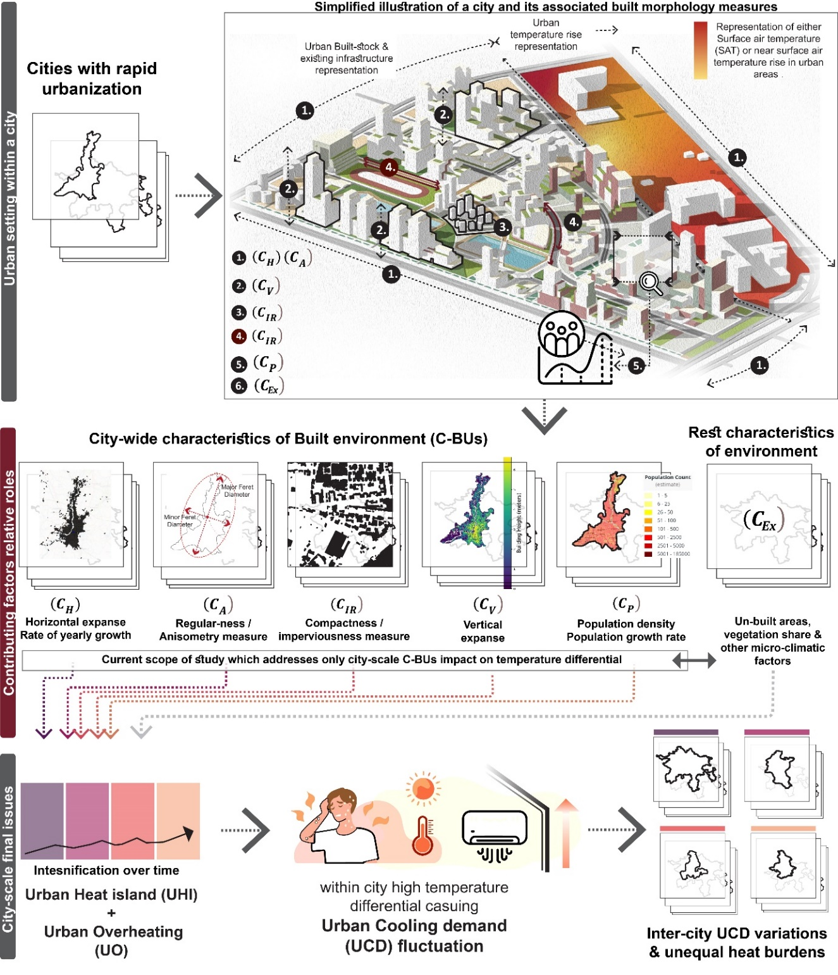
Supplementary Figure 1. Illustration highlighting city-scale volumetric alterations and citywide temperature differentials as indicators of UCD variations, leading to unequal heat burdens within the city. The dark red annotated section focuses on the relative roles of city-scale growth features in UCD variations, which is the scope of this current study.
1.1 City volumetrics data

1.1.1 City horizontal extent data${(C}_{H})$ and its annual growth
The dataset for the horizontal extent ${(C}_{H})$ of built-up areas in cities was derived from the MODIS land use data (MCD12Q1), covering a study period from 2002 to 2023. All these datasets were accessed from the EOSDIS (https://earthdata.nasa.gov/). The box-counting algorithm was employed to compute the fractal dimension for each urban cluster, where the minimum counting size of 0.5 km x 0.5 Km matching with the data set resolution. This approach, of using urban built-up areas as a proxy for city size followed the approach adapted by previous studies^{1,2}. Further to cross validate the lateral expansion data, GHSL built-up surface data is accessed from https://human-settlement.emergency.copernicus.eu/index.php and resampled to 1km x 1 km pixel within city boundary averaged over 2002-2023. A buffer of 5 km is followed around the average city boundary to capture the total built-up surface in urban to rural infringes in the given period. Measure of annual rise of ${ C}_{H}$ is further recorded to highlight the rate at which city grows out laterally.

1.1.2 City Anisomery measure ${(C}_{A})$
It refers to the variation in the horizontal shape and dimensions of urban areas. It assesses how a city's geometric properties differ across the two main axes of its best-fitting bounding ellipse. To estimate C_{A}, we utilized city area shapefiles from GUB shapefile provided by (https://data-starcloud.pcl.ac.cn/iearthdata/), first mentioned in³, along with city urban boundaries provided by Sethi et al. 2024⁴. $C_{A}$ is defined as the ratio of the city's maximum Feret’s diameter to its minimum Feret’s diameter ^{1,5,6}. Feret’s diameter represents the distance between two parallel tangents to an object along a specific direction. This anisometry measure also reflects the long-term lateral expansion pattern of a city. For instance, a value close to one indicates monocentric radial growth, while values greater than one suggest linear expansion in a particular direction^{7,8}.

1.1.3 City imperviousness ratio${ (C}_{IR})$
The ${(C}_{H})$ measures the overall urban extent and built-up area coverage for a city, but all the urban built landcovers are not consisting of impervious surfaces or actual buildings. In this context, we define the urban imperviousness ratio ${(C}_{IR})$ as the actual built ground coverage relative to the overall urban land cover for a specific urban neighborhood. This ratio reflects the share of the area covered by buildings and paved surfaces in relation to the density of buildings within the urban core (typically a 5 km radius from the city centroid). ${(C}_{IR})$ serves as a proxy for city core imperviousness by incorporating both building and paved surface coverage. For this purpose, Google-Open Buildings V3 Polygons data set (https://sites.research.google/gr/open-buildings/) is used^{9,10}. This estimation also provides insights into the density and horizontal extent of built-up areas within the city core.

1.1.4 City vertical extent data ${(C}_{V})$ and its annual growth
The $C_{V}$ metric measures the vertical rise distribution of buildings within the average urban extent of cities and is a key parameter for assessing volumetric urban growth in association with urban horizontal extent (C_{BU}). The GHS Built-Up Height (R2023) dataset (https://human-settlement.emergency.copernicus.eu/index.php) from the Global Human Settlement Layer (GHSL) ¹¹ were used , which includes the average net building height. The spatial raster dataset represents building heights derived from global digital elevation models (ALOS AW3D30 and SRTM30) and refined using shadow markers from Sentinel-2 imagery (2018 composite). Linear regression techniques were applied to filter and update the extracted heights for accurate spatial distribution. Four sub-features: i.e., $C_{V(0-25)}$, $C_{V(25-50)}$, $C_{V(50-75)}$, $C_{V(75-100)}$ were used to analyses the distribution of city vertical rise thresholds based on the percentile shares, representing the 0th to 25th, 25th to 50th, 50th to 75th, and 75th to 100th percentiles, respectively. When analyzing the vertical rise of cities, data is often organized into percentiles to understand the distribution of building heights rather than taking averages within the city-lateral extent¹².

1.1.5 Population Rise data ${(C}_{P})$
The population dataset for the period 2002-2023 was sourced from the Oak Ridge National Laboratory dataset (https://landscan.ornl.gov/). These datasets, originally is in 1 km resolution, and also used for the further analysis in population weighted cooling degree days estimation in subsequent section. Population variations for each city were then calculated by averaging the population estimates across all grid cells within the defined boundaries of each city horizontal extent. For tracking the population density growth trend the simple exponential relation, i.e. -P(t)$=P_{0}e^{r.t}$ , is adapted here, where r is the growth rate expressed in percentage. Under the C_{p} features C_{P(t)} is the current 2023 population density (number of people per square kilometer) value and C_{P(r)} represents the population rise trend per annum.

Supplementary Table 1. Final list of independent built urbanization features and their relative weights while classifying Indian and global cities

Sl. No. | Features of city urban growth |  | Adjusted Weightage while  k-means clustering
1 | $$C_{A}$$ | City Anisometry | 2
2 | $$C_{H}$$ | City Area_2023  (Sq. Km) | 3
3 | $$C_{H}$$ | Annual rise (%) in City Horizontal Extent | 0.5
4 | $$C_{P}$$ | Average Population density (2002-2023 period)  ( ppl/Sq. Km) | 3
5 | $$C_{P}$$ | Annual rise (%) in Population | 0.5
6 | $$C_{IR}$$ | Built-ground coverage (%) in city urban-core of 5km | 2
7 | $$C_{V}$$ | Threshold vertical rise in meter  (0-25 percentile) | 1
8 | $$C_{V}$$ | Threshold vertical rise within  (25-50 percentile) | 2
9 | $$C_{V}$$ | Threshold vertical rise in meter  (50-75 percentile) | 2
10 | $$C_{V}$$ | Threshold vertical rise in meter  (75-100 percentile) | 1
11 |  | Daytime LST rise | 0.5
12 |  | Nighttime LST rise | 0.5
Legend |  | Primary features
 |  | Secondary features

1.1.6 Updating the city profiling with their surface warming trends
The city profiling is completed solely based on the features of volumetric growth features as explained in table S1 and surface warming trends. MODIS datasets (2002–2023) were primarily used for this section of study where land surface temperature (MYD11A2, Aqua LST) datasets were mapped along the city extents for past two decades to record the warming trend. These datasets were accessed from the EOSDIS (https://earthdata.nasa.gov/), while majority of the analysis was done in Google Earth Engine platform. The LST dataset includes two overpasses per day (at ~01:30 am and ~13:30 pm local solar time). The spatial resolution of the LST data is 1 km, and thus, the rest of the volumetric growth feature data were resampled to 1km to match the resolution of the LST data using the nearest neighborhood method.

Supplementary Table 2. Profiling of Indian cities based solely on urban growth features and warming trends.

City profiling | Cities | Common Features of city urban growth
Type-I | Delhi, Kolkata, Mumbai, Pune, Bangalore, Chennai, Hyderabad, Ahmedabad | Large cities, high population density, high vertical development, high built-ground coverage, irregular city shape
Type-II | Amritsar, Jaipur, Kochi, Lucknow, Nagpur, Patna, Raipur, Surat, Agra, Kanpur, Puducherry, Gorakhpur, Nashik, Mysuru, Ludhiana, Aligarh, Vadodara, Panipat, Rajkot, Udaipur, Tirupati, Firozabad, Bareilly, Vijayawada, Muzaffarpur, Coimbatore, Ranchi, Madurai, Jodhpur | Medium cities, high population density, moderate vertical development, high to moderate built-ground coverage, irregular city shape
Type-III | Srinagar, Dehradun, Farrukhabad, Jamnagar, Khammam, Gulbarga, Malegaon, Kolhapur, Dhule, Shillong, Amravati, Dhanbad, Cuttack, Siliguri, Akola, Jhansi, Karnal, Vellore, Hisar, Thoothukudi, Gwalior, Rourkela, Ahmednagar, Indore, Solapur, Durgapur, Bhavnagar, Thanjavur, Bardhhaman | Medium to Small cities, medium population density, moderate vertical development, moderate built-ground coverage, irregular city shape
Type-IV | Bhopal, Bhubaneswar, Chandigarh, Jamshedpur, Visakhapatnam, Ajmer, Jabalpur, Rewa, Bilaspur, Imphal, Patiala, Mangalore, Bhagalpur, Rajahmundry, Gaya, Bhilai and Durg, Aurangabad, Satna, Asansol, Darbhanga, Trichy, Hubli-Dharwad | Smaller cities, low to medium population density, low vertical development, low built-ground coverage, compact city shape

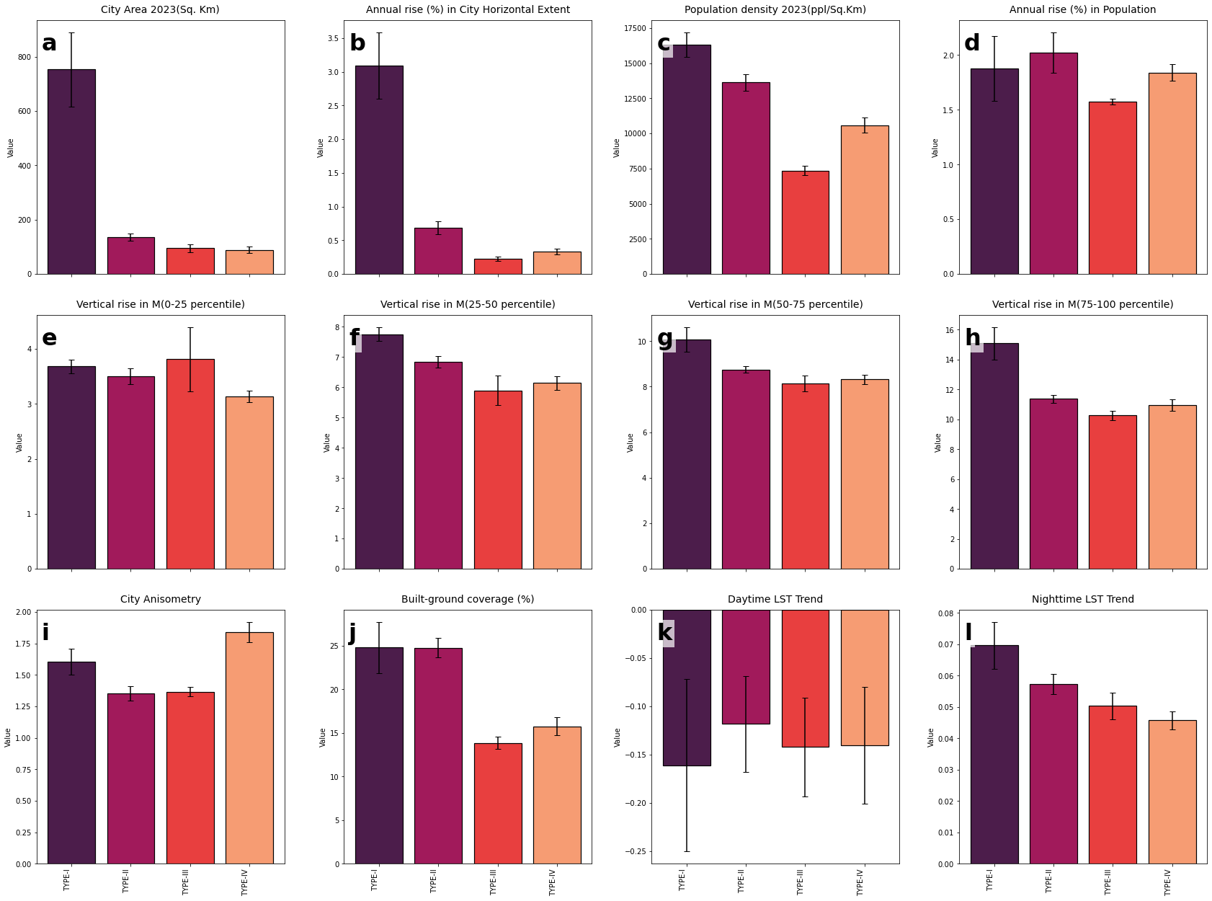

Supplementary Figure 2. The distribution of city-built volumetrics across Indian cities: The bar diagram (mean ± standard error) plots represent the extent of urban parameters across four city profiles (type I to type IV). Where subplots a to i indicate various city volumetrics feature and land surface warming trends.
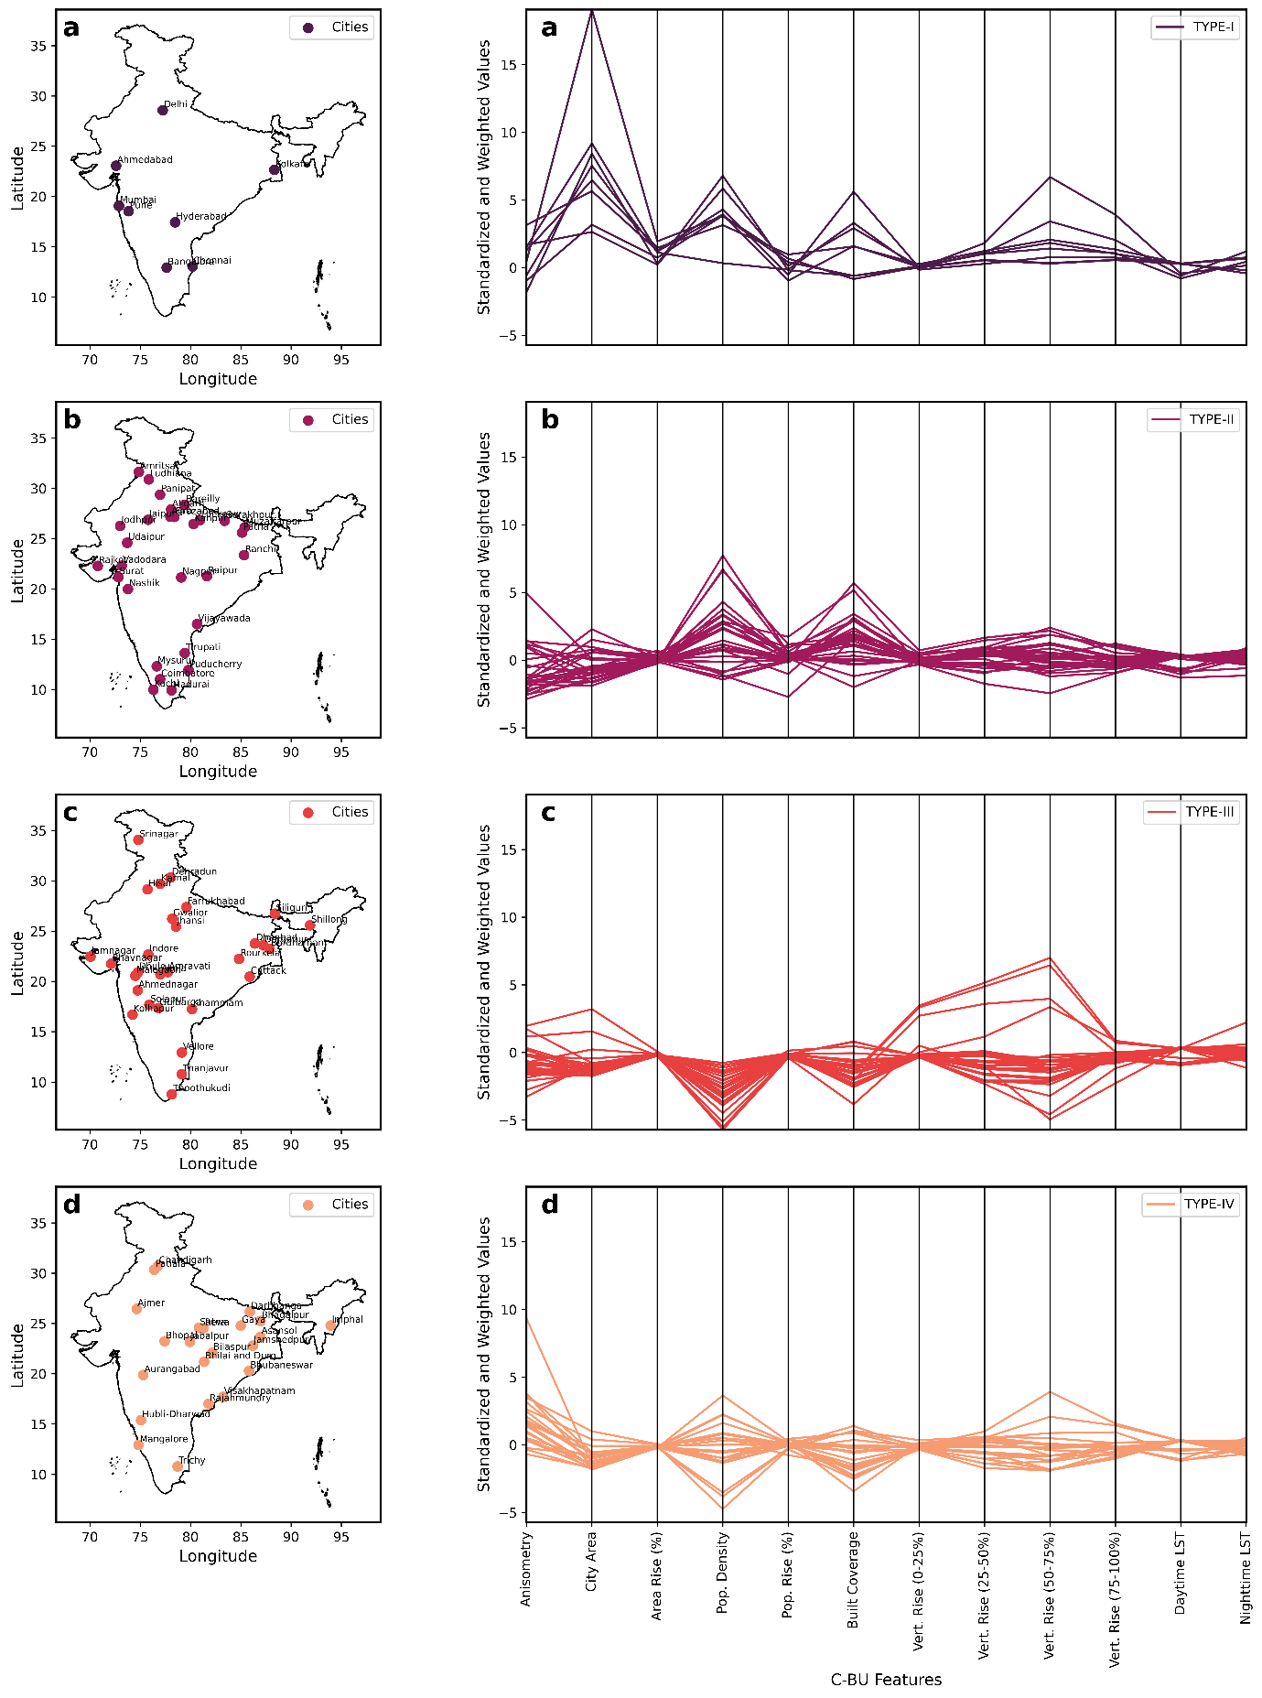
Supplementary Figure 3. The city profiles across India: a) Type I, b) Type II, c) Type III, d) Type IV. The parallel coordinate plots represent standardized and weighted urban parameters across four city profiles (from Type-I to Type-IV) along LST rising trend (°C per year). Each city urban growth feature as well as LST rise trend is standardized using z-scores to normalize different scales, enabling comparison across features. The values are also weighted based on their relative significance as mentioned in table S5. Table S6 can also be referred further for tabulated list of cities.

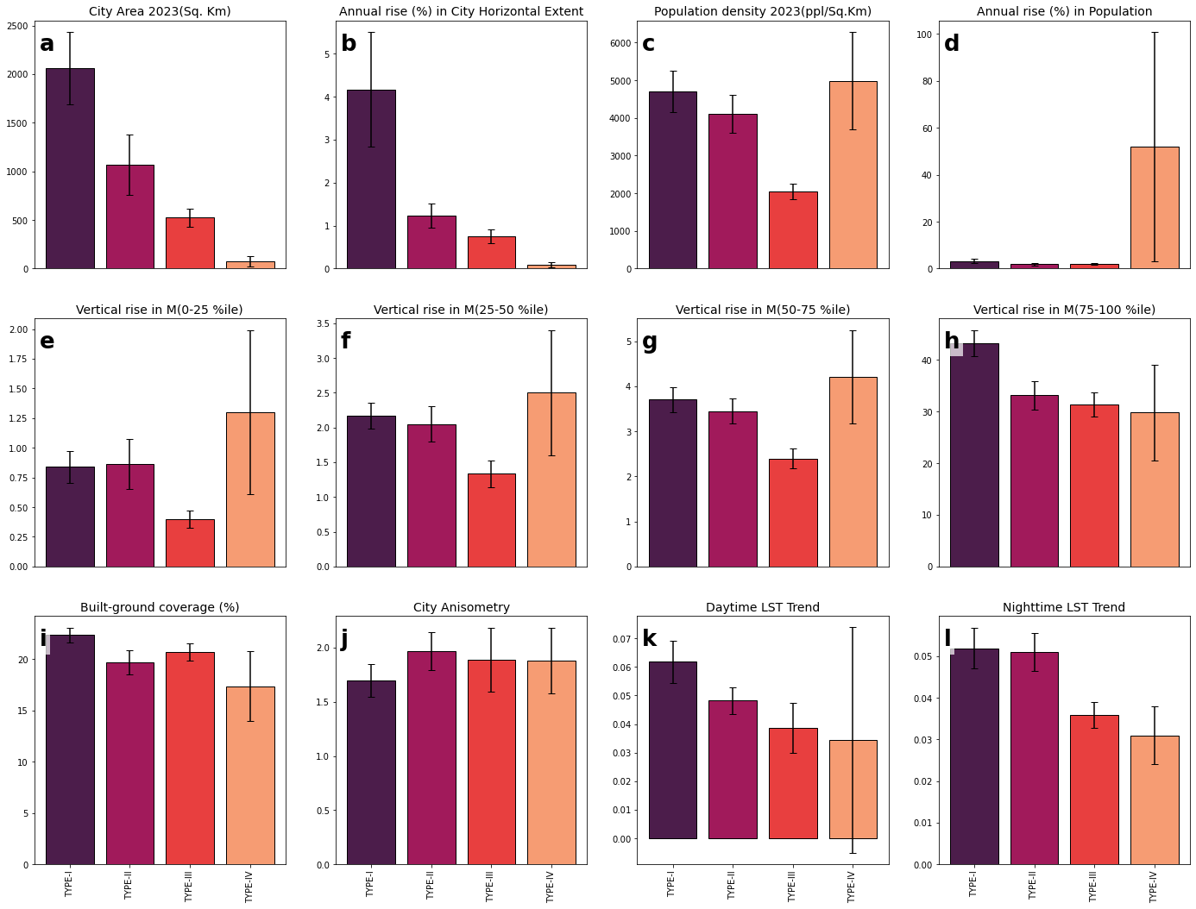 Supplementary Figure 4. The distribution of city-built volumetrics across Indian cities: The bar diagram (mean ± standard error) plots represent the extent of urban parameters across four city profiles (type I to type IV). Where subplots a to i indicate various city volumetrics feature and land surface warming trends.

1.2 Additional data on cities used for Bi-Variate analysis

1.2.1 City volumetric data${(C}_{Vol})$
Apart from city lateral spread and vertical growth, gross volumetric expanse of city built spaces is collected directly from the Global Human Settlement Layer (GHSL) datasets and averaged over the study period using the available data (https://human-settlement.emergency.copernicus.eu/index.php). The annual increment in city volume is also recorded for the available period under study. Although this city volumetric growth data is available, only vertical and lateral growth are used as independent variables for clustering of cities alongside other indicators of urbanization. Direct volumetric measures are excluded from city classification and only used in bi-variate analysis and modelling studies.

1.2.2 City Road network density${(C}_{Road})$
City road data, including total road length in kilometers and overall road network density in meters per square meter, is collected directly from the Global Human Settlement Layer (GHSL) datasets (https://human-settlement.emergency.copernicus.eu/index.php) and averaged over the study period using the available data.

Data on urban green cover and its changes, which reflect shifts in open areas beyond built-up development, were collected from both the GHSL-UCDB list and cross-verified using MODIS-EVI datasets (MOD13A2.061) from 2002 to 2023, considering green cover as another key factor influencing urban temperature rise, which can be potential impactor of cooling demand also ¹³. Apart from changes in urban built and unbuilt areas, regional-scale determinants of economic activity such as gross domestic product (GDP) for urban centers${ (C}_{GDP})$, which ultimately influence city energy demand and overall city-scale affordability ^{14–16}, are also collected. Further, it is also important to note that, since the majority of urban built and unbuilt development datasets are accessed from the GHSL project ¹⁷, readers may refer to earlier works ^{18,19}, where the National Institute of Urban Affairs (NIUA) has validated the accuracy of data source to near realistic, since 2007 in its research collaboration with BBSR while reporting on the urban spatial structure and trends across Indian and European cities.

Section 2
2.1 Brief Literature on the Urban cooling demand estimation approaches
The core frameworks for building to urban scale cooling-demand or energy demand calculations are primarily of four categories^{20,21}: (i) Physical models based on simulation approaches, (ii) Data driven statistical models, (iii) surrogate or Hybrid models, (iv) Degree days models. Physical simulation-based models provide the most accurate building energy demand predictions when well-calibrated with local conditions and in-situ energy data²². Recording built-form archetypes and thus in urban scale recording the changing urban fabrics in built-forms is most detailed with this method, though it is data and effort-intensive at the single-building level. Scaling to an urban extent requires high computational efficiency and detailed recording of various inter-built forms and neighboring micro-climate within energy transfer physics²³. The data-driven statistical models simply try to predict the energy demand based on historical time-series data of energy usage and also takes aid of other building operational parameters, micro-climate data to enhance the accuracy of energy demand prediction. Surrogate models or hybrid models utilize the physical-simulation generated data sets also to train the datasets to enhance the prediction accuracy where the hidden correlations or patterns connecting the energy data and the other parameters (e.g.- climate data, operational parameters). While the three approaches mentioned are suited for building to urban scale energy load predictions and cooling demand evaluation, their major limitation is the spatio-temporal flexibility of the models, which is often limited ^{24–26}.

2.2 Estimated CDD-hum and its relation with actual Urban cooling demand
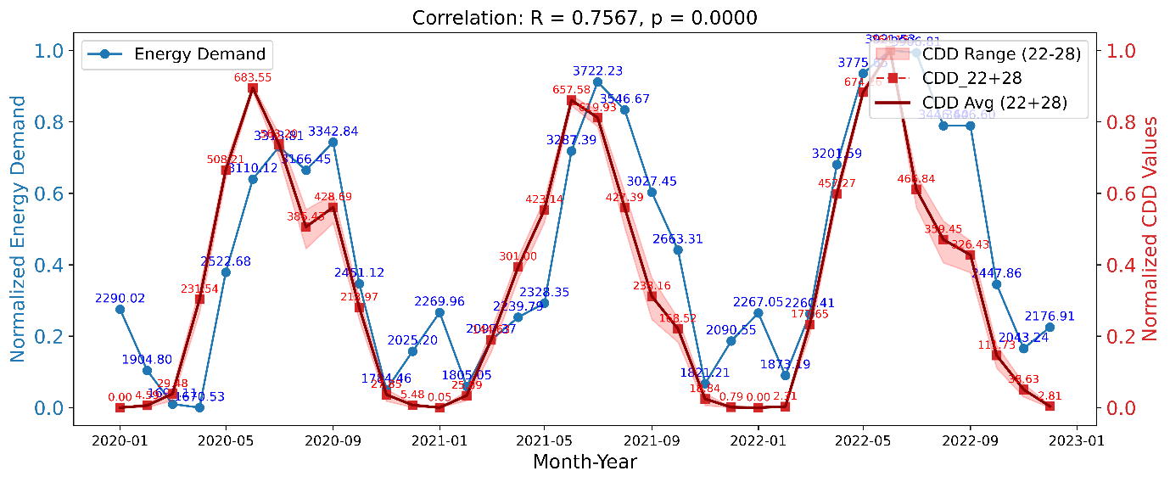 Supplementary Figure 5a. The estimated energy demand over period of 2020-2023 in monthly resolution is plotted against the estimated CDD-hum (using equation vi), which are used in this study as the proxy for urban energy demand. Here is the example of – Delhi with all the CDD ranges averaged over 22-28°C.

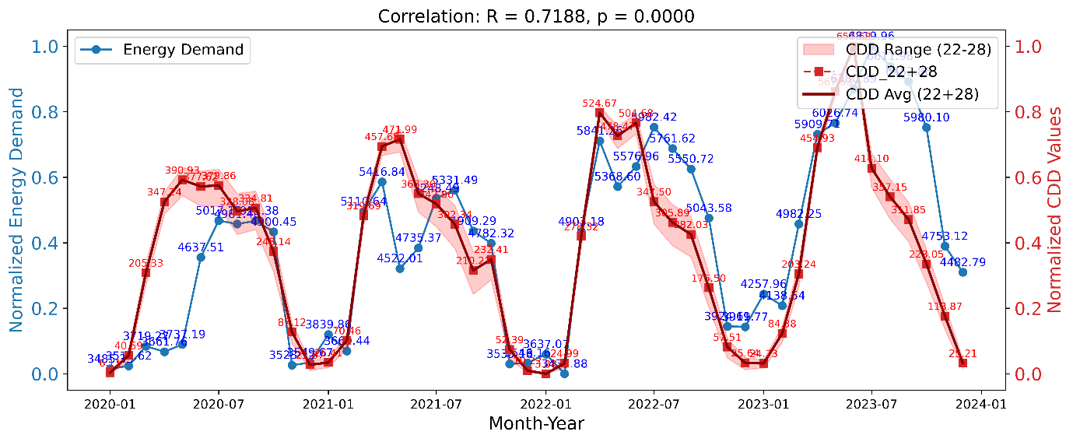
Supplementary Figure 5b. The estimated energy demand over period of 2020-2023 in monthly resolution is plotted against the estimated CDD-hum (using equation vi), which are used in this study as the proxy for urban energy demand. Here is the example of – West Bengal-Kolkata with all the CDD ranges averaged over 22-28°C.

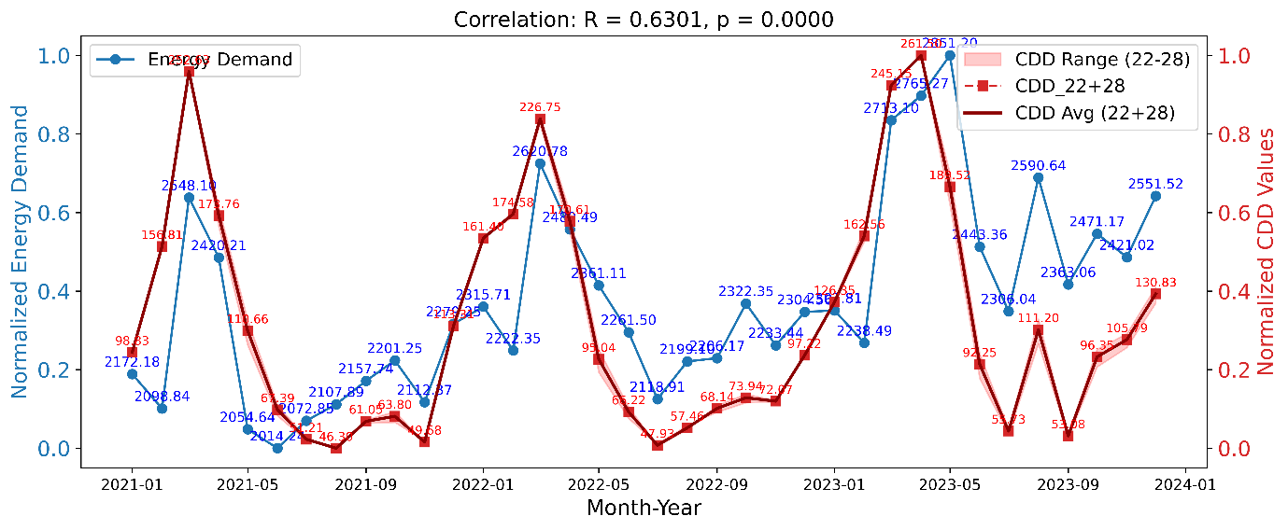
Supplementary Figure 5c. The estimated energy demand over period of 2020-2023 in monthly resolution is plotted against the estimated CDD-hum (using equation vi), which are used in this study as the proxy for urban energy demand. Here is the example of – Kerala with all the CDD ranges averaged over 22-28°C.
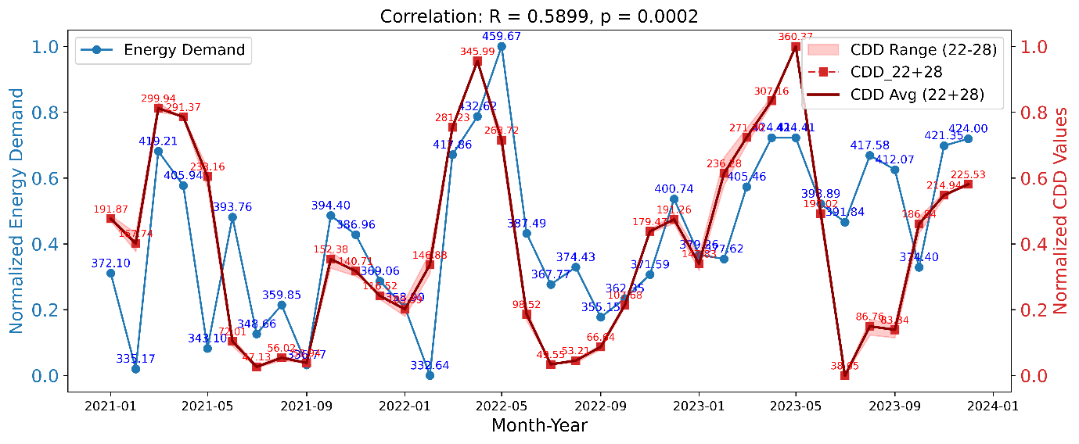
Supplementary Figure 5d. The estimated energy demand over period of 2020-2023 in monthly resolution is plotted against the estimated CDD-hum (using equation vi), which are used in this study as the proxy for urban energy demand. Here is the example of – Goa with all the CDD ranges averaged over 22-28°C.
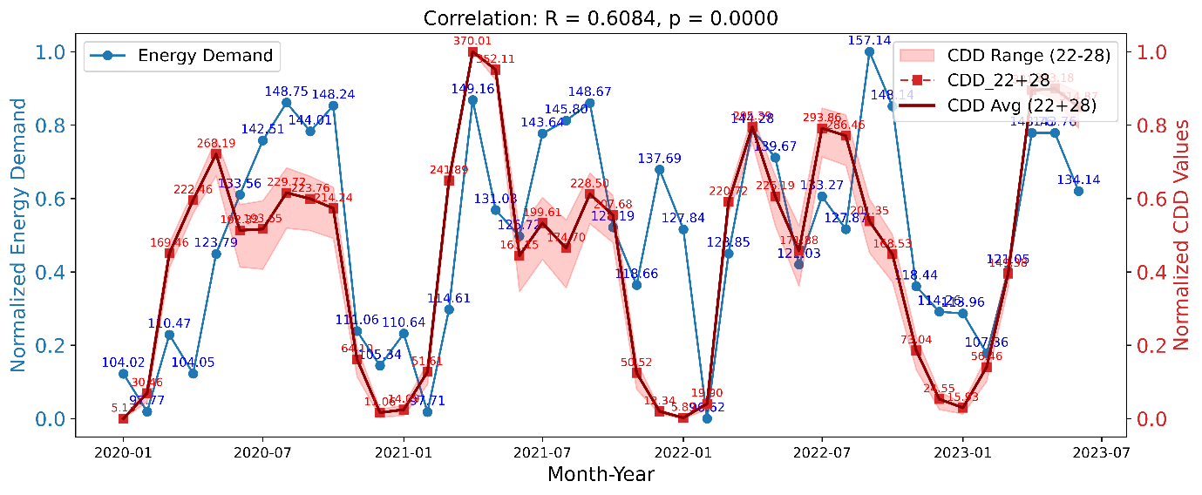
Supplementary Figure 5e. The estimated energy demand over period of 2020-2023 in monthly resolution is plotted against the estimated CDD-hum (using equation vi), which are used in this study as the proxy for urban energy demand. Here is the example of – Tripura with all the CDD ranges averaged over 22-28°C.
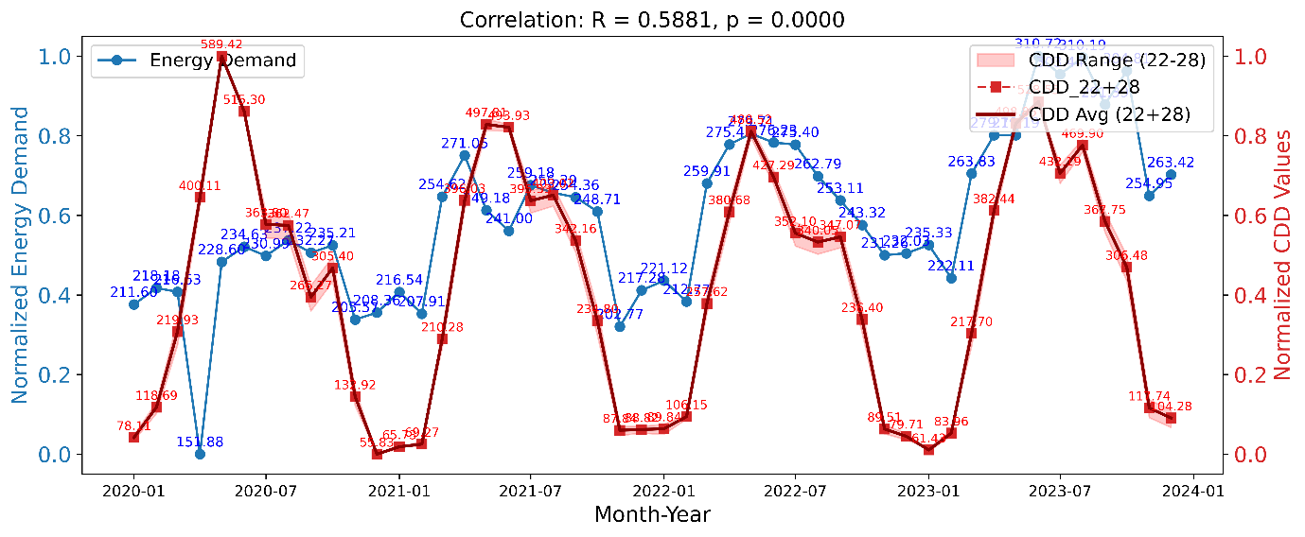
Supplementary Figure 5f. The estimated energy demand over period of 2020-2023 in monthly resolution is plotted against the estimated CDD-hum (using equation vi), which are used in this study as the proxy for urban energy demand. Here is the example of – Puducherry with all the CDD ranges averaged over 22-28°C.
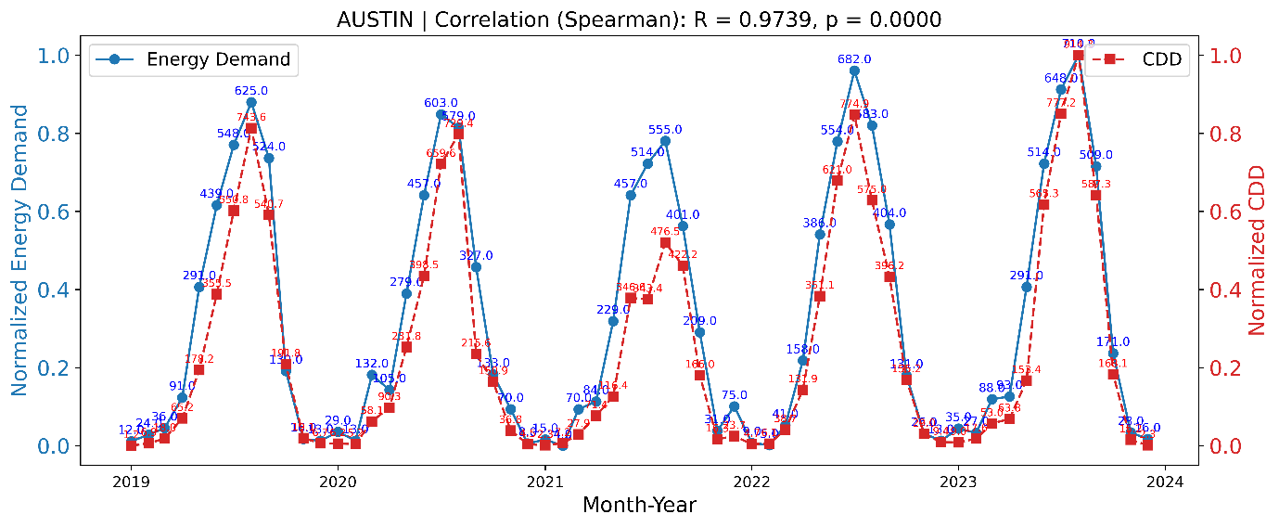
Supplementary Figure 5g. The sourced CDD values used for estimating actual city-wide energy demand over period of 2020-2023 in monthly resolution is plotted against the estimated CDD-hum (using equation vi), which are used in this study as the proxy for urban energy demand. Here is the example of – Austin.
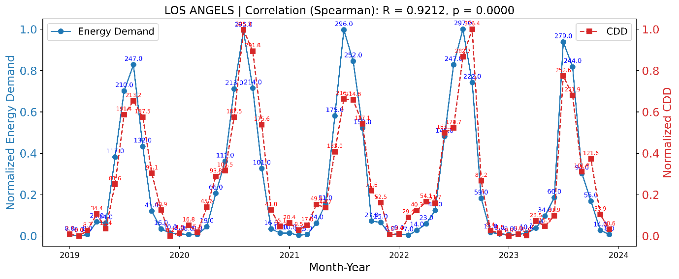
Supplementary Figure 5h. The sourced CDD values used for estimating actual city-wide energy demand over period of 2020-2023 in monthly resolution is plotted against the estimated CDD-hum (using equation vi), which are used in this study as the proxy for urban energy demand. Here is the example of – Los Angels.
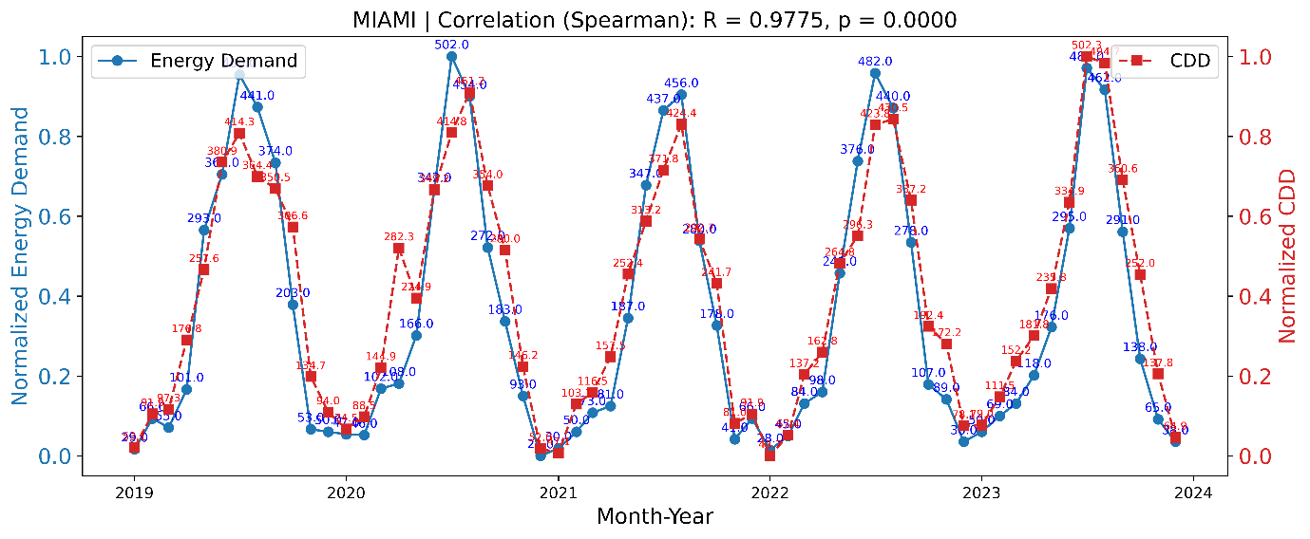
Supplementary Figure 5i. The sourced CDD values used for estimating actual city-wide energy demand over period of 2020-2023 in monthly resolution is plotted against the estimated CDD-hum (using equation vi), which are used in this study as the proxy for urban energy demand. Here is the example of – Miami.
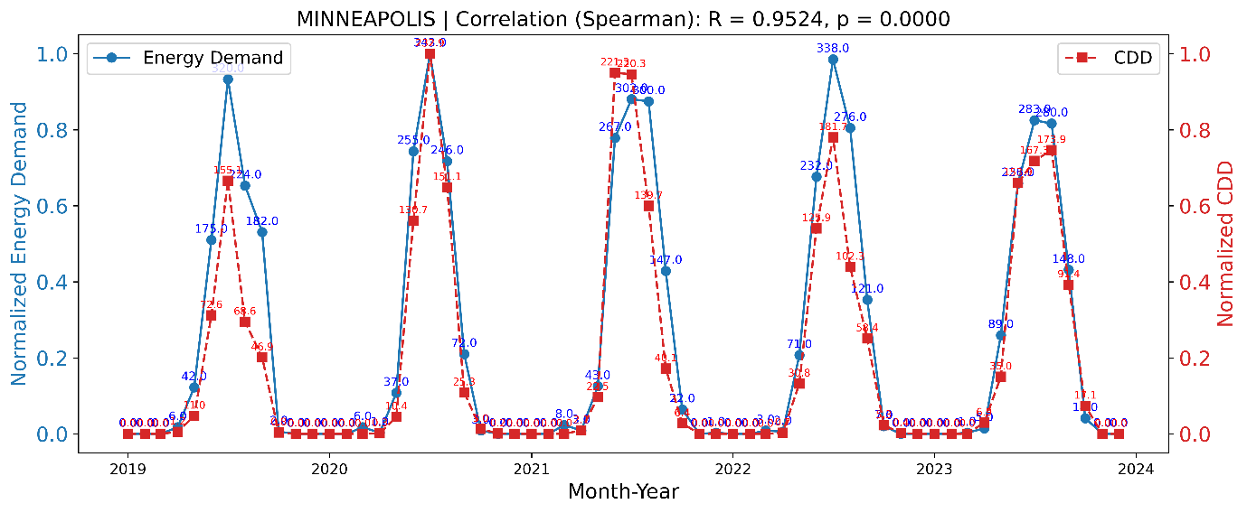
Supplementary Figure 5j. The sourced CDD values used for estimating actual city-wide energy demand over period of 2020-2023 in monthly resolution is plotted against the estimated CDD-hum (using equation vi), which are used in this study as the proxy for urban energy demand. Here is the example of – Minneapolis.
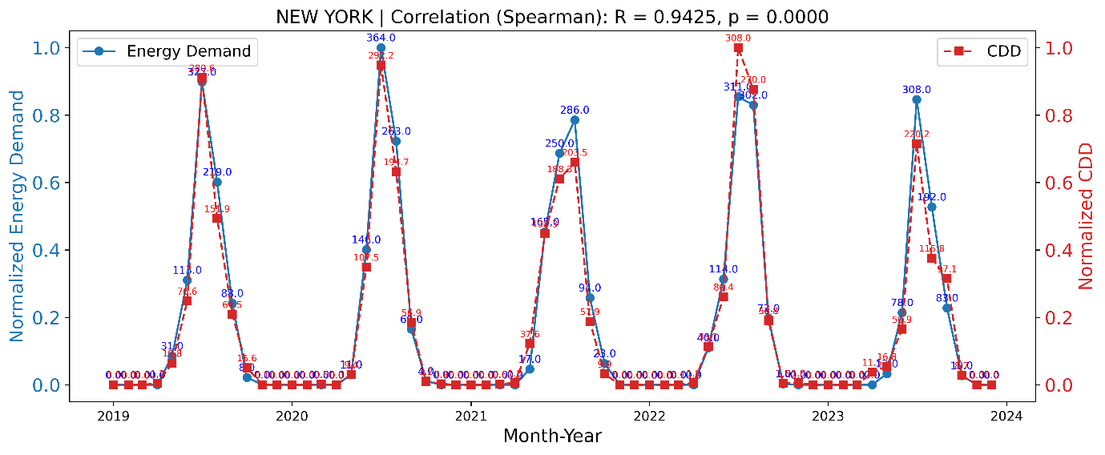
Supplementary Figure 5k. The sourced CDD values used for estimating actual city wide energy demand over period of 2020-2023 in monthly resolution is plotted against the estimated CDD-hum (using equation vi), which are used in this study as the proxy for urban energy demand. Here is the example of – New York.
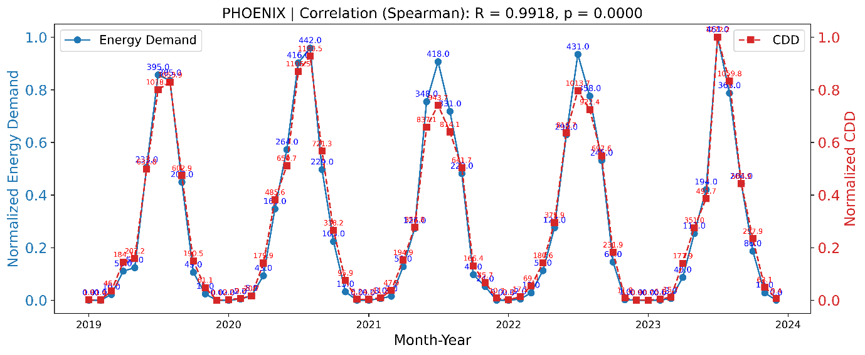
Supplementary Figure 5l. The sourced CDD values used for estimating actual city wide energy demand over period of 2020-2023 in monthly resolution is plotted against the estimated CDD-hum (using equation vi), which are used in this study as the proxy for urban energy demand. Here is the example of – Phoenix.
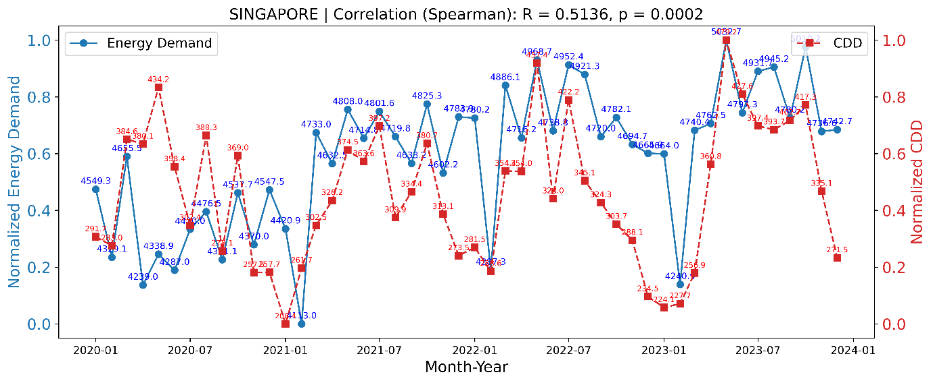
Supplementary Figure 5m. The sourced CDD values used for estimating actual city-wide energy demand over period of 2020-2023 in monthly resolution is plotted against the estimated CDD-hum (using equation vi), which are used in this study as the proxy for urban energy demand. Here is the example of – Singapore.
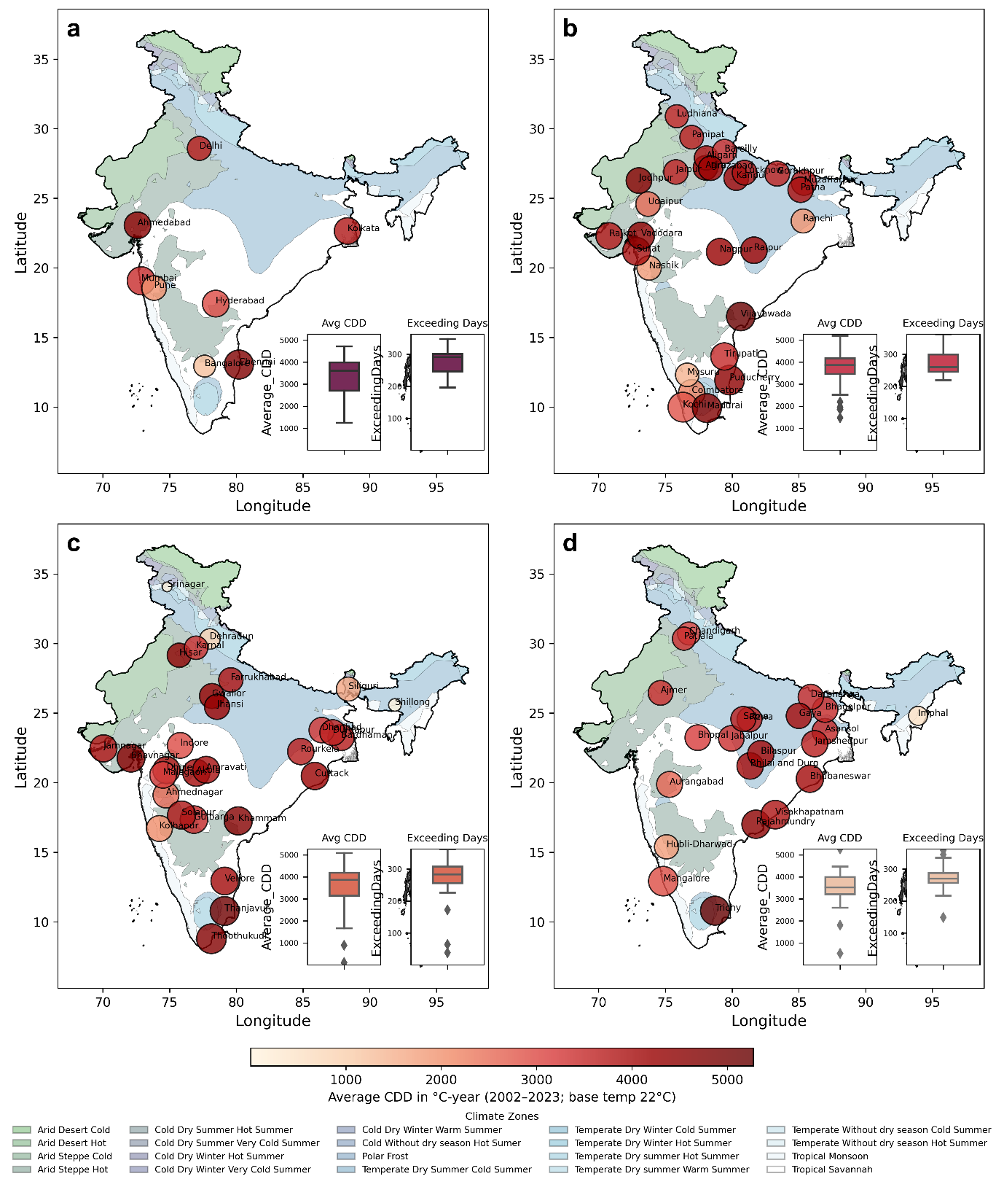

Supplementary Figure 6. Average annual cooling degree days for Indian cities over the past two decades, modelled with a cooling base temperature 22°C. The plots show daily average CDDs exceeding this threshold, indicating city-wide cooling demand across different city typologies: (a) Type-I cities_base 22°C, (b) Type-II cities_base 22°C, (c) Type-III cities_base 22°C, and (d) Type-IV cities_base 22°C. The color of bubble indicates the intensity of average CDD values and the bubble size varies in proportionate with the average days exceeding base temperature.
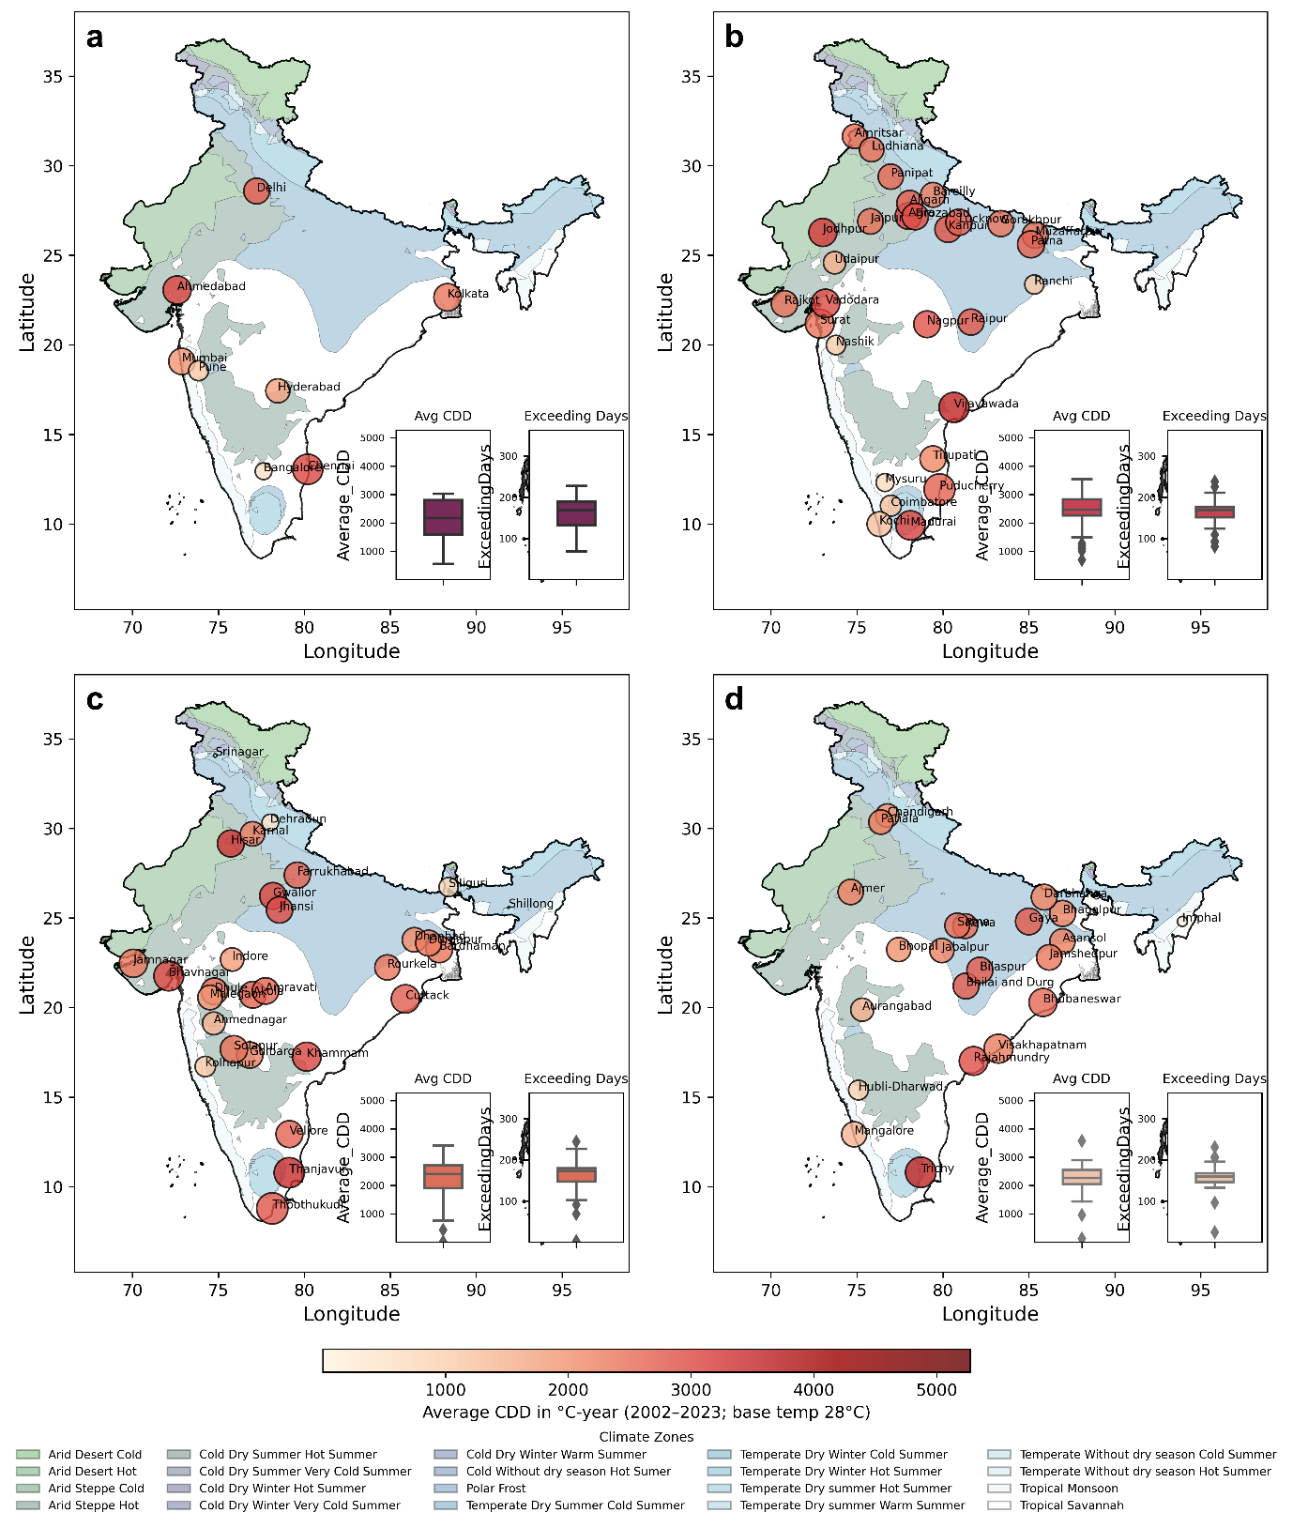

Supplementary Figure 7. Average annual cooling degree days for Indian cities over the past two decades, modelled with a cooling base temperature 28°C. The plots show daily average CDDs exceeding this threshold, indicating city-wide cooling demand across different city typologies: (a) Type-I cities_base 28°C, (b) Type-II cities_base 28°C, (c) Type-III cities_base 28°C, and (d) Type-IV cities_base 28°C. The color of bubble indicates the intensity of average CDD values and the bubble size varies in proportionate with the average days exceeding base temperature.

Supplementary Table 3. The estimated values of CDD-hum across Indian cities and their annual trends over the period 2002–2023 are presented as mean ± standard error. The cities are grouped into inland and coastal categories, aligned with specific climatic zone coherence.

Metric  -estimated over time period  2002-2023 | Indian Cities
Metric  -estimated over time period  2002-2023 | Coastal, near coastal cities |  | In land cities
Metric  -estimated over time period  2002-2023 | East coast  (ec) | West coast  (wc) | Indo Gangetic plain  (ig) | south Himalayan foothills  (sh) | deccan plate  (dp) | Central India+ western India  (ci)
Regional climate patterns  (BEE classification) | Warm and humid | Warm and humid | Warm and humid + composite | Hot and dry + composite | Warm and humid | Hot and dry
Average CDD-hum  (22°C) | 4367.36 ± 161.59 (Median: 4458.34) | 3007.71 ± 363.07 (Median: 2937.39) | 3771.27 ± 73.56 (Median: 3704.53) | 1182.24 ± 573.75 (Median: 712.89) | 3414.77 ± 164.20 (Median: 3717.59) | 3836.51 ± 326.61 (Median: 3985.08)
Average CDD-hum (28°C) | 2771.75 ± 130.87 (Median: 2711.49) | 1608.34 ± 259.00 (Median: 1437.23) | 2546.82 ± 67.75 (Median: 2437.36) | 682.27 ± 427.64 (Median: 285.11) | 2163.53 ± 124.31 (Median: 2400.08) | 2584.84 ± 267.90 (Median: 2744.98)
Days > 22°C (days/year) | 330 ± 1 | 322 ± 4 | 250 ± 1 | 150 ± 7 | 286 ± 1 | 261 ± 2
Days > 28°C (days/year) | 212 ± 2 | 157 ± 4 | 165 ± 1 | 59 ± 5 | 155 ± 1 | 169 ± 2
CDD Increase (22°C) (°C-year) | 17.88 ± 6.40 (Median: 6.23) | 10.98 ± 2.79 (Median: 10.93) | 6.98 ± 1.61 (Median: 5.57) | 31.44 ± 18.01 (Median: 18.95) | 6.00 ± 0.73 (Median: 5.89) | 4.48 ± 1.12 (Median: 5.71)
CDD Increase (28°C) (°C-year) | 14.28 ± 6.16 (Median: 3.77) | 7.37 ± 2.16 (Median: 7.11) | 5.44 ± 0.97 (Median: 5.03) | 4.01 ± 1.72 (Median: 2.51) | 6.70 ± 0.74 (Median: 5.73) | 3.74 ± 1.17 (Median: 3.83)
CDD-hum overall rising trend
CDD-hum overall trend (°C-year) in simple linear regression | 14.41 ± 5.03 | 10.16 ± 2.77 | 6.48 ± 1.05 | 19.31 ± 12.72 | 6.88 ± 1.2 | 8.58 ± 3.27
CDD-hum overall trend (%) in simple linear regression | 0.43 ± 0.16 | 0.46 ± 0.14 | 0.21 ± 0.03 | 4.81 ± 2.69 | 0.26 ± 0.04 | 0.26 ± 0.1
CDD-hum overall trend (%) in Log-linear regression | 0.44 ± 0.17 | 0.43 ± 0.14 | 0.18 ± 0.03 | 4.71 ± 3.38 | 0.25 ± 0.03 | 0.24 ± 0.1

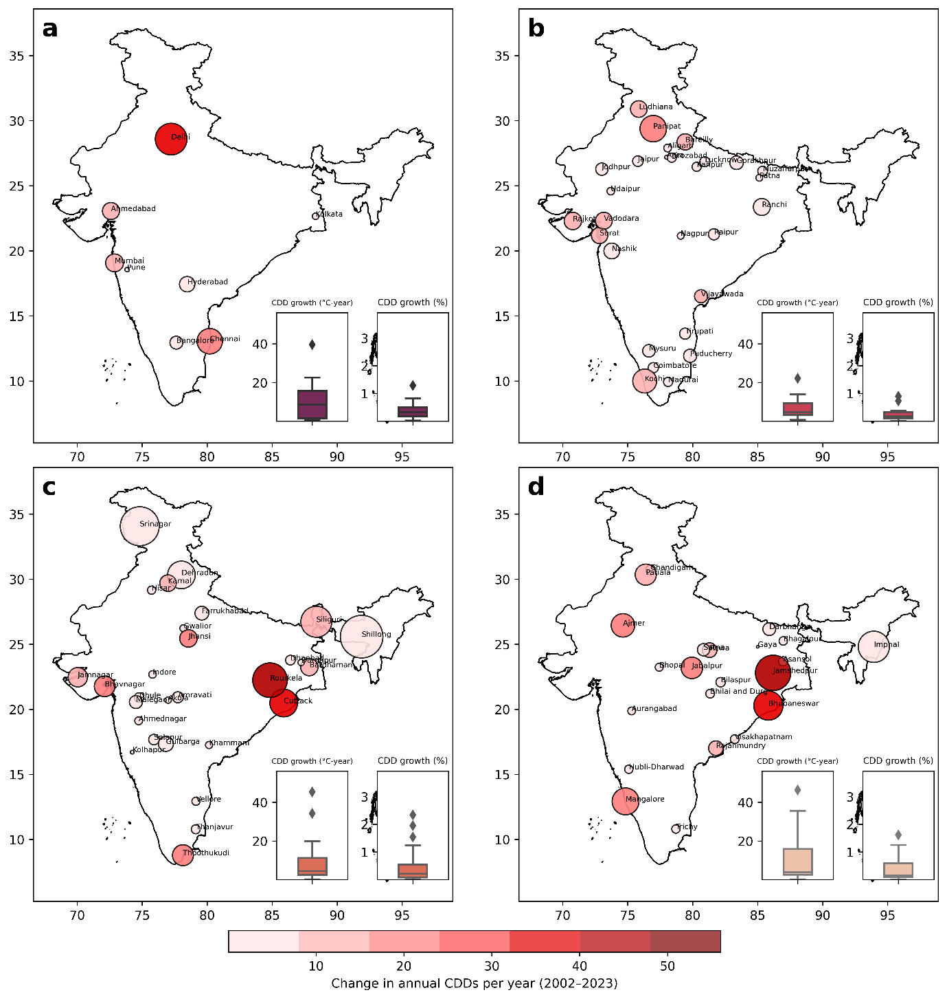
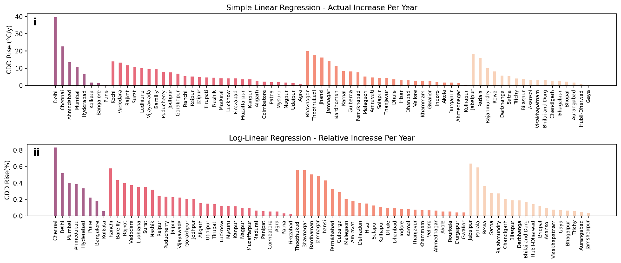

Supplementary Figure 8. The rising trend of CDD-hum for Indian cities over the past two decades, modelled with a cooling base temperature range of 22–28°C. The plots show the increase in CDD-hum per year averaged over the CDD-hum 22 to CDD-hum 28 range, determined through linear regression of data from 2002 to 2023 across different city profiles: (a) Type-I cities, (b) Type-II cities, (c) Type-III cities, and (d) Type-IV cities. The bubble size represents the relative increase per year in CDD-hum. Bar plots (i–ii) represent the corresponding absolute and percentage changes in CDDs across city typologies.
Supplementary Table 4. The estimated values of CDD-hum across representative global cities (excluding Indian cities) and their annual trends over the period 2002–2023 are presented as mean ± standard error. The cities are grouped into inland and coastal categories, aligned with specific climatic zone coherence.

Metric  -estimated over time period  2002-2023 | Global Cities
Metric  -estimated over time period  2002-2023 | US |  | EUROPE |  | ASIA  (excluding Indian cities) |  | AUS
Metric  -estimated over time period  2002-2023 | In-land | coastal | In-land | coastal | In-land | coastal | Coastal majorly
Average CDD-hum | 1451.00 ± 392.26 (Median: 1081.63) | 859.30 ± 258.32 (Median: 450.68) | 340.89 ± 84.66 (Median: 217.15) | 595.35 ± 128.11 (Median: 495.54) | 1927.39 ± 633.93 (Median: 1515.96) | 2067.78 ± 482.06 (Median: 1931.03) | 726.95 ± 159.77 (Median: 746.20)
Days > threshold (days/year) | 136 ± 4 | 120 ± 6 | 58 ± 2 | 99 ±2 | 182 ± 8 | 223 ± 8 | 124 ± 5
CDD-hum overall trend (°C-year) in simple linear regression | 9.87 ± 3.68 | 8.15 ± 1.75 | 5.65 ± 1.28 | 7.16 ± 2.24 | 10.74 ± 4.52 | 14.12 ± 3.73 | 2.97 ± 0.88
CDD-hum overall trend (%) in simple linear regression | 0.59 ± 0.12 | 1.32 ± 0.25 | 2.1 ± 0.28 | 1.18 ± 0.38 | 0.51 ± 0.06 | 0.75 ± 0.19 | 0.4 ± 0.08
CDD-hum overall trend (%) in Log-linear regression | 0.68 ± 0.11 | 1.35 ± 0.24 | 2.38 ± 0.34 | 1.25 ± 0.39 | 0.49 ± 0.08 | 0.75 ± 0.2 | 0.29 ± 0.08

Explanation on Figure 9-
Spatial clustering in subplots show that horizontal expansion alone does not consistently drive increased cooling demand. Cities with balanced horizontal and vertical growth exhibit higher CDD-hum values compared to those with lateral growth but limited vertical intensification. This emphasizes the importance of integrated spatial structuring in cooling energy requirements. Subplots (i-l) highlight a clustering pattern among cities with high population density and vertical expansion, indicating that denser and taller cities require more cooling energy due to their volumetric configuration. However, subplots (m-p) show significant variability in cities with rapid population growth, suggesting that increased density does not always correlate with proportional vertical expansion, reflecting the complexity of urban growth trajectories and their non-linear impact on cooling demand. Subplots (q-t) demonstrate that higher built-ground coverage, especially when coupled with vertical intensification, leads to elevated CDD-hum values. Increased built-ground coverage contributes to greater imperviousness and infilling, exacerbating cooling energy demand. These initial observations lay the groundwork for further examining the complex relationship between urban morphology and cooling energy demand, highlighting the critical role of spatial structuring, vertical densification, and lateral expansion in shaping long-term CDD-hum variations and trends, rather than relying on simple decadal averages.

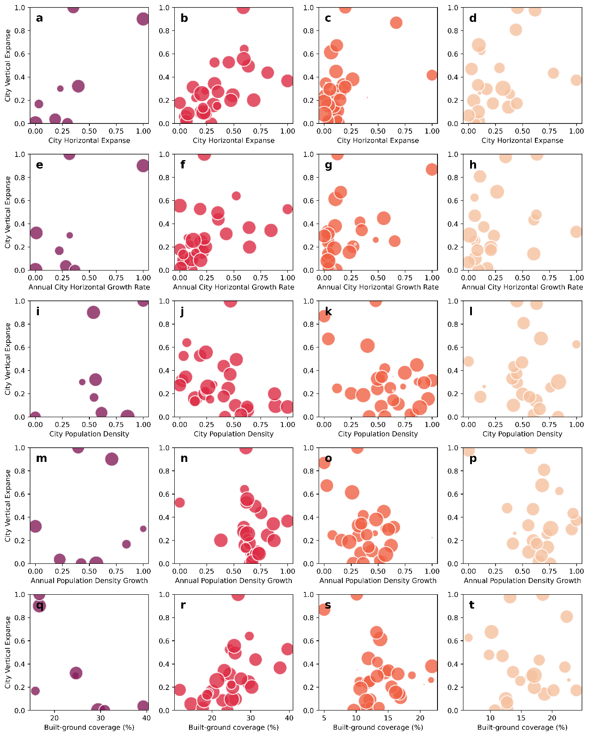

Supplementary Figure 9. Distribution of city-scale average CDD-hum values in relation to urban growth characteristics over the past two decades (2002–2023). The bubble size represents the magnitude of average CDD-hum. Subplots (a–d) correspond to typologies I–IV, showing the relationship between city horizontal expanse (x-axis) and vertical extent (y-axis). Subplots (e–h) illustrate annual horizontal growth trends against vertical extent, capturing how lateral expansion influences vertical development across typologies. Subplots (i–l) depict population density versus vertical extent, highlighting clustering patterns among denser cities. Subplots (m–p) examine annual population density growth trends against vertical extent, revealing variations in growth trajectories. Finally, subplots (q–t) explore the role of built-ground coverage in relation to vertical rise, demonstrating how urban compactness and imperviousness affect cooling demand. The visualization underscores the interplay between urban form, growth dynamics, and cooling energy demand across diverse city classifications.

Explanation on Figure 10-
In subplots, city-volumetric measures are scaled to a 0–1 range based on data range across cities, to facilitate comparison in the scatter plot. The scatter plots highlight that Type-I cities dominate with the largest bubble sizes, scattered across the plot-space, indicating substantial growth in cooling demand driven by both volumetric expanse and rapid vertical expansion. In contrast, Type-II cities exhibit greater variability in horizontal growth rates and cooling trends, reflecting diverse urbanization trajectories characterized by both vertical and horizontal expansion. Smaller bubbles clustering near the origin in Type-III and Type-IV cities correspond to slower cooling demand growth due to less intense volumetric urbanization, where vertical rise is balanced by infilling and population growth (subplots e–h). Subplots (m–p), which examine annual population density growth versus vertical extent, show significant scatter among cities, particularly in Type-I and Type-II typologies. While some cities with rapid population density growth (range >0.6 annually). exhibit proportional vertical expansion (range >0.6), others deviate from this trend, reflecting the decoupling of density growth and volumetric development. This decoupling highlights the complexity of urbanization trajectories and their non-linear influence on cooling demand trends. In contrast, Type-III and IV cities display smaller bubble sizes with limited vertical expansion (range <0.3) and slower population density growth (range <0.3 annually), indicating more stable urban configurations and lower CDD-hum trend growth. Subplots (q–t), which explore built-ground coverage versus vertical extent, reveal that cities with higher built-ground coverage (range >0.5) paired with significant vertical intensification consistently exhibit elevated CDD-hum trends, as evident in larger bubble sizes for Type-I and II cities. This correlation underscores the role of impervious surfaces in amplifying heat retention and cooling energy demands. Conversely, Type-IV cities, characterized by lower built-ground coverage (normalized range <0.3) and smaller bubble sizes, demonstrate minimal impact on cooling demand trends due to their compact and less urbanized forms.

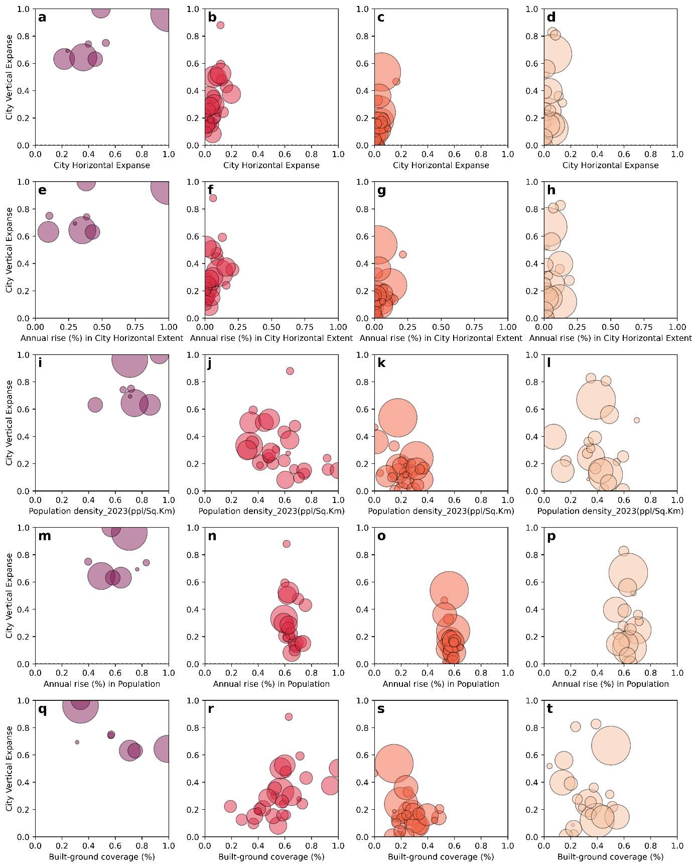

Supplementary Figure 10. Distribution of city-scale annual trends of CDD-hum values in relation to urban growth characteristics over the past two decades (2002–2023). The bubble size represents the magnitude of average CDD-hum. Subplots (a–d) correspond to typologies I–IV, showing the relationship between city horizontal expanse (x-axis) and vertical extent (y-axis). Subplots (e–h) illustrate annual horizontal growth trends against vertical extent, capturing how lateral expansion influences vertical development across typologies. Subplots (i–l) depict population density versus vertical extent, highlighting clustering patterns among denser cities. Subplots (m–p) examine annual population density growth trends against vertical extent, revealing variations in growth trajectories. Finally, subplots (q–t) explore the role of built-ground coverage in relation to vertical rise, demonstrating how urban compactness and imperviousness affect cooling demand. The visualization underscores the interplay between urban form, growth dynamics, and cooling energy demand across diverse city classifications.

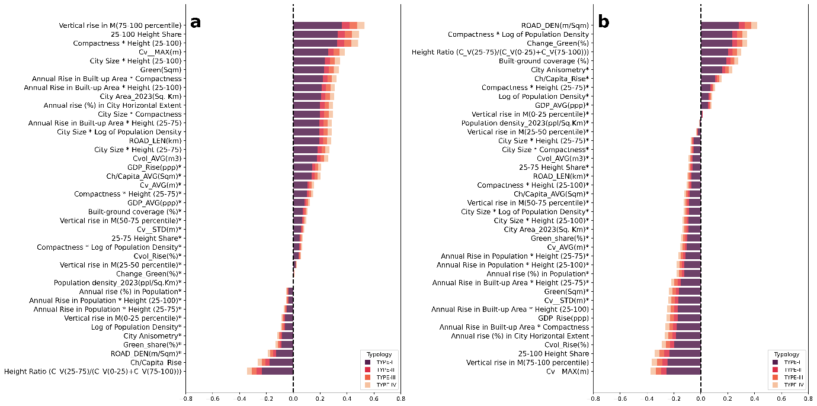

Supplementary Figure 11. Bivariate Pearson’s correlation between urban volumetric indicators and the rising trends of humidity-weighted Cooling Degree Days (CDD-hum) for Global cities excluding Indian cities. Panel (a) illustrate correlations with the actual increase in CDD-hum, while Panel (b) reflect correlations with the relative increase in CDD-hum. Positive coefficients to the right of the vertical axis indicate direct associations with rising CDD-hum, whereas negative values indicate inverse relationships. Natural logarithmic transformations were applied to certain indicators to correct for data skewness. The correlation coefficients reflect the proportion of variance in CDD-hum trends explained by each indicator independently. Asterisks (*) denote statistically non-significant correlations (p ≥ 0.1). The color coding represents different city typologies: TYPE-I, TYPE-II, TYPE-III, and TYPE-IV and their relative contribution in correlations.
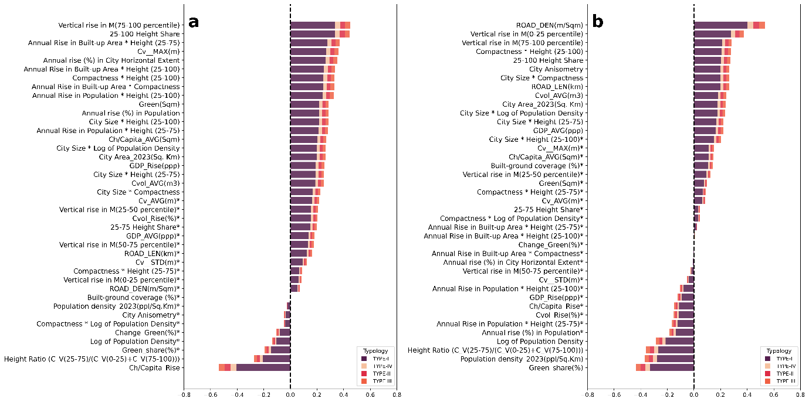
Supplementary Figure 12. Bivariate Pearson’s correlation between urban volumetric indicators and the rising trends of humidity-weighted Cooling Degree Days (CDD-hum) for Global cities including Indian cities. Panel (a) illustrate correlations with the actual increase in CDD-hum, while Panel (b) reflect correlations with the relative increase in CDD-hum. Positive coefficients to the right of the vertical axis indicate direct associations with rising CDD-hum, whereas negative values indicate inverse relationships. Natural logarithmic transformations were applied to certain indicators to correct for data skewness. The correlation coefficients reflect the proportion of variance in CDD-hum trends explained by each indicator independently. Asterisks (*) denote statistically non-significant correlations (p ≥ 0.2). The color coding represents different city typologies: TYPE-I, TYPE-II, TYPE-III, and TYPE-IV and their relative contribution in correlations.

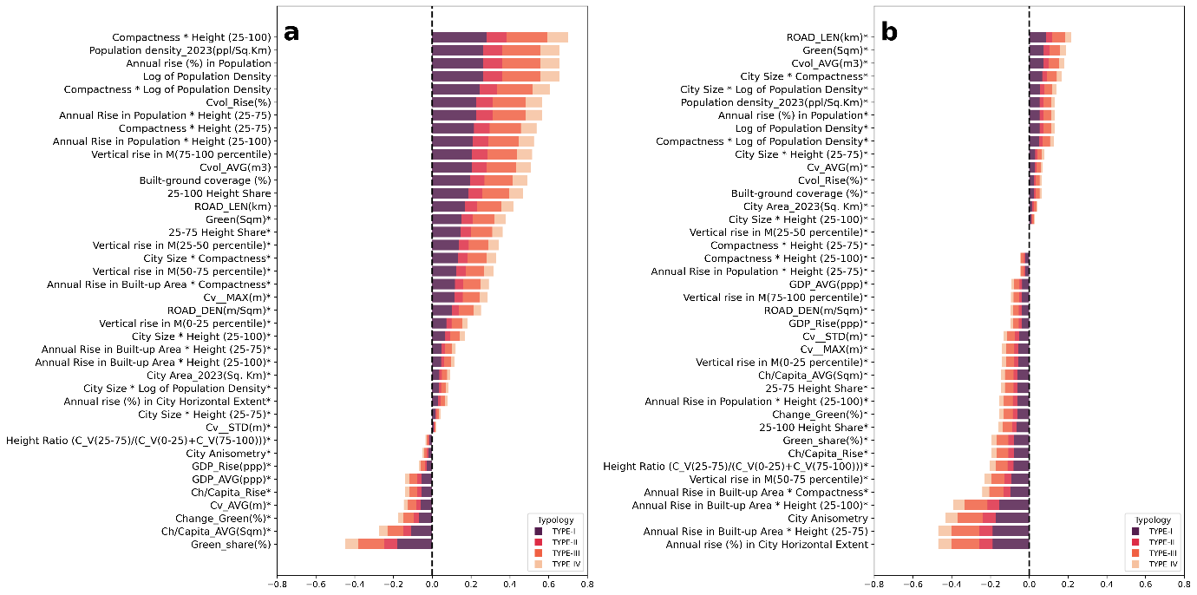

Supplementary Figure 13. Bivariate Spearman rank correlation between urban volumetric indicators and the rising trends of humidity-weighted Cooling Degree Days (CDD-hum) for Indian cities. Panel (a) illustrate correlations with the actual increase in CDD-hum, while Panel (b) reflect correlations with the relative increase in CDD-hum. Positive coefficients to the right of the vertical axis indicate direct associations with rising CDD-hum, whereas negative values indicate inverse relationships. Natural logarithmic transformations were applied to certain indicators to correct for data skewness. The correlation coefficients reflect the proportion of variance in CDD-hum trends explained by each indicator independently. Asterisks (*) denote statistically non-significant correlations (p ≥ 0.2). The color coding represents different city typologies: TYPE-I, TYPE-II, TYPE-III, and TYPE-IV and their relative contribution in correlations.

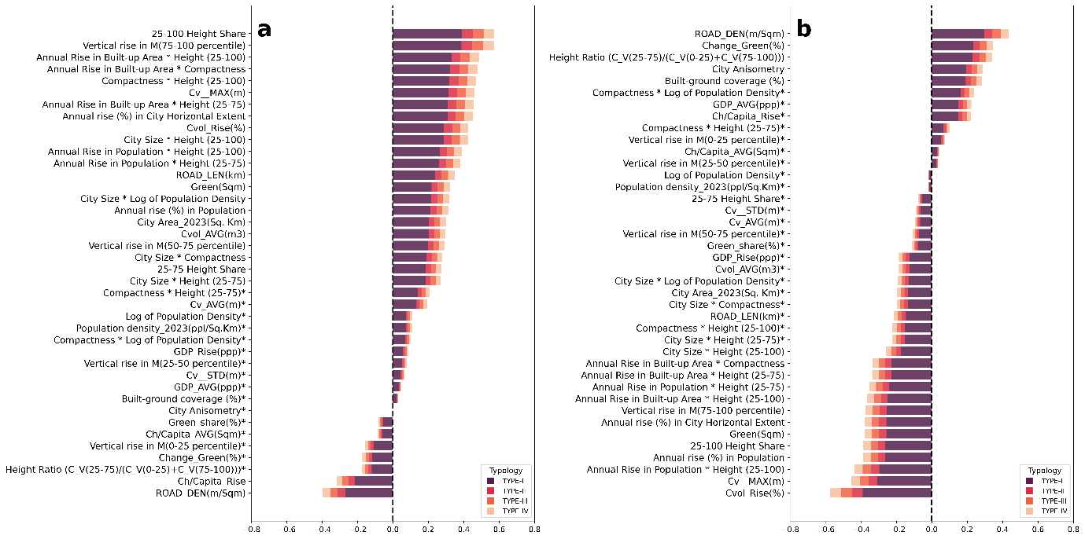
Supplementary Figure 14. Bivariate Spearman rank correlation between urban volumetric indicators and the rising trends of humidity-weighted Cooling Degree Days (CDD-hum) for Global cities. Panel (a) illustrate correlations with the actual increase in CDD-hum, while Panel (b) reflect correlations with the relative increase in CDD-hum. Positive coefficients to the right of the vertical axis indicate direct associations with rising CDD-hum, whereas negative values indicate inverse relationships. Natural logarithmic transformations were applied to certain indicators to correct for data skewness. The correlation coefficients reflect the proportion of variance in CDD-hum trends explained by each indicator independently. Asterisks (*) denote statistically non-significant correlations (p ≥ 0.2). The color coding represents different city typologies: TYPE-I, TYPE-II, TYPE-III, and TYPE-IV and their relative contribution in correlations.

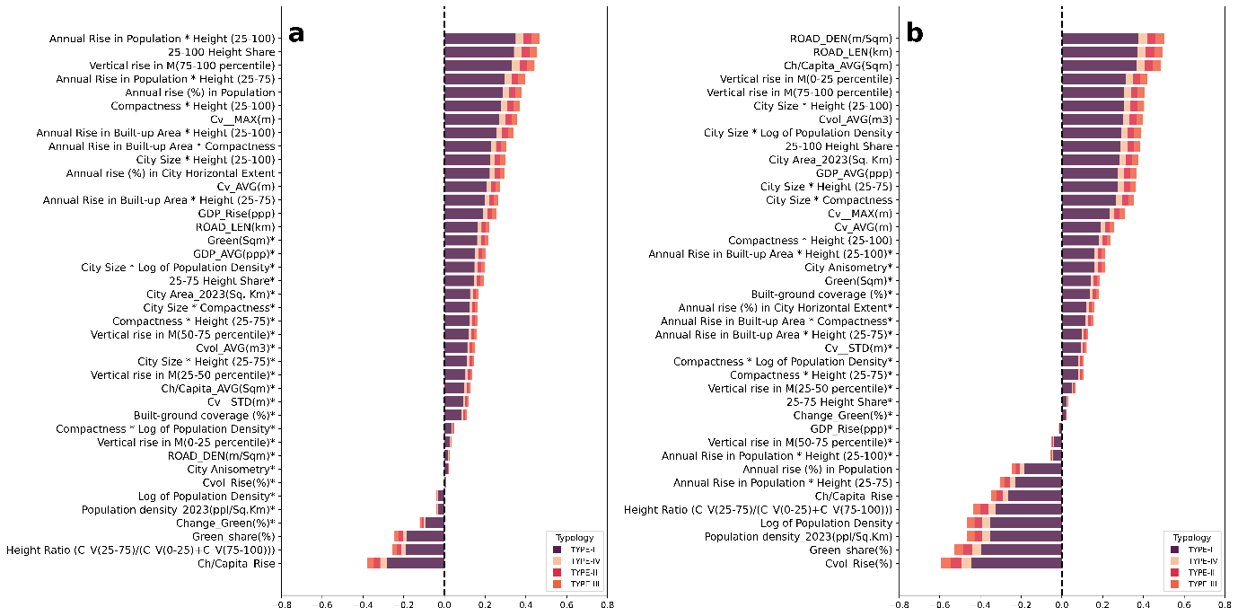
Supplementary Figure 15. Bivariate Spearman rank correlation between urban volumetric indicators and the rising trends of humidity-weighted Cooling Degree Days (CDD-hum) for Global cities including Indian cities. Panel (a) illustrate correlations with the actual increase in CDD-hum, while Panel (b) reflect correlations with the relative increase in CDD-hum. Positive coefficients to the right of the vertical axis indicate direct associations with rising CDD-hum, whereas negative values indicate inverse relationships. Natural logarithmic transformations were applied to certain indicators to correct for data skewness. The correlation coefficients reflect the proportion of variance in CDD-hum trends explained by each indicator independently. Asterisks (*) denote statistically non-significant correlations (p ≥ 0.2). The color coding represents different city typologies: TYPE-I, TYPE-II, TYPE-III, and TYPE-IV and their relative contribution in correlations.

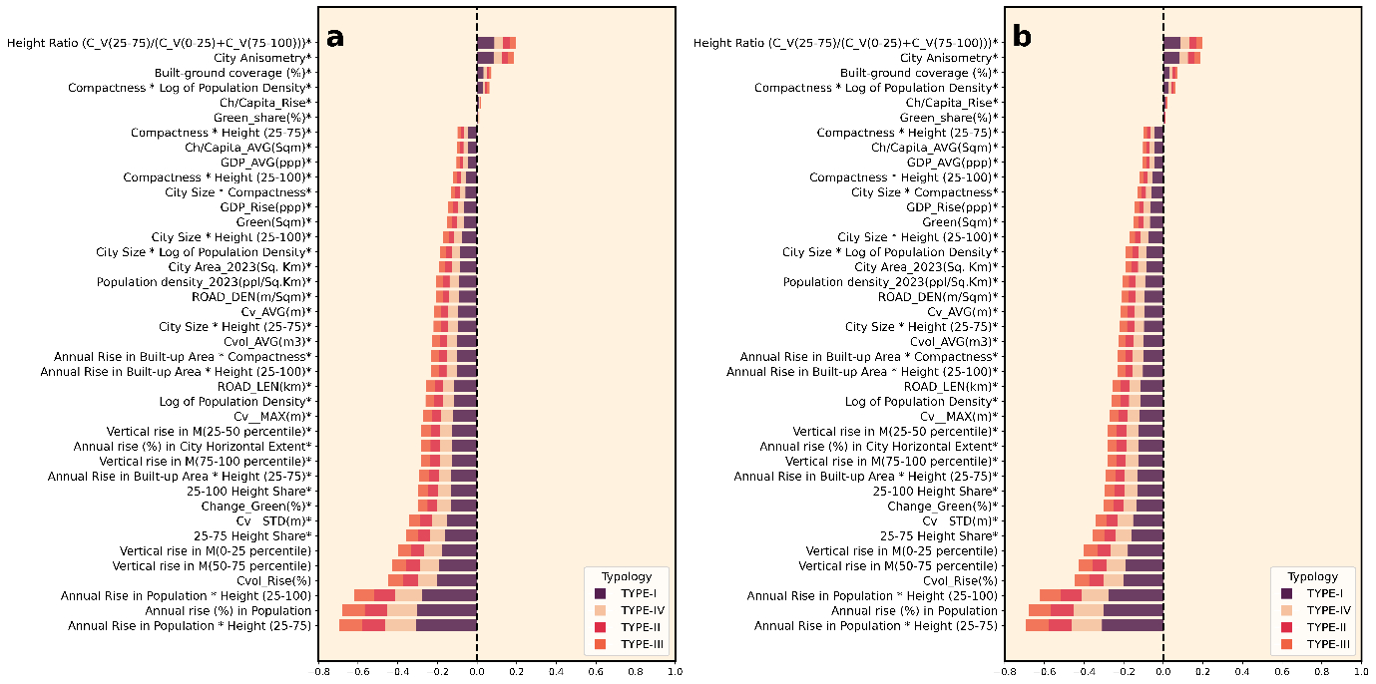
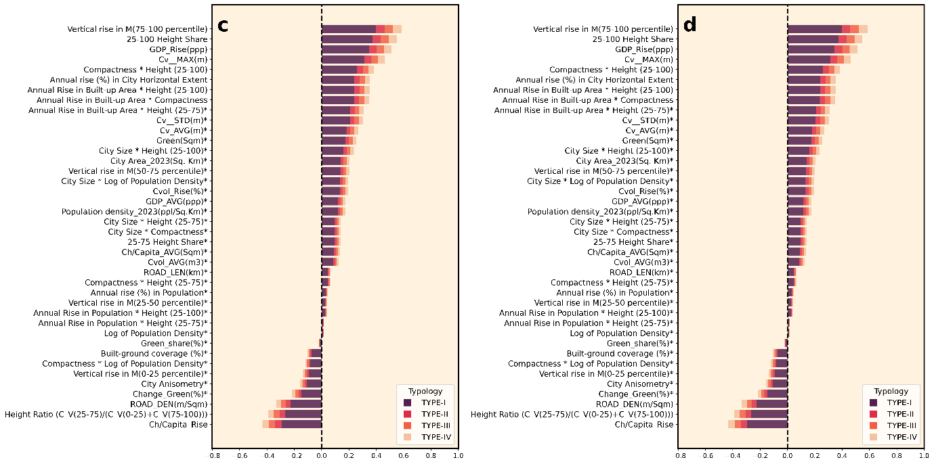
Supplementary Figure 16. Bivariate correlation between urban volumetric indicators and the 20-year average (henceforth as avg.) of humidity-weighted Cooling Degree Days (CDD-hum) for global cities under study. Panel (a) illustrate Person’s correlations (linear) with the avg. CDD-hum of Indian cities, while Panel (b) illustrate Spearman rank correlations (non-linear) with the avg. CDD-hum of Indian cities, (c) illustrate Person’s correlations (linear) with the avg. CDD-hum of Global cities, while Panel (d) illustrate Spearman rank correlations (non-linear) with the avg. CDD-hum of Global cities. Positive coefficients to the right of the vertical axis indicate direct associations with rising CDD-hum, whereas negative values indicate inverse relationships. Natural logarithmic transformations were applied to certain indicators to correct for data skewness. The correlation coefficients reflect the proportion of variance in CDD-hum trends explained by each indicator independently. Asterisks (*) denote statistically non-significant correlations (p ≥ 0.1). The color coding represents different city typologies: TYPE-I, TYPE-II, TYPE-III, and TYPE-IV and their relative contribution in correlations (significance level p < 0.1).

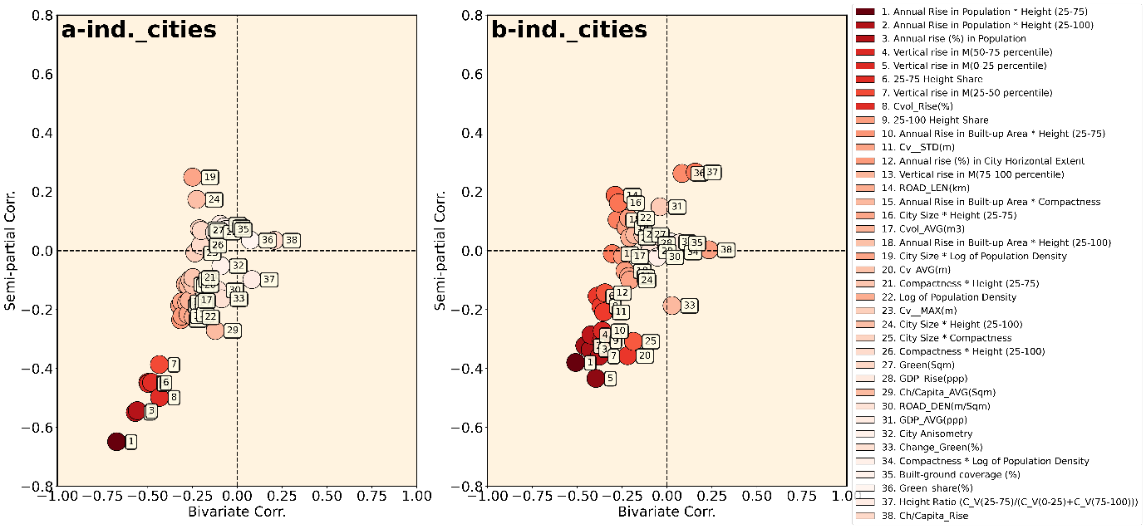
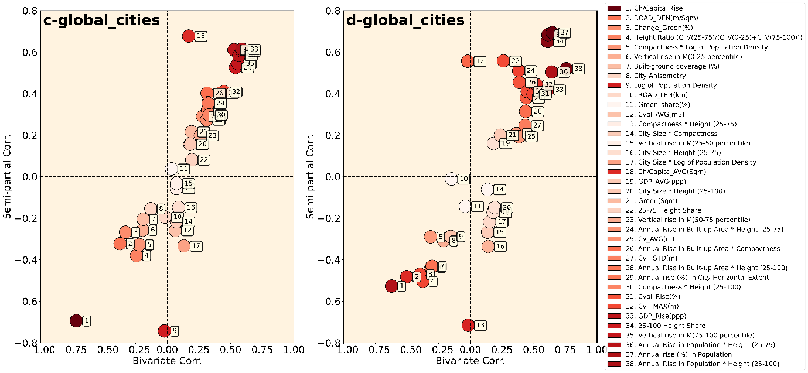

Supplementary Figure 17. Semi partial correlation between urban volumetric indicators and the avg. CDD-Hum for Indian cities as well as global cities under study. Panels (a-d) illustrate the semi-partial correlation between avg. CDD-hum and other indicators of urbanization, controlling for city area and population density. Panel (a) illustrate Person’s correlations based semi-partial (linear) correlation with the avg. CDD-hum of Indian cities, while Panel (b) illustrate Spearman rank correlations based semi-partial (non-linear) correlation with the avg. CDD-hum of Indian cities, (c) illustrate Person’s correlations based semi-partial (linear) correlation with the avg. CDD-hum of Global cities, while Panel (d) illustrate Spearman rank correlations based semi-partial (non-linear) correlation with the avg. CDD-hum of Global cities. The distance from the vertical axis represents the correlation coefficient of the semi-partial correlation, while the distance from the horizontal axis indicates the correlation coefficient of the bivariate (uncontrolled) correlation (significance level p < 0.1).

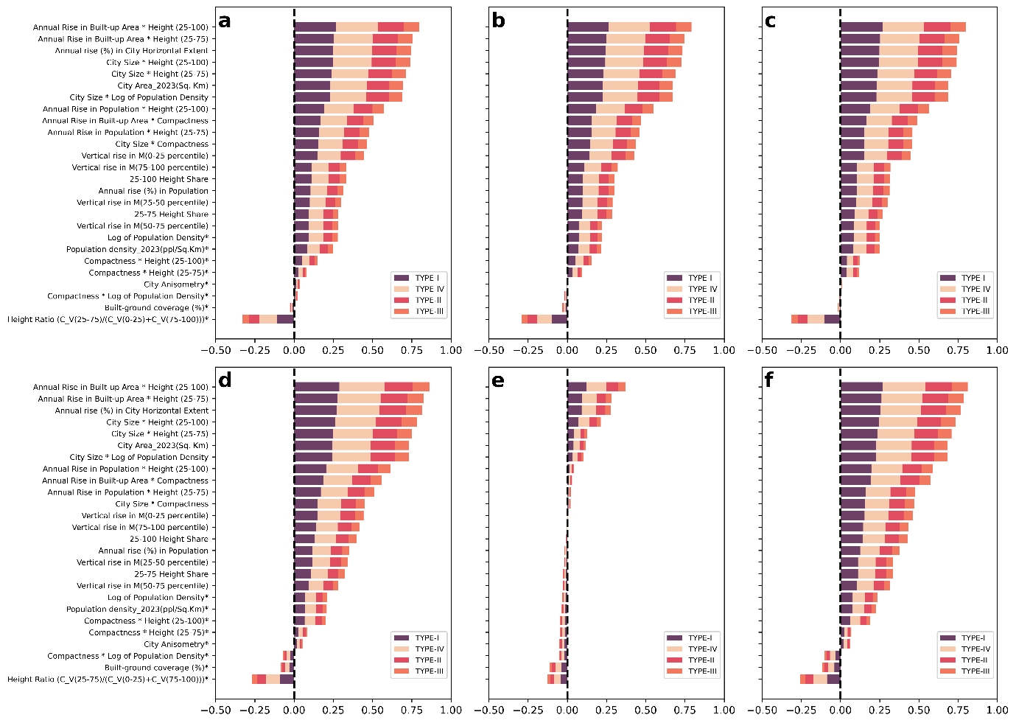

Supplementary Figure 18. Correlation analyses of rising trends of CDD-hum with indicators of built-urbanization. Subplots (a–f) show Pearson’s zero correlation coefficients along the x-axis, with various indicators of built-urbanization listed on the y-axis. Subplots (a–c) depict the actual increase per year in CDD-hum for different datasets: CDD-hum22 (a), CDD-hum 28 (b), and the average of CDD-hum 22 and CDD-hum 28 (c). Subplots (d–f) illustrate the relative increase per year (%) in CDD-hum for the same datasets: CDD-hum 22 (d), CDD-hum 28 (e), and their average (f). Positive correlations to the right of the vertical axis indicate a direct relationship between the indicator and CDD-hum trends, while inverse correlations to the left suggest a negative relationship. Natural logarithms of certain variables were used to account for skewness in the data, and squaring the correlation coefficients provides the percentage of variation in CDD-hum trends explained by each indicator alone. Indicators marked with an asterisk (*) are not statistically significant (significance level, p <0.1). The color coding represents different city typologies: TYPE-I, TYPE-II, TYPE-III, and TYPE-IV and their relative contribution in correlations.

Section 3

3.1 Limitations of the study and future scope
Our study provides a comprehensive analysis of the role of city-scale volumetric growth features in shaping UCD using high-resolution datasets. While the initial analysis for cooling degree day (CDD) estimation and comparative assessments used a ~1 km resolution, the reanalysis data had a resolution of ~9 km, which was resampled to 1 km. This introduces a potential limitation, as localized variations induced by volumetric growth features may be missed. However, previous studies (as highlighted in section S2) have shown the reliability of using reanalysis meteorological data to capture the impact of urban-built physics, and our study supports this approach. For greater accuracy, future studies could employ detailed simulations with downscaled data at a 0.5–1 km range, providing a more reliable assessment of localized temperature variability. Additionally, incorporating finer-scale volumetric growth features could further refine our understanding of outdoor temperature dynamics. Although this study focuses on city-scale volumetric growth, future research could integrate both building-scale and city-scale features within more detailed urban grids to capture the full range of temperature variability. The current study also assumes ten key city-scale volumetric indicators as primary measures of urbanization, without delving into the impact of non-built characteristics. Future work could adopt a linear or non-linear attribution model to better assess the role of both built and non-built urban features on UCD. Lastly, while this study acknowledges population as a key factor influencing UCD, socio-economic drivers of urbanization, which also affect UCD variability, were not explored in detail. Future studies should address these socio-economic factors to provide a more comprehensive understanding of UCD patterns and their underlying causes.

References

1. Zhou, B., Rybski, D. & Kropp, J. P. The role of city size and urban form in the surface urban heat island. Sci. Reports 2017 71 7, 1–9 (2017).
2. Liu, Z. et al. Surface warming in global cities is substantially more rapid than in rural background areas. Commun. Earth Environ. 2022 31 3, 1–9 (2022).
3. Li, X. et al. Mapping global urban boundaries from the global artificial impervious area (GAIA) data. Environ. Res. Lett. 15, 094044 (2020).
4. Sethi, S. S. & Vinoj, V. Urbanization and regional climate change-linked warming of Indian cities. Nat. Cities 2024 16 1, 402–405 (2024).
5. Chen, Y. Derivation of the functional relations between fractal dimension of and shape indices of urban form. Comput. Environ. Urban Syst. 35, 442–451 (2011).
6. Chen, Y. Normalizing and classifying shape indexes of cities by ideas from fractals. Chaos, Solitons & Fractals 154, 111653 (2022).
7. Bettencourt, L. M. A., Lobo, J., Helbing, D., Kühnert, C. & West, G. B. Growth, innovation, scaling, and the pace of life in cities. Proc. Natl. Acad. Sci. U. S. A. 104, 7301–7306 (2007).
8. Bettencourt, L. M. A. The origins of scaling in cities. Science (80-. ). 340, 1438–1441 (2013).
9. Sirko, W. et al. Continental-Scale Building Detection from High Resolution Satellite Imagery. (2021).
10. Open Buildings V3 Polygons | Earth Engine Data Catalog | Google for Developers. https://developers.google.com/earth-engine/datasets/catalog/GOOGLE_Research_open-buildings_v3_polygons.
11. Global Human Settlement - GHSL Homepage - European Commission. https://human-settlement.emergency.copernicus.eu/index.php.
12. Zhou, Y. et al. Satellite mapping of urban built-up heights reveals extreme infrastructure gaps and inequalities in the Global South. Proc. Natl. Acad. Sci. U. S. A. 119, e2214813119 (2022).
13. Li, Y. et al. Green spaces provide substantial but unequal urban cooling globally. Nat. Commun. 2024 151 15, 1–13 (2024).
14. Davis, L. W. & Gertler, P. J. Contribution of air conditioning adoption to future energy use under global warming. Proc. Natl. Acad. Sci. U. S. A. 112, 5962–5967 (2015).
15. Sivak, M. Potential energy demand for cooling in the 50 largest metropolitan areas of the world: Implications for developing countries. Energy Policy 37, 1382–1384 (2009).
16. Stern, D. I. The role of energy in economic growth. Ann. N. Y. Acad. Sci. 1219, 26–51 (2011).
17. Joint Research Centre Data Catalogue - GHS-UCDB R2024A - GHS Urban Centre Database 2025 - European Commission. https://data.jrc.ec.europa.eu/dataset/1a338be6-7eaf-480c-9664-3a8ade88cbcd (2024).
18. Kundu, D. et al. Spatial Structures and Trends of Cities in Europe and Asia: A Joint Methodological Approach Based on the Global Human Settlement Layer. Environ. Urban. ASIA 11, 195–217 (2020).
19. Müller, A. et al. India, Germany and Europe A Spatial Perspective at SDG 11 on Sustainable Cities and Communities. (2020).
20. Mondal, N. et al. Systematic review of the efficacy of data-driven urban building energy models during extreme heat in cities: Current trends and future outlook. Build. Simul. 2024 175 17, 695–722 (2024).
21. Staffell, I., Pfenninger, S. & Johnson, N. A global model of hourly space heating and cooling demand at multiple spatial scales. 8, 1328–1344 (2023).
22. Wilson, E. J. H. et al. End-Use Load Profiles for the U.S. Building Stock: Methodology and Results of Model Calibration, Validation, and Uncertainty Quantification. (2022) doi:10.2172/1854582.
23. Sezer, N. et al. Urban microclimate and building energy models: A review of the latest progress in coupling strategies. Renew. Sustain. Energy Rev. 184, 113577 (2023).
24. Xu, L. et al. Resilience of renewable power systems under climate risks. Nat. Rev. Electr. Eng. 2024 11 1, 53–66 (2024).
25. Haddad, S. et al. Quantifying the energy impact of heat mitigation technologies at the urban scale. Nat. Cities 2024 11 1, 62–72 (2024).
26. Perera, A. T. D. et al. Challenges resulting from urban density and climate change for the EU energy transition. Nat. Energy 8, 397–412 (2023).

