Supplemental Table 1: COPD-Related Deaths per 100,000 in the United States, 1999 to 2020
 | Deaths
Year | Female | Male | NH White | NH Black or African American | Asian or Pacific Islander | American Indian or Alaska Native | Hispanic or Latino
1999 | 97742 | 112434 | 189297 | 13238 | 1590 | 641 | 4823
2000 | 98349 | 110254 | 188201 | 12758 | 1641 | 697 | 4746
2001 | 101399 | 110343 | 190823 | 12773 | 1788 | 724 | 5083
2002 | 103951 | 112315 | 194547 | 13199 | 1780 | 783 | 5403
2003 | 106528 | 113114 | 197508 | 13315 | 1836 | 864 | 5592
2004 | 105188 | 111337 | 194472 | 13170 | 1868 | 946 | 5640
2005 | 112313 | 117280 | 205647 | 14254 | 2045 | 943 | 6318
2006 | 109770 | 114656 | 200687 | 14039 | 2155 | 1003 | 6108
2007 | 111000 | 115550 | 202607 | 14177 | 2157 | 1091 | 6217
2008 | 118175 | 120823 | 213132 | 15282 | 2328 | 1058 | 6766
2009 | 116527 | 119715 | 210304 | 15113 | 2409 | 1112 | 6889
2010 | 119362 | 122799 | 214952 | 15744 | 2487 | 1260 | 7278
2011 | 124627 | 127595 | 223776 | 16418 | 2647 | 1256 | 7688
2012 | 126329 | 129372 | 225923 | 17107 | 2636 | 1303 | 8120
2013 | 131787 | 134272 | 234189 | 18176 | 2969 | 1419 | 8683
2014 | 130246 | 133625 | 231695 | 18195 | 2943 | 1520 | 8709
2015 | 138599 | 139312 | 243372 | 19374 | 3147 | 1652 | 9359
2016 | 138715 | 142672 | 245336 | 20482 | 3203 | 1709 | 9821
2017 | 145140 | 146623 | 253727 | 21339 | 3461 | 1890 | 10360
2018 | 145239 | 148277 | 254254 | 22275 | 3551 | 1855 | 10732
2019 | 144907 | 148422 | 253983 | 22423 | 3485 | 1890 | 10795
2020 | 158463 | 166540 | 275907 | 28045 | 4304 | 2146 | 13785

Supplemental Table 2: Overall COPD-Related Age-Adjusted Mortality Rates per 100,000 in the United States, 1999 to 2020
Age Adjusted Rate (95% CI) OVERALL
Year | Age Adjusted Rate | Age Adjusted Rate Lower 95% Confidence Interval | Age Adjusted Rate Upper 95% Confidence Interval
1999 | 118.986 | 118.477 | 119.495
2000 | 116.804 | 116.303 | 117.305
2001 | 116.772 | 116.274 | 117.269
2002 | 117.537 | 117.041 | 118.032
2003 | 117.498 | 117.007 | 117.99
2004 | 114.176 | 113.695 | 114.658
2005 | 118.906 | 118.419 | 119.393
2006 | 114.131 | 113.658 | 114.604
2007 | 113.007 | 112.54 | 113.473
2008 | 116.805 | 116.335 | 117.275
2009 | 113.151 | 112.693 | 113.61
2010 | 114.103 | 113.646 | 114.561
2011 | 115.632 | 115.177 | 116.087
2012 | 114.082 | 113.636 | 114.528
2013 | 115.654 | 115.21 | 116.098
2014 | 111.724 | 111.293 | 112.155
2015 | 114.798 | 114.366 | 115.23
2016 | 113.6 | 113.175 | 114.025
2017 | 114.745 | 114.323 | 115.166
2018 | 112.488 | 112.077 | 112.899
2019 | 109.772 | 109.371 | 110.174
2020 | 119.207 | 118.793 | 119.621
Supplemental Table 3: Sex‐Stratified COPD-Related Age-Adjusted Mortality Rates per 100,000 in the United States, 1999 to 2020

Age Adjusted Rate (95% CI) SEX (Females)
Year | Age Adjusted Rate | Age Adjusted Rate Lower 95% Confidence Interval | Age Adjusted Rate Upper 95% Confidence Interval
1999 | 91.585 | 91.008 | 92.162
2000 | 91.203 | 90.63 | 91.775
2001 | 92.876 | 92.301 | 93.451
2002 | 94.1 | 93.525 | 94.675
2003 | 95.221 | 94.646 | 95.796
2004 | 93.03 | 92.465 | 93.595
2005 | 97.774 | 97.199 | 98.35
2006 | 94.205 | 93.644 | 94.766
2007 | 93.768 | 93.212 | 94.324
2008 | 98.102 | 97.538 | 98.666
2009 | 95.341 | 94.788 | 95.894
2010 | 96.15 | 95.599 | 96.702
2011 | 98.111 | 97.559 | 98.663
2012 | 97.187 | 96.643 | 97.73
2013 | 99.273 | 98.729 | 99.817
2014 | 95.997 | 95.467 | 96.526
2015 | 99.816 | 99.281 | 100.35
2016 | 98.074 | 97.549 | 98.599
2017 | 100.153 | 99.629 | 100.676
2018 | 97.842 | 97.331 | 98.352
2019 | 95.696 | 95.197 | 96.195
2020 | 102.729 | 102.217 | 103.241

Age Adjusted Rate (95% CI) SEX (Males)
Year | Age Adjusted Rate | Age Adjusted Rate Lower 95% Confidence Interval | Age Adjusted Rate Upper 95% Confidence Interval
1999 | 163.796 | 162.82 | 164.772
2000 | 158.781 | 157.827 | 159.736
2001 | 155.379 | 154.446 | 156.312
2002 | 155.299 | 154.375 | 156.224
2003 | 152.727 | 151.822 | 153.632
2004 | 147.461 | 146.581 | 148.342
2005 | 151.476 | 150.596 | 152.356
2006 | 144.599 | 143.75 | 145.448
2007 | 141.998 | 141.168 | 142.827
2008 | 144.779 | 143.952 | 145.606
2009 | 139.63 | 138.828 | 140.432
2010 | 140.531 | 139.734 | 141.328
2011 | 140.94 | 140.156 | 141.725
2012 | 138.435 | 137.669 | 139.201
2013 | 138.892 | 138.136 | 139.647
2014 | 133.759 | 133.029 | 134.489
2015 | 135.434 | 134.71 | 136.158
2016 | 134.948 | 134.235 | 135.662
2017 | 134.646 | 133.944 | 135.348
2018 | 132.059 | 131.375 | 132.743
2019 | 128.54 | 127.875 | 129.204
2020 | 140.93 | 140.242 | 141.618

Supplemental Table 4: Race‐Stratified COPD-Related Age-Adjusted Mortality Rates per 100,000 in the United States, 1999 to 2020
Age Adjusted Rate (95% CI) AMERICAN INDIAN OR ALASKAN NATIVE
Year | Age Adjusted Rate | Age Adjusted Rate Lower 95% Confidence Interval | Age Adjusted Rate Upper 95% Confidence Interval
1999 | 94.941 | 87.263 | 102.618
2000 | 95.227 | 87.869 | 102.585
2001 | 94.187 | 87.01 | 101.363
2002 | 103.05 | 95.508 | 110.593
2003 | 106.865 | 99.346 | 114.384
2004 | 112.386 | 104.822 | 119.951
2005 | 108.183 | 100.878 | 115.488
2006 | 113.519 | 106.096 | 120.942
2007 | 117.373 | 110 | 124.746
2008 | 108.129 | 101.214 | 115.045
2009 | 109.826 | 102.97 | 116.682
2010 | 122.815 | 115.611 | 130.02
2011 | 113.869 | 107.206 | 120.532
2012 | 111.979 | 105.556 | 118.403
2013 | 115.849 | 109.508 | 122.189
2014 | 116.703 | 110.538 | 122.868
2015 | 119.894 | 113.834 | 125.954
2016 | 117.156 | 111.353 | 122.959
2017 | 124.817 | 118.953 | 130.68
2018 | 117.504 | 111.963 | 123.046
2019 | 113.21 | 107.929 | 118.492
2020 | 122.448 | 117.101 | 127.795

Age Adjusted Rate (95% CI) ASIAN OR PACIFIC ISLANDER
Year | Age Adjusted Rate | Age Adjusted Rate Lower 95% Confidence Interval | Age Adjusted Rate Upper 95% Confidence Interval
1999 | 44.79 | 42.507 | 47.072
2000 | 44.073 | 41.872 | 46.274
2001 | 43.896 | 41.801 | 45.992
2002 | 41.465 | 39.49 | 43.441
2003 | 40.087 | 38.207 | 41.968
2004 | 38.831 | 37.029 | 40.634
2005 | 39.366 | 37.622 | 41.11
2006 | 39.105 | 37.422 | 40.787
2007 | 37.008 | 35.418 | 38.598
2008 | 37.704 | 36.147 | 39.261
2009 | 37.106 | 35.602 | 38.61
2010 | 36.761 | 35.296 | 38.226
2011 | 35.901 | 34.516 | 37.285
2012 | 33.025 | 31.748 | 34.301
2013 | 34.683 | 33.422 | 35.945
2014 | 31.702 | 30.543 | 32.861
2015 | 31.418 | 30.308 | 32.528
2016 | 30.287 | 29.226 | 31.348
2017 | 30.682 | 29.649 | 31.715
2018 | 29.827 | 28.836 | 30.818
2019 | 27.821 | 26.889 | 28.754
2020 | 32.303 | 31.329 | 33.277

Age Adjusted Rate (95% CI) BLACK OR AFRICAN AMERICAN
Year | Age Adjusted Rate | Age Adjusted Rate Lower 95% Confidence Interval | Age Adjusted Rate Upper 95% Confidence Interval
1999 | 91.425 | 89.854 | 92.997
2000 | 86.882 | 85.36 | 88.403
2001 | 85.519 | 84.02 | 87.018
2002 | 86.894 | 85.393 | 88.395
2003 | 85.94 | 84.46 | 87.421
2004 | 83.376 | 81.929 | 84.824
2005 | 87.744 | 86.278 | 89.21
2006 | 84.242 | 82.822 | 85.663
2007 | 83.007 | 81.612 | 84.402
2008 | 86.979 | 85.569 | 88.389
2009 | 82.986 | 81.63 | 84.341
2010 | 84.549 | 83.195 | 85.903
2011 | 85.015 | 83.68 | 86.35
2012 | 85.277 | 83.965 | 86.59
2013 | 87.037 | 85.735 | 88.338
2014 | 83.855 | 82.601 | 85.109
2015 | 86.043 | 84.795 | 87.291
2016 | 87.716 | 86.478 | 88.953
2017 | 88.339 | 87.118 | 89.56
2018 | 89.178 | 87.973 | 90.383
2019 | 86.595 | 85.43 | 87.76
2020 | 105.497 | 104.228 | 106.765

Age Adjusted Rate (95% CI) WHITE
Year | Age Adjusted Rate | Age Adjusted Rate Lower 95% Confidence Interval | Age Adjusted Rate Upper 95% Confidence Interval
1999 | 126.571 | 126.001 | 127.141
2000 | 124.913 | 124.348 | 125.477
2001 | 125.4 | 124.837 | 125.963
2002 | 126.465 | 125.903 | 127.028
2003 | 126.9 | 126.34 | 127.46
2004 | 123.731 | 123.18 | 124.281
2005 | 129.131 | 128.572 | 129.691
2006 | 124.292 | 123.747 | 124.838
2007 | 123.701 | 123.16 | 124.241
2008 | 128.067 | 127.521 | 128.613
2009 | 124.592 | 124.057 | 125.128
2010 | 125.756 | 125.221 | 126.291
2011 | 128.333 | 127.796 | 128.869
2012 | 126.858 | 126.33 | 127.386
2013 | 129.019 | 128.491 | 129.548
2014 | 125.302 | 124.786 | 125.819
2015 | 129.243 | 128.723 | 129.764
2016 | 128.212 | 127.697 | 128.726
2017 | 129.948 | 129.436 | 130.461
2018 | 127.505 | 127.003 | 128.007
2019 | 125.071 | 124.579 | 125.563
2020 | 134.096 | 133.589 | 134.603

Age Adjusted Rate (95% CI) HISPANICS
Year | Age Adjusted Rate | Age Adjusted Rate Lower 95% Confidence Interval | Age Adjusted Rate Upper 95% Confidence Interval
1999 | 63.521 | 61.674 | 65.369
2000 | 59.81 | 58.059 | 61.561
2001 | 59.936 | 58.24 | 61.632
2002 | 60.78 | 59.109 | 62.451
2003 | 59.824 | 58.208 | 61.439
2004 | 56.897 | 55.365 | 58.43
2005 | 60.126 | 58.599 | 61.653
2006 | 55.373 | 53.946 | 56.8
2007 | 52.982 | 51.629 | 54.335
2008 | 54.918 | 53.576 | 56.26
2009 | 52.806 | 51.527 | 54.085
2010 | 53.55 | 52.289 | 54.811
2011 | 52.343 | 51.147 | 53.539
2012 | 52.292 | 51.13 | 53.454
2013 | 52.403 | 51.277 | 53.529
2014 | 49.152 | 48.097 | 50.207
2015 | 49.727 | 48.698 | 50.757
2016 | 49.451 | 48.45 | 50.452
2017 | 49.471 | 48.496 | 50.445
2018 | 48.903 | 47.958 | 49.849
2019 | 47.073 | 46.166 | 47.98
2020 | 57.418 | 56.439 | 58.397

Supplemental Table 5: Region‐Stratified COPD-Related Age-Adjusted Mortality Rates per 100,000 in the United States, 1999 to 2020
Age Adjusted Rate (95% CI) NORTHEAST
Year | Age Adjusted Rate | Age Adjusted Rate Lower 95% Confidence Interval | Age Adjusted Rate Upper 95% Confidence Interval
1999 | 105.589 | 104.549 | 106.629
2000 | 104.912 | 103.881 | 105.943
2001 | 103.143 | 102.126 | 104.16
2002 | 102.164 | 101.157 | 103.171
2003 | 100.444 | 99.451 | 101.438
2004 | 100.408 | 99.418 | 101.398
2005 | 101.949 | 100.956 | 102.943
2006 | 96.469 | 95.507 | 97.432
2007 | 95.275 | 94.323 | 96.226
2008 | 98.127 | 97.167 | 99.087
2009 | 94.21 | 93.273 | 95.147
2010 | 93.953 | 93.021 | 94.884
2011 | 96.019 | 95.084 | 96.955
2012 | 93.914 | 92.997 | 94.83
2013 | 93.019 | 92.113 | 93.924
2014 | 88.977 | 88.097 | 89.857
2015 | 91.886 | 90.997 | 92.775
2016 | 88.845 | 87.977 | 89.714
2017 | 89.124 | 88.268 | 89.98
2018 | 86.944 | 86.107 | 87.782
2019 | 85.062 | 84.241 | 85.883
2020 | 92.386 | 91.536 | 93.236

Age Adjusted Rate (95% CI) MIDWEST
Year | Age Adjusted Rate | Age Adjusted Rate Lower 95% Confidence Interval | Age Adjusted Rate Upper 95% Confidence Interval
1999 | 124.769 | 123.704 | 125.834
2000 | 121.856 | 120.807 | 122.906
2001 | 122.652 | 121.604 | 123.699
2002 | 123.54 | 122.494 | 124.586
2003 | 123.251 | 122.212 | 124.29
2004 | 120.595 | 119.572 | 121.618
2005 | 126.838 | 125.794 | 127.882
2006 | 123.143 | 122.121 | 124.165
2007 | 121.202 | 120.194 | 122.209
2008 | 128.754 | 127.723 | 129.784
2009 | 122.9 | 121.898 | 123.902
2010 | 123.867 | 122.867 | 124.868
2011 | 128.639 | 127.627 | 129.65
2012 | 126.708 | 125.714 | 127.703
2013 | 128.452 | 127.459 | 129.445
2014 | 125.708 | 124.734 | 126.681
2015 | 128.756 | 127.778 | 129.733
2016 | 126.075 | 125.114 | 127.035
2017 | 127.611 | 126.656 | 128.566
2018 | 126.13 | 125.192 | 127.068
2019 | 122.923 | 122.006 | 123.84
2020 | 136.859 | 135.897 | 137.82

Age Adjusted Rate (95% CI) SOUTH
Year | Age Adjusted Rate | Age Adjusted Rate Lower 95% Confidence Interval | Age Adjusted Rate Upper 95% Confidence Interval
1999 | 120.945 | 120.079 | 121.81
2000 | 120.149 | 119.291 | 121.007
2001 | 120.585 | 119.732 | 121.437
2002 | 122.705 | 121.851 | 123.559
2003 | 123.354 | 122.505 | 124.203
2004 | 118.601 | 117.775 | 119.426
2005 | 124.475 | 123.638 | 125.311
2006 | 119.408 | 118.598 | 120.219
2007 | 119.395 | 118.592 | 120.197
2008 | 122.792 | 121.988 | 123.596
2009 | 121.107 | 120.317 | 121.897
2010 | 122.884 | 122.095 | 123.673
2011 | 122.453 | 121.678 | 123.228
2012 | 122.645 | 121.88 | 123.41
2013 | 125.053 | 124.292 | 125.814
2014 | 121.25 | 120.512 | 121.989
2015 | 124.542 | 123.803 | 125.28
2016 | 124.775 | 124.046 | 125.504
2017 | 127.195 | 126.469 | 127.92
2018 | 125.079 | 124.372 | 125.787
2019 | 122.509 | 121.818 | 123.199
2020 | 132.71 | 132 | 133.42

Age Adjusted Rate (95% CI) WEST
Year | Age Adjusted Rate | Age Adjusted Rate Lower 95% Confidence Interval | Age Adjusted Rate Upper 95% Confidence Interval
1999 | 122.821 | 121.655 | 123.987
2000 | 117.239 | 116.11 | 118.368
2001 | 117.163 | 116.048 | 118.277
2002 | 117.278 | 116.174 | 118.383
2003 | 117.853 | 116.759 | 118.947
2004 | 112.749 | 111.689 | 113.81
2005 | 116.931 | 115.865 | 117.997
2006 | 111.852 | 110.82 | 112.883
2007 | 109.91 | 108.899 | 110.92
2008 | 110.918 | 109.914 | 111.921
2009 | 106.562 | 105.591 | 107.533
2010 | 107.259 | 106.294 | 108.224
2011 | 107.933 | 106.98 | 108.885
2012 | 104.473 | 103.55 | 105.396
2013 | 106.458 | 105.541 | 107.375
2014 | 101.12 | 100.241 | 101.999
2015 | 104.038 | 103.16 | 104.916
2016 | 103.493 | 102.629 | 104.357
2017 | 102.834 | 101.984 | 103.684
2018 | 99.245 | 98.424 | 100.066
2019 | 96.089 | 95.293 | 96.886
2020 | 101.638 | 100.83 | 102.446

Age Adjusted Rate (95% CI) URBAN
Year | Age Adjusted Rate | Age Adjusted Rate Lower 95% Confidence Interval | Age Adjusted Rate Upper 95% Confidence Interval
1999 | 114.628 | 114.066 | 115.189
2000 | 111.909 | 111.358 | 112.46
2001 | 111.427 | 110.881 | 111.972
2002 | 111.822 | 111.279 | 112.364
2003 | 111.63 | 111.092 | 112.167
2004 | 108.498 | 107.972 | 109.024
2005 | 112.351 | 111.82 | 112.881
2006 | 107.866 | 107.35 | 108.381
2007 | 106.316 | 105.809 | 106.823
2008 | 109.771 | 109.261 | 110.281
2009 | 105.969 | 105.473 | 106.466
2010 | 107.013 | 106.518 | 107.508
2011 | 108.285 | 107.794 | 108.777
2012 | 106.413 | 105.932 | 106.894
2013 | 107.999 | 107.52 | 108.477
2014 | 104.022 | 103.559 | 104.486
2015 | 106.258 | 105.796 | 106.721
2016 | 104.949 | 104.495 | 105.404
2017 | 105.648 | 105.199 | 106.097
2018 | 103.364 | 102.926 | 103.801
2019 | 100.319 | 99.893 | 100.744
2020 | 108.968 | 108.529 | 109.407

Age Adjusted Rate (95% CI) RURAL
Year | Age Adjusted Rate | Age Adjusted Rate Lower 95% Confidence Interval | Age Adjusted Rate Upper 95% Confidence Interval
1999 | 135.875 | 134.682 | 137.068
2000 | 135.632 | 134.445 | 136.819
2001 | 137.534 | 136.344 | 138.724
2002 | 139.995 | 138.8 | 141.189
2003 | 140.571 | 139.381 | 141.762
2004 | 136.718 | 135.549 | 137.886
2005 | 144.887 | 143.692 | 146.083
2006 | 138.967 | 137.805 | 140.128
2007 | 139.681 | 138.524 | 140.837
2008 | 145.104 | 143.933 | 146.275
2009 | 142.373 | 141.22 | 143.527
2010 | 142.995 | 141.845 | 144.144
2011 | 145.858 | 144.706 | 147.01
2012 | 146.273 | 145.13 | 147.417
2013 | 147.869 | 146.728 | 149.009
2014 | 144.646 | 143.527 | 145.766
2015 | 151.489 | 150.353 | 152.624
2016 | 151.165 | 150.038 | 152.292
2017 | 154.541 | 153.412 | 155.671
2018 | 152.603 | 151.492 | 153.713
2019 | 151.723 | 150.626 | 152.82
2020 | 164.934 | 163.797 | 166.072

Age Adjusted Rate (95% CI) STATES
State | Age Adjusted Rate | Age Adjusted Rate Lower 95% Confidence Interval | Age Adjusted Rate Upper 95% Confidence Interval
Alabama | 130.555 | 129.735 | 131.375
Alaska | 110.537 | 107.79 | 113.285
Arizona | 98.937 | 98.32 | 99.554
Arkansas | 136.824 | 135.77 | 137.877
California | 102.205 | 101.926 | 102.483
Colorado | 131.853 | 130.96 | 132.746
Connecticut | 92.004 | 91.243 | 92.765
Delaware | 118.589 | 116.822 | 120.355
District of Columbia | 70.841 | 69.038 | 72.644
Florida | 104.448 | 104.122 | 104.774
Georgia | 108.212 | 107.616 | 108.807
Hawaii | 50.041 | 49.128 | 50.954
Idaho | 123.392 | 121.93 | 124.853
Illinois | 101.494 | 101.043 | 101.946
Indiana | 151.204 | 150.435 | 151.972
Iowa | 131.765 | 130.797 | 132.734
Kansas | 126.125 | 125.087 | 127.162
Kentucky | 178.791 | 177.772 | 179.81
Louisiana | 108.471 | 107.671 | 109.27
Maine | 134.738 | 133.287 | 136.189
Maryland | 102.42 | 101.731 | 103.108
Massachusetts | 85.172 | 84.626 | 85.718
Michigan | 124.052 | 123.506 | 124.599
Minnesota | 109.173 | 108.458 | 109.889
Mississippi | 143.963 | 142.837 | 145.088
Missouri | 133.365 | 132.639 | 134.091
Montana | 136.908 | 135.144 | 138.671
Nebraska | 135.057 | 133.731 | 136.383
Nevada | 127.157 | 125.962 | 128.351
New Hampshire | 121.059 | 119.57 | 122.548
New Jersey | 85.593 | 85.112 | 86.075
New Mexico | 113.879 | 112.678 | 115.081
New York | 83.27 | 82.95 | 83.59
North Carolina | 128.006 | 127.414 | 128.598
North Dakota | 124.632 | 122.611 | 126.653
Ohio | 145.681 | 145.139 | 146.223
Oklahoma | 183.261 | 182.159 | 184.362
Oregon | 125.092 | 124.216 | 125.969
Pennsylvania | 111.259 | 110.831 | 111.686
Rhode Island | 127.558 | 125.936 | 129.181
South Carolina | 127.886 | 127.052 | 128.72
South Dakota | 128.95 | 127.072 | 130.829
Tennessee | 152.345 | 151.567 | 153.123
Texas | 121.384 | 120.989 | 121.779
Utah | 74.85 | 73.852 | 75.848
Vermont | 141.083 | 138.821 | 143.344
Virginia | 100.905 | 100.317 | 101.494
Washington | 120.838 | 120.146 | 121.53
West Virginia | 195.015 | 193.521 | 196.509
Wisconsin | 109.13 | 108.458 | 109.803
Wyoming | 156.644 | 153.901 | 159.387

Supplemental Table 3: Annual percent change (APC) of COPD related age-adjusted mortality rates per 100,000 in the United States, 1999 to 2020
Year Interval | APC (95% CI)
Overall
1999-2020 | -0.152 (-0.292 to –0.013)
Male
1999-2020 | -0.881 (-1.065 to –0.695)
Female
1999-2020 | 0.374 (0.24 to 0.50)
NH White
1999-2020 | 0.159 (0.036 to 0.281)
NH Black or African American
1999-2018 | -0.026 (-0.241 to 0.189)
2018-2020 | 9.2 (2.97 to 15.796)
NH Asian or Pacific Islander
1999-2020 | -1.98 (-2.28 to –1.679)
NH American Indian or Alaska Native
1999-2004 | 3.862 (0.574 to 7.259)
2004-2020 | 0.509 (0.105 to 0.914)
Hispanic or Latino
1999-2018 | -1.39 (-1.594 to –1.185)
2018-2020 | 7.88 (2.364 to 13.709)
Rural areas
1999-2020 | 0.711 (0.56 to 0.863)
Urban areas
1999-2020 | -0.383 (-0.523 to –0.243)

Supplementary Figure 1: COPD-Related Annual Percentage Change (APC) in the United States from 1999 to 2020 stratified by (A) Overall (B) Sex (C) Race and (D) Census Region (E) Urban (F) Rural

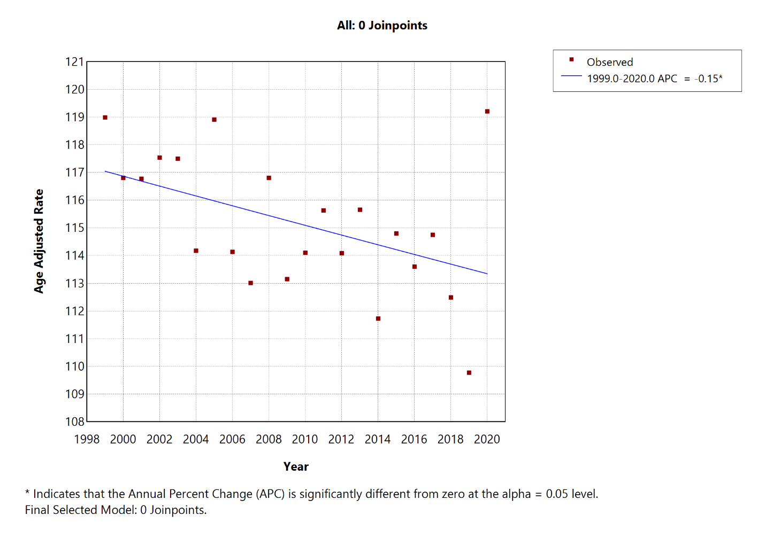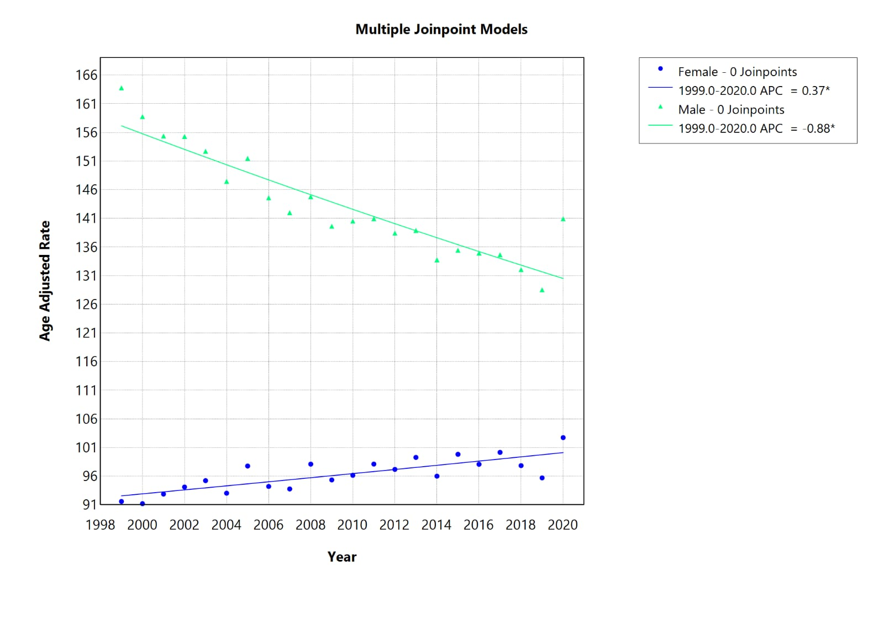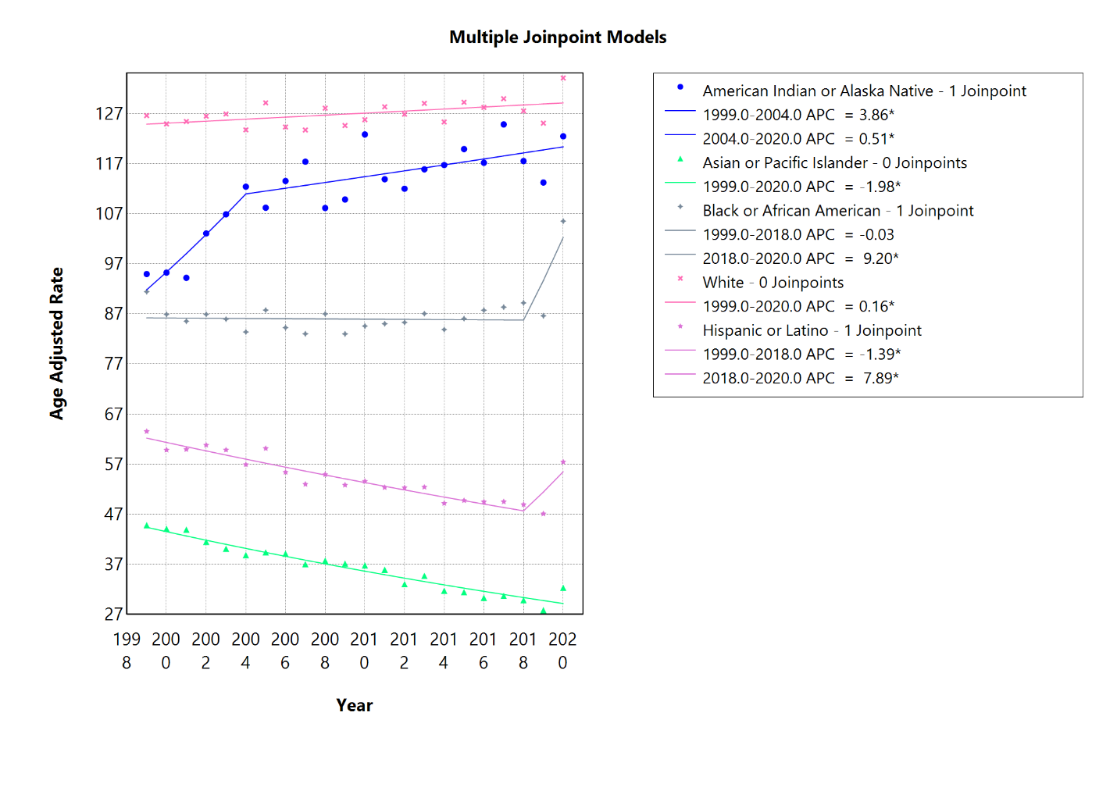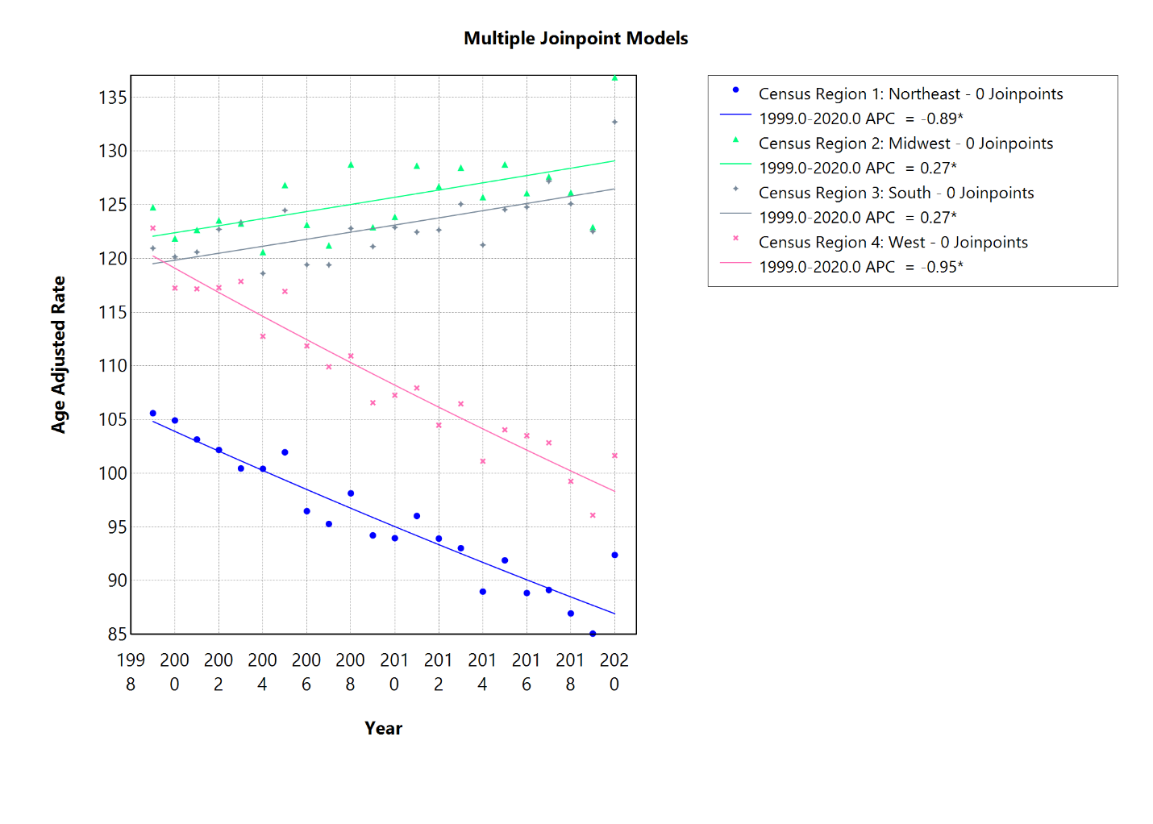
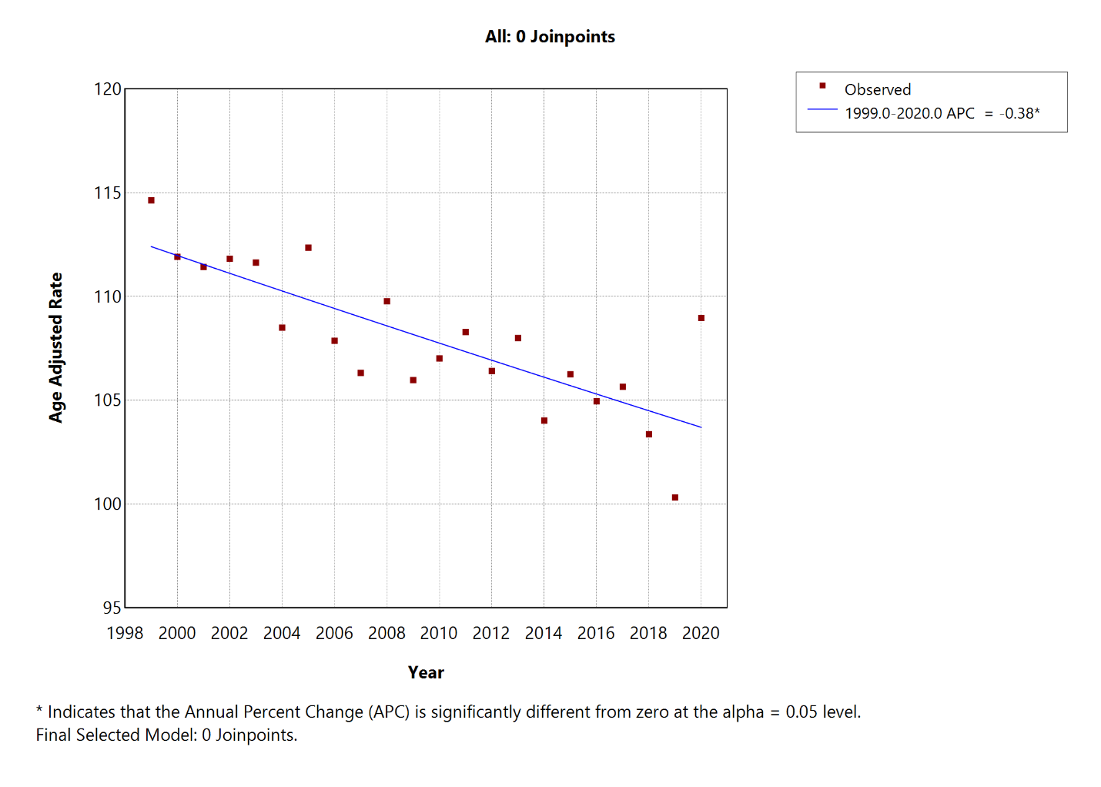
URBAN
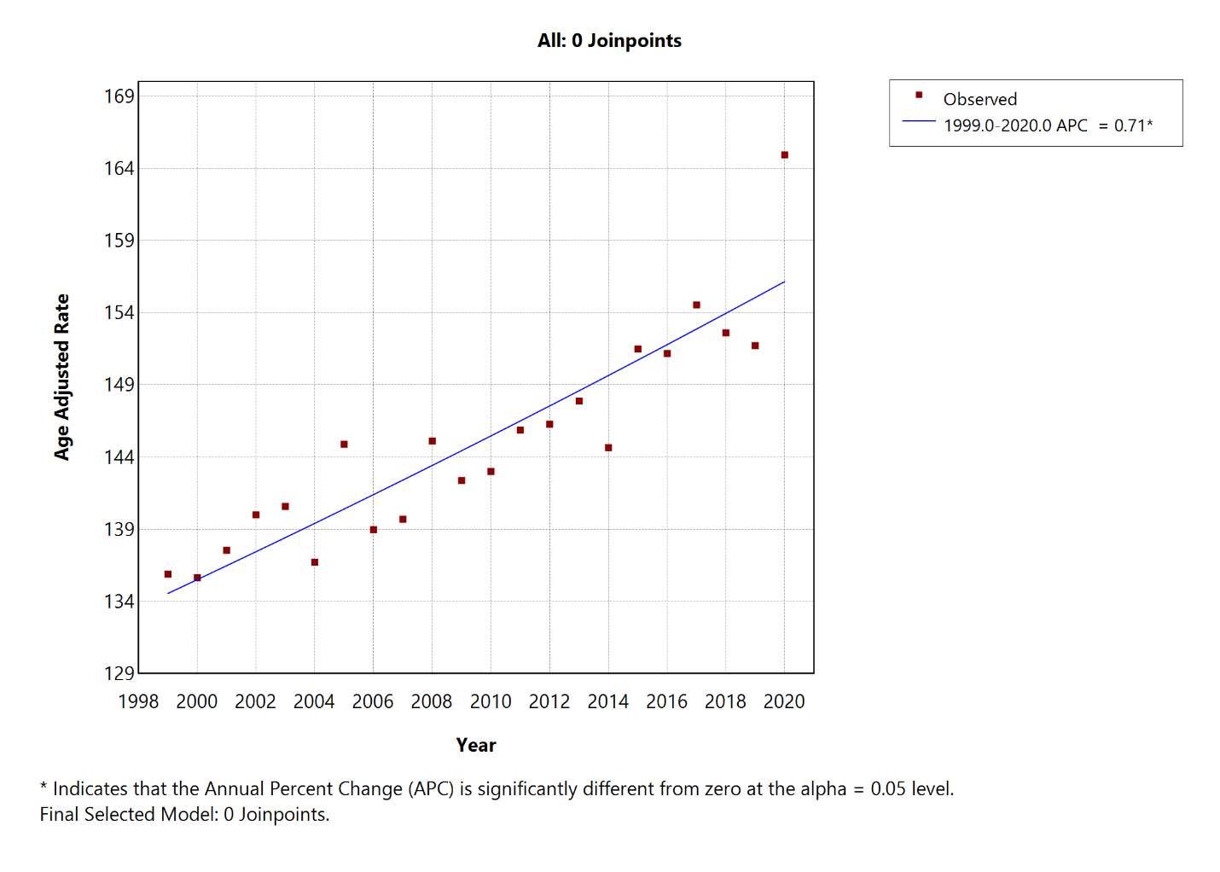
RURAL

