Supplemental Information
Shazia Alam¹(shaziaalam1212@gmail.com), Asma Hanif²*(asma.hanif@uok.edu.pk), Sumara Shaheen³(sumarashaheen16@gmail.com), Min Zhu¹ (minzhu@yzu.edu.cn). Mohammad Mehdizadeh(mehdizade.mohammad@gmail.com) Zainul Abideen^{5*}(zuabideen@uok.edu.pk)

¹College of Agriculture, Yangzhou University, 48 Wenhui Rd, Yangzhou, Jiangsu, China. ²Department of Botany, University of Karachi, Pakistan
³Department of Food Science and Technology, University of Karachi, Pakistan
⁴Department of Agronomy and Plant Breeding, Faculty of Agriculture and Natural Resources, University of Mohaghegh Ardabili, Ardabil, Iran.
⁵Dr. Muhammad Ajmal Khan Institute of Sustainable Halophyte Utilization, University of Karachi, Karachi, 75270, Pakistan
Corresponding author email: zuabideen@uok.edu.pk: asma.hanif@uok.edu.pk

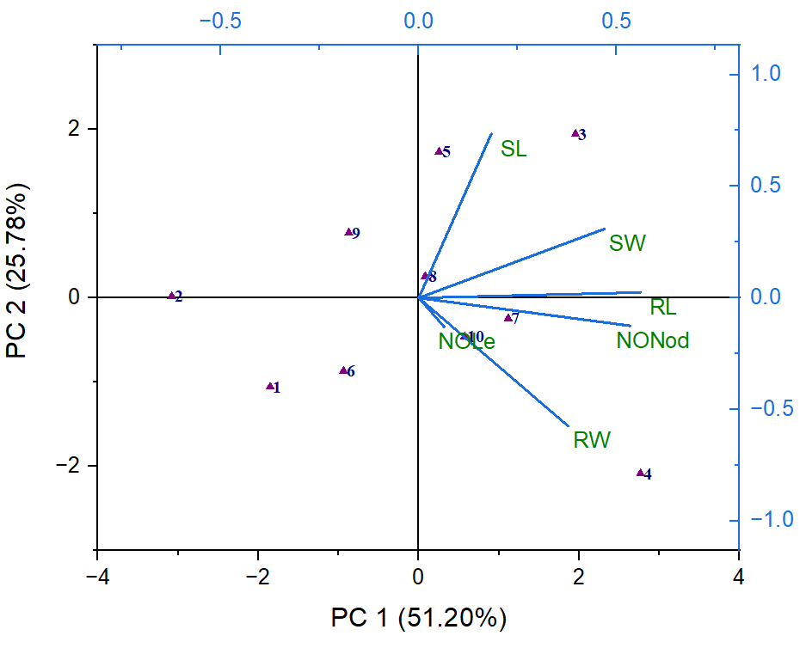

Fig 1: Principal component analysis (PC1 and PC2) of plant biomass (root-shoot length, root-shoot weight, no. of leaves, and no. of nodules) for the treatments, including organic fertilizer and fertilizer+ seed treatment with fresh ginger compared to the untreated control plants of red beans are shown in the biplot.
Whereas RL=root length, RW=root weight, SL=shoot length, SW=shoot weight, NOLE= no. of leaves, NONod=no. of nodules.
1=Control, 2=Seed treatment, 3=Cow dung (CD), 4=Goat dung (GD), 5=DAP, 6=Fudan (F), 7=CD+ seed treatment,
8=GD + seed treatment, 9=DAP + seed treatment, 10=F + seed treatment

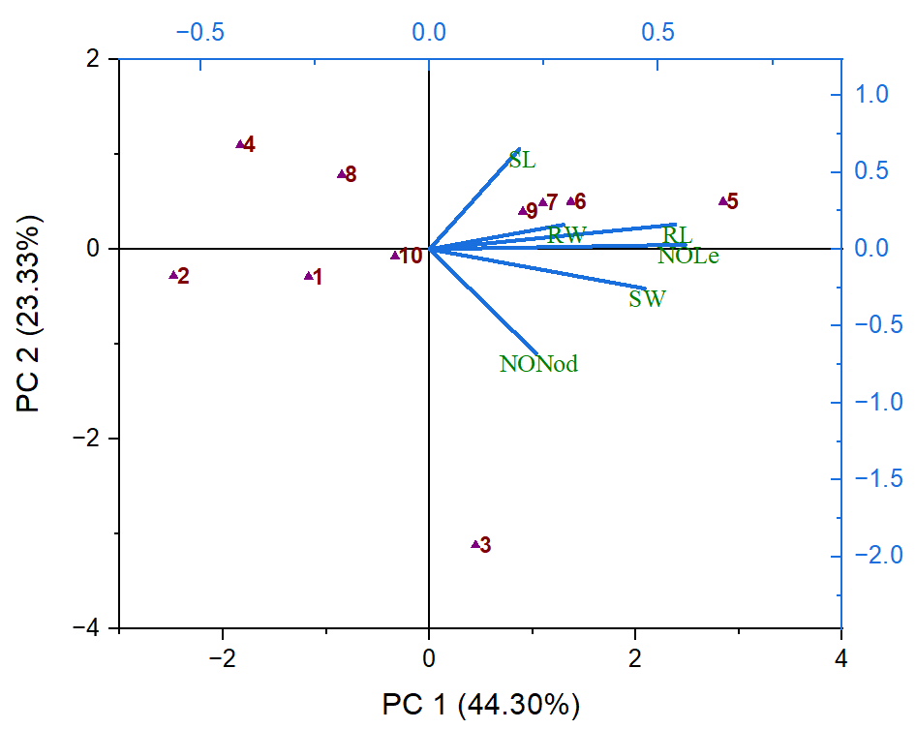

Fig 2: Principal component analysis (PC1 and PC2) of plant biomass (root-shoot length, root-shoot weight, no. of leaves, and no. of nodules) for the treatments, including organic fertilizer and fertilizer+ seed treatment with dry ginger powder compared to the untreated control plants of red beans are shown in the biplot.
Whereas, RL=root length, RW=root weight, SL=shoot length, SW=shoot weight, NOLE= no. of leaves, NONod=no. of nodules.
1=Control, 2=Seed treatment, 3=Cow dung (CD), 4=Goat dung (GD), 5=DAP, 6=Fudan (F), 7=CD+ seed treatment, 8=GD + seed treatment, 9=DAP + seed treatment, 10=F + seed treatment

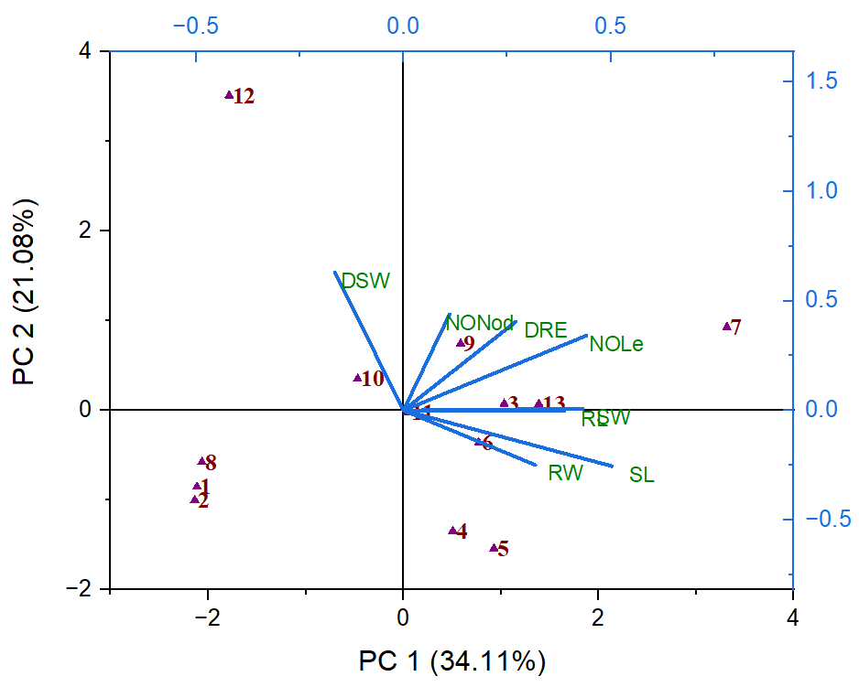

Fig 3: Principal component analysis (PC1 and PC2) of plant biomass (root-shoot length, root-shoot weight, no. of leaves, and no. of nodules) for the treatments, including soil amendment, soil drenching, and seed treatment by fresh ginger and ginger dry powder on the growth of red beans compared to the untreated control plants are shown in the biplot.
Whereas,
RL=root length, RW=root weight, SL=shoot length, SW=shoot weight, NOLE= no. of leaves, NONod=no. of nodules, DSW=dry shoot weight, and DRW=dry root weight.
1=Control, 2=100% S.T with FG, 3=75% S.T with FG, 4=100%S.T with DP, 5=75%S.T with DP, 6=100% S.D with FG, 7=75% S.D with FG, 8=100%S.D with DP, 9=75%S.D with DP, 10=0.5 % S.A with FG, 11=0.1 % S.A with FG, 12=0.5 % S.A with DG, and 13=0.1 % S.A with DG.

