Supplementary Material
Supplementary Table S1. Baseline characteristics at first visit of the 156 REGISPONSERBIO patients not included in the study.
Baseline characteristics at  recruitment | N |  |  | TNFi treatment ≥ 4years n=61  (39.9%) | TNFi treatment < 4years n=92  (60.1%) |  |  |  | All  n=153
Age, years | 101 |  |  | 52.00  (26.00, 73.0) | 48.50  (19.0, 80.0) |  |  |  | 49.00  (19.0, 80.0)
Female, sex % | 156 |  |  | 12 (19.7%) | 26 (28.3%) |  |  |  | 38 (24.4%)
HLA-B27 positive, % | 153 |  |  | 50 (82.0%) | 66 (74.2%) |  |  |  | 119 (77.8%)
AS, % | 156 |  |  | 50 (82.0%) | 64 (69.6%) |  |  |  | 116 (74.4%)
BMI | 139 |  |  | 26.24  (0.19, 37.96) | 26.26  (17.85, 36.42) |  |  |  | 26.26  (0.19, 37.96)
Current smokers, % | 155 |  |  | 15 (25.0%) | 27 (29.3%) |  |  |  | 43 (27.7%)
Symptom duration, years | 142 |  |  | 22.09  (5.37, 49.10) | 12.64  (0.93, 51.51) |  |  |  | 17.75  (0.93, 51.51)
CRP (mg/L) | 153 |  |  | 3.00  (0.00, 77.00) | 5.00  (0.00, 40.10) |  |  |  | 3.59  (0.00, 77.00)
CRP < 5 |  | 153 |  | 42 (71.2%) |  |  | 47 (51.6%) |  | 92 (60.1%)
BASDAI (0-10) |  | 133 |  | 3.30  (0.00, 90.00) |  |  | 5.60  (0.30, 30.00) |  | 4.60  (0.00, 90.00)
BASDAI < 4 |  | 133 |  | 24 (46.2%) |  |  | 30 (66.7%) |  | 54 (55.7%)
ASDAS-CRP |  | 136 |  | 2.15  (0.00, 4.26) |  |  | 2.74  (0.26, 5.11) |  | 2.42  (0.00, 5.11)
Low disease (ASDAS < 2.1), % |  | 136 |  | 24 (48.0%) |  |  | 29 (34.5%) |  | 55 (40.4%)
Inactive disease (ASDAS <1.3), % |  | 136 |  | 13 (26.0%) |  |  | 10 (11.9%) |  | 24 (17.6%)
BASFI (0-10) |  | 154 |  | 2.50  (0.00, 9.80) |  |  | 4.70  (0.00, 10.00) |  | 3.70  (0.00, 10.00)
BASMI (0-10) |  | 77 |  | 3.80  (1.00, 6.80) |  |  | 3.00  (1.00, 7.80) |  | 3.40  (1.00, 7.80)
On NSAID treatment, % |  | 155 |  | 31 (51.7%) |  |  | 65 (70.7%) |  | 98 (63.2%)
On TNFi treatment, % |  | 156 |  | 61 (100.0%) |  |  | 36 (39.1%) |  | 100 (64.1%)
Number of previous TNFi |  | 0 | 156 | 33 (54.1%) |  | 82 (89.1%) |  |  | 118(75.6%)
 |  | 1 | 156 | 20 (32.8%) |  | 7 (7.6%) |  |  | 27 (17.3%)
 |  | 2 | 156 | 6 (9.8%) |  | 2 (2.2%) |  |  | 8 (5.1%)
 |  | 3 | 156 | 2 (3.3%) |  | 1 (1.1%) |  |  | 3 (1.9%)
Biological treatment at recruitment |  | Adalimumab |  | 17 (28.8%) |  |  |  | 27 (30.3%) | 46 (30.5%)
 |  | Etanercept |  | 23 (39.0%) |  |  |  | 29 (32.6%) | 52 (34.4%)
 |  | Golimumab |  | 3 (5.1%) |  |  |  | 25 (28.1%) | 29 (19.2%)
 |  | Infliximab |  | 16 (27.1%) |  |  |  | 8 (9.0%) | 24 (15.9%)
Months of TNFi treatment in treated  patients |  | 153 |  | 81.02  (48.76, 156.71) |  |  |  | 0.00  (0.00, 46.98) | 32.69  (0.00, 156.71)
Uveitis |  | 155 |  | 21 (35.0%) |  |  |  | 22 (23.9%) | 45 (29.0%)
Psoriasis |  | 155 |  | 8 (13.3%) |  |  |  | 5 (5.4%) | 13 (8.4%)
IBD |  | 154 |  | 5 (8.3%) |  |  |  | 12 (13.2%) | 17 (11.0%)
Continuous variables are described by their median and their minimum and maximum values (between brackets), while absolute and percentages are showed for categorical variables. HLA-B27, human leucocyte antigen B27; AS= Ankylosing Spondlitis; BMI= body mass index; CRP= C reactive protein; BASDAI = Bath Ankylosing Spondylitis; Disease Activity Index; ASDAS-CRP= Ankylosing Spondylitis Disease Activity Score; BASFI=Bath Ankylosing Spondylitis Functional Index; BASMI= Bath Ankylosing Spondylitis Metrology Index; NSAID, non-steroidal anti-inflammatory drug; TNFi = tumour necrosis factor inhibitor; IBD: Inflammatory bowel disease

Supplementary Table S2. Inter-observer reliability
ICC for the mSASSS status score baseline | 0.99 (0.979-0.990)
ICC for the mSASSS status score follow-up | 0.98 (0.972-0.987)
ICC for the change score | 0.65 (0.481-0.764)
Kappa for the development of new/growth of existing syndesmophytes | 0.61 (SD. 0.080)
Kappa for the development of new syndesmophytes | 0.60 (SD. 0.087)
Kappa for the change score ≥ 2 points | 0.53 (SD. 0.090)
mSASSS = modified Stoke Ankylosing Spondylitis Spine Score; ICC= Intraclass correlation coefficient; SD= Standard Deviation

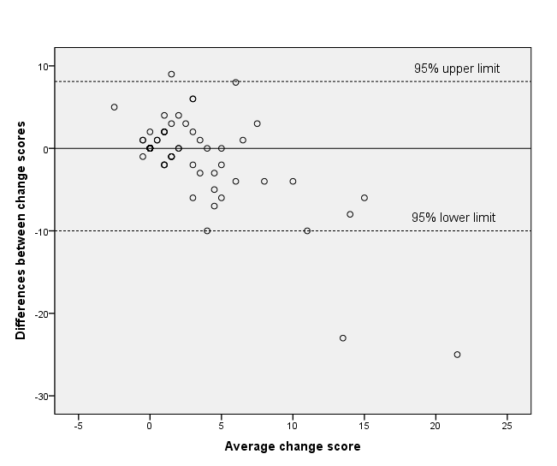

Supplementary Figure S1 Blat and Altman Pot, inter-reader reliability

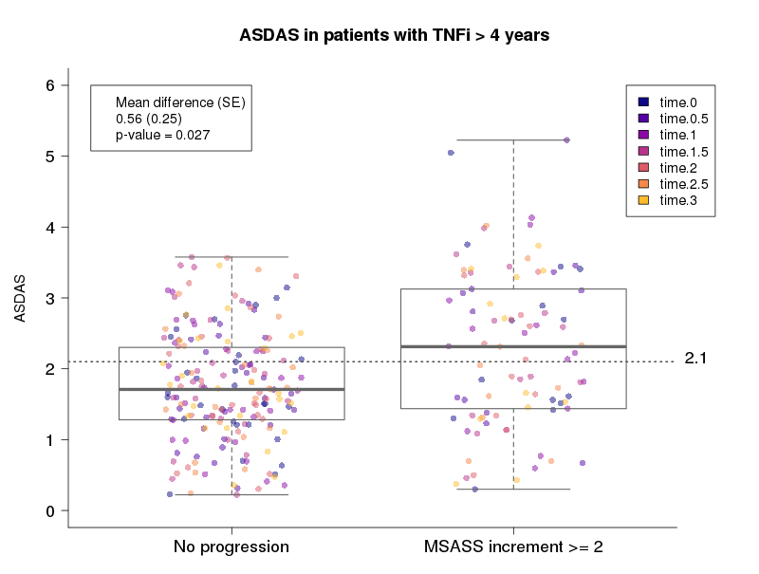

Supplementary Figure S2. Boxplot of the ASDAS values averaged across all time points in patients under long-term TNFi treatment.
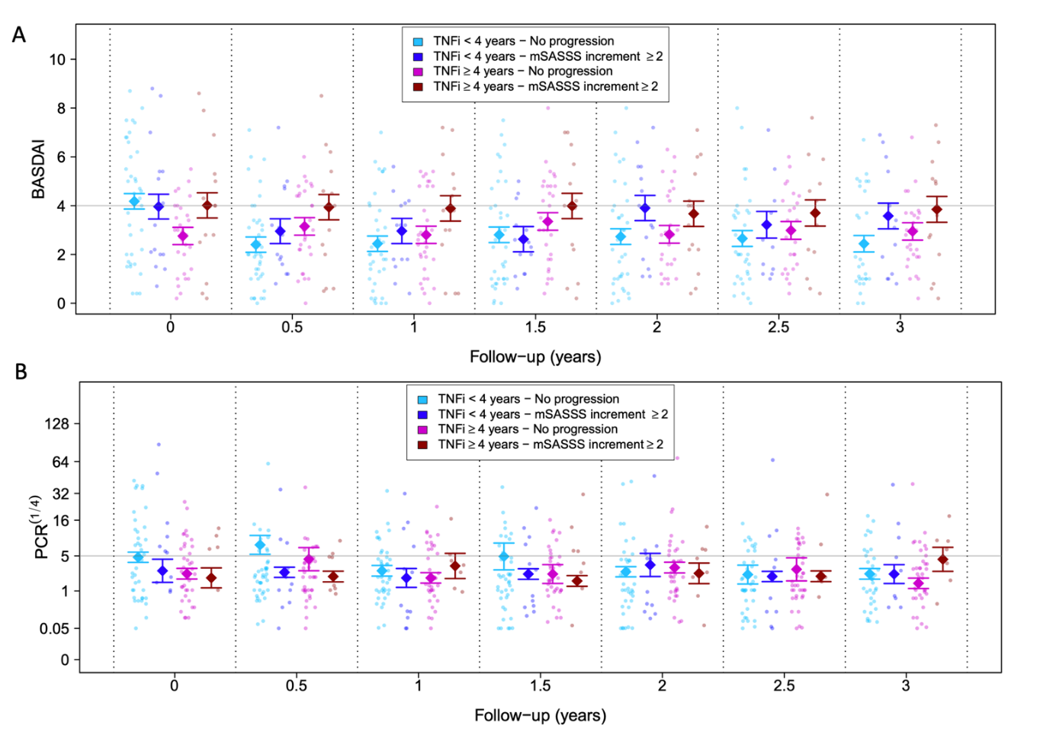
Supplementary Figure S3. Association between disease activity measured by BASDAI (a) and CRP(b) every 6 months with radiographic progression defined as an increase in the mSASSS score at ≥2 points in patients unter TNFi treatment during a follow-up period of three years. Bold dots and intervals represent means and +/- their corresponding standard errors provided a the mixed-effects linear model (no other covariates included).

